Smart Traffic Camera Data Processing System for Alexandria
Student Name: Jana Mohamed Kamal Elnaggar
ID: 22011530
Introduction
The city of Alexandria plans to deploy 5,000 smart cameras at major intersections to improve traffic management and road safety. These cameras can detect accidents, count vehicles, estimate speed, and help adjust traffic light timings in real-time.
Since each 4K camera produces a huge amount of video data every second, sending all footage to a central data center is expensive and inefficient. A better solution is to process the most important information locally on the camera and only send useful data to the central system.
1. Local Filtering Algorithm

Objective
Reduce transmitted data while preserving important information.

Proposed Algorithm

Step 1: Capture Video Frames
The camera continuously captures frames.

Step 2: Object Detection
Use a lightweight AI model such as:
- YOLO
- MobileNet
To detect:
- Cars
- Trucks
- Motorcycles
- Buses
- Pedestrians

Step 3: Tracking
Assign IDs to moving objects across frames.
Example:
Vehicle #101 → appears in frame 1, 2, 3 …

Step 4: Event Detection Rules
Trigger only important events such as:
- Accident/collision detected
- Speed violation
- Vehicle stopped too long
- Traffic congestion

Step 5: Local Summarization
Instead of storing full video:
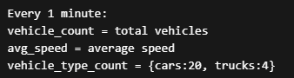
Pseudocode
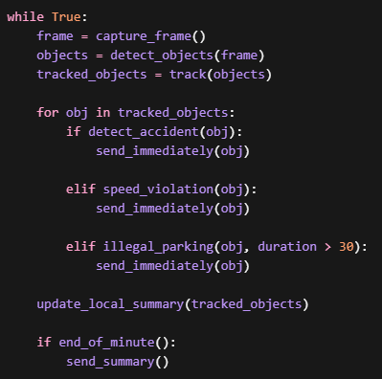

Benefits
✔ Reduces bandwidth
✔ Faster response time
✔ Lower storage cost

2. Criteria for Interesting Data
The data can be divided into:

A) Immediate Transmission (Real-Time Alerts)
Sent instantly to central server.
Event | Condition
Accident | Sudden stop/collision detected
Over-speeding | Speed > allowed limit
Illegal parking | Vehicle stopped > 30 sec in no-parking zone
Traffic jam | Avg_speed < threshold and vehicle_count high
Wrong-way driving | Vehicle direction opposite lane
Emergency vehicle detection | Ambulance/fire truck approaching
Example:
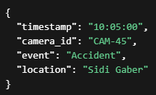

B) Batch Transmission (Midnight Reports)
Sent once daily.
Examples:
- Total car counts
- Hourly average speed
- Vehicle type statistics
- Peak congestion times
Example:
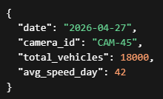

3. Average Traffic Density
We should calculate without storing full video.

Formula
Average Traffic Density:
Traffic density = Vehicle Count / Road Segment Length
For every 5-minute window:
Density = Total Detected Vehicles / Road Length

Sliding Window Method
Maintain only aggregated counters:
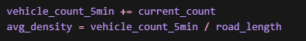
No need to store full frames or raw video.

Benefits
- Memory efficient
- Real-time analytics
- Fast querying

4. Partitioning Strategy
To ensure sightings of the same vehicle go to the same analytics node.

Option 1: Geographic Zone Partitioning
Partition by city zones:
- East Alexandria
- Central Alexandria
- West Alexandria
Example:

Benefits:
- Nearby cameras processed together
- Good for local traffic analytics

Option 2: License Plate Hash Partitioning
Partition based on:
Example:
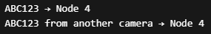Benefits:
✔ Same vehicle always routed to same node
✔ Easier vehicle path matching
✔ Efficient duplicate detection

5. Out-of-Order Data Arrival
If Camera B’s data arrives before Camera A’s due to network delays, the server should process events using the event timestamp instead of arrival time.
Technologies such as Apache Kafka and Apache Flink support event-time processing and watermarks to handle delayed events.
6. Unique Vehicles Through the City Center
To count unique vehicles across all 5,000 cameras, the system can use license plate recognition, but the problem is large memory consumation
For large-scale counting, HyperLogLog is recommended because it estimates unique counts efficiently using less memory.
7. Handling Duplicate Events
Duplicate events can happen due to retries or multiple cameras capturing the same vehicle.
The system should generate a unique event ID and use time-window-based deduplication to ignore repeated events.

