Student Name: Jana Mohamed Kamal Elnaggar ID: 22011530
1. Local Filtering Algorithm

Step 1: Capture Video Frames
The camera continuously captures frames.

Step 2: Object Detection
Use a lightweight AI model to detect cars, trucks, motorcycles, buses, pedestrians

Step 3: Tracking
Assign IDs to moving objects across frames.

Step 4: Event Detection Rules
Trigger only important events such as: Accident/collision detected, Speed violation, Vehicle stopped too long, and Traffic congestion

Step 5: Local Summarization
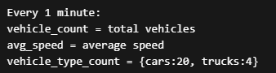
For non-critical data, the camera creates periodic summaries such as vehicle count and average speed every minute instead of transmitting raw video:
Pseudocode
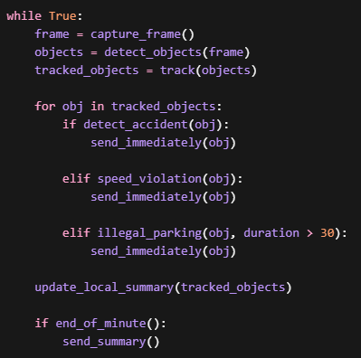
2. Criteria for Interesting Data
The data can be divided into:

A) Immediate Transmission (Real-Time Alerts)
Sent instantly to central server.
Example:
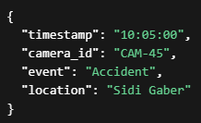

B) Batch Transmission (Midnight Reports)
Sent once daily.
Example:
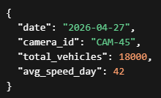
3. Average Traffic Density
We should calculate without storing full video.

Formula
Average Traffic Density:
Density = Total Detected Vehicles / Road Length

Sliding Window Method
Maintain only aggregated counters; no need to store full frames or raw video.

4. Partitioning Strategy
To ensure sightings of the same vehicle go to the same analytics node.

Option 1: Geographic Zone Partitioning
Partition by city zones (east, central, west)

Option 2: License Plate Hash Partitioning
Partition by license plates.

5. Out-of-Order Data Arrival
If Camera B’s data arrives before Camera A’s due to network delays, the server should process events using the event timestamp instead of arrival time.
Technologies such as Apache Kafka and Apache Flink support event-time processing and watermarks to handle delayed events.

6. Unique Vehicles Through the City Center
To count unique vehicles across all 5,000 cameras, the system can use license plate recognition, but the problem is large memory consumation
For large-scale counting, HyperLogLog is recommended because it estimates unique counts efficiently using less memory.

7. Handling Duplicate Events
Duplicate events can happen due to retries or multiple cameras capturing the same vehicle.
The system should generate a unique event ID and use time-window-based deduplication to ignore repeated events.

