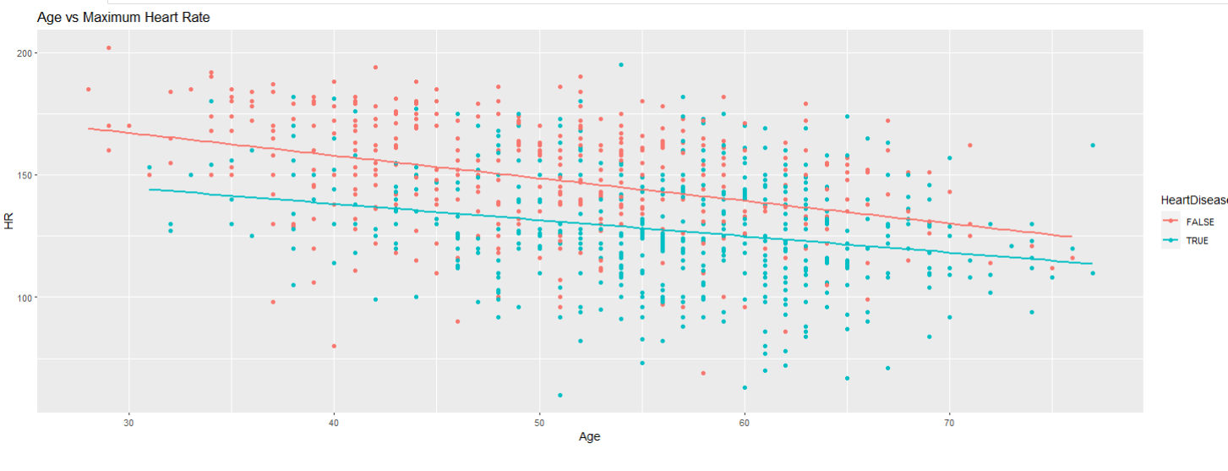
-The scatter plot shows the relationship between age and cholesterol levels, differentiated by the presence or absence of heart disease.
-Most data points are clustered between ages 40 to 60 and cholesterol levels of around 200 to 300.
-There is a correlation between age and cholesterol levels, that people with heart disease generally have higher cholesterol levels than those without

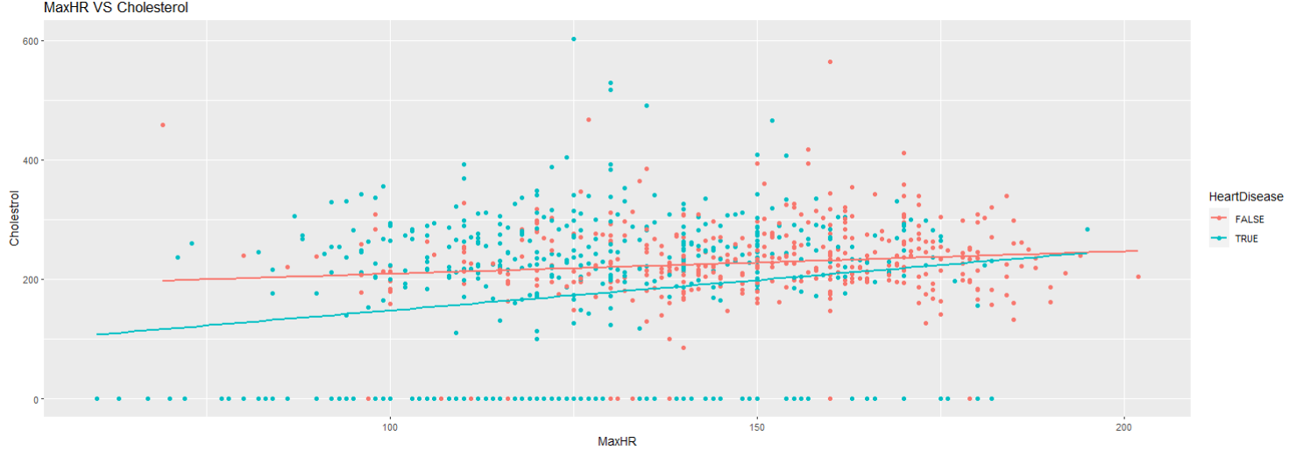
-The scatter shows the relationship between Maximum Heart Rate (MaxHR) and Cholesterol levels, differentiated by the presence or absence of heart disease.
- Most data points are scattered but more concentrated between 100 and 150 MaxHR and between 200 and 300 cholesterol levels.
-There is a correlation between MaxHR and cholesterol levels, with cholesterol levels generally decreasing with increasing MaxHR. It also indicates that people with heart disease generally have lower MaxHR and higher cholesterol levels than those without.

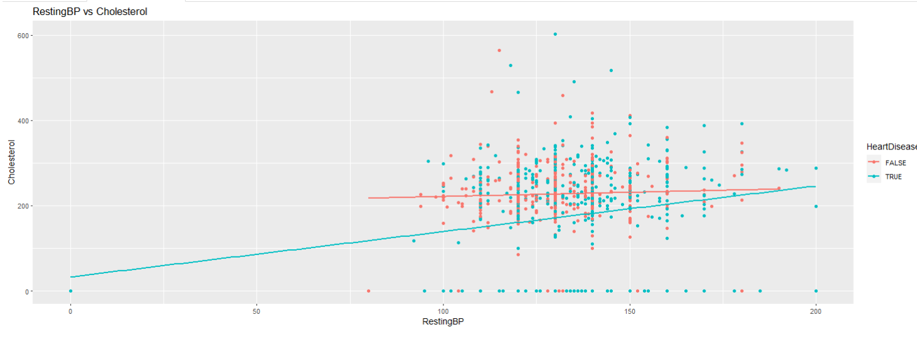
-The scatter plot shows the relationship between RestingBP and Cholesterol levels, differentiated by the presence or absence of heart disease.
-Most data points are clustered between approximately 100 to 150 RestingBP and 200 to 300 Cholesterol. A trend line shows a positive correlation between RestingBP and Cholesterol levels.
-There is a correlation between RestingBP and Cholesterol levels, with cholesterol levels generally increasing with increasing RestingBP. It also indicates that people with heart disease generally have higher RestingBP and higher cholesterol levels than those without.

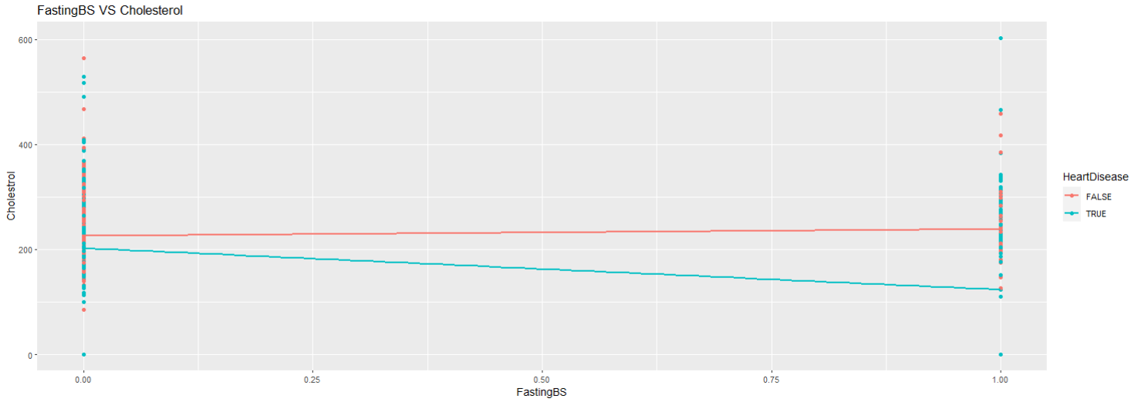
-The graph shows the relationship between FastingBS and Cholesterol levels, differentiated by cases of heart disease (True or False).
-Most of (without heart disease) are clustered around the lower range of cholesterol levels, while (with heart disease) are scattered but have higher cholesterol levels.
-There is a correlation between FastingBS and Cholesterol levels, with cholesterol levels generally increasing with increasing FastingBS. It also indicates that people with heart disease generally have higher FastingBS and higher cholesterol levels than those without.

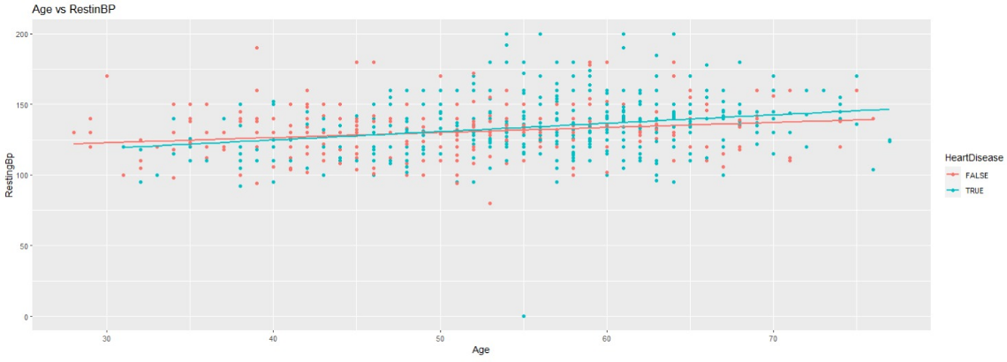

-The graph shows the relationship between age and resting blood pressure (RestinBP), differentiated by the presence or absence of heart disease.
-Most data points are clustered between the ages of 40 and 70, and RestinBP of 100 to 150.
-There is a correlation between age and RestinBP, with RestinBP generally increasing with age. It also indicates that people with heart disease generally have higher RestinBP than those without.

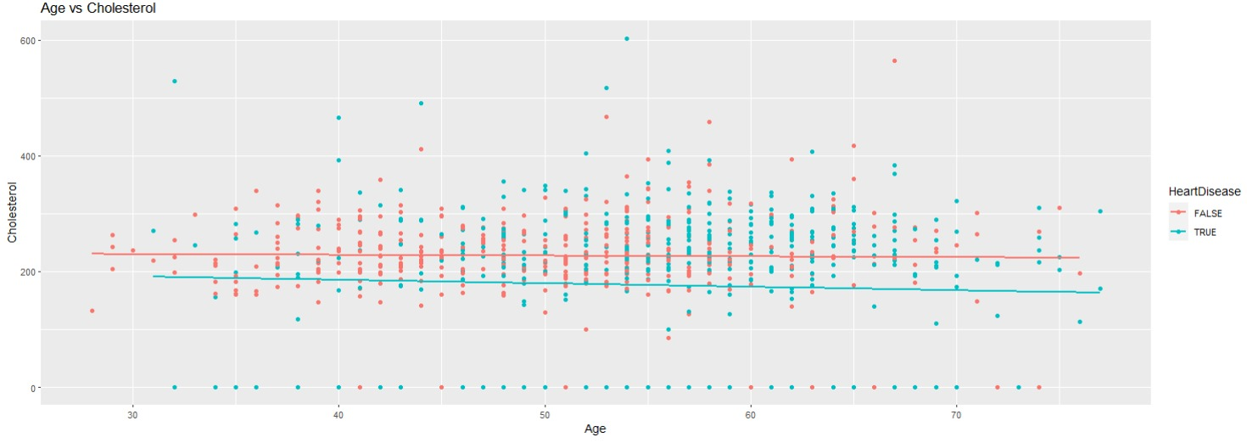
The graph shows the relationship between age and cholesterol levels, differentiated by whether or not individuals have heart disease.
Both sets of data points are scattered throughout the graph, but red points tend to be higher on the y-axis. There are two lines of best fit corresponding to each set of data points; the red line is generally above the blue one.
There is a correlation between age and cholesterol levels, with cholesterol levels generally increasing with age. It also indicates that people with heart disease generally have higher cholesterol levels than those without.

