Task 1
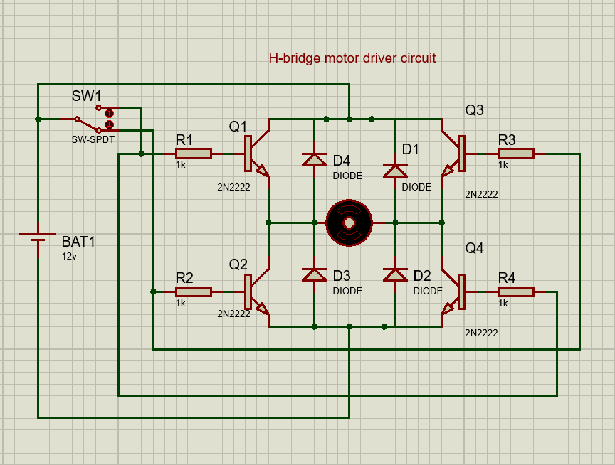
1. Purpose of the circuit
The H-bridge motor driver circuit uses four NPN BJTs (2N2222).
This arrangement allows you to:
- Drive a DC motor in both directions (CW & CCW).
- Stop the motor by turning off the battery.
- Change direction using a control switch (SW1).
2. Components and their functions
a) Q1, Q2, Q3, Q4 — Transistors (2N2222)
- Function: Act as electronic switches to control current flow through the motor in either direction.
- Reason for use: 2N2222 is a common small-signal NPN transistor.
- Operation in H-bridge:
  - For forward rotation: Q1 and Q4 are ON, Q2 and Q3 are OFF.
  - For reverse rotation: Q2 and Q3 are ON, Q1 and Q4 are OFF.
- However, BJTs are less efficient than MOSFETs for motor drive because they have higher voltage drop and power loss, but they are simpler.
b) R1, R2, R3, R4 — Base resistors (1 kΩ)
- Function: Limit the base current into each transistor.
- Why needed: Without these, the base-emitter junction could draw too much current from the control signal and damage the transistor.
- Typical value: 1 kΩ works for low-current logic control; it sets base current to a safe and sufficient level to saturate the transistor.
c) SW1 — Control switch
- Function: Chooses which diagonal pair of transistors to turn ON, thus changing motor direction.
- Reason for use: Simplest manual control for forward/reverse without needing a microcontroller.
- Operation:
  - In one position: Activates Q1 & Q4 → motor spins one way.
  - In the other position: Activates Q2 & Q3 → motor spins the other way.
d) BAT1 — Power source (12 V)
- Function: Provides the motor’s operating voltage.
- Reason for use: 12 V is a common motor supply.
e) Motor
- Function: Converts electrical energy to mechanical rotation.
- Reason for use: This is the load we are driving — direction control is the main goal of the H-bridge.
3. How it works
Forward direction:
- SW1 connects the left control inputs to power in such a way that Q1 and Q4 base current.
- Q1 allows current from +12 V into the motor’s left terminal.
- Q4 connects the motor’s right terminal to ground.
- Current flows V+ → Q1 → Motor → Q4 → GND, spinning the motor forward.

Reverse direction:
- SW1 toggles so Q2 and Q3 turn ON.
- Q3 lets current from +12 V into the motor’s right terminal.
- Q2 connects the motor’s left terminal to ground.
- Current flows V+ → Q3 → Motor → Q2 → GND, spinning the motor backward.
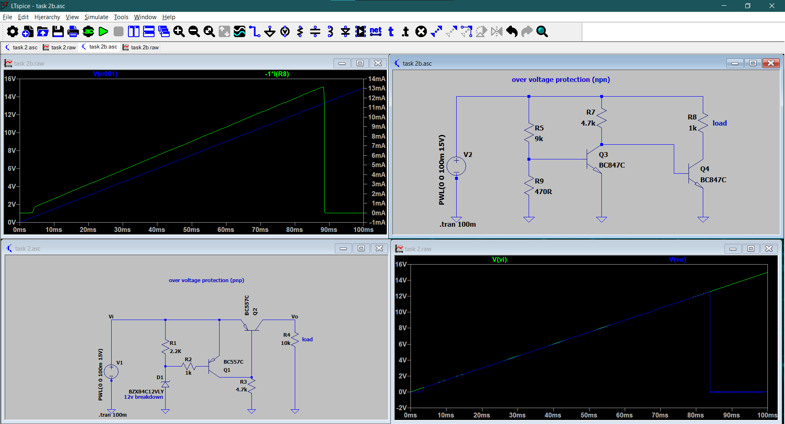
Task 2
NPN Over-Voltage Protection Circuit
Transistors Used: Two NPN transistors (BC847C).
Operation Principle:
When the input voltage exceeds a set threshold, the first NPN transistor conducts and triggers the second NPN transistor, this action either disconnects the load or diverts current to protect the circuit.
Behavior:
- Works well for low side switching (ground side).
- requires a reference voltage and biasing resistors.
- The circuit monitors the input voltage.
- When the voltage exceeds a certain threshold, Q3 turns on.
- This causes Q4 to activate, creating a path to divert the excess voltage away from the load.
- The simulation shows V(n001) (voltage at a node) and I(R8) (current through R8), indicating how the circuit responds to over-voltage.

PNP Over-Voltage Protection Circuit
Components: A Zener diode (e.g., 12V) sets the over-voltage threshold One PNP transistor (e.g., BC557C) and one NPN transistor.
Operation Principle:
  - When the input voltage exceeds the Zener breakdown voltage, the PNP transistor turns on.
  - This then activates the NPN transistor to disconnect the load or shunt current.
Behavior:
  - Works well for high side switching (positive supply side).
  - Provides better isolation
  - The Zener diode D1 is key here. It stays off until the input voltage exceeds 12V.
  - Once that happens, D1 breaks down, allowing current to flow and turn on Q1.
  - Q1 then activates Q2, which shunts the excess voltage away from the load.
  - The simulation shows V(vi) (input voltage) and V(vo) (output voltage), demonstrating how the circuit clamps the output when over-voltage occurs.

