Wheelchair Accessibility Map

- Problem:
People of determination, especially wheelchair users, face major challenges when moving around cities or visiting public and private facilities.
- Lack of accurate information: There is no reliable, centralized system that provides details about accessibility in places such as restaurants, malls, universities, or government offices.
- Gap between expectations and reality: Many facilities claim to be accessible, but upon arrival, users often find stairs without ramps, elevators that are out of service, or restrooms that are not properly equipped.
- Dependence on personal trial and error: Individuals are forced to try places themselves, wasting time and effort, which often leads to frustration and social isolation.

- Result:
- Restricted freedom of movement.
- Loss of independence and limited participation in community life.
- Negative social, psychological, and economic impact on people of determination and their families.

- Solution:
We propose the development of a digital platform (web) that acts as a "Google Maps for wheelchair accessibility," focusing on displaying places and their readiness for wheelchair users.
- Key Features:
- Interactive Map:
Display nearby locations that support:
Ramps for wheelchairs.
Functional elevators.
Accessible restrooms.
Stair-free entrances.

- User Contributions:
Add new places and rate accessibility.
Upload real photos for verification.
Categorize places as: Accessible / Partially Accessible / Not Accessible.
- Smart Alerts:
Notifications about issues such as broken elevators.
Continuous updates based on user reports.
- Recommendation System:
The System collects statistics about visits by people of determination.
If a location receives high visits but lacks proper facilities, the system generates a recommendation for the business owner to encourage improvements.
This creates a cycle where businesses enhance accessibility to attract more visitors.
- Additional Features:
Smart Search: Example, "nearest restaurant with an accessible restroom."
Badges and Labels: Places receive labels such as Fully Accessible or Partially Accessible.
Safe Routes: Suggest routes that highlight ramps and avoid obstacles.
User Reviews: Personal experiences shared to provide practical insights.
Partnerships with authorities: Data can be shared with municipalities, universities, and malls to encourage improvements.
Heatmaps and Statistics: Show areas with high or low accessibility to support decision-making.
Multi-language & Accessibility Support: Interface available in Arabic and English, with voice support for the visually impaired and large-text options.
- Emergency Services in the Website:
- If the location has a responsible person or security staff:
- The website provides a "Request Help" button.
- When pressed:
A real-time notification with live location is sent to the registered security staff through the location’s dashboard.
The person’s position appears on the internal map of the place (if registered).
Security staff can reach the individual quickly to provide assistance.
- If the location has no responsible staff:
- Alternative plan with two key options:
1. Contacting family or relatives:
The website stores emergency contact numbers chosen by the user (parent, relative, or friend).
Once the "Request Help" button is pressed, a notification with live location is sent to those contacts.
A confirmation message appears on the user’s screen: "Your emergency contacts have been notified," along with a clear alert sound.
2. Automatic call to local emergency services:
For example, 122 in Egypt, with the user’s live location shared directly.

- Expected Outcomes:
- Social Impact:
- Improve the quality of life for people of determination by providing greater independence and mobility.
- Reduce frustration and social isolation, encouraging stronger community participation.
- Raise awareness among businesses and institutions about the importance of accessibility and inclusion.

- Economic Impact:
- Increase customer traffic to accessible places, directly boosting revenue for businesses that invest in accessibility.
- Encourage competition among service providers to enhance accessibility and achieve higher ratings.

- Return for People of Determination:
- Easier access to essential services, leisure activities, and educational or governmental facilities.
- Enhanced independence and dignity, reducing reliance on others.
- Stronger sense of belonging and equal opportunities in society.

- List of User Functional Requirements
- 1. Independence Promotion
- 1.1 The system shall enable wheelchair users to plan movement independently.
1.1.1 The system shall provide a route planning module for wheelchair users.
1.1.1.1 Users shall input start and destination locations using the website interface.
1.1.1.2 System shall calculate accessible routes avoiding stairs, narrow paths, and steep slopes.
1.1.2 The website shall provide route and accessibility data to reduce reliance on others.
- 2. Inclusion Management
- 2.1 The user shall be able to share experiences about places.
2.1.1 The system shall provide a review and rating module linked to each location.
2.1.2 The system shall allow users to upload photos related to accessibility features.
2.2 The system shall promote social inclusion by highlighting accessible venues.
2.2.1 The system shall display accessible and non-accessible places together on the same map.
- 3. Business Engagement Management
- 3.1 Business owners (e.g., restaurants, malls, cafés) shall be able to register their places on the system.
3.1.1 The system shall provide a registration and verification process for business partners.
3.2 Business owners shall be able to update accessibility-related information (e.g., ramps, elevators, parking availability).
3.2.1 The system shall allow verified businesses to add, edit, and manage their accessibility details.
3.3 Business owners shall be able to respond to user reviews or feedback.
3.3.1 The system shall support communication or feedback modules between users and business owners.
- 4. Help Center Management
- 4.1 Users shall access FAQs, tutorials, and videos.
4.1.1 The system shall include accessibility tips and safety guidance.
4.1.2 The system shall provide tutorials and guided photos to help the user in using the system.
4.2 Users shall be able to search within the help section.
4.2.1 The system shall implement a search function that allows users to find specific topics within the help section.
- 5. User Management
- 5.1 Users shall be able to login or register an account via email or social accounts.
5.1.1 System shall allow registration via email.
5.1.2 System shall allow login via email or social accounts (e.g., Facebook, Google).
5.1.3 System shall save the username and password.
5.1.4 System shall inform the user with invalid information input within login (username or password).
5.2 Users shall receive confirmation of successful registration.
5.2.1 System shall send confirmation email for activation.
5.2.2 System shall notify user of successful or failed registration.
- 6. Role Management
- 6.1 Users shall be able to use the system and login according to their role (Regular user, Business owner, Admin, Authority representative).
6.1.1 The system shall support four main roles: Regular user, Business owner, Admin, Authority representative.
6.1.2 Each role shall have defined permissions and access limits.
6.2 Admins can suspend or approve accounts.
6.2.1 System shall allow the Admins only to suspend or approve accounts.
- 7. Location Management
- 7.1 Users shall view locations with detailed information and filters.
7.1.2 Each location card shall include name, category, rating, and accessibility score.
7.1.3 Filters for “Accessible,” “Partially Accessible,” or “Not Accessible”; combined filters (type, distance, rating).
7.2 Users shall be able to save their location and to retrieve it whenever needed.
7.2.1 System shall retrieve and store location data and display nearby locations using GPS and radius.
7.3 Business owners and admins shall be able to edit, update the state of accessibility, and verify submission.
7.3.1 System shall provide admin interface for managing and verifying submissions.
- 8. Notification Management
- 8.1 Users shall receive notification when favorite places change accessibility status.
8.1.1 Customizable notification settings in profile.
8.1.2 System shall provide notification module for sending notifications.
8.2 Users shall receive real-time alerts for accessibility updates or issues.
8.2.1 System shall send real-time notification with live location to security dashboard.
- 9. Emergency Assistance Management
- 9.1 Users shall request help in emergencies, with or without staff available.
9.1.1 System shall display user’s position on internal map and automatically share GPS coordinates.
9.1.2 In case of existence of available staff, the system shall enable staff to respond and mark issue as resolved.
9.1.3 In case of unavailable staff, the system shall allow the user to contact the emergency contacts.
9.1.3.1 Store up to 3 emergency numbers.
9.1.3.2 Automatic call to local emergency services (e.g., 122).
9.2 The user shall receive confirmation message with their emergency issue.
9.2.1 Display confirmation message: “Your emergency contacts have been notified.”
- 10. Support System Management
- 10.1 Users shall be able to chat with chatbot.
10.2 Users shall be able to contact support through email or live chat.
10.2.1 Built-in help center with FAQs and chatbot.
10.2.2 Provide contact form for user issues.
10.2.3 Include feedback and feature request options.
- 11. Route Management
- 11.1 Users shall receive safe wheelchair-friendly routes.
11.1.1 System shall generate wheelchair-friendly routes.
11.1.2 Routes shall avoid stairs, narrow paths, and steep slopes.
11.1.3 System shall provide voice-guided navigation.
11.1.4 Routes shall update in real time upon detecting obstacles.
11.1.5 System should use mapping APIs to generate obstacle-free routes.
11.1.6 Directions shall be provided via voice, text, and vibration.
11.1.7 Routes shall dynamically re-route when detecting stairs, construction, or blocked paths.
- 12. Data Analytics Management
- 12.1 System shall analyze accessibility data to detect patterns and trends.
12.1.1 Aggregate regional statistics from user submissions.
12.1.2 Use machine learning to detect patterns in accessibility data.
- 13. Intelligent Recommendations Module
- 13.1 The user shall be able to view recommended places and accessibility trends.
13.1.1 The system shall utilize machine learning algorithms to identify accessibility trends.
13.1.2 The system shall predict and recommend frequently visited accessible routes based on user behavior and usage patterns.
- 14. Language Support Management
- 14.1 The user can use the system in Arabic or English languages.
14.1.1 System shall support Arabic and English.
14.1.2 Auto-switch layout between RTL and LTR.
14.1.3 Allow manual language switching by user.
- 15. Data Visualization Management
- 15.1 System administrators and partner organizations shall be able to view analytical dashboards that summarize accessibility data.
15.1.1 The system shall provide an interactive analytics dashboard displaying visual insights related to accessibility.
15.2 Users shall be able to visualize the proportion of accessible versus non-accessible places.
15.2.1 The system shall calculate and display ratios of accessible vs. non-accessible locations dynamically.
15.2.2 The system shall show statistics on the most visited categories (e.g., restaurants, malls, universities) and frequent problem spots based on user reports.
15.3 Authorized users (e.g., researchers, NGOs, or decision-makers) shall be able to export charts and analytics for further analysis.
15.4 Business partners shall be able to track feedback trends related to their places’ accessibility.
- 16. User Support Management
- 16.1 Users shall contact support and track ticket status.
16.1.1 Provide contact form for user issues.
16.1.2 Auto-generate support tickets with ID and timestamp.
16.1.3 Users shall track ticket status from dashboard.
16.1.4 Users shall submit feedback and feature requests.
- 17. Audio Support Management
- 17.1 Users shall receive audio assistance and screen reader support.
17.1.1 Enable ARIA labels and alt text for all images.
17.1.2 Support full keyboard navigation.
17.1.3 Allow reading of page content aloud.
17.1.4 Auto-read accessibility details when requested.
- 18. Authority Dashboard Management
- 18.1 Authorized government and municipal users shall be able to access anonymized regional accessibility data for analysis.
18.1.1 The system shall provide role-based access control to grant government and municipal users access to relevant datasets.
18.1.2 The system shall generate and display anonymized regional accessibility statistics (without revealing individual user data).
18.2 Government users shall be able to export datasets and reports to support policy-making and urban planning decisions.
18.2.1 The system shall include data export functionality allowing authorized users to download datasets in standard formats (e.g., CSV, Excel, or PDF).
18.2.2 The system shall produce dynamic heatmaps and trend visualizations showing accessibility progress across regions.
18.2.3 The system shall automatically update regional analytics as new accessibility data and reports are added to the system.
- 19. Backup System Management
- 19.1 The administrator shall be able to manually create restore points to preserve system data before updates or major changes.
19.1.1 The system shall allow the creation and restoration of manual backup points by administrators through the admin panel.
19.2 The administrator shall be able to restore previous data versions in case of data corruption or system failure.
19.2.1 The system shall implement version control for location and route data to track modifications and allow rollback to previous versions if needed.
19.3 Authorized users (e.g., admins or technical staff) shall be notified when automatic backups are successfully completed or if any error occurs.
19.3.1 The system shall perform automatic daily backups of all critical data, including location, route, and user-generated content, and store them securely in the database environment.
19.3.2 The system shall encrypt backup data to ensure data integrity and security.
19.3.3 The system shall maintain a log of backup and restore activities, including timestamps and responsible users.

- 20. User Reviews Management
- 20.1 Users shall be able to submit reviews with text and photos.
20.1.1 System shall allow submitting text reviews and attaching photos.
20.2 Reviews shall be publicly displayed.
20.2.1 Reviews shall be displayed publicly and sorted by most recent.
20.3 Users shall report inappropriate reviews.
20.3.1 System shall allow reporting inappropriate reviews for admin review.
-
- 21. Map Visualization Management

21.1 Users shall be able to view and manipulate an interactive map that presents information for nearby accessible locations.

21.1.1 System shall display accessible locations on the map with clear visual identifiers corresponding to their accessibility level.

21.1.2 System shall visually differentiate accessibility categories (Accessible, Partially Accessible, Not Accessible) using standardized map indicators.

21.1.3 System shall allow users to adjust map scale and orientation and select among available map visualization modes (zoom, pan, satellite views).
- 22. Report Management
- 22.1 Users shall be able to report accessibility obstacles.

22.1.1 System shall allow users to submit accessibility obstacle reports of broken ramp or blocked path.

22.1.2 System shall allow users to attach photos or comments as evidence when submitting reports.

22.2 Users shall be able to submit correction reports for inaccurate or outdated accessibility data.

22.2.1 System shall allow users to submit correction reports for inaccurate or outdated accessibility data.

22.3 Admin shall be able to access and view accessibility reports, correction reports, and corresponding visual summaries of accessibility data.

22.3.1 System shall require admin verification of each user-submitted report and correction report before updating the map.

22.3.2 System shall notify admins of new user reports and mark each case as ‘Reported’.

22.3.3 System shall notify other users about reported changes.
- 23. Profile Management
- 23.1 Users shall be able to view and edit their personal profile information.

23.1.1 System shall allow users to view and edit their personal profile information.

23.1.2 System shall allow users to update their name, email, and accessibility preferences.

23.1.3 System shall save user accessibility preferences.

23.2 Users shall be able to upload a personal profile picture.

23.2.1 System shall allow users to upload a profile picture.

23.3 Users shall be able to delete their account.

23.3.1 System shall allow users to delete their account.
- 24. User Contributions Management
- 24.1 Users shall earn a type of “Contributor” badge after completing a defined contribution threshold for each type (e.g., 10 approved photos, 20 ratings, and 10 reviews).

24.1.1 System shall automatically award a type of “Contributor” badge when a user meets the defined contribution threshold.

24.1.2 The system shall have three types of badges (top contributor, photo master, and review master).

24.2 Top Contributors shall be able to post new photos and reviews directly without prior admin approval.

24.2.1 System shall permit users holding the “Top Contributor” badge to publish photos and reviews immediately without admin approval as their special feature.

24.3 Admins shall verify and approve all user-submitted photos and reviews before publishing.

24.3.1 The system shall allow admin to verify submissions of photos and reviews before publishing.

24.4 Users shall be notified whenever an admin edits or removes their submitted content.

24.4.1 System shall notify users when an admin edits or removes their submitted content.
- 25. Community Engagement
- 25.1 Users shall be able to create and join virtual community groups dedicated to accessibility discussions and events (to share tips, organize accessibility-focused events, and collaborate on advocacy initiatives).
25.1.1 System shall provide a Community Engagement Module that enables users to create, join, and manage virtual accessibility groups.
25.1.2 System shall allow group members to create events specifying date, time, location, and accessibility requirements.
25.2 Users shall be able to share accessibility challenges and success stories within community groups to encourage peer interaction and foster awareness. 25.2.1 System shall allow users to publish post text and attach pictures or videos within community groups to share accessibility experiences or challenges.
25.2.2 System shall provide a feedback mechanism (e.g., vote, like) that allows users to positively endorse community posts and to highlight impactful contributions.
25.2.3 System shall allow users to report inappropriate community posts for admin review.

- List of User Non-Functional Requirements
- 1. Performance Requirements
- 1.1 The system shall load the interactive map and nearby accessible locations within 3 seconds under normal network conditions (10 Mbps).
1.2 The system shall handle at least 500 concurrent users without noticeable performance degradation.

- 2. Security Requirements
- 2.1 The system shall encrypt all sensitive user data, including login credentials and location information, using AES-256 encryption.
2.2 The system shall transmit all data securely using the HTTPS (SSL) protocol.
2.3 The system shall implement role-based access control (RBAC) to ensure that only authorized users can access or modify specific modules and data.

- 3. Availability and Reliability Requirements
- 3.1 The system shall maintain an uptime of at least 99% per month to ensure continuous availability.
3.2 The system shall perform automatic daily backups of all critical data, including user accounts, locations, and routes.
3.3 The system shall allow complete recovery within 10 minutes after any system failure or crash.

- 4. Usability and Accessibility Requirements
- 4.1 The system interface shall comply with WCAG 2.1 Level AA accessibility standards to support users with different abilities.
4.2 The system shall support both Arabic and English languages and automatically adjust between RTL and LTR layouts.
4.3 The system shall provide accessibility aids such as large-text mode, screen reader compatibility, and voice assistance to ensure ease of use for all users.

Subsystem Table
Subsystem Name | Subsystem Function | Subsystem Interface
Independence Promotion Module | - Enables route planning & data access.  • 1.1.1.1 Accept start/dest.  • 1.1.1.2 Compute accessible route.  • 1.1.2 Provide data. | java interface IndependencePromotion { void planMovementIndependently(); void provideAccessibilityData(); }
Inclusion Management | 2.1 Share reviews & photos.  • 2.1.1 Review/rating.  • 2.1.2 Upload photos.  • 2.2.1 Show venues. | java interface Inclusion { void shareExperience(); void uploadAccessibilityPhotos(); void displayAccessibleVenues(); }
Business Engagement | 3.1 Register, update, respond.  • 3.1.1 Register/verify.  • 3.2.1 Edit details.  • 3.3.1 Reply to feedback. | java interface BusinessEngagement { void registerBusiness(); void updateAccessibilityInfo(); void viewUserRatings(); void respondToFeedback(); }
Help Center Management | 4.1 FAQs, tutorials, search.  • 4.1.1 Tips & guidance.  • 4.1.2 Tutorials.  • 4.2.1 Search. | java interface HelpCenter { void accessFAQs(); void viewTutorials(); void searchHelpContent(String keyword); }
User Management | 5.1 Register/login/validate.  • 5.1.1 Email register.  • 5.1.2 Email/social login.  • 5.1.3 Save creds.  • 5.1.4 Validate.  • 5.2.1 Send email.  • 5.2.2 Notify status. | java interface UserManagement { void registerByEmail(); void loginWithEmailOrSocial(); void validateCredentials(); void sendConfirmationEmail(); }
Role Management | 6.1 Roles & permissions.  • 6.1.1 4 roles.  • 6.1.2 Permissions.  • 6.2.1 Suspend/approve. | java interface RoleManagement { void assignRole(String role); void definePermissions(); void suspendAccount(); void approveAccount(); }
Location Management | 7.1 View/filter/save/verify.  • 7.1.2 Card info.  • 7.1.3 Filters.  • 7.2.1 GPS nearby.  • 7.3.1 Admin verify. | java interface LocationManagement { void displayAccessibleLocations(); void filterLocations(String filterType); void saveUserLocation(); void verifySubmission(); }
Notification Management | 8.1 Real-time alerts.  • 8.1.1 Settings.  • 8.1.2 Send.  • 8.2.1 Live alert. | java interface NotificationManagement { void sendNotification(String message); void customizeNotificationSettings(); void sendRealTimeAlert(); }
Emergency Assistance Management | 9.1 Help request & contacts.  • 9.1.1 Show on map.  • 9.1.2 Staff resolve.  • 9.1.3 Emergency contacts.  • 9.1.3.2 Call 122.  • 9.2.1 Confirmation. | java interface EmergencyAssistance { void requestEmergencyHelp(); void shareGPSLocation(); void contactEmergencyServices(); }
Support System Management | 10.1 Chatbot & tickets.  • 10.1 Chatbot.  • 10.2.1 Help center.  • 10.2.2 Form.  • 10.2.3 Feedback. | java interface SupportSystem { void startChatbot(); void contactSupport(); void createSupportTicket(); }
Route Management | 11.1 Safe routes & navigation.  • 11.1.1 Generate.  • 11.1.2 Avoid obstacles.  • 11.1.3 Voice.  • 11.1.4 Real-time update.  • 11.1.5 API.  • 11.1.6 Multi-mode.  • 11.1.7 Re-route. | java interface RouteManagement { void generateAccessibleRoute(); void provideVoiceNavigation(); void updateRouteInRealTime(); }
Data Analytics Management | 12.1 Trends & stats.  • 12.1.1 Aggregate.  • 12.1.2 ML patterns. | java interface DataAnalytics { void aggregateAccessibilityData(); void detectPatterns(); }
Intelligent Recommendations Module | 13.1 ML-based suggestions.  • 13.1.1 Trends.  • 13.1.2 Predict routes. | java interface IntelligentRecommendations { void recommendAccessiblePlaces(); void predictPopularRoutes(); }
Language Support Management | 14.1 Arabic/English + layout. • 14.1.1 Support both.  • 14.1.2 Auto RTL/LTR.  • 14.1.3 Manual switch. | java interface LanguageSupport { void switchLanguage(String lang); void autoAdjustLayout(); }
Data Visualization Management | 15.1 Dashboards & export.  • 15.1.1 Dashboard.  • 15.2.1 Ratio. • 15.2.2 Categories. • 15.3 Export.  • 15.4 Business trends. | java interface DataVisualization { void displayDashboard(); void showAccessibilityRatio(); void exportAnalytics(String format); }
User Support Management | 16.1 Tickets & feedback.  • 16.1.1 Form.  • 16.1.2 Generate ticket.  • 16.1.3 Track.  • 16.1.4 Feedback. | java interface UserSupport { void submitFeedback(); void trackTicketStatus(); void requestFeature(); }
Audio Support Management | 17.1 Screen-reader & audio. • 17.1.1 ARIA/alt.  • 17.1.2 Keyboard.  • 17.1.3 Read aloud.  • 17.1.4 Auto-read. | java interface AudioSupport { void readPageContent(); void controlPlayback(String action); void changeVoiceOption(String type); }
Government Dashboard | 18.1 Anonymized data for gov.  • 18.1.1 Access.  • 18.1.2 Stats.  • 18.2.1 Export.  • 18.2.2 Heatmaps.  • 18.2.3 Auto-update. | java interface AuthorityDashboard { void accessRegionalData(); void exportReports(String format); void viewAccessibilityHeatmap(); }
Backup System Management | 19.1 Auto/manual backup.  • 19.1.1 Manual point.  • 19.2.1 Restore.  • 19.3.1 Daily backup.  • 19.3.2 Encrypt.  • 19.3.3 Log. | java interface BackupSystem { void createBackup(); void restoreBackup(); void encryptBackupData(); void logBackupActivity(); }
User Reviews Management | 20.1 Submit/view/report.  • 20.1.1 Text+photo.  • 20.2.1 Public list.  • 20.3.1 Report. | java interface UserReviews { void submitReview(String text); void uploadReviewPhoto(); void reportInappropriateReview(); }
Map Visualization Management | 21.1 Interactive map.  • 21.1.1 Markers.  • 21.1.2 Icons.  • 21.1.3 Controls. | java interface MapVisualization { void showAccessibleMarkers(); void enableMapControls(); void displayAccessibilityIcons(); }
Report Management | 22.1 Obstacle reports.  • 22.1.1 Submit.  • 22.1.2 Verify.  • 22.1.3 Notify.  • 22.1.4 Evidence. | java interface ReportManagement { void submitAccessibilityReport(); void attachEvidence(); void notifyAdmins(); }
Profile Management | 23.1 Edit profile & prefs.  • 23.1.1 View/edit.  • 23.2.1 Save prefs.  • 23.2.2 Photo.  • 23.3.1 Delete. | java interface ProfileManagement { void viewProfile(); void editProfile(); void uploadProfilePicture(); void deleteAccount(); }
User Contributions | 24.1 Badges & moderation.  • 24.1.1 Award badge.  • 24.1.2 Types.  • 24.2.1 Direct publish.  • 24.3.1 Verify.  • 24.4.1 Notify. | java interface UserContributions { void addNewLocation(); void manageContribution(); void receiveContributorBadge(); }
Community Engagement | 25.1 Groups, events, posts.  • 25.1.1 Create/join.  • 25.1.2 Events.  • 25.2.1 Post media.  • 25.2.2 Vote.  • 25.2.3 Report. | java interface CommunityEngagement { void createCommunityGroup(); void joinCommunityGroup(); void postToCommunity(String content); void createEvent(String eventDetails); void moderatePost(String action); void reportCommunityPost(); }

Traceability Matrix — Part 1 (C1 to C13)
Requirement ID(s) | Independence Promotion | Inclusion | Business Engagement | Help Center | User Management | Role Management | Location Management | User Contributions | Notification Management | Emergency Assistance | Support System
C1.1.1–C1.1.2 | ✔
C2.1.1–C2.1.2 |  | ✔ |  |  |  |  |  | ✔
C3.1.1–C3.3.1 |  |  | ✔ |  |  |  | ✔
C4.1.1–C4.2.1 |  |  |  | ✔ |  |  |  |  |  |  | ✔
C5.1.1–C5.2.2 |  |  |  |  | ✔
C6.1.1–C6.1.3 |  |  |  |  |  | ✔
C7.1.1–C7.3.2 |  |  | ✔ |  |  |  | ✔
C8.1.1–C8.2.1 |  |  |  |  |  |  |  |  | ✔
C9.1.1–C9.1.3.2 | ✔ | ✔ |  |  |  |  |  |  | ✔ | ✔
C10.1.1–C10.2.2 |  |  |  |  |  |  |  |  |  |  | ✔
C11.1.1–C11.1.6 | ✔
C12.1.1–C12.1.2 |  |  |  |  |  |  | ✔
C13.1.1–C13.1.2 |  | ✔ |  |  |  |  |  |  | ✔
Traceability Matrix — Part 2 (D14 to D25)
Requirement ID(s) | Route Management | Data Analytics | Intelligent Recommendations | Language Support | Data Visualization | User Support | Assistive Accessibility | Authority Dashboard | Backup System | Report Management | User Reviews | Profile Management | Community Engagement
D14.1–D14.3 |  |  |  | ✔
D15.1–D15.4 |  | ✔ | ✔ |  | ✔ |  |  | ✔
D16.1–D16.4 |  |  |  |  |  | ✔
D17.1–D17.6 |  |  |  |  |  |  | ✔
D18.1–D18.3 |  | ✔ | ✔ |  | ✔ |  |  | ✔
D19.1–D19.6 |  |  |  |  |  |  |  |  | ✔
D20.1–D20.3 |  |  |  |  |  |  |  |  |  |  | ✔
D21.1–D21.3 |  |  |  |  | ✔
D22.1–D22.5 |  |  |  |  |  |  |  |  |  | ✔
D23.1–D23.3 |  |  |  |  |  |  |  |  |  |  |  | ✔
D24.1–D24.4 |  |  |  |  |  |  |  |  |  |  | ✔ |  | ✔
D25.1–D25.2.3 |  | ✔ | ✔ |  |  | ✔ |  |  |  |  |  |  | ✔

- Initial GUI Sketches:
https://www.figma.com/design/0qzWRNZUjcelroP0OITXCs/Wheelchair-Accessibility-
Map?node-id=0-1&t=b3RSwiMQpPh9KN7t-1

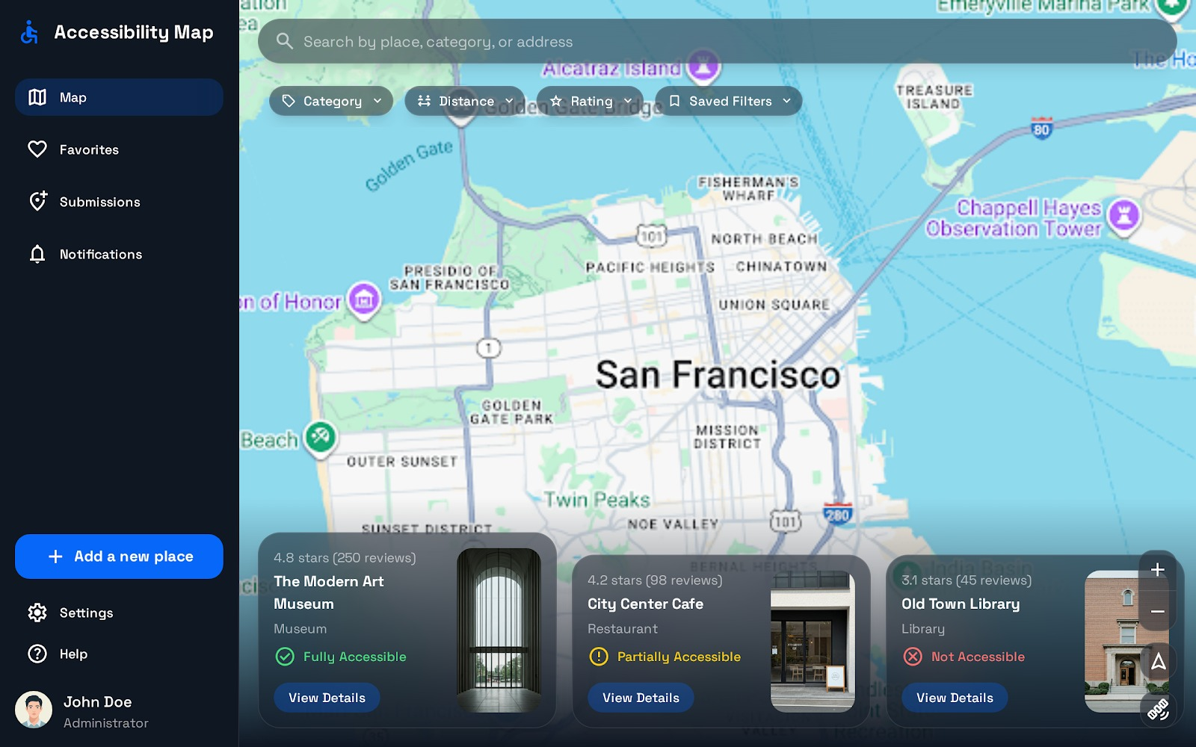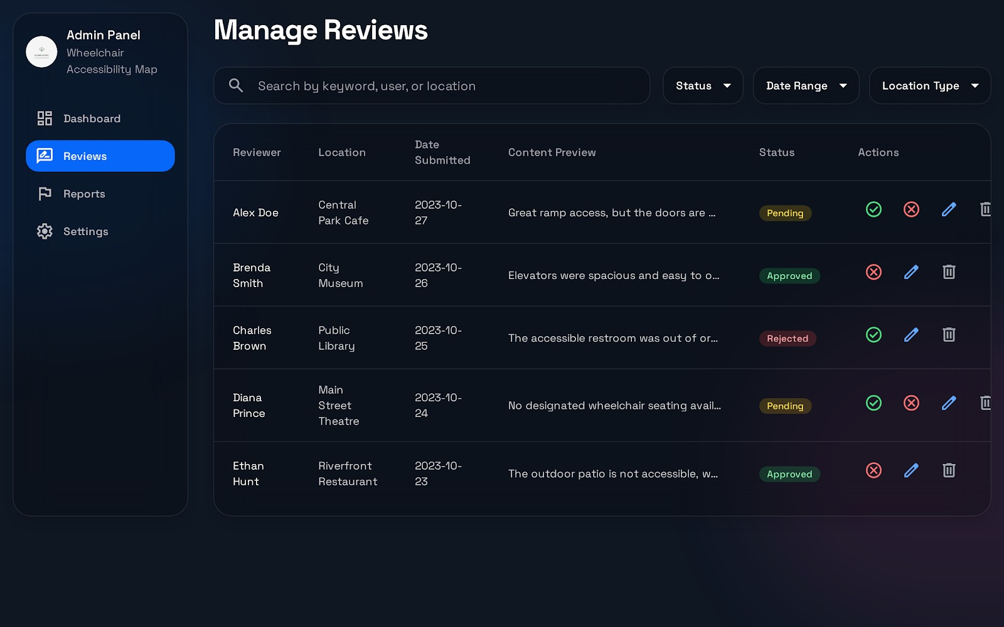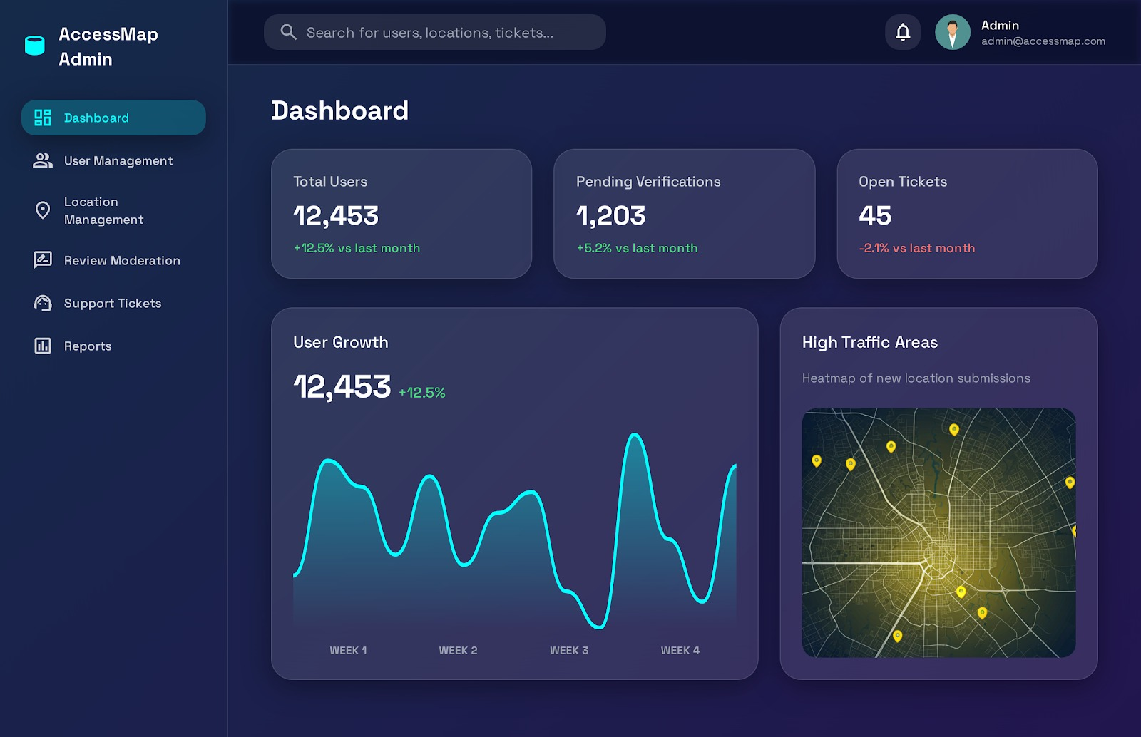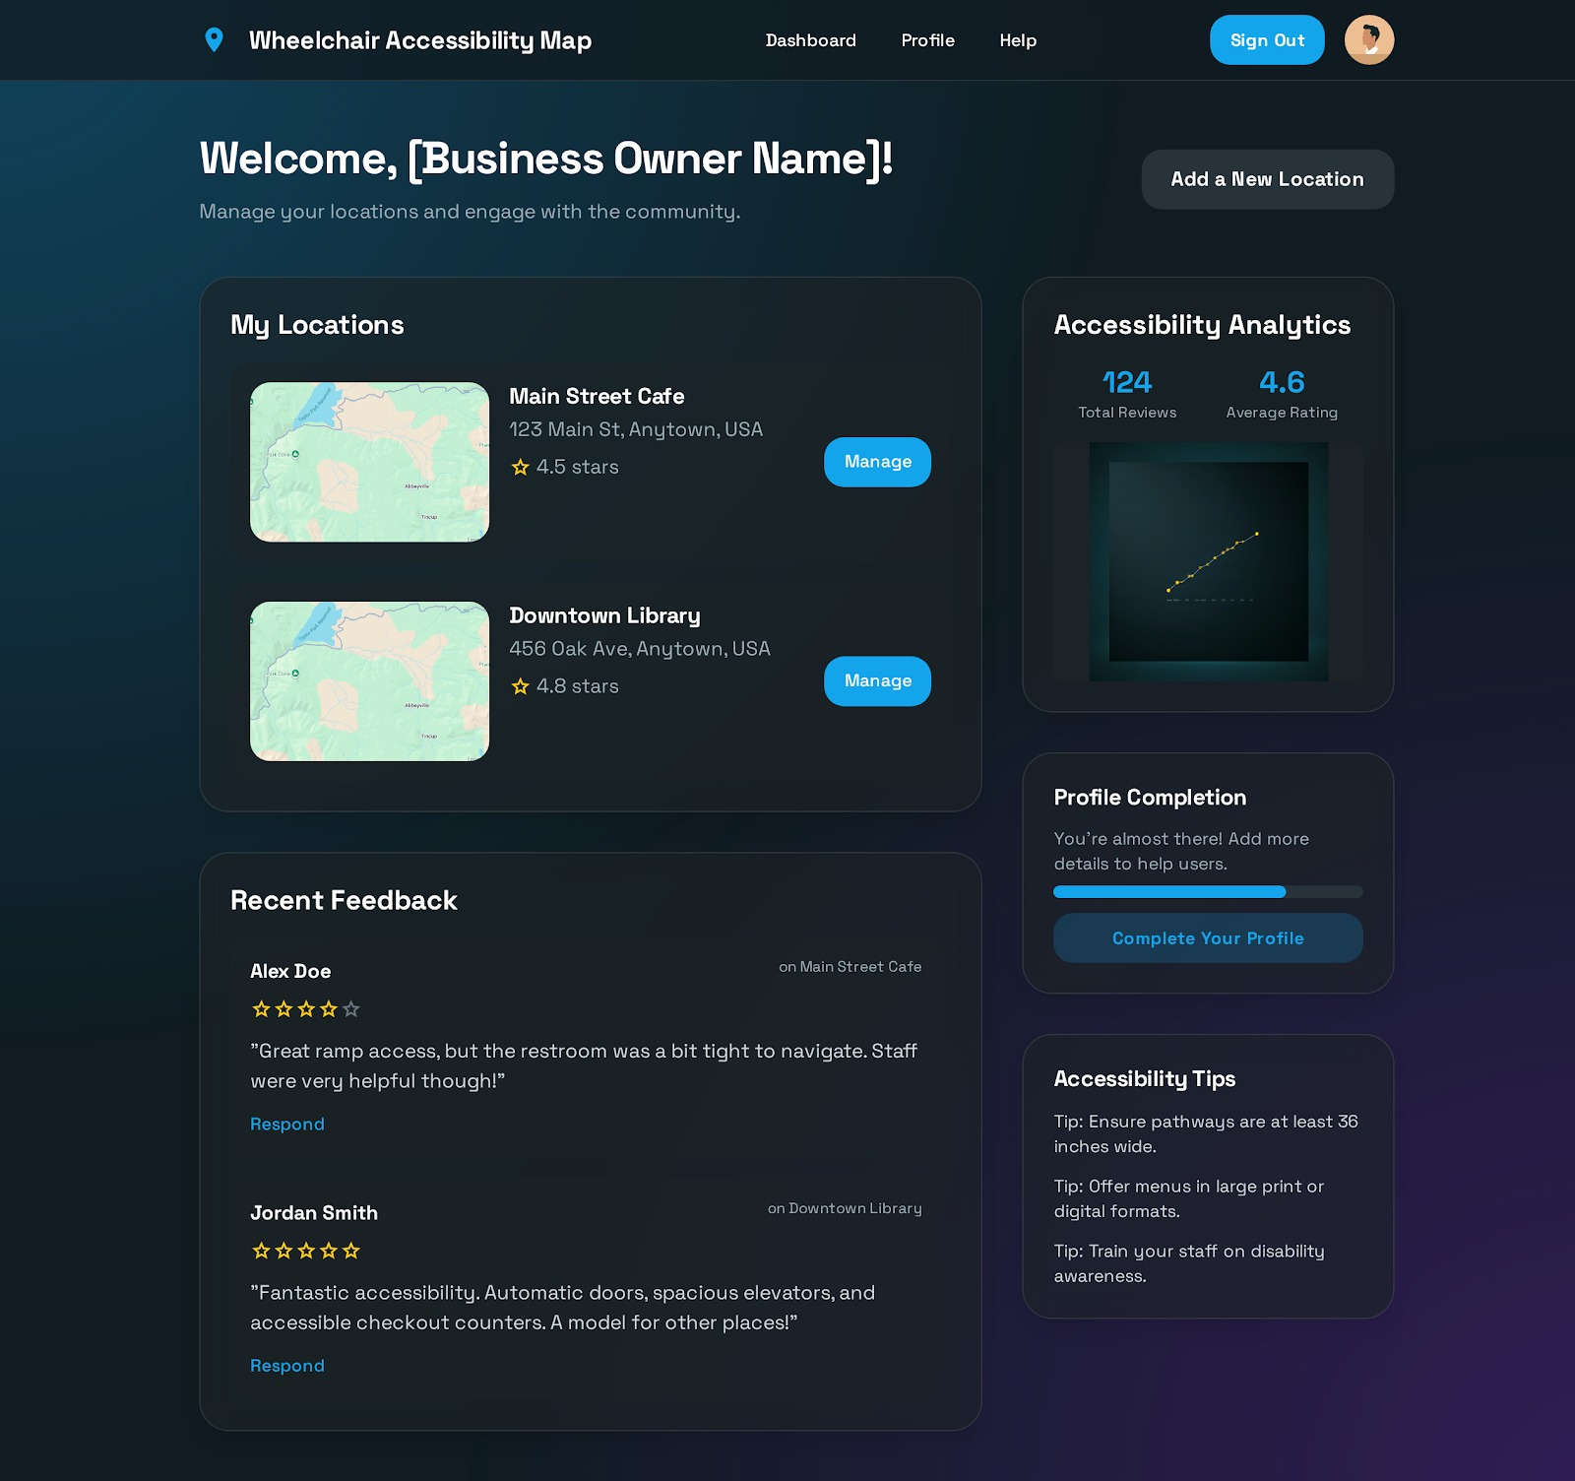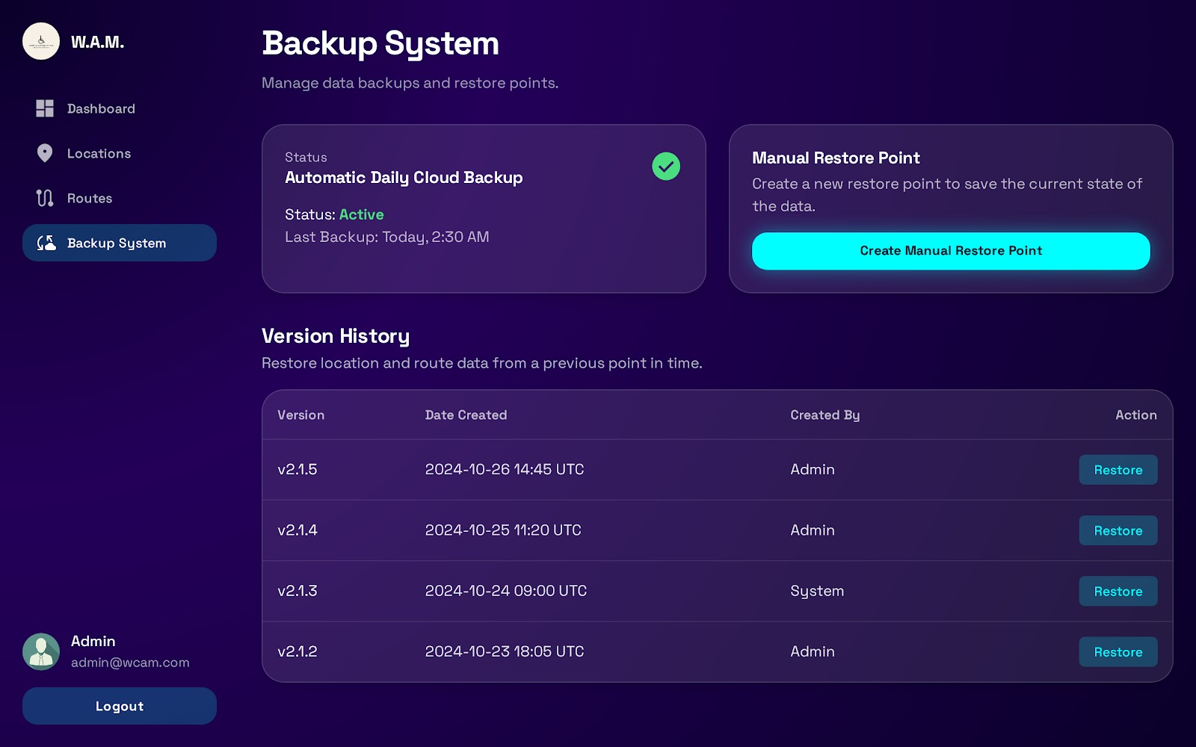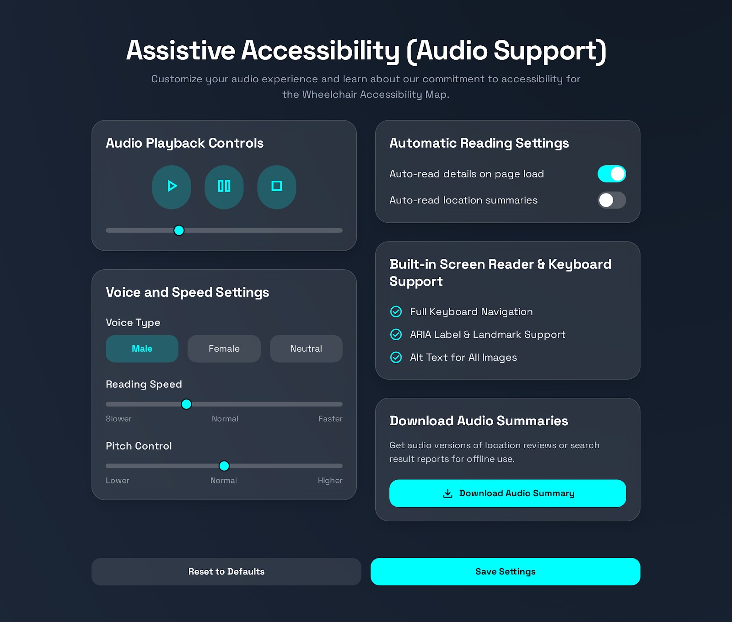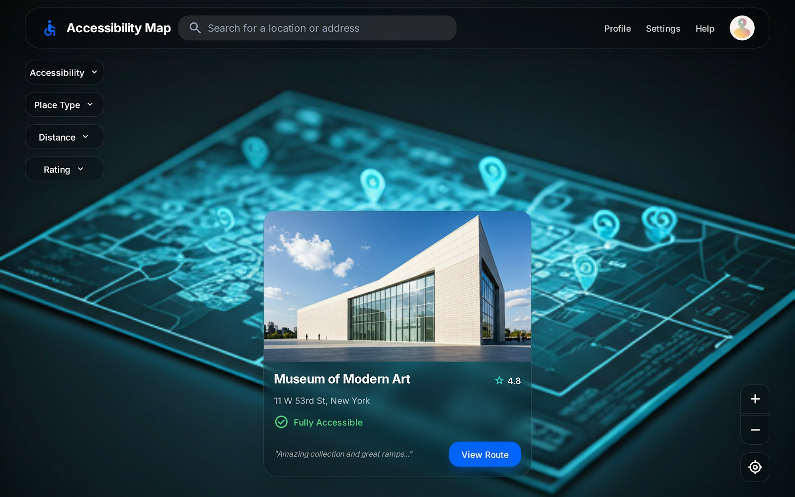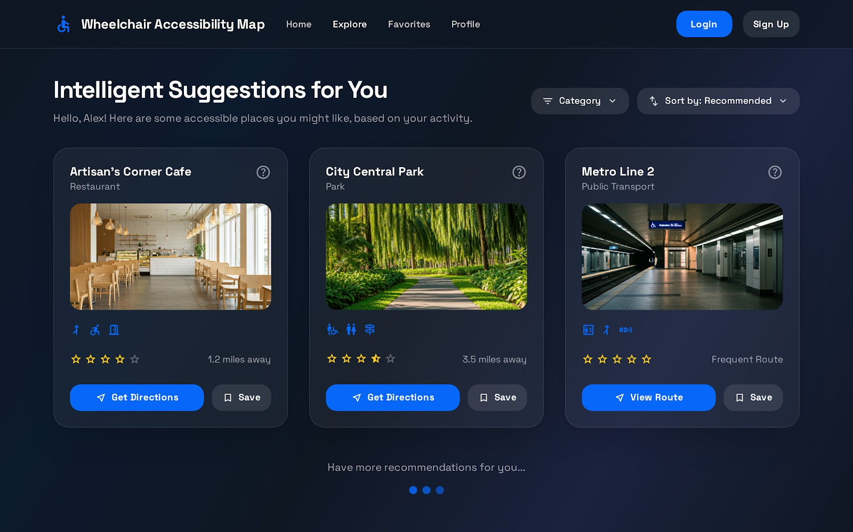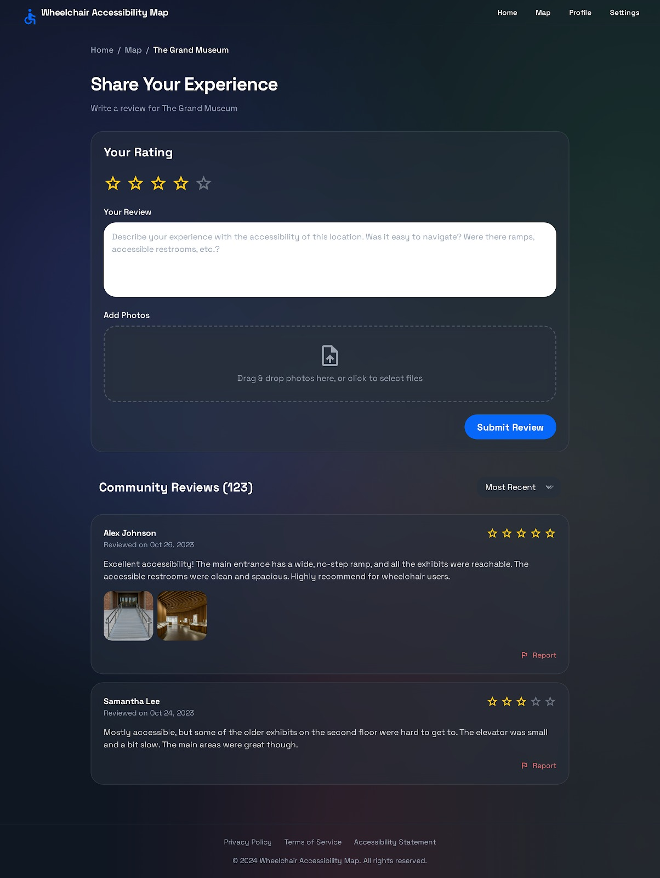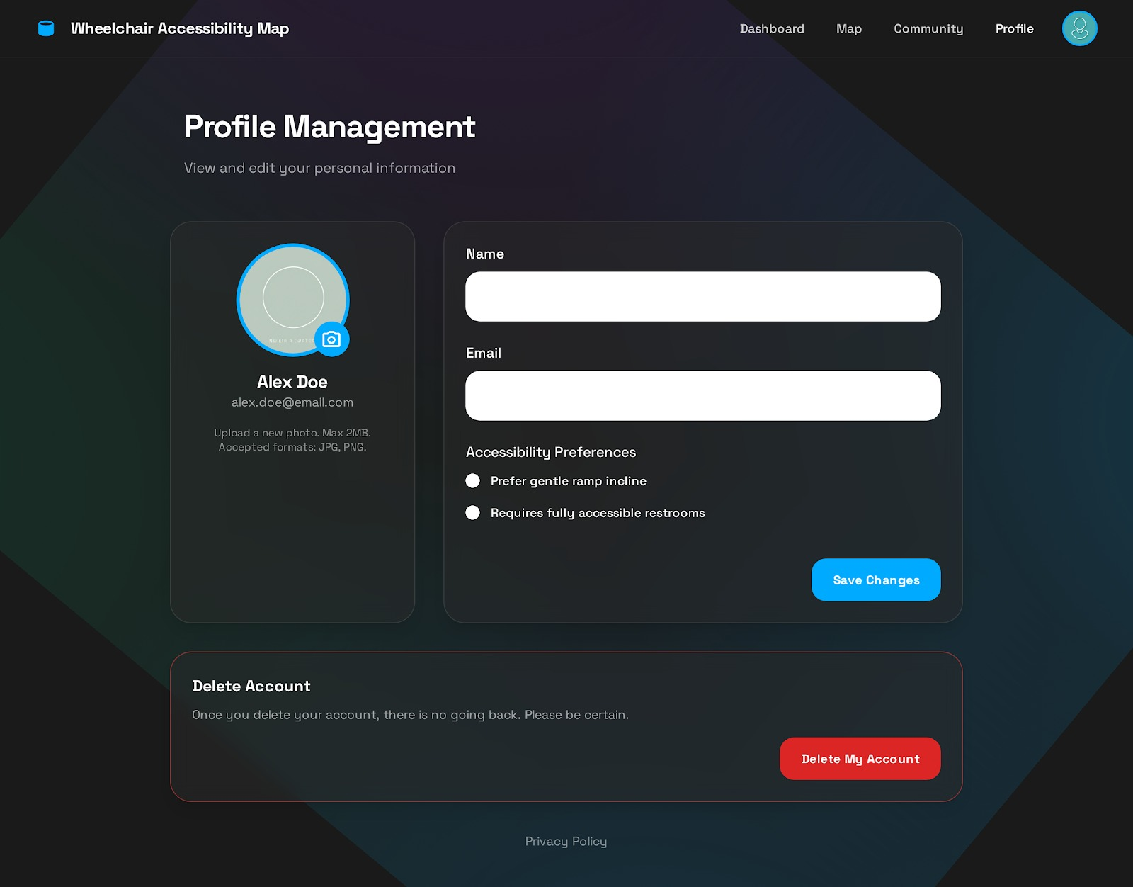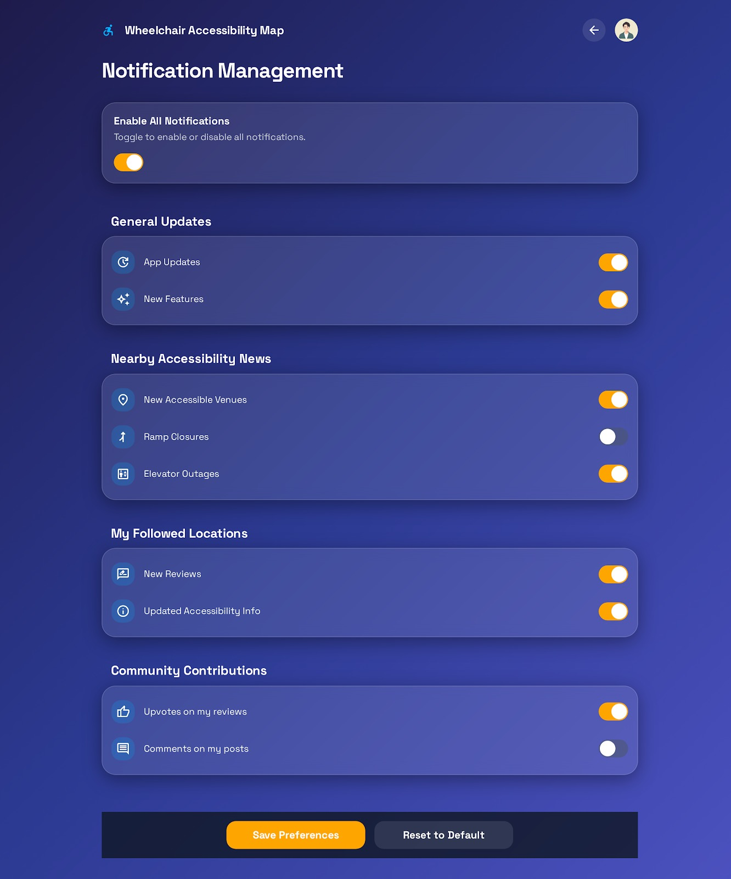
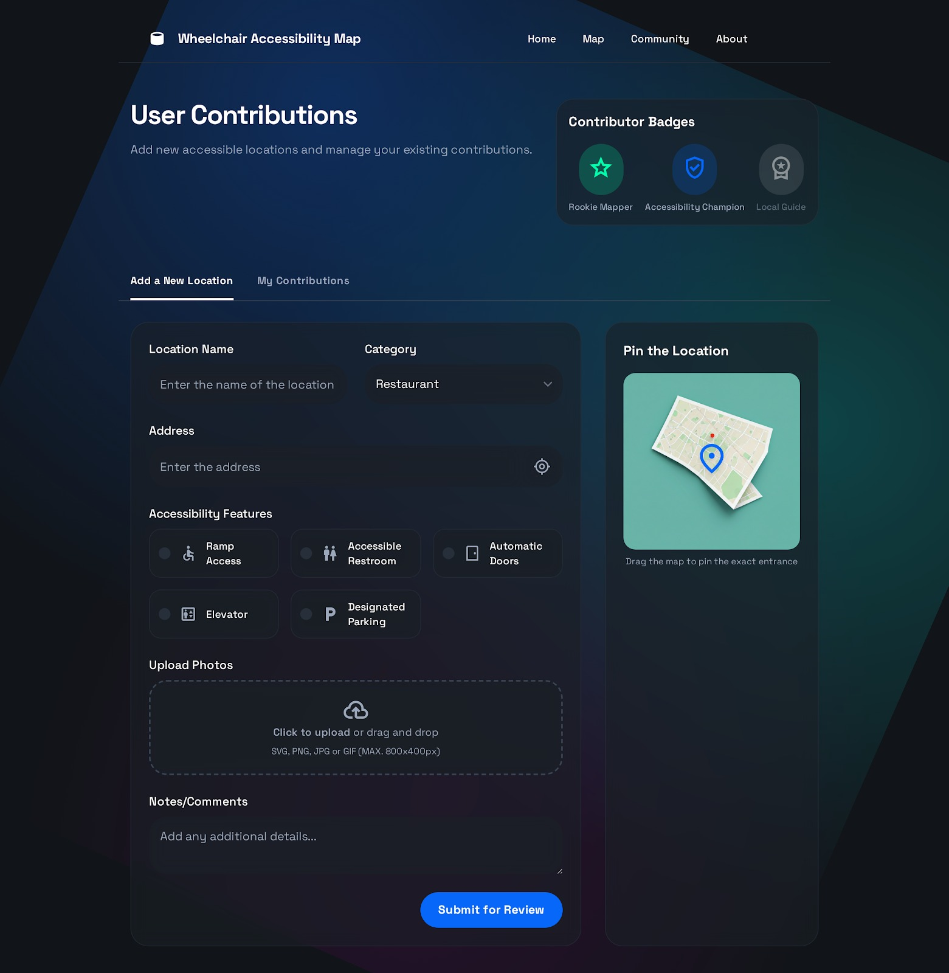

PHASE 2

- List of User Functional Requirements
- 1. Independence Promotion
- 1.1 The system shall enable wheelchair users to plan movement independently.
1.1.1 The system shall provide a route planning module for wheelchair users.
1.1.1.1 Users shall input start and destination locations using the website interface.
1.1.1.2 System shall calculate accessible routes avoiding stairs, narrow paths, and steep slopes.
1.1.2 The website shall provide route and accessibility data to reduce reliance on others.
- 2. Inclusion Management
- 2.1 The user shall be able to share experiences about places.
2.1.1 The system shall provide a review and rating module linked to each location.
2.1.2 The system shall allow users to upload photos related to accessibility features.
2.2 The system shall promote social inclusion by highlighting accessible venues.
2.2.1 The system shall display accessible and non-accessible places together on the same map.
- 3. Business Engagement Management
- 3.1 Business owners (e.g., restaurants, malls, cafés) shall be able to register their places on the system.
3.1.1 The system shall provide a registration and verification process for business partners.
3.2 Business owners shall be able to update accessibility-related information (e.g., ramps, elevators, parking availability).
3.2.1 The system shall allow verified businesses to add, edit, and manage their accessibility details.
3.3 Business owners shall be able to respond to user reviews or feedback.
3.3.1 The system shall support communication or feedback modules between users and business owners.
- 4. Help Center Management
- 4.1 Users shall access FAQs, tutorials, and videos.
4.1.1 The system shall include accessibility tips and safety guidance.
4.1.2 The system shall provide tutorials and guided photos to help the user in using the system.
4.2 Users shall be able to search within the help section.
4.2.1 The system shall implement a search function that allows users to find specific topics within the help section.
- 5. User Management
- 5.1 Users shall be able to login or register an account via email or social accounts.
5.1.1 System shall allow registration via email.
5.1.2 System shall allow login via email or social accounts (e.g., Facebook, Google).
5.1.3 System shall save the username and password.
5.1.4 System shall inform the user with invalid information input within login (username or password).
5.2 Users shall receive confirmation of successful registration.
5.2.1 System shall send confirmation email for activation.
5.2.2 System shall notify user of successful or failed registration.
- 6. Role Management
- 6.1 Users shall be able to use the system and login according to their role (Regular user, Business owner, Admin, Authority representative).
6.1.1 The system shall support four main roles: Regular user, Business owner, Admin, Authority representative.
6.1.2 Each role shall have defined permissions and access limits.
6.2 Admins can suspend or approve accounts.
6.2.1 System shall allow the Admins only to suspend or approve accounts.
- 7. Location Management
- 7.1 Users shall view locations with detailed information and filters.
7.1.2 Each location card shall include name, category, rating, and accessibility score.
7.1.3 Filters for “Accessible,” “Partially Accessible,” or “Not Accessible”; combined filters (type, distance, rating).
7.2 Users shall be able to save their location and to retrieve it whenever needed.
7.2.1 System shall retrieve and store location data and display nearby locations using GPS and radius.
7.3 Business owners and admins shall be able to edit, update the state of accessibility, and verify submission.
7.3.1 System shall provide admin interface for managing and verifying submissions.
- 8. Notification Management
- 8.1 Users shall receive notification when favorite places change accessibility status.
8.1.1 Customizable notification settings in profile.
8.1.2 System shall provide notification module for sending notifications.
8.2 Users shall receive real-time alerts for accessibility updates or issues.
8.2.1 System shall send real-time notification with live location to security dashboard.
- 9. Emergency Assistance Management
- 9.1 Users shall request help in emergencies, with or without staff available.
9.1.1 System shall display user’s position on internal map and automatically share GPS coordinates.
9.1.2 In case of existence of available staff, the system shall enable staff to respond and mark issue as resolved.
9.1.3 In case of unavailable staff, the system shall allow the user to contact the emergency contacts.
9.1.3.1 Store up to 3 emergency numbers.
9.1.3.2 Automatic call to local emergency services (e.g., 122).
9.2 The user shall receive confirmation message with their emergency issue.
9.2.1 Display confirmation message: “Your emergency contacts have been notified.”
- 10. Support System Management
- 10.1 Users shall be able to chat with chatbot.
10.2 Users shall be able to contact support through email or live chat.
10.2.1 Built-in help center with FAQs and chatbot.
10.2.2 Provide contact form for user issues.
10.2.3 Include feedback and feature request options.
- 11. Route Management
- 11.1 Users shall receive safe wheelchair-friendly routes.
11.1.1 System shall generate wheelchair-friendly routes.
11.1.2 Routes shall avoid stairs, narrow paths, and steep slopes.
11.1.3 System shall provide voice-guided navigation.
11.1.4 Routes shall update in real time upon detecting obstacles.
11.1.5 System should use mapping APIs to generate obstacle-free routes.
11.1.6 Directions shall be provided via voice, text, and vibration.
11.1.7 Routes shall dynamically re-route when detecting stairs, construction, or blocked paths.
- 12. Data Analytics Management
- 12.1 System shall analyze accessibility data to detect patterns and trends.
12.1.1 Aggregate regional statistics from user submissions.
12.1.2 Use machine learning to detect patterns in accessibility data.
- 13. Intelligent Recommendations Module
- 13.1 The user shall be able to view recommended places and accessibility trends.
13.1.1 The system shall utilize machine learning algorithms to identify accessibility trends.
13.1.2 The system shall predict and recommend frequently visited accessible routes based on user behavior and usage patterns.
- 14. Language Support Management
- 14.1 The user can use the system in Arabic or English languages.
14.1.1 System shall support Arabic and English.
14.1.2 Auto-switch layout between RTL and LTR.
14.1.3 Allow manual language switching by user.
- 15. Data Visualization Management
- 15.1 System administrators and partner organizations shall be able to view analytical dashboards that summarize accessibility data.
15.1.1 The system shall provide an interactive analytics dashboard displaying visual insights related to accessibility.
15.2 Users shall be able to visualize the proportion of accessible versus non-accessible places.
15.2.1 The system shall calculate and display ratios of accessible vs. non-accessible locations dynamically.
15.2.2 The system shall show statistics on the most visited categories (e.g., restaurants, malls, universities) and frequent problem spots based on user reports.
15.3 Authorized users (e.g., researchers, NGOs, or decision-makers) shall be able to export charts and analytics for further analysis.
15.4 Business partners shall be able to track feedback trends related to their places’ accessibility.
- 16. User Support Management
- 16.1 Users shall contact support and track ticket status.
16.1.1 Provide contact form for user issues.
16.1.2 Auto-generate support tickets with ID and timestamp.
16.1.3 Users shall track ticket status from dashboard.
16.1.4 Users shall submit feedback and feature requests.
- 17. Audio Support Management
- 17.1 Users shall receive audio assistance and screen reader support.
17.1.1 Enable ARIA labels and alt text for all images.
17.1.2 Support full keyboard navigation.
17.1.3 Allow reading of page content aloud.
17.1.4 Auto-read accessibility details when requested.
- 18. Authority Dashboard Management
- 18.1 Authorized government and municipal users shall be able to access anonymized regional accessibility data for analysis.
18.1.1 The system shall provide role-based access control to grant government and municipal users access to relevant datasets.
18.1.2 The system shall generate and display anonymized regional accessibility statistics (without revealing individual user data).
18.2 Government users shall be able to export datasets and reports to support policy-making and urban planning decisions.
18.2.1 The system shall include data export functionality allowing authorized users to download datasets in standard formats (e.g., CSV, Excel, or PDF).
18.2.2 The system shall produce dynamic heatmaps and trend visualizations showing accessibility progress across regions.
18.2.3 The system shall automatically update regional analytics as new accessibility data and reports are added to the system.
- 19. Backup System Management
- 19.1 The administrator shall be able to manually create restore points to preserve system data before updates or major changes.
19.1.1 The system shall allow the creation and restoration of manual backup points by administrators through the admin panel.
19.2 The administrator shall be able to restore previous data versions in case of data corruption or system failure.
19.2.1 The system shall implement version control for location and route data to track modifications and allow rollback to previous versions if needed.
19.3 Authorized users (e.g., admins or technical staff) shall be notified when automatic backups are successfully completed or if any error occurs.
19.3.1 The system shall perform automatic daily backups of all critical data, including location, route, and user-generated content, and store them securely in the database environment.
19.3.2 The system shall encrypt backup data to ensure data integrity and security.
19.3.3 The system shall maintain a log of backup and restore activities, including timestamps and responsible users.

- 20. User Reviews Management
- 20.1 Users shall be able to submit reviews with text and photos.
20.1.1 System shall allow submitting text reviews and attaching photos.
20.2 Reviews shall be publicly displayed.
20.2.1 Reviews shall be displayed publicly and sorted by most recent.
20.3 Users shall report inappropriate reviews.
20.3.1 System shall allow reporting inappropriate reviews for admin review.
-
- 21. Map Visualization Management

21.1 Users shall be able to view and manipulate an interactive map that presents information for nearby accessible locations.

21.1.1 System shall display accessible locations on the map with clear visual identifiers corresponding to their accessibility level.

21.1.2 System shall visually differentiate accessibility categories (Accessible, Partially Accessible, Not Accessible) using standardized map indicators.

21.1.3 System shall allow users to adjust map scale and orientation and select among available map visualization modes (zoom, pan, satellite views).
- 22. Report Management
- 22.1 Users shall be able to report accessibility obstacles.

22.1.1 System shall allow users to submit accessibility obstacle reports of broken ramp or blocked path.

22.1.2 System shall allow users to attach photos or comments as evidence when submitting reports.

22.2 Users shall be able to submit correction reports for inaccurate or outdated accessibility data.

22.2.1 System shall allow users to submit correction reports for inaccurate or outdated accessibility data.

22.3 Admin shall be able to access and view accessibility reports, correction reports, and corresponding visual summaries of accessibility data.

22.3.1 System shall require admin verification of each user-submitted report and correction report before updating the map.

22.3.2 System shall notify admins of new user reports and mark each case as ‘Reported’.

22.3.3 System shall notify other users about reported changes.
- 23. Profile Management
- 23.1 Users shall be able to view and edit their personal profile information.

23.1.1 System shall allow users to view and edit their personal profile information.

23.1.2 System shall allow users to update their name, email, and accessibility preferences.

23.1.3 System shall save user accessibility preferences.

23.2 Users shall be able to upload a personal profile picture.

23.2.1 System shall allow users to upload a profile picture.

23.3 Users shall be able to delete their account.

23.3.1 System shall allow users to delete their account.
- 24. User Contributions Management
- 24.1 Users shall earn a type of “Contributor” badge after completing a defined contribution threshold for each type (e.g., 10 approved photos, 20 ratings, and 10 reviews).

24.1.1 System shall automatically award a type of “Contributor” badge when a user meets the defined contribution threshold.

24.1.2 The system shall have three types of badges (top contributor, photo master, and review master).

24.2 Top Contributors shall be able to post new photos and reviews directly without prior admin approval.

24.2.1 System shall permit users holding the “Top Contributor” badge to publish photos and reviews immediately without admin approval as their special feature.

24.3 Admins shall verify and approve all user-submitted photos and reviews before publishing.

24.3.1 The system shall allow admin to verify submissions of photos and reviews before publishing.

24.4 Users shall be notified whenever an admin edits or removes their submitted content.

24.4.1 System shall notify users when an admin edits or removes their submitted content.
- 25. Community Engagement
- 25.1 Users shall be able to create and join virtual community groups dedicated to accessibility discussions and events (to share tips, organize accessibility-focused events, and collaborate on advocacy initiatives).
25.1.1 System shall provide a Community Engagement Module that enables users to create, join, and manage virtual accessibility groups.
25.1.2 System shall allow group members to create events specifying date, time, location, and accessibility requirements.
25.2 Users shall be able to share accessibility challenges and success stories within community groups to encourage peer interaction and foster awareness. 25.2.1 System shall allow users to publish post text and attach pictures or videos within community groups to share accessibility experiences or challenges.
25.2.2 System shall provide a feedback mechanism (e.g., vote, like) that allows users to positively endorse community posts and to highlight impactful contributions.
25.2.3 System shall allow users to report inappropriate community posts for admin review.

- List of User Non-Functional Requirements
- 1. Performance Requirements
- 1.1 The system shall load the interactive map and nearby accessible locations within 3 seconds under normal network conditions (10 Mbps).
1.2 The system shall handle at least 500 concurrent users without noticeable performance degradation.

- 2. Security Requirements
- 2.1 The system shall encrypt all sensitive user data, including login credentials and location information, using AES-256 encryption.
2.2 The system shall transmit all data securely using the HTTPS (SSL) protocol.
2.3 The system shall implement role-based access control (RBAC) to ensure that only authorized users can access or modify specific modules and data.

- 3. Availability and Reliability Requirements
- 3.1 The system shall maintain an uptime of at least 99% per month to ensure continuous availability.
3.2 The system shall perform automatic daily backups of all critical data, including user accounts, locations, and routes.
3.3 The system shall allow complete recovery within 10 minutes after any system failure or crash.

- 4. Usability and Accessibility Requirements
- 4.1 The system interface shall comply with WCAG 2.1 Level AA accessibility standards to support users with different abilities.
4.2 The system shall support both Arabic and English languages and automatically adjust between RTL and LTR layouts.
4.3 The system shall provide accessibility aids such as large-text mode, screen reader compatibility, and voice assistance to ensure ease of use for all users.
(Jana Mamdouh Hassan Moustafa Hegazy 23101377)
1.Manage Authentication
Name | Manage Authentication
Type | Primary | Essential

Actors | Regular User, Business Owner,Admin, Authority representative
Description | - The user log to his account or register to a new account.(The user could be Regular user. Business owner, Admin , Authority representative )  - The user shall receive confirmation email with his registration  - The Regular user shall input the start and destination locations so he could be able to plan his movement  - The Regular user shall be able to join virtual community to share his experience by uploading photos, making reviews and ratings.  - The business owner shall register his places on the system
Cross Reference | R1,R2,R3,R4,R5,R6
Precondition | Manage Authentication
Postcondition | Request Emergency help
Alternative scenario | •If the user couldn’t be able to login to the system then the system must show error message  •If the user didn’t receive the confirmation email then the system should show send the email again
Relations | Manage Authentication Plan Movement (<<include>>)  Manage Authentication Manage participation (<<include>>)  Manage Authentication ◁---Manage  Account (Generalization)  Manage Authentication ◁---Manage Profile (Generalization)

Cross Reference:
R1: Register & Login interface
R2: Email
R3: business owner interface
R4: Regular user interface
R5: Admin interface
R6: Authority representative interface

Use Case interaction Scenario :
Actor’s intention | System Response
- The user log to his account or register to a new account.  3.The user shall receive confirmation email with his registration  5.The Regular user shall input the start and destination locations so he could be able to plan his movement  7.The Regular user shall be able to join virtual community to share his experience by uploading photos, making reviews and ratings.  9.The business owner shall register his places on the system  11.The business owner shall register his places to system | 2 . The system shall provide registration & login interface that suits the user role  4. The system shall send confirmation email to the user  6.The system shall provide route and accessibility data  8.The system shall allow user to upload photos related to accessibility features  10.The system shall provide a registration and verification process for business owners.  12.The system shall allow business owners to manage their accessibility places details.

Test Requirements (TRs)
- Manage Authentication :
Function 1: Registration and login
Validate that the user can login and register according to his role by filling correct and suitable email and password and the business owner can register his places
TR ID | Description
TR_LOGIN_001 | Validate that user can login with correct email and password whatever his role is ( Regular user , Business owner, Admin, Authority representative).
TR_LOGIN_002 | Validate that the user can access only to his dashboard according to his role .
TR_REG_001 | Validate that user can register and create new account
TR_REG_002 | Validate that user receive confirmation email with his registration
TR_REG_003 | Validate that the business owner can register his places to the system
Test Case
TEST CASE ID | TR ID | TEST SCENARIO | TEST CASE | PRE-CONDITION | TEST STEPS | TEST DATA | EXPECTED RESULT | POST CONDITION | ACTUAL RESULT | STATUS (PASS/FAIL)
TC_LOGIN_001_01 | TR_LOGIN_001 | Verify successful login with valid email and password | Enter valid email and password | 1. User has registered account 2. Account is activated | 1. Enter Email 2. Enter Password 3. Click "Login" | Email: user@example.com Password: Pass123! | Login successful | User redirected to dashboard
TC_LOGIN_001_02 | TR_LOGIN_001 | Verify login with email in different case (case-insensitive) | Enter email in uppercase/lowercase | 1. Valid account exists | 1. Enter Email in mixed case 2. Enter correct Password 3. Click "Login" | Email: UsEr@Example.COM Password: Pass123! | Login successful | Dashboard shown
TC_LOGIN_001_03 | TR_LOGIN_001 | Verify login after password reset | Login after resetting password | 1. User reset password via "Forgot Password" 2. New password set | 1. Enter Email 2. Enter new Password 3. Click "Login" | Email: user@example.com Password: NewPass456@ | Login successful | Dashboard shown
TC_LOGIN_001_04 | TR_LOGIN_001 | Verify login from mobile app | Login using mobile application | 1. App installed 2. Valid credentials | 1. Open app 2. Enter Email & Password 3. Tap "Login" | Email: user@example.com Password: Pass123! | Login successful | Mobile home screen shown
TC_LOGIN_001_05 | TR_LOGIN_001 | Verify login persists after app restart | Login session retained | 1. User logged in previously | 1. Close and reopen app | — | User remains logged in | Dashboard auto-loaded
TC_LOGIN_002_01 | TR_LOGIN_002 | Verify BO login with correct credentials | Enter valid BO email/password | 1. BO account exists | 1. Enter Email 2. Enter Password 3. Click "Login" | Email: owner@cafe.com Password: Owner123! | Login successful | BO dashboard with "Manage Places"
TC_LOGIN_002_02 | TR_LOGIN_002 | Verify BO sees "Manage Places" after login | Check dashboard content | 1. BO logged in | 1. Observe menu | — | "Add Place", "My Places" visible | BO-specific UI
TC_LOGIN_002_03 | TR_LOGIN_002 | Verify BO cannot login with regular user credentials | Use regular user login as BO | 1. Regular user exists | 1. Try login as BO | Email: user@example.com | Access denied or redirected | No BO tools shown
TC_LOGIN_002_04 | TR_LOGIN_002 | Verify BO login after email verification | Login post-activation | 1. BO registered & activated | 1. Use verified email | Email: owner@cafe.com | Login successful | Full access granted
TC_LOGIN_002_05 | TR_LOGIN_002 | Verify session timeout for BO after inactivity | Auto logout after idle | 1. BO logged in | 1. Wait 30 mins 2. Try action | — | Session expired | Redirect to login
TC_REG_001_01 | TR_REG_001 | Verify successful registration with all valid fields | Enter all valid registration data | 1. Registration page accessible | 1. Enter Name, Email, Password, Confirm 2. Click "Register" | Name: Ahmed Ali Email: ahmed.new@test.com Pass: Secure123! | Account created | Redirect to login or email sent message
TC_REG_001_02 | TR_REG_001 | Verify registration with minimum password length | Use 8-char password | 1. Password policy: min 8 chars | 1. Fill form 2. Enter 8-char password 3. Click "Register" | Pass: Abcd1234 | Registration successful | Account created
TC_REG_001_03 | TR_REG_001 | Verify registration with special characters in name | Name contains symbols | 1. Name field allows symbols | 1. Enter name with ' or - 2. Complete form | Name: O'Connor | Registration successful | Account created
TC_REG_001_04 | TR_REG_001 | Verify registration via Google OAuth | Register using Google sign-up | 1. Google OAuth configured | 1. Click "Sign up with Google" 2. Select Google account | — | Account auto-created with Google data | Login automatic
TC_REG_001_05 | TR_REG_001 | Verify registration from mobile device | Register via mobile browser | 1. Mobile site responsive | 1. Open mobile browser 2. Fill registration form 3. Submit | Same as TC_REG_001_01 | Registration successful | Mobile-friendly success page
TC_REG_002_01 | TR_REG_002 | Verify confirmation email is sent after registration | Check inbox after register | 1. Email service active | 1. Complete registration 2. Check email | Email: testuser@temp.com | Email received within 1 min | Link in email
TC_REG_002_02 | TR_REG_002 | Verify email contains activation link | Open received email | 1. Email sent | 1. Open email 2. Check for link | — | Valid clickable activation link | Link leads to activation page
TC_REG_002_03 | TR_REG_002 | Verify account activates after clicking link | Click activation link | 1. Email received | 1. Click link in email | — | "Account activated" message | User can now login
TC_REG_002_04 | TR_REG_002 | Verify resend email works if not received | Use "Resend" feature | 1. Email not in inbox | 1. Go to login 2. Click "Resend confirmation" | Email: testuser@temp.com | New email sent | Counter shows "Email sent"
TC_REG_002_05 | TR_REG_002 | Verify email not sent if registration fails | Invalid data submission | 1. Email field invalid | 1. Submit invalid form | Email: invalid | No email sent | Error shown on form
TC_REG_003_01 | TR_REG_003 | Verify BO can add place with all required fields | Add complete place info | 1. BO logged in | 1. Go to "Add Place" 2. Fill all fields 3. Submit | Name: Cairo Cafe Address: 123 Tahrir Features: Wheelchair, Elevator | Place added | Appears in "My Places"
TC_REG_003_02 | TR_REG_003 | Verify place appears on public map | Check public view | 1. Place approved | 1. Search place name | Name: Cairo Cafe | Place visible on map | Pin with accessibility icons
TC_REG_003_03 | TR_REG_003 | Verify BO can upload place photos | Add images during registration | 1. File upload enabled | 1. Click "Upload Photo" 2. Select image | Image: cafe_ramp.jpg | Photo uploaded and shown | Thumbnail in place profile
TC_REG_003_04 | TR_REG_003 | Verify place status is "Pending" initially | Check after submission | 1. Admin approval required | 1. Submit place | — | Status: Pending Approval | BO sees pending tag
TC_REG_003_05 | TR_REG_003 | Verify BO can edit place after adding | Modify registered place | 1. Place added | 1. Click "Edit" 2. Change phone 3. Save | Phone: +20123456789 | Changes saved | Updated info shown

- Plan Movement
Name | Plan movement
Type | Primary | Essential

Actors | Regular User
Description | - The user shall be able to input his start and destination location .  - The user shall view and plan the route  - The user shall view the accessibility details of the location.
Cross Reference | R1,R2
Precondition | Manage Authentication
Postcondition | Share experience
Alternative scenario | •If the user couldn’t be able to view the route then the system must show error message
Relations | Manage Authentication Plan Movement (<<include>>)  Plan Movement ◁---Manage  Route (Generalization)  Plan Movement ◁---Manage Location (Generalization)

Cross Reference:
R1: Register & Login interface
R2: enable the system to access to the user’s location

Use Case interaction Scenario :
Actor’s intention | System Response
- The Regular user shall be able to input his start and destination location .  - The Regular user shall view and plan the route  - The Regular user shall view the accessibility details of the location. | - System shall calculate accessible routes avoiding stairs, narrow paths, and steep slopes  - The website shall provide route and accessibility data to reduce reliance on others.

Test Requirements (TRs)
Use Case Name: Plan movement
Function: 1. The Regular user shall be able to plan his movement
Validate that the Regular user can Manage his route without obstacles .
TR ID | Description
TR_PM_001 | Validate that the Regular User can input start and destination
TR_PM_002 | Validate that the System generates wheelchair-accessible route
TR_PM_003 | Validate that the Route is safe for the user
TR_PM_004 | Validate that the Route would be visible for the user within 5 seconds
TR_PM_005 | Validate that the user can report a problem with the route
Test Cases
TEST CASE ID | TR ID | TEST SCENARIO | TEST CASE | PRE-CONDITION | TEST STEPS | TEST DATA | EXPECTED RESULT | POST CONDITION | ACTUAL RESULT | STATUS (PASS/FAIL)
TC_PM_001_01 | TR_PM_001 | Verify input of valid start and destination locations | Enter valid addresses | 1. User logged in 2. Map loaded | 1. Open route planner 2. Enter start address 3. Enter destination address 4. Submit | Start: Home Address Destination: Mall X | Inputs accepted and processed | Route preview shown
TC_PM_001_02 | TR_PM_001 | Verify input with GPS current location as start | Use current location | 1. GPS enabled | 1. Click "Use Current Location" for start 2. Enter destination 3. Submit | Destination: University Y | Start auto-filled with GPS | Route calculated
TC_PM_001_03 | TR_PM_001 | Verify input with saved favorite as destination | Select from favorites | 1. Favorites saved | 1. Enter start 2. Select favorite from dropdown 3. Submit | Start: Office Favorite: Restaurant Z | Destination populated from favorites | Route generated
TC_PM_001_04 | TR_PM_001 | Verify input validation for invalid address | Enter invalid destination | 1. Map loaded | 1. Enter start 2. Enter invalid destination 3. Submit | Destination: Invalid123 | Error: "Invalid address" | No route generated
TC_PM_001_05 | TR_PM_001 | Verify input from mobile device | Enter via mobile interface | 1. Mobile app open | 1. Tap start field 2. Enter address 3. Tap destination 4. Submit | Start: Home Destination: Park | Mobile keyboard used | Inputs saved for session
TC_PM_002_01 | TR_PM_002 | Verify generation of accessible route | Generate route avoiding obstacles | 1. Valid inputs | 1. Submit start/destination 2. Wait for calculation | Start: A Destination: B | Route shows ramps, no stairs | Route displayed
TC_PM_002_02 | TR_PM_002 | Verify route with multiple options | Show alternative routes | 1. Multiple paths available | 1. Submit inputs 2. Select "Alternatives" | Start: C Destination: D | 3 routes shown (fastest, safest) | User selects one
TC_PM_002_03 | TR_PM_002 | Verify integration with mapping API | Use external API for route | 1. API key configured | 1. Submit inputs | Start: E Destination: F | Route fetched from API | Accessible path rendered
TC_PM_002_04 | TR_PM_002 | Verify error if no accessible route exists | No path available | 1. Obstacles block all paths | 1. Submit inputs | Start: G Destination: H | Error: "No accessible route found" | Suggestions shown
TC_PM_002_05 | TR_PM_002 | Verify route generation offline | Use cached data | 1. Offline mode | 1. Submit known inputs | Start: I Destination: J | Cached route displayed | Warning: "Offline mode"
TC_PM_003_01 | TR_PM_003 | Verify route avoids stairs | Check for stair-free path | 1. Known stair area | 1. Generate route | Start: K Destination: L | Route reroutes via elevator | Safety badge shown
TC_PM_003_02 | TR_PM_003 | Verify route avoids steep slopes | Filter high inclines | 1. Slope data available | 1. Generate route | Start: M Destination: N | Flat or low-slope path selected | Alert if slope >5%
TC_PM_003_03 | TR_PM_003 | Verify route safety with real-time updates | Handle live obstacles | 1. Construction reported | 1. Generate route 2. Update live | Start: O Destination: P | Route avoids construction | Safety confirmed
TC_PM_003_04 | TR_PM_003 | Verify safety for narrow paths | Avoid tight spaces | 1. Path width data | 1. Generate route | Start: Q Destination: R | Wide paths only | Safety score 100%
TC_PM_003_05 | TR_PM_003 | Verify safety audit log | Log route safety checks | 1. Route generated | 1. View details | Start: S Destination: T | Log shows "No obstacles" | Audit available
TC_PM_004_01 | TR_PM_004 | Verify route visibility within 5 seconds | Measure load time | 1. Stable network | 1. Submit inputs 2. Time response | Start: U Destination: V | Route loads in <5s | Timer success
TC_PM_004_02 | TR_PM_004 | Verify visibility on slow network | Simulate 3G | 1. Slow connection | 1. Submit inputs | Start: W Destination: X | Route loads (may take longer) | Progress bar shown
TC_PM_004_03 | TR_PM_004 | Verify visibility with large map area | Zoom out view | 1. Broad area | 1. Submit distant inputs | Start: Y Destination: Z | Route renders quickly | Map optimized
TC_PM_004_04 | TR_PM_004 | Verify timeout if >5s | Force delay | 1. Server delay | 1. Submit inputs | Start: AA Destination: BB | Timeout error | Retry option
TC_PM_004_05 | TR_PM_004 | Verify visibility in high traffic | Concurrent users | 1. 500 users | 1. Submit inputs | Start: CC Destination: DD | Route loads in <5s | No degradation
TC_PM_005_01 | TR_PM_005 | Verify reporting a route problem | Submit report | 1. Route displayed | 1. Click "Report Issue" 2. Describe 3. Submit | Issue: Blocked path | Report sent | Admin notified
TC_PM_005_02 | TR_PM_005 | Verify report with photo | Attach evidence | 1. Camera access | 1. Report 2. Upload photo | Photo: blocked.jpg | Report with photo | Visible in logs
TC_PM_005_03 | TR_PM_005 | Verify report validation | Invalid report | 1. Empty description | 1. Submit empty | — | Error: "Description required" | No submission
TC_PM_005_04 | TR_PM_005 | Verify report confirmation | Receive ack | 1. Report sent | 1. Submit | — | "Report received" message | User dashboard updated
TC_PM_005_05 | TR_PM_005 | Verify admin review of report | Admin views | 1. Report in queue | 1. Login as admin 2. View reports | — | Report listed | Status: Pending

- Share Experience
Name | Share experience
Type | Primary | Optional

Actors | Regular User,Admin
Description | - The Regular user shall be able to share his experience by giving a review or feedback about the place by comments or uploading photos  - The Regular user shall be able to join virtual community to share his experience with other users
Cross Reference | R1,R2
Precondition | Plan movement
Postcondition | Share experience
Alternative scenario | •If the user couldn’t be able give his feedback then the system should ask him to has the access to his gallery or ask him to check his connection
Relations | Manage Authentication Share experience (<<include>>)  Manage Participation ◁---Share experience (Generalization)

Cross Reference:
R1: Register & Login interface
R2: enable the system to access to the user’s gallery

Use Case interaction Scenario :
Actor’s intention | System Response
- The Regular user shall be able to share his experience by giving a review or feedback about the place by comments or uploading photos  2.The Regular user shall be able to join virtual community to share his experience with other users | - The system shall allow users to upload photos related to accessibility features.  - The system shall allow user to join the virtual community

Test Requirements (TRs)
Use Case Name: Share experience
Function: 1. The Regular user shall be able to share his experience about his journey or about the website
Validate that the Regular user can share his experience with other through communities .
TR ID | Description
TR_SE_001 | Validate that the Regular User can submit review with text and photo
TR_SE_002 | Validate that the Regular user cannot share inappropriate content
TR_SE_003 | Validate that the Admin can approve or decline the user’s comment
TR_SE_004 | Verify that users with “Top Contributor” badge can post reviews without admin approval
TR_SE_005 | Verify that the user receive confirmation message with his submission

Test Cases
TEST CASE ID | TR ID | TEST SCENARIO | TEST CASE | PRE-CONDITION | TEST STEPS | TEST DATA | EXPECTED RESULT | POST CONDITION | ACTUAL RESULT | STATUS (PASS/FAIL)
TC_SE_001_01 | TR_SE_001 | Verify submission of text review | Submit text only | 1. User logged in 2. Location selected | 1. Open review form 2. Enter text 3. Submit | Text: "Great access!" | Review posted (pending approval) | Visible in profile
TC_SE_001_02 | TR_SE_001 | Verify submission with photo | Attach image | 1. Gallery access | 1. Enter text 2. Upload photo 3. Submit | Photo: ramp.jpg | Review with photo submitted | Thumbnail shown
TC_SE_001_03 | TR_SE_001 | Verify submission with max length text | Use long text | 1. Char limit 1000 | 1. Enter 1000 chars 2. Submit | Text: [long description] | Review accepted | Truncated preview
TC_SE_001_04 | TR_SE_001 | Verify submission from community group | Post in group | 1. Joined group | 1. Go to group 2. Submit review | Text: "Shared experience" | Review in group feed | Group notified
TC_SE_001_05 | TR_SE_001 | Verify submission with rating | Include stars | 1. Rating enabled | 1. Enter text 2. Select 5 stars 3. Submit | Rating: 5 | Review with rating | Average updated
TC_SE_002_01 | TR_SE_002 | Verify block of profane language | Submit bad words | 1. Filter active | 1. Enter profane text 2. Submit | Text: [profanity] | Error: "Inappropriate content" | No submission
TC_SE_002_02 | TR_SE_002 | Verify block of spam links | Include URL | 1. Spam detection | 1. Enter text with link 2. Submit | Text: "Visit spam.com" | Blocked as spam | Warning shown
TC_SE_002_03 | TR_SE_002 | Verify image content filter | Upload inappropriate photo | 1. AI filter | 1. Upload bad image | Photo: [inappropriate] | Upload rejected | "Content violation"
TC_SE_002_04 | TR_SE_002 | Verify repeated submissions | Duplicate posts | 1. Anti-spam | 1. Submit same review twice | Text: "Duplicate" | Second blocked | "Already posted"
TC_SE_002_05 | TR_SE_002 | Verify report by other users | Flag content | 1. Post visible | 1. Other user clicks "Report" | — | Admin alerted | Status: Flagged
TC_SE_003_01 | TR_SE_003 | Verify admin approval | Approve review | 1. Pending review | 1. Login admin 2. Click approve | — | Review published | Publicly visible
TC_SE_003_02 | TR_SE_003 | Verify admin decline | Decline with reason | 1. Pending | 1. Click decline 2. Enter reason | Reason: "Off-topic" | Declined notification to user | Removed from queue
TC_SE_003_03 | TR_SE_003 | Verify bulk approval | Approve multiple | 1. Multiple pending | 1. Select all 2. Approve | — | All published | Batch success
TC_SE_003_04 | TR_SE_003 | Verify edit before approve | Modify review | 1. Pending | 1. Edit text 2. Approve | — | Edited version published | User notified of edit
TC_SE_003_05 | TR_SE_003 | Verify decline log | Log action | 1. Declined | 1. View logs | — | Log shows "Declined by admin" | Audit trail
TC_SE_004_01 | TR_SE_004 | Verify direct post for top contributor | Submit without approval | 1. Badge earned | 1. Submit review | — | Immediately published | No pending
TC_SE_004_02 | TR_SE_004 | Verify badge check | Post as non-top | 1. No badge | 1. Submit | — | Pending approval | Admin queue
TC_SE_004_03 | TR_SE_004 | Verify post in community | Group post direct | 1. Badge + joined group | 1. Submit in group | — | Instantly visible in group | Members see
TC_SE_004_04 | TR_SE_004 | Verify revocation if abused | Post after badge loss | 1. Badge revoked | 1. Submit | — | Back to pending | Approval required
TC_SE_004_05 | TR_SE_004 | Verify high-volume posts | Multiple direct posts | 1. Badge active | 1. Submit 10 reviews | — | All published instantly | No limits
TC_SE_005_01 | TR_SE_005 | Verify confirmation message | After submission | 1. Review sent | 1. Submit | — | Message: "Submitted successfully" | Redirect to profile
TC_SE_005_02 | TR_SE_005 | Verify email confirmation | Optional email | 1. Settings enabled | 1. Submit | — | Email sent with details | Inbox updated
TC_SE_005_03 | TR_SE_005 | Verify in-app notification | Push alert | 1. Notifications on | 1. Submit | — | Alert: "Your review is under review" | Bell icon
TC_SE_005_04 | TR_SE_005 | Verify no message on error | Failed submission | 1. Invalid data | 1. Submit | — | No confirmation, error shown | Retry prompted
TC_SE_005_05 | TR_SE_005 | Verify confirmation for photo upload | After photo attach | 1. Photo submitted | 1. Submit | — | Message: "Photo uploaded" | Preview shown

(Catherine Adel Zaki Gaballah Wassef 23102369)
Requirement 7: Location Management
- C7.1: Users shall view locations with detailed information and filters.
- C7.1.1: The map displays accessible places using icons with color codes.
- C7.1.1.1: Each location card shall include name, category, rating, and accessibility score.
- C7.1.2: Filters for “Accessible,” “Partially Accessible,” or “Not Accessible”; combined filters (type, distance, rating).
- C7.2: Users shall be able to save their location and retrieve it whenever needed.
- C7.2.1: System shall retrieve and store location data and display nearby locations using GPS and radius.
- C7.3: Business owners and admins shall be able to edit, update the state of accessibility, and verify submission.
- C7.3.1: System shall provide an admin interface for managing and verifying submissions.
Test Requirements:
- TR7.1: Validate that the map displays locations with color-coded icons corresponding to accessibility status (Accessible, Partially Accessible, Not Accessible).
- TR7.2: Validate that each location card displays the name, category, rating, and accessibility score.
- TR7.3: Validate that users can apply a single filter (e.g., “Accessible”) to display only matching locations.
- TR7.4: Validate that users can apply combined filters (e.g., type, distance, rating) to refine location results.
- TR7.5: Validate that the system saves a user-selected location to their profile.
- TR7.6: Validate that a user can retrieve a saved location from their profile.
- TR7.7: Validate that the system uses GPS to retrieve and display nearby locations within a specified radius.
- TR7.8: Validate that an Admin or Business Owner can edit accessibility details of a location.
- TR7.9: Validate that an Admin or Business Owner can verify a user-submitted location.
- TR7.10: Validate that unverified location submissions are not displayed on the public map.
- TR7.11: Validate that the system prevents unauthorized users from editing or verifying location submissions.

Requirement 7: Location Management
Test Requirement: TR7.1: Validate that the map displays locations with color-coded icons corresponding to accessibility status (Accessible, Partially Accessible, Not Accessible).
TC7.1.1
Test Case ID | Test Scenario | Pre-Condition | Test Data | Test Steps | Expected Result | Post Condition | Actual Result | Status
TC7.1.1 | TR7.1  Verify map displays Accessible locations | 1. User logged in | <Location: Location1> <Accessibility: Accessible> | 1. Log in 2. View map | Green icon displayed for Location1 | Map remains visible
TC7.1.1 | TR7.1  Verify map displays Partially Accessible locations | 1. User logged in | <Location: Location2> <Accessibility: Partially Accessible> | 1. Log in 2. View map | Yellow icon displayed for Location2 | Map remains visible
TC7.1.1 | TR7.1  Verify map displays Not Accessible locations | 1. User logged in | <Location: Location3> <Accessibility: Not Accessible> | 1. Log in 2. View map | Red icon displayed for Location3 | Map remains visible
TC7.1.1 | TR7.1  Verify map with no locations (Failure) | 1. User logged in | <Location: None> | 1. Log in 2. View map | Message "No locations available" displayed | Map remains visible
TC7.1.1 | TR7.1  Verify map with invalid accessibility (Failure) | 1. User logged in | <Location: Location4> <Accessibility: Invalid> | 1. Log in 2. View map | Message "Invalid accessibility status" displayed | Map remains visible
TC7.1.1 | TR7.1  Verify clicking Next without entering any data (Failure) | 1. User on map page | <Location: > <Accessibility: > | 1. Leave all fields empty 2. Click "Next" button | Remains on map page or shows "Please select a location" | User remains on map page
Test Requirement: TR7.2: Validate that each location card displays the name, category, rating, and accessibility score.
TC7.2.1
Test Case ID | Test Scenario | Pre-Condition | Test Data | Test Steps | Expected Result | Post Condition | Actual Result | Status
TC7.2.1 | TR7.2  Verify location card with all details | 1. User logged in 2. Location exists | <Name: Cafe A> <Category: Cafe> <Rating: 4.5> <Accessibility Score: 90> | 1. Log in 2. Select Location 3. View card | Card shows "Cafe A", "Cafe", "4.5", "90" | Card remains visible
TC7.2.1 | TR7.2  Verify location card with missing name (Failure) | 1. User logged in 2. Location with incomplete data | <Name: > <Category: Restaurant> <Rating: 4.0> <Accessibility Score: 70> | 1. Log in 2. Select Location 3. View card | Card shows "N/A" for name | Card remains visible
TC7.2.1 | TR7.2  Verify location card with invalid rating (Failure) | 1. User logged in 2. Location with invalid data | <Name: Cafe B> <Category: Cafe> <Rating: 6.0> <Accessibility Score: 90> | 1. Log in 2. Select Location 3. View card | Message "Invalid rating" displayed | Card not displayed
TC7.2.1 | TR7.2  Verify clicking Next without entering any data (Failure) | 1. User on location page | <Name: > <Category: > <Rating: > <Accessibility Score: > | 1. Leave all fields empty 2. Click "Next" button | Remains on location page or shows "Please select a location" | User remains on location page
Test Requirement: TR7.3: Validate that users can apply a single filter (e.g., “Accessible”) to display only matching locations.
TC7.3.1
Test Case ID | Test Scenario | Pre-Condition | Test Data | Test Steps | Expected Result | Post Condition | Actual Result | Status
TC7.3.1 | TR7.3  Verify single filter "Accessible" | 1. User logged in 2. Multiple locations | <Filter: Accessible> | 1. Log in 2. Apply filter "Accessible" | Only green icon locations displayed | Filter applied
TC7.3.1 | TR7.3  Verify single filter with no matches (Failure) | 1. User logged in 2. No Accessible locations | <Filter: Accessible> | 1. Log in 2. Apply filter "Accessible" | Message "No matching locations" displayed | Filter applied
TC7.3.1 | TR7.3  Verify single filter with invalid value (Failure) | 1. User logged in | <Filter: Invalid> | 1. Log in 2. Apply filter "Invalid" | Message "Invalid filter" displayed | No filter applied
TC7.3.1 | TR7.3  Verify clicking Next without entering any data (Failure) | 1. User on filter page | <Filter: > | 1. Leave filter empty 2. Click "Next" button | Remains on filter page or shows "Please select a filter" | User remains on filter page
Test Requirement: TR7.4: Validate that users can apply combined filters (e.g., type, distance, rating) to refine location results.
TC7.4.1
Test Case ID | Test Scenario | Pre-Condition | Test Data | Test Steps | Expected Result | Post Condition | Actual Result | Status
TC7.4.1 | TR7.4  Verify combined filters | 1. User logged in 2. Multiple locations | <Type: Cafe> <Distance: 5km> <Rating: 4.0> | 1. Log in 2. Apply filters 3. View results | Locations matching all filters displayed | Filters applied
TC7.4.1 | TR7.4  Verify combined filters with no matches (Failure) | 1. User logged in 2. No matching locations | <Type: Cafe> <Distance: 1km> <Rating: 5.0> | 1. Log in 2. Apply filters 3. View results | Message "No matching locations" displayed | Filters applied
TC7.4.1 | TR7.4  Verify combined filters with invalid distance (Failure) | 1. User logged in | <Type: Cafe> <Distance: -1km> <Rating: 4.0> | 1. Log in 2. Apply filters 3. View results | Message "Invalid distance" displayed | No filter applied
TC7.4.1 | TR7.4  Verify clicking Next without entering any data (Failure) | 1. User on filter page | <Type: > <Distance: > <Rating: > | 1. Leave all filters empty 2. Click "Next" button | Remains on filter page or shows "Please select filters" | User remains on filter page
Test Requirement: TR7.5: Validate that the system saves a user-selected location to their profile.
TC7.5.1
Test Case ID | Test Scenario | Pre-Condition | Test Data | Test Steps | Expected Result | Post Condition | Actual Result | Status
TC7.5.1 | TR7.5  Verify saving a location | 1. User logged in 2. Location exists | <Location: Cafe A> | 1. Log in 2. Select "Cafe A" 3. Save location | Location saved in profile | Location visible in profile
TC7.5.1 | TR7.5  Verify saving with invalid location (Failure) | 1. User logged in | <Location: Invalid> | 1. Log in 2. Select "Invalid" 3. Save location | Message "Location not found" displayed | No location saved
TC7.5.1 | TR7.5  Verify saving with no location (Failure) | 1. User logged in | <Location: > | 1. Log in 2. Attempt to save 3. Save location | Message "Please select a location" displayed | No location saved
TC7.5.1 | TR7.5  Verify clicking Next without entering any data (Failure) | 1. User on location page | <Location: > | 1. Leave location empty 2. Click "Next" button | Remains on location page or shows "Please select a location" | User remains on location page
Test Requirement: TR7.6: Validate that a user can retrieve a saved location from their profile.
TC7.6.1
Test Case ID | Test Scenario | Pre-Condition | Test Data | Test Steps | Expected Result | Post Condition | Actual Result | Status
TC7.6.1 | TR7.6  Verify retrieving saved location | 1. User logged in 2. Location saved | <Location: Cafe A> | 1. Log in 2. View profile 3. Retrieve location | Cafe A displayed | Location accessible
TC7.6.1 | TR7.6  Verify retrieving with no saved location (Failure) | 1. User logged in | <Location: None> | 1. Log in 2. View profile 3. Retrieve location | Message "No saved locations" displayed | No location retrieved
TC7.6.1 | TR7.6  Verify retrieving with invalid profile (Failure) | 1. User logged in | <Location: Invalid> | 1. Log in 2. View profile 3. Retrieve location | Message "Profile error" displayed | No location retrieved
TC7.6.1 | TR7.6  Verify clicking Next without entering any data (Failure) | 1. User on profile page | <Location: > | 1. Leave all fields empty 2. Click "Next" button | Remains on profile page or shows "Please select a location" | User remains on profile page
Test Requirement: TR7.7: Validate that the system uses GPS to retrieve and display nearby locations within a specified radius.
TC7.7.1
Test Case ID | Test Scenario | Pre-Condition | Test Data | Test Steps | Expected Result | Post Condition | Actual Result | Status
TC7.7.1 | TR7.7  Verify nearby locations with GPS | 1. User logged in 2. GPS enabled | <Radius: 5km> | 1. Log in 2. Enable GPS 3. View nearby locations | Locations within 5km displayed | Locations visible
TC7.7.1 | TR7.7  Verify with GPS disabled (Failure) | 1. User logged in | <Radius: 5km> | 1. Log in 2. Disable GPS 3. View nearby locations | Message "Enable GPS to view locations" displayed | No locations shown
TC7.7.1 | TR7.7  Verify with invalid radius (Failure) | 1. User logged in 2. GPS enabled | <Radius: -1km> | 1. Log in 2. Enable GPS 3. View nearby locations | Message "Invalid radius" displayed | No locations shown
TC7.7.1 | TR7.7  Verify clicking Next without entering any data (Failure) | 1. User on location page | <Radius: > | 1. Leave radius empty 2. Click "Next" button | Remains on location page or shows "Please enter radius" | User remains on location page
Test Requirement: TR7.8: Validate that an Admin or Business Owner can edit accessibility details of a location.
TC7.8.1
Test Case ID | Test Scenario | Pre-Condition | Test Data | Test Steps | Expected Result | Post Condition | Actual Result | Status
TC7.8.1 | TR7.8  Verify Admin edits accessibility | 1. Admin logged in 2. Location exists | <User: admin1> <Location: Cafe A> <New Accessibility: Partially Accessible> | 1. Log in as Admin 2. Select "Cafe A" 3. Edit accessibility  4. Save | Accessibility updated to "Partially Accessible" | Change reflected
TC7.8.1 | TR7.8  Verify Business Owner edits accessibility | 1. Business Owner logged in 2. Location exists | <User: business1> <Location: Cafe A> <New Accessibility: Accessible> | 1. Log in as Business Owner 2. Select "Cafe A" 3. Edit accessibility 4. Save | Accessibility updated to "Accessible" | Change reflected
TC7.8.1 | TR7.8  Verify unauthorized user edit (Failure) | 1. Regular User logged in | <User: user1> <Location: Cafe A> | 1. Log in as Regular User 2. Attempt to edit | Message "Unauthorized access" displayed | No change
TC7.8.1 | TR7.8  Verify edit with invalid accessibility (Failure) | 1. Admin logged in | <User: admin1> <Location: Cafe A> <New Accessibility: Invalid> | 1. Log in as Admin 2. Select "Cafe A" 3. Edit accessibility 4. Save | Message "Invalid accessibility status" displayed | No change
TC7.8.1 | TR7.8  Verify clicking Next without entering any data (Failure) | 1. User on edit page | <User: > <Location: > <New Accessibility: > | 1. Leave all fields empty 2. Click "Next" button | Remains on edit page or shows "Please select a location" | User remains on edit page
Test Requirement: TR7.9: Validate that an Admin or Business Owner can verify a user-submitted location.
TC7.9.1
Test Case ID | Test Scenario | Pre-Condition | Test Data | Test Steps | Expected Result | Post Condition | Actual Result | Status
TC7.9.1 | TR7.9  Verify Admin verifies location | 1. Admin logged in 2. Submitted location | <User: admin1> <Location: New Cafe> | 1. Log in as Admin 2. Select "New Cafe" 3. Verify location | Location marked as verified | Location displayed
TC7.9.1 | TR7.9  Verify Business Owner verifies location | 1. Business Owner logged in 2. Submitted location | <User: business1> <Location: New Cafe> | 1. Log in as Business Owner 2. Select "New Cafe" 3. Verify location | Location marked as verified | Location displayed
TC7.9.1 | TR7.9  Verify unauthorized user verify (Failure) | 1. Regular User logged in | <User: user1> <Location: New Cafe> | 1. Log in as Regular User 2. Attempt to verify | Message "Unauthorized access" displayed | No verification
TC7.9.1 | TR7.9  Verify verify with invalid location (Failure) | 1. Admin logged in | <User: admin1> <Location: Invalid> | 1. Log in as Admin 2. Select "Invalid" 3. Verify location | Message "Location not found" displayed | No verification
TC7.9.1 | TR7.9  Verify clicking Next without entering any data (Failure) | 1. User on verify page | <User: > <Location: > | 1. Leave all fields empty 2. Click "Next" button | Remains on verify page or shows "Please select a location" | User remains on verify page
Test Requirement: TR7.10: Validate that unverified location submissions are not displayed on the public map.
TC7.10.1
Test Case ID | Test Scenario | Pre-Condition | Test Data | Test Steps | Expected Result | Post Condition | Actual Result | Status
TC7.10.1 | TR7.10  Verify unverified location not displayed | 1. User logged in 2. Unverified location | <Location: New Cafe (unverified)> | 1. Log in 2. View public map | New Cafe not displayed | Map updated
TC7.10.1 | TR7.10  Verify verified location displayed | 1. User logged in 2. Verified location | <Location: Cafe A (verified)> | 1. Log in 2. View public map | Cafe A displayed | Map updated
TC7.10.1 | TR7.10  Verify invalid location check (Failure) | 1. User logged in | <Location: Invalid> | 1. Log in 2. View public map | Message "Location not found" displayed | Map unchanged
TC7.10.1 | TR7.10  Verify clicking Next without entering any data (Failure) | 1. User on map page | <Location: > | 1. Leave all fields empty 2. Click "Next" button | Remains on map page or shows "Please select a location" | User remains on map page
Test Requirement: TR7.11: Validate that the system prevents unauthorized users from editing or verifying location submissions.
TC7.11.1
Test Case ID | Test Scenario | Pre-Condition | Test Data | Test Steps | Expected Result | Post Condition | Actual Result | Status
TC7.11.1 | TR7.11  Verify Regular User edit attempt (Failure) | 1. Regular User logged in | <User: user1> <Location: Cafe A> | 1. Log in as Regular User 2. Attempt to edit | Message "Unauthorized access" displayed | No change
TC7.11.1 | TR7.11  Verify Regular User verify attempt (Failure) | 1. Regular User logged in | <User: user1> <Location: New Cafe> | 1. Log in as Regular User 2. Attempt to verify | Message "Unauthorized access" displayed | No verification
TC7.11.1 | TR7.11  Verify Admin edit success | 1. Admin logged in | <User: admin1> <Location: Cafe A> | 1. Log in as Admin 2. Edit location | Edit successful | Change reflected
TC7.11.1 | TR7.11  Verify clicking Next without entering any data (Failure) | 1. User on edit/verify page | <User: > <Location: > | 1. Leave all fields empty 2. Click "Next" button | Remains on page or shows "Please select a location" | User remains on page

(Catherine Adel Zaki Gaballah wassef 23102369)

9. Emergency Assistance

Use Case Description: Request Emergency Help
Field | Details
Use Case Name | Request Emergency Help
Type | Essential
Actors | User (Registered or Guest), System, Security Staff (on-site), Emergency Contacts
Description | This use case allows a wheelchair user to request immediate assistance in case of an emergency by pressing the “Request Help” button. The system checks the user’s login status, verifies location and network access, and displays the emergency assistance interface. The user selects the emergency type (Medical, Mechanical, Accessibility Issue, or Other) and can optionally enter a short description of the issue. The system then sends real-time alerts containing the user’s location and emergency details to on-site staff or, if unavailable, to predefined emergency contacts or local emergency services.
Pre-Condition | - User is logged into the system. If not, the system will prompt the user to log in before proceeding.  - Location services are enabled.  - Internet connection is active.  - Emergency contacts are configured (optional if on-site staff are available).
Post-Condition | - A notification containing the user’s location and emergency details is sent to on-site staff or emergency contacts.  - The user receives a confirmation message.  - The system logs the emergency request and status updates.
Main Success Scenario | 1. The user presses the “Request Help” button on the app interface  2. The system verifies login status. If the user is not logged in, it redirects to the login screen.  3. The system checks if location services are active.  4. If location access is disabled, the system prompts: “Please enable location to continue.”  5. The user enables location and presses “Retry.”  6. The system retrieves the current GPS coordinates  7. The system checks internet connection.  8. If no internet connection is detected, the system displays: “No connection. Try again.”  9. Once reconnected, the system opens the Emergency Assistance screen showing the user’s location and available help options.  10. The user selects the type of emergency (Medical / Mechanical / Accessibility Issue / Other).  11. The system validates the selected type and displays an optional input field labeled “Describe your issue (optional).”  12. The user enters a short description (e.g., “Wheelchair ramp blocked”) or skips this step.  13. The system saves the input provided (if any) and checks if registered staff or security are available at the user’s location.  14. If staff are available, the system sends a real-time alert with the user’s ID, live location, emergency type, and description to the staff dashboard.  15. The system displays a confirmation message: “Help request sent to on-site staff.”  16. If no staff are available, the system triggers the alternative help process:  16.1 Sends alert + live location + issue details to the user’s emergency contacts.  16.2 Optionally initiates an automatic call to local emergency services (e.g., 122).  17. The system displays: “Your emergency contacts have been notified.”  18. The system plays an alert sound and shows the estimated response time, if available.  19. The user views the status message: “Assistance on the way.”  20. The user can cancel or update the emergency details if the situation changes.  21. The system updates or terminates the request accordingly.
Alternative Scenarios | 2a. User Not Logged In: The system detects that the user is not logged in and prompts for login before continuing  3a. Location Disabled: The system shows a prompt: “Please enable location to continue.” If not enabled, the request cannot proceed.  7a. No Internet Connection: The system saves the request locally and retries once the connection is restored.  13a. Weak GPS Signal: The system prompts the user to move to an open area or enable GPS manually; retries until a valid location is obtained.  14a. No Staff Available: The system notifies emergency contacts or local emergency services instead.  20a. User Cancels Request: The user cancels before help arrives; the system logs the cancellation and halts all notifications.

Use Case Interaction Table — Request Emergency Help
Actor Interaction | System Response
1. User presses “Request Help” button. | 2. System checks if the user is logged in.
 | 3. If user is not logged in, system shows popup: “You must log in to request emergency help.”
4. User selects “Login / Register.” | 5. System redirects to Login screen.
6. User enters username and password. | 7. System validates credentials.
 | 8. If invalid, system displays “Incorrect username or password.”
9. User re-enters correct credentials. | 10. System logs in successfully and redirects to Emergency Help screen.
11. (If already logged in) or (after login success), user presses “Request Help.” | 12. System checks if location access is enabled.
 | 13. If location access is disabled, system shows: “Please enable location to continue.”
14. User enables location access and presses “Retry.” | 15. System retrieves current GPS coordinates.
 | 16. System checks internet connection.
 | 17. If no internet, system shows: “No connection. Try again.”
18. User reconnects and presses “Retry.” | 19. System verifies connection and continues the process.
 | 20.System opens Emergency Assistance screen showing user’s location and available help options.
21. User selects Emergency Type (Medical / Mechanical / Accessibility Issue / Other). | 22. System validates the selected type.
 | 23. System displays optional input field: “Describe your issue (optional).”
24. User enters short description (e.g., “Wheelchair ramp blocked”) or skips this step. | 25. System saves input (if provided) and checks for available on-site staff/security near user’s location.
 | 26. If staff are available: system sends real-time alerts with user ID, live location, emergency type, and issue description to staff dashboard.
 | 27. System displays confirmation: “Help request sent to on-site staff.”
 | 28. If no staff are available, system triggers alternative emergency process.
 | 29.1. Sends alert + live location + issue details to user’s emergency contacts.
 | 29.2. Optionally initiates automatic call to local emergency service (e.g., 122).
 | 30. System displays: “Your emergency contacts have been notified.”
 | 31. System plays an alert sound and shows estimated response time if applicable.
32. User views status: “Assistance on the way.” | 33. User may cancel or update the emergency details if situation changes.
 | 34. System updates or terminates the request accordingly.

Requirement 9: Emergency Assistance
Business Requirements:
- C9.1: Users shall request help in emergencies, with or without staff available.
- C9.1.1: System shall display the user’s position on an internal map and automatically share GPS coordinates.
- C9.1.2: In case of available staff, the system shall enable staff to respond and mark the issue as resolved.
- C9.1.3: In case of unavailable staff, the system shall allow the user to contact emergency contacts.
- C9.1.3.1: Store up to 3 emergency numbers.
- C9.1.3.2: Automatic call to local emergency services (e.g., 122).
- C9.2: The user shall receive a confirmation message with their emergency issue.
- C9.2.1: Display confirmation message: “Your emergency contacts have been notified.”
Test Requirements:
- TR9.1: Validate that a user can initiate an emergency help request by pressing the “Request Help” button.
- TR9.2: Validate that the system retrieves and shares the user’s GPS coordinates during an emergency request.
- TR9.3: Validate that the system sends notification to on-site staff, including emergency type and description, when staff are available.
- TR9.4: Validate that the system contacts up to three stored emergency numbers when no staff are available.
- TR9.5: Validate that the system initiates an automatic call to local emergency services (e.g., 122) when no staff are available.
- TR9.6: Validate that the system displays a confirmation message (“Your emergency contacts have been notified”) after an emergency request.
- TR9.7: Validate that security staff can mark an emergency request as resolved in the system.
- TR9.8: Validate that the system prevents emergency request processing if location services are disabled.
- TR9.9: Validate that the system saves up to three emergency contact numbers in the user’s profile.
- TR9.10: Validate that the system logs all emergency requests and their statuses for auditing.
- Requirement 9: Emergency Assistance
- Test Requirement: TR9.1: Validate that a user can initiate an emergency help request by pressing the “Request Help” button.
- TC9.1.1
Test Case ID | Test Scenario | Pre-Condition | Test Data | Test Steps | Expected Result | Post Condition | Actual Result | Status
TC9.1.1 | TR9.1  Verify emergency request | 1. User logged in | <Emergency Type: Medical> | 1. Log in 2. Press "Request Help" | Request initiated | Request logged
TC9.1.1 | TR9.1  Verify request with no type (Failure) | 1. User logged in | <Emergency Type: > | 1. Log in 2. Press "Request Help" | Message "Please specify emergency type" | No request sent
TC9.1.1 | TR9.1  Verify invalid emergency type (Failure) | 1. User logged in | <Emergency Type: Invalid> | 1. Log in 2. Press "Request Help" | Message "Invalid emergency type" | No request sent
TC9.1.1 | TR9.1  Verify clicking Next without entering any data (Failure) | 1. User on emergency page | <Emergency Type: > | 1. Leave all fields empty 2. Click "Next" button | Remains on page or shows "Please specify emergency type" | User remains on page
- Test Requirement: TR9.2: Validate that the system retrieves and shares the user’s GPS coordinates during an emergency request.
- TC9.2.1
Test Case ID | Test Scenario | Pre-Condition | Test Data | Test Steps | Expected Result | Post Condition | Actual Result | Status
TC9.2.1 | TR9.2  Verify GPS retrieval | 1. User logged in 2. GPS enabled | <Emergency Type: Medical> <GPS: 30.1N, 31.2E> | 1. Log in 2. Press "Request Help" | GPS coordinates shared | Coordinates logged
TC9.2.1 | TR9.2  Verify with GPS disabled (Failure) | 1. User logged in | <Emergency Type: Medical> | 1. Log in 2. Disable GPS 3. Press "Request Help" | Message "Enable GPS" displayed | No request sent
TC9.2.1 | TR9.2  Verify invalid GPS (Failure) | 1. User logged in 2. GPS enabled | <Emergency Type: Medical> <GPS: Invalid> | 1. Log in 2. Press "Request Help" | Message "Invalid GPS" displayed | No request sent
TC9.2.1 | TR9.2  Verify clicking Next without entering any data (Failure) | 1. User on emergency page | <Emergency Type: > <GPS: > | 1. Leave all fields empty 2. Click "Next" button | Remains on page or shows "Please enable GPS" | User remains on page
- Test Requirement: TR9.3: Validate that the system sends a notification to on-site staff, including emergency type and description, when staff are available.
- TC9.3.1
Test Case ID | Test Scenario | Pre-Condition | Test Data | Test Steps | Expected Result | Post Condition | Actual Result | Status
TC9.3.1 | TR9.3  Verify staff notification | 1. User logged in 2. Staff available | <Emergency Type: Medical> <Description: Fell> | 1. Log in 2. Press "Request Help" | Notification sent to staff | Staff notified
TC9.3.1 | TR9.3  Verify no staff available (Failure) | 1. User logged in | <Emergency Type: Medical> | 1. Log in 2. No staff 3. Press "Request Help" | No staff notification | Emergency contacts notified
TC9.3.1 | TR9.3  Verify invalid description (Failure) | 1. User logged in 2. Staff available | <Emergency Type: Medical> <Description: Invalid> | 1. Log in 2. Press "Request Help" | Message "Invalid description" displayed | No notification
TC9.3.1 | TR9.3  Verify clicking Next without entering any data (Failure) | 1. User on emergency page | <Emergency Type: > <Description: > | 1. Leave all fields empty 2. Click "Next" button | Remains on page or shows "Please specify emergency" | User remains on page
- Test Requirement: TR9.4: Validate that the system contacts up to three stored emergency numbers when no staff are available.
- TC9.4.1
Test Case ID | Test Scenario | Pre-Condition | Test Data | Test Steps | Expected Result | Post Condition | Actual Result | Status
TC9.4.1 | TR9.4  Verify contact emergency numbers | 1. User logged in 2. No staff 3. 3 numbers saved | <Number1: 123456> <Number2: 234567> <Number3: 345678> | 1. Log in 2. Press "Request Help" | Calls made to all 3 numbers | Calls logged
TC9.4.1 | TR9.4  Verify with no numbers saved (Failure) | 1. User logged in 2. No staff | <Number1: > <Number2: > <Number3: > | 1. Log in 2. Press "Request Help" | Message "No emergency contacts saved" | No calls made
TC9.4.1 | TR9.4  Verify with invalid number (Failure) | 1. User logged in 2. No staff | <Number1: 123456> <Number2: Invalid> <Number3: 345678> | 1. Log in 2. Press "Request Help" | Message "Invalid contact number" displayed | Calls to valid numbers only
TC9.4.1 | TR9.4  Verify clicking Next without entering any data (Failure) | 1. User on emergency page | <Number1: > <Number2: > <Number3: > | 1. Leave all fields empty 2. Click "Next" button | Remains on page or shows "Please save emergency contacts" | User remains on page
- Test Requirement: TR9.5: Validate that the system initiates an automatic call to local emergency services (e.g., 122) when no staff are available.
- TC9.5.1
Test Case ID | Test Scenario | Pre-Condition | Test Data | Test Steps | Expected Result | Post Condition | Actual Result | Status
TC9.5.1 | TR9.5  Verify automatic call | 1. User logged in 2. No staff | <Emergency Number: 122> | 1. Log in 2. Press "Request Help" | Call to 122 initiated | Call logged
TC9.5.1 | TR9.5  Verify with staff available (Failure) | 1. User logged in | <Emergency Number: 122> | 1. Log in 2. Staff available 3. Press "Request Help" | No call to 122 | Staff notified
TC9.5.1 | TR9.5  Verify invalid emergency number (Failure) | 1. User logged in 2. No staff | <Emergency Number: Invalid> | 1. Log in 2. Press "Request Help" | Message "Invalid emergency number" displayed | No call
TC9.5.1 | TR9.5  Verify clicking Next without entering any data (Failure) | 1. User on emergency page | <Emergency Number: > | 1. Leave all fields empty 2. Click "Next" button | Remains on page or shows "Please specify emergency" | User remains on page
- Test Requirement: TR9.6: Validate that the system displays a confirmation message (“Your emergency contacts have been notified”) after an emergency request.
- TC9.6.1
Test Case ID | Test Scenario | Pre-Condition | Test Data | Test Steps | Expected Result | Post Condition | Actual Result | Status
TC9.6.1 | TR9.6  Verify confirmation message | 1. User logged in 2. No staff | <Emergency Type: Medical> | 1. Log in 2. Press "Request Help" | Message "Your emergency contacts have been notified" displayed | Request logged
TC9.6.1 | TR9.6  Verify with staff available (Failure) | 1. User logged in | <Emergency Type: Medical> | 1. Log in 2. Staff available 3. Press "Request Help" | Message "Staff notified" displayed | Request logged
TC9.6.1 | TR9.6  Verify no confirmation with invalid request (Failure) | 1. User logged in | <Emergency Type: Invalid> | 1. Log in 2. Press "Request Help" | Message "Invalid request" displayed | No confirmation
TC9.6.1 | TR9.6  Verify clicking Next without entering any data (Failure) | 1. User on emergency page | <Emergency Type: > | 1. Leave all fields empty 2. Click "Next" button | Remains on page or shows "Please specify emergency" | User remains on page
- Test Requirement: TR9.7: Validate that security staff can mark an emergency request as resolved in the system.
- TC9.7.1
Test Case ID | Test Scenario | Pre-Condition | Test Data | Test Steps | Expected Result | Post Condition | Actual Result | Status
TC9.7.1 | TR9.7  Verify staff marks resolved | 1. Staff logged in 2. Emergency request | <Request ID: 001> | 1. Log in as Staff 2. Select request 3. Mark as resolved | Status updated to "Resolved" | Request closed
TC9.7.1 | TR9.7  Verify unauthorized user attempt (Failure) | 1. Regular User logged in | <Request ID: 001> | 1. Log in as Regular User 2. Attempt to resolve | Message "Unauthorized access" displayed | No change
TC9.7.1 | TR9.7  Verify invalid request ID (Failure) | 1. Staff logged in | <Request ID: Invalid> | 1. Log in as Staff 2. Select request 3. Mark as resolved | Message "Request not found" displayed | No change
TC9.7.1 | TR9.7  Verify clicking Next without entering any data (Failure) | 1. User on request page | <Request ID: > | 1. Leave all fields empty 2. Click "Next" button | Remains on page or shows "Please select a request" | User remains on page
- Test Requirement: TR9.8: Validate that the system prevents emergency request processing if location services are disabled.
- TC9.8.1
Test Case ID | Test Scenario | Pre-Condition | Test Data | Test Steps | Expected Result | Post Condition | Actual Result | Status
TC9.8.1 | TR9.8  Verify with GPS disabled | 1. User logged in | <Emergency Type: Medical> | 1. Log in 2. Disable GPS 3. Press "Request Help" | Message "Enable GPS" displayed | No request sent
TC9.8.1 | TR9.8  Verify with GPS enabled | 1. User logged in | <Emergency Type: Medical> | 1. Log in 2. Enable GPS 3. Press "Request Help" | Request processed | Request logged
TC9.8.1 | TR9.8  Verify with GPS error (Failure) | 1. User logged in | <Emergency Type: Medical> | 1. Log in 2. GPS error 3. Press "Request Help" | Message "GPS error" displayed | No request sent
TC9.8.1 | TR9.8  Verify clicking Next without entering any data (Failure) | 1. User on emergency page | <Emergency Type: > | 1. Leave all fields empty 2. Click "Next" button | Remains on page or shows "Please enable GPS" | User remains on page
- Test Requirement: TR9.9: Validate that the system saves up to three emergency contact numbers in the user’s profile.
- TC9.9.1
Test Case ID | Test Scenario | Pre-Condition | Test Data | Test Steps | Expected Result | Post Condition | Actual Result | Status
TC9.9.1 | TR9.9  Verify saving three numbers | 1. User logged in | <Number1: 123456> <Number2: 234567> <Number3: 345678> | 1. Log in 2. Save numbers 3. View profile | All 3 numbers saved | Numbers visible
TC9.9.1 | TR9.9  Verify saving more than three (Failure) | 1. User logged in | <Number1: 123456> <Number2: 234567> <Number3: 345678> <Number4: 456789> | 1. Log in 2. Save numbers 3. View profile | Only first 3 numbers saved | Numbers limited
TC9.9.1 | TR9.9  Verify saving with invalid number (Failure) | 1. User logged in | <Number1: 123456> <Number2: Invalid> <Number3: 345678> | 1. Log in 2. Save numbers 3. View profile | Message "Invalid contact number" displayed | Only valid numbers saved
TC9.9.1 | TR9.9  Verify clicking Next without entering any data (Failure) | 1. User on profile page | <Number1: > <Number2: > <Number3: > | 1. Leave all fields empty 2. Click "Next" button | Remains on page or shows "Please enter contacts" | User remains on page
- Test Requirement: TR9.10: Validate that the system logs all emergency requests and their statuses for auditing.
- TC9.10.1
Test Case ID | Test Scenario | Pre-Condition | Test Data | Test Steps | Expected Result | Post Condition | Actual Result | Status
TC9.10.1 | TR9.10  Verify request logging | 1. User logged in | <Request ID: 001> <Status: Pending> | 1. Log in 2. Send request 3. Check logs | Request logged with status | Log updated
TC9.10.1 | TR9.10  Verify resolved status logging | 1. Staff logged in | <Request ID: 001> <Status: Resolved> | 1. Log in as Staff 2. Mark resolved 3. Check logs | Status updated to "Resolved" | Log updated
TC9.10.1 | TR9.10  Verify no log with invalid request (Failure) | 1. User logged in | <Request ID: Invalid> | 1. Log in 2. Send request 3. Check logs | Message "Request not found" displayed | No log
TC9.10.1 | TR9.10  Verify clicking Next without entering any data (Failure) | 1. User on log page | <Request ID: > | 1. Leave all fields empty 2. Click "Next" button | Remains on page or shows "Please select a request" | User remains on page

Requirments Proposal
Jowairya Mohamed Fahmy Mohamed Kassem 23101379
Use Case List:
No. | Requirement | Use Case Name | Primary Actor(s)
21 | Map Visualization Management | View and Manipulate Accessibility Map | User
22 | Report Management | Submit Accessibility Report | User, Admin
23 | Profile Management | Manage User Profile | User
24 | User Contributions Management | Earn and Manage Contributor Badges | User, Admin
25 | Community Engagement | Create and Join Accessibility Community Groups | User

RQ21: Map Visualization Management
1. Use Case:
Use Case Name: View and Manipulate Accessibility Map
Primary Actor(s): User (General User, Person with Disability)
2. Use Case Description:
Use Case Name | View and Manipulate Accessibility Map
Type | Primary
Description | User views and manipulates an interactive map displaying nearby accessible locations. The system provides visual indicators differentiating accessibility levels and allows zooming, panning, and view mode changes.
Pre-condition | User is logged in and system map service is available.
Post-condition | User successfully views or interacts with map elements; accessibility data are displayed according to category.
Alternative Scenario | - Map service temporarily unavailable → display “Unable to load map.”  - No accessible locations found nearby → show “No results found.”  - User selects invalid map mode → system reverts to default view.

3. Use Case Interaction Table:
User Interaction | System Response
1. User opens map module
 | 2. System loads map centered on user’s location
3. User adjusts zoom or pan
 | 4. Map updates view dynamically
5. User selects satellite or standard view
 | 6. System changes visualization mode
7. User taps an accessibility icon
 | 8. System displays accessibility details (name, category, address, rating)
9. User filters by accessibility level
 | 10. System updates markers accordingly

4. Use Case Relation:
Relation Type | Primary Use Case | Secondary Use Case
< <include>> | View and Manipulate Accessibility Map | Manage Location
< < include >> | View and Manipulate Accessibility Map | Manage Route
< <extend>> | View and Manipulate Accessibility Map | Manage Recommendations

5. Test Requirements [TR-Initials-Num]:
Use Case: 21. View and Manipulate Accessibility Map
Function: 21.1 View Map
TR-VM-01 Validate that user can access the map interface successfully after login.
TR-VM-02 Validate that system automatically centers the map on user’s GPS location.
TR-VM-03 Validate that system displays all accessible locations within the map radius.
TR-VM-04 Verify that user receives an error message when map data fails to load.
TR-VM-05 Verify that system refreshes the map when user location changes.

Function: 21.2 Display Accessibility Levels
TR-DAL-01 Validate that system visually differentiates accessibility categories with distinct colors or symbols.
TR-DAL-02 Verify that user can interpret accessibility icons using a visible legend.
TR-DAL-03 Validate that system maintains visibility of accessibility icons during zoom/pan actions.
TR-DAL-04 Verify that user can hover or click icons to view accessibility category details.
TR-DAL-05 Validate that system preserves consistent color codes across all map views.

Function: 21.3 Adjust Map View
TR-AMV-01 Validate that user can zoom in and out smoothly using on-screen buttons or gestures.
TR-AMV-02 Validate that system correctly renders map tiles after each zoom level adjustment.
TR-AMV-03 Verify that user can pan the map in all directions without lag.
TR-AMV-04 Validate that system prevents user from panning beyond supported coordinates.
TR-AMV-05 Verify that user can reorient the map based on current direction or compass view.

Function: 21.4 Change Visualization Mode
TR-CVM-01 Validate that user can switch between Standard, Satellite, and Hybrid map modes.
TR-CVM-02 Verify that system loads corresponding map tiles for each view mode correctly.
TR-CVM-03 Validate that system retains markers and icons after changing view mode.
TR-CVM-04 Verify that system remembers the last selected view mode for the user.

Function: 21.5 Select Location
TR-SL-01 Validate that user can select any map location icon to view details in a pop-up.
TR-SL-02 Verify that system displays location details including name, address, and accessibility status.
TR-SL-03 Validate that user can close the pop-up and continue map interaction.
TR-SL-04 Validate that system dynamically highlights the selected location marker.

6. Test Case:
Project Name | Wheelchair Accessibility Map
Module Name | Map Visualization
Reference Document | Requirement 21
Created By | Jowairya Kassem
Date of Creation | DD-MM-YYYY
Date of Review | DD-MM-YYYY

Test Case ID | Test Scenario | Test Case Description | Pre-Condition | Test Steps | Test Data | Expected Result | Post-Condition | Actual Result | Status (P/F)
TC-VM | TR-VM-01 Validate that user can access the map interface successfully after login. | Verify map opens successfully for a desktop user immediately after login. | User account exists | 1. Login with valid credentials. 2. Select Map menu. 3. Observe page load. | <Valid credentials> | Map interface loads with controls and legend visible. | Map UI displayed.
 |  | Validate map responsiveness by accessing via mobile browser (responsive layout). | Valid mobile account | 1. Login on mobile. 2. Open Map. 3. Observe layout. | <Valid mobile session> | Map adapts to screen size with no layout errors. | Map accessible on mobile.
 |  | Check cached session access: returning user lands on map directly without new login. | Active session token | 1. Open app after session saved. 2. Observe map load. | <Session cookie> | System restores map screen instantly. | Session map open.
 |  | Validate performance: map loads under 3 seconds on standard network. | System running normally | 1. Time map load from click. 2. Record duration. | <Network 300 ms latency> | Load time ≤ 3 s. | Performance logged.
TC-VM | TR-VM-02 Validate that system automatically centers the map on user’s GPS location. | Verify map requests location permission and centers on current coordinates. | Location enabled | 1. Open map. 2. Allow permission. | <Valid GPS> | Map centers on current GPS position. | Center stored.
 |  | Validate fallback when permission denied (map uses last-known/default city). | GPS disabled | 1. Deny permission. 2. Observe center. | <Denied permission> | Map centers on last-known/default location | Map loaded default.
 |  | Verify “Center on me” button re-centers map manually | Map loaded & button visible | 1. Pan map away. 2. Tap Center on me. | <Button click> | Map returns to current position. | Map recentered.
 |  | Validate auto-center refresh rate per configuration (e.g., every 30 s). | Config interval set | 1. Move device physically. 2. Observe map refresh interval. | <GPS motion> | Map recenters per set interval. | GPS tracking active.
TC-VM | TR-VM-03 Validate that system displays all accessible locations within the map radius. | Verify markers for Accessible locations appear on initial map load. | DB seeded with locations | 1. Load map. 2. Inspect markers. | <Valid location data> | Accessible markers visible in radius. | Map populated.
 |  | Validate map updates markers after zoom in/out. | Map open | 1. Zoom in/out. 2. Observe marker refresh. | <Zoom levels> | Markers update with zoom. | Map refreshed.
 |  | Verify that filtering by “Wheelchair Accessible” shows correct subset. | Map filter available | 1. Select filter. 2. Observe result. | <Filter = wheelchair> | Only wheelchair accessible markers shown. | Filter active.
TC-VM | TR-VM-04 Verify that user receives an error message when map data fails to load. | Validate message display when tile service unavailable. | Service down | 1. Open map. | <Invalid map URL> | “Unable to load map” banner shown. | Error logged.
 |  | Verify “Retry” button reloads tiles successfully after connection restored. | Connection restored | 1. Click Retry. | <Restored network> | Map reloads without error. | Map visible.
 |  | Validate error logs sent to server for diagnostics. | Admin access | 1. Trigger error. 2. Check logs. | <Server logs> | Error recorded with timestamp. | Log entry created.
TC-VM | TR-VM-05 Verify that system refreshes the map when user location changes. | Validate auto-refresh after significant movement > 100 m. | GPS active | 1. Simulate move. 2. Observe refresh. | <Move >100 m> | Map recenters on new position. | Map updated.
 |  | Verify manual refresh button appears when auto-refresh disabled. | Auto-refresh off | 1. Disable auto-refresh. 2. Move. | <Config off> | “Re-center map” button appears. | User may recenter.
 |  | Validate update frequency does not exceed configured rate. | Config interval set | 1. Move device incrementally. 2. Check update events. | <Simulated path> | Updates occur per config interval only. | Stable refresh rate.
TC-DAL | TR-DAL-01 Validate that system visually differentiates accessibility categories with distinct colors or symbols. | Verify that the system assigns green icons for Accessible, yellow icons for Partially Accessible, and red icons for Not Accessible locations. | Map loaded with locations of all categories | 1. Open map.  2. Observe color and icon pattern. | <Accessible, Partially Accessible, Not Accessible data> | Each accessibility level has distinct icon and color per standard. | Legend and icons match data.
 |  | Validate that the color codes and icon shapes remain consistent after a system reload or user refresh. | Map initialized | 1. Refresh browser.  2. Reopen map.  3. Compare icon visuals. | <Location dataset> | Icons retain their shape and color coding post-refresh. | Visual consistency maintained.
 |  | Validate that accessibility icons maintain color-contrast compliance (minimum 4.5:1 ratio). | Accessibility compliance mode enabled | 1. Activate accessibility checker.  2. Inspect icon color contrast. | <Accessibility audit tool> | Icons meet WCAG color contrast standards. | Icons readable under accessibility mode.
 |  | Verify that icons for each accessibility level appear correctly on different display resolutions (desktop, tablet, mobile). | Application responsive views | 1. Open map on each device.  2. Compare icon colors and clarity. | <Device types: desktop/tablet/mobile> | Icons maintain proper color and clarity on all screen sizes. | Icons scale correctly.
TC-DAL | TR-DAL-02 Verify that user can interpret accessibility icons using a visible legend. | Validate that a map legend is displayed, labeling all icon categories with matching colors and text. | Map loaded | 1. Locate legend on map UI.  2. Observe listed categories and icons. | <Legend element> | Legend accurately represents icon colors and categories. | Legend visible..
 |  | Verify that the legend updates dynamically when categories are toggled on/off. | Filter feature enabled | 1. Enable/disable map filters.  2. Check legend entries. | <Filter options> | Legend updates to show only active categories. | Legend synchronized.
 |  | Validate that the legend is collapsible on mobile devices but permanently visible on desktop. | Responsive layout active | 1. Open map on mobile and desktop.  2. Check legend display mode. | <Device type: mobile/desktop> | Legend collapsible in mobile view; fixed in desktop view. | Legend adapts per device.
 |  | Verify that each legend label has accessible text for screen readers. | Screen reader active | 1. Enable screen reader.  2. Focus on legend labels. | <Assistive tech> | Screen reader reads correct category name per legend item. | Accessible labeling confirmed.
TC-DAL | TR-DAL-03 Validate that system maintains visibility of accessibility icons during zoom/pan actions. | Verify that icons remain visible and reposition correctly after multiple zoom levels. | Map loaded | 1. Zoom in and out repeatedly.  2. Observe icon clarity and location. | <Zoom actions> | Icons remain visible and correctly aligned across zoom levels. | Icons stable.
 |  | Validate that icons cluster together at lower zoom levels and separate at higher zoom levels. | Cluster feature enabled | 1. Zoom out fully.  2. Observe clustering.  3. Zoom in. | <Marker density> | Icons cluster/decluster dynamically with zoom. | Marker visibility maintained.
 |  | Validate that panning across the map area continuously loads new icons in visible region. | Network connection active | 1. Pan map in all directions.  2. Observe icons update. | <Map tiles and marker data> | Icons load dynamically in visible area during pan. | Icons refreshed.
 |  | Verify that icon transitions are smooth (no flicker, overlap, or blank gaps). | Map engine loaded | 1. Perform rapid pan/zoom. 2. Observe transitions. | <Interaction events> | Icons animate smoothly without flicker. | Smooth transitions achieved.
TC-DAL | TR-DAL-04 Verify that user can hover or click icons to view accessibility category details. | Validate that hovering over a location displays tooltip text (category + name). | Map loaded with markers | 1. Hover cursor over marker.  2. Observe tooltip. | <Marker data> | Tooltip shows accessibility type and name. | Tooltip visible.
 |  | Verify that clicking marker opens detail pop-up window. | Marker interactive | 1. Click marker.  2. Observe pop-up details. | <Valid marker> | Pop-up displays location details (name, address, accessibility level). | Pop-up visible.
 |  | Validate that pop-up design matches map theme (dark/light) and remains readable. | Map loaded | 1. Switch theme.  2. Click marker.  3. Observe pop-up color. | <Theme: dark/light> | Pop-up contrasts well in both themes. | Pop-up readable.
 |  | Verify that pop-up closes automatically when clicking outside of it. | Pop-up open | 1. Click empty map space. | <User click> | Pop-up closes smoothly without UI lag. | Pop-up closed.
TC-DAL | TR-DAL-05 Validate that system preserves consistent color codes across all map views. | Validate that icons retain the same color coding across Standard, Satellite, and Hybrid modes. | Map loaded | 1. Toggle between view modes.  2. Observe icon colors. | <View mode: Standard/Satellite/Hybrid> | Colors remain identical for all views. | Icon color preserved.
 |  | Verify that color legend updates accordingly but retains same color mappings. | Legend visible | 1. Switch map mode.  2. Observe legend. | <View mode toggle> | Legend updates background style but preserves color codes. | Legend synced.
 |  | Validate that color consistency holds during dark mode and light mode transitions. | Theme toggle available | 1. Switch theme.  2. Observe marker colors. | <Theme toggle> | Marker colors remain consistent and readable. | Color stable across themes.
 |  | Verify that color scheme remains same across devices (desktop, tablet, mobile). | Multiple devices | 1. Open map on different devices.  2. Observe color difference. | <Device viewport tests> | Icons display consistent colors across all platforms. | Uniform colors maintained.
TC-AMV | TR-AMV-01 Validate that user can zoom in and out smoothly using on-screen buttons or gestures. | Verify that clicking the “+” button incrementally zooms in and updates map details seamlessly. | Map loaded with markers | 1. Open map.  2. Click “+” button multiple times.  3. Observe zoom effect. | <Zoom control click> | Map zooms in smoothly with refined details at each level. | Zoom state updated.
 |  | Validate that pinch gesture on touch device zooms in/out responsively. | Map opened on touch device | 1. Use two-finger pinch gestures.  2. Observe scaling. | <Touch gesture> | Map zooms in/out without lag or flicker. | Map scale updated.
 |  | Verify zoom animation transition time (not exceeding 300ms) for smoothness. | Performance tools active | 1. Zoom in/out repeatedly.  2. Measure animation delay. | <Zoom event log> | Animation time ≤ 300ms ensures smoothness. | Performance stable.
 |  | Validate that maximum and minimum zoom levels are restricted appropriately (e.g., level 5–20). | Map API active | 1. Attempt to zoom beyond limit.  2. Observe behavior. | <Zoom level input> | System prevents zooming beyond supported levels. | Limits enforced.
TC-AMV | TR-AMV-02 Validate that system correctly renders map tiles after each zoom level adjustment. | Verify that new map tiles load properly at every zoom level. | Map connected to tile server | 1. Zoom in/out.  2. Observe tile rendering. | <Tile data> | Tiles render correctly with no missing or blank areas. | Map tiles cached.
 |  | Validate that old tiles are unloaded to free memory upon zoom level change. | Developer console open | 1. Zoom repeatedly.  2. Inspect memory usage. | <Performance profiler> | Old tiles unloaded; no memory leaks. | Memory stable.
 |  | Verify that tile boundaries align correctly (no overlaps or gaps) after zoom adjustment. | Map fully loaded | 1. Zoom in small increments.  2. Observe tile alignment. | <Zoom increments> | Tiles align seamlessly without gaps or overlaps. | Correct rendering.
 |  | Validate that tile loading speed meets performance standard (<1s per zoom). | Stable network | 1. Record tile load times at various levels. | <Timing tool> | Tile load ≤ 1 second per zoom. | Map updates within limit.
TC-AMV | TR-AMV-03 Verify that user can pan the map in all directions without lag. | Verify smooth horizontal panning from east to west edge. | Map displayed | 1. Drag map left/right. | <Drag gesture> | Map pans horizontally with no lag or distortion. | Map repositioned.
 |  | Validate smooth vertical panning from north to south edge. | Map displayed | 1. Drag map up/down. | <Pan gesture> | Map pans vertically without delay. | Map repositioned.
 |  | Verify map movement stays synchronized with cursor or finger motion. | Map initialized | 1. Hold and drag map. | <User drag> | Map follows drag in real time. | Map centered.
 |  | Validate that system maintains frame rate ≥ 30 FPS during continuous panning. | Performance monitor active | 1. Pan map continuously.  2. Check frame rate. | <Performance log> | Map maintains ≥ 30 FPS while panning. | Motion smooth.
TC-AMV | TR-AMV-04 Validate that system prevents user from panning beyond supported coordinates. | Verify that map restricts panning outside the supported latitude/longitude bounds.. | Map coordinate limits configured | 1. Pan map to boundary.  2. Try exceeding limit. | <Boundary coordinates> | Map stops at defined lat/long boundaries. | Boundary locked.
 |  | Validate that boundary indicators appear when reaching pan limits. | Visual cue feature enabled | 1. Drag map to edge.  2. Observe border cues. | <Edge coordinates> | Faint boundary glow or indicator appears. | Visual feedback visible.
 |  | Verify that system automatically re-centers map when limit exceeded programmatically. | Visual cue feature enabled | 1. Programmatically set view beyond boundary.  2. Observe auto-center. | <Out-of-bound coords> | System re-centers map within valid coordinates. | Map re-centered.
 |  | Validate that map tiles beyond supported region are never fetched or cached. | Network monitor active | 1. Pan to map edge.  2. Observe network calls. | <Network logs> | No tile requests beyond bounds. | Data confined within region.
TC-AMV | TR-AMV-05 Verify that user can reorient the map based on current direction or compass view. | Validate that tapping compass icon resets map to north-up orientation. | Map compass control active | 1. Rotate map manually.  2. Tap compass icon.. | <Compass input> | Map reorients to north-up instantly. | Orientation reset.
 |  | Verify that rotating device adjusts map orientation dynamically (mobile). | Mobile device with compass | 1. Rotate device.  2. Observe map rotation. | <Device compass sensor> | Map rotates in sync with device heading. | Orientation matched.
 |  | Validate that “Follow My Direction” mode maintains heading during navigation. | Navigation mode enabled | 1. Enable “Follow Direction.”  2. Move device directionally. | <Live compass> | Map continuously aligns with user’s heading. | Direction tracking on.
 |  | Verify that switching between “North-Up” and “Direction-Up” modes works without lag. | Map loaded | 1. Toggle between both modes.  2. Observe responsiveness. | <Mode toggle> | Orientation mode toggles instantly with smooth transition. | Orientation updated.
TC-CVM | TR-CVM-01 Validate that user can switch between Standard, Satellite, and Hybrid map modes. | Verify that clicking the “Satellite View” option loads the satellite imagery successfully. | Map loaded in Standard mode | 1. Open Map Settings menu.  2. Select “Satellite.”  3. Observe visual change. | <ViewMode = Satellite> | Satellite imagery replaces standard view instantly. | Satellite mode active.
 |  | Validate that selecting “Hybrid” displays combined satellite and road overlays. | Map loaded | 1. Open Map Mode menu.  2. Choose “Hybrid.”  3. Observe map overlay. | <ViewMode = Hybrid> | Map displays hybrid layer (satellite + road names). | Hybrid mode active.
 |  | Verify that switching repeatedly among all modes causes no lag or crashes. | Stable network | 1. Rapidly toggle among modes.  2. Observe responsiveness. | <View toggling actions> | Mode changes occur seamlessly without freezing. | UI stable.
 |  | Validate that each mode displays correct background theme (standard = flat, satellite = imagery). | Map initialized | 1. Open each mode sequentially.  2. Compare visuals. | <All view modes> | Visual background corresponds to selected mode. | Mode theme matched.
TC-CVM | TR-CVM-02 Verify that system loads corresponding map tiles for each view mode correctly. | Verify that standard mode loads flat vector tiles with road and boundary details. | Tile service active | 1. Select Standard mode.  2. Monitor network requests. | <Tile data> | Standard vector tiles fetched from correct endpoint. | Map tiles cached.
 |  | Validate that satellite mode loads raster imagery tiles with appropriate resolution. | Tile service active | 1. Switch to Satellite mode.  2. Inspect tile layers. | <Satellite imagery source> | Raster tiles appear with clear image quality. | Satellite layer rendered.
 |  | Verify that hybrid mode layers both raster (satellite) and vector (roads) tiles simultaneously. | Map open | 1. Switch to Hybrid mode.  2. Observe dual-layer rendering. | <Hybrid tile stack> | Both raster and vector layers visible together. | Dual layer active.
 |  | Validate that tile server URLs change dynamically when switching modes. | Developer tools open | 1. Monitor network logs.  2. Switch modes.  3. Verify URLs. | <Network inspector> | Different tile sources fetched per mode. | Logs captured.
TC-CVM | TR-CVM-03 Validate that system retains markers and icons after changing view mode. | Verify that accessibility markers remain visible after switching from Standard to Satellite. | Markers visible | 1. Change view to Satellite.  2. Observe markers. | <Marker data> | All markers persist in Satellite mode. | Markers retained.
 |  | Validate that marker tooltips and colors are preserved across all view modes. | Map markers loaded | 1. Open tooltip in Standard mode.  2. Switch to Hybrid.  3. Compare tooltip and color. | <Marker attributes> | Tooltip text and color unchanged. | Consistent marker data.
 |  | Verify that user interactions (click/hover) on markers continue to work after view change. | Map markers enabled | 1. Switch view mode.  2. Click/hover markers.  3. Observe pop-ups. | <Marker interaction> | Markers respond normally after mode change. | Interactions functional.
 |  | Validate that no duplicate markers appear after multiple mode switches. | Map initialized | 1. Toggle modes repeatedly.  2. Count markers. | <Marker dataset> | Marker count consistent across mode toggles. | No duplication.
TC-CVM | TR-CVM-04 Verify that system remembers the last selected view mode for the user. | Validate that system saves last selected view (e.g., Hybrid) in user preferences. | User logged in | 1. Switch to Hybrid.  2. Logout.  3. Login again.  4. Observe mode. | <User account data> | Map reopens in Hybrid mode automatically. | Preference stored.
 |  | Verify that last selected view persists across different devices under same account. | User profile sync enabled | 1. Select Satellite mode on desktop.  2. Login via mobile.  3. Observe view. | <Cross-device login> | Same mode (Satellite) loads automatically. | Sync verified.
 |  | Validate that local storage saves view mode for guest users (non-logged). | Guest mode enabled | 1. Open map.  2. Switch to Satellite.  3. Refresh page. | <Guest session> | Page reloads preserving Satellite mode. | Guest preference retained.
 |  | Verify that clearing cache resets to default Standard mode. | Browser cache access | 1. Clear local storage.  2. Reload map. | <Cleared cache> | System defaults back to Standard view. | Default mode restored.
TC-SL | TR-SL-01 Validate that user can select any map location icon to view details in a pop-up. | Verify that clicking a location marker opens a pop-up window. | Map fully loaded with markers | 1. Hover over a marker.  2. Click on the marker.  3. Observe pop-up. | <Marker ID = A123> | Pop-up appears with location information. | Pop-up displayed.
 |  | Validate that tapping a location icon on a mobile device opens the pop-up. | Map opened on mobile browser | 1. Tap on a map icon.  2. Observe popup behavior. | <Touch input> | Pop-up appears correctly for touch input. | Pop-up displayed.
 |  | Verify that multiple clicks on same icon do not duplicate or overlap pop-ups. | Map loaded | 1. Double-click on same marker. | <Marker = A123> | Only one pop-up instance appears. | No duplicate pop-up.
 |  | Validate that clicking a new marker automatically closes the previous pop-up. | Map active with multiple markers | 1. Click on first marker.  2. Click second marker. | <Marker = B321> | First pop-up closes, second opens automatically. | Active pop-up switched.
TC-SL | TR-SL-02 Verify that system displays location details including name, address, and accessibility status. | Validate that pop-up shows the location name, address, and accessibility category. | Pop-up triggered | 1. Click on marker.  2. Inspect pop-up. | <Location = City Mall> | Name, address, and accessibility status visible. | Pop-up content visible.
 |  | Verify that accessibility category matches map icon color (e.g., green = Accessible). | Location dataset loaded | 1. Select Accessible marker.  2. Check pop-up color and text. | <Category = Accessible> | Pop-up category matches marker icon color. | Data consistency confirmed.
 |  | Validate that pop-up retrieves details from correct database record. | Backend service active | 1. Open marker.  2. Compare pop-up with DB record. | <DB record ID> | Pop-up displays correct linked data. | Correct record shown.
 |  | Verify that system gracefully handles missing address field (shows “N/A”). | Map loaded with incomplete record | 1. Select marker with missing data. | <Record missing address> | “N/A” placeholder appears for missing field. | UI stable.
TC-SL | TR-SL-03 Validate that user can close the pop-up and continue map interaction. | Verify that clicking “X” icon closes the pop-up. | Pop-up visible | 1. Click “X” on pop-up.  2. Observe closure. | <Close action> | Pop-up closes immediately. | Map interaction restored.
 |  | Validate that clicking outside the pop-up dismisses it. | Pop-up visible | 1. Click any blank area on map. | <Mouse click> | Pop-up disappears instantly. | Map active again.
 |  | Verify that pressing ESC key closes pop-up on desktop. | Map focused in browser | 1. Press ESC key. | <Keyboard input> | Pop-up closes with keyboard event. | Pop-up closed.
 |  | Validate that after closing pop-up, user can still zoom, pan, and select new markers. | Map controls enabled | 1. Close pop-up.  2. Try zoom/pan/select new location. | <Map events> | Map interactions remain fully functional. | Controls working.
TC-SL | TR-SL-04 Validate that system dynamically highlights the selected location marker. | Verify that clicked marker glows or enlarges visually upon selection. | Map loaded | 1. Click marker.  2. Observe visual highlight. | <Marker = A123> | Selected marker is visually highlighted. | Highlight active.
 |  | Validate that previous marker’s highlight is removed when new marker is clicked. | Multiple markers displayed | 1. Click first marker.  2. Click second marker. | <Marker IDs> | Highlight moves to the newly selected marker only. | One marker highlighted.
 |  | Verify that highlighted marker remains visible while map is panned or zoomed. | Map interaction enabled | 1. Select marker.  2. Pan/zoom map.  3. Observe highlight. | <Pan/zoom> | Highlight persists after map movement. | Highlight maintained.
 |  | Validate that marker highlight returns to normal after pop-up is closed. | Pop-up open | 1. Close pop-up.  2. Observe marker style. | <Close event> | Marker reverts to default appearance. | Highlight reset.

RQ22: Report Management
1. Use Case:
Use Case Name: Submit and Manage Accessibility Reports
Primary Actor(s): User, Admin
2. Use Case Description:
Use Case Name | Submit and Manage Accessibility Reports
Type | Primary
Description | User reports accessibility issues or submits corrections. Admin reviews and verifies reports before updating map data.
Pre-condition | User logged in; reporting interface available.
Post-condition | Report saved, notification sent to admin.
Alternative Scenario | 1. Report submission fails → user shown retry option.  2. Admin rejects invalid report → system marks as “Rejected.”

3. Use Case Interaction Table:
User Interaction | System Response
1. User selects “Report Issue” | 2. System opens report form
3. User fills report with details and photo | 4. System validates input
5. User submits report | 6. System saves and sends admin notification
7. Admin reviews report | 8. System displays submission details
9. Admin approves report | 10. System updates map and notifies users

4. Use Case Relation:
Relation Type | Primary Use Case | Secondary Use Case | Description
< <include>> | Submit and Manage Reports | Attach Evidence | Subprocess to add photo/comment.
< <extend>> | Submit and Manage Reports | Notify Admin | Triggered upon submission.
< <generalization>> | Manage Reports | Submit and Manage Accessibility Reports | Specialized form for accessibility-related submissions.

5. Test Requirements [TR-Initials-Num]:
Use Case: 22. Submit and Manage Accessibility Reports
Function: 22.1 Submit Obstacle Report
TR-SOR-01 Validate that user can access and open the “Report Obstacle” form.
TR-SOR-02 Validate that user can select a specific location for the report.
TR-SOR-03 Verify that system requires all mandatory fields (location, description) before submission.
TR-SOR-04 Validate that system saves and timestamps each submitted obstacle report.
TR-SOR-05 Verify that user receives a confirmation message after successful submission.
Function: 22.2 Attach Evidence
TR-AE-01 Validate that user can upload a photo attachment with the report.
TR-AE-02 Validate that system accepts only valid image formats (.jpg, .png).
TR-AE-03 Verify that system displays attached images in the report preview.
TR-AE-04 Validate that system rejects unsupported or oversized files and displays an error.
TR-AE-05 Verify that user can add an optional text comment alongside attachments.
Function: 22.3 Submit Correction Report
TR-SCR-01 Validate that user can open the “Correction Report” form for inaccurate data.
TR-SCR-02 Verify that system links the correction report to the original location entry.
TR-SCR-03 Validate that system saves correction reports under “Pending Verification.”
TR-SCR-04 Validate that user cannot submit duplicate corrections for the same location.
TR-SCR-05 Verify that system provides success acknowledgment for valid submissions.
Function: 22.4 Admin Review Report
TR-ARR-01 Validate that admin can access and review all submitted reports and corrections.
TR-ARR-02 Verify that admin can approve or reject reports with comments.
TR-ARR-03 Validate that system records admin decisions with timestamps.
TR-ARR-04 Verify that system restricts report review access to authorized admins.
TR-ARR-05 Validate that system updates map data automatically after admin approval.
Function: 22.5 Notify Admins
TR-NA-01 Validate that system sends notifications to admins when new reports are submitted.
TR-NA-02 Validate that system sends confirmation to users upon report verification or rejection.
TR-NA-03 Verify that system marks verified reports as “Resolved” and updates map icons.
TR-NA-04 Validate that system notifies all users subscribed to the affected map region.

RQ23: Profile Management
1. Use Case:
Use Case Name: Manage User Profile
Primary Actor(s): User
2. Use Case Description:
Use Case Name | Manage User Profile
Type | Primary
Description | User views, edits, or deletes personal profile, updates preferences, and uploads a photo.
Pre-condition | User authenticated.
Post-condition | Profile data saved or deleted.
Alternative Scenario | 1. Invalid file upload → system rejects photo.  2. User cancels changes → profile remains unchanged.

3. Use Case Interaction Table:
User Interaction | System Response
1. User opens profile | 2. System loads profile data
3. User edits fields | 4. System validates entries
5. User uploads image | 6. System verifies format and saves
7. User deletes account | 8. System asks for confirmation and removes data

4. Use Case Relation:
Relation Type | Primary Use Case | Secondary Use Case | Description
< <include>> | Manage Profile | Upload Photo | Optional photo upload step.
< <extend>> | Manage Profile | Delete Account | Triggered on user confirmation.
< <generalization>> | Manage Account | Manage Profile | Specific to user details.

5. Test Requirements [TR-Initials-Num]:
Use Case: 23. Manage User Profile
Function: 23.1 Edit Profile
TR-EP-01 Validate that user can access the profile page successfully.
TR-EP-02 Validate that user can modify editable fields like name and email.
TR-EP-03 Verify that system enforces email format validation before saving.
TR-EP-04 Validate that system rejects blank mandatory fields.
TR-EP-05 Verify that user receives a confirmation message after successful update.
Function: 23.2 Update Accessibility Preferences
TR-UAP-01 Validate that user can select accessibility options (wheelchair ramps, elevators, etc.).
TR-UAP-02 Validate that system stores preferences immediately after user confirmation.
TR-UAP-03 Verify that system reflects updated preferences in future recommendations.
TR-UAP-04 Validate that preferences persist across logins.
TR-UAP-05 Verify that user can reset preferences to default values.
Function: 23.3 Upload Profile Picture
TR-UPP-01 Validate that user can upload a photo to their profile successfully.
TR-UPP-02 Validate that system accepts only supported file formats and sizes.
TR-UPP-03 Verify that system displays a real-time upload progress indicator.
TR-UPP-04 Validate that system replaces the existing photo with the newly uploaded one.
TR-UPP-05 Verify that user receives success feedback after upload completion.
Function: 23.4 Delete Account
TR-DA-01 Validate that user can request account deletion from the profile page.
TR-DA-02 Validate that system asks for confirmation before deletion.
TR-DA-03 Verify that system permanently deletes user data upon confirmation.
TR-DA-04 Validate that system invalidates login credentials after deletion.
TR-DA-05 Verify that user receives confirmation of successful deletion.
RQ24: User Contributions Management
1. Use Case:
Use Case Name: Manage User Contributions and Badges
Primary Actor(s): User, Admin
2. Use Case Description:
Use Case Name | Manage User Contributions and Badges
Type | Primary
Description | System tracks user contributions, awards badges, allows top contributors to post without admin approval, and notifies users when content is edited or removed.
Pre-condition | User logged in; contribution system active.
Post-condition | Badges awarded or updated; notifications sent.
Alternative Scenario | 1. User below threshold → no badge awarded.  2. Admin removes content → notification sent.

3. Use Case Interaction Table:
User Interaction | System Response
1. User submits reviews/photos | 2. System tracks contribution count
3. Threshold reached | 4. Badge awarded automatically
5. Admin reviews submissions | 6. Approve/reject content
7. User notified of edits/removal | 8. Notification sent

4. Use Case Relation:
Relation Type | Primary Use Case | Secondary Use Case | Description
< <include>> | Manage Contributions | Award Badge | Automatic process when threshold met.
< <extend>> | Manage Contributions | Notify User | Triggered on admin action.
< <generalization>> | Manage Contributions | Manage User Contributions and Badges | Specialized for accessibility contributions.

5. Test Requirements [TR-Initials-Num]:
Use Case: 24. Manage User Contributions and Badges
Function: 24.1 Track Contributions
TR-TC-01 Validate that system accurately records all submitted reviews, photos, and ratings.
TR-TC-02 Verify that system excludes rejected or deleted submissions from total count.
TR-TC-03 Validate that user can view contribution history on their profile.
TR-TC-04 Verify that system updates contribution totals in real time.
Function: 24.2 Award Badges
TR-AB-01 Validate that system automatically awards badges when contribution thresholds are reached.
TR-AB-02 Verify that user receives notification of awarded badges.
TR-AB-03 Validate that system displays earned badges correctly on the user profile.
TR-AB-04 Verify that system prevents duplicate badge issuance.
TR-AB-05 Validate that system logs all badge assignments.
Function: 24.3 Post Without Approval
TR-PWA-01 Validate that Top Contributor can post photos/reviews directly without admin approval.
TR-PWA-02 Verify that system publishes content immediately for top contributors.
TR-PWA-03 Validate that system prevents non-badge users from bypassing approval.
TR-PWA-04 Verify that system maintains audit logs of auto-published content.
Function: 24.4 Admin Verify Submissions
TR-AVS-01 Validate that admin can view, approve, or reject user submissions.
TR-AVS-02 Validate that system captures admin feedback with every review action.
TR-AVS-03 Verify that system updates post status automatically upon approval.
TR-AVS-04 Validate that system prevents unverified submissions from going live.
Function: 24.5 Notify Users of Edits/Removals
TR-NUE-01 Validate that system notifies users when their submissions are edited or removed.
TR-NUE-02 Verify that user can view reasons provided by admin.
TR-NUE-03 Validate that system archives previous versions for tracking.
TR-NUE-04 Verify that user acknowledgment is recorded after reading the notification.

RQ25: Community Engagement
1. Use Case:
Use Case Name: Participate in Accessibility Community
Primary Actor(s): User, Admin
2. Use Case Description:
Use Case Name | Participate in Accessibility Community
Type | Primary
Description | Users create or join community groups, share posts, and interact through likes or reports.
Pre-condition | User logged in.
Post-condition | Group created/joined; posts published or reported.
Alternative Scenario | 1. Event creation fails → retry option.  2. Report submitted → admin notified.

3. Use Case Interaction Table:
User Interaction | System Response
1. User creates group | 2. System saves group and sets as owner
3. User joins group | 4. System adds user to member list
5. User posts text/photo | 6. System validates and publishes post
7. User likes a post | 8. System increments like count
9. User reports post | 10. System flags and alerts admin

4. Use Case Relation:
Relation Type | Primary Use Case | Secondary Use Case | Description
< <include>> | Participate in Accessibility Community | Publish Post | Standard content-sharing process.
< <extend>> | Participate in Accessibility Community | Report Inappropriate Content | Optional user-triggered event.
< <generalization>> | Manage Community | Participate in Accessibility Community | Specialized for accessibility-related groups.

5. Test Requirements [TR-Initials-Num]:
Use Case: 25. Participate in Accessibility Community
Function: 25.1 Create Group
TR-CG-01 Validate that user can create a new community group by providing name and description.
TR-CG-02 Verify that system prevents creation of groups with duplicate names.
TR-CG-03 Validate that system automatically assigns the creator as group admin.
TR-CG-04 Verify that system displays the newly created group in the public list.
Function: 25.2 Join Group
TR-JG-01 Validate that user can search for existing groups by name or topic.
TR-JG-02 Verify that system allows users to join open groups immediately.
TR-JG-03 Validate that system requests admin approval for private groups.
TR-JG-04 Verify that system updates group membership list upon approval.
Function: 25.3 Create Event
TR-CE-01 Validate that group member can create a new event by entering event details (title, date, time, location).
TR-CE-02 Verify that system rejects events with invalid or past dates.
TR-CE-03 Validate that system posts event automatically in the group feed.
TR-CE-04 Verify that system updates the group calendar with new event.
Function: 25.4 Post Content
TR-PC-01 Validate that user can create posts containing text, images, or videos.
TR-PC-02 Verify that system accepts supported file types only.
TR-PC-03 Validate that system displays new posts instantly in group feed.
TR-PC-04 Verify that user can edit or delete their own posts.
TR-PC-05 Validate that system enforces content size limits.
Function: 25.5 React to Posts
TR-RP-01 Validate that user can like or upvote posts.
TR-RP-02 Verify that system prevents multiple likes from the same user.
TR-RP-03 Validate that system updates like counts instantly.
TR-RP-04 Verify that user can remove their like reaction.
Function: 25.6 Report Inappropriate Post
TR-RIP-01 Validate that user can report inappropriate posts to admin.
TR-RIP-02 Verify that system flags reported posts as “Pending Review.”
TR-RIP-03 Validate that admin receives a notification of reported content.
TR-RIP-04 Verify that admin can remove or restore reported posts after review.

Jana Hazem Hegazi Mohamed 23101378

Use Case 1: Route Management (Requirement 11)
Use Case Name: Manage Route
Type: Primary
Primary Actor: Regular Wheelchair User
Goal: To safely navigate to a destination using a route optimized for wheelchair accessibility.
Description
This use case allows a wheelchair user to find, generate, and navigate a route that avoids obstacles such as stairs, narrow paths, steep slopes, or construction areas. The system provides multimodal guidance (voice, text, vibration) and adapts to real-time changes.
Preconditions
- The user is logged into the application.
- Location permissions and GPS are enabled.
- Internet connection is available.
Main Flow
- User enters their destination (e.g., “Cairo University Main Gate”).
- System accesses mapping APIs (Google Maps, OpenStreetMap).
- System generates multiple possible routes.
- Each route is analyzed to avoid obstacles.
- App displays the best wheelchair-friendly route.
- User starts navigation and receives:
  - Voice guidance (“Turn left in 50 meters”)
  - On-screen directions
  - Vibration alerts for turns or obstacles.
- System monitors real-time conditions using crowdsourced data.
- If a new obstacle appears, the website re-routes instantly to a safer path.
Alternative Flow
- If no accessible route exists, the website suggests the nearest partially accessible route and shows warnings.
Postconditions
- The user reaches their destination safely via an accessibility-verified route.
- Data about obstacles and route performance is stored for future analytics.

Test Requirements (TR)
Requirement ID | Description
TR11.1 | Verify that the system generates wheelchair-friendly routes avoiding obstacles.
TR11.2 | Verify that navigation provides multimodal guidance (voice, text, vibration).
TR11.3 | Verify that the system re-routes automatically when a new obstacle appears.
TR11.4 | Verify that all navigation and obstacle data are stored for analytics.
TR11.5 | Verify that the app suggests the nearest partially accessible route if none are fully accessible.

Test Case ID | Test Scenario | Test Case | Precondition | Test Steps | Test Data | Expected Result | Postcondition | Actual Result | Status
TC11.1 | Wheelchair-friendly route generation | Generate wheelchair-friendly route avoiding obstacles | User logged in and GPS enabled | 1. Enter destination.2. Select “Accessible Route”.3. Click “Generate Route”. | Destination = “Cairo University Main Gate” | Route avoids stairs, slopes, and obstacles. | Route saved in cache.
TC11.2 | Multimodal navigation | Start navigation with voice, text, and vibration guidance | Route generated successfully | 1. Press “Start Navigation”. | Voice=True, Vibration=True | Multimodal guidance activated. | Navigation in progress.
TC11.3 | Dynamic re-routing | Auto re-route when obstacle detected | Navigation active | 1. Simulate obstacle.2. Detect obstacle. | ObstacleType=“Construction” | Route recalculated instantly. | Updated route displayed.
TC11.4 | Data storage | Save route and obstacle data | Navigation ended | 1. End navigation.2. Save route. | Obstacles=[“stairs”,“ramp”] | Data saved in analytics DB. | Analytics updated.
TC11.5 | Accessibility fallback | Suggest partially accessible route | Destination not fully accessible | 1. Enter inaccessible destination.2. Generate route. | Destination=“Old Town Museum” | Suggests nearest partially accessible route with warning. | Warning logged.
TC11.6 | Offline detection | Handle offline mode when generating route | No internet | 1. Disable internet.2. Enter destination. | Network=False | Error: “No connection. Please reconnect.” | App waits for reconnection.
TC11.7 | Invalid input | Handle invalid destination input | User logged in | 1. Enter invalid destination. | Destination=“@#$$%” | Displays “Invalid location” message. | Error logged.
TC11.8 | GPS disabled | Handle GPS off scenario | GPS disabled | 1. Open app.2. Try to generate route. | GPS=False | “Enable GPS to continue” prompt shown. | GPS request triggered.
TC11.9 | Multiple routes | Display multiple wheelchair-friendly route options | User logged in | 1. Enter destination.2. Generate route. | Destination=“Giza Zoo” | Multiple routes displayed ranked by accessibility. | Best route auto-selected.
TC11.10 | Voice guidance toggle | Turn off voice navigation | Navigation active | 1. Turn off voice. | Voice=False | No voice prompts; text/vibration remain. | User preference stored.
TC11.11 | Vibration alert accuracy | Verify vibration triggers at turns | Navigation active | 1. Approach turn.2. Observe vibration. | TurnDistance=50m | Vibration occurs within ±5m accuracy. | Haptic feedback logged.
TC11.12 | Real-time obstacle reporting | User reports new obstacle | Route active | 1. Tap “Report obstacle”.2. Submit type. | Obstacle=“Broken ramp” | Obstacle uploaded to server. | Database updated.
TC11.13 | Crowdsourced update reception | System receives new obstacle from other users | Navigation active | 1. Wait for crowdsourced update. | Region=“Cairo” | Route auto-updates to avoid obstacle. | Path adjusted.
TC11.14 | Accessibility rating display | Show route accessibility rating | Route displayed | 1. Generate route.2. View rating. | RouteID=R245 | Rating (1–5 stars) visible. | Rating cached.
TC11.15 | ETA accuracy | Validate estimated time of arrival | Navigation active | 1. Start route.2. Compare ETA vs actual. | Speed=5 km/h | ETA within ±10% accuracy. | ETA updated dynamically.
TC11.16 | Route comparison | Compare two routes for accessibility | Routes available | 1. Select two routes.2. Tap “Compare”. | RouteA=R101, RouteB=R102 | Comparison chart shown. | User selects preferred route.
TC11.17 | Step-free path detection | Ensure no stairs in wheelchair route | Map data loaded | 1. Generate route.2. Check path. | Destination=“Library Entrance” | No stairs detected in path. | Verification log updated.
TC11.18 | Night-mode navigation | Verify UI in dark mode during navigation | System dark mode enabled | 1. Start navigation at night. | Theme=Dark | UI switches to dark mode automatically. | Preference saved.
TC11.19 | Obstacle warning timing | Check warning timing before obstacle | Obstacle ahead | 1. Navigate route.2. Observe alert time. | ObstacleDistance=30m | Alert issued ≥ 20 m before obstacle. | Alert log created.
TC11.20 | Map zoom interaction | Test pinch-zoom during navigation | Navigation active | 1. Pinch to zoom map. | ZoomLevel=3→7 | Map zooms smoothly; no crash. | UI state preserved.
TC11.21 | Battery optimization | Monitor battery usage during navigation | Navigation active > 30 min | 1. Start route.2. Measure battery drain. | Duration=30 min | Battery consumption < 10%. | Stats stored.
TC11.22 | Low-storage handling | Handle insufficient device storage | Storage full | 1. Try saving route data. | Storage=100% full | Warning “Storage full – data not saved.” | Action logged.
TC11.23 | Accessibility summary report | Generate accessibility report after trip | Navigation completed | 1. End trip.2. Tap “View Summary”. | RouteID=R245 | Summary report displayed with obstacles & distance. | Report saved.
TC11.24 | Restart recovery | Resume navigation after app restart | App restarted mid-navigation | 1. Restart app.2. Reopen navigation. | RouteID=R245 | Route resumes from last position. | Session recovered.
TC11.25 | Database sync | Verify route data syncs with server | Internet connected | 1. Finish navigation.2. Wait for sync. | SyncStatus=Pending | Data successfully synced to cloud. | Sync confirmed.

Use Case 2: Data Analytics Management (Requirement 12)
Use Case Name: Analyze Accessibility Data for Trends and Insights
Type: Essential
Primary Actor: Admin User
Goal: To analyze accessibility data to detect regional accessibility patterns.
Description
This use case enables administrators to analyze aggregated user data, detect recurring accessibility issues, and identify trends that can inform accessibility improvement decisions.
Preconditions
- The system has collected sufficient user reports and route data.
Main Flow
- System aggregates accessibility data from all users (e.g., slope levels, obstacle frequency).
- Data is categorized by region, place type, and frequency.
- ML models detect trends such as:
  - Regions with recurring accessibility issues.
  - Areas frequently blocked or difficult to navigate.
  - Times of day with increased route changes.
- Analytics engine updates dashboards with summarized insights.
- Administers view trends for planning accessibility improvements.
Alternative Flow
- If data is incomplete, the system prompts user feedback or merges external API datasets.
Postconditions
- Regional accessibility reports are generated.
- ML models are refined continuously for improved prediction accuracy.

Use Case 3: Intelligent Recommendations Module (Requirement 13)
Use Case Name: Personalize Accessibility Recommendations
Type: Primary
Primary Actor: Regular Wheelchair User
Goal: To receive personalized, intelligent suggestions for accessible routes and locations.
Description
This use case provides AI-driven recommendations for accessible places and routes based on user preferences, history, and behavioral patterns, enhancing the app’s usefulness over time.
Preconditions
- The user has previously used the app and generated route history exists.
Main Flow
- System analyzes user’s past trips, searches, and feedback.
- Identifies behavioral patterns (e.g., preference for cafés and universities).
- ML algorithm recommends:
  - Accessible venues nearby.
  - routes are frequently used.
  - Accessibility improvement trends (“Downtown area improved 20% this month”).
- User taps a recommendation to view route details and start navigation.
Alternative Flow
- If no user history exists, the system provides general recommendations based on location and accessibility trends.
Postconditions
- The user receives adaptive, personalized suggestions.
- Engagement data is stored to improve future recommendations.

Use Case 4: Language Support Management (Requirement 14)
Use Case Name: Switch Application Language and Adjust Layout Automatically
Type: Essential
Primary Actor: Regular Wheelchair User
Goal: To interact with the system in the preferred language (Arabic or English).
Description
This use case ensures that users can view and interact with the app in their preferred language, with automatic adjustments to layout and accessibility features.
Preconditions
- App is installed on a multilingual-compatible device.
Main Flow
- On first launch, the app detects the system language and sets it as default.
- The user can switch languages manually in settings.
- When switching:
  - Text, labels, and voice guidance are translated.
  - Layout adjusts automatically (Arabic → RTL, English → LTR).
- Notifications, voice cues, and accessibility terms update to the selected language.
Alternative Flow
- If translation files are missing, the system defaults to English and displays a notice.
Postconditions
- All interface elements, voice, and vibration cues align with the selected language and layout.

Use Case 5: Data Visualization Management (Requirement 15)
Use Case Name: View Accessibility Dashboard and Generate Reports
Type: Primary
Primary Actor: Admin User
Goal: To visualize, interpret, and export accessibility trends through interactive dashboards.
Description
This use case allows administrators and authorized users to visualize accessibility analytics via interactive dashboards and export reports for planning and research.
Preconditions
- Data analytics have been generated by the system.
- Users have proper access rights.
Main Flow
- Admin logs into the web dashboard.
- Dashboard displays charts showing:
  - Accessible vs. non-accessible locations.
  - Most visited accessible categories.
  - Heat maps of frequently reported problem areas.
- Users can filter data by region, date, or place type.
- Reports and charts can be exported (CSV, PDF).
- Businesses track feedback related to their venues.
Alternative Flow
- If no recent data is available, the dashboard loads the latest stored snapshot and displays “Data Update in Progress.”
Postconditions
- Actionable insights are available for urban planning and accessibility improvement.
- Exported reports support data-driven decision-making.

Use Case Interaction Table
Use Case 4: Switch Application Language and Adjust Layout Automatically
Step | User Interaction |  | System Response
1 | User launches the app for the first time. |  | The system detects the device’s system language (Arabic or English) and automatically sets the app language to match.
2 | User views the interface in the default language. |  | The system displays all text, buttons, and guidance in the detected language with corresponding layout direction (RTL or LTR).
3 | User opens the Settings menu and navigates to Language Options. |  | The system displays available languages (Arabic and English).
4 | User selects a different language (e.g., switches from Arabic → English). |  | The system confirms the selection and initiates the language change.
5 | User waits for the update. |  | The system translates all interface text, labels, and buttons.  the layout direction updates automatically:  • Arabic → Right-to-Left (RTL)  • English → Left-to-Right (LTR).
6 | User navigates the app after the change. |  | The system updates all notifications, voice guidance, and accessibility messages (e.g., “steep slope ahead”) to the selected language.
7 (Alternate Flow) | User selects a language whose translation files are missing. |  | The system displays a notice: “Some translations are unavailable. Defaulting to English.”  Then loads the interface in English.
8 | User continues interacting with the app. |  | The system maintains the selected language and layout across all screens and features.

Test Requirements Mapping (BR → TR)
Business Requirement (BR) | Test Requirement (TR)
BR11 – Route Management | TR11.1: Verify the system generates wheelchair-friendly routes avoiding obstacles.  TR11.2: Verify navigation provides multimodal guidance (voice, text, vibration).  TR11.3: Verify system re-routes automatically when a new obstacle appears.  TR11.4: Verify all navigation and obstacle data are stored for analytics.  TR11.5: Verify the app suggests the nearest partially accessible route if none are fully accessible.
BR12 – Data Analytics Management | TR12.1: Verify system aggregates accessibility data from multiple users.  TR12.2: Verify ML models detect regional accessibility trends and visualize results.  TR12.3: Verify system prompts feedback or merges external API data if data is incomplete.  TR12.4: Verify reports and dashboards update with new data trends.  TR12.5: Verify analytics dashboard refreshes automatically when new data is added.
BR13 – Intelligent Recommendations Module | TR13.1: Verify system analyzes user history to generate personalized recommendations.  TR13.2: Verify AI recommends accessible nearby venues and frequently used routes.  TR13.3: Verify general recommendations are displayed for new users.  TR13.4: Verify user interactions are stored as engagement data for learning.  TR13.5: Verify system adapts recommendations based on recurring user behavior.
BR14 – Language Support Management | TR14.1: Verify app auto-detects device language and sets it as default.  TR14.2: Verify user can manually switch between Arabic and English.  TR14.3: Verify text translation and layout direction adjust correctly (LTR ↔ RTL).  TR14.4: Verify system defaults to English when translation files are missing.  TR14.5: Verify selected language persists after restarting the app.
BR15 – Data Visualization Management | TR15.1: Verify only authorized admins can access the dashboard.  TR15.2: Verify dashboard displays visual analytics (charts, graphs, heat maps).  TR15.3: Verify filtering options (region, date, place type) work properly.  TR15.4: Verify dashboard supports exporting data in multiple formats (CSV, PDF).  TR15.5: Verify snapshot data loads and a “Data Update in Progress” message is displayed when new data is unavailable.

Menna Allah Osama Khalil Khalil Ibrahim 23102157
· User Support Management
· Audio Support Management
· Authority Dashboard Management
· Backup System Management
· User Reviews Management

ACTORS:
Actor | Description
User | Regular system user (wheelchair user or visitor).
Business Owner | Manages and edits accessibility info about their business.
Admin | Manages system data, verifies reports, handles backups, and moderates reviews.
Authority Representative | Government or municipal user analyzing regional accessibility data.
System (External/Automated) | Performs background tasks such as generating tickets, auto-backups, etc.
Screen Reader (External System) | Assists in audio/speech output for visually impaired users.

16. User Support Management:
Use Case | Actor(s) | Relationships | Notes
Contact Support | User ↔ System | Association | User fills contact form.
Track Ticket Status | User ↔ System | Association | View updates of open support tickets.
Auto-Generate Support Ticket | System | «include» in Contact Support | Automatically assigns ticket ID and timestamp.
Submit Feedback / Feature Requests | User ↔ System | Association | Optional extension of Contact Support («extend»).
Include / Extend Relations
- Contact Support includes Auto-Generate Support Ticket
- Contact Support extends Submit Feedback / Feature Requests
- Track Ticket Status is associated (no dependency)
17. Audio Support Management:
Use Case | Actor(s) | Relationships | Notes
Enable ARIA Labels & Alt Text | System ↔ Screen Reader | «include» | Improves accessibility.
Support Full Keyboard Navigation | User ↔ System | Association | Accessibility navigation.
Read Page Content Aloud | Screen Reader ↔ User | Association | Converts text to speech.
Auto-Read Accessibility Details | System | «extend» Read Page Content Aloud | Triggered when user requests auto-read.
Relations:
- Read Page Content Aloud includes Enable ARIA Labels & Alt Text
- Auto-Read Accessibility Details extends Read Page Content Aloud

18. Authority Dashboard Management:
Use Case | Actor(s) | Relationships | Notes
Access Regional Accessibility Data | Authority Representative | Association | Main dashboard access.
Role-Based Access Control | Admin / System | «include» | Ensures authorized use.
Generate Anonymized Statistics | System | «include» | For privacy-compliant reports.
Export Datasets & Reports | Authority Representative | «extend» | Optional, for planning.
View Heatmaps & Trends | Authority Representative | «include» | Visualization for decision-making.
Auto-Update Analytics | System | «include» | Automatic data refresh.
Relations:
- Access Regional Accessibility Data includes (Role-Based Access Control, Generate Anonymized Statistics, View Heatmaps & Trends)
- Export Datasets & Reports extends Access Regional Accessibility Data
- Auto-Update Analytics includes Generate Anonymized Statistics

19. Backup System Management:
Use Case | Actor(s) | Relationships | Notes
Create Manual Backup | Admin | Association | From admin panel.
Restore Data Version | Admin | «extend» | Optional when corruption occurs.
Perform Automatic Daily Backup | System | Association | Runs daily.
Encrypt Backup Data | System | «include» | Part of backup process.
Notify Authorized Users | System ↔ Admin | «extend» | Notification on success/failure.
Maintain Backup Logs | System | «include» | Audit records.
Relations:
- Perform Automatic Daily Backup includes (Encrypt Backup Data, Maintain Backup Logs)
- Perform Automatic Daily Backup extends Notify Authorized Users
- Restore Data Version extends Create Manual Backup

20. User Reviews Management:
Use Case | Actor(s) | Relationships | Notes
Submit Review with Text & Photos | User | Association | Uploads review and images.
Display Reviews Publicly | System | «include» | Shows reviews to all users.
Report Inappropriate Reviews | User | «extend» | Optional action on bad content.
Moderate Reviews | Admin | «include» | Admin verifies or removes content.
Respond to Reviews | Business Owner | Association | Reply to feedback.
Relations:
- Submit Review includes Display Reviews Publicly
- Report Inappropriate Reviews extends Display Reviews Publicly
- Moderate Reviews includes Report Inappropriate Reviews
- Respond to Reviews is directly associated with Submit Review

Use Case: Contact Support

Field | Details
Use Case Name | Contact Support
Use Case ID | UC_016_Contact_Support
Module | User Support Management
Actor(s) | User (Regular User), System (Support Ticket Management), External Email Service (SMTP, Gmail API, SendGrid)
Type | Primary, Essential
Description | This use case enables users to contact technical support by filling out a support request form. The system validates the input, creates a support ticket with a unique ID and timestamp, and sends a confirmation email to the user. Users can track their ticket status from their dashboard and submit feedback or feature requests.
Preconditions | • User must be logged into the system.• Internet connection must be active.• Support system is operational and connected to email service.
Postconditions | • Support ticket is created and stored in the database.• Confirmation email is sent to the user.• Ticket ID and status update are available for user reference.
Main Flow (Basic Success Scenario) | 1. User opens the support contact form.2. User fills in required fields (description of issue, contact details).3. User submits the form.4. System validates input fields.5. If validation passes: • System creates a support ticket with a unique ID and timestamp. • System assigns the ticket to the support team. • System sends a confirmation email to the user's registered email address.6. User views ticket status on the dashboard.7. Support team updates ticket status based on progress.8. System displays updated status to the user.
Alternate Flows | Invalid Input:3a. If validation fails (missing fields, invalid data):  • System displays error messages, prompting user to correct the input.  • Returns to step 2.Email Sending Failure:5a. If email fails to send:  • System notifies the support staff and logs the error.  • Confirmation is marked as pending; user may request manual follow-up.Ticket Duplication:4a. If a similar support ticket exists:  • The system prompts user whether to create a new ticket or update existing ticket.
Business Rules | • Ticket IDs are unique and generated automatically.• System timestamps are recorded at the moment of ticket creation.• Users can only submit one open ticket per issue type within a defined period.• Confirmation emails must be sent within 2 minutes of ticket creation.• Support staff can reassign or escalate tickets as needed.
Includes | • Validate Input Fields: System checks for required information and correctness.• Send Email Confirmation: System automatically sends confirmation email upon successful ticket creation.
Extends | • Send Manual Follow-up Email: Support team can manually notify users via email for special cases.
Additional Notes | • The use case supports feedback and feature requests, optionally linked to support tickets.• The process is designed to improve user experience and streamline support operations.

Interaction Scenario: Contact Support

Actor Interaction | System Response
1. User navigates to the Contact Support form on the website or app. | 2. System displays the support form with fields for issue details, contact info, and file attachments.
3. User enters issue details, contact information, and optionally attaches screenshots/files. | 4. System validates the input fields for correctness and completeness.
5. If validation fails, user reviews errors and corrects the information. | 6. System displays error messages indicating missing or invalid fields and returns to the form.
7. Upon successful validation, user submits the form. | 8. System auto-generates a unique support ticket ID and timestamp.
9. User waits for confirmation. | 10. System saves all user-provided details into the ticket database.
 | 12. System triggers a confirmation email (with ticket ID and summary) to the user via the External Email Service.
 | 13.System displays an on-screen confirmation message including the ticket ID.
14. User views the ticket status from their dashboard. | 15. System retrieves and displays the ticket’s current status and details.
16. Support personnel update the ticket status. | 17. System sends status update notifications to the user.

Test Requirements Table

Test Req ID | Description
TR_CONTACT_001 | System displays Contact Support form when user selects “Contact Us.”
TR_CONTACT_002 | Submit button enabled only after mandatory fields filled.
TR_CONTACT_003 | Validate email format before submission.
TR_CONTACT_004 | Store valid messages in DB and generate unique Ticket ID.
TR_CONTACT_005 | Send automatic confirmation email with ticket details.
TR_CONTACT_006 | Display success message after ticket creation.
TR_CONTACT_007 | Users can view tickets and statuses on “My Tickets” page.
TR_CONTACT_008 | Display error messages on missing/invalid mandatory fields.
TR_CONTACT_009 | Prevent submission if invalid data present.
TR_CONTACT_010 | Reject invalid or oversized file attachments.
TR_CONTACT_011 | Log and notify support staff on email delivery failures.
TR_CONTACT_012 | Prompt user on duplicate ticket detection.
TR_CONTACT_013 | Allow file attachments with tickets.
TR_CONTACT_014 | Show ticket creation timestamp.
TR_CONTACT_015 | Refresh ticket status dynamically or on request.
TR_CONTACT_016 | Enforce CAPTCHA for anti-bot protection on contact form.

Test Cases Table:

Test Case ID | Scenario | Steps | Preconditions | Test Data | Expected Outcome | Postconditions | Actual Result | Status
TC_CONTACT_001 | Contact Support form loads | Select “Contact Us” | User logged in | N/A | Contact Support form displayed. | Form ready for input
TC_CONTACT_002 | Submit enablement | Enter valid Name, Email, Message | Form open | Valid Name, Email, Message | Submit button enabled. | Ready for submission
TC_CONTACT_003 | Email validation | Enter invalid email and submit | Form open | Invalid Email | Error “Invalid email format.” | No ticket created
TC_CONTACT_004 | Store ticket | Submit valid form | Submit enabled | Valid inputs | Ticket stored with unique ID. | Ticket stored
TC_CONTACT_005 | Confirmation email | Submit valid form and check inbox | Valid ticket created | Valid Email | Confirmation email received. | Email sent
TC_CONTACT_006 | Success message | Submit valid form | Submit enabled | Valid Data | Success message displayed. | Ticket creation acknowledged
TC_CONTACT_007 | View ticket status | Navigate to “My Tickets.” | User has ticket | User account | User’s tickets and status displayed. | Tickets displayed
TC_CONTACT_008 | Error on missing mandatory | Leave a mandatory field empty and try submit | Form open | Missing field | Specific error next to field; submit disabled. | No submission
TC_CONTACT_009 | Prevent invalid submissions | Enter invalid data and submit | Form open | Invalid data | Submission blocked with error messages. | No submission
TC_CONTACT_010 | Reject invalid files | Attach unsupported files and submit | Form open | Unsupported file | Error on file upload; submission rejected. | No submission
TC_CONTACT_011 | Email failure logging | Simulate email failure after submission | Valid ticket created | Valid Email | Failure logged and staff notified. | Email not sent
TC_CONTACT_012 | Duplicate ticket prompt | Submit duplicate issue | Form open | Duplicate issue | User prompted to update or create new ticket. | User choice processed
TC_CONTACT_013 | File attachments | Attach screenshot/files and submit | Form open | Valid attachment | Ticket created with attachments stored. | Ticket + attachments saved
TC_CONTACT_014 | Show ticket timestamp | Create ticket and view in lists | Ticket created | N/A | Correct timestamp shown in ticket list. | Timestamp visible
TC_CONTACT_015 | Refresh ticket status | Update ticket status on server and refresh page | Ticket exists | N/A | Latest status displayed. | Status updated
TC_CONTACT_016 | CAPTCHA enforcement | Attempt submission as bot/script | Form open | N/A | CAPTCHA enforced, blocking bots. | Bot blocked

• Manage Authentication
• ⁠Plan Movement
• ⁠Request Emergency help
• ⁠Update Accessibility
• ⁠Share Experience
• ⁠Manage Location
• ⁠Manage Recommendation
• ⁠Mange Review
• ⁠Manage Route
• ⁠Manage Role
• Manage Contact support
• ⁠Manage Audio Support
• ⁠Manage Authority Dashboard
• ⁠Manage Backup System
• ⁠Manage User Reviews
• Manage Accessibility Map
• Manage Accessibility Reports
• Manage User Profile
• Manage User Contributions
• Manage participation

• Jana mamdouh Hassan Moustafa Hegazy
⁠23101377 Manage authentication

• Jowairya Mohamed Fahmy Mohamed Kassem
23101379
Manage Map
• Jana Hazem Hegazi Mohamed
23101378
Manage route
• Menna Allah Osama Khalil Khalil Ibrahim
23102157
Contact support
• Catherine Adel Zaki Gaballah wassef
23102369
Manage location
Request Emergency help
Internal actors
Regular User
Business Owner
Admin
Authority

External actor
Security Staff
Family / Contacts

External System
Emergency Services (122)
Google Maps API
Email service

phase3
Traceability Matrix: Use Cases to Designed Classes
This document provides the mapping modeling matrix (traceability matrix) between the required use cases and the designed classes for the Daleel System (Wheelchair Accessibility Map System).
1. High-Level Traceability Matrix (Level 1)
This matrix maps the general use case groups to the primary system components (Level 1 Classes).
Use Case Group | Primary Level 1 Classes | Description
Authentication & User Management | AuthenticationManagement, Controller | Handles user login, logout, and session management.
Map & Location Services | MapService, Controller | Manages map rendering, location validation, and route calculation.
Community & Contributions | CommunityManagement, Controller | Manages user contributions, participation levels, and badges.
Emergency Services | EmergencyManagement, Controller | Handles emergency requests and assistant dispatching.
Support & Reporting | SupportService, Controller | Manages support tickets, contact requests, and system reports.
Notifications | NotificationService | Handles sending alerts and notifications to users and agents.
2. Detailed Traceability Matrix (Level 2)
This matrix provides a granular mapping between specific use cases from the diagram and the detailed classes (Level 2) that implement them.
Use Case | Level 2 Classes | Supporting Interfaces
Manage Authentication | RoleManagement, ProfileManagement | IRoleManagement, IProfileManagement
Manage Location | LocationManagement | ILocationManagement
Manage Map | MapManagement | IMapManagement
Manage Route | RouteManagement | IRouteManagement
Manage Contributions | CommunityParticipation, ContributionBadge | ICommunityParticipation, IContributionBadge
Manage Participation | CommunityParticipation | ICommunityParticipation
Manage Review | CommunityParticipation | ICommunityParticipation
Request Emergency Help | HelpCenter, EmergencyAssistantManagement | IHelpCenter, IEmergencyAssistantManagement
Manage Contact Support | ContactSupport, HelpSupport, LanguageSupport | IContactSupport, IHelpSupport, ILanguageSupport
Manage Report | ReportSupport | IReportSupport
Manage Notification | AlertManagement, NotificationManagement | IAlertManagement, INotificationManagement
3. Mapping Rationale
The following table explains the logic behind the mapping for complex use cases.
Use Case | Mapping Rationale
Manage Authentication | Relies on RoleManagement to verify permissions and ProfileManagement to handle user-specific data during the session.
Manage Contributions | Involves CommunityParticipation for tracking the activity and ContributionBadge for rewarding the user based on their input.
Request Emergency Help | Coordinates between the HelpCenter (to log the incident) and EmergencyAssistantManagement (to find and dispatch help).
Manage Contact Support | Uses LanguageSupport to validate the user's language, ContactSupport to create the ticket, and HelpSupport to assign an agent.
Manage Map/Route | MapManagement handles the visual display, while RouteManagement performs the heavy lifting of calculating accessible paths.
4. Controller Role
The Controller class acts as a mediator across all use cases. It does not "own" the logic but coordinates the flow between the user interface and the specialized services. Every use case in the diagram is technically supported by the Controller through its IController interface methods (e.g., requestRouteCalculation, notifyEmergencyRequest).

PROJECT ESTIMATION & PLANNING
(Using Planning Poker, Story Points, Sprints, Deadlines, Critical Path & Risk Analysis)

1. Estimation Assumptions
• Estimation technique: Planning Poker – Fibonacci (1, 2, 3, 5, 8, 13)
• 1 Story Point (SP) ≈ 0.5 Person-Day
• Sprint length: 2 weeks = 10 working days
• Team size: 5 developers
• Capacity per developer per sprint: 10 SP
• Team Velocity = 5 × 10 = 50 SP / sprint

2. Story Points per Low-Level Function

1. Manage Authentication
Function | SP
login | 5
logout | 2
validateUser | 5
manageSession | 8
verifyPassword | 3
notifyAuthenticationSuccess | 1
notifyAuthenticationFailed | 1
Total = 25 SP

2. Manage Contribution
Function | SP
checkBadges | 5
awardBadge | 3
calculatePoints | 5
displayBadges | 3
Total = 16 SP

3. Manage Participation
Function | SP
updateParticipation | 5
registerParticipant | 3
trackParticipation | 5
updateStatus | 3
Total = 16 SP

4. Manage Contact Support
Function | SP
createTicket | 5
submitContact | 3
trackContact | 3
respondToContact | 5
Total = 16 SP

5. Manage Location
Function | SP
validateLocations | 5
getCurrentLocation | 3
updateLocation | 5
getLocationHistory | 3
Total = 16 SP

6. Manage Review
Function | SP
writeReview | 5
uploadReviewPhotos | 5
editOrDeleteReview | 3
approveOrRejectReview | 5
notifyReviewStatus | 1
Total = 19 SP

7. Manage Route
Function | SP
calculateRoute | 8
optimizeRoute | 13
filterRouteByAccessibility | 8
Total = 29 SP

8. Manage Report
Function | SP
submitReport | 3
processReport | 5
getReportStatus | 3
Total = 11 SP

9. Manage Map
Function | SP
displayRouteOnMap | 5
loadMap | 3
addMarker | 5
updateLayer | 5
addFeatureIconsToMarker | 3
Total = 21 SP

10. Manage Notification
Function | SP
createNotification | 3
sendNotification | 5
trackDelivery | 3
Total = 11 SP

11. Request Emergency Help
Function | SP
dispatchEmergency | 8
receiveEmergencyCall | 5
dispatchHelp | 5
logIncident | 3
Total = 21 SP

3. Total Story Points
Use Case | Story Points
Authentication | 25
Contribution | 16
Participation | 16
Contact Support | 16
Location | 16
Review | 19
Route | 29
Report | 11
Map | 21
Notification | 11
Emergency | 21
TOTAL = 221 Story Points

4. Effort Estimation
Formula:
Effort = Total Story Points × Effort per SP
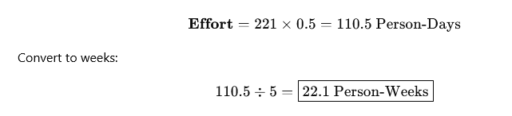

5. Sprint Estimation
- Team Velocity = 50 SP / Sprint
- Number of sprints = 221 / 50 = 4.42 ⇒ 5 sprints
- Sprint Duration = 2 weeks
Total Schedule = 5 × 2 = 10 weeks

6. Deadline Calculation
Deadline = Total Effort / Team Size
= 22.1 / 5 = 4.42 weeks ≈ 4.5 weeks
Planned schedule = 10 weeks (safe & realistic)

7. Sprint Breakdown & Commitments

Sprint | Target SP | Commitment SP | Delivered SP

1 | 50 | 45 | 44

2 | 50 | 48 | 47

3 | 50 | 50 | 49

4 | 50 | 48 | 46

5 | 21 | 21 | 21

8. Sprint Burndown Table
Sprint | Remaining SP
Start | 221

After S1 | 177

After S2 | 130

After S3 | 81

After S4 | 35

After S5 | 0

9. Team Size Calculation
Formula:


• Total SP = 221
• Number of sprints = 5
• Capacity per developer per sprint = 10 SP


Minimum Team Size for Risk-Adjusted Deadline


• Risk-adjusted deadline = 10.3 weeks ≈ 51.5 working days
• Total effort = 110.5 person-days



This shows our 5-person team is more than sufficient, giving extra buffer for delays and risks.

10. Estimation vs Target vs Commitment
- Estimate: 221 SP (technical calculation)
- Target: Finish within 10 weeks (business goal)
- Commitment: 50 SP per sprint (team promise)

11. Critical Path Analysis
Critical Chain: Authentication → Load Map → Manage Location → Calculate Route → Optimize Route → Emergency Dispatch → Notification
Activity | SP
Authentication | 25
Map | 21
Location | 16
Route Calc | 8
Route Optimize | 13
Emergency | 21
Notification | 11
Critical Path = 115 SP
Any delay here delays the whole project

12. Risk Analysis
Risk | Type | Probability | Impact (weeks) | Exposure | Description

Over-optimistic estimates | Estimation | High (0.5) | 4 | 2.0 | The initial story point estimates are too optimistic, leading to schedule slippage when tasks take longer than expected.

Requirements change | Requirements | Moderate (0.4) | 3 | 1.2 | Stakeholders request new features or changes after development has started, causing rework and delays.

Size underestimate | Estimation | Moderate (0.3) | 4 | 1.2 | The overall size and complexity of the system is underestimated, resulting in insufficient effort and time allocation.

Staff turnover | People | Low (0.2) | 5 | 1.0 | One or more team members leave the project or become unavailable, reducing productivity and increasing knowledge transfer time.

Technology change | Technology | Low (0.15) | 3 | 0.45 | Changes in underlying platforms, tools, or frameworks require adaptation or redesign of implemented components.

13. Risk-Adjusted Deadline Calculation
Risk-Adjusted Deadline = Calculated Deadline + Total Risk Exposure
- Calculated Deadline = 4.42 weeks
- Total Risk Exposure = 2.0 + 1.2 + 1.2 + 1.0 + 0.45 = 5.85 weeks
Risk-Adjusted Deadline = 4.42 + 5.85 = 10.27 weeks ≈ 10.3 weeks
Gantt Chart Table: Activities, Duration, Dependencies, Start & End Days
Activity | Duration (days) | Dependencies | Start Day | End Day
Manage Authentication | 3 | None | 1 | 3
Manage Contribution | 2 | Authentication | 4 | 5
Manage Participation | 2 | Authentication | 4 | 5
Manage Contact Support | 2 | Authentication | 4 | 5
Manage Location | 2 | Authentication | 4 | 5
Manage Review | 2 | Manage Contribution, Manage Participation | 6 | 7
Manage Map | 2 | Manage Location | 6 | 7
Manage Route | 3 | Manage Location, Manage Map | 8 | 10
Request Emergency Help | 2 | Manage Route | 11 | 12
Manage Notification | 1 | Request Emergency Help | 13 | 13
Manage Report | 1 | Manage Review | 8 | 8

- Features (the low-level functions / activities)
- Effort Points (SP)
- Estimated Duration (in days)
We’ll use your assumption:
- 1 SP = 0.5 person-day
- Team size = 5 developers
- Duration (days) = (SP × 0.5) ÷ 5 → rounded to nearest whole day
. Manage Authentication (Total SP = 25)
Feature | SP | Duration (days)
login | 5 | 1
logout | 2 | 1
validateUser | 5 | 1
manageSession | 8 | 1
verifyPassword | 3 | 1
notifyAuthenticationSuccess | 1 | 1
notifyAuthenticationFailed | 1 | 1
Total Duration = 3 days (parallel work considered)

2. Manage Contribution (Total SP = 16)
Feature | SP | Duration (days)
checkBadges | 5 | 1
awardBadge | 3 | 1
calculatePoints | 5 | 1
displayBadges | 3 | 1
Total Duration = 2 days (can run in parallel)

3. Manage Participation (Total SP = 16)
Feature | SP | Duration (days)
updateParticipation | 5 | 1
registerParticipant | 3 | 1
trackParticipation | 5 | 1
updateStatus | 3 | 1
Total Duration = 2 days

4. Manage Contact Support (Total SP = 16)
Feature | SP | Duration (days)
createTicket | 5 | 1
submitContact | 3 | 1
trackContact | 3 | 1
respondToContact | 5 | 1
Total Duration = 2 days

5. Manage Location (Total SP = 16)
Feature | SP | Duration (days)
validateLocations | 5 | 1
getCurrentLocation | 3 | 1
updateLocation | 5 | 1
getLocationHistory | 3 | 1
Total Duration = 2 days

6. Manage Review (Total SP = 19)
Feature | SP | Duration (days)
writeReview | 5 | 1
uploadReviewPhotos | 5 | 1
editOrDeleteReview | 3 | 1
approveOrRejectReview | 5 | 1
notifyReviewStatus | 1 | 1
Total Duration = 2 days

7. Manage Route (Total SP = 29)
Feature | SP | Duration (days)
calculateRoute | 8 | 1
optimizeRoute | 13 | 2
filterRouteByAccessibility | 8 | 1
Total Duration = 3 days

8. Manage Report (Total SP = 11)
Feature | SP | Duration (days)
submitReport | 3 | 1
processReport | 5 | 1
getReportStatus | 3 | 1
Total Duration = 1 day

9. Manage Map (Total SP = 21)
Feature | SP | Duration (days)
displayRouteOnMap | 5 | 1
loadMap | 3 | 1
addMarker | 5 | 1
updateLayer | 5 | 1
addFeatureIconsToMarker | 3 | 1
Total Duration = 2 days

10. Manage Notification (Total SP = 11)
Feature | SP | Duration (days)
createNotification | 3 | 1
sendNotification | 5 | 1
trackDelivery | 3 | 1
Total Duration = 1 day

11. Request Emergency Help (Total SP = 21)
Feature | SP | Duration (days)
dispatchEmergency | 8 | 1
receiveEmergencyCall | 5 | 1
dispatchHelp | 5 | 1
logIncident | 3 | 1
Total Duration = 2 days

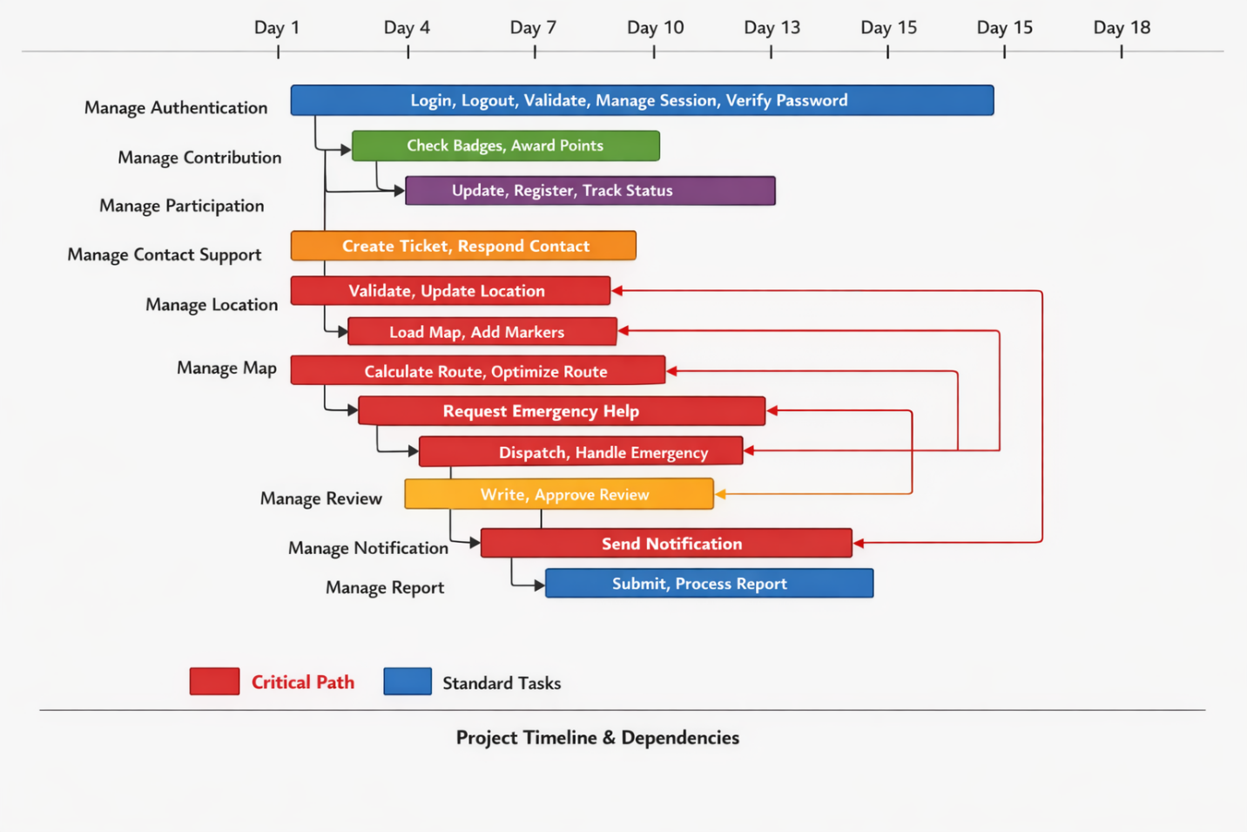

1. Milestones by Module Completion
Milestone | Description | Expected Completion
M1 – Authentication Module Complete | All authentication features (login, logout, validateUser, etc.) are implemented and tested | End of Sprint 1
M2 – Contribution & Participation Modules Complete | All functions for managing contributions and participation finished | End of Sprint 2
M3 – Contact Support & Location Modules Complete | All support and location features implemented | Mid Sprint 3
M4 – Map Module Complete | Map features (displayRoute, loadMap, add markers) finished | Mid Sprint 3
M5 – Route Module Complete | Route calculation and optimization ready | End of Sprint 3
M6 – Request Emergency Help Module Complete | Emergency dispatch and logging ready | End of Sprint 4
M7 – Notification Module Complete | Notifications creation, sending, and tracking ready | End of Sprint 4
M8 – Review & Report Modules Complete | Review, approval, report submission features ready | End of Sprint 4
M9 – System Integration Complete | All modules integrated, functional testing passed | End of Sprint 5
M10 – Project Delivered / Final Release | Risk-adjusted final project delivery | End of Sprint 5

2. Milestones by Critical Path
Since the critical path is Authentication → Map → Location → Route → Emergency → Notification, milestones aligned with critical path ensure project on-time delivery:
- M1: Authentication finished
- M2: Map & Location completed
- M3: Route module completed
- M4: Emergency Help module completed
- M5: Notification module completed → triggers final release

3. Optional: Sprint-Based Milestones
You could also define milestones at the end of each sprint:
Sprint | Milestone
Sprint 1 | Authentication module + initial sprint review
Sprint 2 | Contribution + Participation completed
Sprint 3 | Location + Map + Route modules completed
Sprint 4 | Emergency + Notification + Review modules completed
Sprint 5 | Final integration and project delivery

Final Task Duration and Dependencies Table (42 Functions with Milestones)
This table lists all 42 low-level functions from the Daleel Project Estimation document, named as F1 to F46, with their exact durations and associated milestones.

Activity | Activity Name | Duration (days) | Dependencies | Milestone
F1 | login | 1 | None | M1
F2 | logout | 1 | F1 | M1
F3 | validateUser | 1 | F2 | M1
F4 | manageSession | 1 | F3 | M1
F5 | verifyPassword | 1 | F4 | M1
F6 | notifyAuthenticationSuccess | 1 | F5 | M1
F7 | notifyAuthenticationFailed | 1 | F6 | M1
F8 | checkBadges | 1 | F7 | M2
F9 | awardBadge | 1 | F8 | M2
F10 | calculatePoints | 1 | F9 | M2
F11 | displayBadges | 1 | F10 | M2
F12 | updateParticipation | 1 | F7 | M2
F13 | registerParticipant | 1 | F12 | M2
F14 | trackParticipation | 1 | F13 | M2
F15 | updateStatus | 1 | F14 | M2
F16 | createTicket | 1 | F7 | M3
F17 | submitContact | 1 | F16 | M3
F18 | trackContact | 1 | F17 | M3
F19 | respondToContact | 1 | F18 | M3
F20 | validateLocations | 1 | F7 | M3
F21 | getCurrentLocation | 1 | F20 | M3
F22 | updateLocation | 1 | F21 | M3
F23 | getLocationHistory | 1 | F22 | M3
F24 | writeReview | 1 | F11, F15 | M8
F25 | uploadReviewPhotos | 1 | F24 | M8
F26 | editOrDeleteReview | 1 | F25 | M8
F27 | approveOrRejectReview | 1 | F26 | M8
F28 | notifyReviewStatus | 1 | F27 | M8
F29 | calculateRoute | 1 | F39 | M5
F30 | optimizeRoute | 2 | F29 | M5
F31 | filterRouteByAccessibility | 1 | F30 | M5
F32 | submitReport | 1 | F11, F15 | M8
F33 | processReport | 1 | F32 | M8
F34 | getReportStatus | 1 | F33 | M8
F35 | displayRouteOnMap | 1 | F23 | M4
F36 | loadMap | 1 | F35 | M4
F37 | addMarker | 1 | F36 | M4
F38 | updateLayer | 1 | F37 | M4
F39 | addFeatureIconsToMarker | 1 | F38 | M4
F40 | createNotification | 1 | F46 | M7
F41 | sendNotification | 1 | F40 | M7
F42 | trackDelivery | 1 | F41 | M7
F43 | dispatchEmergency | 1 | F31 | M6
F44 | receiveEmergencyCall | 1 | F43 | M6
F45 | dispatchHelp | 1 | F44 | M6
F46 | logIncident | 1 | F45 | M6
