HIREX
Domain Selection Document
HR Technology - Talent Acquisition and Recruitment Automation
Project | HireX - AI-Powered Interview System
Selected domain | HR Technology (HRTech) - Talent Acquisition and Recruitment Automation
Prepared for | Mentor/lead review and project tracker documentation
Document purpose | Record domain selection, business functions, as-is workflow, pain points, and AI opportunities.

Selected domain decision
The selected domain is HR Technology (HRTech), focused on recruitment automation. This domain was selected because recruitment has repeated manual work, high candidate volume, inconsistent screening, and clear opportunities for AI-assisted decision support while keeping final hiring control with HR.
1. Selected Domain
The selected domain is HR Technology (HRTech), with a focus on Talent Acquisition and Recruitment Automation.
HRTech uses software, automation, analytics, and AI to improve human resource operations. In this project, the focus area is recruitment, where organizations need to source candidates, screen resumes, conduct interviews, evaluate applicants, and support HR teams in making consistent hiring decisions.
2. Domain Research Summary
Recruitment is a critical business function because hiring quality directly affects productivity, delivery capacity, team performance, and business growth. Companies continuously need to identify suitable candidates quickly while maintaining fairness, consistency, and final human oversight.
Traditional recruitment workflows still rely heavily on manual resume screening, job portal searches, spreadsheet tracking, interview coordination, and separate evaluation notes. Modern HRTech platforms improve this process by introducing structured candidate data, automated screening, AI-assisted evaluation, hiring dashboards, and decision-support systems.
3. Core Business Functions
Function | Description
Candidate sourcing | Finding candidates from LinkedIn, Naukri, referrals, company portals, resumes, or internal databases.
Resume collection | Collecting candidate profiles and resumes from different sources.
Resume parsing | Extracting skills, education, experience, projects, certifications, and contact information.
Pre-screening | Checking candidate fit against job role, skills, experience, education, location, and salary expectations.
HR screening | Validating communication, availability, interest, salary expectations, and basic role alignment.
Technical evaluation | Assessing technical skills, projects, problem-solving ability, and domain knowledge.
Behavioral evaluation | Evaluating communication, confidence, attitude, and team fit.
Final decision support | Combining screening, interview, and HR evidence to support select, hold, or reject decisions.

4. Existing Workflow: As-Is Process
- HR or recruiter receives a job requirement from the business team.
- Recruiter posts the job or searches candidates on LinkedIn, Naukri, Indeed, referrals, or internal databases.
- Candidate resumes are collected manually through portals, emails, spreadsheets, or applicant tracking systems.
- Recruiter reviews resumes manually and checks role, experience, skills, education, and location fit.
- Shortlisted candidates are contacted for HR screening.
- HR evaluates communication, availability, salary expectations, interest, and basic role fit.
- Candidates are moved to technical interview rounds.
- Interviewers assess technical skills, projects, problem-solving, and domain knowledge.
- Interview feedback is recorded manually or in separate systems.
- HR combines screening feedback, technical feedback, and business requirements.
- Final decision is made: select, hold, reject, or move to additional rounds.
5. As-Is Process Flow Diagram
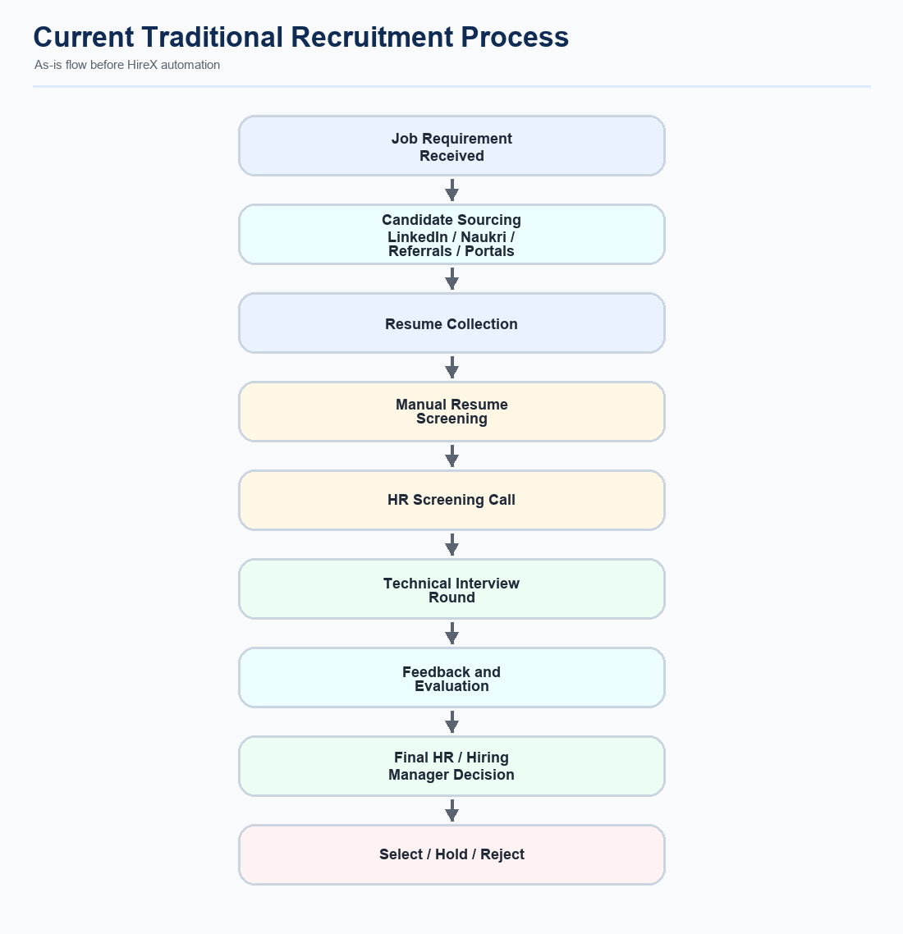
6. Pain Points Observed in the Domain
Pain point | Domain-level impact
Manual screening effort | Recruiters spend significant time reviewing resumes before identifying suitable candidates.
Fragmented candidate data | Candidate information is spread across resumes, Excel files, portals, emails, and notes.
Inconsistent evaluation | Different recruiters and interviewers may judge candidates using different standards.
Slow hiring cycle | Screening, coordination, interviews, and feedback collection can delay hiring.
Limited candidate reuse | Previously rejected candidates are often not structured for future openings.
Weak audit trail | It is difficult to explain why a candidate was moved forward or rejected.
Remote interview risk | Online interviews can involve copy-paste, tab switching, outside help, or identity concerns.

7. AI Intervention Opportunities
Process area | AI opportunity
Resume parsing | Extract structured candidate details from unstructured resumes.
Candidate matching | Compare candidate profile with job requirements and required skills.
Pre-screening | Generate evidence-based PASS, REVIEW, or FAIL categories.
HR review support | Show missing skills, score breakdown, and structured decision evidence.
Technical interview | Generate adaptive questions based on role, resume, and candidate answers.
Behavioral interview | Analyze communication, confidence, and role alignment.
Integrity monitoring | Detect suspicious activity during online interviews.
Talent pool reuse | Reuse previously processed candidates for future openings.
Periodic refresh | Update candidate metadata when new source data is found.
Hiring analytics | Provide dashboards for batches, funnel status, rejection reasons, and candidate quality trends.

8. Summary
Conclusion
The selected domain, HRTech - Talent Acquisition and Recruitment Automation, has strong potential for AI-driven improvement because recruitment involves large candidate data volumes, repetitive screening tasks, multiple evaluation stages, and high business impact. AI can support structured screening, interview automation, integrity monitoring, candidate reuse, and recruiter decision support while keeping final hiring decisions under HR control.

