HIREX
Current Process Flow Diagram
Existing as-is recruitment workflow before HireX AI automation.

Field | Details
Document purpose | Document the existing as-is recruitment workflow before HireX AI automation.
Project | HireX - AI-Powered Interview System
Domain | HR Technology (HRTech) - Talent Acquisition and Recruitment Automation

1. Current As-Is Process Flow
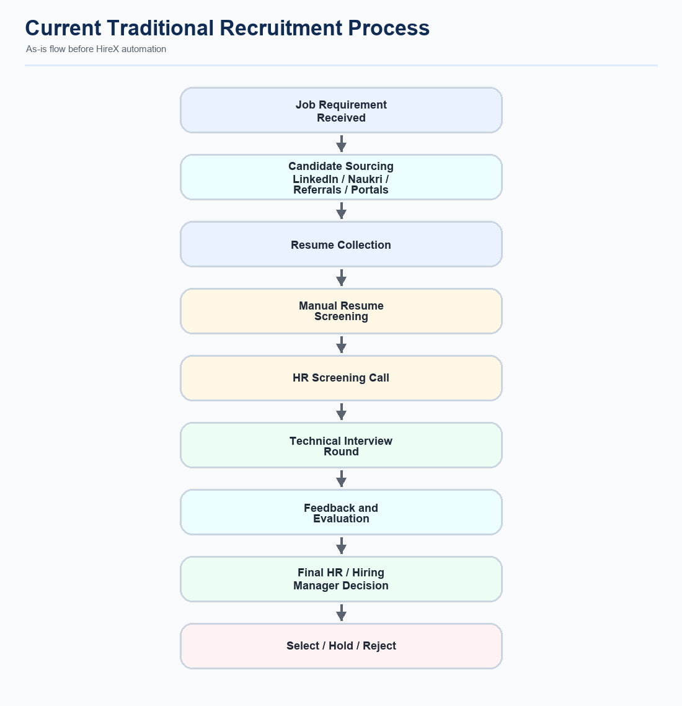
Figure 1. Traditional recruitment flow before HireX automation.
Step | Current activity | What happens
1 | Job Requirement Received | Business/hiring need is raised.
2 | Candidate Sourcing | Candidates are found through LinkedIn, Naukri, referrals, emails, and portals.
3 | Resume Collection | Profiles and resumes are collected from multiple sources.
4 | Manual Resume Screening | Recruiter manually checks fit against role, skills, and experience.
5 | HR Screening Call | HR validates communication, interest, availability, and expectations.
6 | Technical Interview Round | Interviewer checks technical skills, projects, and problem solving.
7 | Feedback and Evaluation | Interview feedback is recorded manually or in separate tools.
8 | Final HR / Hiring Manager Decision | HR and hiring manager combine feedback.
9 | Select / Hold / Reject | Candidate gets final process status.

2. Process Summary
Summary
The current recruitment process begins with receiving a job requirement, sourcing candidates, collecting resumes, manually screening profiles, conducting HR and technical interviews, and then making a final hiring decision. Most steps are handled manually or through separate tools, which increases recruiter workload, slows down hiring, and creates inconsistent candidate evaluation.

