Fitness Center and Gym Website
Website screenshot 1 of 4
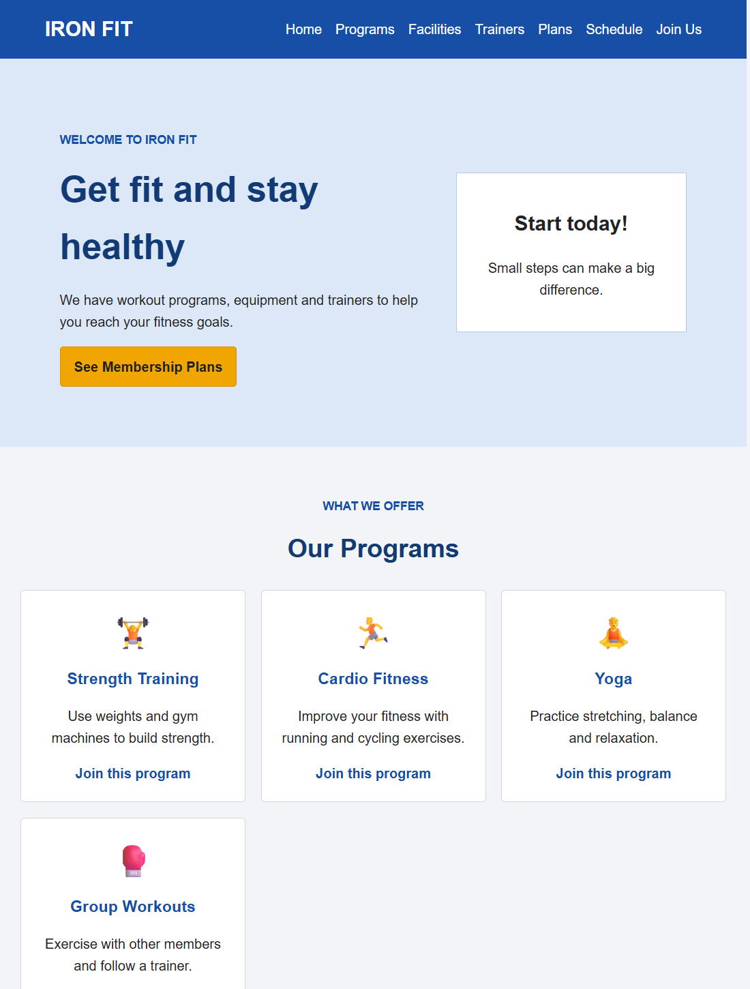

Fitness Center and Gym Website
Website screenshot 2 of 4


Fitness Center and Gym Website
Website screenshot 3 of 4
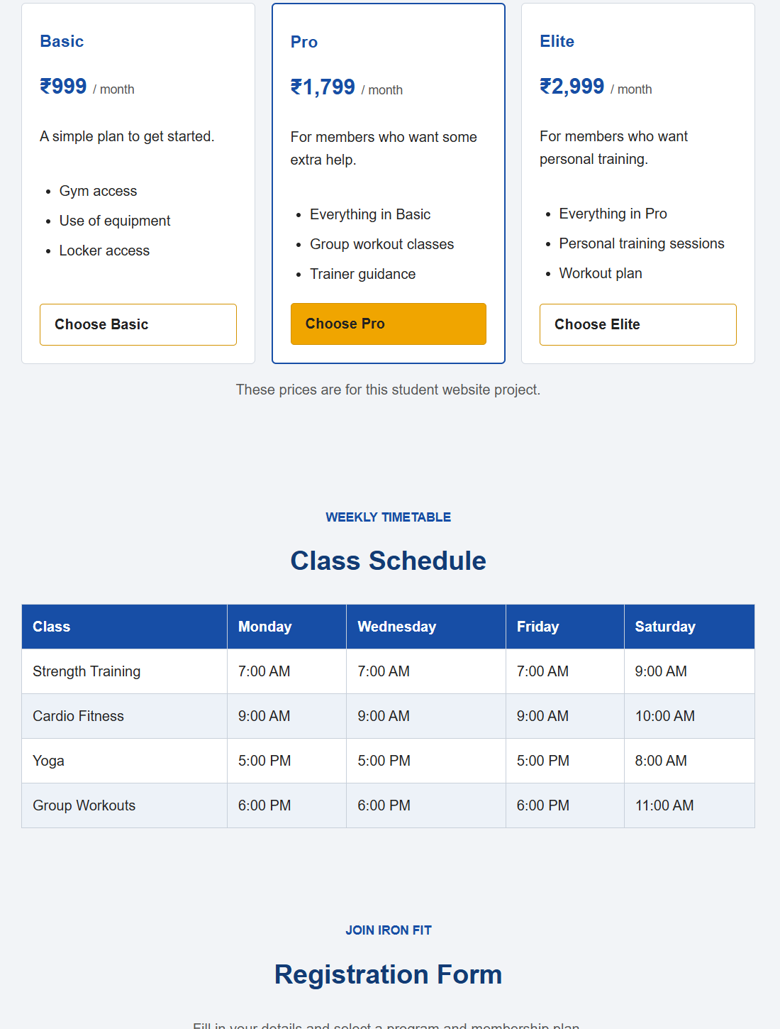

Fitness Center and Gym Website
Website screenshot 4 of 4
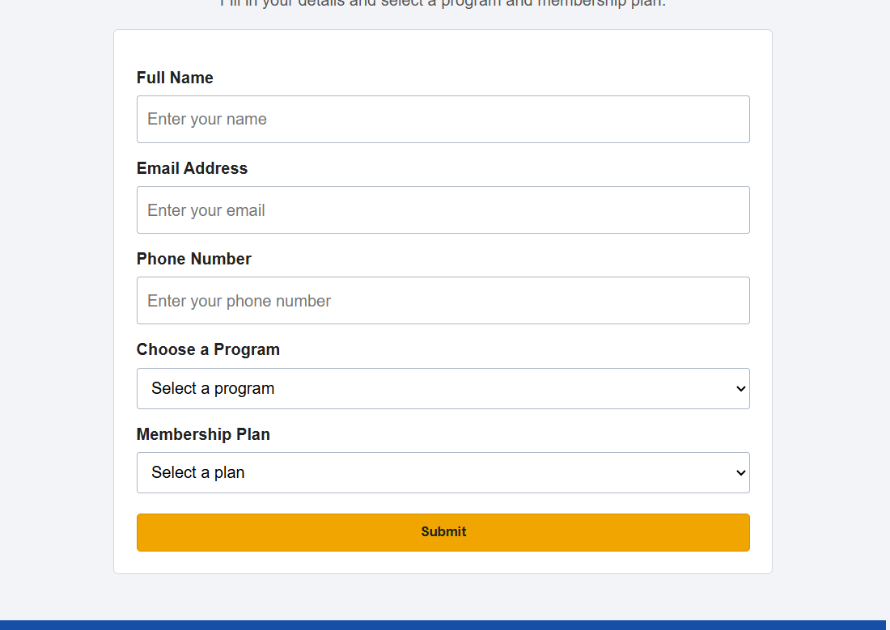

Online Shopping Website
Website screenshot 1 of 2


Online Shopping Website
Website screenshot 2 of 2


Restaurant Menu Website
Website screenshot 1 of 3


Restaurant Menu Website
Website screenshot 2 of 3
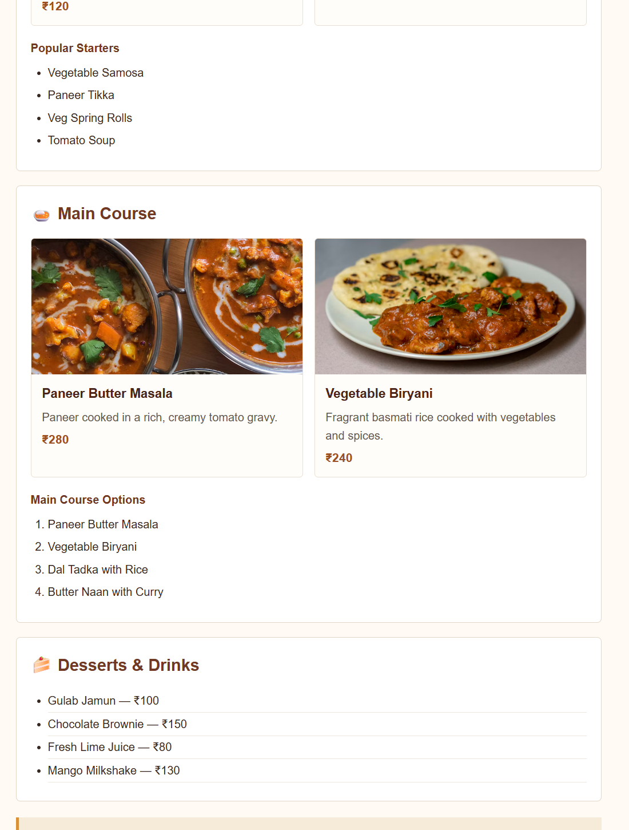

Restaurant Menu Website
Website screenshot 3 of 3


