Dockerfile

FROM node:latest

WORKDIR /usr/src/app

COPY package.json ./

RUN npm install

COPY . .

ENV PORT 3000

CMD ["node", "index.js"]

Docker img link: <https://hub.docker.com/r/ctscsliitjanaka/ctscapp>

Kubernates ss

Deployment.yaml

apiVersion: apps/v1

kind: Deployment

metadata:

  name: ctscapp-deployment

  labels:

    app: ctscapp

spec:

  replicas: 1

  selector:

    matchLabels:

      app: ctscapp

  template:

    metadata:

      labels:

        app: ctscapp

    spec:

      containers:

      - name: ctscappserver

        image: ctscsliitjanaka/ctscapp:latest

        ports:

        - containerPort: 3000

Service.yaml

apiVersion: v1

kind: Service

metadata:

  name: ctscapp-service

spec:

  selector:

    app: ctscapp

  type: LoadBalancer

  ports:

  - protocol: TCP

    port: 3000

    targetPort: 3000

    nodePort: 31110

Screenshot of pods running in Kubernetes cluster taken via kubectl

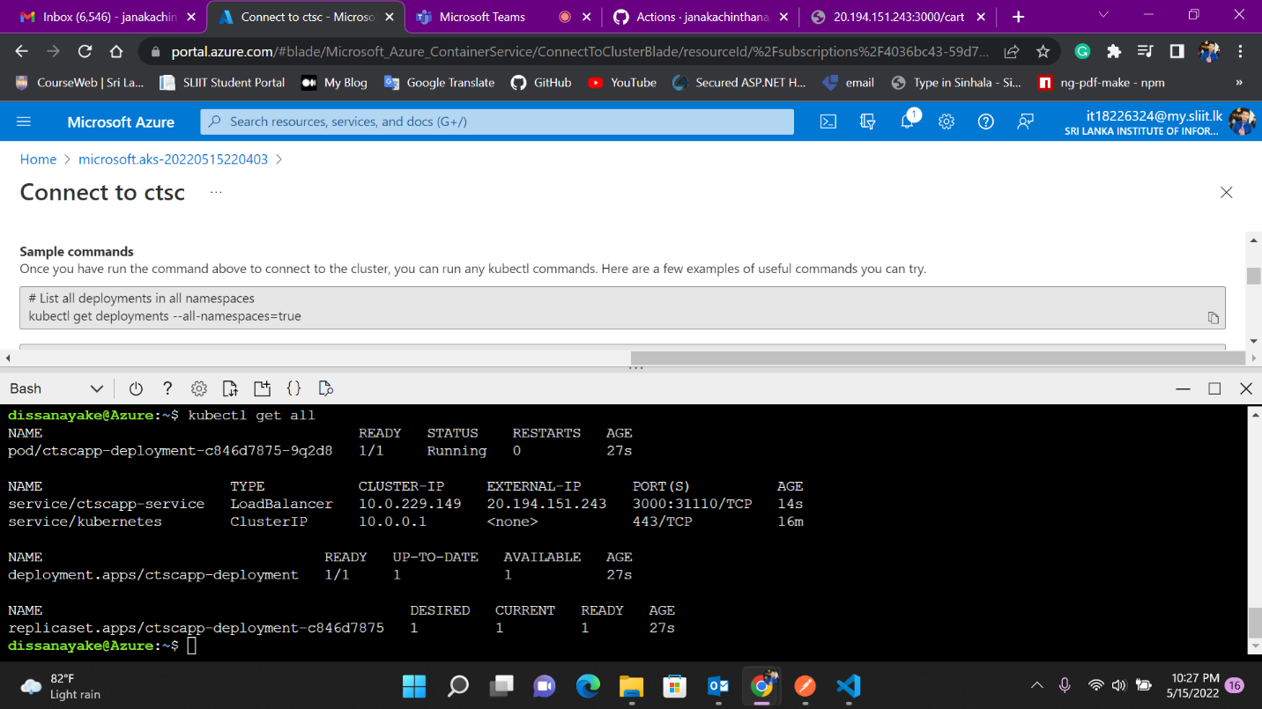

Github Action yml

# This is a basic workflow to help you get started with Actions

name: ci

# Controls when the workflow will run

on:

  # Triggers the workflow on push or pull request events but only for the main branch

  push:

    branches:

      - 'main'

    tags:

      - 'v*'

  # Allows you to run this workflow manually from the Actions tab

  workflow_dispatch:

# A workflow run is made up of one or more jobs that can run sequentially or in parallel

jobs:

  # This workflow contains a single job called "build"

  build:

    # The type of runner that the job will run on

    runs-on: ubuntu-latest

    # Steps represent a sequence of tasks that will be executed as part of the job

    steps:

      # Checks-out your repository under $GITHUB_WORKSPACE, so your job can access it

      -

        name: Checkout

        uses: actions/checkout@v2

      -

        name: Login to Docker Hub

        uses: docker/login-action@v1

        with:

          username: ${{ secrets.DOCKER_HUB_USERNAME }}

          password: ${{ secrets.DOCKER_HUB_ACCESS_TOKEN }}

      -

        name: Set up Docker Buildx

        uses: docker/setup-buildx-action@v1

      -

        name: Build and push

        uses: docker/build-push-action@v2

        with:

          context: ./

          file: ./Dockerfile

          builder: ${{ steps.buildx.outputs.name }}

          push: true

          tags: ${{ secrets.DOCKER_HUB_USERNAME }}/ctscapp:latest

          cache-from: type=registry,ref=${{ secrets.DOCKER_HUB_USERNAME }}/ctscapp:buildcache

          cache-to: type=registry,ref=${{ secrets.DOCKER_HUB_USERNAME }}/ctscapp:buildcache,mode=max

Screenshot of a successful action job run log.

