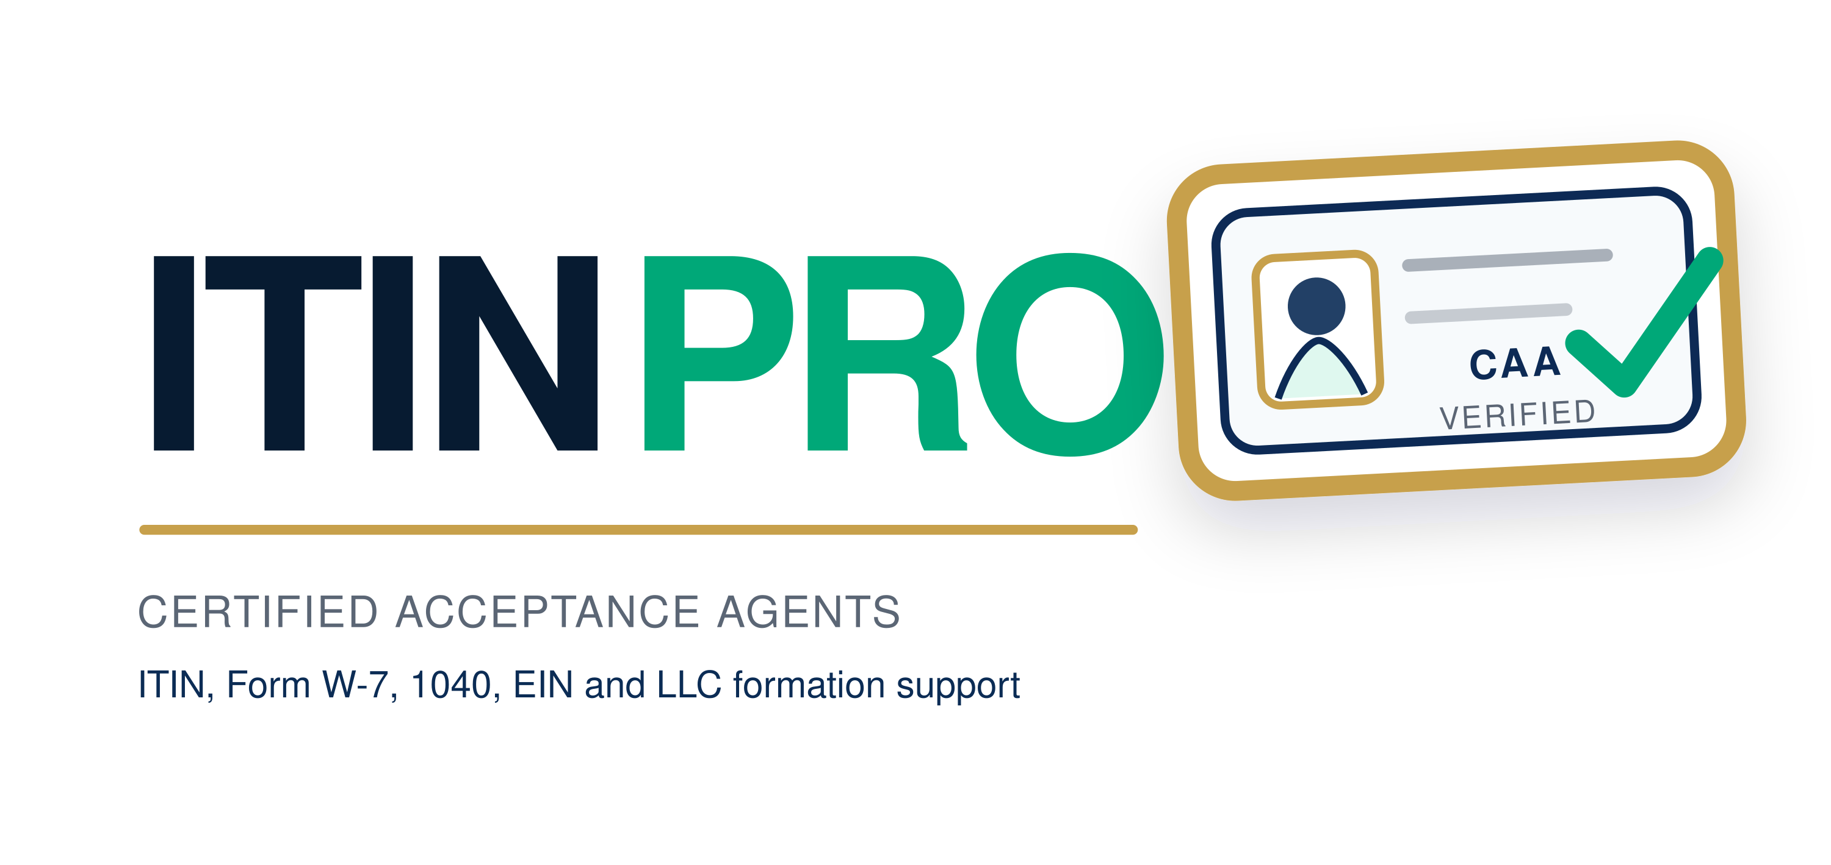
Invoice templates and logo use guide
ITIN Pro | Thasneem Alzari (Taz) CAA, Principal/Owner | Bedford, United Kingdom | Taz@itinpro.uk | +44 7864 113967

How to use this document
Duplicate the relevant template for each business expense, complete the bracketed fields, attach the supplier receipt and retain the payment confirmation. These templates are internal records and do not replace a supplier invoice or tax advice.

Software and app invoice
Software subscriptions, AI tools, design tools and business applications.
Invoice number | [INV-0001]
Invoice date | [DD Month YYYY]
Supplier | [Legal name and address]
Customer | ITIN Pro / Thasneem Alzari (Taz) CAA
Service period | [Start date to end date]
Description | [Detailed description]
Net amount | [£0.00]
VAT or tax | [£0.00 or N/A]
Total paid or due | [£0.00]
Payment method | [Card, bank transfer or other]
Notes | Business expense record. Keep the supplier receipt.

Mail hosting invoice
Email hosting, mailbox, domain and communications services.
Invoice number | [INV-0001]
Invoice date | [DD Month YYYY]
Supplier | [Legal name and address]
Customer | ITIN Pro / Thasneem Alzari (Taz) CAA
Service period | [Start date to end date]
Description | [Detailed description]
Net amount | [£0.00]
VAT or tax | [£0.00 or N/A]
Total paid or due | [£0.00]
Payment method | [Card, bank transfer or other]
Notes | Business expense record. Keep the supplier receipt.

LinkedIn upload and marketing invoice
LinkedIn profile, page, upload, post, campaign or marketing work.
Invoice number | [INV-0001]
Invoice date | [DD Month YYYY]
Supplier | [Legal name and address]
Customer | ITIN Pro / Thasneem Alzari (Taz) CAA
Service period | [Start date to end date]
Description | [Detailed description]
Net amount | [£0.00]
VAT or tax | [£0.00 or N/A]
Total paid or due | [£0.00]
Payment method | [Card, bank transfer or other]
Notes | Business expense record. Keep the supplier receipt.

Logo versions
Use the horizontal logo for the website header, email and letterhead. Use the icon logo for Instagram, YouTube, LinkedIn, social avatars and the favicon. Use the stacked version for cover pages and square layouts. Use the monochrome version for one-colour printing. Do not stretch, crop, recolour or place the mark over busy imagery.

Compliance wording
Use “Certified Acceptance Agent support” and “ITIN, Form W-7, 1040NR, EIN and LLC formation support” where accurate. Do not use an official IRS seal, IRS logo, eagle, Treasury badge or wording such as “IRS endorsed”, “IRS partner” or “official IRS agent”. Keep the statement “ITIN Pro is an independent service and is not the IRS.”

