Version 3.0

**Online MRP System Developments**

**System Modification Requirements Specification – (21-Feb-2017)**

Table of Contents

1. Revision History 2
2. Introduction 2

Purpose 2

1. Overall Description 3

3.1. Background 3

3.2 Objectives 4

3.2.1 Design Diagrams 4

Flow Chart 4

User Interface Designs 6

3.3 System Integration 13

3.4. Unsolved issues 13

3.5. Assumptions 14

# 1. Revision History

|  |  |  |  |
| --- | --- | --- | --- |
| Date | Version | Description | Author |
| 07/02/2017 | 1.0 | SRS | Tharindu Dilanka  Shalini Amanda |
| 16/02/2017 | 2.0 | SRS | Tharindu Dilanka  Shalini Amanda |
| 21/02/2017 | 3.0 | SRS | Tharindu Dilanka  Shalini Amanda |

# 2. Introduction

## Purpose

The MRP System is currently handling by the Head Office. Head office users perform all the tasks relate to MRP. From this project, we plan to automate the MRP system and also to allocate some parts of the MRP activities to bank assurance officers. Allocating some tasks to the bank officer will reduce the work load of head office users. Also with this system, MRP users can follow up given quotation details and generate reports.

# 3. Overall Description

## 3.1. Background

Currently MRP System is handling by the head office of HNB Assurance. According to the given requirement, some functions of the process/system will be allocated to bank assurance officers.

At first, bank assurance officer (in HNB Bank branch) asks about the general information, and loan details from the customer. Then the bank officer calculates the premium amount according to the given details (include fields like, name, NIC, Sum assured, term, interest rate, type of loan, occupation). If customer agrees with the amount, bank officer gives a proposal to fill. If customer requests for a discount only, bank officer sends the request to the head office. Then bank officer looks into given loan amount, he calculates the premium amount. BA Officer can produce quotations for requests. Sometimes customer can directly go with the proposal, without having any quotation.

After receiving the filled proposal (with a copy of the National Identity Card) from customer, officer adds the details to the system. Then he/she scans the proposal and the NIC copy, attach and send those to the relevant underwriter in head office (customer needs to fax the attachments when the scanning is not available). This job is passed to MRP department of head office. They will allocate underwriters to review the job. Then underwriter validates the details in the proposal. Underwriter can view the previous policies of the relevant customer. After reviewing the proposal, proposal details will be added to the MRP system. There can be two different types of policies, standard and substandard (medical and non-medical). If underwriter rejects the proposal he/she must mention the reasons for their rejection. Also if there are any required details needs from the branch officer, the pending requirements will be informed to the bank officer requesting for pending details via email.

After underwriter adds the proposal details to the system, cover note for the selected policy, generates from the system and it will send to customers’ given email address together with emails to relevant business channels.

**Note:** After sending the cover note, BA Officer is not allowed to view the uploaded proposal.

## 3.2 Objectives

### 3.2.1 Design Diagrams

#### Flow Chart

Flow chart 01 - Defines the main process including the one sub process. Sub process is described in flow chart 02.

Send a proposal to the proposer

Start

No

Need quotation?

Enter details to the system scan the proposal form

No

Is proposal complete?

Yes

Fill quotation screen and calculate premium

Yes

Underwriter takes the allocated job

Assign job to underwriter from work flow

Send the scanned proposal form to Head Office

Flow chart 01 – Main Process

Stop

Validate Proposal by Underwriter ()

Flow chart 02 - Defines underwriters’ activities. It includes details validation, proposal confirmation and if exists, send pending requirements back to the customer.

Validate Proposal by underwriter ()

View proposal, quotation and previous policies

Enter the proposal details to MRP system

Proposal Accepted?

Send cover note to BA officers, underwriter together with relevant business channels via email

Yes

Upon clearance of pending requirements

No

Sent cover note within 30 min?

Yes

Send pending requirements to BA officers’ business channels

No

Send an email to manager & CTO automatically

Return

Flow chart 02 – Underwriters’ activities

#### User Interface Designs

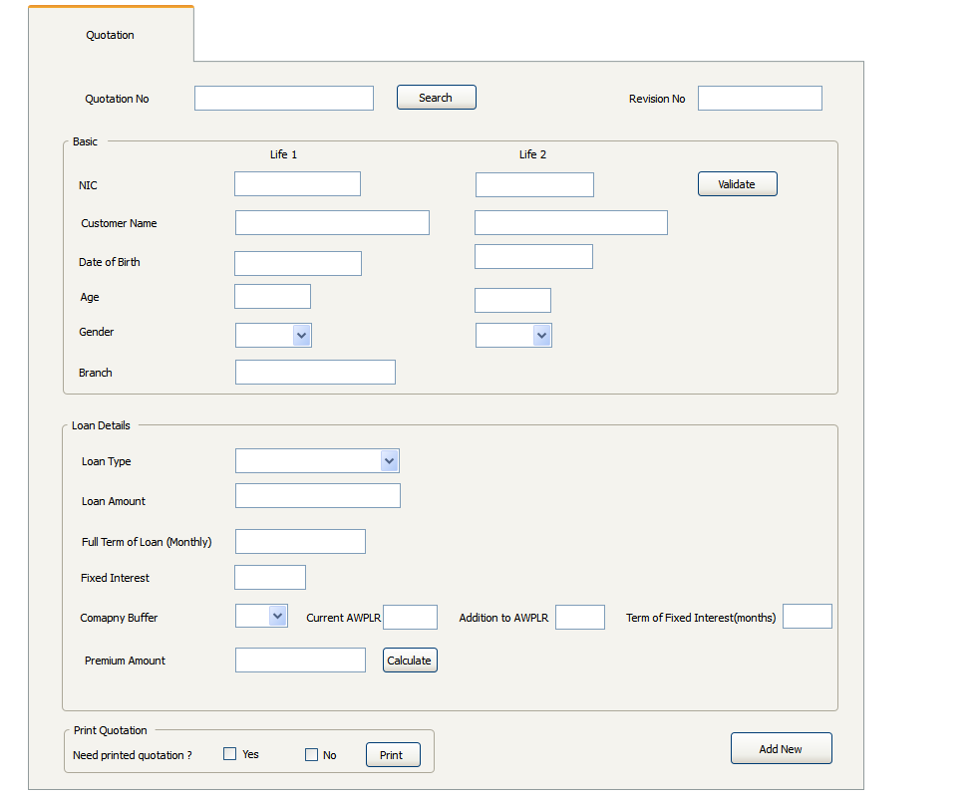

1. Quotation Screen

Interface 1- Quotation for Bank Officer

Quotation form is the first stage of the process. Bank Officer fills the customer details and loan details as above and calculates the premium. If customers request a different interest loan amount, bank officer takes the amount and calculates premium. Relevant request details must fill as given below.

Interface 01 – Quotation slip

Interface 02 – Discount Request Pop-up window

1. Proposal Register

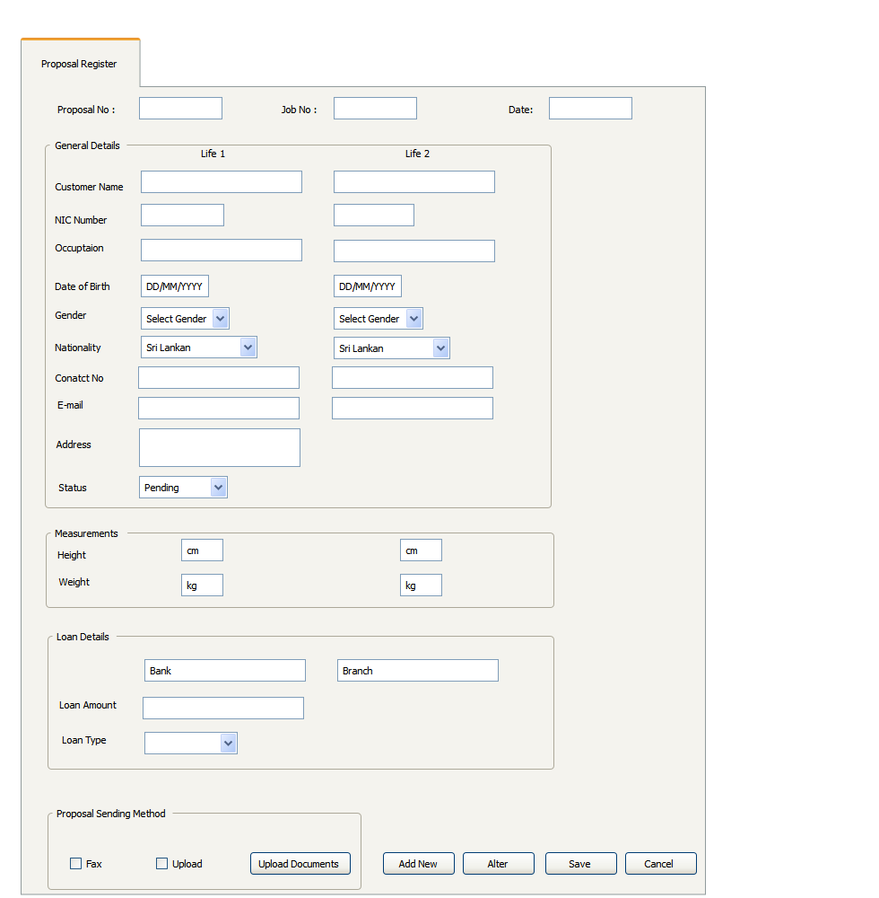

Interface 02 – Proposal Register for bank officer

After customer agrees with the premium amount in the quotation stage, bank assurance officer provides a proposal form. After customer completes the form, bank officer add those data using above interface (interface 04) and upload the relevant documents. In contact details section, only Life 01s’ address will be taken as the address.

Bank officer uploads documents using the below tab.

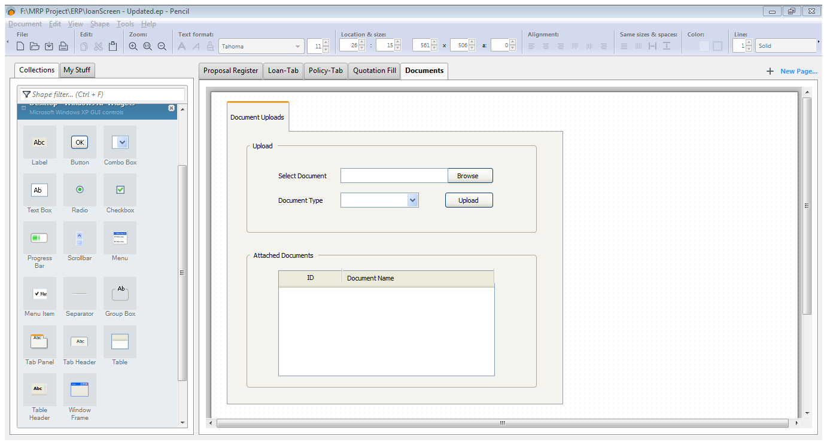

Interface 03 – Document upload and viewer

1. Proposal Details

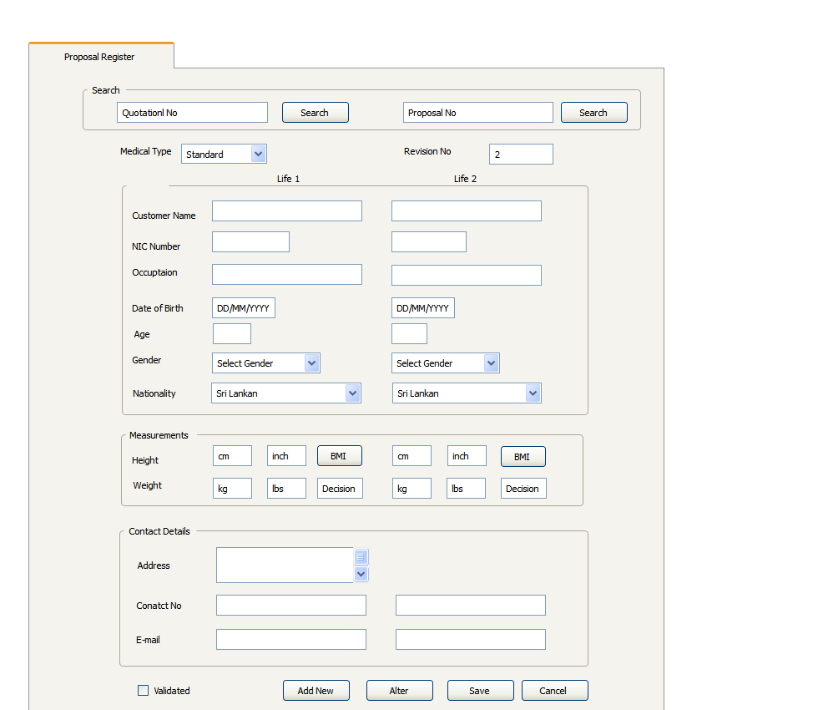

Interface 04 – Tab 1 – Proposal Register to underwriter

After bank officer sends the proposal details, underwriter at head office, fills the other details relevant to the proposal using above tab (interface 06 – tab 1) and below two tabs (for loan and policy details). Underwriter can search for quotation slips and proposal forms, then the relevant details display on relevant fields. In measurement section, BMI value calculates based on the given height and weight. The decision on BMI value displays on the Decision text box.

1. 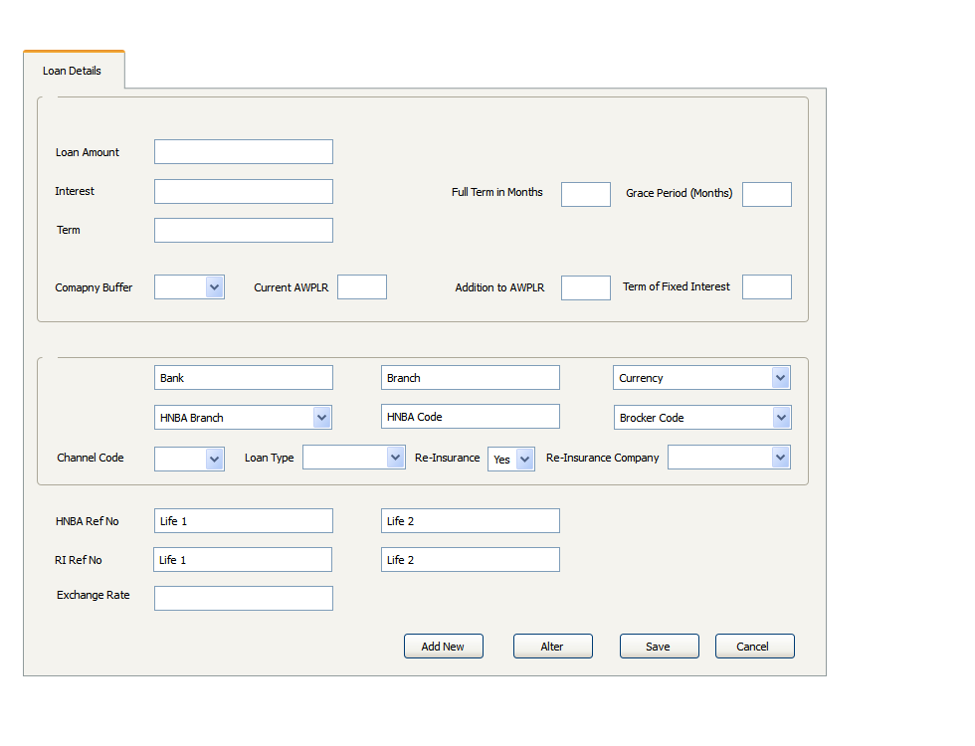Loan Details Form

Interface 04 – Tab 2 – Loan Details tab to underwriter

\

In this tab, underwriter fills the loan details including loan amount, interest rate, term etc.

1. 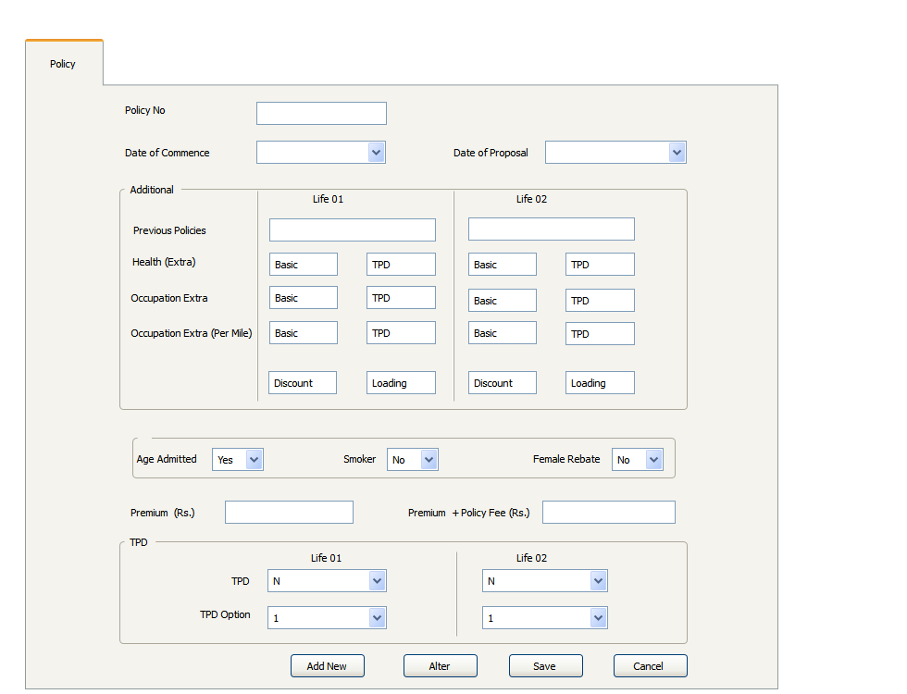Policy Details

Interface 04 – Tab 3 – Policy details tab to underwriter

From this tab, underwriter adds policy details and calculates the premium amount. He/she can get details about customers’ previous policies.

Underwriter can mention any pending on the remarks box, if there’s any pending remaining for a proposal.

1. Douments Upload



Interface 03 – Document upload and viewer

All the documents that receive by branch officer can be viewed by above tab. These documents can be the proposal form, copy of the NIC etc. In the table, underwriter can view all the uploaded documents.

After sending the cover note, BA Officer is not allowed to view the uploaded proposal.

## . System Integration

## 

As this new system is a supporting system for current MRP System, we have to pass the data to MRP System after approving the proposal by the head office underwriters. So MRP users can continue the proposal related work using MRP System. For this particular task we have to contact the developers of MRP system and request interface to pass data.

## Unsolved issues

Still there isn’t any interface provided to pass the data from bank officers’ side. There isn’t any database designed to store their data.

## Assumptions

* Bancassurance officers have knowledge to use the system and enter quotation details and calculate the premium and also he/she should able to scan and attached the proposal form and NICs and also enter basic details of proposal form to the system
* As the first stage of the Online MRP system project we use the system to process only Non-Medical cases. Medical related proposals will be implemented on the second stage.

…….…………………………………..…

Checked By

**Ms. Harshini Yatawara**

**(Executive - MRP)**

…………………………………………..

Recommended By

**Ms. Anuradha Ranasinghe**

**(Manager – MRP)**

…………………………………………..

Approved By

**Mr. Dinesh Udawatta**

**(Chief Technical Officer - CTO)**