|  |
| --- |
| HNB Assurance PLC |
| Flow Chart |
| IT Department – IT Work Flow / Change Management System |
|  |

**Flow Chart- IT Work Flow**

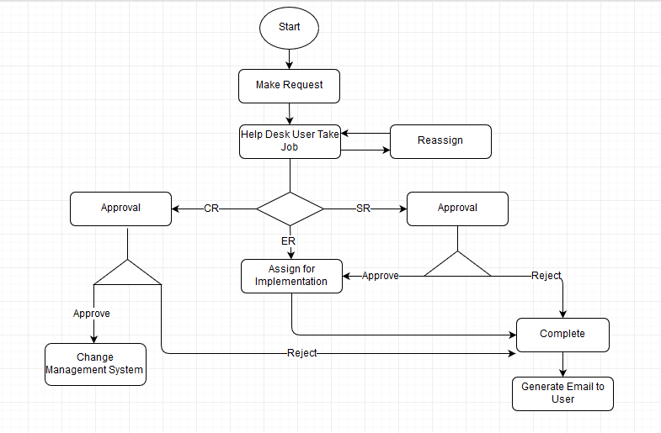

Approve

Reject

View Reject Reason and Continue With same request (Request Update facility)

Generate Email to IT Assign User

**Flow Chart - Change Management System**

IT Work Flow

Close (IT WF and CM)

Approve Release

Dynamically created document and process validation (Check boxes with document upload)

Upload mandatory Docs & Processes

Select Mandatory Documents & Processes

Generate Email to IT Workflow Assign User and IT request user

Release

Implement

Update Details

Generate Email to Manager, Implementer, QA agent, Release person

Approve

Reject

Close IT Work Flow Request

Generate Email to IT Workflow Assign User

Assign and Plan

View All IT Work Flow Data

Change Intimation

CR

**Flow Chart - Change Management System V2**

IT Work Flow

Close (IT WF and CM)

Dynamically created document and process validation (Check boxes with document upload)

Upload mandatory Docs & Processes

Select Mandatory Documents & Processes

UAT Release

Implement

Update Details

Generate Email to Manager, Implementer, QA agent, Release person

Approve

Reject

Close IT Work Flow Request

Generate Email to IT Workflow Assign User

Assign and Plan

View All IT Work Flow Data

Change Intimation

CR

Reject

UAT Return

UAT Confirm

Send to IT WF request User

Release

Approve Release

Generate Email to IT Workflow Assign User and IT request user