UI can be used to add and read records

- Add record
Fill all input fields and click submit button
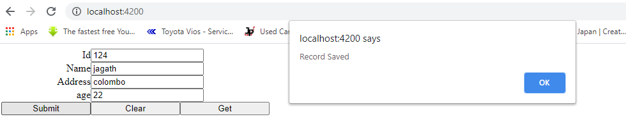
- Clear button clears all entries
- Get entry
Fill id and click Get button
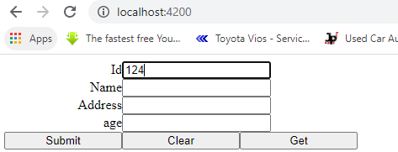
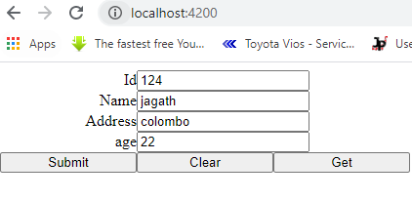
log files can be seen in C:\cache\ folder

