1. Modules description

portablecache-caching logic is implemented here, currently this create a file in local disk, this is designed to save in a cloud. As this does not support distributed caching, only one instance should be started.
testemployeeservice-this is just to show the caching usage, expose a dummy service
portalwebservice-this works as the server module for the web portal, this call portablecache's API to load a record, if not found it calls testemployeeservice's API. Hystrix is used for fail tolerance, has not configured bulk head. For client side load balancing ribbon has been used.
portalgateway-this is the gateway, this performs the intelligence routing
testconfigserver-coonfig server which points to git
testeurekaserver-discovery server

Architecture
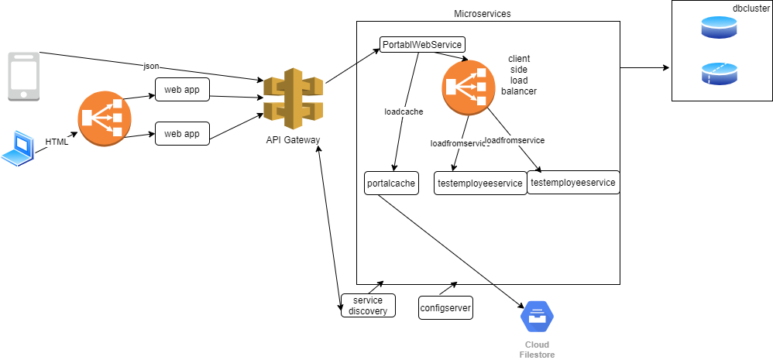

2.Technology Selection

I have used micro-service architecture, even though this module is a smaller one in the startup, when it is growing it will result in a huge monolithic application which is hard to be maintained, bug fixing, conflict resolving etc. Micro-service architecture enables us to scale only required application; to gain many more benefits I designed the app to follow micro-service architecture. For the development I have used spring cloud as the spring cloud offers tools for developers to easily develop distributed systems in short period.

3.Sequence diagram
I have drawn sequnce diagram for loading a employee record once the id is given(image will be uploaded as it is blurred)

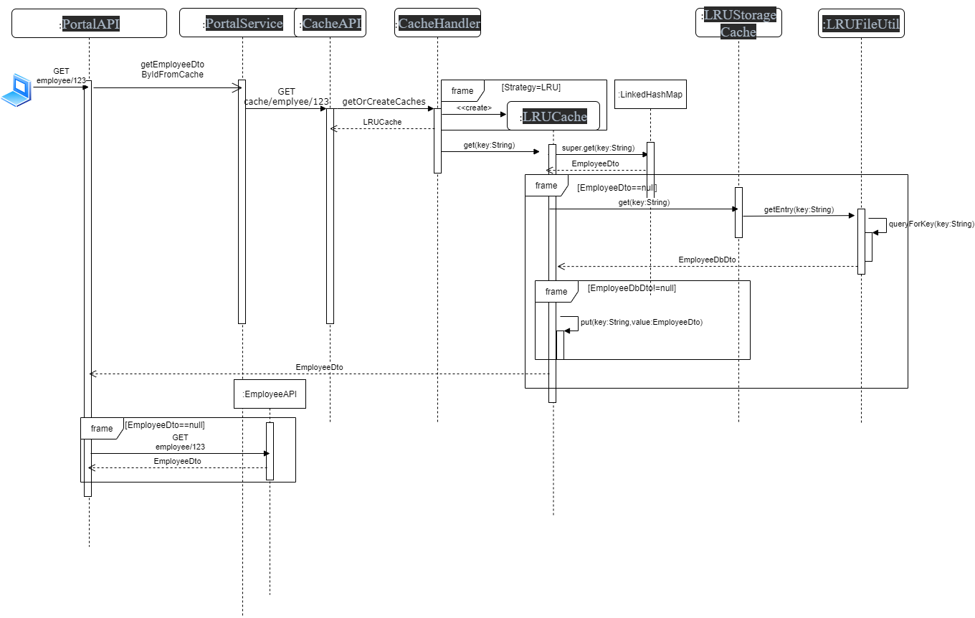

4.Infrastructure Architecture
I have used AWS as the deployment cloud. AWS is cost effective and
pay as you go platform which offers reliable, salable and high performing and secure infrastructure. Also it offers a lot of services which keeps evolving day by day.

