**AWS Application Load Balancer using host based routing**

**- Create Load Balancer "myapploadbalancer" with minimum two subnets**

aws elbv2 create-load-balancer --name hostnamebasedelb --subnets "subnet-b0eb0b9f" "subnet-fb4acb9f" "subnet-3a9c7967" --security-groups sg-8e3804fc

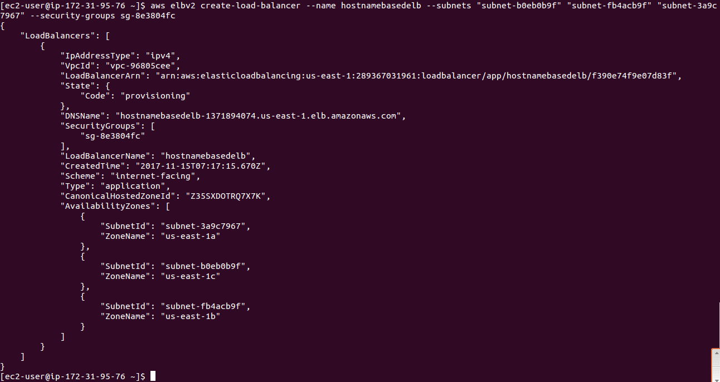

**- Create Target Group**

aws elbv2 create-target-group --name server1 --protocol HTTP --port 80 --vpc-id vpc-96805cee --health-check-path /healthy.html

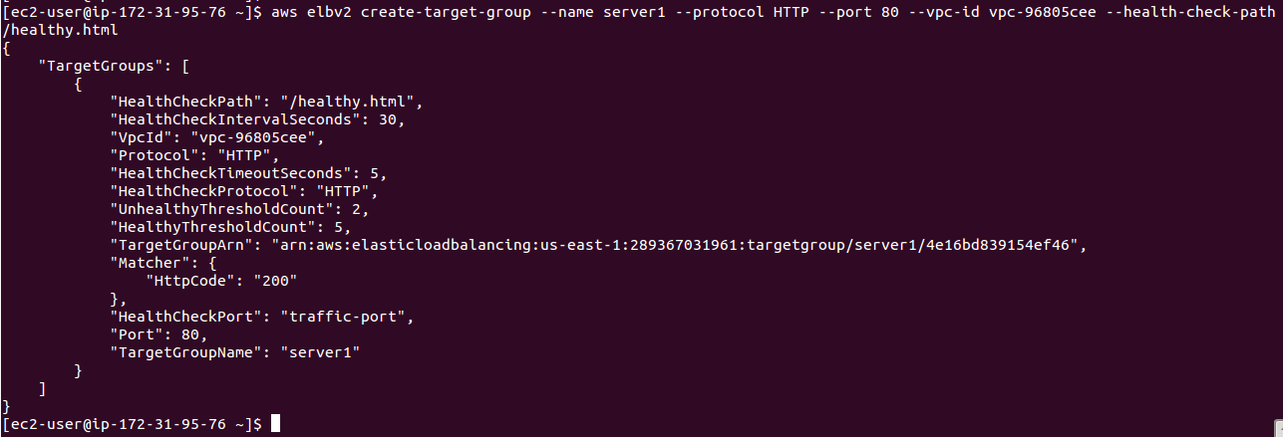

aws elbv2 create-target-group --name server2 --protocol HTTP --port 80 --vpc-id vpc-96805cee --health-check-path /healthy.html

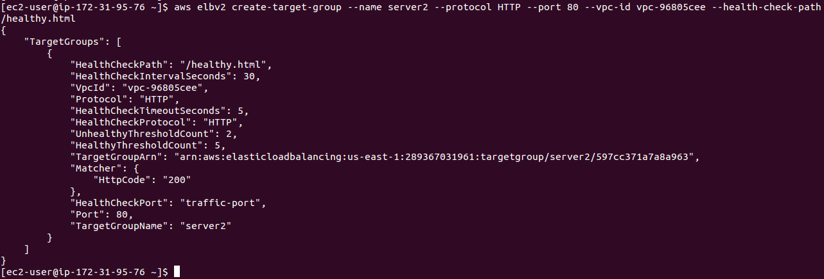

aws elbv2 create-target-group --name server3 --protocol HTTP --port 80 --vpc-id vpc-96805cee --health-check-path /healthy.html

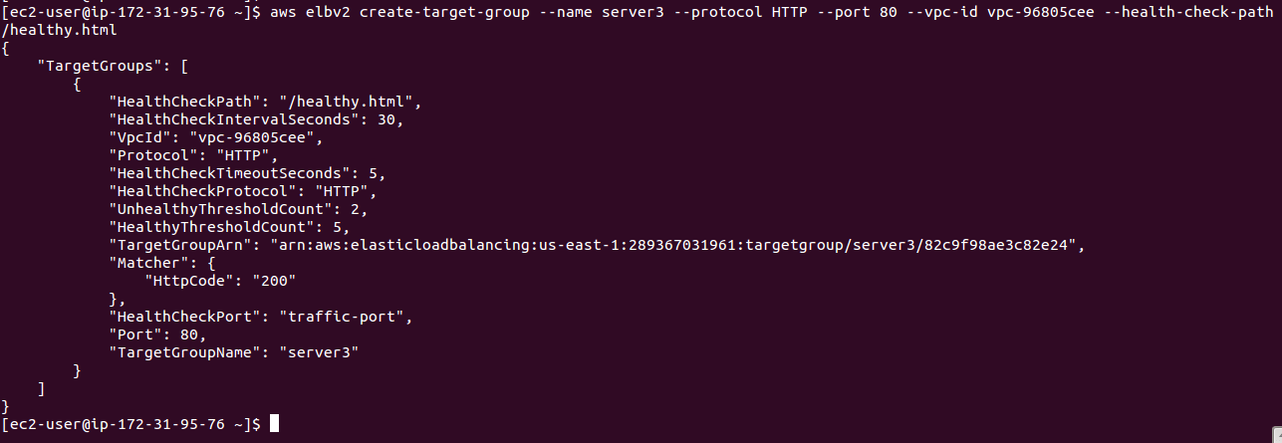

**- Register instance to target group**

aws elbv2 register-targets --target-group-arn arn:aws:elasticloadbalancing:us-east-1:289367031961:targetgroup/server1/4e16bd839154ef46 --targets Id=i-0edb25b9ec119328f,Port=80



aws elbv2 register-targets --target-group-arn arn:aws:elasticloadbalancing:us-east-1:289367031961:targetgroup/server2/597cc371a7a8a963 --targets Id=i-06c6ad5b0aa041be9,Port=80



aws elbv2 register-targets --target-group-arn arn:aws:elasticloadbalancing:us-east-1:289367031961:targetgroup/server3/82c9f98ae3c82e24 --targets Id=i-02e0aee0b95f97e9f,Port=80



**- Create Default Listener**

We have set it to route query to host1 default

aws elbv2 create-listener --load-balancer-arn arn:aws:elasticloadbalancing:us-east-1:289367031961:loadbalancer/app/hostnamebasedelb/f390e74f9e07d83f --protocol HTTP --port 80 --default-actions Type=forward,TargetGroupArn=arn:aws:elasticloadbalancing:us-east-1:289367031961:targetgroup/server1/4e16bd839154ef46

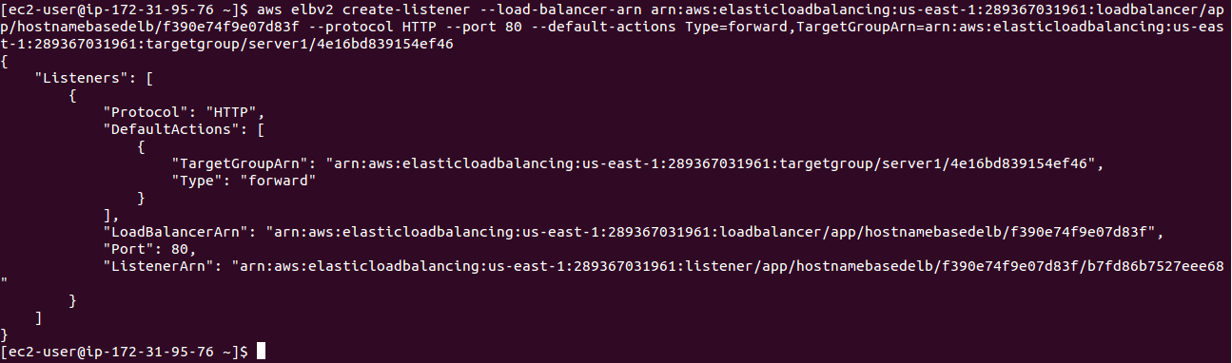

**- View DNS records**

aws route53 list-hosted-zones

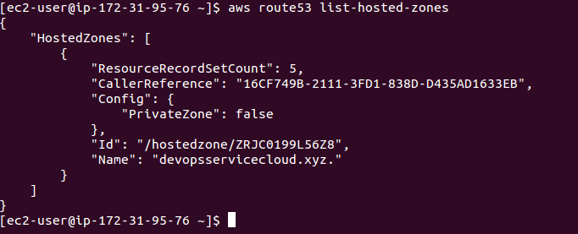

aws route53 list-resource-record-sets help --hosted-zone-id ZRJC0199L56Z8

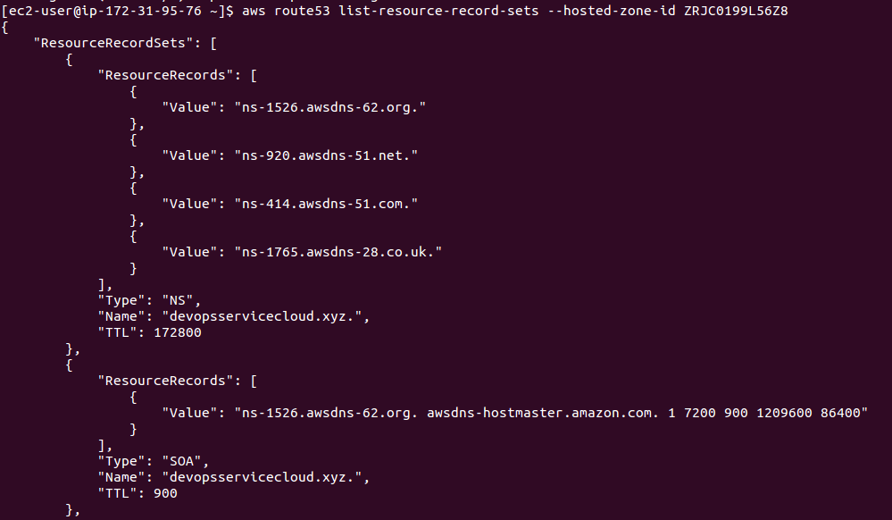

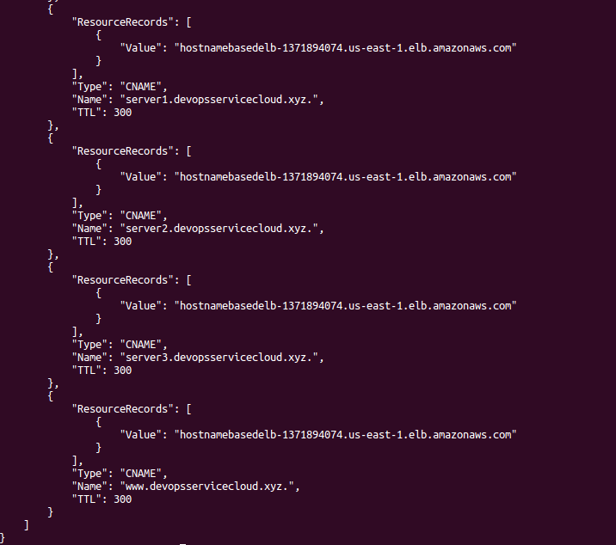

**- Create rule for host based routing**

aws elbv2 create-rule --listener-arn arn:aws:elasticloadbalancing:us-east-1:289367031961:listener/app/hostnamebasedelb/f390e74f9e07d83f/b7fd86b7527eee68 --priority 10 --conditions Field=host-header,Values='**server1.devopsservicecloud.xyz**' --actions Type=forward,TargetGroupArn=arn:aws:elasticloadbalancing:us-east-1:289367031961:targetgroup/server1/4e16bd839154ef46

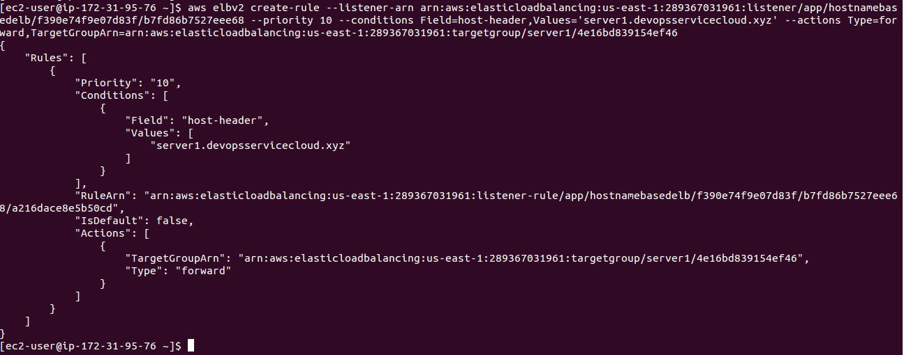

aws elbv2 create-rule --listener-arn arn:aws:elasticloadbalancing:us-east-1:289367031961:listener/app/hostnamebasedelb/f390e74f9e07d83f/b7fd86b7527eee68 --priority 11 --conditions Field=host-header,Values='**server2.devopsservicecloud.xyz**' --actions Type=forward,TargetGroupArn=arn:aws:elasticloadbalancing:us-east-1:289367031961:targetgroup/server2/597cc371a7a8a963

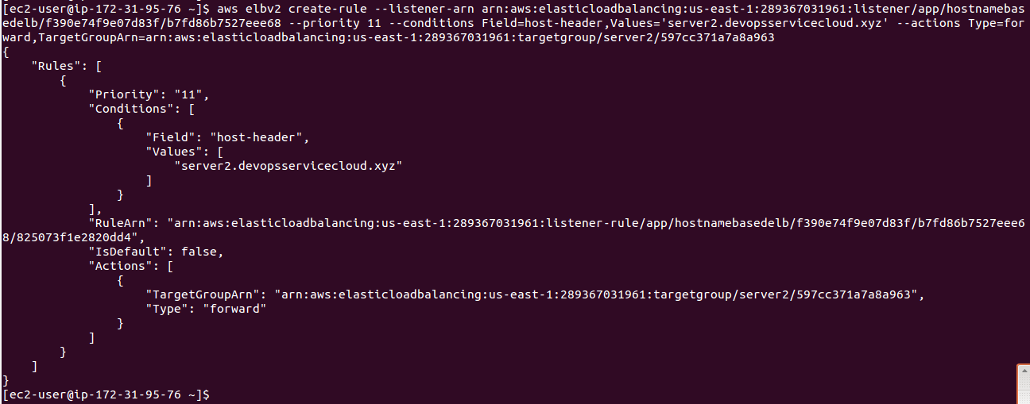

aws elbv2 create-rule --listener-arn arn:aws:elasticloadbalancing:us-east-1:289367031961:listener/app/hostnamebasedelb/f390e74f9

e07d83f/b7fd86b7527eee68 --priority 12 --conditions Field=host-header,Values='**server3.devopsservicecloud.xyz**' --actions Type=forward,TargetGroupArn=

arn:aws:elasticloadbalancing:us-east-1:289367031961:targetgroup/server3/82c9f98ae3c82e24

