Console:

> data1 <- read.csv("C:/Users/I340968/Desktop/ed-code/R programming-elective/Week_5/house.csv",header = TRUE)

> boxplot(X~(price+room),data=data1);

#code given by your support ended in error

Error in eval(predvars, data, env) : object 'room' not found

> boxplot(X~(data1$price+data1$room),data=data1);

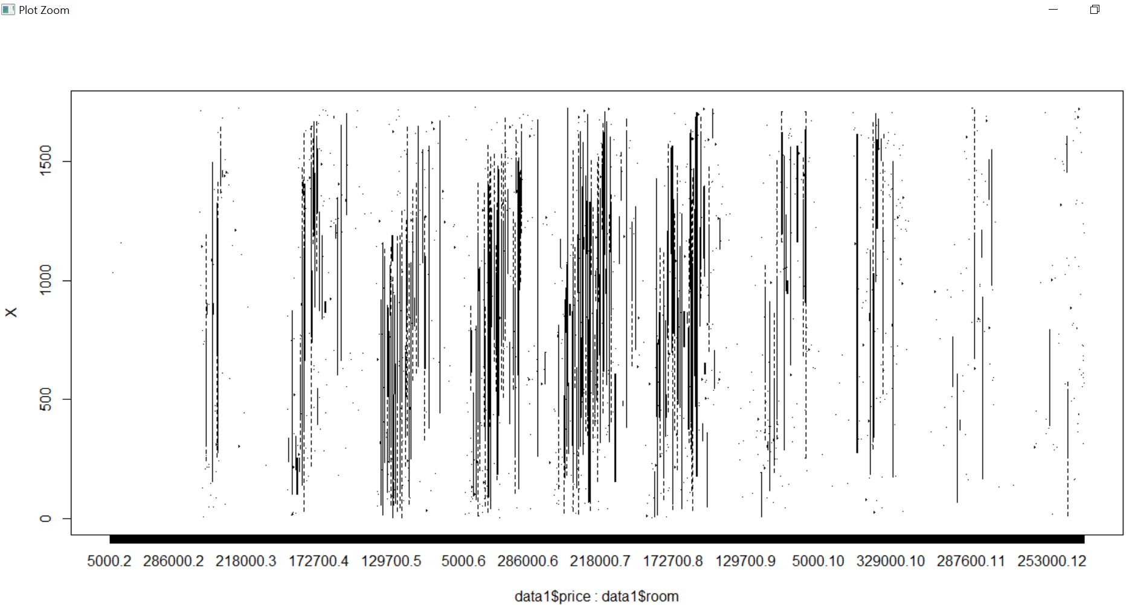

boxplot(data1$price~data1$room)

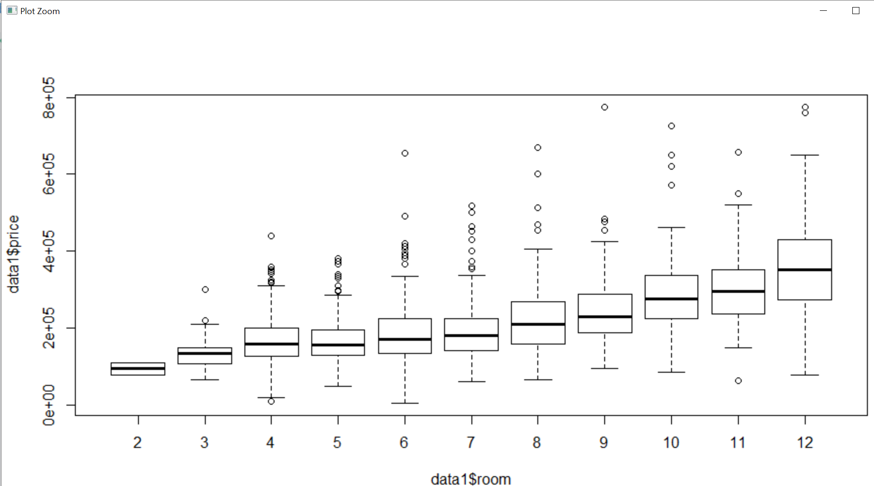

Can you explain me why I am not getting result in ggplot?

How the expected result is changed?