R programming certificate training – Module 5 - Data Visualization – 2nd video -Geometic options.

BOXPLOT issue:

=================

Code:

========

ggplot(house,aes(y=price,x=rooms))+geom_boxplot()

ggplot(house,aes(y=price,x=rooms,col=rooms))+geom_boxplot()

ggplot(house,aes(y=price,x=rooms,fill=rooms))+geom_boxplot()

Console:

============

|  |
| --- |
| ggplot(house,aes(y=price,x=rooms))+geom_boxplot()  Warning message:  Continuous x aesthetic -- did you forget aes(group=...)?  > ggplot(house,aes(y=price,x=rooms,col=rooms))+geom_boxplot()  Warning message:  Continuous x aesthetic -- did you forget aes(group=...)?  > ggplot(house,aes(y=price,x=rooms,fill=rooms))+geom_boxplot()  Warning message:  Continuous x aesthetic -- did you forget aes(group=...)? |
|  |
| |  | | --- | | > | |

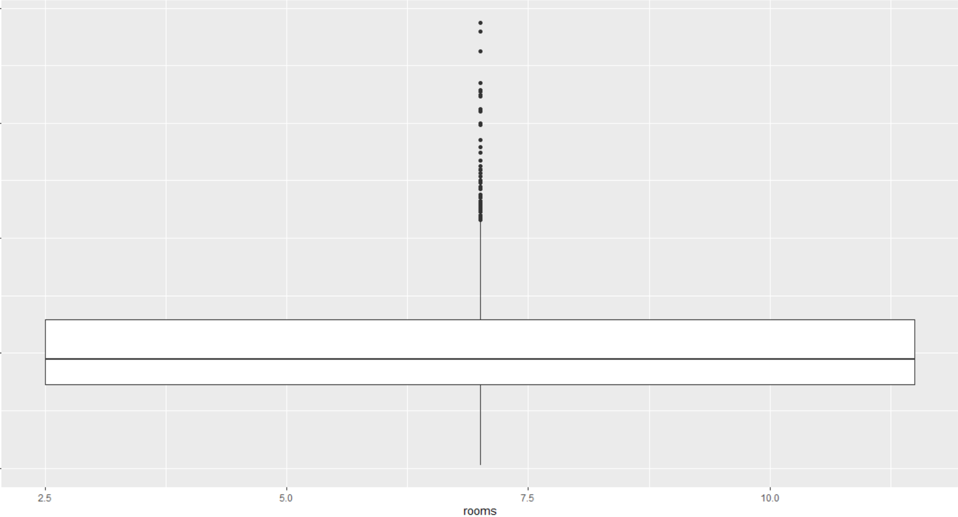

Expected output

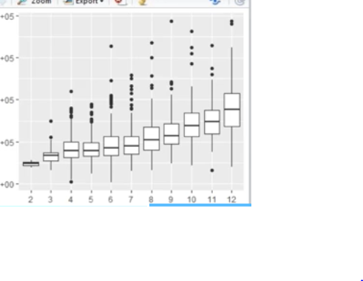

For warning message I have added group=1 warring disappeared but output is not as per what expected.

The issue is only with boxplot whatever code you have explained I used the same dataset and also same line of code but the result is different.