Trader Performance vs Market Sentiment Analysis
Primetrade.ai Data Science/Analytics Intern Assessment
Prepared by Janaki Ram Vallapu | July 2026

Executive Summary
This report analyzes 211,218 Hyperliquid trade records after merging historical trading data with the daily Crypto Fear & Greed Index. The final analytical table contains 2,340 trader-day records across 32 traders. The purpose is to understand whether trader profitability and behavior change across sentiment regimes such as Fear, Greed, Extreme Fear, and Extreme Greed.
- Fear days produced the highest average daily PnL among the analyzed sentiment groups.
- Trading activity was highest during Extreme Fear, suggesting stronger participation during stressed market conditions.
- Average trade size was largest during Fear, indicating larger capital deployment under fearful conditions.
- Win rates were relatively stable across sentiments, so sentiment alone does not explain trading success.
- Correlations between profitability, activity, trade size, and win rate were weak, suggesting that performance is driven by multiple factors.

1. Objective and Data
The assignment objective was to evaluate how market sentiment relates to trader behavior and performance. The analysis focused on realized PnL, trading frequency, average trade size, win rate, and trader-level segmentation.
Dataset | Rows | Columns | Role in Analysis
Fear & Greed Index | 2,644 | 4 | Daily market sentiment classification
Historical Trader Data | 211,224 | 16 | Trade-level activity and realized PnL
Merged Trade Data | 211,218 | 20 | Each trade enriched with daily sentiment
Daily Metrics Table | 2,340 | 10 | Trader-day metrics used for analysis

2. Methodology
- Loaded both CSV datasets and checked row counts, column counts, missing values, and duplicate records.
- Converted trade timestamps from string format to datetime and extracted a daily date field for alignment.
- Merged the trading data with the Fear & Greed data using a left join on date to retain all trade records.
- Identified 6 unmatched trade records, all from 2024-10-26, where sentiment was unavailable; these rows were removed from analysis.
- Created daily trader metrics: Daily PnL, total trades, average trade size in USD, total volume, fees, and win-rate features.
- Compared performance and behavioral metrics across sentiment categories and summarized trader segments.

3. Sentiment-Level Results
The table below summarizes the main trader-day metrics by market sentiment. Values are averages unless otherwise noted.

Sentiment | Avg Daily PnL | Median PnL | Avg Trades | Avg Trade Size | Avg Win Rate
Extreme Fear | $4,619 | $218 | 133.8 | $6,773 | 61.7%
Fear | $5,329 | $108 | 98.2 | $8,976 | 61.9%
Neutral | $3,439 | $168 | 100.2 | $6,964 | 63.1%
Greed | $3,318 | $158 | 77.6 | $6,428 | 61.4%
Extreme Greed | $5,162 | $418 | 76.0 | $5,372 | 65.0%

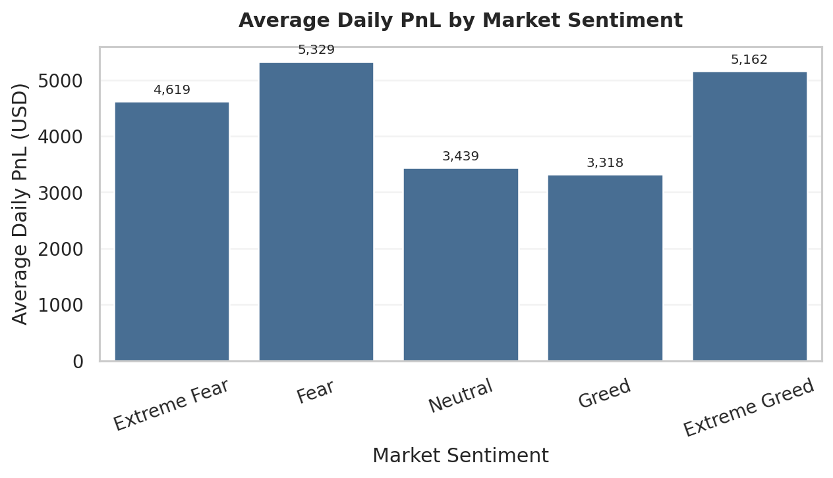

Figure 1. Average Daily PnL by market sentiment.

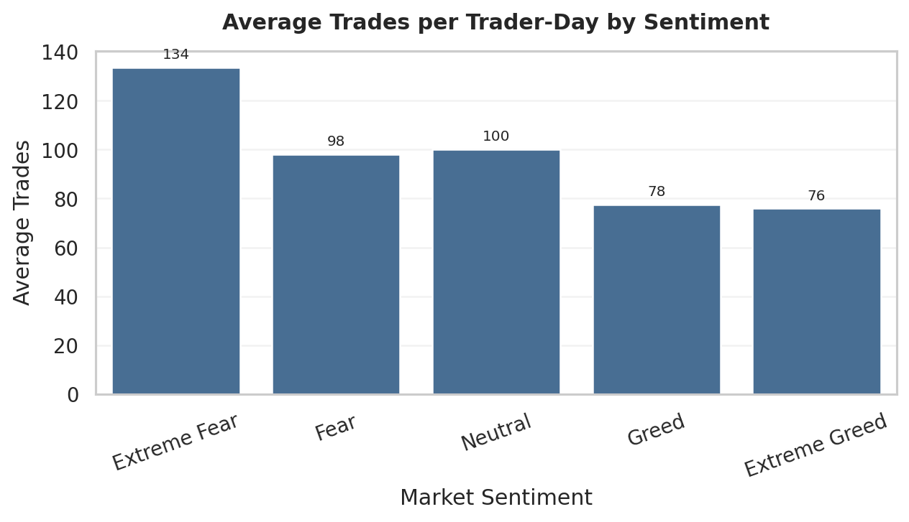

Figure 2. Trading activity by market sentiment.

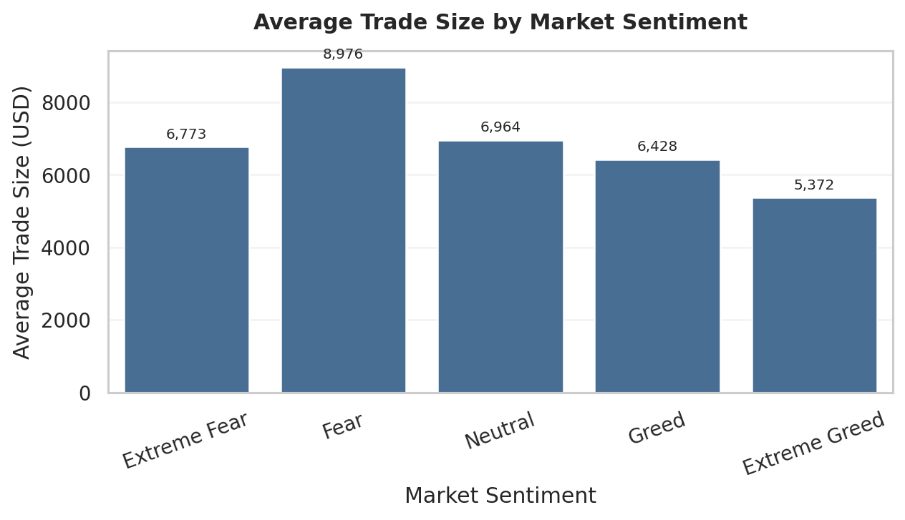

Figure 3. Average trade size by market sentiment.

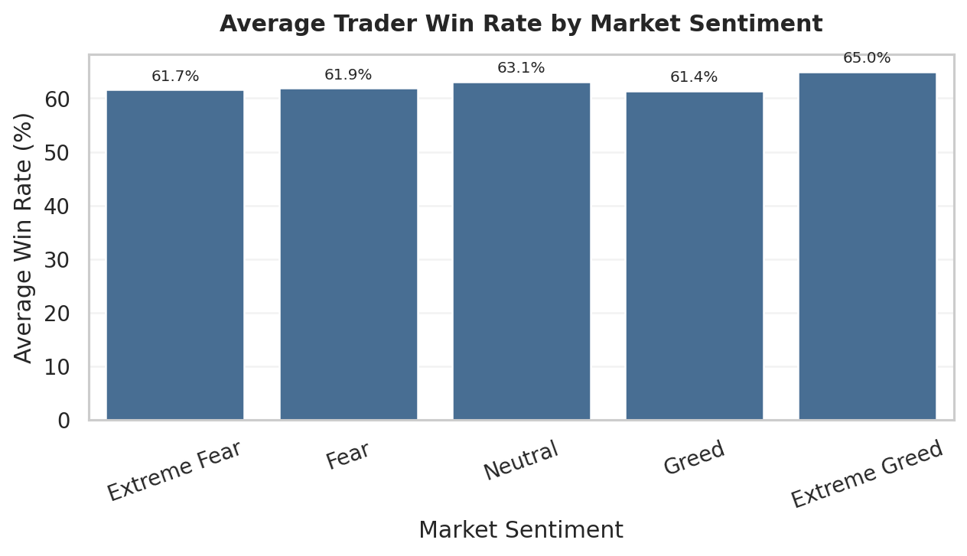

Figure 4. Average trader win rate by market sentiment.

4. Distribution and Correlation Checks
The distribution view was included to avoid relying only on averages. Outliers were hidden in the plot for readability, but not removed from the data. The heatmap checks whether the engineered metrics have strong linear relationships.

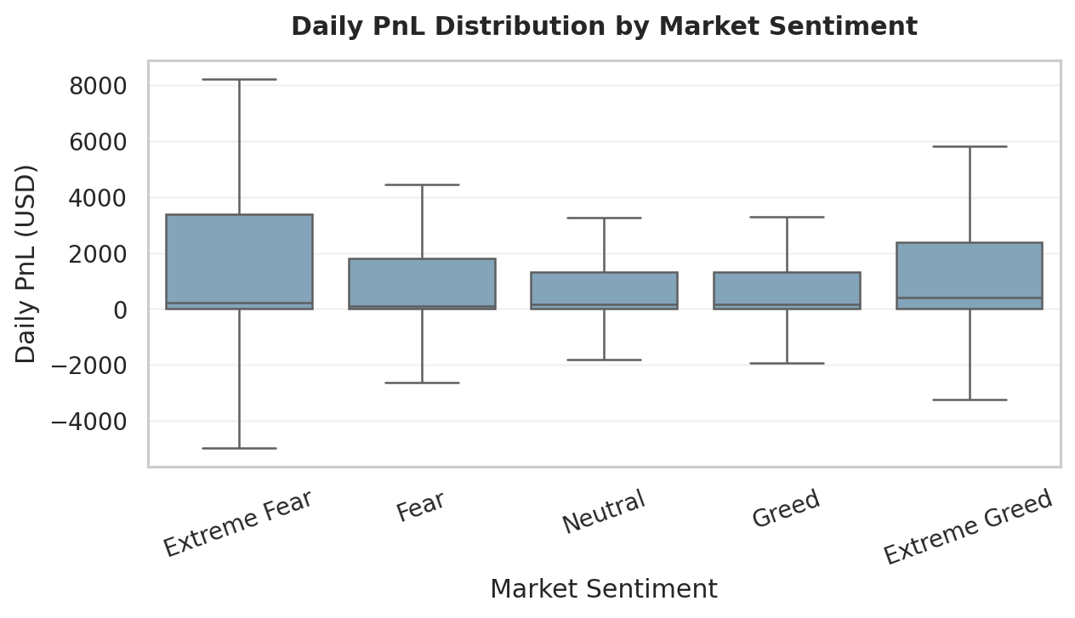

Figure 5. Daily PnL distribution by sentiment, with outliers hidden for readability

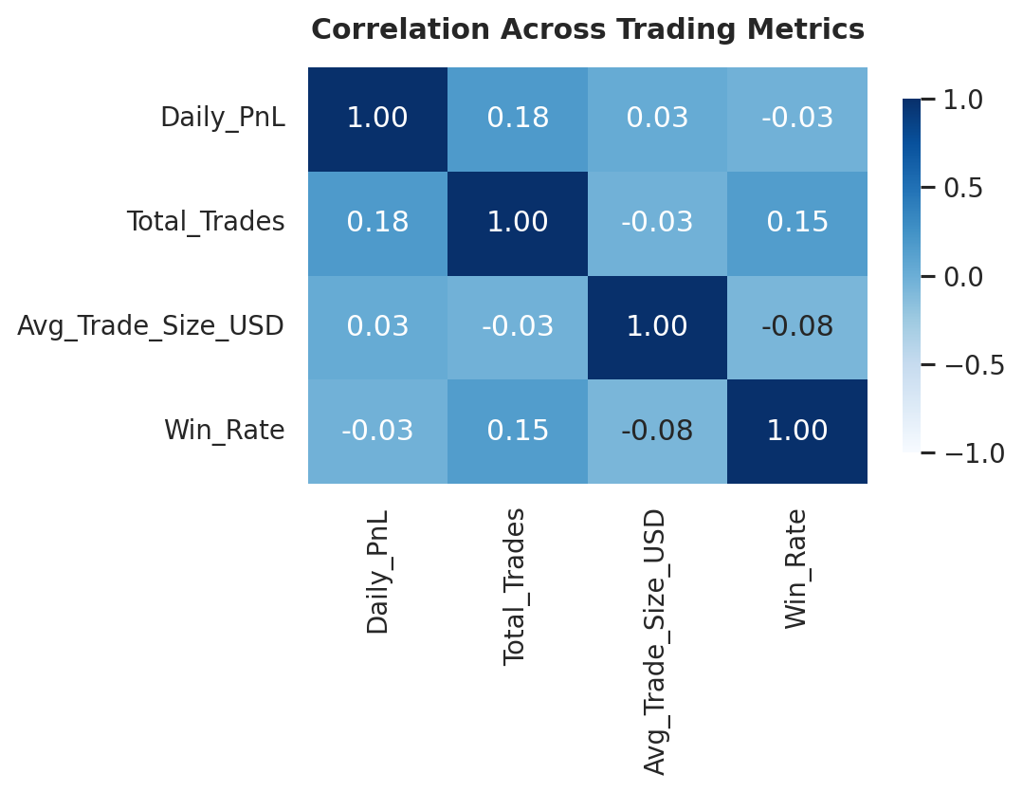

Figure 6. Correlation matrix across the key numerical metrics.

5. Trader Segmentation
Traders were segmented using quartile-based thresholds. This keeps the approach transparent and easy to reproduce without overfitting a small trader population.
Segment | Traders | Avg Daily PnL | Avg Win Rate | Avg Total Trades
High Activity | 8 | $9,401 | 73.9% | 17,769
Low Activity | 8 | $4,491 | 45.4% | 657
Medium Activity | 16 | $7,308 | 53.9% | 3,988
The high-activity group had the highest average daily PnL in this dataset, but the correlation results show that trade count alone is not a reliable explanation for profitability.

6. Key Findings
- Fear days had the highest average daily PnL ($5,329), while Greed days had the lowest average daily PnL among the sentiment categories.
- Extreme Fear showed the highest trading activity, with an average of 133.8 trades per trader-day.
- Average trade size was largest during Fear days ($8,976).
- Average win rates were close across all sentiment groups, indicating that sentiment was more strongly reflected in behavior than in win probability.
- The strongest correlation with Daily PnL was Total Trades (0.18), which is still weak and should not be interpreted as a strong driver.

7. Strategy Recommendations
- Treat Fear periods as high-opportunity but risk-sensitive periods. The data shows stronger average profits and larger trade sizes, so position sizing should be controlled rather than increased blindly.
- Avoid using trade frequency as the sole decision rule. More trades were associated with only a weak improvement in daily PnL, so higher activity should be paired with risk controls.
- Use sentiment as a context feature, not a standalone signal. Win rates were stable across sentiments, so sentiment should be combined with volatility, liquidity, and trader-specific history.
- For high-activity traders, monitor fees and exposure closely. Their performance was stronger on average, but higher activity can also increase transaction costs and downside risk.

8. Limitations
- The dataset did not include an explicit leverage field, so leverage distribution could not be analyzed reliably.
- Closed PnL captures realized profit/loss only; unrealized gains or losses from open positions were not available.
- The analysis is descriptive and does not establish causality between sentiment and trader performance.
- Some extreme PnL values exist; these were retained in calculations but handled carefully in visualizations.

9. Conclusion
The analysis shows that market sentiment is associated with measurable changes in trader behavior. Fear and Extreme Fear periods were linked to larger trade sizes and higher activity, while profitability varied noticeably across sentiment categories. However, win rates and correlations suggest that market sentiment alone is not enough to explain trader success. A practical trading strategy should therefore combine sentiment with trader-specific performance history, volatility, fees, and risk controls.

