Section 1: Variables (15 points)

Question 1.1 (5 points)
Write a script that demonstrates the difference between local and environment variables.

Question 1.2 (5 points)
What will be the output of this script? Explain each line.
#!/bin/bash
echo "Script name: $0"
Displays the script name we are currently running.
Script name: bash

echo "First argument: $1"
Displays the first argument that we pass
First argument: ABC

echo "Number of arguments: $#"
Displays the count of arguments we passed, suppose you pass 2 arguments ram ram
Number of arguments: 2

echo "All arguments: $@"
Displays all the arguments we passed, suppose you pass 2 arguments ram ram
All arguments: ram ram

echo "Process ID: $$"
Displays the process ID of current running shell
Process ID:1234

echo "Exit status of last command: $?"
It will show the exit status of last ran command.
success it will display
Exit status of last command: 0,
Failure it will display
Exit status of last command: 1

Question 1.3 (5 points)
Fix the errors in this script:
#!/bin/bash
user name="Alice"
echo "Welcome $username"
PATH=$path:/new/directory
export path
while we are declaring a variable, we cannot use any special character except under score “_”
we need to update declaring like below
#!/bin/bash
username="Alice"
echo "Welcome $username"
PATH=$path:/new/directory
export path

Section 2: Arrays (15 points)

Question 2.1 (8 points)
Write a script that:
Creates an array with 5 fruit names
fruits=( apple banana orange grapes goa )
Prints all elements
echo ${fruits[@]}
Prints the length of the array
echo ${#fruits[@]}
Adds a new fruit to the array
fruits+=( kiwi )
Prints the third element
echo ${fruits[2]}

Question 2.2 (7 points)
Complete this script to process an array:
#!/bin/bash
numbers=(10 25 30 15 40)
# Write code to:
# 1. Find and print the largest number
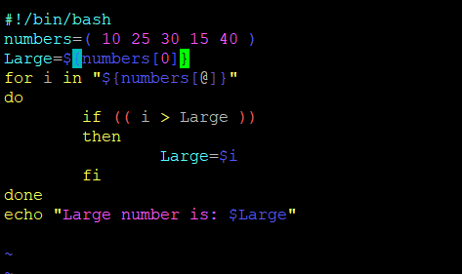
# 2. Calculate and print the sum of all numbers
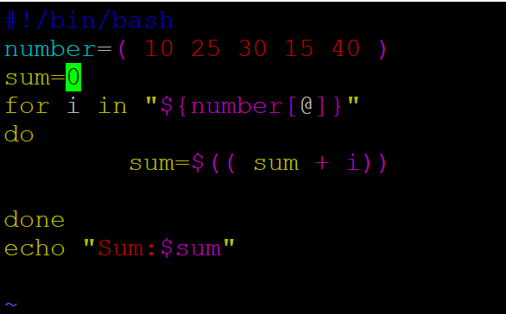
# 3. Print numbers greater than 20
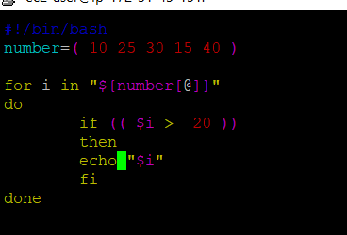

Section 3: I/O Redirections (15 points)
Explain what each command does:
- ls > file.txt
ls lists all the files and the output will be saved in file.txt (It will write if any existing data)
- cat < input.txt
It will take the input from input.txt and it will be displayed
- command 2> error.log
when command fails it will the save the error displayed as error into error.log file
d) ls >> file.txt
ls lists all the files and the output will be saved in file.txt(It will append the data to the file along with existing data)
- command &> output.txt
it will save the output and error into a single file output.txt

Question 3.2 (5 points)
Write a command that:
Lists all files in /etc directory
ll -a /etc/
Saves successful output to success.log
ll -a /etc/ > success.txt
Saves errors to error.log
ll ---a /etc/ 2> error.log

Does both redirections in a single command
ll -a /etc/ &> both.txt

Question 3.3 (5 points)
What's wrong with this script? Fix it.
#!/bin/bash
echo "Enter your name: "
read name < /dev/stdin
echo "Hello $name" > output.txt
cat output.txt >> output.txt

Redirecting output to the same file from the same file is not possible because it will be already opened by cat command and when we redirect out it will truncate the pointer for cat command and it will read an empty file

Section 4: Loops (20 points)

Question 4.1 (7 points)
Write a for loop that prints numbers from 1 to 10 but skips 5 and stops if it encounters 8.
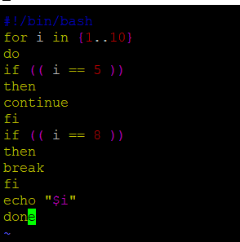

Question 4.2 (7 points)
Write a while loop to read a file line by line and print "Line X: [content]" for each line.
X – is the number of the line.
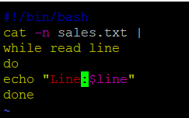

Question 4.3 (6 points)
Write a script using a loop that:
Asks user to enter numbers
Continues until user enters 'quit'
Calculates the average of entered numbers
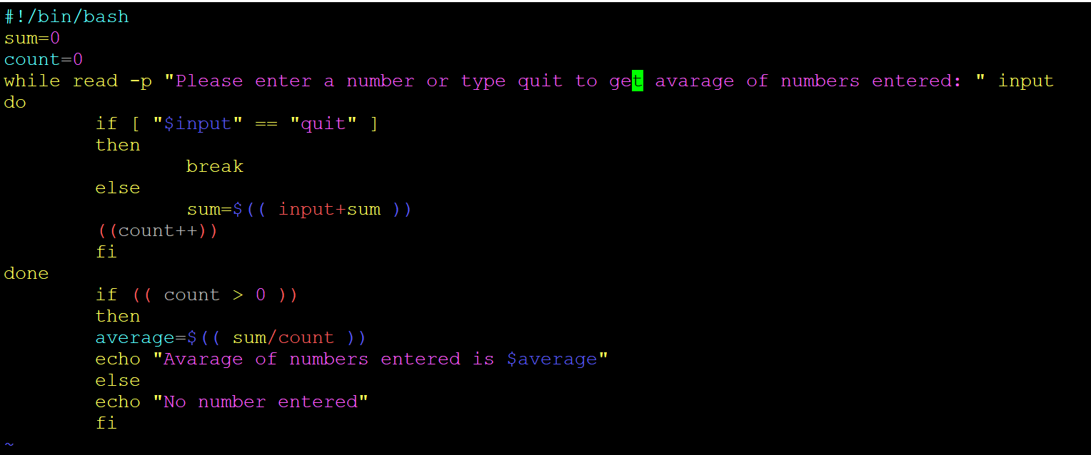

Section 5: Functions (15 points)

Question 5.1 (8 points)
Write a function called calculator that:
- Takes three parameters: number1, operation (+,-,*,/), number2
- Performs the calculation
- Returns the result
- Include error handling for division by zero

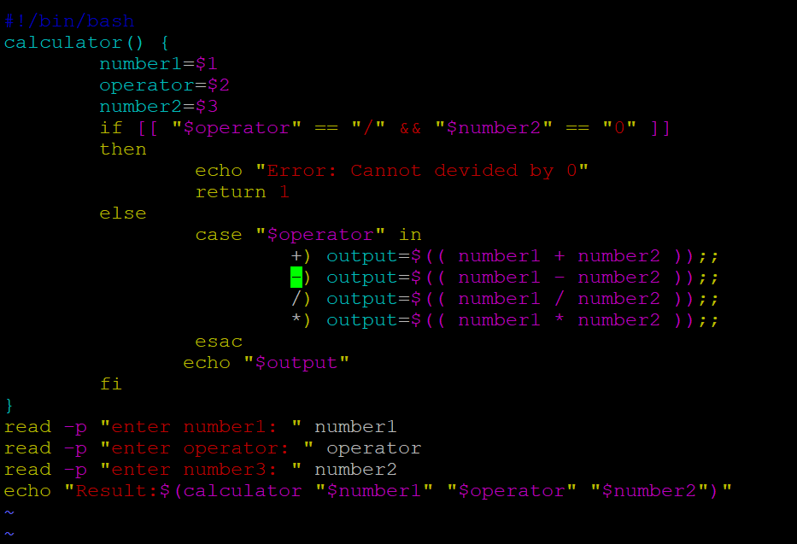

Question 5.2 (7 points)

What's the output of this script? Explain the scope of variables.
#!/bin/bash
global_var="I am global"

function test_function() {
local local_var="I am local"
global_var="Modified global"
echo "Inside function: $local_var"
echo "Inside function: $global_var"
}

echo "Before function: $global_var"
test_function
echo "After function: $global_var"
echo "Outside function: $local_var"

Section 6: Text Processing (grep/sed/cut/awk) (15 points)

Given this sample file employees.txt:
John,Developer,50000,IT
Alice,Manager,75000,IT
Bob,Analyst,45000,Finance
Carol,Developer,55000,IT
David,Manager,80000,Finance

Question 6.1 (4 points)
Write commands using cut to:
- Extract only names (first column)
- Extract salary and department (3rd and 4th columns)

Question 6.2 (4 points)
Write grep commands to:
- Find all IT department employees
- Find all employees with salary > 50000 (use grep with regex)

Question 6.3 (4 points)
Write sed commands to:
- Replace all "IT" with "Technology"
- Delete all Manager entries

Question 6.4 (3 points)
Write an awk command to:
- Calculate and print the average salary
- Count employees by department

Section 7: Operators (5 points)

Question 7.1 (5 points)

Complete this script that uses different operators:
#!/bin/bash
read -p "Enter first number: " num1
read -p "Enter second number: " num2

# Use arithmetic operators to calculate and print:
# Addition, Subtraction, Multiplication, Division, Modulus

# Use comparison operators to check:
# If num1 is greater than num2
# If numbers are equal

# Use logical operators to check:
# If both numbers are positive
# If at least one number is even

Scoring Guidelines:
- Syntax correctness: 40% of each question
- Logic correctness: 40% of each question
- Best practices: 20% of each question

