**Applied Data Science**

**Air Quality Analysis and Prediction in Tamil Nadu**

|  |  |
| --- | --- |
| **DOMAIN:** | **Applied Data Science** |
| **PROJECT TITLE:** | **Air Quality Analysis and Prediction in Tamil Nadu** |
| **TEAM MEMBERS AND REGISTER NUMBER:** | **1.GIRIPRASATH S - 420421104020**  **2.GUGAN M - 420421104024**  **3.HEMANTH RAO BK - 420421104027**  **4.JANAKIRAMAN S - 420421104029** |

**Introduction:**

Air quality analysis and prediction in Tamil Nadu is a critical area of research and environmental monitoring aimed at assessing the quality of the air in this Indian state and forecasting future air quality conditions. This is essential because air quality has a profound impact on public health, the environment, and overall quality of life. In Tamil Nadu, like many other regions, factors such as industrialization, urbanization, vehicular emissions, and agricultural practices can contribute to air pollution and its associated health and environmental effects.

# Project Objectives:

The project’s objective was to analyze air quality in Tamil Nadu by examining historical data, with a focus on SO2, NO2, and RSPM/PM10 levels. We implemented data preprocessing, visualization, and linear regression modeling. Example outputs include time series plots and predictive models.

This analysis offers insights into trends, showing fluctuations in pollutant levels over time. The code aids in estimating air quality, providing valuable information for understanding and managing pollution in Tamil Nadu.

**DESIGN THINKING:**

Project Objectives: Define objectives such as analyzing air quality trends, identifying pollution hotspots, and building a predictive model for RSPM/PM10 levels.Analysis Approach: Plan the steps to load, preprocess, analyze, and visualize the air quality data.Visualization Selection: Determine visualization techniques (e.g., line charts, heatmaps) to effectively represent air quality trends and pollution levels.

**1. Data Collection:**

a. Air Quality Data: Obtain historical air quality data for different locations in

Tamil Nadu. This data should include parameters such as PM2.5, PM10, NO2,

SO2, CO, O3, and AQI (Air Quality Index).

b. Meteorological Data: Collect meteorological data, including temperature,

humidity, wind speed, and wind direction. These factors can influence air

quality.

c. Geographical Data: Gather information about the geography of Tamil Nadu,

including topography, land use, and urbanization levels, as these can impact air

quality.

d. Emission Sources: Identify major sources of air pollution in the region, such

as industries, vehicular emissions, and agricultural practices.

**2. Data Preprocessing:**

a. Data Cleaning: Clean and preprocess the collected data by handling missing values, outliers, and inconsistent data.

b. Feature Engineering: Create additional features if necessary, such as time of

day, day of the week, or holidays, which may affect air quality.

c. Data Integration: Combine air quality, meteorological, and geographical data

for a comprehensive analysis.

**3. Exploratory Data Analysis (EDA):**

a. Conduct EDA to understand the distribution and patterns in the data.

b. Visualize the data using graphs and maps to identify trends and correlations.

**4. Modeling:**

a. Time Series Analysis: Since air quality data is often time-dependent, consider

time series analysis techniques such as ARIMA or LSTM (Long Short-Term

Memory) neural networks for predicting future air quality.

b. Regression Analysis: Use regression models to analyze the relationships

between air quality parameters and meteorological or geographical variables.

c. Machine Learning: Implement machine learning models like Random Forest,

Gradient Boosting, or Support Vector Machines for prediction and classification

tasks, such as forecasting AQI levels or identifying air quality trends.

**5. Model Evaluation:**

a. Split the data into training and testing sets to evaluate model performance.

b. Use appropriate metrics like Mean Absolute Error (MAE), Root Mean

Squared Error (RMSE), or R-squared for regression models. For classification

tasks, use accuracy, precision, recall, and F1-score.

**6. Visualization:**

a. Create visualizations such as time series plots, heatmaps, and geographical

maps to present the results effectively.

**7. Air Quality Prediction:**

a. Develop a predictive model that takes meteorological and geographical data

as input and provides air quality predictions as output.

b. Use real-time meteorological data to continuously update and improve the

predictions.

**8. Communication:**

a. Communicate the findings and predictions to relevant stakeholders,

including government agencies, environmental organizations, and the public.

b. Create a user-friendly dashboard or website to provide real-time air quality

information and forecasts.

**9. Mitigation Strategies:**

a. Use the insights from the analysis to suggest mitigation strategies to reduce

air pollution in the region. This could include stricter regulations, public

awareness campaigns, or green infrastructure development.

**10. Monitoring and Feedback:**

a. Continuously monitor air quality and compare predictions with actual

measurements to improve the accuracy of the models.

b. Collect feedback from users and stakeholders to make necessary

improvements to the system.

Remember that solving air quality problems is a complex task that requires

ongoing effort and collaboration with various stakeholders. Additionally,

staying updated with the latest research and technologies in the field of air

quality monitoring and prediction is essential for making progress in this area.

**PHASE OF DEVELOPMENT:**

**DETAILED COMPREHENSION OF THE PROBLEM STATEMENT**

Air quality analysis and prediction in Tamil Nadu is critical to addressing the region's air pollution challenges and protecting public health. Here's an overview of the strategies and approaches that can be employed for effective air quality analysis and prediction in Tamil Nadu:

1. **Air Quality Monitoring Stations**: Establish a comprehensive network of air quality monitoring stations across Tamil Nadu. These stations should measure key air pollutants such as particulate matter (PM2.5 and PM10), nitrogen dioxide (NO2), sulfur dioxide (SO2), carbon monoxide (CO), ozone (O3), and volatile organic compounds (VOCs). Real-time data from these stations should be made accessible to the public.
2. **Data Quality and Accuracy**: Ensure that monitoring equipment is well-maintained and calibrated regularly to maintain data accuracy. Quality control measures should be in place to verify the reliability of collected data.
3. **Satellite Data Integration**: Incorporate satellite data, including remote sensing and satellite imagery, to complement ground-based monitoring. Satellite technology can provide valuable information on air quality over larger areas and help identify pollution sources.
4. **Air Quality Index (AQI) Calculation**: Calculate and report the Air Quality Index (AQI) based on the measured pollutant concentrations. The AQI provides an easily understandable assessment of air quality and its associated health risks.
5. **Data Visualization**: Develop user-friendly interfaces and apps that visualize air quality data in real-time. Provide color-coded maps and charts that allow residents to easily understand air quality conditions in their area.
6. **Air Quality Forecasting**: Implement air quality forecasting models that use historical data, meteorological information, and pollutant emission data to predict future air quality conditions. These forecasts can help residents plan outdoor activities and take preventive measures during periods of poor air quality.
7. **Meteorological Integration**: Integrate meteorological data into air quality forecasting models. Weather conditions play a significant role in pollutant dispersion and concentration, so accurate meteorological data is essential for reliable predictions.
8. **Public Alerts and Communication**: Establish a robust system for issuing air quality alerts and advisories to the public through various communication channels, including SMS, mobile apps, and social media. Provide guidance on protective measures during poor air quality episodes.
9. **Pollution Source Identification**: Utilize advanced modeling techniques to identify and track pollution sources. This can aid regulatory agencies in targeting enforcement actions and policy interventions.
10. **Research and Development**: Encourage research and development in the field of air quality analysis and prediction. Collaborate with universities and research institutions to continuously improve modeling techniques and data analysis methods.
11. **Policy and Regulation**: Implement and enforce air quality regulations that limit emissions from industries, vehicles, and other pollution sources. Regularly update and strengthen these regulations to keep pace with changing pollution patterns.
12. **Public Awareness and Education:** Conduct public awareness campaigns on the health impacts of air pollution and the importance of individual actions in reducing pollution. Educate citizens on how to interpret air quality data and take protective measures.
13. **Cross-State Collaboration:** Collaborate with neighboring states to address regional air quality issues, as pollution often travels across borders.
14. **Green Initiatives:** Promote green and sustainable practices, including the use of electric vehicles, renewable energy sources, and urban green spaces, to reduce pollution and improve air quality.
15. **Analysis:**

**STEPS TO BE FOLLOWED FOR THE ANALYSIS**

**STEP 1** - Collect the dataset of TN AIR QUALITY ANALYSIS. We have collected it from

<https://tn.data.gov.in/resource/location-wise-daily-ambient-air-quality-tamil-nadu-year-2014>

**STEP 2** - Preprocess the data and transform it according to the analysis

**STEP 3** - Remove the outliers, null values and other error data

**STEP 4** - Fit the preprocessed data into a model for predictions

**STEP 5** - Find the prediction score using r2_score, accuracy_score

**STEP 6** - Use the preprocessed data for visualizations and other summarization of data given

**STEP 7** - Derive the insights from the visualizations made and make it as a report

1. **The analysis of air quality data in Tamil Nadu offers valuable in- sights into air pollution trends and pollution levels in the region in the following ways Analysis:**

**Temporal Trends:**

By visualizing time series data for pollutants like SO2, NO2, and RSPM/PM10, the analysis reveals how pollution levels change over time. Patterns, fluctuations, and long-term trends become apparent, aiding in understanding the impact of various factors on air quality.

**Spatial Variations:**

Heatmaps and location-based visualizations show variations in pollutant levels across different monitoring stations in Tamil Nadu. This helps identify areas with consistently high or low pollution, which can inform policy decisions and resource allocation.

**Statistical Summaries:**

Summary statistics and box plots provide a comprehensive view of the distribution of pollutant concentrations. Mean, median, and standard deviation values, as well as potential outliers, offer insights into the central tendency and variability of air pollution levels.

**Regression Modeling:**

The linear regression model for estimating RSPM/PM10 levels based on SO2 and NO2 concentrations allows us to make predictions and understand how these key pollutants contribute to particulate matter in the air. This can be crucial for pollution control efforts.

Overall, the analysis enables stakeholders, policymakers, and researchers to gain a deeper under- standing of air pollution trends in Tamil Nadu. This understanding can drive informed decisions and interventions to improve air quality, protect public health, and mitigate environmental impacts.

[ ]:

**import pandas as pd**

**import matplotlib.pyplot as plt**

[ ]:

*# Assuming your data is in a CSV file*

data = pd.read_csv('/content/cpcb_dly_aq_tamil_nadu-2014 (1).csv')

[ ]:

# Data Preprocessing:

# We cleaned and structured the air quality dataset, handling missing values and data format conversions.

*# Display basic statistics*

print(data.describe())

*# Check for missing values*

print(data.isnull().sum())

*# Check unique values in categorical columns* print(data['State'].unique()) print(data['City/Town/Village/Area'].unique()) *# ... Repeat for other categorical columns*

|  |  |  |  |  |  |  |
| --- | --- | --- | --- | --- | --- | --- |
|  | Stn Code | SO2 | NO2 | RSPM/PM10 | PM | 2.5 |
| count | 2879.000000 | 2868.000000 | 2866.000000 | 2875.000000 |  | 0.0 |
| mean | 475.750261 | 11.503138 | 22.136776 | 62.494261 |  | NaN |
| std | 277.675577 | 5.051702 | 7.128694 | 31.368745 |  | NaN |
| min | 38.000000 | 2.000000 | 5.000000 | 12.000000 |  | NaN |
| 25% | 238.000000 | 8.000000 | 17.000000 | 41.000000 |  | NaN |
| 50% | 366.000000 | 12.000000 | 22.000000 | 55.000000 |  | NaN |
| 75% | 764.000000 | 15.000000 | 25.000000 | 78.000000 |  | NaN |
| max | 773.000000 | 49.000000 | 71.000000 | 269.000000 |  | NaN |

Stn Code 0

Sampling Date 0

State 0

City/Town/Village/Area 0

Location of Monitoring Station 0

Agency 0

Type of Location 0

SO2 11

NO2 13

RSPM/PM10 4

PM 2.5 2879

dtype: int64 ['Tamil Nadu']

['Chennai' 'Coimbatore' 'Cuddalore' 'Madurai' 'Mettur' 'Salem' 'Thoothukudi' 'Trichy']

[ ]:

**import matplotlib.pyplot as plt**

*# Plot a line chart for RSPM/PM10 levels over time*

plt.figure(figsize=(22,12))

plt.plot(data.index, data['RSPM/PM10'], marker='o', linestyle='-', color='b',␣

↪label='RSPM/PM10')

plt.xlabel('Date') plt.ylabel('RSPM/PM10 Levels')

plt.title('Trends in RSPM/PM10 Pollution Levels Over Time') plt.grid(**True**)

plt.legend() plt.show()

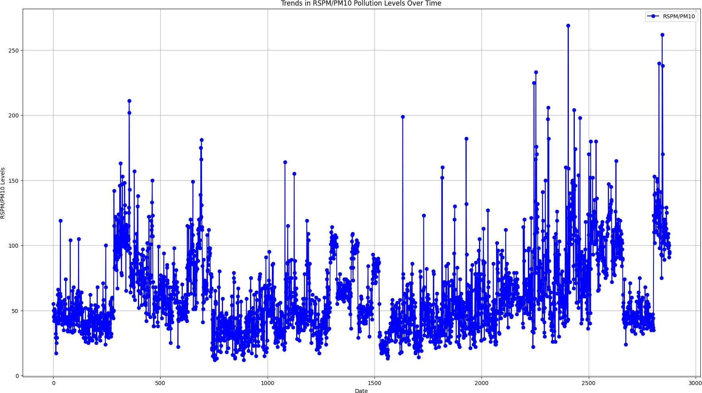

[ ]:

# Groups the air quality data by date

1. **Calculates the mean values for SO2, NO2, and RSPM/PM10, and plots the daily average air quality in Tamil Nadu. The line chart provides a clear visualization of how these pollutant concentrations vary over time, aiding in understanding daily air quality trends and fluctuations.**

*# Group data by date and calculate mean values*

daily_mean = data.groupby('Sampling Date').mean()

*# Plot daily average air quality*

plt.figure(figsize=(12, 6))

plt.plot(daily_mean.index, daily_mean['SO2'], label='Mean SO2') plt.plot(daily_mean.index, daily_mean['NO2'], label='Mean NO2') plt.plot(daily_mean.index, daily_mean['RSPM/PM10'], label='Mean RSPM/PM10') plt.xlabel('Sampling Date')

plt.ylabel('Mean Concentration')

plt.title('Daily Average Air Quality in Tamil Nadu') plt.legend()

plt.grid(**True**) plt.show()

<ipython-input-5-4b27baf3318f>:2: FutureWarning: The default value of numeric_only in DataFrameGroupBy.mean is deprecated. In a future version, numeric_only will default to False. Either specify numeric_only or select only columns which should be valid for the function.

daily_mean = data.groupby('Sampling Date').mean()

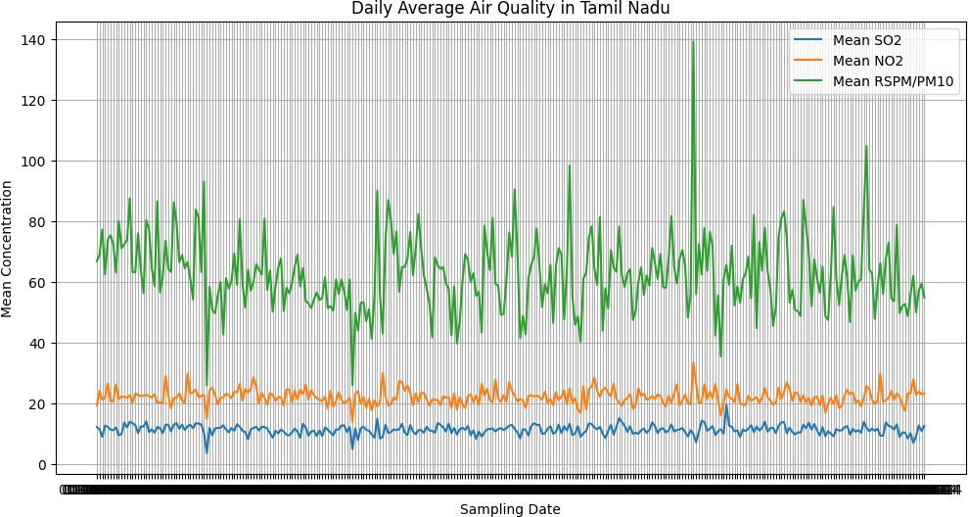

# Concentrations of Sulfur Dioxide (SO2) and Nitrogen Dioxide (NO2)

#Calculates the daily average concentrations of Sulfur Dioxide (SO2) and Nitrogen Dioxide (NO2) in Tamil Nadu. The resulting line chart provides insights into how these pollutants’ levels change over time. It aids in visualizing and understanding the variations in SO2 and NO2 concentrations, essential for monitoring air quality in the region.

[ ]:

*# Calculate daily average SO2 and NO2 concentrations for all monitoring stations*

daily_mean = data.groupby('Sampling Date')[['SO2', 'NO2']].mean()

*# Plot daily average SO2 and NO2 concentrations*

plt.figure(figsize=(12, 6))

plt.plot(daily_mean.index, daily_mean['SO2'], label='Mean SO2 Concentration') plt.plot(daily_mean.index, daily_mean['NO2'], label='Mean NO2 Concentration') plt.xlabel('Sampling Date')

plt.ylabel('Mean Concentration (µg/m³)') *# Units may vary based on your data* plt.title('Daily Average SO2 and NO2 Concentrations in Tamil Nadu') plt.legend()

plt.grid(**True**) plt.show()

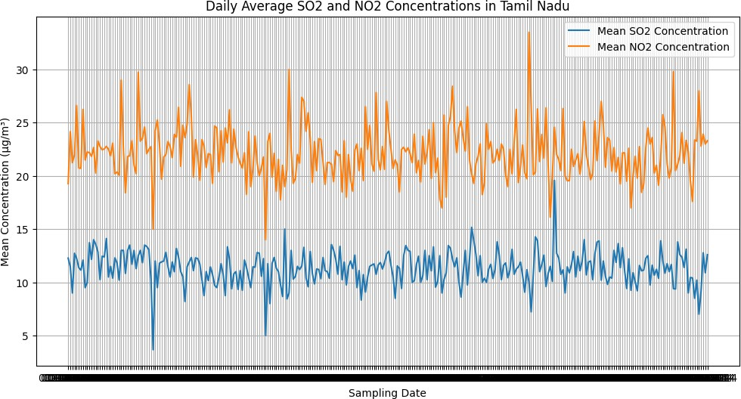

[ ]:

# Displays statistics for Sulfur Dioxide (SO2) and Nitrogen Diox- ide (NO2) concentrations

# computes and displays statistics for Sulfur Dioxide (SO2) and Nitrogen Dioxide (NO2) concentra- tions. It generates two box plots, one for SO2 and the other for NO2. These plots help visualize the distribution of concentration values, showing the central tendency, spread, and potential outliers in the data, aiding in the identification of extreme values and data variability.

*# Summary statistics*

so2_stats = data['SO2'].describe() no2_stats = data['NO2'].describe()

*# Box plots to visualize the distribution and identify outliers*

plt.figure(figsize=(12, 6))

plt.subplot(1, 2, 1) data.boxplot(column='SO2') plt.title('SO2 Concentration Box Plot')

plt.subplot(1, 2, 2) data.boxplot(column='NO2') plt.title('NO2 Concentration Box Plot')

plt.tight_layout() plt.show()

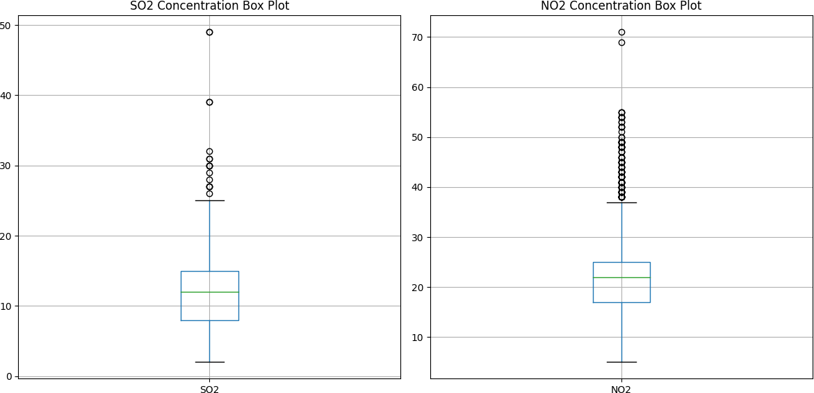

[ ]:

*# Summary statistics*

rspm_pm10_stats = data['RSPM/PM10'].describe()

*# Box plot to visualize the distribution and identify outliers*

plt.figure(figsize=(6, 6)) data.boxplot(column='RSPM/PM10') plt.title('RSPM/PM10 Concentration Box Plot')

plt.ylabel('Concentration (µg/m³)') *# Units may vary based on your data*

plt.grid(**True**) plt.show()

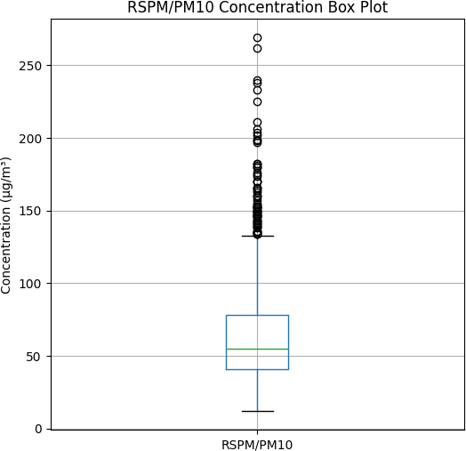

[ ]:

**import seaborn as sns**

*# Preprocess the data*

*# - Convert the 'Sampling Date' column to datetime format* data['Sampling Date'] = pd.to_datetime(data['Sampling Date']) *# - Filter data for Tamil Nadu*

tn_data = data[data['State'] == 'Tamil Nadu']

*# Visualize trends in air pollution over time*

plt.figure(figsize=(12, 6))

*# Plot time series of SO2, NO2, and RSPM/PM10 concentrations*

**for** pollutant **in** ['SO2', 'NO2', 'RSPM/PM10']:

sns.lineplot(data=tn_data, x='Sampling Date', y=pollutant, label=pollutant)

plt.xlabel('Year')

plt.ylabel('Concentration (µg/m³)') plt.title('Air Pollution Trends in Tamil Nadu') plt.legend()

plt.grid(**True**) plt.show()

<ipython-input-9-8fdd52923255>:5: UserWarning: Parsing dates in DD/MM/YYYY format when dayfirst=False (the default) was specified. This may lead to inconsistently parsed dates! Specify a format to ensure consistent parsing.

data['Sampling Date'] = pd.to_datetime(data['Sampling Date'])

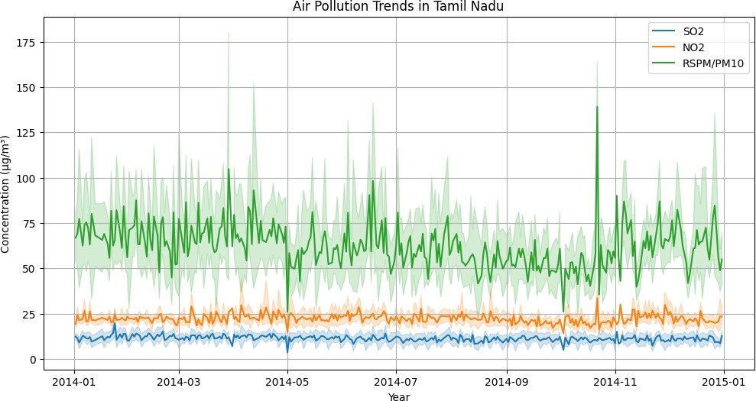

[ ]:

**import matplotlib.pyplot as plt**

avg_so2_no2_by_location = data.groupby('City/Town/Village/Area')[['SO2',␣

↪'NO2']].mean().reset_index()

*# Create a bar chart for average SO2 levels by location* plt.figure(figsize=(12, 6)) plt.bar(avg_so2_no2_by_location['City/Town/Village/Area'],␣

↪avg_so2_no2_by_location['SO2'], label='Average SO2 Levels', alpha=0.7,␣

↪color='b')

# Data Visualization:

1. **We used Matplotlib and Seaborn to create visualizations such as time series plots to explore pollutant trends.**

*# Create a bar chart for average NO2 levels by location*

plt.bar(avg_so2_no2_by_location['City/Town/Village/Area'],␣

↪avg_so2_no2_by_location['NO2'], label='Average NO2 Levels', alpha=0.7,␣

↪color='b')

plt.xlabel('Location') plt.ylabel('Average Levels')

plt.title('Average SO2 and NO2 Levels by Location') plt.xticks(rotation=90) *# Rotate x-axis labels for better readability* plt.legend()

plt.tight_layout() plt.show()

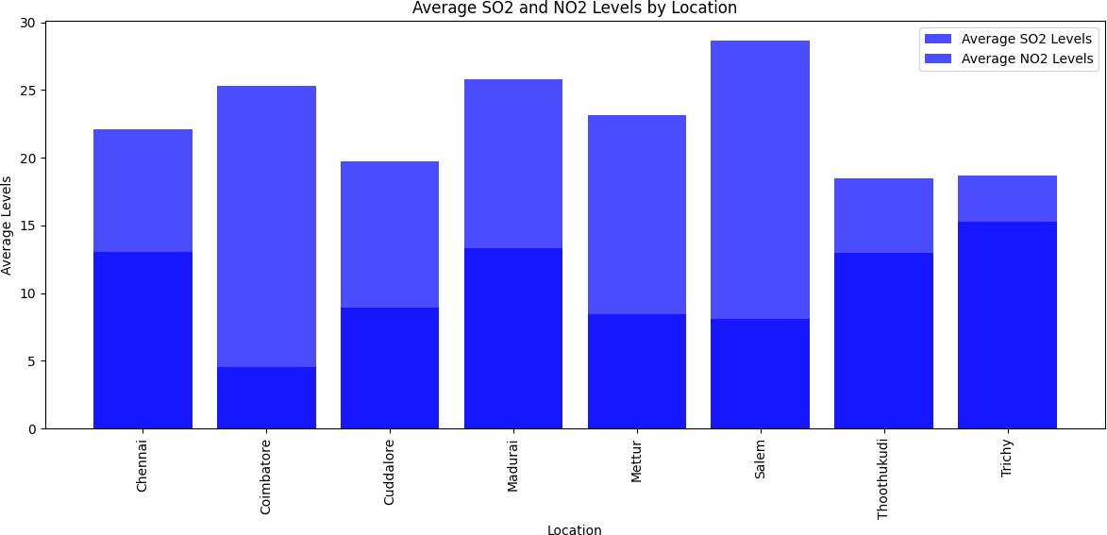

[ ]:

**from sklearn.model_selection import** train_test_split

**from sklearn.linear_model import** LinearRegression

**from sklearn.metrics import** mean_squared_error, r2_score

*# Preprocess the data and select relevant columns* data['Sampling Date'] = pd.to_datetime(data['Sampling Date']) tn_data = data[data['State'] == 'Tamil Nadu'] selected_columns = ['SO2', 'NO2', 'RSPM/PM10']

tn_data = tn_data[selected_columns].dropna() *# Remove rows with missing values*

*# Split the data into training and testing sets*

X = tn_data[['SO2', 'NO2']]

y = tn_data['RSPM/PM10']

X_train, X_test, y_train, y_test = train_test_split(X, y, test_size=0.2,␣

↪random_state=42)

*# Create and train a linear regression model* model = LinearRegression() model.fit(X_train, y_train)

*# Make predictions on the test set*

y_pred = model.predict(X_test)

*# Evaluate the model*

mse = mean_squared_error(y_test, y_pred) r2 = r2_score(y_test, y_pred)

print(f'Mean Squared Error: **{**mse**}**')

print(f'R-squared (Coefficient of Determination): **{**r2**}**')

*# Plot the predicted vs. actual values* plt.figure(figsize=(8, 8)) plt.scatter(y_test, y_pred) plt.xlabel('Actual RSPM/PM10 Levels') plt.ylabel('Predicted RSPM/PM10 Levels')

plt.title('Actual vs. Predicted RSPM/PM10 Levels') plt.grid(**True**)

plt.show()

Mean Squared Error: 835.4788249190386

R-squared (Coefficient of Determination): 0.20658507746336507

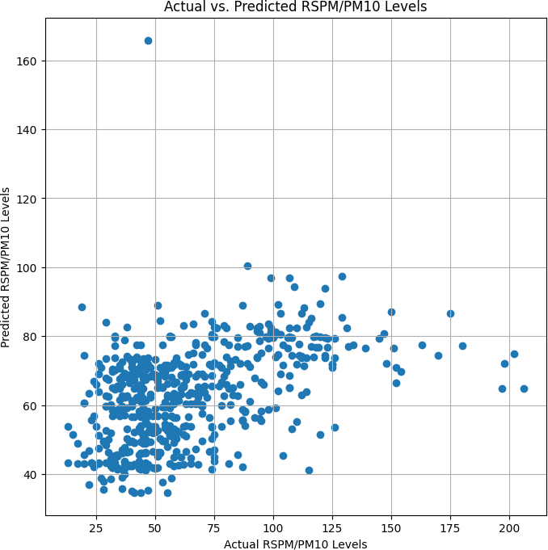

[ ]:

!pip install folium geopandas

Requirement already satisfied: folium in /usr/local/lib/python3.10/dist-packages (0.14.0)

Requirement already satisfied: geopandas in /usr/local/lib/python3.10/dist- packages (0.13.2)

Requirement already satisfied: branca>=0.6.0 in /usr/local/lib/python3.10/dist- packages (from folium) (0.6.0)

Requirement already satisfied: jinja2>=2.9 in /usr/local/lib/python3.10/dist- packages (from folium) (3.1.2)

Requirement already satisfied: numpy in /usr/local/lib/python3.10/dist-packages (from folium) (1.23.5)

Requirement already satisfied: requests in /usr/local/lib/python3.10/dist-

[ ]:

packages (from folium) (2.31.0)

Requirement already satisfied: fiona>=1.8.19 in /usr/local/lib/python3.10/dist- packages (from geopandas) (1.9.5)

Requirement already satisfied: packaging in /usr/local/lib/python3.10/dist- packages (from geopandas) (23.2)

Requirement already satisfied: pandas>=1.1.0 in /usr/local/lib/python3.10/dist- packages (from geopandas) (1.5.3)

Requirement already satisfied: pyproj>=3.0.1 in /usr/local/lib/python3.10/dist- packages (from geopandas) (3.6.1)

Requirement already satisfied: shapely>=1.7.1 in /usr/local/lib/python3.10/dist- packages (from geopandas) (2.0.2)

Requirement already satisfied: attrs>=19.2.0 in /usr/local/lib/python3.10/dist- packages (from fiona>=1.8.19->geopandas) (23.1.0)

Requirement already satisfied: certifi in /usr/local/lib/python3.10/dist- packages (from fiona>=1.8.19->geopandas) (2023.7.22)

Requirement already satisfied: click~=8.0 in /usr/local/lib/python3.10/dist- packages (from fiona>=1.8.19->geopandas) (8.1.7)

Requirement already satisfied: click-plugins>=1.0 in

/usr/local/lib/python3.10/dist-packages (from fiona>=1.8.19->geopandas) (1.1.1) Requirement already satisfied: cligj>=0.5 in /usr/local/lib/python3.10/dist- packages (from fiona>=1.8.19->geopandas) (0.7.2)

Requirement already satisfied: six in /usr/local/lib/python3.10/dist-packages (from fiona>=1.8.19->geopandas) (1.16.0)

Requirement already satisfied: setuptools in /usr/local/lib/python3.10/dist- packages (from fiona>=1.8.19->geopandas) (67.7.2)

Requirement already satisfied: MarkupSafe>=2.0 in

/usr/local/lib/python3.10/dist-packages (from jinja2>=2.9->folium) (2.1.3) Requirement already satisfied: python-dateutil>=2.8.1 in

/usr/local/lib/python3.10/dist-packages (from pandas>=1.1.0->geopandas) (2.8.2) Requirement already satisfied: pytz>=2020.1 in /usr/local/lib/python3.10/dist- packages (from pandas>=1.1.0->geopandas) (2023.3.post1)

Requirement already satisfied: charset-normalizer<4,>=2 in

/usr/local/lib/python3.10/dist-packages (from requests->folium) (3.3.1) Requirement already satisfied: idna<4,>=2.5 in /usr/local/lib/python3.10/dist- packages (from requests->folium) (3.4)

Requirement already satisfied: urllib3<3,>=1.21.1 in

/usr/local/lib/python3.10/dist-packages (from requests->folium) (2.0.7)

!pip install gmaps

Collecting gmaps

Downloading gmaps-0.9.0.tar.gz (1.1 MB)

1.1/1.1 MB

8.2 MB/s eta 0:00:00

Preparing metadata (setup.py) … done

Requirement already satisfied: ipython>=5.3.0 in /usr/local/lib/python3.10/dist- packages (from gmaps) (7.34.0)

Requirement already satisfied: ipywidgets>=7.0.0 in

/usr/local/lib/python3.10/dist-packages (from gmaps) (7.7.1) Requirement already satisfied: traitlets>=4.3.0 in

/usr/local/lib/python3.10/dist-packages (from gmaps) (5.7.1) Collecting geojson>=2.0.0 (from gmaps)

Downloading geojson-3.0.1-py3-none-any.whl (15 kB)

Requirement already satisfied: six in /usr/local/lib/python3.10/dist-packages (from gmaps) (1.16.0)

Requirement already satisfied: setuptools>=18.5 in

/usr/local/lib/python3.10/dist-packages (from ipython>=5.3.0->gmaps) (67.7.2) Collecting jedi>=0.16 (from ipython>=5.3.0->gmaps)

Downloading jedi-0.19.1-py2.py3-none-any.whl (1.6 MB)

1.6/1.6 MB

46.0 MB/s eta 0:00:00

Requirement already satisfied: decorator in

/usr/local/lib/python3.10/dist-packages (from ipython>=5.3.0->gmaps) (4.4.2) Requirement already satisfied: pickleshare in /usr/local/lib/python3.10/dist- packages (from ipython>=5.3.0->gmaps) (0.7.5)

Requirement already satisfied: prompt-toolkit!=3.0.0,!=3.0.1,<3.1.0,>=2.0.0 in

/usr/local/lib/python3.10/dist-packages (from ipython>=5.3.0->gmaps) (3.0.39) Requirement already satisfied: pygments in /usr/local/lib/python3.10/dist- packages (from ipython>=5.3.0->gmaps) (2.16.1)

Requirement already satisfied: backcall in /usr/local/lib/python3.10/dist- packages (from ipython>=5.3.0->gmaps) (0.2.0)

Requirement already satisfied: matplotlib-inline in

/usr/local/lib/python3.10/dist-packages (from ipython>=5.3.0->gmaps) (0.1.6) Requirement already satisfied: pexpect>4.3 in /usr/local/lib/python3.10/dist- packages (from ipython>=5.3.0->gmaps) (4.8.0)

Requirement already satisfied: ipykernel>=4.5.1 in

/usr/local/lib/python3.10/dist-packages (from ipywidgets>=7.0.0->gmaps) (5.5.6) Requirement already satisfied: ipython-genutils~=0.2.0 in

/usr/local/lib/python3.10/dist-packages (from ipywidgets>=7.0.0->gmaps) (0.2.0) Requirement already satisfied: widgetsnbextension~=3.6.0 in

/usr/local/lib/python3.10/dist-packages (from ipywidgets>=7.0.0->gmaps) (3.6.6) Requirement already satisfied: jupyterlab-widgets>=1.0.0 in

/usr/local/lib/python3.10/dist-packages (from ipywidgets>=7.0.0->gmaps) (3.0.9) Requirement already satisfied: jupyter-client in /usr/local/lib/python3.10/dist- packages (from ipykernel>=4.5.1->ipywidgets>=7.0.0->gmaps) (6.1.12)

Requirement already satisfied: tornado>=4.2 in /usr/local/lib/python3.10/dist- packages (from ipykernel>=4.5.1->ipywidgets>=7.0.0->gmaps) (6.3.2)

Requirement already satisfied: parso<0.9.0,>=0.8.3 in

/usr/local/lib/python3.10/dist-packages (from jedi>=0.16->ipython>=5.3.0->gmaps) (0.8.3)

Requirement already satisfied: ptyprocess>=0.5 in

/usr/local/lib/python3.10/dist-packages (from pexpect>4.3->ipython>=5.3.0->gmaps) (0.7.0)

Requirement already satisfied: wcwidth in /usr/local/lib/python3.10/dist- packages (from prompt-

toolkit!=3.0.0,!=3.0.1,<3.1.0,>=2.0.0->ipython>=5.3.0->gmaps) (0.2.8)

Requirement already satisfied: notebook>=4.4.1 in

/usr/local/lib/python3.10/dist-packages (from widgetsnbextension~=3.6.0->ipywidgets>=7.0.0->gmaps) (6.5.5)

Requirement already satisfied: jinja2 in /usr/local/lib/python3.10/dist-packages (from notebook>=4.4.1->widgetsnbextension~=3.6.0->ipywidgets>=7.0.0->gmaps) (3.1.2)

Requirement already satisfied: pyzmq<25,>=17 in /usr/local/lib/python3.10/dist- packages (from

notebook>=4.4.1->widgetsnbextension~=3.6.0->ipywidgets>=7.0.0->gmaps) (23.2.1) Requirement already satisfied: argon2-cffi in /usr/local/lib/python3.10/dist- packages (from

notebook>=4.4.1->widgetsnbextension~=3.6.0->ipywidgets>=7.0.0->gmaps) (23.1.0) Requirement already satisfied: jupyter-core>=4.6.1 in

/usr/local/lib/python3.10/dist-packages (from

notebook>=4.4.1->widgetsnbextension~=3.6.0->ipywidgets>=7.0.0->gmaps) (5.4.0) Requirement already satisfied: nbformat in /usr/local/lib/python3.10/dist- packages (from

notebook>=4.4.1->widgetsnbextension~=3.6.0->ipywidgets>=7.0.0->gmaps) (5.9.2) Requirement already satisfied: nbconvert>=5 in /usr/local/lib/python3.10/dist- packages (from

notebook>=4.4.1->widgetsnbextension~=3.6.0->ipywidgets>=7.0.0->gmaps) (6.5.4) Requirement already satisfied: nest-asyncio>=1.5 in

/usr/local/lib/python3.10/dist-packages (from

notebook>=4.4.1->widgetsnbextension~=3.6.0->ipywidgets>=7.0.0->gmaps) (1.5.8) Requirement already satisfied: Send2Trash>=1.8.0 in

/usr/local/lib/python3.10/dist-packages (from

notebook>=4.4.1->widgetsnbextension~=3.6.0->ipywidgets>=7.0.0->gmaps) (1.8.2) Requirement already satisfied: terminado>=0.8.3 in

/usr/local/lib/python3.10/dist-packages (from

notebook>=4.4.1->widgetsnbextension~=3.6.0->ipywidgets>=7.0.0->gmaps) (0.17.1) Requirement already satisfied: prometheus-client in

/usr/local/lib/python3.10/dist-packages (from

notebook>=4.4.1->widgetsnbextension~=3.6.0->ipywidgets>=7.0.0->gmaps) (0.17.1) Requirement already satisfied: nbclassic>=0.4.7 in

/usr/local/lib/python3.10/dist-packages (from

notebook>=4.4.1->widgetsnbextension~=3.6.0->ipywidgets>=7.0.0->gmaps) (1.0.0) Requirement already satisfied: python-dateutil>=2.1 in

/usr/local/lib/python3.10/dist-packages (from jupyter- client->ipykernel>=4.5.1->ipywidgets>=7.0.0->gmaps) (2.8.2) Requirement already satisfied: platformdirs>=2.5 in

/usr/local/lib/python3.10/dist-packages (from jupyter-core>=4.6.1->notebook>=4.4

.1->widgetsnbextension~=3.6.0->ipywidgets>=7.0.0->gmaps) (3.11.0) Requirement already satisfied: jupyter-server>=1.8 in

/usr/local/lib/python3.10/dist-packages (from nbclassic>=0.4.7->notebook>=4.4.1-

>widgetsnbextension~=3.6.0->ipywidgets>=7.0.0->gmaps) (1.24.0) Requirement already satisfied: notebook-shim>=0.2.3 in

/usr/local/lib/python3.10/dist-packages (from nbclassic>=0.4.7->notebook>=4.4.1-

>widgetsnbextension~=3.6.0->ipywidgets>=7.0.0->gmaps) (0.2.3)

Requirement already satisfied: lxml in /usr/local/lib/python3.10/dist-packages (from nbconvert>=5->notebook>=4.4.1->widgetsnbextension~=3.6.0->ipywidgets>=7.0. 0->gmaps) (4.9.3)

Requirement already satisfied: beautifulsoup4 in /usr/local/lib/python3.10/dist- packages (from nbconvert>=5->notebook>=4.4.1->widgetsnbextension~=3.6.0->ipywidg ets>=7.0.0->gmaps) (4.11.2)

Requirement already satisfied: bleach in /usr/local/lib/python3.10/dist-packages (from nbconvert>=5->notebook>=4.4.1->widgetsnbextension~=3.6.0->ipywidgets>=7.0. 0->gmaps) (6.1.0)

Requirement already satisfied: defusedxml in /usr/local/lib/python3.10/dist- packages (from nbconvert>=5->notebook>=4.4.1->widgetsnbextension~=3.6.0->ipywidg ets>=7.0.0->gmaps) (0.7.1)

Requirement already satisfied: entrypoints>=0.2.2 in

/usr/local/lib/python3.10/dist-packages (from nbconvert>=5->notebook>=4.4.1->wid getsnbextension~=3.6.0->ipywidgets>=7.0.0->gmaps) (0.4)

Requirement already satisfied: jupyterlab-pygments in

/usr/local/lib/python3.10/dist-packages (from nbconvert>=5->notebook>=4.4.1->wid getsnbextension~=3.6.0->ipywidgets>=7.0.0->gmaps) (0.2.2)

Requirement already satisfied: MarkupSafe>=2.0 in

/usr/local/lib/python3.10/dist-packages (from nbconvert>=5->notebook>=4.4.1->wid getsnbextension~=3.6.0->ipywidgets>=7.0.0->gmaps) (2.1.3)

Requirement already satisfied: mistune<2,>=0.8.1 in

/usr/local/lib/python3.10/dist-packages (from nbconvert>=5->notebook>=4.4.1->wid getsnbextension~=3.6.0->ipywidgets>=7.0.0->gmaps) (0.8.4)

Requirement already satisfied: nbclient>=0.5.0 in

/usr/local/lib/python3.10/dist-packages (from nbconvert>=5->notebook>=4.4.1->wid getsnbextension~=3.6.0->ipywidgets>=7.0.0->gmaps) (0.8.0)

Requirement already satisfied: packaging in /usr/local/lib/python3.10/dist- packages (from nbconvert>=5->notebook>=4.4.1->widgetsnbextension~=3.6.0->ipywidg ets>=7.0.0->gmaps) (23.2)

Requirement already satisfied: pandocfilters>=1.4.1 in

/usr/local/lib/python3.10/dist-packages (from nbconvert>=5->notebook>=4.4.1->wid getsnbextension~=3.6.0->ipywidgets>=7.0.0->gmaps) (1.5.0)

Requirement already satisfied: tinycss2 in /usr/local/lib/python3.10/dist- packages (from nbconvert>=5->notebook>=4.4.1->widgetsnbextension~=3.6.0->ipywidg ets>=7.0.0->gmaps) (1.2.1)

Requirement already satisfied: fastjsonschema in /usr/local/lib/python3.10/dist- packages (from

nbformat->notebook>=4.4.1->widgetsnbextension~=3.6.0->ipywidgets>=7.0.0->gmaps) (2.18.1)

Requirement already satisfied: jsonschema>=2.6 in

/usr/local/lib/python3.10/dist-packages (from

nbformat->notebook>=4.4.1->widgetsnbextension~=3.6.0->ipywidgets>=7.0.0->gmaps) (4.19.1)

Requirement already satisfied: argon2-cffi-bindings in

/usr/local/lib/python3.10/dist-packages (from argon2-cffi->notebook>=4.4.1->widg etsnbextension~=3.6.0->ipywidgets>=7.0.0->gmaps) (21.2.0)

Requirement already satisfied: attrs>=22.2.0 in /usr/local/lib/python3.10/dist-

packages (from jsonschema>=2.6->nbformat->notebook>=4.4.1->widgetsnbextension~=3

.6.0->ipywidgets>=7.0.0->gmaps) (23.1.0)

Requirement already satisfied: jsonschema-specifications>=2023.03.6 in

/usr/local/lib/python3.10/dist-packages (from jsonschema>=2.6->nbformat->noteboo k>=4.4.1->widgetsnbextension~=3.6.0->ipywidgets>=7.0.0->gmaps) (2023.7.1) Requirement already satisfied: referencing>=0.28.4 in

/usr/local/lib/python3.10/dist-packages (from jsonschema>=2.6->nbformat->noteboo k>=4.4.1->widgetsnbextension~=3.6.0->ipywidgets>=7.0.0->gmaps) (0.30.2) Requirement already satisfied: rpds-py>=0.7.1 in /usr/local/lib/python3.10/dist- packages (from jsonschema>=2.6->nbformat->notebook>=4.4.1->widgetsnbextension~=3

.6.0->ipywidgets>=7.0.0->gmaps) (0.10.6) Requirement already satisfied: anyio<4,>=3.1.0 in

/usr/local/lib/python3.10/dist-packages (from jupyter-server>=1.8->nbclassic>=0. 4.7->notebook>=4.4.1->widgetsnbextension~=3.6.0->ipywidgets>=7.0.0->gmaps) (3.7.1)

Requirement already satisfied: websocket-client in

/usr/local/lib/python3.10/dist-packages (from jupyter-server>=1.8->nbclassic>=0. 4.7->notebook>=4.4.1->widgetsnbextension~=3.6.0->ipywidgets>=7.0.0->gmaps) (1.6.4)

Requirement already satisfied: cffi>=1.0.1 in /usr/local/lib/python3.10/dist- packages (from argon2-cffi-bindings->argon2-cffi->notebook>=4.4.1->widgetsnbexte nsion~=3.6.0->ipywidgets>=7.0.0->gmaps) (1.16.0)

Requirement already satisfied: soupsieve>1.2 in /usr/local/lib/python3.10/dist- packages (from beautifulsoup4->nbconvert>=5->notebook>=4.4.1->widgetsnbextension

~=3.6.0->ipywidgets>=7.0.0->gmaps) (2.5)

Requirement already satisfied: webencodings in /usr/local/lib/python3.10/dist- packages (from bleach->nbconvert>=5->notebook>=4.4.1->widgetsnbextension~=3.6.0-

>ipywidgets>=7.0.0->gmaps) (0.5.1)

Requirement already satisfied: idna>=2.8 in /usr/local/lib/python3.10/dist- packages (from anyio<4,>=3.1.0->jupyter-server>=1.8->nbclassic>=0.4.7->notebook>

=4.4.1->widgetsnbextension~=3.6.0->ipywidgets>=7.0.0->gmaps) (3.4)

Requirement already satisfied: sniffio>=1.1 in /usr/local/lib/python3.10/dist- packages (from anyio<4,>=3.1.0->jupyter-server>=1.8->nbclassic>=0.4.7->notebook>

=4.4.1->widgetsnbextension~=3.6.0->ipywidgets>=7.0.0->gmaps) (1.3.0)

Requirement already satisfied: exceptiongroup in /usr/local/lib/python3.10/dist- packages (from anyio<4,>=3.1.0->jupyter-server>=1.8->nbclassic>=0.4.7->notebook>

=4.4.1->widgetsnbextension~=3.6.0->ipywidgets>=7.0.0->gmaps) (1.1.3) Requirement already satisfied: pycparser in /usr/local/lib/python3.10/dist-

packages (from cffi>=1.0.1->argon2-cffi-bindings->argon2-cffi->notebook>=4.4.1-> widgetsnbextension~=3.6.0->ipywidgets>=7.0.0->gmaps) (2.21)

Building wheels for collected packages: gmaps Building wheel for gmaps (setup.py) … done

Created wheel for gmaps: filename=gmaps-0.9.0-py2.py3-none-any.whl size=2076086 sha256=40b7725c2867fe885f2fe0fd33fff84621eb01e27185d11647a72f1cab3cc5a8

Stored in directory: /root/.cache/pip/wheels/b3/c2/dc/48b3ef16c2184dae51a003f1 7eb5d065bbbf1af3437d9f14e3

Successfully built gmaps

Installing collected packages: jedi, geojson, gmaps Successfully installed geojson-3.0.1 gmaps-0.9.0 jedi-0.19.1

#In the Air Quality Analysis, incorporating Google Maps (GMap) can visually display pollution hotspots, helping users pinpoint areas with higher pollution levels. This feature enhances spatial understanding and facilitates informed decisions for better air quality management in Tamil Nadu.

## [ ]: import geopandas as gpd

**import matplotlib.pyplot as plt**

## import pandas as pd

*# Load geographic boundary data for Tamil Nadu (replace 'tamil_nadu_location.*

↪*shp' with the actual file path)*

tamil_nadu_boundary = gpd.read_file('/content/tamil_nadu_location.shp',␣

↪encoding='utf-8')

*# Merge your data with the Tamil Nadu boundary data based on a common*␣

↪*identifier (e.g., location name)*

merged_data = tamil_nadu_boundary.merge(data, left_on='NAME', right_on='City/

↪Town/Village/Area', how='right')

*# Create a map with the Tamil Nadu boundary data*

ax = tamil_nadu_boundary.plot(figsize=(12, 8), color='lightgray',␣

↪edgecolor='white')

*# Plot the locations and values on the map*

merged_data.plot(ax=ax, markersize=merged_data['SO2'], alpha=0.1, legend=**True**,␣

↪cmap='gist_heat', label = "SO2")

merged_data.plot(ax=ax, markersize=merged_data['NO2'], alpha=0.2, legend=**True**,␣

↪cmap='winter', label = "NO2")

*# Add place names as labels to the points on the map*

**for** x, y, label **in** zip(merged_data.geometry.x, merged_data.geometry.y,␣

↪merged_data['City/Town/Village/Area']):

**if not** pd.isna(x) **and not** pd.isna(y):

plt.annotate(label, (x, y), fontsize=10, ha='center', va='bottom')

plt.title('Average of SO2 and NO2 Values in Tamil Nadu') ax.legend()

plt.show()

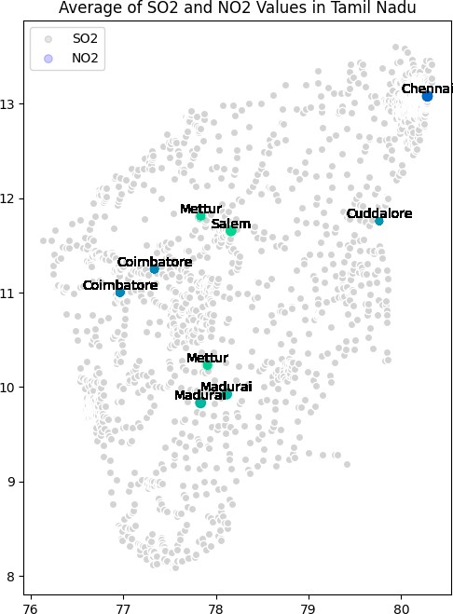

# Linear Regression Modeling:

1. **We employed a simple linear regression model to estimate RSPM/PM10 levels based on SO2 and NO2 concentrations**

# Predict Respirable Suspended Particulate Matter (RSPM/PM10) levels

1. **The segment demonstrates how to use a linear regression model to predict Respirable Suspended Particulate Matter (RSPM/PM10) levels based on Sulfur Dioxide (SO2) and Nitrogen Dioxide (NO2) levels. It loads and preprocesses the data, trains a linear regression model, and then predicts RSPM/PM10 levels for new data with specified SO2 and NO2 values.**

[27]: **import pandas as pd**

**from sklearn.linear_model import** LinearRegression

*# Load your air quality data into a Pandas DataFrame*

data = pd.read_csv('/content/cpcb_dly_aq_tamil_nadu-2014 (1).csv')

*# Preprocess the data and select relevant columns* data['Sampling Date'] = pd.to_datetime(data['Sampling Date']) tn_data = data[data['State'] == 'Tamil Nadu'] selected_columns = ['SO2', 'NO2', 'RSPM/PM10']

tn_data = tn_data[selected_columns].dropna() *# Remove rows with missing values*

*# Separate the features (SO2 and NO2) from the target (RSPM/PM10)*

X = tn_data[['SO2', 'NO2']]

y = tn_data['RSPM/PM10']

*# Create and train a linear regression model*

model = LinearRegression() model.fit(X, y)

*# Now, you can use the trained model to make predictions for new data*

*# Replace 'new_data' with the values of SO2 and NO2 you want to predict RSPM/*

↪*PM10 for*

new_data = [[100, 200]] *# Example values for SO2 and NO2*

predicted_rspm_pm10 = model.predict(new_data)

print(f'Predicted RSPM/PM10: **{**predicted_rspm_pm10[0]**}** µg/m³') Predicted RSPM/PM10: 331.29760210728915 µg/m³

<ipython-input-27-3d609d8cf440>:8: UserWarning: Parsing dates in DD/MM/YYYY format when dayfirst=False (the default) was specified. This may lead to inconsistently parsed dates! Specify a format to ensure consistent parsing.

data['Sampling Date'] = pd.to_datetime(data['Sampling Date'])

/usr/local/lib/python3.10/dist-packages/sklearn/base.py:439: UserWarning: X does not have valid feature names, but LinearRegression was fitted with feature names

warnings.warn(

# Heatmap to visualize pollutant levels (RSPM/PM10)

1. **To loads an air quality dataset and creates a heatmap to visu- alize pollutant levels (RSPM/PM10) by location and time in Tamil Nadu. It uses the Seaborn library for heatmap creation. The heatmap provides a graphical representation of air quality trends across different monitoring locations over time, aiding in identifying variations and hotspots in pollution levels.**

## [ ]: import pandas as pd import seaborn as sns

**import matplotlib.pyplot as plt**

*# Load your air quality dataset*

*# Replace 'your_dataset.csv' with the actual file path*

df = pd.read_csv('/content/cpcb_dly_aq_tamil_nadu-2014 (1).csv')

*# Select the relevant columns for the heatmap (e.g., pollutant levels by*␣

↪*location and time)*

*# Replace 'Pollutant', 'Location', and 'Time' with your column names*

data = df.pivot_table(index='Location of Monitoring Station', values='RSPM/

↪PM10')

*# Create a heatmap*

plt.figure(figsize=(12, 8)) *# Adjust the figure size as needed*

sns.heatmap(data, cmap='YlGnBu', annot=**True**, fmt=".1f")

*# Customize the heatmap labels and title* plt.xlabel('Time') plt.ylabel('Location')

plt.title('Air Quality Heatmap')

*# Display the heatmap*

plt.show()

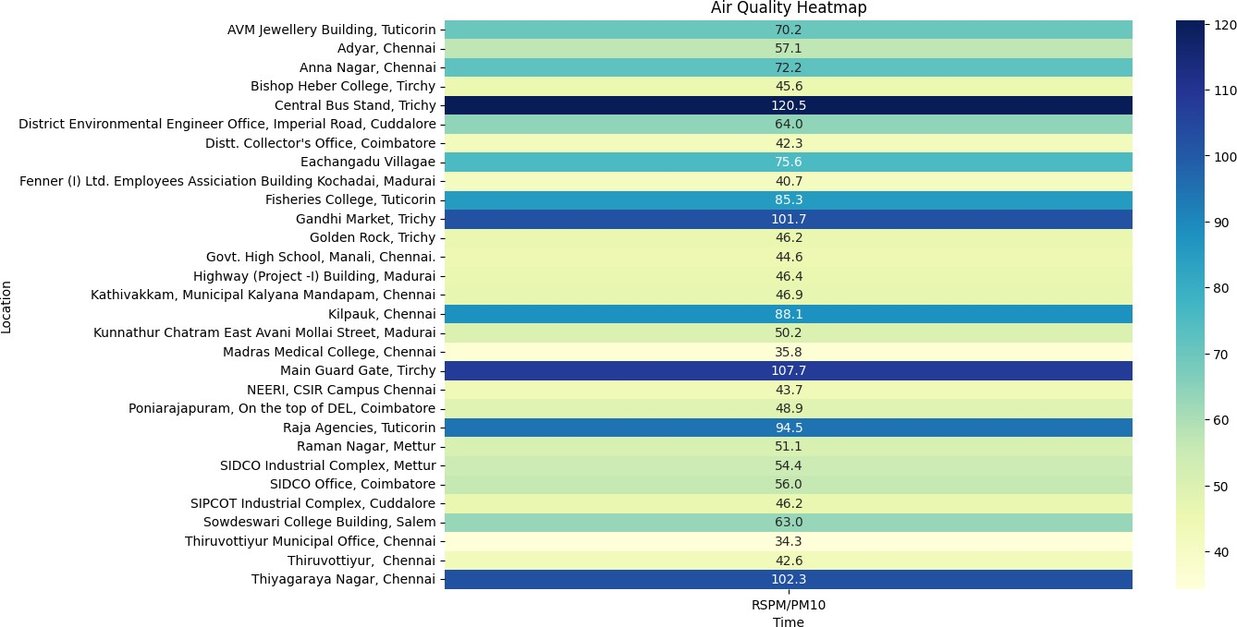

[ ]:

**import pandas as pd**

*# Load your CSV dataset into a DataFrame*

data = pd.read_csv('/content/cpcb_dly_aq_tamil_nadu-2014 (1).csv')

*# Group the data by the 'Region' column and calculate the mean for each group*

grouped = data.groupby('City/Town/Village/Area')[['SO2', 'NO2', 'RSPM/PM10']].

↪mean()

*# Display the calculated averages*

print(grouped)

|  |  |  |  |
| --- | --- | --- | --- |
|  | SO2 | NO2 | RSPM/PM10 |
| City/Town/Village/Area |  |  |  |
| Chennai | 13.014042 | 22.088442 | 58.998000 |
| Coimbatore | 4.541096 | 25.325342 | 49.217241 |
| Cuddalore | 8.965986 | 19.710884 | 61.881757 |
| Madurai | 13.319728 | 25.768707 | 45.724490 |
| Mettur | 8.429268 | 23.185366 | 52.721951 |
| Salem | 8.114504 | 28.664122 | 62.954198 |
| Thoothukudi | 12.989691 | 18.512027 | 83.458904 |
| Trichy | 15.293956 | 18.695055 | 85.054496 |

[ ]:

**import pandas as pd**

*# Load your CSV dataset into a DataFrame*

data = pd.read_csv('/content/cpcb_dly_aq_tamil_nadu-2014 (1).csv')

*# Group the data by the 'Region' column and calculate the mean for each group*

grouped = data.groupby('Location of Monitoring Station')[['SO2', 'NO2', 'RSPM/

↪PM10']].mean()

*# Display the calculated averages*

print(grouped)

|  |  |  |  |
| --- | --- | --- | --- |
| SO2 | | NO2 | \ |
| Location of Monitoring Station AVM Jewellery Building, Tuticorin | 9.302083 12.697917 | | |
| Adyar, Chennai | 13.252174 18.965217 | | |
| Anna Nagar, Chennai | 13.873874 20.754545 | | |
| Bishop Heber College, Tirchy | 11.800000 14.942857 | | |
| Central Bus Stand, Trichy | 18.013333 21.506667 | | |
| District Environmental Engineer Office, Imperia… | 8.101010 19.151515 | | |
| Distt. Collector's Office, Coimbatore | 4.554348 25.793478 | | |
| Eachangadu Villagae | 11.916667 22.395833 | | |
| Fenner (I) Ltd. Employees Assiciation Building … | 13.643564 27.198020 | | |
| Fisheries College, Tuticorin | 14.526882 20.204301 | | |
| Gandhi Market, Trichy | 17.148649 20.797297 | | |
| Golden Rock, Trichy | 12.014085 15.000000 | | |
| Govt. High School, Manali, Chennai. | 13.043011 15.408602 | | |
| Highway (Project -I) Building, Madurai | 11.947917 24.458333 | | |
| Kathivakkam, Municipal Kalyana Mandapam, Chennai | 12.925532 15.170213 | | |
| Kilpauk, Chennai | 19.232759 27.172414 | | |
| Kunnathur Chatram East Avani Mollai Street, Mad… | 14.340206 25.577320 | | |
| Madras Medical College, Chennai | 7.418605 | 27.465116 | |
| Main Guard Gate, Tirchy | 17.135135 | 20.837838 | |
| NEERI, CSIR Campus Chennai | 5.931034 | 23.758621 | |
| Poniarajapuram, On the top of DEL, Coimbatore | 4.126214 | 23.019417 | |
| Raja Agencies, Tuticorin | 15.058824 | 22.441176 | |
| Raman Nagar, Mettur | 7.572816 | 20.407767 | |
| SIDCO Industrial Complex, Mettur | 9.294118 | 25.990196 | |
| SIDCO Office, Coimbatore | 4.969072 | 27.329897 | |
| SIPCOT Industrial Complex, Cuddalore | 6.969697 | 17.666667 | |
| Sowdeswari College Building, Salem | 8.114504 | 28.664122 | |
| Thiruvottiyur Municipal Office, Chennai | 8.360465 | 28.069767 | |
| Thiruvottiyur, Chennai | 13.010417 | 15.583333 | |
| Thiyagaraya Nagar, Chennai | 18.849558 | 28.250000 | |
| Location of Monitoring Station | RSPM/PM10 | | |
| AVM Jewellery Building, Tuticorin | 70.175258 | | |
| Adyar, Chennai | 57.068966 | | |
| Anna Nagar, Chennai | 72.187500 | | |
| Bishop Heber College, Tirchy | 45.633803 | | |
| Central Bus Stand, Trichy | 120.546667 | | |

|  |  |  |  |
| --- | --- | --- | --- |
|  | | District Environmental Engineer Office, Imperia… | 64.020202 |
| Distt. Collector's Office, Coimbatore | 42.322222 |
| Eachangadu Villagae | 75.591837 |
| Fenner (I) Ltd. Employees Assiciation Building … | 40.732673 |
| Fisheries College, Tuticorin | 85.255319 |
| Gandhi Market, Trichy | 101.743243 |
| Golden Rock, Trichy | 46.222222 |
| Govt. High School, Manali, Chennai. | 44.612903 |
| Highway (Project -I) Building, Madurai | 46.427083 |
| Kathivakkam, Municipal Kalyana Mandapam, Chennai | 46.851064 |
| Kilpauk, Chennai | 88.103448 |
| Kunnathur Chatram East Avani Mollai Street, Mad… | 50.226804 |
| Madras Medical College, Chennai | 35.837209 |
| Main Guard Gate, Tirchy | 107.693333 |
| NEERI, CSIR Campus Chennai | 43.678161 |
| Poniarajapuram, On the top of DEL, Coimbatore | 48.883495 |
| Raja Agencies, Tuticorin | 94.544554 |
| Raman Nagar, Mettur | 51.106796 |
| SIDCO Industrial Complex, Mettur | 54.352941 |
| SIDCO Office, Coimbatore | 55.969072 |
| SIPCOT Industrial Complex, Cuddalore | 46.171717 |
| Sowdeswari College Building, Salem | 62.954198 |
| Thiruvottiyur Municipal Office, Chennai | 34.310345 |
| Thiruvottiyur, Chennai | 42.604167 |
| Thiyagaraya Nagar, Chennai | 102.327434 |
| [ | ]: | **import pandas as pd** |  |
| *# Load your CSV dataset into a DataFrame*  data = pd.read_csv('/content/cpcb_dly_aq_tamil_nad  *# Calculate the average pollution level for each*  data['Average_Pollution'] = data[['SO2', 'NO2', '  *# Sort the areas in increasing order of average po*  sorted_data = data.sort_values(by='Average_Polluti  *# Display the sorted DataFrame*  print(sorted_data[['City/Town/Village/Area', 'Aver | | | u-2014 (1).csv')  *area*  RSPM/PM10']].mean(axis=1)  *llution levels*  on',ascending = **False**)  age_Pollution']]) |
|  |  | City/Town/Village/Area Average_Pollution |  |
|  |  |  |  |
|  |  |  |  |

|  |  |  |
| --- | --- | --- |
| 354 | Chennai | 113.500000 |
| 2636 | Trichy | 107.000000 |
| 438 | Chennai | 102.000000 |
| 2844 | Trichy | 100.333333 |
| 2846 | Trichy | 100.333333 |
| … | … | … |
| 1556 | Cuddalore | 11.333333 |

|  |  |  |
| --- | --- | --- |
| 849 | Chennai | 11.333333 |
| 1563 | Cuddalore | 11.333333 |
| 1557 | Cuddalore | 11.000000 |
| 1562 | Cuddalore | 10.666667 |

[2879 rows x 2 columns]

**CONCLUSION:**

In conclusion, ambient air pollution a health hazard. It is a global challenges, as evidence shows that adverse effects still exist even at relatively low air pollutant concentrations, and so no threshold values for classical air pollutants can be established based on the available data.