Process Name: Import Loan Extract

Client: Absa Group Limited

Version: 1.0

**BOT Migration Steps**

*Table of Contents*

Guild lines before starting 1

BOT Migration Steps 1

Step-1 : Create Directories 1

Step -2 : Create Secrets Vaults in Control Tower. 2

Step – 3: Import package from Backup. 3

Step – 4 : Configure the Business Process 5

# Guild lines before starting

* Check if Teradata application is installed and running correctly.
* Check BOT is able to access EBox application from chrome web browser.
* Check appropriate file access permissions are available to BOT user.
* Install WorkFusion and check the status of control tower.

# BOT Migration Steps

## Step-1 : Create Directories

* BOT uses following directories to perform automation.

1. Input files :

This directory is uses as storage location of files generated in Teradata application.

1. Reconciliation Files :

This directory contains the reconciliation files from previous months and the final processed reconciliation file will be saved in this directory.

1. SQL Queries :

This directory contains the query files used in the Teradata application.

* The Folder Structure should be created as shown below:

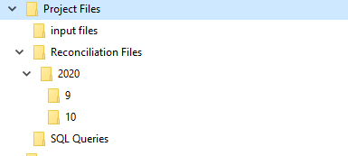

## Step -2 : Create Secrets Vaults in Control Tower.

* Secrect Vault is the location where we store credentials used by the BOT.
* In this process we need to create three secret vaults.
  1. Teradata Application
  2. Excel access pass-code
  3. EBox application
* Save the Alias names of each secret vault in a notepad as they will be used in the future steps.
* Follow below steps to create a secret vault

1. Log in to Control Tower

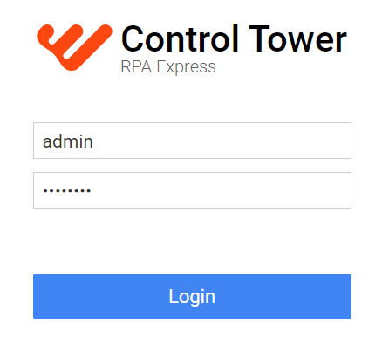

1. Select Secrets Vault (located on the left side of the panel).

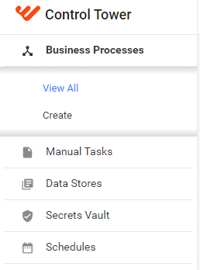

1. Select Add option.

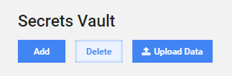

1. Enter details as below:

* Alias : Name of the Vault
* Key : User Name
* Value: Password

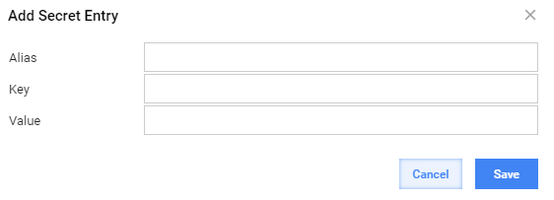

1. Select Save.

## Step – 3: Import package from Backup.

* Locate the latest Backup file in the Code – BackUp folder.(refer technical document)
* Follow bellow steps to import the package to control tower.
  1. Open Control Tower.
  2. select “…” located right side of “*Create New button*”(which it self located at top right size of the page) and select “*Import package”* option.

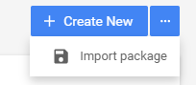

1

2

1. Select Add.

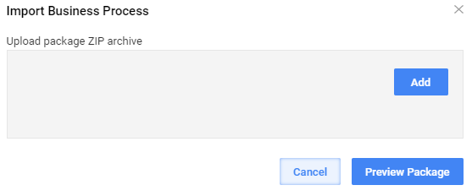

1. Browse the latest backup file and select open.
2. Select Preview Package.



1. Select Import Package located at bottom left of the page.



1. Wait for the confirmation message and select “*View imported Business Process*” link.

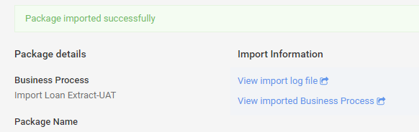

## Step – 4 : Configure the Business Process

1. Open Import Loan Extract Busniess Process.

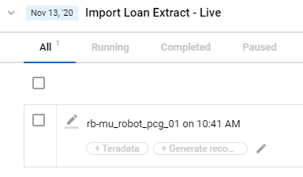

2

1

1. Select Work Flow Tab.

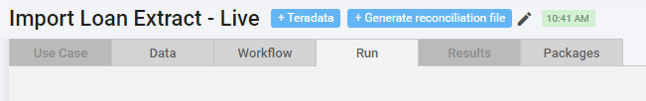

1. Accessing Bot Task to set configuration settings.

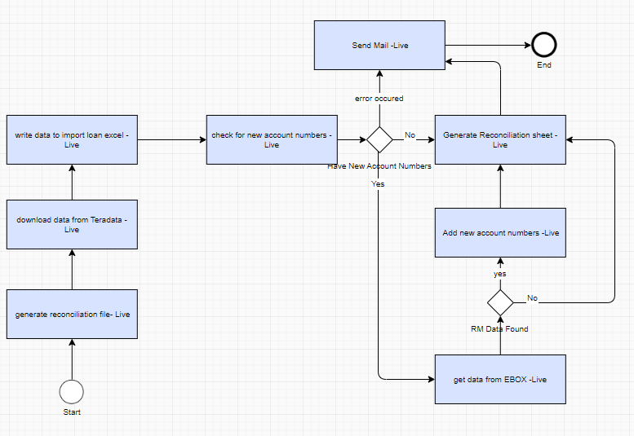

e

d

a

b

c3

* 1. Set Reconciliation file location.
     1. Access “*generate reconciliation file*” Bot Task by double click.
     2. Scroll down and enter the location of Reconiliation file in the *reconciliation_files_location* field.

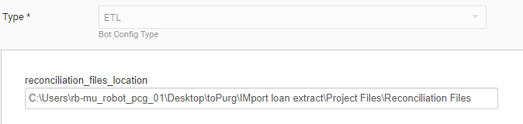

* + 1. Scroll up & select Save.

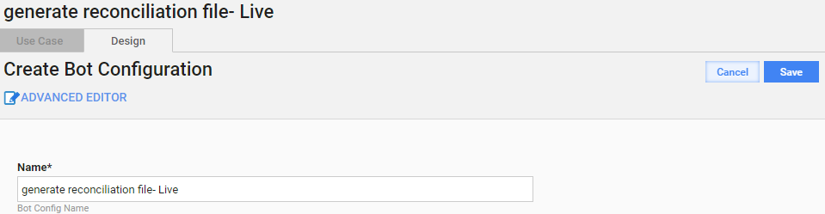

* 1. Set Teradata Automation settings.
     1. Access “*download data from Teradata*” Bot Task by doble click.
     2. Scroll down and enter the location of SQL Queries file in *queries_location* field.
     3. Enter the input files directory path in *output_location* field.
     4. Enter the Teradata executable location in *teradata_app_location* field.
     5. Enter the Teradata credential vault name created in Step -2 in *credentail_vault_name* field.

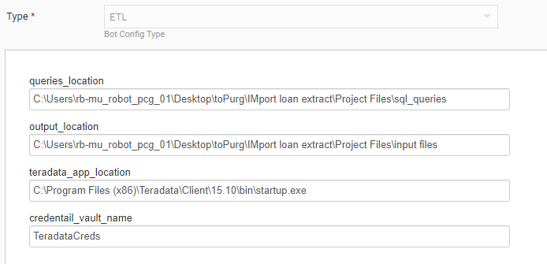

iii

v

iv

ii

* + 1. Scroll up & select Save.

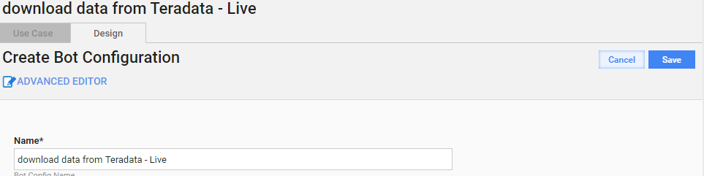

* 1. Set Input file parameters.
     1. Access “*write data to import loan excel*” Bot Task by doble click.
     2. Scroll down and enter the Excel access credential vault name created in Step -2 in *excel_password_vault* field.

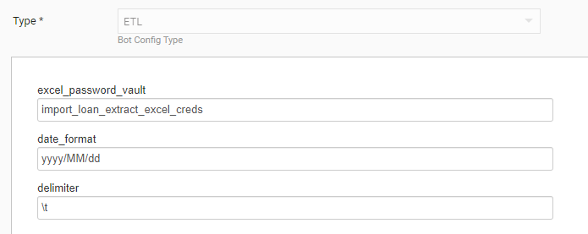

* + 1. Scroll up & select Save.

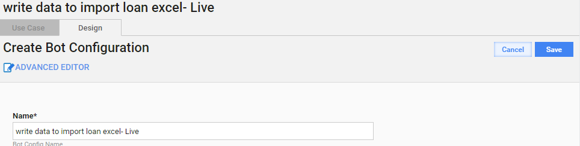

* 1. Set EBox automation Bost task settings.
     1. Access “*get data from EBOX*” Bot Task by doble click.
     2. Scroll down and enter the EBox login address in *ebox_login_page* field.
     3. Enter the EBox credential vault name created in Step -2 in *ebox_credentails_vault_name* field.

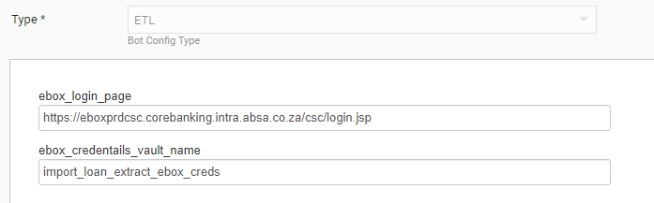

ii

iii

* + 1. Scroll up & select Save.

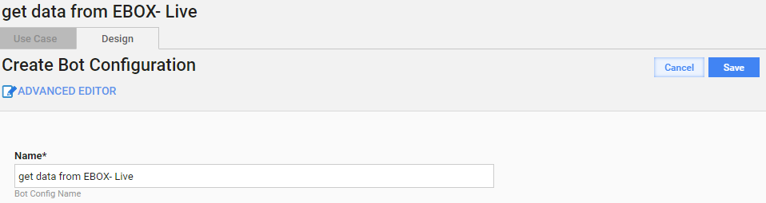

* 1. Set Email automation Bost task settings.
     1. Access “*Send Mail*” Bot Task by doble click.
     2. Scroll down and enter the CC mail addresses with comma to separate mail-ids in *cc_address* field.
     3. Enter the To mail addresses with comma to separate mail-ids in *to_address* field.
     4. Enter the OutLook executable path in *outlook_app_path* field.

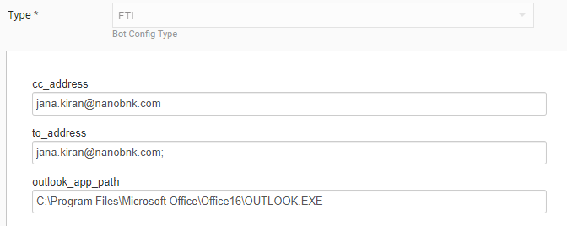

iii

iv

ii

* + 1. Scroll up &select Save.

