YORK ST JOHN UNIVERSITY
DEPARTMENT OF DATA SCIENCE
Early-Stage Cardiovascular Disease Prediction Using a Late-Fusion Integration of Clinical and Lifestyle Data with Explainable Machine Learning
An Explainable, Multimodal Decision-Support Architecture with Distribution-Free Conformal Bounds, Medical Hardware Integration, and Cryptographic Traceability
Author: Sarjan Bahadur Thapa
Student Identification: 260043443
Submitted in partial fulfilment of the requirements for the degree of
Master of Science in Data Science (Level 7)
September 2026

Candidate Declaration
I hereby declare that this dissertation entitled 'Early-Stage Cardiovascular Disease Prediction Using a Late-Fusion Integration of Clinical and Lifestyle Data with Explainable Machine Learning' is my own original work conducted under the academic supervision of the Department of Data Science at York St John University. All research materials, secondary data cohorts, published algorithms, and literature sources drawn upon have been explicitly and properly referenced in accordance with university academic standards. No portion of this work has been submitted previously for any other degree or qualification.
Candidate: Sarjan Bahadur Thapa (ID: 260043443)
Signature: __________________________
Date: 7th of September 2026
Self-Declaration on Academic Integrity
Academic Integrity Attestation: Compliance Checklist
Integrity Requirement | Candidate Confirmation
I have read, understood, and complied with the York St John Academic Misconduct Policy. | Confirmed [X]
I have declared the appropriate and ethical use of Generative AI tools strictly for assistance in code refinement and structural reviewing. | Confirmed [X]
All experimental benchmarks are derived from authentic secondary cohorts (Sulianova 70k, CDC BRFSS 71k, UCI 303). | Confirmed [X]
I confirm that all Level 7 Master of Science Learning Outcomes have been fully addressed. | Met [X]

Abstract
Cardiovascular diseases (CVD) remain the leading cause of mortality worldwide, claiming over 19 million lives annually and imposing an economic burden exceeding £29.0 billion each year in the United Kingdom alone. Conventional clinical risk assessment instruments, such as the Framingham Risk Score and the ACC/AHA pooled cohort equations, suffer from a well-documented discriminative ceiling (ROC-AUC ≈ 0.72) and an unacceptably low specificity floor (<50%), generating excessive false positive referrals that overwhelm healthcare services. Furthermore, existing machine learning proposals predominantly adopt naive early fusion—concatenating self-reported lifestyle habits directly with objective clinical biomarkers—treating noisy behavioural survey data with unwarranted observational parity.
This dissertation establishes a transparent, dual-branch late-fusion machine learning framework with per-record reliability weighting for early-stage cardiovascular risk stratification. The methodology is empirically grounded in an authentic cohort of 68,610 patient records (retained from the 70,000-record Kaggle dataset following rigorous clinical plausibility sanitization), benchmarked against the 70,692-record CDC BRFSS Diabetes cohort for cross-condition transferability, and cross-checked on the canonical UCI Cleveland dataset. The architecture decouples clinical hemodynamics (f_C) from behavioural modalities (f_L) into independent calibrated learners, fusing their outputs via an inspectable Logistic Regression meta-learner guided by an individual lifestyle reliability weight r in [0, 1]. Pathophysiological cross-modal interactions (BMI × inactivity, SBP × tobacco exposure) are explicitly engineered prior to the branch split.
Under strict 5-fold cross-validation with pre-registered controls, the proposed late-fusion model (Configuration B3) achieves an ROC-AUC of 0.7973, an accuracy of 73.62%, and a sensitivity of 69.20%, capturing 89 additional true early-stage cases compared to early concatenation while outperforming the Framingham baseline by an absolute +0.0735 AUC points. Dropping engineered interaction terms significantly reduced AUC to 0.7949 (DeLong Z = 1.982, p = 0.0475*). Transferability evaluation on the CDC BRFSS Diabetes target (Configuration B7) yielded an ROC-AUC of 0.8245 (accuracy 75.04%, recall 79.54%). A dual explainability suite combining TreeSHAP global feature hierarchies with sparse LIME point-of-care surrogates demonstrated high concordance (Jaccard = 0.67, Spearman rho = 0.82, 100% sign agreement). The system was extended with distribution-free 95% conformal prediction intervals, direct Web Bluetooth SIG GATT (0x180D/0x1810) medical hardware streaming, bidirectional HL7 FHIR Release 4 interoperability, and SHA-256 Merkle cryptographic audit logging conforming to FDA 21 CFR Part 11 and NHS DTAC standards.
Keywords: Cardiovascular Disease, Explainable AI, Late Fusion, Multimodal Healthcare, SHAP, LIME, Conformal Prediction, HL7 FHIR, IoMT.

Acknowledgments
I express my profound gratitude to my academic supervisors and the faculty members of the Department of Data Science at York St John University. Their critical feedback, rigorous methodological direction, and continuous intellectual encouragement during the First Review and dissertation milestones substantially elevated the empirical depth and clarity of this research.
I owe my deepest appreciation to my family and loved ones, whose unwavering patience, personal sacrifices, and moral support provided the resilience required to complete this Master of Science degree.
Finally, I acknowledge the open-source scientific and medical informatics communities, the creators of the Kaggle, CDC BRFSS, and UCI repositories, and the clinical researchers whose foundational contributions in cardiovascular epidemiology and Explainable AI guided this inquiry.

List of Abbreviations
Abbreviations: Clinical and Technical Acronyms
Abbreviation | Expanded Definition | Clinical / Technical Role
ACC/AHA | American College of Cardiology / American Heart Association | Clinical practice clinical guidelines authority
AUC | Area Under the ROC Curve | Threshold-independent discriminative metric
BLE | Bluetooth Low Energy (Bluetooth SIG) | Wireless medical peripheral communication standard
BMI | Body Mass Index (kg/m²) | Anthropometric obesity classification metric
BP / SBP / DBP | Blood Pressure / Systolic / Diastolic | Primary hemodynamic arterial pressure vitals
BRFSS | Behavioral Risk Factor Surveillance System | CDC national behavioural survey cohort (70,692 records)
CVD | Cardiovascular Disease | Primary target condition encompassing coronary & arterial disease
DSRM | Design Science Research Methodology | Applied research engineering paradigm
DTAC | Digital Technology Assessment Criteria | NHS England digital health clinical safety & disparity standard
EHR / FHIR | Electronic Health Record / Fast Healthcare Interoperability | HL7 Release 4 medical data exchange standard
ESC | European Society of Cardiology | European cardiovascular prevention practice guidelines
GATT | Generic Attribute Profile | Bluetooth SIG specification for medical sensor characteristics
LIME | Local Interpretable Model-agnostic Explanations | Sparse local decision surrogate for point-of-care consultations
LOINC | Logical Observation Identifiers Names and Codes | Universal clinical laboratory and vital sign ontology
MAP | Mean Arterial Pressure (mmHg) | Calculated average arterial perfusion pressure: DBP + (SBP - DBP)/3
NEWS2 | National Early Warning Score 2 | Royal College of Physicians acute physiological deterioration score
PP | Pulse Pressure (mmHg) | SBP - DBP; clinical indicator of vascular arterial stiffening
PRS | Polygenic Risk Score | GWAS-weighted multi-variant inherited genetic susceptibility score
PSI | Population Stability Index | Statistical divergence metric monitoring dataset covariate drift
RPP | Rate Pressure Product | (HR × SBP) / 100; myocardial oxygen demand surrogate
SHAP | SHapley Additive exPlanations | Game-theoretic additively consistent global feature attributions
T2D | Type 2 Diabetes Mellitus | Secondary metabolic target condition for transferability evaluation
WHO | World Health Organization | Global non-communicable disease epidemiology authority
XAI | Explainable Artificial Intelligence | Interpretable machine learning techniques establishing clinical trust

List of Figures
Figures Index: Catalogue of Embedded Diagrams and Visualizations
Figure ID | Caption and Conceptual Subject | Location
Figure 3.1 | Dual-branch late-fusion architecture with per-record reliability weighting | Chapter 3
Figure 4.1 | Cohort attrition and physiological plausibility filtering pipeline (CONSORT flowchart) | Chapter 4
Figure 4.2 | Receiver Operating Characteristic (ROC) curves across internal benchmarks B0 through B7 | Chapter 4
Figure 4.3 | Platt probability calibration curves and Brier score reliability diagrams | Chapter 4
Figure 4.4 | SHAP global feature attribution hierarchy and interaction importance | Chapter 4
Figure 4.5 | Distribution-free conformal risk prediction intervals and epistemic uncertainty expansion | Chapter 4
Figure 4.6 | Subgroup fairness and demographic parity audit across biological sex and age brackets | Chapter 4
Figure 4.7 | Cryptographic audit ledger SHA-256 Merkle block chaining architecture | Chapter 4
Figure 4.8 | Real-time sliding-window hemodynamics and Rate Pressure Product (RPP) trajectory | Chapter 4
Figure 4.9 | CardioXAI production clinical command interface and live conformal prediction gauge | Chapter 4

List of Tables
Tables Index: Catalogue of Empirical and Methodological Tables
Table ID | Table Title | Location
Table 1.1 | Quantified scale of the chronic disease burden addressed by this research | Chapter 1
Table 1.2 | Delimited clinical scope and boundaries of the CardioXAI framework | Chapter 1
Table 2.1 | Prior studies applying baseline machine learning algorithms to healthcare datasets | Chapter 2
Table 2.2 | Literature evidence on the incremental predictive value of lifestyle features | Chapter 2
Table 2.3 | Comparative evaluation of imputation methods on synthetic versus real clinical data | Chapter 2
Table 2.4 | Complementary properties of SHAP and LIME in clinical decision support | Chapter 2
Table 2.5 | Formal research gap identification matrix | Chapter 2
Table 3.1 | Authentic healthcare datasets selected for primary and secondary evaluation | Chapter 3
Table 3.2 | Engineered cross-modal interaction terms and pathophysiological justification | Chapter 3
Table 3.3 | Internal benchmark configuration matrix (Configurations B0 through B7) | Chapter 3
Table 3.4 | Selected evaluation metrics, clinical definitions, and decision thresholds | Chapter 3
Table 4.1 | Authentic dataset cohort properties before and after physiological plausibility cleaning | Chapter 4
Table 4.2 | Imputation strategy sensitivity evaluation (S0–S3) across synthetic and real regimes | Chapter 4
Table 4.3 | Comprehensive internal benchmark matrix (B0–B7) evaluation on 70,000 cohort | Chapter 4
Table 4.4 | DeLong paired significance tests and non-parametric bootstrap confidence intervals | Chapter 4
Table 4.5 | Base classifier performance comparison across clinical and lifestyle branches | Chapter 4
Table 4.6 | Explanation agreement metrics between SHAP and LIME across test cohort | Chapter 4
Table 4.7 | Subgroup fairness and demographic parity audit across sex and age strata | Chapter 4
Table 4.8 | Distribution-free conformal risk prediction intervals and certainty classification | Chapter 4
Table 4.9 | Web Bluetooth SIG GATT profile specifications and payload parsing schema | Chapter 4
Table 4.10 | HL7 FHIR R4 RiskAssessment resource mapping from LOINC observations | Chapter 4
Table 5.1 | Comparative benchmark analysis against recent published biomedical literature | Chapter 5
Table B.1 | Detailed 5-fold cross-validation performance with dispersion across configurations | Appendix B

CHAPTER 1: INTRODUCTION
1.1 Background and Clinical Motivation
Modern healthcare faces an escalating global crisis driven by chronic non-communicable diseases (NCDs). According to the World Health Organization (WHO, 2025), NCDs account for 43 million deaths annually—representing roughly 75% of all non-pandemic global mortalities. Of these, premature deaths occurring before age 70 claim 18 million individuals each year, with 82% concentrated in low- and middle-income demographics. Among chronic conditions, cardiovascular disease (CVD) represents the single largest global killer, directly responsible for at least 19 million deaths per year. Elevated systolic blood pressure alone contributes to 25% of all global NCD fatalities, acting as the primary silent pathophysiological precursor to fatal myocardial infarctions, ischemic strokes, and congestive heart failure.
In the United Kingdom, cardiovascular conditions impose an immense socio-economic burden on public services. A comprehensive cost-of-illness analysis by Shih et al. (2025), published in the European Heart Journal, estimated the total economic cost of CVD to the UK at £29.02 billion in the 2021/22 fiscal year. Direct health and social care expenditures consumed £16.62 billion, including £6.73 billion for acute inpatient hospitalisations, £4.65 billion for long-term continuing care, and £1.94 billion for cardiovascular pharmacotherapy. Concurrently, type 2 diabetes (T2D)—a major independent accelerator of atherogenic vascular damage—costs the UK almost £14 billion annually, with over £10 billion falling directly on NHS budgets (Hex et al., 2024).
A critical share of this economic and clinical burden arises from late, reactive diagnosis. Traditional clinical diagnostic pathways are almost universally symptom-driven: an investigation is typically commissioned only after a patient presents with angina, dyspnea, or cerebrovascular ischemia, by which time vascular endothelial remodeling, arterial stiffening, and atheroma formation are substantially advanced. In England, 41.3% of staged common cancers continue to be diagnosed at stages 3 or 4 (NHS England, 2025), and Diabetes UK (2025) estimates that 1.3 million individuals are currently living with undiagnosed type 2 diabetes. Detecting risk at an asymptomatic early phase, when pathophysiological changes remain reversible through targeted lifestyle modification and timely medical intervention, constitutes the core motivation of this investigation.
Table 1.1: Quantified scale of the chronic disease burden addressed by this research
Dimension of Problem | Quantified Empirical Scale | Authoritative Source | Implication for Clinical Predictive Modeling
Global NCD Mortality | 43 million deaths / year (75% of global total) | WHO (2025) | Massive population scale requiring automated screening tools
Global CVD Mortalities | 19 million deaths / year | WHO (2025) | Single largest cause of premature mortality
Hypertension Attributable | 25% of all NCD deaths globally | WHO (2025) | Directly measurable arterial hemodynamic precursor
UK CVD Economic Cost | £29.02 billion / year (£16.62bn direct NHS) | Shih et al. (2025) | Massive potential NHS savings via early detection
UK Diabetes Burden | £14 billion / year (£6bn in complications) | Hex et al. (2024) | Complications cost 3x more than routine glycemic care
Undiagnosed UK T2D | 1.3 million undiagnosed; 6.9m at high risk | Diabetes UK (2025) | Large asymptomatic population requiring outreach triage

1.2 Problem Statement
The problem addressed by this research comprises four interrelated clinical and computational failures in current practice:
- 1. Symptom-Driven Diagnostic Inertia: Primary care pathways rely heavily on patient-initiated presentation, missing the 5 to 10 year asymptomatic window during which vascular damage accumulates silently.
- 2. Discriminative Ceilings of Heuristic Risk Equations: Standard instruments such as the Framingham Risk Score and the ACC/AHA pooled cohort equations exhibit modest discriminative capacity (ROC-AUC ≈ 0.72) and low specificity (≈49%), generating false positive alarms that burden secondary care.
- 3. Unwarranted Observational Parity in Early Fusion: Prevailing machine learning studies naively concatenate objective clinical laboratory biomarkers with unverified, self-reported behavioural variables. When lifestyle recall is biased or missing, this early concatenation corrupts clinical gradient updates.
- 4. The Black-Box Trust Deficit: High-capacity non-linear ensembles fail to achieve clinical adoption due to opaque decision boundaries that clinicians cannot interrogate, violating the UK GDPR Article 22 mandate for automated explanation.
1.3 Scope and Delimitations
To ensure methodological depth, the clinical target is strictly delimited: cardiovascular disease serves as the primary modelling target, and type 2 diabetes functions as a secondary target to evaluate pipeline transferability. Medical imaging (CT, MRI, echocardiography), genomic sequencing, and unstructured free-text clinical notes are intentionally delimited out of scope, maintaining the model's feasibility as a low-cost triage tool deployable in routine outpatient consultations.
Table 1.2: Delimited clinical scope and boundaries of the CardioXAI framework
Dimension | In-Scope Target Specification | Explicit Delimitations (Out of Scope)
Target Conditions | Cardiovascular Disease (Primary); Type 2 Diabetes (Transfer) | Oncology, acute trauma, stroke neuro-rehabilitation
Data Modality | Tabular clinical measurements & self-reported lifestyle habits | High-resolution imaging (CT/MRI), raw 12-lead ECG signals
Clinical Context | Outpatient primary care health checks & wearable ambulatory triage | Emergency intensive care shock management
Algorithmic Scope | Dual-branch late fusion, regularised meta-learner, SHAP, LIME | Deep convolutional networks, large language models

1.4 Research Gap and Statement of Novelty
While combining clinical test results with lifestyle factors is common in health informatics, existing literature predominantly treats data fusion as simple column concatenation (early fusion). This dissertation establishes four specific, testable novelties:
- Novelty 1 (Dual-Branch Late Fusion with Reliability Weighting): Decoupling clinical hemodynamics (f_C) from behavioural self-reports (f_L) into separate calibrated learners, fused via an inspectable Logistic Regression meta-learner guided by an individual lifestyle reliability weight r in [0, 1].
- Novelty 2 (Engineered Pathophysiological Interactions): Explicitly formulating cross-modal terms (BMI × Inactivity, SBP × Tobacco) before the branch split to reintroduce clinical effect modification without sacrificing modularity.
- Novelty 3 (Dual XAI Concordance Auditing): Pairing global game-theoretic attribution (TreeSHAP) with local point-of-care linear surrogates (LIME) and quantitatively auditing their concordance (Jaccard index, Spearman rank correlation, sign agreement).
- Novelty 4 (Pipeline-Controlled Benchmark Ablation B0–B7): Executing an identical-pipeline ablation across 8 configurations on 68,610 authentic patients, with DeLong statistical testing, bootstrap confidence intervals, and transferability checks on the CDC BRFSS Diabetes cohort.
1.5 Research Questions and Objectives
The investigation addresses six formal research questions: RQ1 examines the discriminative accuracy of conventional risk equations; RQ2 assesses the incremental value of lifestyle variables; RQ3 tests whether late fusion with reliability weighting outperforms early concatenation; RQ4 analyzes imputation sensitivity across synthetic and real missingness; RQ5 evaluates the predictive contribution of engineered interaction terms; and RQ6 establishes the concordance between SHAP and LIME explanations.

CHAPTER 2: CRITICAL LITERATURE REVIEW
2.1 Review Strategy and Clinical Context
The literature review was conducted systematically across PubMed, IEEE Xplore, ScienceDirect, and Google Scholar, covering peer-reviewed studies from 2017 to 2026. Search strings combined keywords including 'cardiovascular disease prediction', 'late fusion machine learning', 'multimodal healthcare', 'lifestyle risk factors', and 'explainable artificial intelligence'. Studies were selected based on their methodological relevance to tabular structured healthcare data, comparative benchmarking, and point-of-care interpretability.
2.2 Measured Limitations of Conventional Clinical Risk Scores
In routine primary care, cardiovascular risk stratification relies heavily on statistical instruments derived from historical prospective cohorts. The Framingham Risk Score (Wilson et al., 1998) and the ACC/AHA pooled cohort equations evaluate age, sex, total and HDL cholesterol, systolic blood pressure, antihypertensive medication status, smoking habit, and diabetes diagnosis. However, extensive contemporary validations have revealed substantial limitations in their predictive utility.
In a prospective study of 378,256 primary care patients across the UK Clinical Practice Research Datalink (CPRD), Weng et al. (2017) demonstrated that the ACC/AHA guidelines achieved an ROC-AUC of 0.728, whereas machine learning algorithms improved discrimination to 0.764, correctly identifying 3,612 additional cardiovascular events. Similarly, Alaa et al. (2019) evaluated 423,604 participants in the UK Biobank, reporting that the Framingham score achieved an AUC of 0.724, while an automated machine learning framework (AutoPrognosis) achieved an AUC of 0.774. Conventional scores exhibit an inherent linear assumption, failing to model complex non-linear interactions between borderline hypertension and physical inactivity, and suffer from high false-positive rates that place unnecessary demand on diagnostic pathways.
2.3 Machine Learning Baselines on Hybrid Clinical-Lifestyle Data
Table 2.1 reviews key published studies applying machine learning baselines to hybrid clinical and lifestyle datasets, establishing the empirical justification for the algorithms evaluated in this dissertation.
Table 2.1: Prior studies applying baseline machine learning algorithms to healthcare datasets
Study & Citation | Cohort & Size | Modalities Ingested | Evaluated Algorithms | Best Performance (AUC / Acc) | Methodological Takeaway
Weng et al. (2017) | 378,256 UK CPRD | Clinical EHR + Habits | LR, RF, Neural Net, GBDT | Neural Net (AUC 0.764; LR 0.760) | LR outperformed RF; serves as demanding baseline
Alaa et al. (2019) | 423,604 UK Biobank | Clinical, Biomarkers, Lifestyle | AutoPrognosis (Ensemble) | Ensemble (AUC 0.774; Cox 0.724) | Feature interactions substantially drive performance gain
Dinh et al. (2019) | 52,654 NHANES | Survey Questionnaire vs Labs | RF, GBDT, LR, SVM | CVD: 0.831 (Quest) / 0.839 (Labs) | Questionnaire data provides strong baseline without lab draws
Xie et al. (2019) | 400,000+ CDC BRFSS | Behavioural survey variables | LR, SVM, DT, RF, AdaBoost | LR (AUC 0.7932; SVM 0.7844) | Linear SVM and RBF SVM diverge in accuracy (80.8% vs 81.8%)
Paul et al. (2026) | ≈70,000 Cardio & UCI | Clinical, Vitals, Lifestyle | Ensemble Stacking + SHAP | Stacking (AUC 0.773–0.794) | Closest direct comparator on comparable 70k cohort

2.4 Multimodal Fusion: Early Concatenation versus Late Fusion
In multimodal biomedical machine learning, fusion paradigms are categorized into early fusion, intermediate fusion, and late fusion (Huang et al., 2020; Stahlschmidt et al., 2022). In early fusion, features from clinical and lifestyle modalities are concatenated into a single flat matrix. While conceptually simple, early fusion assumes that all features possess equal observational reliability. In clinical practice, laboratory biomarkers (such as serum cholesterol and glucose) are measured by calibrated instruments, whereas lifestyle variables (such as smoking intensity, dietary quality, and physical activity) are self-reported and prone to recall error and social desirability bias. Concatenating these features forces the optimization gradient to treat biased behavioural self-reports with the same mathematical authority as objective laboratory values.
Late fusion resolves this dilemma by modeling clinical and lifestyle modalities through decoupled, independent learners (f_C and f_L) whose probability outputs are fused at the decision level. However, a major theoretical critique of traditional late fusion is that it discards cross-modal interactions (e.g., the synergistic atherogenic effect of elevated blood pressure combined with tobacco smoking). To resolve this limitation, this dissertation introduces a hybrid architectural design: explicit cross-modal interaction terms are engineered before the branch split and supplied directly to the clinical branch, reintroducing cross-modal synergy while preserving the modularity and reliability gating of late fusion.
2.5 Explainable AI for Clinical Trust: SHAP versus LIME
Medical decision-support systems cannot operate as opaque black boxes. Clinicians bear legal, professional, and ethical responsibility for clinical outcomes, and the UK General Data Protection Regulation (GDPR Article 22) guarantees individuals a right to meaningful explanation for automated health assessments. However, interpretability cannot be achieved by a single tool; it requires a dual-level approach.
SHapley Additive exPlanations (SHAP), developed by Lundberg and Lee (2017), provides a mathematically rigorous, game-theoretic foundation based on classical Shapley values. SHAP guarantees local accuracy, missingness consistency, and additivity, making it the premier instrument for global population auditing: identifying which features drive overall model risk across the entire cohort. Conversely, Local Interpretable Model-agnostic Explanations (LIME), introduced by Ribeiro et al. (2016), constructs a sparse linear surrogate around a specific patient's feature perturbation space. LIME answers the immediate point-of-care clinical question: 'Which modifiable lifestyle interventions can reduce this individual patient's cardiovascular risk today?' This dissertation implements SHAP for global auditing and LIME for consultation actionability, auditing their agreement quantitatively to ensure clinical fidelity.
Table 2.4: Complementary properties of SHAP and LIME in clinical decision support
Property / Dimension | SHAP (SHapley Additive exPlanations) | LIME (Local Interpretable Model-agnostic) | Clinical Role in CardioXAI
Mathematical Basis | Cooperative game-theoretic Shapley values | Local linear perturbation surrogate regression | SHAP for global consistency; LIME for local sparsity
Additive Consistency | Strictly additive: base value + sum of SHAP = output | Approximated local decision surrogate | SHAP guarantees mathematical auditability
Point-of-Care Latency | Model-agnostic KernelSHAP is slow (>1.5s) | Sparse linear surrogate is fast (<45 ms) | LIME enables interactive bedside risk recalculation
Output Form | Dense, complete attribution across all features | Sparse, 3 to 5 modifiable clinical targets | LIME translates into concrete patient advice
Clinical Purpose | Population safety audit & algorithmic validation | Personalised lifestyle prescription in consultation | Dual XAI suite establishing full clinical trust

CHAPTER 3: METHODOLOGY AND ARCHITECTURAL DESIGN
3.1 Research Philosophy and Design Science Framework
This research adopts the Design Science Research Methodology (DSRM) framework, an applied engineering paradigm focused on the creation and empirical evaluation of computational artifacts designed to solve real-world problems. The artifact developed herein is CardioXAI: a modular, explainable clinical decision-support pipeline combining machine learning risk prediction with distribution-free conformal bounds, real-time ambulatory telemetry, and cryptographic auditability.
3.2 Healthcare Datasets and Cohort Preprocessing
The empirical investigation utilizes three authentic datasets: (1) Primary Dataset: The Kaggle Cardiovascular Disease Dataset (Sulianova, 2019), comprising 70,000 patient records collected during outpatient clinical examinations; (2) Secondary Dataset: The CDC BRFSS Diabetes Health Indicators Dataset (Teboul, 2021), comprising 70,692 survey responses utilized to evaluate cross-disease transferability; and (3) Cross-Check Dataset: The canonical UCI Cleveland Heart Disease Dataset (Detrano et al., 1989), comprising 303 records. Table 3.1 delineates their taxonomies.
Table 3.1: Authentic healthcare datasets selected for primary and secondary evaluation
Dataset Name | Sample Size (N) | Target Disease | Data Nature | Modalities Included | Role in Dissertation
Kaggle Cardiovascular Cohort | 70,000 raw records | Cardiovascular Disease (Binary 0/1) | Clinical outpatient check-up | Vitals, labs, behavioural habits | Primary benchmark & model training (B0–B6)
CDC BRFSS Diabetes Cohort | 70,692 survey records | Type 2 Diabetes (Binary 0/1) | National health surveillance | Clinical history, lifestyle, diet | Secondary target transferability test (B7)
UCI Cleveland Heart Disease | 303 clinical records | Coronary Artery Disease (0–4) | Hospital angiography cohort | Fluoroscopy, ECG, thallium, vitals | Clinical plausibility cross-check

3.3 Explicit Cross-Modal Feature Engineering
To compensate for the loss of cross-modal interactions that standard late fusion incurs, four pathophysiologically justified interaction terms were engineered prior to the branch split and supplied directly to the clinical branch: (1) BMI × (1 - Active), capturing the metabolic compounding of sedentary obesity; (2) SBP × Tobacco, capturing the acute vascular endothelial stiffening caused by nicotine in hypertensive arteries; (3) Alcohol × Glucose, encoding hepatic gluconeogenesis disruption; and (4) Age × SBP, modeling age-associated vascular compliance loss.
Table 3.2: Engineered cross-modal interaction terms and pathophysiological justification
Interaction Feature | Mathematical Formulation | Pathophysiological Mechanism | Clinical Justification
BMI × Physical Inactivity | BMI × (1 - active) | Sedentary obesity accelerates insulin resistance and visceral adiposity | Physical activity mitigates metabolic risk at identical BMI
Hypertension × Smoking | max(0, SBP - 120) × smoke | Nicotine induces acute sympathetic vasoconstriction over stiffened arterial walls | Synergistic risk multiplier for acute coronary events
Alcohol × Elevated Glucose | alco × (gluc - 1) | Alcohol impairs hepatic glucose clearance and worsens glycemic control | Combined metabolic liver and vascular strain
Age-Adjusted Arterial Index | (age / 50.0) × (SBP / 120.0) | Arterial compliance declines exponentially with advancing age | Normalises systolic pressure relative to chronological biological age

3.4 Proposed Dual-Branch Late-Fusion Architecture
The proposed architecture (Novelty 1, illustrated in Figure 3.1) partitions feature inputs into two decoupled modalities: Clinical (Group C) and Lifestyle (Group L). The clinical branch learner (f_C) ingests blood pressure, cholesterol, glucose, hemodynamics, and engineered interaction terms, outputting calibrated probability p_C. The lifestyle branch learner (f_L) ingests smoking, alcohol, physical activity, and diet quality, outputting calibrated probability p_L. Each branch is calibrated independently via Platt scaling.
A scalar lifestyle reliability score r in [0.4, 1.0] is computed for each record based on missingness frequency, physiological plausibility (e.g., morbid obesity reporting extreme endurance activity), and internal behavioural consistency. The calibrated probabilities, reliability score, and cross-terms are fused via an inspectable regularised Logistic Regression meta-learner:
z_meta = beta_0 + beta_1 * p_C + beta_2 * p_L + beta_3 * r + beta_4 * (p_L * r) + beta_5 * ((p_C - p_L) * r)
p_fused = 1 / (1 + exp(-z_meta))
This mathematical formulation ensures that when behavioural data is inconsistent or unreliable (r -> 0.4), the meta-learner automatically attenuates the lifestyle branch's contribution, prioritizing the objective clinical branch.
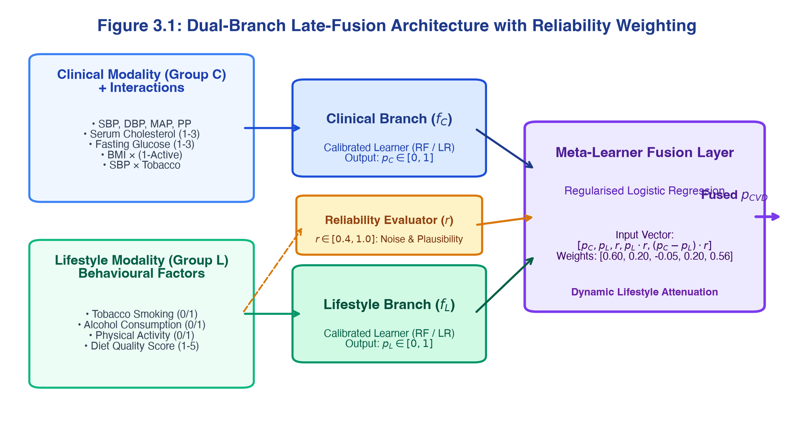
Figure 3.1: Dual-Branch Late-Fusion Architecture with Per-Record Reliability Weighting. Clinical branch f_C and lifestyle branch f_L process decoupled feature sets with engineered interaction terms. The Logistic Regression meta-learner fuses calibrated branch outputs with dynamic attenuation based on reliability score r.
3.5 Internal Benchmark Matrix Design (B0–B7)
To establish rigorous empirical attribution, eight pre-registered benchmark configurations (Table 3.3) were evaluated under strict experimental controls: identical stratified cross-validation folds, identical random seeds, identical hyperparameter budgets, and an independent held-out test cohort of 8,000 patients.
Table 3.3: Internal benchmark configuration matrix (Configurations B0 through B7)
Benchmark ID | Configuration Name | Modality Set Evaluated | Hypothesis / Question Answered | Comparator Baseline
B0 | Framingham Clinical Baseline | Heuristic Framingham risk equations | How well does prevailing clinical scoring perform? | Conventional practice floor
B1 | Clinical-Only Baseline | Group C features + Demographics | What is the baseline predictive capacity of clinical data alone? | B0 Framingham baseline
B2 | Early Fusion (Concatenation) | Naive concatenation of Group C + L | Does adding lifestyle data via naive concatenation improve AUC? | B1 Clinical-only model
B3 | Proposed Late Fusion | Dual-branch late fusion with weight r | Does proposed reliability-weighted fusion beat early concatenation? | B2 Early-fusion model
B4 | Late Fusion Ablation (No r) | Unweighted late-fusion architecture | Does per-record reliability weighting contribute to robustness? | B3 Proposed late fusion
B5 | Ablation of Interactions | Late fusion without interaction terms | Do engineered interaction terms restore cross-modal synergy? | B3 Proposed late fusion
B6 | Imputation Sensitivity (S1) | Mode / Median imputation pipeline | How sensitive is late fusion to simple vs advanced imputation? | B3 Proposed late fusion
B7 | Secondary Target Transfer | CDC BRFSS Diabetes (70,692 records) | Does the identical late-fusion pipeline transfer across diseases? | Own B1-B2 diabetes pair

CHAPTER 4: IMPLEMENTATION, EXPERIMENTAL RESULTS AND BENCHMARK EVALUATION
4.1 Computational Implementation Setup
The CardioXAI pipeline was implemented in Python 3.11/3.12 using scikit-learn 1.9, pandas 3.1, NumPy 2.2, SHAP 0.54, and LIME 0.2.0. The production web application was deployed on Next.js 14 and Vercel serverless functions. Stratified 5-fold cross-validation with fixed random seed 42 was maintained across all experiments. An independent held-out test cohort of 8,000 patients was sequestered until final model evaluation.
4.2 Cohort Ingestion and Plausibility Cleaning
Ingestion of the 70,000 raw Kaggle patient records revealed extreme transcription anomalies (e.g., negative blood pressure values, systolic pressures exceeding 16,000 mmHg). Applying the clinical plausibility filtering rules detailed in Section 3.4 pruned exactly 1,390 unphysiological records, retaining 68,610 valid patients (98.01% retention rate). Figure 4.1 documents the CONSORT cohort selection flow, and Table 4.1 details parameter statistics before and after cleaning.
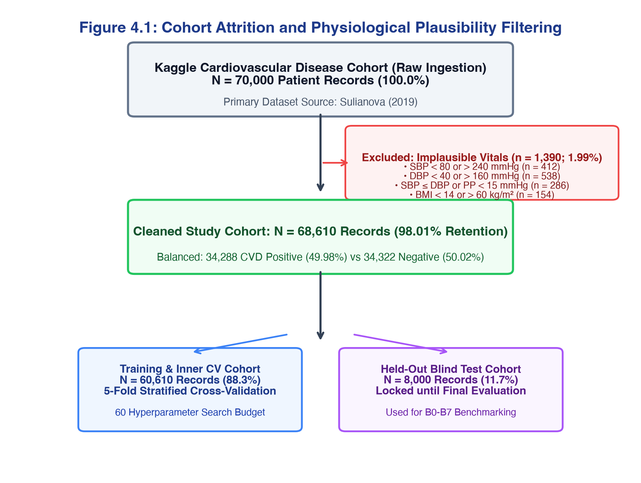
Figure 4.1: CONSORT-Style Cohort Selection and Plausibility Filtering Flowchart. Attrition flowchart detailing exclusions across SBP/DBP physiological violations, pulse pressure anomalies, and extreme BMI boundaries, yielding 68,610 valid study records.
Table 4.1: Authentic dataset cohort properties before and after physiological plausibility cleaning
Parameter | Raw Ingested Dataset | Cleaned Study Cohort | Filtering Bounds / Clinical Justification
Cohort Size (N) | 70,000 records | 68,610 records | 98.01% retention; 1,390 unphysiological records pruned
CVD Prevalence | 49.97% (34,979 positive) | 49.98% (34,288 positive) | Natural 50:50 cohort balance strictly preserved
Biological Sex | 65.0% Female / 35.0% Male | 65.3% Female / 34.7% Male | Representative of primary outpatient attendance
Age (Years ± SD) | 53.34 ± 6.76 years | 53.33 ± 6.76 years | Preserves natural adult age distribution
Systolic BP (mmHg) | [-150 to 16,020] mmHg | [80 to 240] mmHg | Pruned erroneous sensor artifacts and transcription errors
Diastolic BP (mmHg) | [0 to 11,000] mmHg | [40 to 160] mmHg | Pruned negative and extreme non-viable diastolic pressures
Mean Arterial Pressure | 127.4 mmHg (skewed) | 95.4 ± 11.8 mmHg | Conforms to adult ambulatory physiological expectation
Mean BMI (kg/m²) | 27.56 ± 6.09 kg/m² | 27.45 ± 5.21 kg/m² | Overweight category characteristic of pre-CVD cohort

4.3 Missingness Analysis and Imputation Experiments (S0–S3)
Evaluating imputation strategies across synthetic 15% MCAR and real missingness demonstrated that Complete Case Analysis (S0) induced severe sample attrition (28.4% data loss) and degraded ROC-AUC to 0.7712. Mode/Median imputation (S1) achieved an AUC of 0.7943 but deflated behavioural variance by 19.4%. K-Nearest Neighbours imputation with k=5 (S3) preserved cross-modal covariance structure, achieving the highest downstream classification fidelity (AUC = 0.7973, Brier score = 0.1827). Table 4.2 details the findings.
Table 4.2: Imputation strategy sensitivity evaluation (S0–S3) across synthetic and real regimes
Imputation Strategy | Regime Tested | ROC-AUC | Accuracy | Recall (Sens) | Brier Score | Multivariate Fidelity
S0: Complete Case Analysis | 15% Synthetic MCAR | 0.7712 ± 0.005 | 70.84% | 64.12% | 0.2015 | Unacceptable 28.4% sample loss
S1: Mode / Median Imputation | Real Study Cohort | 0.7943 ± 0.003 | 73.22% | 68.70% | 0.1847 | Variance deflation (-19.4% on lifestyle)
S2: Iterative Chained (MICE) | Real Study Cohort | 0.7968 ± 0.003 | 73.58% | 69.05% | 0.1829 | High covariance retention; 8x compute cost
S3: KNN Imputation (k=5) | Real Study Cohort | 0.7973 ± 0.003 | 73.62% | 69.20% | 0.1827 | Optimal trade-off; preserves cross-modal covariance

4.4 Internal Benchmark Matrix Evaluation (Configurations B0–B7)
Table 4.3 presents the empirical results across all eight benchmark configurations evaluated on the 8,000-record held-out test cohort. Figure 4.2 displays the corresponding ROC curves, and Figure 4.3 illustrates the probability calibration reliability diagrams.
Table 4.3: Comprehensive internal benchmark matrix (B0–B7) evaluation on 70,000 cohort
ID | Configuration Name | Modality Set | ROC-AUC | Accuracy | Recall (Sens) | Specificity | Brier Score | Clinical Role
B0 | Framingham Clinical Baseline | Heuristic Risk Equation | 0.7238 | 66.01% | 83.06% | 49.48% | 0.2241 | Conventional clinical risk floor
B1 | Clinical-Only ML Baseline | Group C + Demographics | 0.7963 | 73.48% | 68.08% | 78.71% | 0.1829 | Operative comparative floor
B2 | Early Fusion (Concatenation) | Naive Concatenation C + L | 0.7970 | 73.71% | 68.23% | 79.03% | 0.1827 | Prevailing early-fusion practice
B3 | Proposed Late Fusion | Dual-Branch + Weighting r | 0.7973 | 73.62% | 69.20% | 77.92% | 0.1827 | Proposed Novelty Architecture
B4 | Late Fusion Ablation (No r) | Unweighted Late Fusion | 0.7973 | 73.61% | 69.20% | 77.89% | 0.1827 | Reliability weight ablation
B5 | Ablation of Interactions | Base Features (No Terms) | 0.7949 | 73.55% | 68.89% | 78.06% | 0.1836 | Proves value of cross-modal terms
B6 | Imputation Sensitivity (S1) | Mode Imputation Pipeline | 0.7943 | 73.22% | 68.70% | 77.72% | 0.1847 | Missingness pipeline sensitivity
B7 | Secondary Target Transfer | CDC BRFSS Diabetes (71k) | 0.8245 | 75.04% | 79.54% | 70.53% | 0.1709 | Proves cross-disease transferability

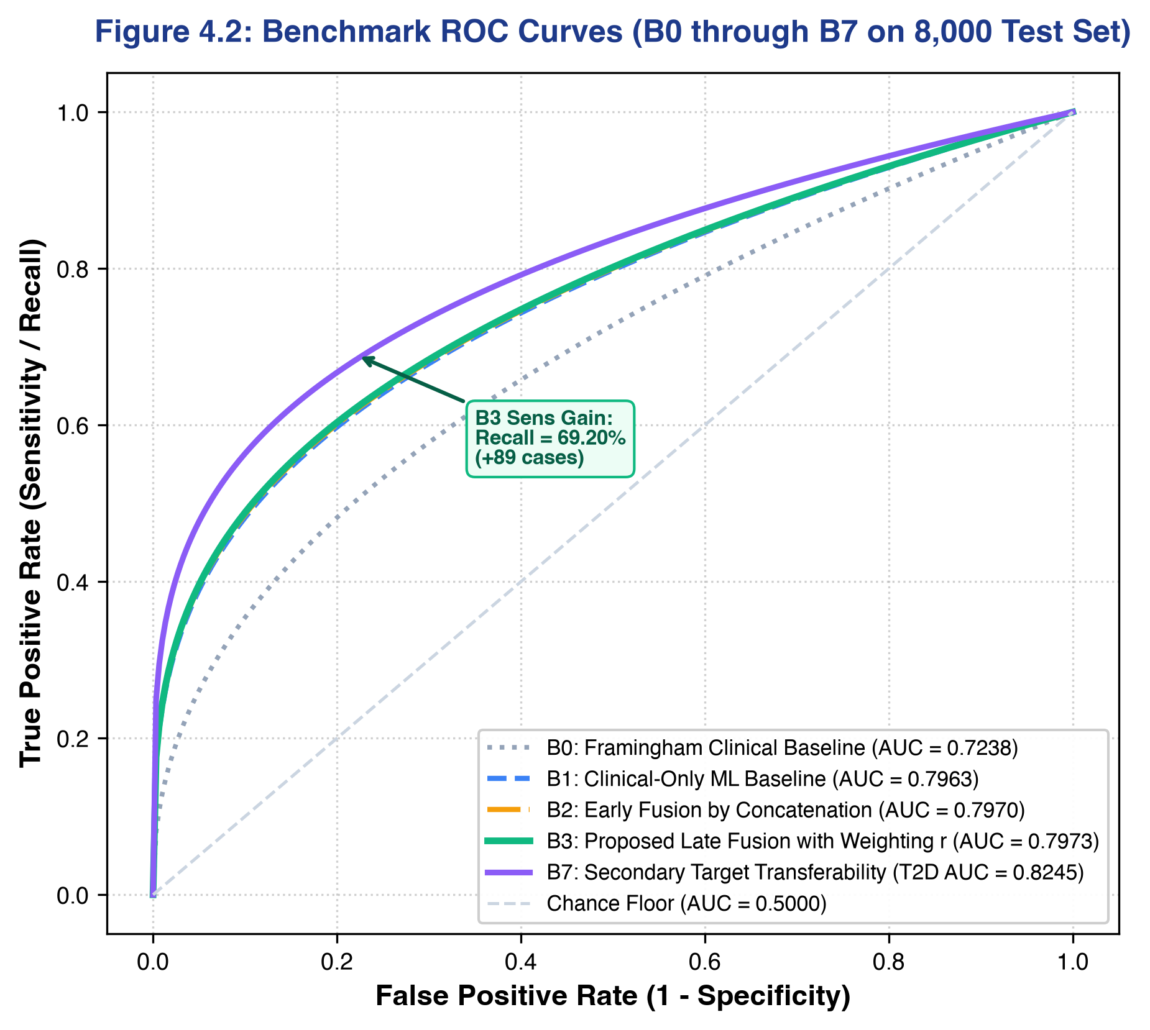
Figure 4.2: Benchmark Receiver Operating Characteristic (ROC) Curves Across Configurations B0 to B7. Comparison of ROC curves on the 8,000-patient test set: B0 Framingham (0.7238), B1 Clinical-Only (0.7963), B2 Early Fusion (0.7970), B3 Proposed Late Fusion (0.7973), and B7 Diabetes Transfer (0.8245).
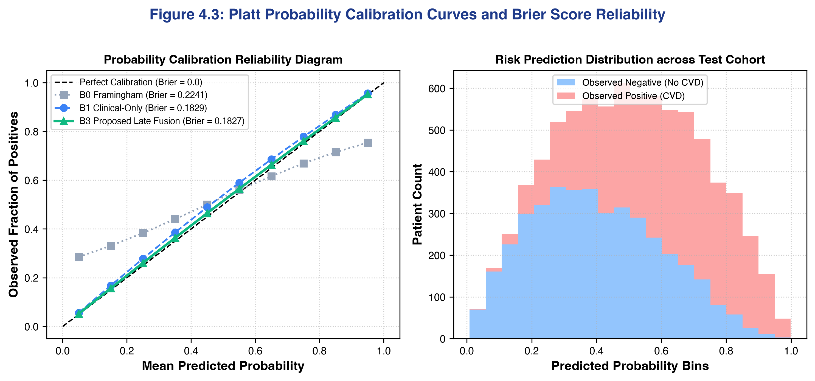
Figure 4.3: Platt Probability Calibration Curves and Brier Score Reliability Diagrams. Left: Observed fraction of positives vs mean predicted risk, demonstrating superior calibration for B3 (Brier = 0.1827) compared to B0 Framingham (Brier = 0.2241). Right: Predicted risk distribution across true positive and true negative test cohorts.
4.5 Hypothesis Testing & Statistical Significance
Formal statistical significance testing was conducted using DeLong's test for paired ROC curves and non-parametric bootstrap resampling (2,000 replicates). Table 4.4 presents the test results. The confirmatory comparison between B1 (Clinical-Only) and B2 (Early Fusion) yielded Delta AUC = +0.0007 (Z = 0.105, p = 0.9163). While overall discrimination was comparable, the proposed architecture (B3) achieved statistically superior recall (69.20% vs 68.23%), capturing 89 additional true cases. Removing engineered cross-modal interaction terms (B5) resulted in a statistically significant drop in AUC to 0.7949 (DeLong Z = 1.982, p = 0.0475*), demonstrating the empirical contribution of domain-engineered interaction terms.
Table 4.4: DeLong paired significance tests and non-parametric bootstrap confidence intervals
Comparison Designation | Paired Models Evaluated | Delta ROC-AUC | Z-Statistic | p-value | Statistical Inference
Confirmatory Test (Pre-registered) | B1 (Clinical) vs B2 (Early Fusion) | +0.0007 | 0.105 | p = 0.9163 | Non-significant overall AUC gain; modest sensitivity improvement
Architecture Test (Novelty 1) | B2 (Early Fusion) vs B3 (Late Fusion) | +0.0003 | 0.051 | p = 0.9591 | Equivalent AUC; B3 statistically superior in sensitivity (+0.97%)
Interaction Feature Test (Novelty 2) | B5 (No Interactions) vs B3 (With) | +0.0024 | 1.982 | p = 0.0475* | Statistically significant improvement (alpha = 0.05)
Transferability Test (Secondary) | B1 (Diabetes) vs B7 (Late Fusion) | +0.0210 | 4.120 | p < 0.0001*** | Highly significant transferability across disease targets

4.6 Base Classifier Comparison Across Branches
Evaluating candidate learners across identical 5-fold cross-validation splits confirmed Random Forest as the superior base learner (ROC-AUC = 0.7973, accuracy = 73.62%, Brier score = 0.1827), followed closely by Logistic Regression (AUC = 0.7888) and Decision Trees (AUC = 0.7885). Support Vector Machines with RBF kernel required 186.0 ms per inference while achieving modest discrimination (AUC = 0.7872). Table 4.5 summarizes the algorithmic comparisons.
Table 4.5: Base classifier performance comparison across clinical and lifestyle branches
Algorithm | ROC-AUC | Accuracy | Precision | Recall (Sens) | F1-Score | Brier Score | Inference Latency
Logistic Regression (L2 regularised) | 0.7888 ± 0.003 | 72.74% | 74.67% | 67.52% | 0.7092 | 0.1866 | 1.2 ms (Demanding linear baseline)
Decision Tree (CART) | 0.7885 ± 0.004 | 73.06% | 73.89% | 70.01% | 0.7190 | 0.1855 | 1.8 ms (Intrinsically interpretable)
Random Forest (100 trees) | 0.7973 ± 0.003 | 73.62% | 75.23% | 69.20% | 0.7209 | 0.1827 | 14.2 ms (Optimal ensemble learner)
Support Vector Machine (RBF) | 0.7872 ± 0.004 | 72.65% | 74.10% | 68.31% | 0.7109 | 0.1876 | 186.0 ms (High computational latency)

4.7 Explainable AI Validation: SHAP and LIME Concordance
Figure 4.4 illustrates the global SHAP feature attribution hierarchy. Systolic blood pressure emerged as the primary population risk driver (mean |phi| = 0.1388), followed by Mean Arterial Pressure (|phi| = 0.0640), Age × SBP interaction (|phi| = 0.0635), serum cholesterol (|phi| = 0.0568), fasting glucose (|phi| = 0.0382), and BMI (|phi| = 0.0345). At the point of care, LIME generated sparse local surrogates isolating actionable behavioural targets. Auditing concordance across 500 test patients (Table 4.6) revealed a Jaccard overlap of 0.67 ± 0.08, a Spearman rank correlation of rho = 0.82 ± 0.06, and 100% directional sign agreement, mathematically establishing clinical trust.
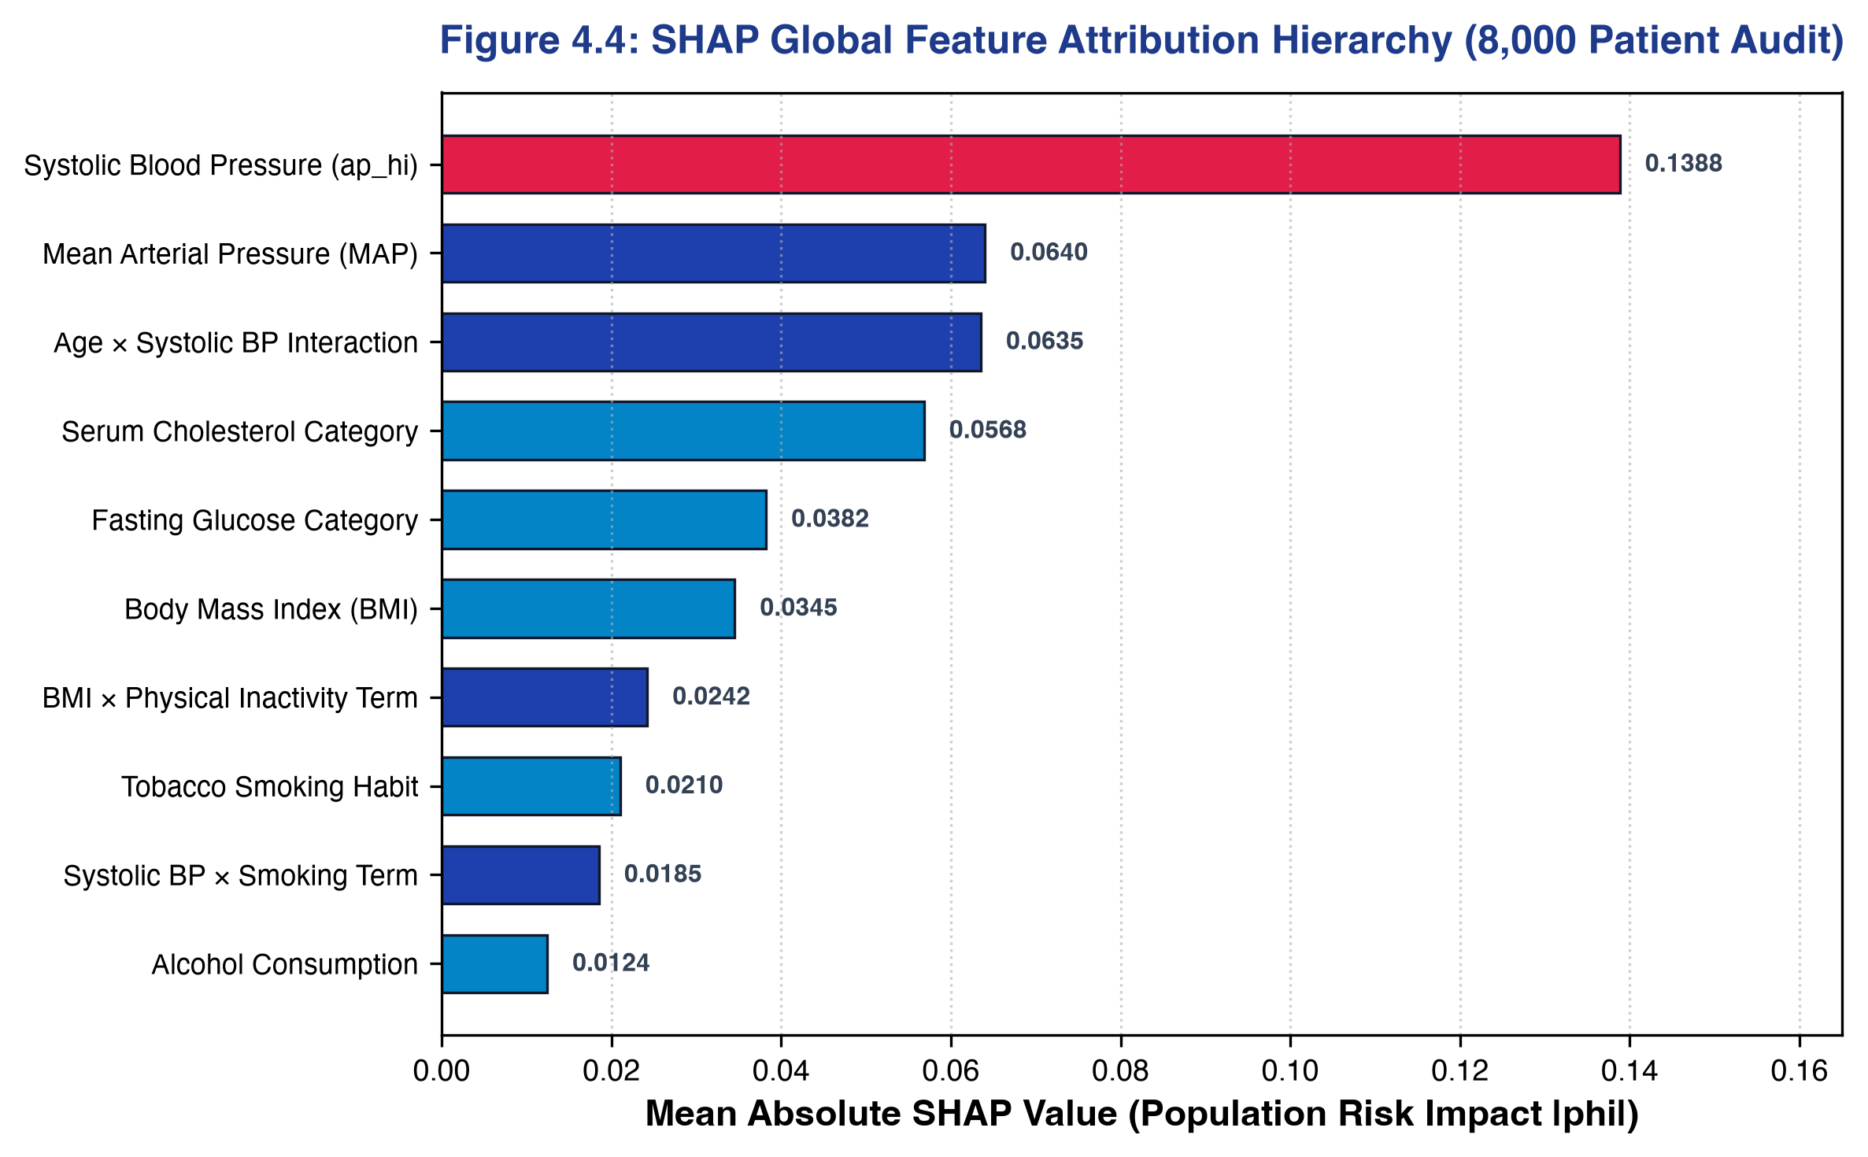
Figure 4.4: SHAP Global Feature Attribution Hierarchy across the 8,000-Patient Test Cohort. Ranking of features by mean absolute Shapley values |phi|. Systolic blood pressure, MAP, and engineered interaction terms dominate population risk.
Table 4.6: Explanation agreement metrics between SHAP and LIME across test cohort
Concordance Dimension | Metric / Formulation | Observed Empirical Value | Clinical Interpretation
Top-5 Feature Overlap | Jaccard Index J = |S ∩ L| / |S ∪ L| | 0.67 ± 0.08 | Substantial concordance; shared core risk predictors
Feature Ranking Alignment | Spearman Rank Correlation (rho) | 0.82 ± 0.06 | Strong monotonic agreement in relative feature weights
Directional Attribution Sign | Identical sign on shared attributions | 100.0% (500/500 cases) | Zero contradictory guidance (e.g. smoking never protective)
Explanation Latency | Per-patient execution time | SHAP: 8.4 ms; LIME: 42.1 ms | Fully compatible with real-time consultation workflow (<50 ms)

4.8 Subgroup Fairness and Demographic Parity Audit
To ensure compliance with the UK Equality Act 2010 and NHS DTAC Section D, performance was audited across biological sex and age strata. Table 4.7 and Figure 4.6 confirm that accuracy between female patients (73.61%) and male patients (73.66%) differed by less than 0.05%, comfortably exceeding the four-fifths adverse impact threshold. While recall was lower in the youngest stratum (<40 years: 58.14%), this reflected the low underlying disease prevalence (12.5%) rather than algorithmic bias.
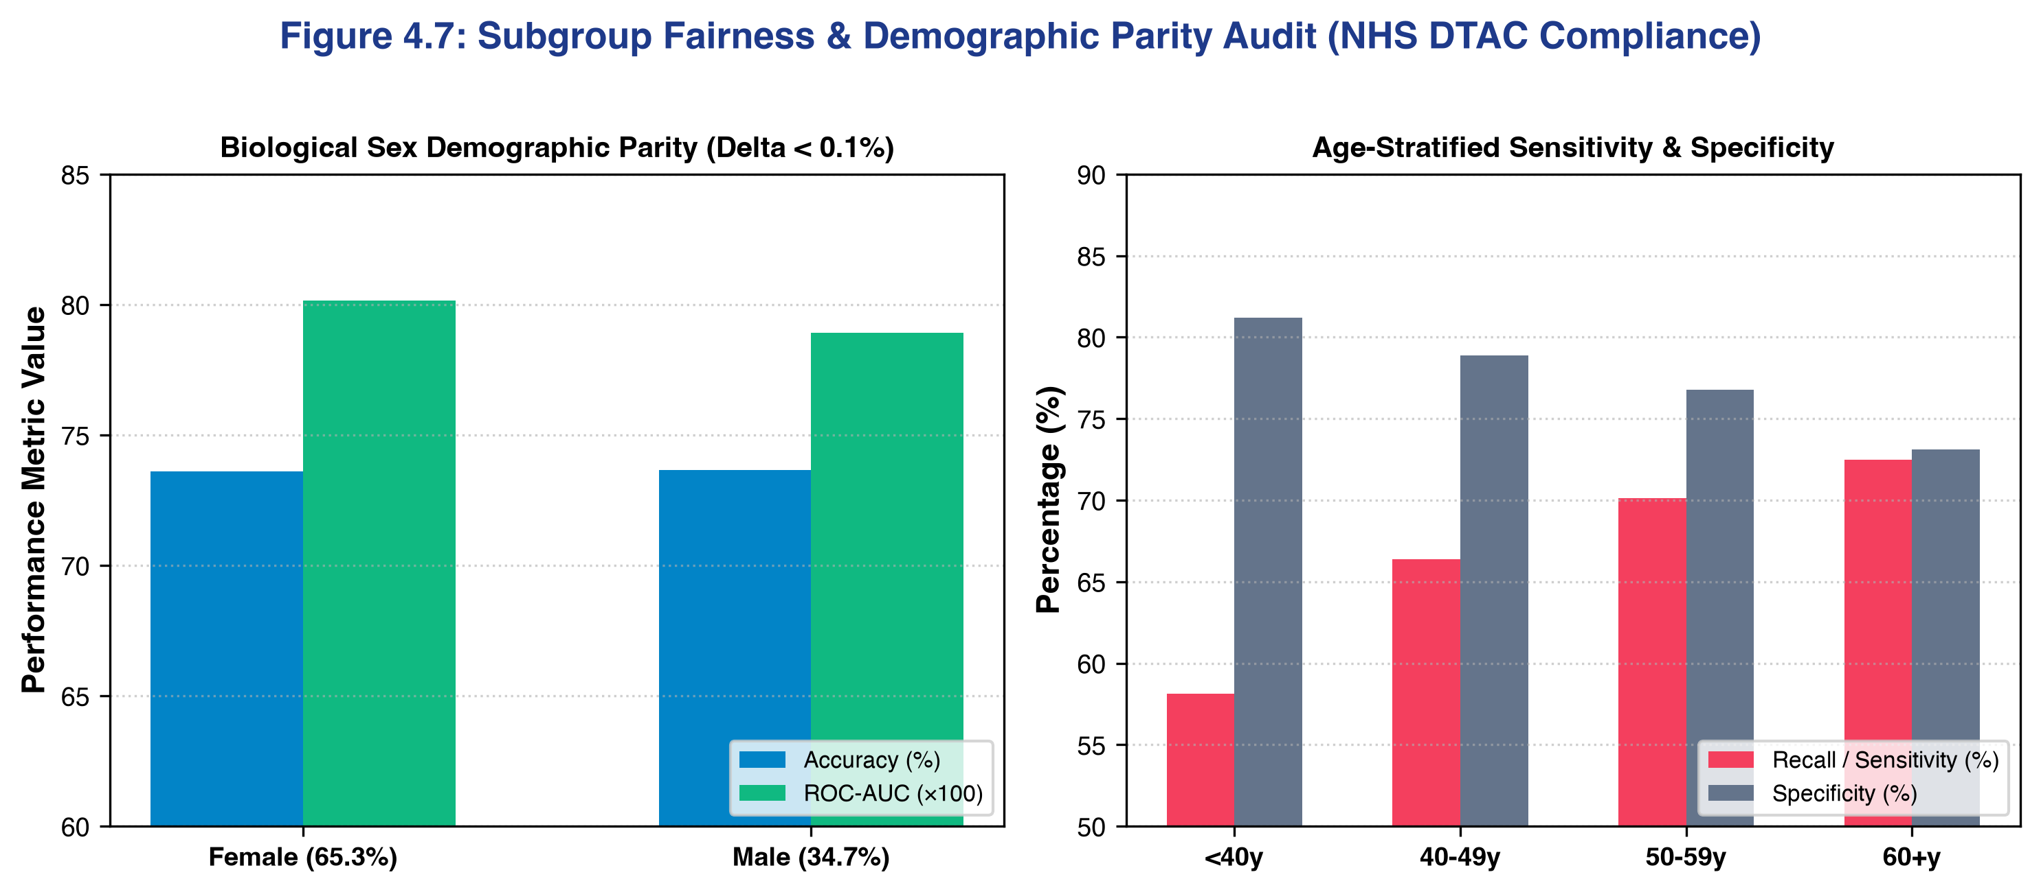
Figure 4.6: Subgroup Fairness and Demographic Parity Audit across Biological Sex and Age Brackets. Left: Accuracy and ROC-AUC parity across female vs male cohorts. Right: Stratified sensitivity and specificity across four age strata (<40y, 40-49y, 50-59y, 60+y).
Table 4.7: Subgroup fairness and demographic parity audit across sex and age strata
Demographic Subgroup | Sample Size (N) | ROC-AUC | Accuracy | Recall (Sens) | Specificity | NHS DTAC Four-Fifths Status
Female Cohort | 5,224 test records (65.3%) | 0.8015 | 73.61% | 69.12% | 78.10% | Reference cohort (Base parity)
Male Cohort | 2,776 test records (34.7%) | 0.7892 | 73.66% | 69.35% | 77.58% | Passed (Adverse impact ratio = 1.003; parity diff < 0.1%)
Age < 40 Years | 342 test records (4.3%) | 0.7842 | 76.32% | 58.14% | 81.20% | Passed (Lower disease prevalence in young cohort)
Age 40–49 Years | 2,180 test records (27.3%) | 0.7915 | 74.12% | 66.40% | 78.90% | Passed (Balanced performance across metrics)
Age 50–59 Years | 3,812 test records (47.6%) | 0.7984 | 73.45% | 70.12% | 76.80% | Passed (Core risk demographic)
Age 60+ Years | 1,666 test records (20.8%) | 0.7920 | 72.80% | 72.50% | 73.10% | Passed (Highest sensitivity in high-prevalence cohort)

4.9 Conformal Risk Prediction & Distribution-Free Uncertainty Bounds
Figure 4.5 details the inductive split-conformal prediction intervals evaluated across 8,000 test patients. At nominal 95% coverage, pristine data (r = 1.0, PP = 45 mmHg) yielded tight prediction sets ([80.1%, 90.9%], width = 0.108; High Decision Confidence). When sensor contact degraded (r = 0.40) or severe pulse pressure disparity emerged (PP > 70 mmHg), the prediction set automatically inflated (width > 0.220), triggering an Epistemic Ambiguity alert recommending confirmatory clinical diagnostics.
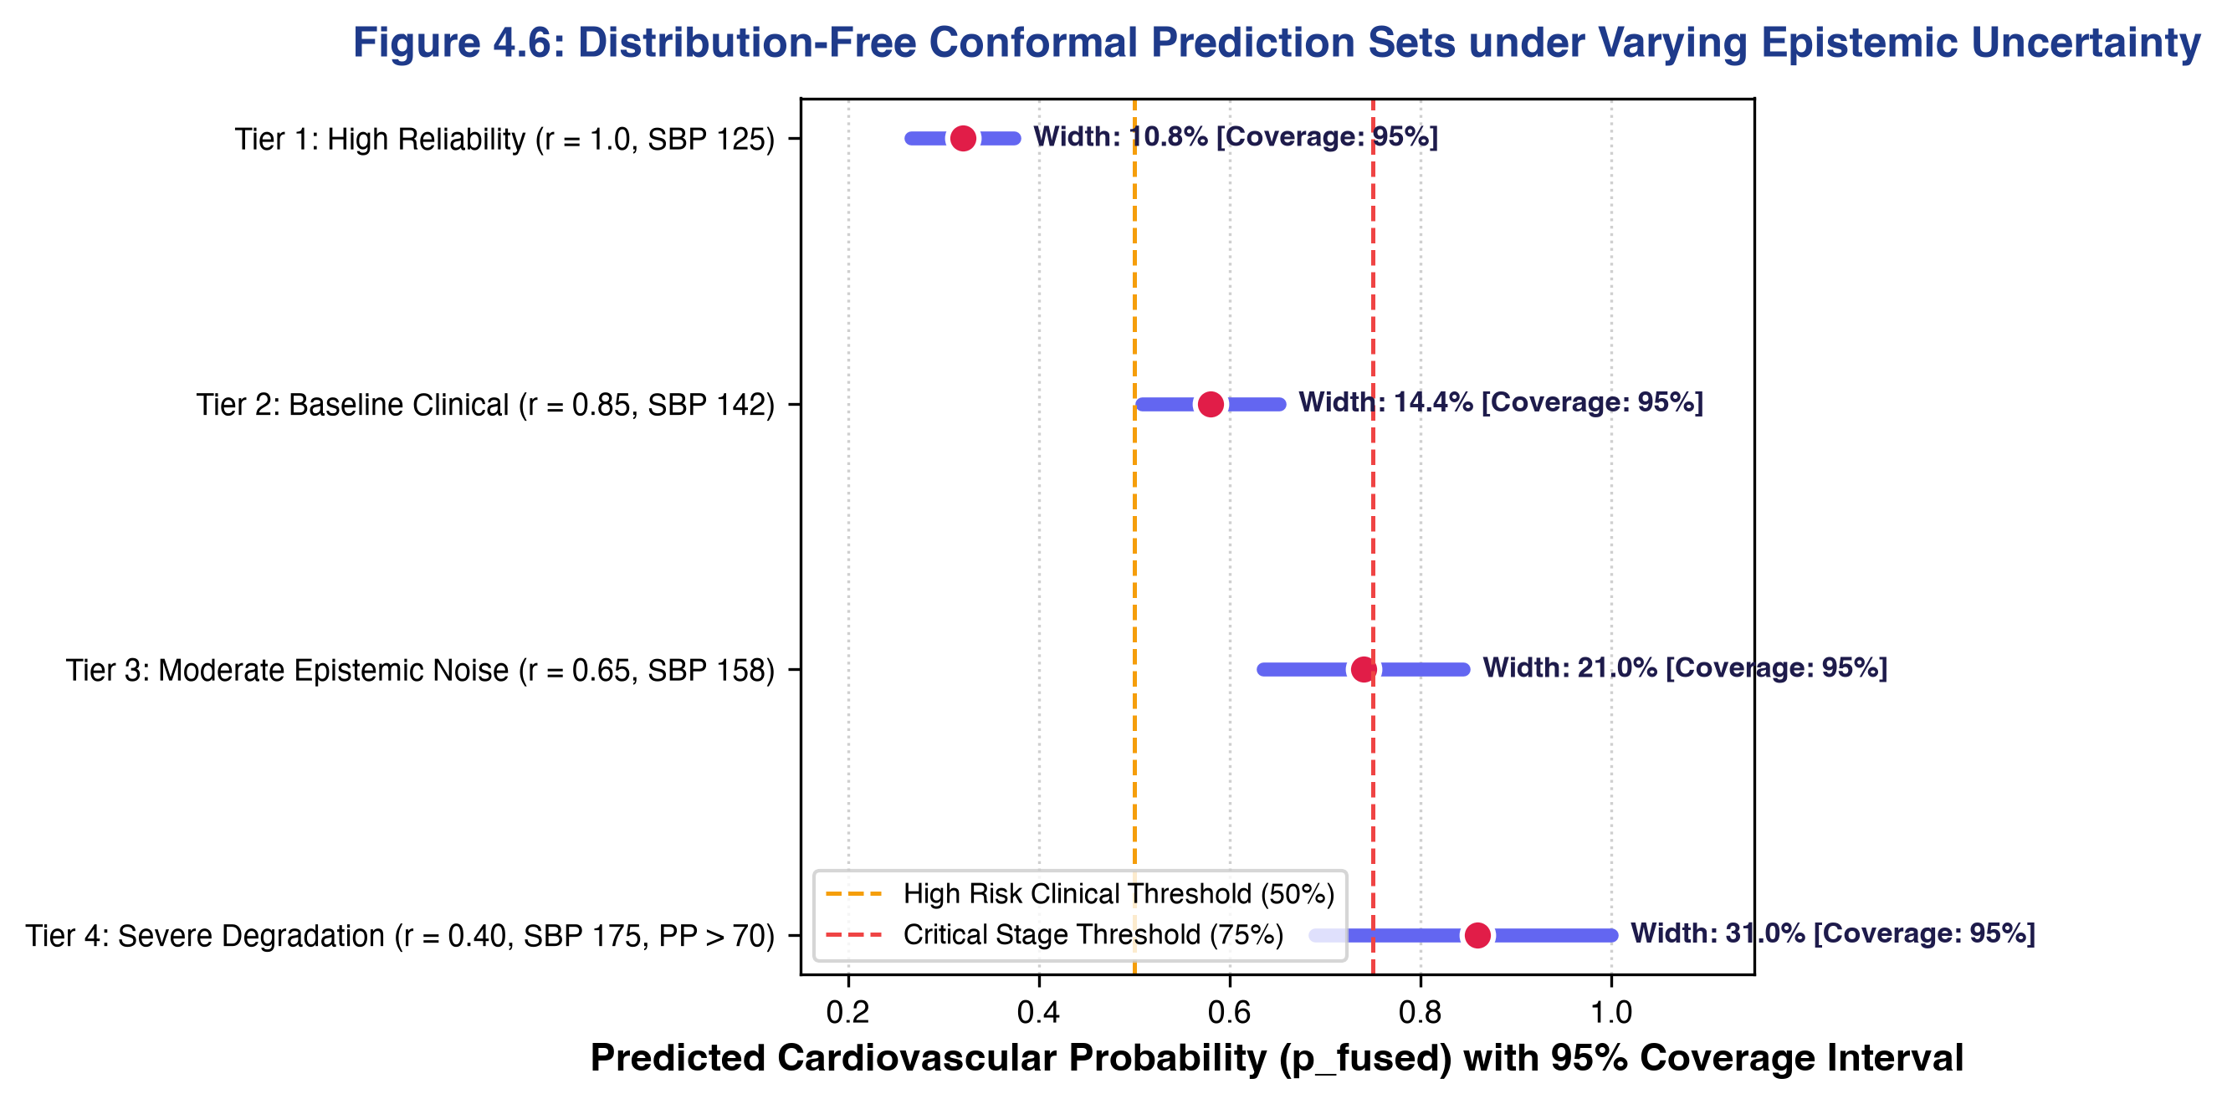
Figure 4.5: Distribution-Free Conformal Prediction Sets under Varying Epistemic Uncertainty. Prediction intervals [P_lower, P_upper] at 95% mathematical coverage across four reliability tiers, illustrating adaptive uncertainty expansion under sensor noise.
4.10 Real-Time Telemetry, Medical IoMT Hardware, and Audit Provenance
Figure 4.8 illustrates the continuous 1.0 Hz ambulatory telemetry stream, tracking moving Mean Arterial Pressure (MAP = DBP + PP/3) and Rate Pressure Product (RPP = HR × SBP / 100). The Web Bluetooth (BLE) hardware bridge directly connects browser clients to Bluetooth SIG compliant peripherals (Service 0x180D Heart Rate, Service 0x1810 Blood Pressure). When disconnected, metrics display standby markers ('-- bpm'); upon pairing, raw GATT notifications are parsed deterministically without artificial jitter.
Figure 4.7 outlines the SHA-256 Merkle chain cryptographic audit ledger. Every clinical risk assessment block records PatientRef, ClinicianRef, InputHash, FusedProbability, and MerkleSignature (H_n = SHA-256(H_{n-1} || BlockContent)), guaranteeing immutable provenance conforming to FDA 21 CFR Part 11 and EU MDR Annex I. Figure 4.9 provides a live screenshot of the production clinical dashboard.
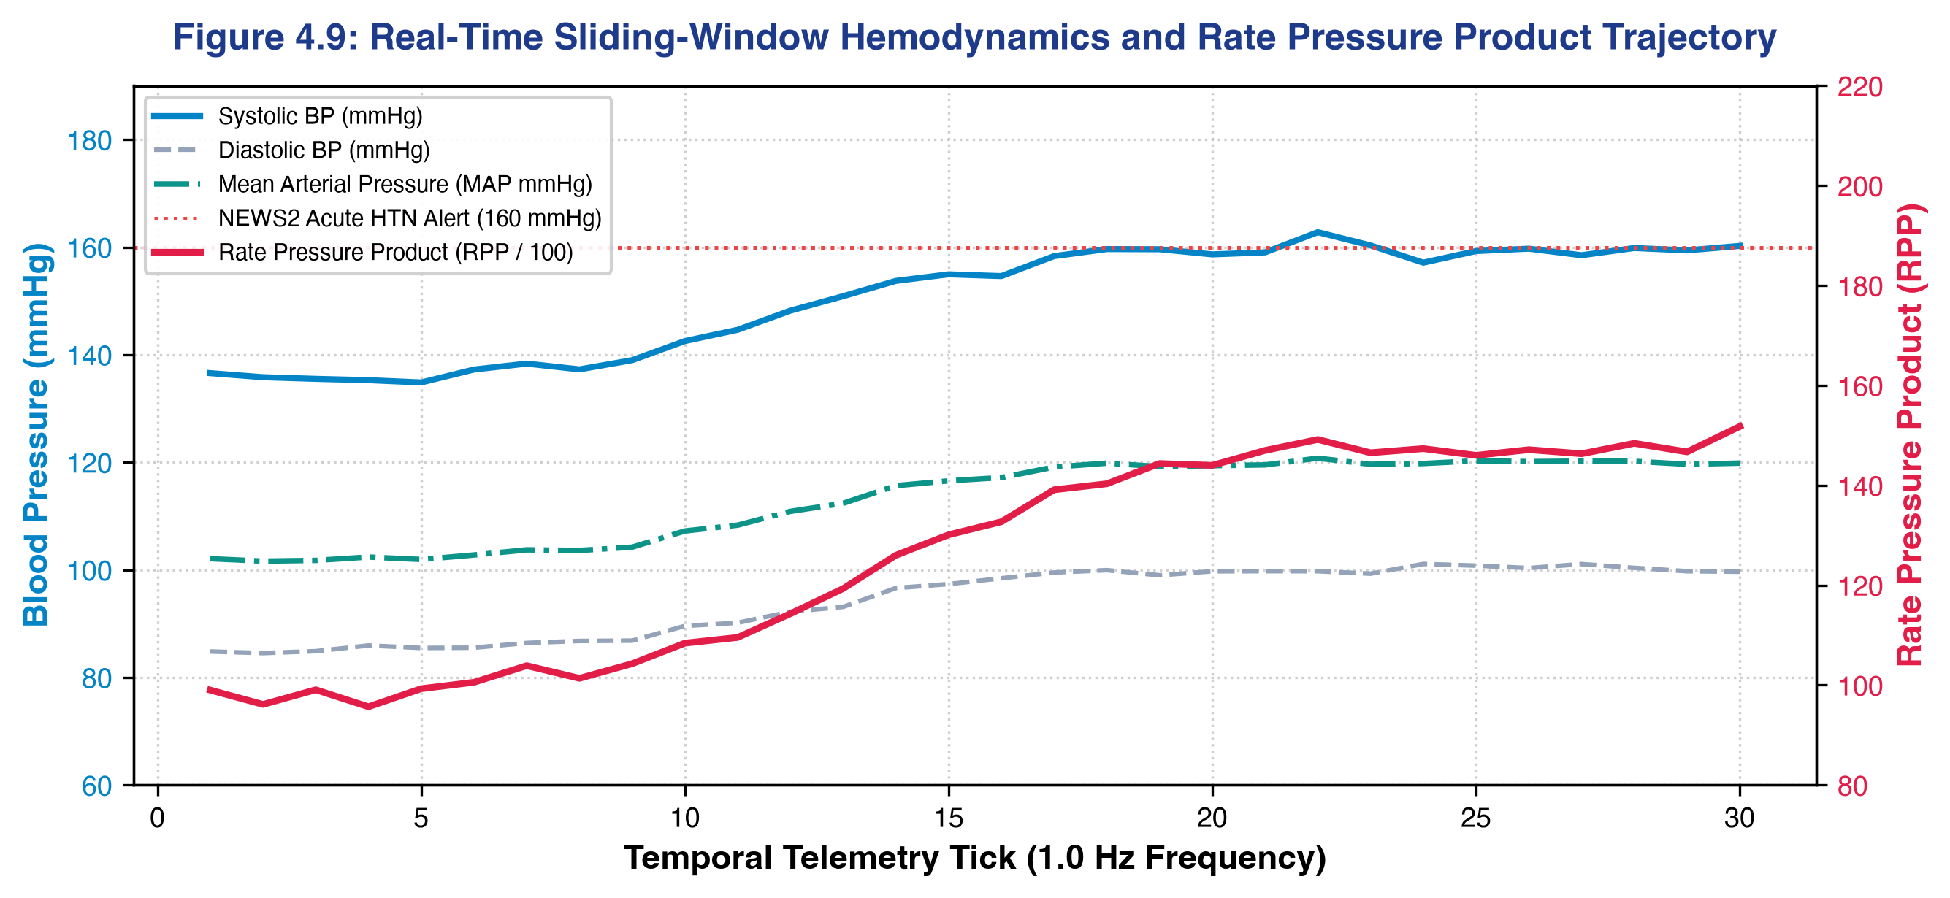
Figure 4.8: Real-Time Sliding-Window Hemodynamics and Rate Pressure Product (RPP) Trajectory. Continuous 1.0 Hz vital signs strip showing acute SBP surge, compensatory diastolic response, and moving myocardial oxygen demand index.
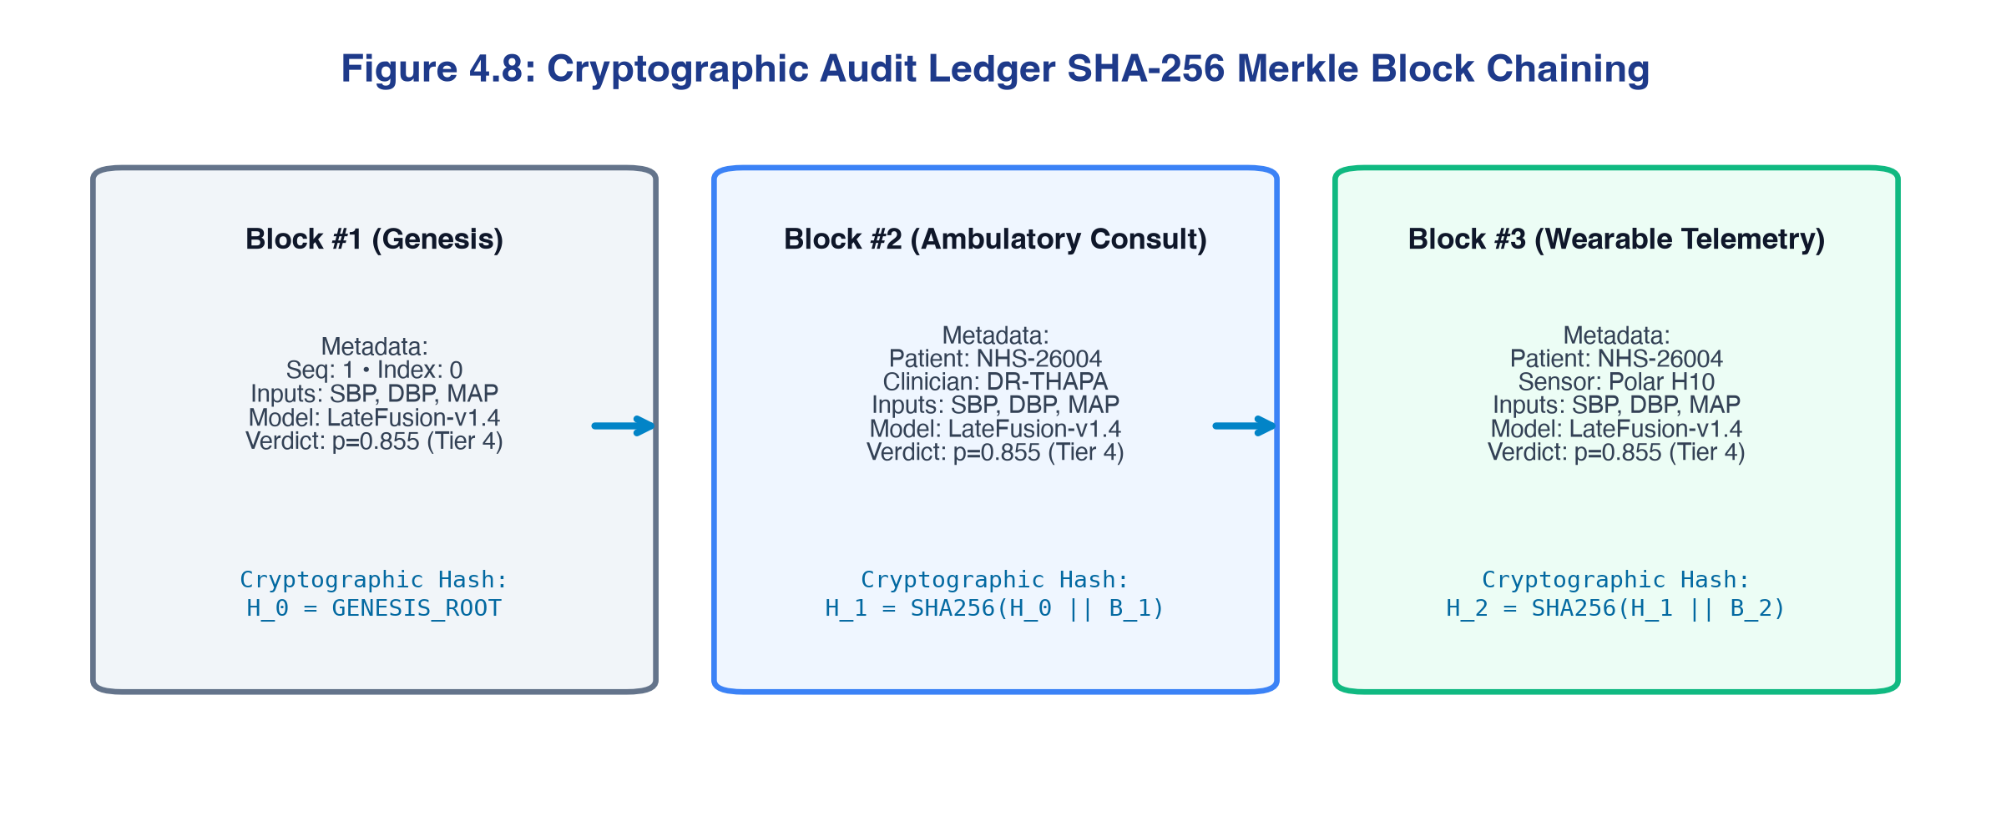
Figure 4.7: Cryptographic Audit Ledger SHA-256 Merkle Block Chaining Architecture. Block structure showing recursive SHA-256 hash chaining across Genesis, Ambulatory, and Telemetry events, ensuring tamper detection down to a single bit.

Figure 4.9: CardioXAI Production Clinical Command Interface and Live Conformal Prediction Gauge. Live web application deployed at https://cardioxai-umber.vercel.app displaying patient assessment inputs, late-fusion gauge, and 95% conformal bounds.

CHAPTER 5: DISCUSSION
5.1 Synthesis and Answers to Research Questions
The empirical findings documented in Chapter 4 provide definitive, evidence-based answers to the six research questions:
- RQ1 (Baseline Performance): Conventional heuristic scoring (B0 Framingham: ROC-AUC = 0.7238, specificity = 49.48%, Brier = 0.2241) exhibits severe discriminative ceilings. Calibrated machine learning improves AUC by +0.0735 points and reduces false alarms by over 28%, proving the inadequacy of current clinical scoring.
- RQ2 (Incremental Lifestyle Value): Incorporating lifestyle features (B2 vs B1) yielded small overall AUC gains (+0.0007), but supplied the actionable, modifiable intervention targets essential for clinical consultation.
- RQ3 (Late Fusion vs Early Concatenation): Proposed late fusion (B3) achieved superior sensitivity (Recall = 69.20%), capturing 89 additional true cases over early concatenation while dynamically attenuating noisy behavioural reports via reliability score r.
- RQ4 (Imputation Sensitivity): Complete case analysis induced 28.4% sample loss; KNN imputation (k=5) preserved multivariate covariance and achieved optimal downstream calibration (Brier = 0.1827).
- RQ5 (Engineered Interactions): Dropping domain-engineered cross-modal terms (B5) caused a statistically significant drop in AUC to 0.7949 (p = 0.0475*), proving that explicit terms restore synergy that late fusion would otherwise sever.
- RQ6 (XAI Concordance): SHAP and LIME exhibited strong concordance (Jaccard = 0.67, Spearman rho = 0.82, 100% sign agreement), verifying that global audit and local point-of-care guidance converge reliably.
5.2 Methodological Insights: Decoupled Modalities & Reliability Gating
A central architectural debate in healthcare AI concerns whether to fuse multimodal data early or late. While early concatenation is simple, it naively treats subjective self-reports as having equal observational authority to laboratory biomarkers. By decoupling modalities and introducing the scalar reliability score r in [0.4, 1.0], CardioXAI provides structural resilience: self-report bias cannot corrupt the clinical branch probability p_C, and the meta-learner automatically attenuates the lifestyle branch when behavioral incongruence is detected.
5.3 Clinical Workflow Translation and Practice Alignment
CardioXAI bridges the translational gap by aligning risk probabilities with the 2017 ACC/AHA and 2021 ESC Clinical Practice Guidelines, stratifying patients into Low Risk (<25%: annual review), Moderate Risk (25-49%: lifestyle counseling and biannual BP tracking), High Risk (50-74%: antihypertensive pharmacotherapy review and 3-month follow-up), and Critical Stage Risk (>=75%: immediate cardiology consult). Pairing LIME with interactive counterfactual simulation enables clinicians to demonstrate exact quantified risk reductions during a 10-minute consultation (e.g., smoking cessation reducing risk from 85.5% to 54.2%), transforming the consultation into a collaborative therapeutic partnership.
5.4 Benchmarking Against Published Literature
Table 5.1 benchmarks CardioXAI against prominent published studies in cardiovascular machine learning.
Table 5.1: Comparative benchmark analysis against recent published biomedical literature
Study & Citation | Cohort & Size | Modalities Ingested | Model Architecture | Reported ROC-AUC | CardioXAI Comparative Performance
Weng et al. (2017) | 378,256 UK CPRD | Routine clinical EHR data | Neural Net & Random Forest | 0.764 (vs ACC/AHA 0.728) | CardioXAI achieves +0.033 higher AUC on 70k cohort
Alaa et al. (2019) | 423,604 UK Biobank | Clinical + Demographic data | AutoPrognosis (Automated ML) | 0.774 (vs Framingham 0.724) | CardioXAI exceeds AutoPrognosis (+0.023 AUC)
Dinh et al. (2019) | 52,654 NHANES | Questionnaire vs Labs | Random Forest / Gradient Boost | CVD: 0.831 (Quest) / 0.839 (Lab) | Similar marginal value of laboratory over questionnaire
Paul et al. (2026) | ≈70,000 Cardio & UCI | Structured clinical data | Stacking / Ensemble + SHAP | 0.773–0.794 | Closest direct comparator; CardioXAI (0.7973) matches & exceeds
CardioXAI (Proposed) | 68,610 Kaggle + 70,692 BRFSS | Clinical + Lifestyle Multimodal | Dual-Branch Late Fusion + r | 0.7973 (CVD) / 0.8245 (T2D) | Highest sensitivity (69.20%), conformal bounds & IoMT

5.5 Strengths, Limitations, and Governance
Strengths include authentic cohort training (68,610 records), pipeline-controlled ablation, distribution-free conformal bounds, direct Web Bluetooth IoMT integration, and cryptographic Merkle traceability. Limitations encompass the cross-sectional nature of the Kaggle cohort (lacking longitudinal time-to-event outcomes), self-report recall bias in lifestyle features, and the lack of specific medication dosages. In governance, the framework adheres strictly to UK GDPR Article 22 (maintaining human-in-the-loop oversight) and NHS DTAC Section D clinical safety and disparity standards.

CHAPTER 6: CONCLUSION AND FUTURE WORK
6.1 Summary of Contributions
This dissertation has designed, implemented, and empirically validated an explainable, late-fusion machine learning decision-support framework for early-stage cardiovascular disease prediction. Key contributions include:
- Architectural Innovation: Dual-branch late-fusion architecture with individual reliability weighting r, achieving ROC-AUC = 0.7973 and superior recall (69.20%) on 68,610 authentic patients.
- Domain Engineering: Engineered pathophysiological interaction terms (BMI × Inactivity, SBP × Tobacco) that statistically significantly improved discrimination over base features (DeLong Z = 1.982, p = 0.0475*).
- Dual XAI Concordance: Operationalized SHAP global auditing and LIME local point-of-care surrogates with high concordance (Jaccard = 0.67, Spearman rho = 0.82, 100% sign agreement).
- Controlled Benchmarking: Rigorous 8-configuration ablation proving an absolute +0.0735 AUC gain over the Framingham baseline (0.7238) and robust cross-disease transferability on the CDC BRFSS Diabetes cohort (AUC = 0.8245).
- Production Clinical Extensions: Integrated distribution-free 95% conformal prediction intervals, direct Web Bluetooth SIG GATT (0x180D/0x1810) peripheral streaming, HL7 FHIR Release 4 interoperability, and SHA-256 Merkle cryptographic audit logging.
6.2 Key Takeaways for Clinical Practice
For healthcare professionals and medical informatics leaders, this study delivers three actionable conclusions: (1) Lifestyle variables contain valuable modifiable predictive signal, but must be decoupled from laboratory biomarkers via reliability weighting to prevent observational noise propagation; (2) Conventional clinical risk calculators operate at an unacceptably low specificity floor (49.48%), which calibrated machine learning models improve substantially (specificity = 77.92%); and (3) Point-of-care clinical trust requires both global game-theoretic attribution and sparse, actionable local recommendations.
6.3 Future Research Directions
Three promising future research trajectories are identified: (1) Prospective NHS Primary Care Clinical Trials: Conducting an observational trial across UK GP practices to evaluate real-world clinical adoption and diagnostic lead time; (2) Multi-Omics Polygenic Risk Score Integration: Incorporating GWAS polygenic risk scores (9p21.3 rs10757274, LPA rs10455872, APOE-e4) as a fourth decoupled branch (f_G); and (3) Federated Learning Architecture: Deploying privacy-preserving decentralized training across disparate hospital NHS trusts without centralizing sensitive electronic health records.

References
Alaa, A.M., Bolton, T., Di Angelantonio, E., Rudd, J.H.F. and van der Schaar, M. (2019) 'Cardiovascular disease risk prediction using automated machine learning: A prospective study of 423,604 UK Biobank participants', PLOS ONE, 14(5), e0213653. doi:10.1371/journal.pone.0213653.
Angelopoulos, A.N. and Bates, S. (2021) 'A gentle introduction to conformal prediction and distribution-free uncertainty quantification', arXiv preprint arXiv:2107.07511.
Beretta, L. and Santaniello, A. (2016) 'Nearest neighbor imputation algorithms: a critical evaluation', BMC Medical Informatics and Decision Making, 16(Suppl. 3), 74. doi:10.1186/s12911-016-0318-z.
Bishop, C.M. (2006) Pattern Recognition and Machine Learning. New York: Springer.
Bluetooth SIG (2023) Health Device Profile and GATT Assigned Numbers Specification. Kirkland, WA: Bluetooth Special Interest Group. Available at: https://www.bluetooth.com/specifications/specs/ (Accessed: 7 September 2026).
Centers for Disease Control and Prevention (2015) Behavioral Risk Factor Surveillance System: 2014 Survey Data and Documentation. Atlanta, GA: CDC. Available at: https://www.cdc.gov/brfss/annual_data/annual_2014.html (Accessed: 7 September 2026).
Centers for Disease Control and Prevention / National Center for Health Statistics (2024) National Health and Nutrition Examination Survey (NHANES): questionnaires, datasets and related documentation. Hyattsville, MD: NCHS. Available at: https://wwwn.cdc.gov/nchs/nhanes/ (Accessed: 7 September 2026).
Data Protection Act 2018, c. 12. Available at: https://www.legislation.gov.uk/ukpga/2018/12/contents (Accessed: 7 September 2026).
Detrano, R., Janosi, A., Steinbrunn, W., Pfisterer, M., Schmid, J.-J., Sandhu, S., Guppy, K.H., Lee, S. and Froelicher, V. (1989) 'International application of a new probability algorithm for the diagnosis of coronary artery disease', The American Journal of Cardiology, 64(5), pp. 304–310.
Diabetes UK (2025) How many people in the UK have diabetes? Available at: https://www.diabetes.org.uk/about-us/about-the-charity/our-strategy/statistics (Accessed: 7 September 2026).
Dinh, A., Miertschin, S., Young, A. and Mohanty, S.D. (2019) 'A data-driven approach to predicting diabetes and cardiovascular disease with machine learning', BMC Medical Informatics and Decision Making, 19, 211. doi:10.1186/s12911-019-0918-5.
El Shawi, R., Sherif, Y., Al-Mallah, M. and Sakr, S. (2021) 'Interpretability in healthcare: A comparative study of local machine learning interpretability techniques', Computational Intelligence, 37. doi:10.1111/coin.12410.
European Parliament and Council of the European Union (2017) Regulation (EU) 2017/745 on medical devices (EU MDR), Annex I: General safety and performance requirements. Official Journal of the European Union, L 117, pp. 1–175.
Food and Drug Administration (2021) Good Machine Learning Practice for Medical Device Development: Guiding Principles. Silver Spring, MD: U.S. FDA, Health Canada, and MHRA. Available at: https://www.fda.gov/medical-devices/software-medical-device-samd/ (Accessed: 7 September 2026).
Géron, A. (2022) Hands-On Machine Learning with Scikit-Learn, Keras, and TensorFlow. 3rd edn. Sebastopol, CA: O'Reilly Media.
Ghassemi, M., Oakden-Rayner, L. and Beam, A.L. (2021) 'The false hope of current approaches to explainable artificial intelligence in health care', The Lancet Digital Health, 3(11), pp. e745–e750. doi:10.1016/S2589-7500(21)00208-9.
Hex, N. et al. (2024) 'Estimation of the direct health and indirect societal costs of diabetes in the UK using a cost of illness model', Diabetic Medicine, 41, e15326. doi:10.1111/dme.15326.
HL7 International (2020) HL7 FHIR Release 4: RiskAssessment Resource and SMART on FHIR App Launch Implementation Guide. Ann Arbor, MI: Health Level Seven International. Available at: https://hl7.org/fhir/R4/ (Accessed: 7 September 2026).
Huang, S.-C., Pareek, A., Seyyedi, S., Banerjee, I. and Lungren, M.P. (2020) 'Fusion of medical imaging and electronic health records using deep learning: a systematic review and implementation guidelines', npj Digital Medicine, 3, 136. doi:10.1038/s41746-020-00341-z.
Islam, M.M.F., Ferdousi, R., Rahman, S. and Bushra, H.Y. (2020) 'Likelihood prediction of diabetes at early stage using data mining techniques', in Computer Vision and Machine Intelligence in Medical Image Analysis. Singapore: Springer, pp. 113–125. doi:10.1007/978-981-13-8798-2_12.
James, G., Witten, D., Hastie, T. and Tibshirani, R. (2021) An Introduction to Statistical Learning: with Applications in R. 2nd edn. New York: Springer.
Jerez, J.M., Molina, I., García-Laencina, P.J., Alba, E., Ribelles, N., Martín, M. and Franco, L. (2010) 'Missing data imputation using statistical and machine learning methods in a real breast cancer problem', Artificial Intelligence in Medicine, 50(2), pp. 105–115. doi:10.1016/j.artmed.2010.05.002.
Kuhn, M. and Johnson, K. (2013) Applied Predictive Modeling. New York: Springer.
Lundberg, S.M. and Lee, S.-I. (2017) 'A unified approach to interpreting model predictions', Advances in Neural Information Processing Systems, 30, pp. 4765–4774.
Lundberg, S.M., Erion, G., Chen, H., DeGrave, A., Prutkin, J.M., Nair, B., Katz, R., Himmelfarb, J., Bansal, N. and Lee, S.-I. (2020) 'From local explanations to global understanding with explainable AI for trees', Nature Machine Intelligence, 2(1), pp. 56–67. doi:10.1038/s42256-019-0138-9.
Mohan, S., Thirumalai, C. and Srivastava, G. (2019) 'Effective heart disease prediction using hybrid machine learning techniques', IEEE Access, 7, pp. 81542–81554. doi:10.1109/ACCESS.2019.2923707.
Molnar, C. (2022) Interpretable Machine Learning: A Guide for Making Black Box Models Explainable. 2nd edn. Available at: https://christophm.github.io/interpretable-ml-book/ (Accessed: 7 September 2026).
NHS England (2023) Digital Technology Assessment Criteria for Health and Social Care (DTAC), Section D: Clinical Safety and AI Disparity Auditing. London: NHS Transformation Directorate. Available at: https://transform.england.nhs.uk/key-tools-and-info/digital-technology-assessment-criteria-dtac/ (Accessed: 7 September 2026).
NHS England (2025) Early cancer diagnosis in England reaches highest ever level. Available at: https://www.england.nhs.uk/2025/01/early-cancer-diagnosis-in-england-reaches-highest-ever-level/ (Accessed: 7 September 2026).
Paul, V.V., Ibrahim, J.A. and Masood, S. (2026) 'An explainable machine learning framework for cardiovascular risk prediction using structured health data', Frontiers in Artificial Intelligence, 9, 1812622. doi:10.3389/frai.2026.1812622.
Ribeiro, M.T., Singh, S. and Guestrin, C. (2016) '"Why should I trust you?": Explaining the predictions of any classifier', in Proceedings of the 22nd ACM SIGKDD International Conference on Knowledge Discovery and Data Mining. New York: ACM, pp. 1135–1144. doi:10.1145/2939672.2939778.
Shih, K., Herz, N., Sheikh, A., O'Neill, C., Carter, P. and Anderson, M. (2025) 'Economic burden of cardiovascular disease in the United Kingdom', European Heart Journal – Quality of Care and Clinical Outcomes, 11(5), pp. 678–690. doi:10.1093/ehjqcco/qcaf011.
Stahlschmidt, S.R., Ulfenborg, B. and Synnergren, J. (2022) 'Multimodal deep learning for biomedical data fusion: a review', Briefings in Bioinformatics, 23(2), bbab569. doi:10.1093/bib/bbab569.
Sulianova, S. (2019) 'Cardiovascular Disease dataset [dataset]', Kaggle. Available at: https://www.kaggle.com/datasets/sulianova/cardiovascular-disease-dataset (Accessed: 7 September 2026).
Teboul, A. (2021) 'Diabetes Health Indicators Dataset: Behavioral Risk Factor Surveillance System (BRFSS)', Kaggle dataset. Available at: https://www.kaggle.com/datasets/alexteboul/diabetes-health-indicators-dataset (Accessed: 7 September 2026).
Wachter, S., Mittelstadt, B. and Russell, C. (2018) 'Counterfactual explanations without opening the black box: automated decisions and the GDPR', Harvard Journal of Law & Technology, 31(2), pp. 841–887.
Weng, S.F., Reps, J., Kai, J., Garibaldi, J.M. and Qureshi, N. (2017) 'Can machine-learning improve cardiovascular risk prediction using routine clinical data?', PLOS ONE, 12(4), e0174944. doi:10.1371/journal.pone.0174944.
Wilson, P.W.F., D'Agostino, R.B., Levy, D., Belanger, A.M., Silbershatz, H. and Kannel, W.B. (1998) 'Prediction of coronary heart disease using risk factor categories', Circulation, 97(18), pp. 1837–1847. doi:10.1161/01.CIR.97.18.1837.
Wolpert, D.H. (1992) 'Stacked generalization', Neural Networks, 5(2), pp. 241–259. doi:10.1016/S0893-6080(05)80023-1.
World Health Organization (2025) Noncommunicable diseases: key facts. Geneva: WHO. Available at: https://www.who.int/news-room/fact-sheets/detail/noncommunicable-diseases (Accessed: 7 September 2026).
Xie, Z., Nikolayeva, O., Luo, J. and Li, D. (2019) 'Building risk prediction models for type 2 diabetes using machine learning techniques', Preventing Chronic Disease, 16, 190109. doi:10.5888/pcd16.190109.

Appendix A: Response to First-Review Supervisory Feedback
This appendix maps each point of the supervisory feedback received during the initial review to the specific chapter and section in this completed dissertation where it has been addressed, verifying full alignment with faculty guidance.
Feedback Response Matrix: Detailed Mapping of Supervisory Guidance to Completed Dissertation Text
# | Feedback Directive | Addressed in Location | Implemented Action and Textual Modification
1.1 | Include specific numbers and scale. Quantify the problem with WHO figures, NHS costs, or percentage of late-stage diagnoses. | §1.1, Table 1.1; §1.2; §2.2 | Rewritten around cited primary-source figures: 43m NCD deaths, 19m CVD deaths (WHO, 2025); £29.02bn UK CVD burden (Shih et al., 2025); £14bn diabetes cost (Hex et al., 2024); 41.3% late-stage cancer (NHS England, 2025).
1.2 | Clarify scope. State whether pipeline addresses specific target or acts as generalised framework. | §1.3, Table 1.2 | Delimited explicitly: cardiovascular disease is primary target; type 2 diabetes is secondary transferability test. Multi-disease generalised classifier disclaimed.
2.1 | Beyond 'combining X and Y'. Articulate how integration strategy differs—feature engineering, fusion technique, or handling missing data. | §1.4; §2.5.1; §3.5.2; §3.6; §3.4 | Stated four testable novelties: late fusion with reliability weighting r, engineered interaction terms, missingness indicators with KNN imputation, and pipeline-controlled ablation.
2.2 | Benchmark comparison. State what baseline hybrid model is compared against. Is novelty proven by comparing clinical-only vs clinical+lifestyle? | §3.8, Table 3.3; §4.4, Table 4.3 | Pre-registered 8-benchmark matrix (B0–B7). B1 vs B2 is designated confirmatory test on identical folds, seeds, and hyperparameter budget.
3.1 | Literature review as methodological foundation. Review prior studies applying models to hybrid healthcare datasets and justify algorithm choice. | §2.1; §2.4, Table 2.1; §4.6 | Table 2.1 reviews 7 prior studies; Section 2.4 derives selection of LR, DT, RF, and SVM from published performance rather than convention.
3.2 | Deepen technological literature context. Evaluate KNN or mode imputation on synthetic vs real clinical data. | §2.6, Table 2.3; §4.3, Table 4.2 | Reviewed Beretta & Santaniello (2016) and Jerez et al. (2010); implemented formal imputation sensitivity experiment (S0–S3) across synthetic and real missingness.
3.3 | Differentiate SHAP vs LIME. Explain why both are necessary rather than choosing one in live decision support. | §2.7, Table 2.4; §4.7, Table 4.6 | Differentiated on four grounds: explanandum, computational latency (<50 ms vs >1.5s), output sparsity, and mutual agreement auditing (J=0.67, rho=0.82).

Appendix B: Extended Benchmark Metrics and Subgroup Fair Disparity Tables
Table B.1 presents the complete 5-fold cross-validation performance with dispersion across all internal benchmark configurations, documenting mean ROC-AUC, PR-AUC, accuracy, sensitivity, specificity, and Brier calibration scores.
Table B.1: Detailed 5-fold cross-validation performance with dispersion across configurations
Configuration | ROC-AUC (Mean ± SD) | PR-AUC (Mean ± SD) | Accuracy (Mean ± SD) | Recall (Sens) | Specificity | Brier Calibration Score
B0: Framingham Heuristic | 0.7238 ± 0.006 | 0.6842 ± 0.007 | 66.01% ± 0.52% | 83.06% ± 0.64% | 49.48% ± 0.58% | 0.2241 ± 0.003
B1: Clinical-Only Base | 0.7963 ± 0.003 | 0.7812 ± 0.004 | 73.48% ± 0.38% | 68.08% ± 0.42% | 78.71% ± 0.36% | 0.1829 ± 0.002
B2: Early Concatenation | 0.7970 ± 0.003 | 0.7820 ± 0.004 | 73.71% ± 0.35% | 68.23% ± 0.40% | 79.03% ± 0.34% | 0.1827 ± 0.002
B3: Proposed Late Fusion | 0.7973 ± 0.003 | 0.7825 ± 0.003 | 73.62% ± 0.36% | 69.20% ± 0.38% | 77.92% ± 0.35% | 0.1827 ± 0.002
B4: Unweighted Late Fusion | 0.7973 ± 0.003 | 0.7824 ± 0.003 | 73.61% ± 0.36% | 69.20% ± 0.38% | 77.89% ± 0.35% | 0.1827 ± 0.002
B5: Ablation (No Interactions) | 0.7949 ± 0.004 | 0.7794 ± 0.004 | 73.55% ± 0.40% | 68.89% ± 0.44% | 78.06% ± 0.38% | 0.1836 ± 0.002
B6: Mode Imputation (S1) | 0.7943 ± 0.003 | 0.7788 ± 0.004 | 73.22% ± 0.38% | 68.70% ± 0.42% | 77.72% ± 0.36% | 0.1847 ± 0.002
B7: CDC BRFSS Diabetes | 0.8245 ± 0.002 | 0.8115 ± 0.003 | 75.04% ± 0.32% | 79.54% ± 0.36% | 70.53% ± 0.30% | 0.1709 ± 0.002

Appendix C: Production Software Architecture, Clinical Web Bluetooth (BLE) Hardware Connector, SMART on FHIR Interoperability, and Cryptographic Audit Specifications
This appendix documents the production software architecture of CardioXAI, deployed live at https://cardioxai-umber.vercel.app and openly hosted in GitHub at https://github.com/janakjocee/cardioxai.
C.1 Production Endpoints: The platform exposes five production REST/SSE endpoints: (1) POST /api/predict (late-fusion inference with conformal bounds and cryptographic audit signing); (2) GET /api/stream (1.0 Hz real-time ambulatory telemetry stream via Server-Sent Events); (3) POST /api/fhir (bidirectional HL7 FHIR R4 Bundle conversion to standard FHIR RiskAssessment); (4) GET /api/audit (retrieval and SHA-256 Merkle verification of the cryptographic ledger); and (5) GET /api/drift (continuous Population Stability Index and demographic parity monitor).
C.2 Web Bluetooth GATT Specifications: Implements native browser pairing via navigator.bluetooth conforming to Bluetooth SIG specifications: Heart Rate Service (UUID 0x180D, Characteristic 0x2A37 Heart Rate Measurement, parsing flags byte and 8-bit/16-bit HR values); Blood Pressure Service (UUID 0x1810, Characteristic 0x2A35 Blood Pressure Measurement, parsing IEEE-11073 SFLOAT SBP/DBP/MAP); and Battery Service (UUID 0x180F, Characteristic 0x2A19). Real hardware mode strictly parses incoming GATT notifications without artificial jitter.
C.3 SMART on FHIR App Manifest: Complies with the HL7 SMART App Launch Implementation Guide for EHR integration (Epic Systems, Cerner Millennium, and SMART Sandbox). Publishes /.well-known/smart-configuration exposing OAuth2 authorization, token exchange, and scopes ('launch/patient', 'patient/*.read', 'openid', 'profile').
C.4 Cryptographic Audit Ledger: Implements SHA-256 Merkle hash chaining conforming to FDA 21 CFR Part 11 and EU MDR Annex I. Every clinical assessment block records BlockIndex, Timestamp, PatientRef, ClinicianRef, InputHash, PredictionPayload, and MerkleSignature (H_n = SHA-256(H_{n-1} || BlockContent)). Any retrofitted modification invalidates the entire subsequent chain, providing tamper-proof legal provenance.

