“Adventure Time: Defense”

A look into the design and development
Janak Shaun Singh Kalar  Kwantlen Polytechnic University of Surrey, British Columbia, Canada  janak.kalar@email.kpu.ca | Lee Liang  Kwantlen Polytechnic University of Surrey, British Columbia, Canada  lei.liang@email.kpu.ca

ABSTRACT
For this project, I decided to create a game called “Adventure Time: Defense”. Within this game, you play as Finn, from the hit American fantasy animated Cartoon Network show, Adventure Time.

Within this game, you are trying to protect your companion, Jake the Dog, of which who is pictured in the bottom right of the screen.
The game features a multiple level system, but as this is only a smaller showcase of the systemics, there is only 1 implemented level, level 1. (Level 0 is our home screen, level 2 is our lose screen and level 3 is the win screen).
Within the game, you start prompted with a home screen, in which you are given some information. You are given the title of the game. You are given a play button, which features highlighting when you hover over it. And at the bottom of the screen, you are given instructions on how to play the game. Below is an image of the main screen.
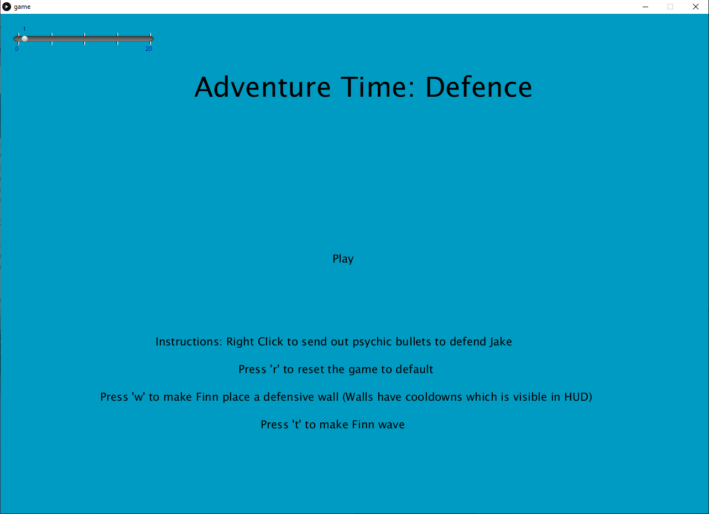
As you can see above, there is some text for instructions. It reads “Instructions, Right Click to send out Psychic bullets to defend jake”. There are also some additional instructions provided. Such as “Press ‘r’ to reset the game” and “Press ‘w’ to make Finn Wave”. If the player presses the “Play” button, they will be sent to level 1.
Once players access level 1, they are prompted with visuals of Finn standing off to the right with Jake, standing in the field of the Lands of Ooo, from the cartoon.
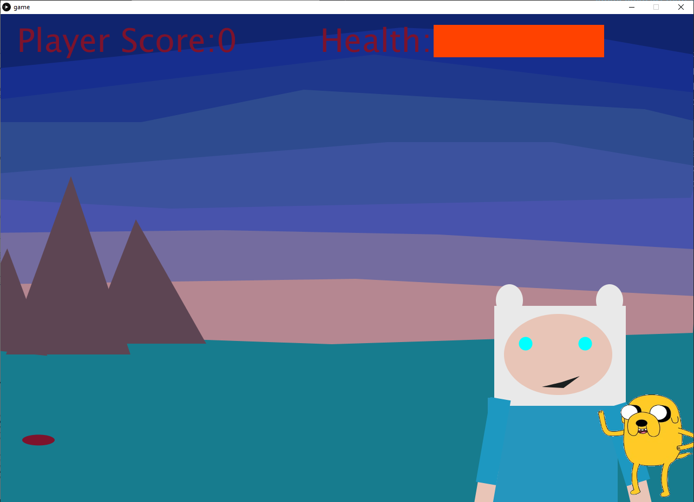
Above, Early Build
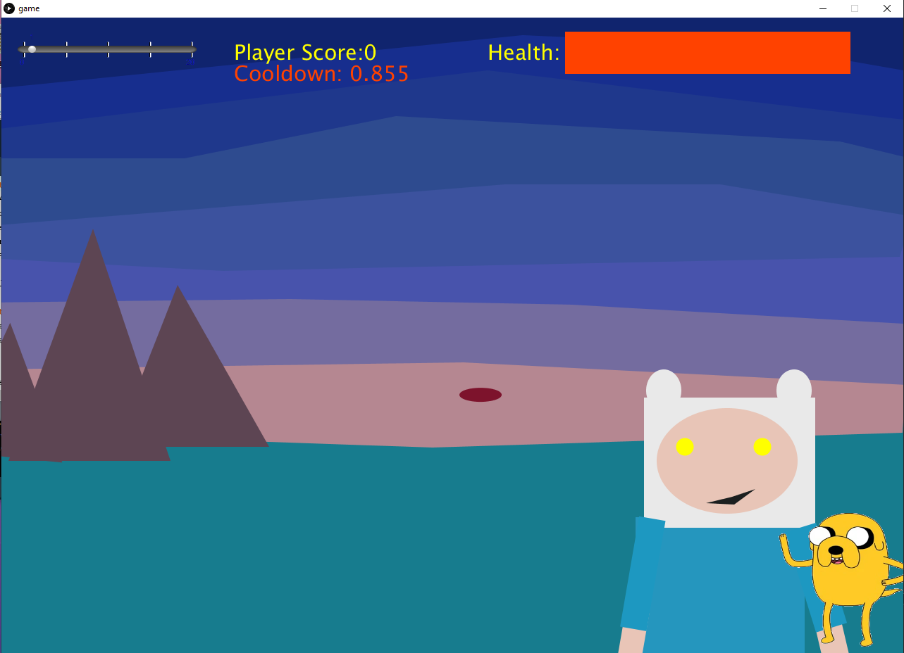
Below, New Build

Players can summons Psychic pellets to destroy oncoming pellets and earn “Player Score”. If the player Earns 25 score, they win. If the Enemy Pellets touch the right side of the screen, it will lower the health bar of Jake. If Jake’s Health Bar bottoms out, you lose.
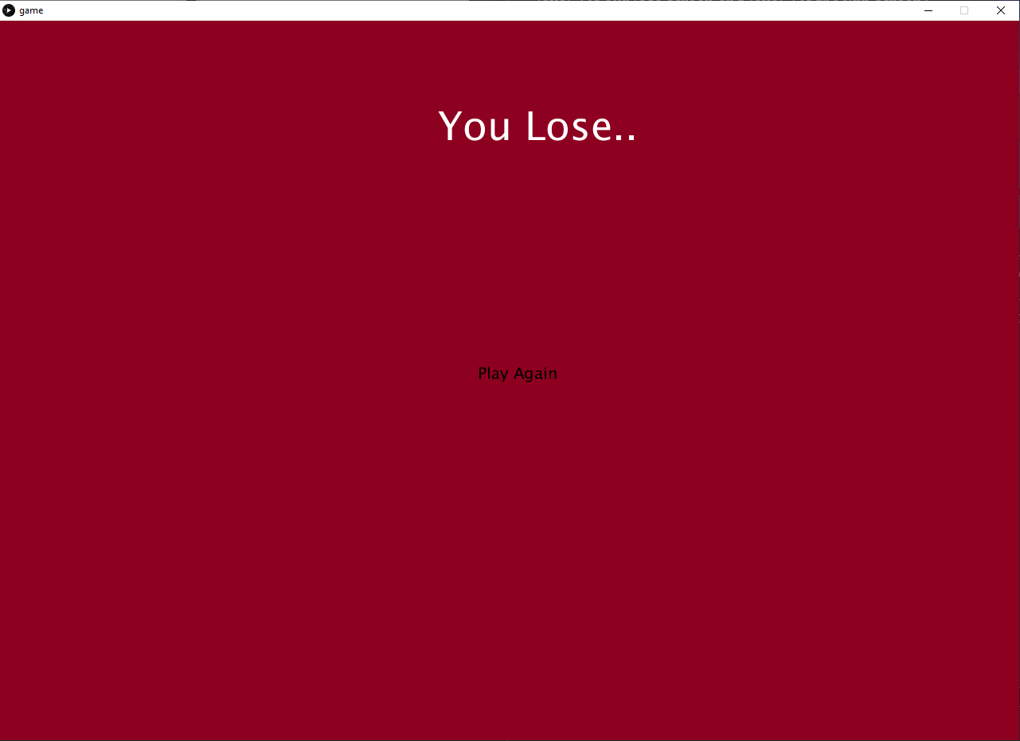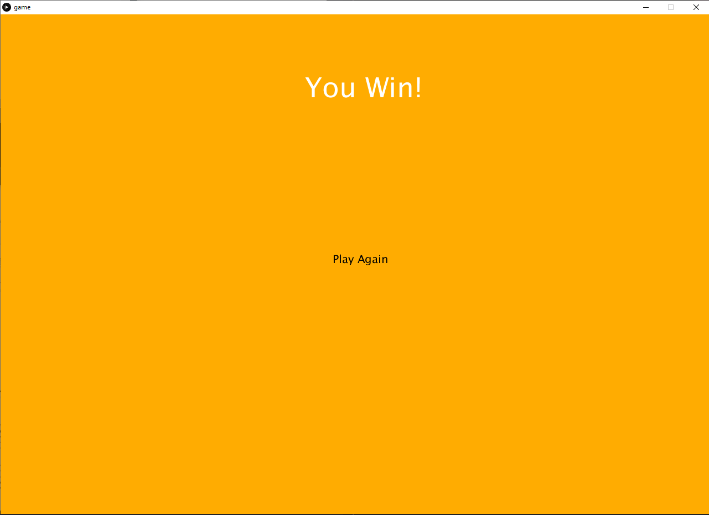
Losing Screen and Winning Screen Respectively.
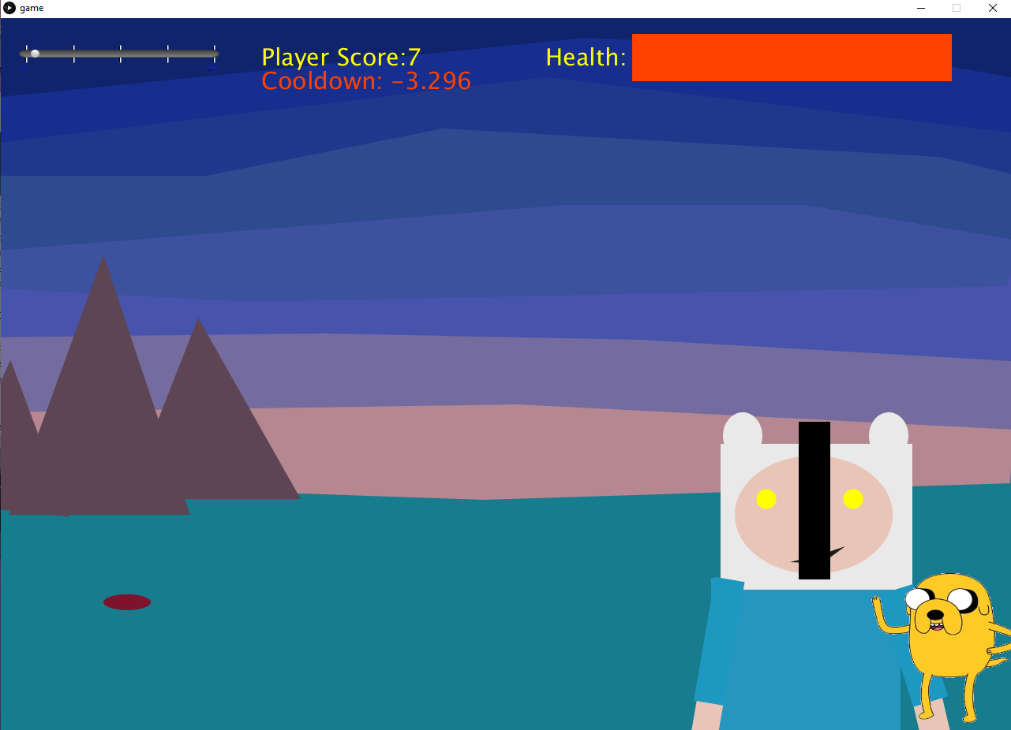
Players are also able to place down walls with the ‘w’ key, as pictured above. This will allow players to play more strategically. The walls have a 5 second cooldown, and the player can see the cooldown in the HUD. Also within the hud, the player has a slider, which ive pictured below. It acts as a sort of difficulty option, allowing the player to increase there projectile size.

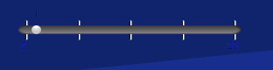

The game also features a boss fight, which is a multi stage enounter.
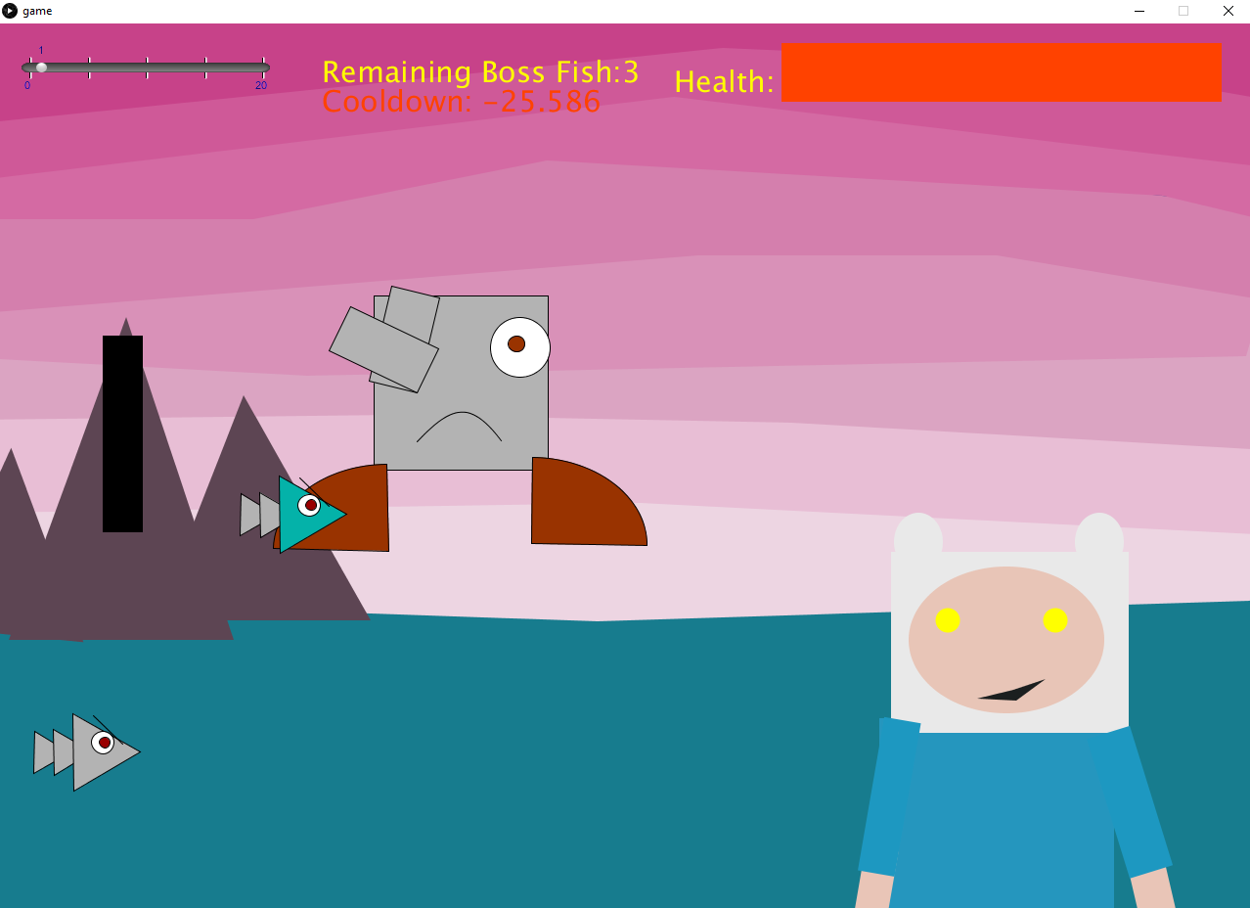
With the bossfight, the appearance of the stage changes. The boss character is in the background, summoning fish enemies to assult the player. The player has to kill 3 multicolored fish in order to repell the boss. As the player hits the fish with projectiles, its colors change as it gets lower in health.
This enemy differs from other characters in that, similar to the player, it has its own health. Each fish has health that you can lower by hitting it. Overall the player needs to defeat 3 enemy fish to repell the boss and win the game.
PROCESS
The core structure of the program must first be described before we get into the specifics of how certain systems are made. Below, there is a Use Case Diagram to help illustrate the systems, and we will go into further detail as well.
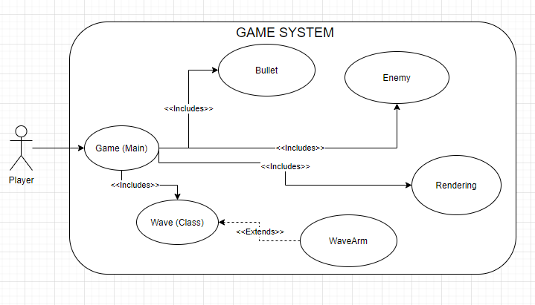
Some facts about this layout:
- Rendering Handles Drawing: The background, the ground, the mountains, Finn Himself, The Health Bar
- Enemy Handles: Spawning Enemies, Moving Enemies.
- Bullet: The bullet objects, displaying them, there movement, and the collision system between the bullet and the enemies.
- Wave: Wave Object, angle handling
- WaveArm: Object Data, and displaying the arm
- Game (Main): Most of the game logic for health, levels, etc.

Since this old version, the complexity has further increased with new content, as such, the current game system looks like this in its final version.

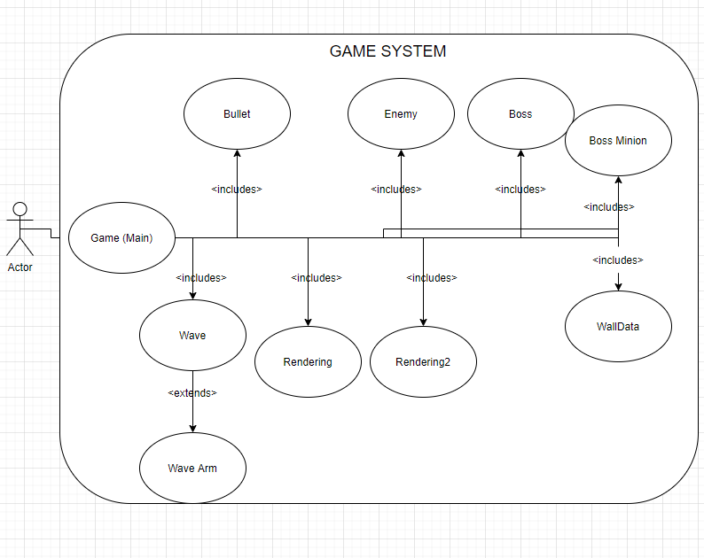

The additional objects are quite self explanatory.
- Boss: Boss data
- Boss Minion: Boss Minion Data
- Rendering2: Additional Rendering
- WallData: Player Wall Placement information
LEVEL SYSTEM
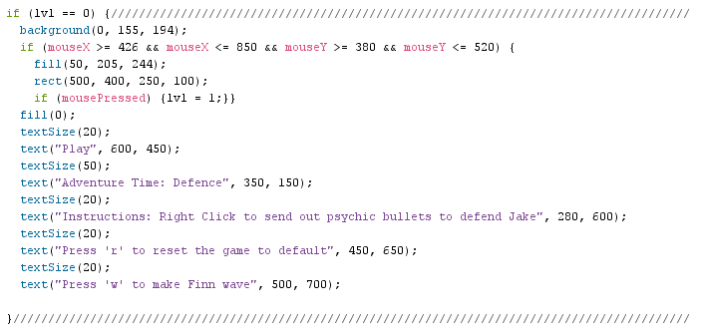
Above are an example of the game handles the level system. By default, the game opens with level 0, the main menu, level’s count is increased when you press the play button, and you are sent to level 1.
ARRAYLIST OBJECT / COLLISION DETECTION
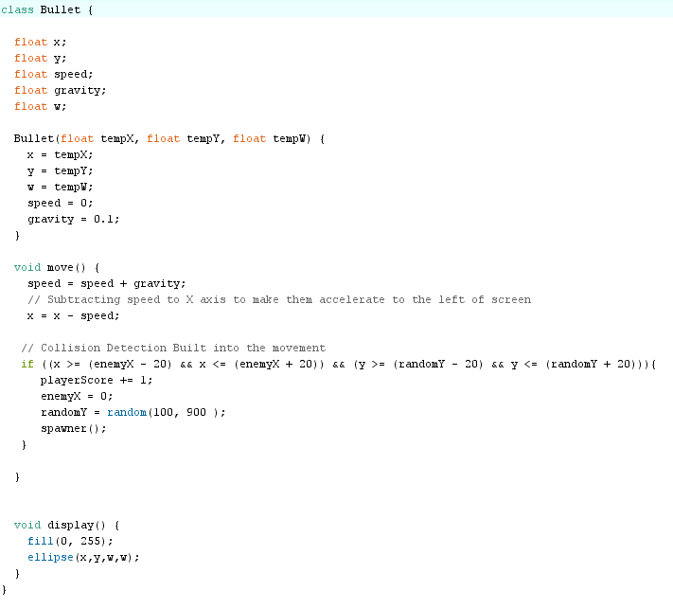
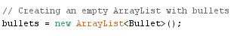
The game stores the “bullets” the main character fires in the arrayList format. There are many benefits because of this, such as the array not being finite (which is important, so the player isn’t limited in how many bullets they shoot).
The pellets also handle the Collision detection within this portion of code.
The collision detection works as such:
- During the move command, the code checks for collision
- It detects its based on the X position and Y position of the current moving ball.
- It checks that within a Radius of 20 pixels of the X position
- And 20 pixels of the Y position
- That there are no Enemy X or Y positions corresponding to the current balls.
- If the positions match, it increased the enemies score by 1
- Resets the Enemy Position (For X and Y)
- Runs Enemy Script

PARENT-CHILD HIERARCHY
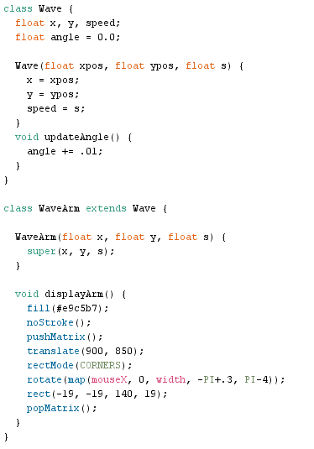
We practice parent-child hierarchy on the “wave” class, as WaveArm extends the wave class. This makes the system more extensible and would allow for us to make other objects handling the same data that extend from the wave class.

UNIQUE DESIGN APPROACH
When it came to designing the systems of the game there is a design philosophy that I have really come to appreciate since it was taught to me by one of my professors.

“The simplest design is usually the best design”, as such, whenever necessary, I reduced complexity. For example, when I was originally adding in collision detection, I had a whole system that would check the bounds of the objects and it was needlessly complex. When I broke down what collision really was, I realized it could be made much simpler.

RESEARCH ENDEAVOR
For this I didn’t research too much, as a lot of the concepts that are shown within this project I already understood. However, I did read a bit into how collisions are done. I mainly read the open processing documentation to aid myself as well, to further understand any ideas that I found to complicated.

