Reproduced analysis of FARS data

## Results

**Percentages of drivers testing positive by drug type, sex, and year group**

|  |  |  |  |  |  |  |
| --- | --- | --- | --- | --- | --- | --- |
| Drug type | F 1999-2002 | F 2003-2006 | F 2007-2010 | M 1999-2002 | M 2003-2006 | M 2007-2010 |
| Alcohol | 26.5 | 24.3 | 27.1 | 43.2 | 42.9 | 43.3 |
| Cannabinoid | 3.4 | 5.8 | 7.4 | 6.6 | 10.7 | 12.2 |
| Depressant | 3.5 | 3.9 | 4.9 | 2.1 | 2.5 | 3.2 |
| Narcotic | 4.6 | 5.0 | 7.3 | 2.4 | 3.4 | 4.0 |
| Other | 5.5 | 6.8 | 7.5 | 4.3 | 4.6 | 4.3 |
| Stimulant | 7.7 | 9.3 | 8.9 | 10.7 | 12.3 | 9.5 |

**Figure 1: Prevalence of nonalcohol drugs in fatally injured drivers by year and age group**

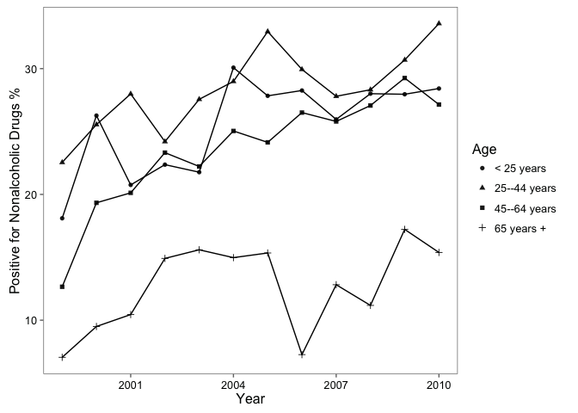

**Figure 2: Prevalence of nonalcohol drugs in fatally injured drivers by year and drug type**

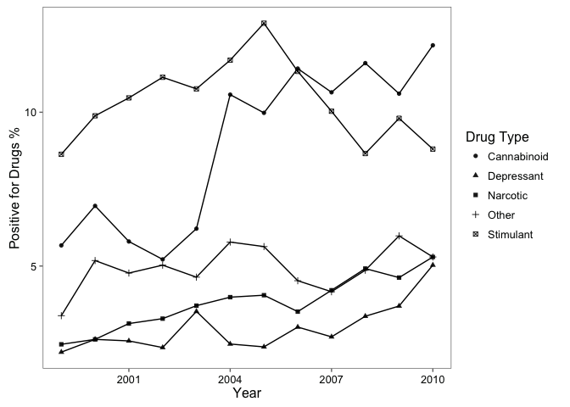

**Figure 3: Prevalence of cannabinoid drugs in fatally injured drivers by year and age group**

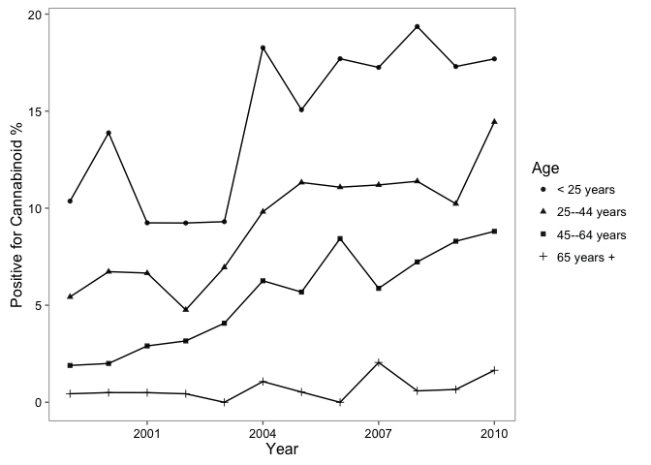

**Prevalence of drugs in fatally injured drivers for 1999 and 2010 by drug type**

|  |  |  |
| --- | --- | --- |
| Drug type | 1999 | 2010 |
| Alcohol | 38.2% (36.4%, 39.9%) | 39.1% (36.7%, 41.5%) |
| Cannabinoid | 5.7% (4.7%, 6.6%) | 12.2% (10.5%, 13.8%) |
| Depressant | 2.2% (1.6%, 2.8%) | 5% (3.9%, 6.1%) |
| Narcotic | 2.5% (1.8%, 3.1%) | 5.3% (4.2%, 6.4%) |
| Other | 3.4% (2.7%, 4.1%) | 5.3% (4.2%, 6.4%) |
| Stimulant | 8.6% (7.5%, 9.8%) | 8.8% (7.4%, 10.2%) |

**Statistics for testing for trend in prevalence of drugs over study years by drug type using Cochran-Armitage trend test**

|  |  |  |
| --- | --- | --- |
| drug | Z | p.value |
| Alcohol | 1.1 | 0.292 |
| Nonalcohol | 10.8 | 0.000 |
| Narcotic | 6.3 | 0.000 |
| Depressant | 4.6 | 0.000 |
| Stimulant | 0.3 | 0.752 |
| Cannabinoid | 12.3 | 0.000 |
| Other | 2.1 | 0.034 |

**Statistics for testing for trend in prevalence of drugs over study years by drug type using Wald test of logistic regression coefficient for “year”**

|  |  |  |
| --- | --- | --- |
| drug | Z | p.value |
| Alcohol | 1.1 | 0.292 |
| Nonalcohol | 10.8 | 0.000 |
| Narcotic | 6.2 | 0.000 |
| Depressant | 4.6 | 0.000 |
| Stimulant | -0.3 | 0.752 |
| Cannabinoid | 12.2 | 0.000 |
| Other | 2.1 | 0.034 |