MICROSERVICES FUNDAMENTALS
Monolith, Service Decomposition, Database-per-Service & Communication
Detailed student notes with architecture diagrams, examples, design guidance and interview questions

Client / Web / Mobile
↓
API Layer
↓
Business Capabilities
↓
Data + External Systems
The core idea: application architecture organizes how client requests reach business capabilities and data.

Learning Objectives
- Understand what a monolithic application is and how it is deployed.
- Understand microservices architecture and the idea of independently deployable services.
- Compare monolith and microservices across deployment, scaling, data, failures and team ownership.
- Explain the major benefits and practical challenges of microservices.
- Learn service decomposition strategies and identify good service boundaries.
- Understand the database-per-service pattern and why direct cross-service database access is discouraged.
- Understand synchronous and asynchronous inter-service communication and when to use each.

What is a Monolithic Application?
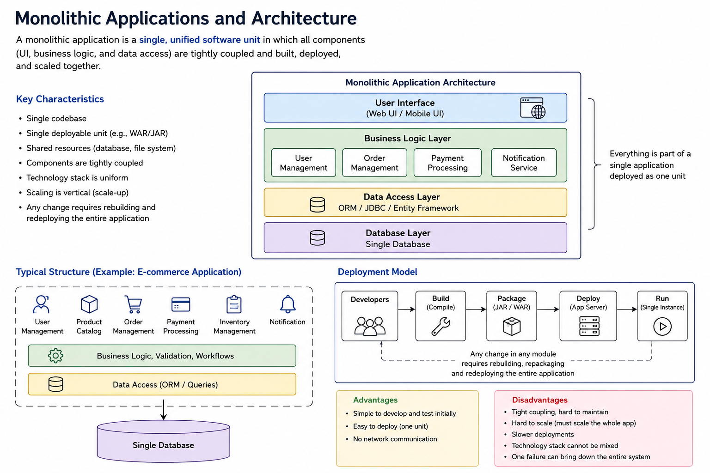
A monolithic application is an application in which major functional modules are packaged and deployed as one application unit. The UI/API layer, business logic and data-access code normally live in the same codebase or deployment artifact and are released together.

Typical Monolithic Architecture
Clients
↓ HTTP
Single Application / Single Deployment Unit
Controller Layer → Service Layer → Repository Layer
↓
Shared Database
Figure 1 - Typical monolithic application flow

Example: E-Commerce Monolith
A single Spring Boot application might contain all of these modules:
- User Management
- Product Catalog
- Cart
- Order Management
- Payment
- Inventory
- Notifications
Even though the source code can be organized into packages, all modules are commonly built into one JAR/WAR and deployed together. A small change in one module can therefore require rebuilding, testing and redeploying the entire application.

Characteristics
- Single deployable artifact such as one JAR, WAR or container image.
- Modules usually execute in the same process.
- Often uses one shared database/schema.
- Internal method calls are fast because modules run in the same process.
- Scaling normally means creating more instances of the whole application.
- A single release pipeline can initially make development and operations simple.

Advantages of a Monolith
- Simple to start, especially for small teams and early-stage applications.
- Easy local development and debugging because the whole flow is in one process.
- Simple transactions when all data is in one database.
- Fewer network calls between modules.
- Deployment, monitoring and testing infrastructure can be simpler.

Limitations as the System Grows
- Large codebase becomes harder to understand and modify.
- Longer build, test and deployment cycles.
- Whole application may need scaling even when only one feature is heavily used.
- Technology upgrades become risky because many modules are coupled.
- A severe resource or application failure can affect the entire deployment.
- Large teams can experience merge conflicts and ownership problems.

What are Microservices?

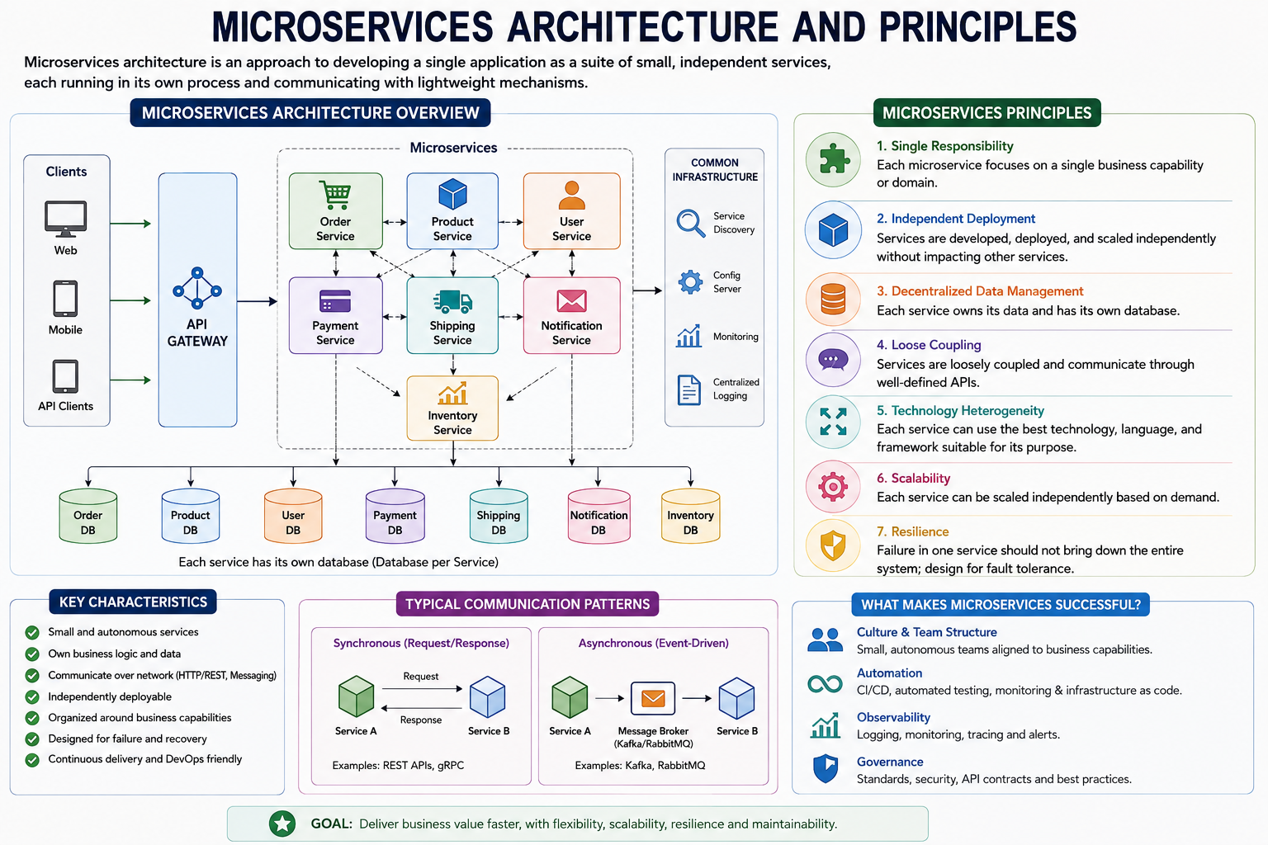
Microservices architecture structures an application as a collection of small, independently deployable services. Each service focuses on a specific business capability, owns its implementation, and normally owns its data. Services communicate through well-defined APIs or messages/events.
Web / Mobile Client
↓
API Gateway / Edge
↓
User Service | Product Service | Order Service | Payment Service
↓ ↓ ↓ ↓
User DB | Product DB | Order DB | Payment DB
Services communicate using APIs and/or events
Figure 2 - Simplified microservices architecture

Key Principles
- Single business responsibility: a service should represent a meaningful business capability.
- Independent deployment: one service can be released without redeploying every other service.
- Independent scaling: scale only services experiencing high load.
- Loose coupling: services depend on contracts, not internal implementation details.
- High cohesion: related business rules should stay together.
- Data ownership: a service controls its own data and exposes it through contracts.
- Automation: CI/CD, observability and infrastructure automation are important for operating many services.

Example Service Responsibilities
Service | Responsibility | Owns
Customer Service | Customer profile and customer lifecycle | Customer data
Product Service | Product catalog and product details | Product data
Order Service | Order creation and order status | Order data
Inventory Service | Stock availability and reservation | Inventory data
Payment Service | Payment processing and payment status | Payment data
Notification Service | Email/SMS/push delivery | Notification history/configuration

Monolith vs Microservices

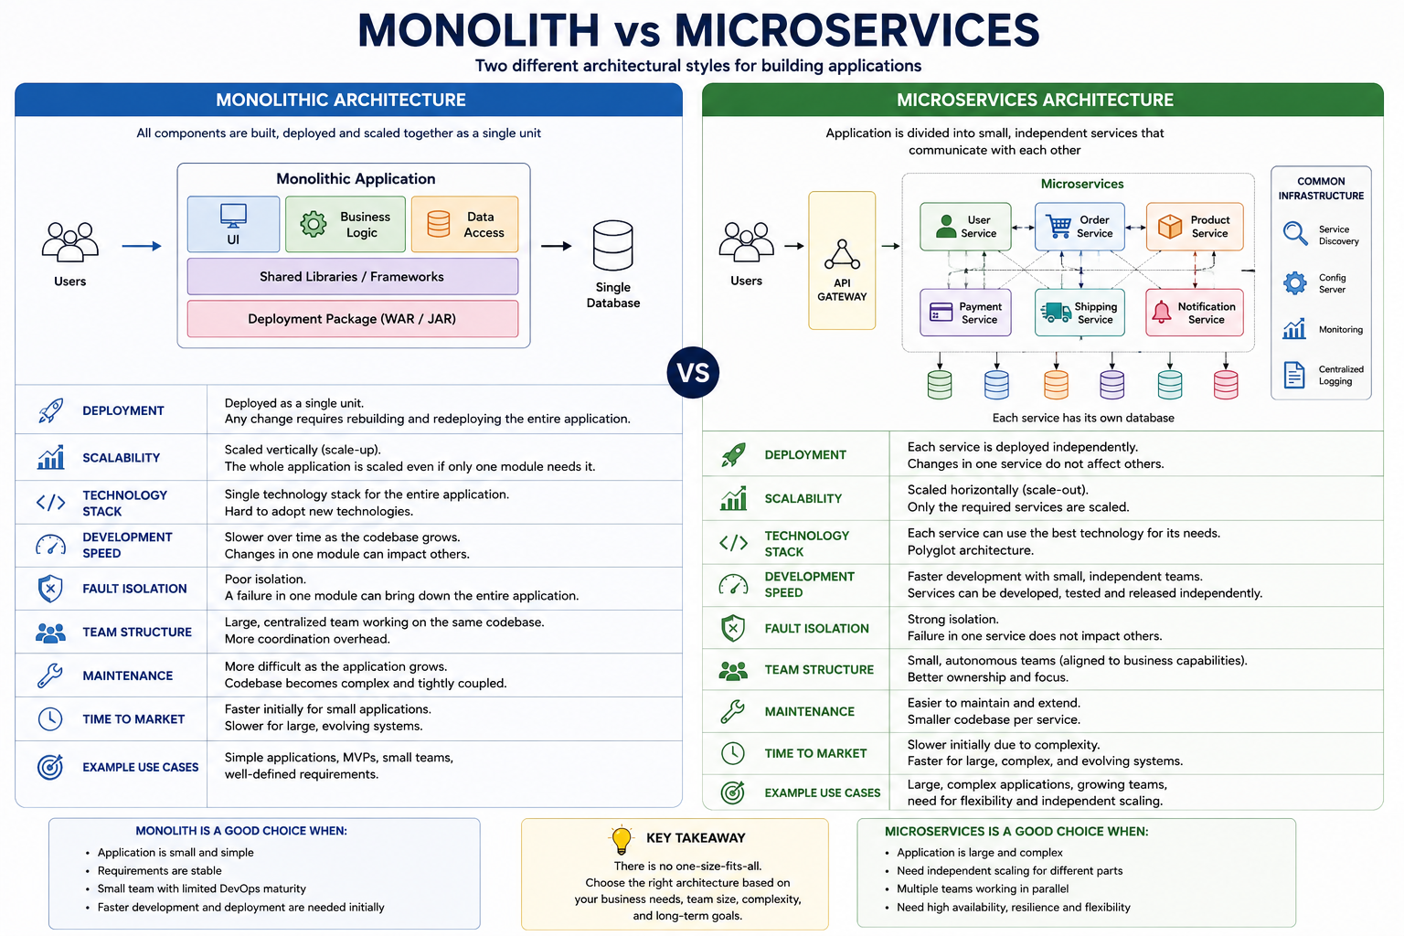
Area | Monolith | Microservices
Deployment | Entire application deployed together | Services can be deployed independently
Codebase | Usually one large application | Multiple smaller service codebases/modules
Scaling | Scale the complete application | Scale selected services
Database | Often shared database | Prefer database/data ownership per service
Communication | In-process method calls | Network APIs and/or messaging
Failure impact | Failure may affect whole app | Can isolate failures, but cascading failures must be controlled
Transactions | Local ACID transactions are easier | Distributed workflows require patterns such as Saga
Technology | Usually one primary stack | Services can evolve independently when justified
Team ownership | Many teams may touch same app | Teams can own business-aligned services
Operations | Initially simpler | Requires stronger DevOps and observability
Testing | End-to-end setup can be simpler | Contract, integration and distributed testing become important

Scaling Difference
MONOLITH: High Order load → Scale [Entire App] [Entire App] [Entire App]
MICROSERVICES: High Order load → Scale [Order] [Order] [Order]
Other services can remain at their required capacity
Figure 3 - Coarse-grained scaling vs independent service scaling

Benefits of Microservices

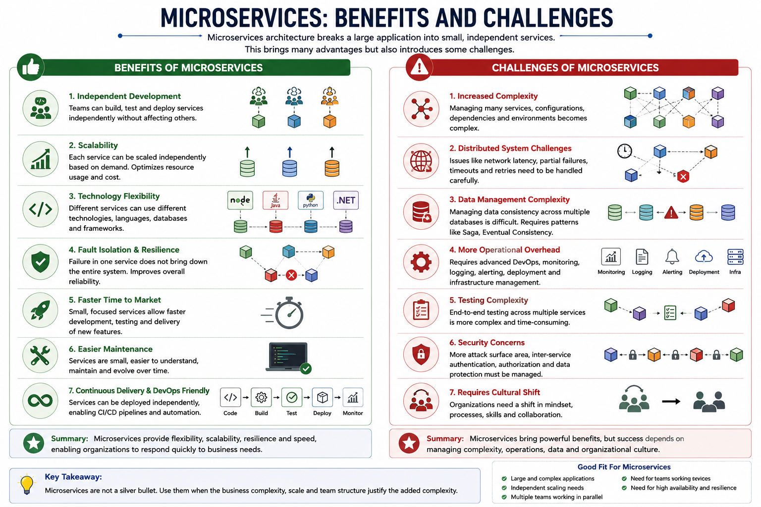

Independent Deployment
A service can be changed and released with less coordination, provided its public contracts remain compatible.

Independent Scaling
CPU/memory-intensive or high-traffic services can be scaled separately.

Fault Isolation
Failure can be contained to a service when timeouts, circuit breakers, bulkheads and graceful degradation are designed correctly.

Team Autonomy
A team can own a service from development through production.

Faster Evolution
Smaller bounded codebases can make focused changes easier.

Technology Flexibility
Different technology choices are possible where they provide real value, although uncontrolled diversity increases operational cost.

Business Alignment
Services can map to business capabilities such as Orders, Payments or Inventory.

Replaceability
A well-isolated service can be rewritten or replaced with lower impact than replacing a large monolith module.

5. Challenges of Microservices
Microservices move complexity from a single process into a distributed system. They are not automatically better than a monolith. Teams should adopt them when the organizational and scaling benefits justify the additional operational complexity.
Challenge | What it means / mitigation direction
Network complexity | Calls can be slow, unavailable or partially fail. Use timeouts, retries carefully, circuit breakers and idempotency.
Distributed data | Data is spread across services, making joins and multi-service transactions harder.
Data consistency | Many workflows become eventually consistent instead of immediately consistent.
Observability | Logs from one user request may span many services. Centralized logging, metrics, tracing and correlation IDs are needed.
Deployment complexity | Many independently deployed components require mature CI/CD and configuration management.
Testing complexity | Integration, contract and end-to-end tests must validate service interactions.
Versioning | API/event contracts must evolve without unexpectedly breaking consumers.
Security | Authentication, authorization, service identity, secrets and secure communication must be handled across the network.
Operational cost | Containers, orchestration, gateways, brokers and observability platforms add infrastructure and skills requirements.

6. Service Decomposition
Service decomposition is the process of deciding how a large business system should be divided into services. Good boundaries minimize unnecessary coupling while keeping closely related business rules and data together.

Bad Decomposition vs Good Decomposition
BAD: Service A ↔ Service B ↔ Service C ↔ Service D (chatty calls, shared tables, unclear ownership)
GOOD: Customer | Catalog | Order | Inventory | Payment
Each service has a clear business responsibility and explicit contracts
Figure 4 - Service boundaries should follow business cohesion, not arbitrary technical layers

Common Decomposition Strategies

A. Decompose by Business Capability
Identify what the business does and create services around stable capabilities. For an e-commerce system: Catalog, Ordering, Payments, Inventory, Shipping and Customer Management.

B. Decompose by Subdomain / Domain-Driven Design (DDD)
Model the domain and identify bounded contexts. A bounded context defines a boundary inside which a domain model and its terminology are consistent. A bounded context is often a strong candidate for a service boundary, though it does not have to map one-to-one.
E-Commerce Domain
↓
Sales Context → Order Service
Inventory Context → Inventory Service
Billing Context → Payment/Billing Service
Customer Context → Customer Service
Figure 5 - DDD bounded contexts can guide service boundaries

C. Strangler Pattern for Migration
When moving from a monolith, do not necessarily rewrite everything at once. Route selected capabilities to new services while the remaining functionality stays in the monolith. Over time, more capabilities are extracted until the old implementation can be retired.
Client
↓
Gateway / Routing Layer
↙ ↘
Existing Monolith New Product Service
Remaining modules Product capability extracted
Later: extract Order → Payment → Inventory as justified
Figure 6 - Incremental migration using the Strangler approach

How to Identify a Good Service Boundary
- It represents a clear business capability.
- It can change with limited impact on other services.
- It owns the business rules and data required for its responsibility.
- Its API is meaningful to consumers and does not expose internal tables.
- It avoids excessive synchronous calls for a single business operation.
- A team can reasonably understand, test, deploy and operate it.
- It does not create a distributed monolith where every service must be deployed together.

7. Database-per-Service Concept

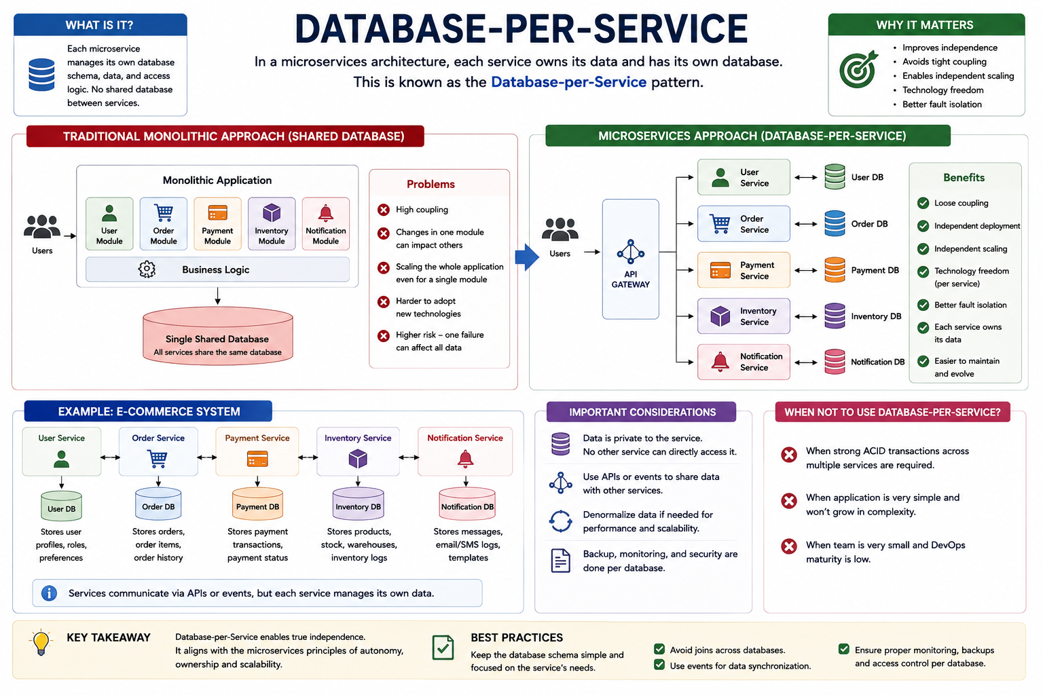
Database-per-service means each microservice owns its persistent data. Other services must not directly read or update that service's private tables. They obtain information through the owning service's API, events or purpose-built read models.
Customer Service → Customer DB
Order Service → Order DB
Inventory Service → Inventory DB
Payment Service → Payment DB
Rule: Order Service must not directly query Payment DB or Inventory DB
Figure 7 - Data ownership in database-per-service

Does Every Service Need a Separate Database Server?
Not necessarily. The architectural requirement is logical ownership and isolation. Depending on scale and constraints, services may use separate database servers, separate database instances, separate schemas, or other isolation mechanisms. The key rule is that one service owns the data contract and other services do not bypass it.

Why Avoid a Shared Database?
- Direct table access tightly couples services to another service's schema.
- A schema change can break multiple services.
- Independent deployment becomes harder.
- Business rules can be bypassed by directly updating another service's tables.
- Database-level joins can hide cross-service coupling.

Benefits
- Clear data ownership
- Independent schema evolution
- Better service autonomy
- Independent scaling/storage choices
- Reduced accidental coupling

Challenges
- Cross-service joins are no longer simple SQL joins.
- Distributed transactions should usually be replaced with coordinated business workflows.
- Duplicate/read-model data may be required.
- Eventual consistency must be understood by both developers and business stakeholders.

Distributed Transaction Example
1. Order Service creates order: PENDING
2. Inventory Service reserves stock
3. Payment Service charges customer
4. Order Service marks order: CONFIRMED
If payment fails → release inventory → mark order FAILED/CANCELLED
Figure 8 - A multi-service business transaction is a workflow, not one database transaction
The Saga pattern is commonly used to model this type of workflow. Each service performs a local transaction. If a later step fails, compensating actions are executed where appropriate.

8. Inter-Service Communication
Microservices need to exchange information. Communication is broadly synchronous (the caller waits for a response) or asynchronous (the producer sends a message/event and continues without waiting for the consumer's immediate business response).

A. Synchronous Communication
Common technologies include HTTP/REST and gRPC.
Order Service
↓ GET /inventory/{productId}
Inventory Service
↓ immediate response
200 Available / 404 / timeout / error
Figure 9 - Synchronous request-response communication

When Synchronous Communication Fits
- The caller needs an immediate answer before it can continue.
- The interaction is naturally request-response.
- The dependency chain is short and latency is acceptable.

Risks
- Runtime coupling: caller depends on the callee being reachable.
- Latency increases across multiple sequential calls.
- Failures can cascade across services.
- Retry storms can worsen an outage if retries are not bounded and backoff is not used.
Typical protections: timeouts, circuit breakers, bulkheads, bounded retries, caching where appropriate and graceful fallbacks.

B. Asynchronous Communication
Common technologies include Kafka, RabbitMQ and cloud messaging services.
Order Service
↓ publishes OrderCreated event
Message Broker / Event Stream
↙ ↓ ↘
Inventory Payment Notification
Consumer Consumer Consumer
Figure 10 - Event-driven asynchronous communication

When Asynchronous Communication Fits
- The producer does not require an immediate business response.
- Multiple consumers need to react to the same event.
- Loose temporal coupling and buffering are valuable.
- The business accepts eventual consistency.

Important Messaging Concerns
- Idempotency: processing the same message more than once should not corrupt state.
- Ordering: determine whether event order matters and at what key/aggregate level.
- Retries and dead-letter handling: define what happens when processing repeatedly fails.
- Schema evolution: events are contracts and should evolve compatibly.
- Observability: trace message IDs, correlation IDs and processing outcomes.

Synchronous vs Asynchronous
Aspect | Synchronous | Asynchronous
Response | Immediate | Usually later / event-driven
Coupling | Higher runtime dependency | Lower temporal coupling
Failure handling | Timeouts, circuit breakers, retries | Retries, DLQ, replay/idempotency
Latency | Caller waits | Producer can continue
Typical use | Queries, immediate validations | Events, workflows, fan-out processing
Examples | REST, gRPC | Kafka, RabbitMQ

9. End-to-End Example: Place Order
Client → API Gateway → Order Service
Order Service → Inventory Service (check/reserve stock)
Order Service → creates PENDING order in Order DB
Order Service → publishes OrderCreated
Payment Service consumes event → processes payment
Notification Service consumes event/status → sends confirmation
Order status becomes CONFIRMED when workflow succeeds
Figure 11 - Example order workflow combining service ownership and communication
This example demonstrates the major microservices ideas together: business-aligned services, database ownership, explicit communication, independent responsibilities and distributed workflow management.

10. Practical Design Guidelines
- Start with business boundaries, not with a target number of services.
- Prefer a modular monolith when the domain/team is still small and microservices complexity is not justified.
- Do not create one microservice for every database table or entity.
- Do not share private service databases.
- Keep synchronous dependency chains short.
- Use events for facts that other services may react to, such as OrderCreated or PaymentCompleted.
- Define API/event contracts and compatibility rules.
- Add correlation IDs and distributed tracing early.
- Design every remote call assuming latency and failure are possible.
- Automate builds, tests, deployments, configuration and monitoring.
- Use idempotency for operations that can be retried.
- Avoid a distributed monolith: independent services should not require coordinated deployment for routine changes.

11. Common Anti-Patterns
- Nano-services: services are so small that most business operations require many network calls.
- Shared database microservices: services look separate but are tightly coupled through tables.
- Chatty architecture: a single request triggers many sequential remote calls.
- Shared domain model library everywhere: internal changes propagate across many services.
- No ownership: multiple teams frequently modify the same service without clear responsibility.
- Microservices without observability: production issues become extremely difficult to diagnose.
- Using microservices only because they are popular, without a scaling, domain or organizational reason.

12. Quick Decision Guide: Monolith or Microservices?
Situation | Usually Prefer | Reason
Small product / small team / rapidly changing domain | Modular monolith | Lower operational overhead and faster initial iteration
Large domain with clear independent capabilities | Microservices may fit | Boundaries and ownership can be separated
Different modules have very different scaling needs | Microservices may fit | Independent scaling can reduce waste
Organization has multiple autonomous teams | Microservices may fit | Team-service ownership aligns well
Weak DevOps/monitoring maturity | Monolith first | Distributed operations can overwhelm the team
Need simple strong transactions across many modules | Monolith may be simpler | Single-database ACID transactions are straightforward

13. Interview Questions and Answers
Q: What is a monolithic application?
A: An application whose major modules are packaged and deployed together as one unit, commonly sharing the same runtime and database.
Q: What is a microservice?
A: An independently deployable service focused on a business capability, communicating through explicit contracts and normally owning its data.
Q: Is microservices architecture always better than a monolith?
A: No. It adds distributed-system and operational complexity. A modular monolith is often better for smaller systems or teams.
Q: Why database-per-service?
A: To preserve data ownership, independent schema evolution and loose coupling. Other services use APIs/events instead of private tables.
Q: Can two microservices share one database?
A: They can physically use the same database infrastructure, but they should maintain clear logical ownership. Directly sharing the same tables creates coupling and is generally discouraged.
Q: What is service decomposition?
A: The process of splitting a system into business-aligned services with high cohesion and low coupling.
Q: What is a bounded context?
A: A DDD boundary within which a particular domain model and terminology are consistent; it can help identify service boundaries.
Q: REST vs messaging between microservices?
A: REST/gRPC is useful for immediate request-response needs. Messaging is useful for event-driven workflows, fan-out and looser temporal coupling.
Q: What is eventual consistency?
A: Different services may not reflect the same business change at exactly the same instant; they converge as messages/workflow steps are processed.
Q: What is a distributed monolith?
A: A system deployed as multiple services but still tightly coupled, for example through shared databases, chatty calls or coordinated releases.
Q: How do you trace one request across multiple services?
A: Propagate a correlation/trace context and use centralized logs plus distributed tracing.
Q: What happens if a downstream service is unavailable?
A: Use explicit timeouts and appropriate resilience patterns such as circuit breakers, bounded retries, fallbacks or asynchronous processing.

