Microservices Architecture
Detailed Notes for Spring Boot Students
Microservices architecture divides a business application into smaller services. Each service focuses on a specific business capability and can usually be built, deployed, operated, and scaled independently.

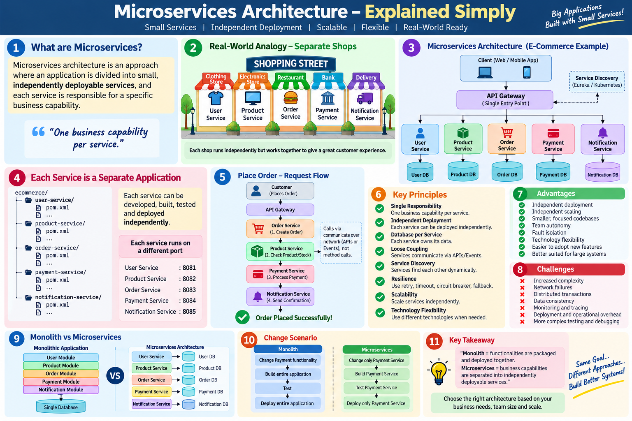

1. What Are Microservices?
- Microservices architecture is an approach in which an application is divided into small, independently deployable services.
- Each service is designed around a business capability such as users, products, orders, payments, or notifications.
- Services collaborate through well-defined APIs or asynchronous events instead of depending on direct in-process calls across the whole system.

2. Real-World Analogy – Separate Shops
- Think of a shopping street containing independent clothing, electronics, restaurant, bank, and delivery businesses.
- Each shop has its own responsibility, staff, operating process, and ability to change independently, while the shops cooperate to serve the customer.
- Microservices follow the same idea: separate business capabilities, independent operation, and controlled communication.

3. E-Commerce Microservices Example
- User Service – registration, profiles, authentication-related user functions.
- Product Service – product catalog, categories, prices, and product information.
- Order Service – order creation, order status, and order business rules.
- Payment Service – payment processing and payment status.
- Notification Service – email, SMS, push, or other notifications.

4. Each Service Is a Separate Spring Boot Application
- A microservice is not simply another Java service class. It can be a complete Spring Boot application with its own pom.xml, configuration, controller, service, repository, tests, and deployment artifact.
- Example development ports: User 8081, Product 8082, Order 8083, Payment 8084, Notification 8085.
- Ports are only a local-development illustration; production deployments commonly use dynamic networking, containers, orchestration, and service discovery.

5. Database per Service and Data Ownership
- A common microservices principle is that each service owns its data.
- User Service may own User DB, Product Service Product DB, Order Service Order DB, and Payment Service Payment DB.
- Other services should normally request data through the owning service's API or events rather than directly querying another service's database.
- Database-per-service does not require different database technologies; the important idea is ownership and isolation of data boundaries.

6. Inter-Service Communication
- Because services run independently, communication crosses process or network boundaries.
- Synchronous options include REST APIs, OpenFeign, and WebClient.
- Asynchronous options include messaging and event streaming technologies such as Kafka or RabbitMQ.
- Network communication introduces latency and failure possibilities, so timeouts, retries, resilience, and observability become important.

7. Place Order – Request Flow
- 1. Customer sends an order request.
- 2. API Gateway routes the request to Order Service.
- 3. Order Service coordinates order creation.
- 4. Product Service is contacted to check product/stock information.
- 5. Payment Service processes payment.
- 6. Order Service stores order information.
- 7. Notification Service sends confirmation.
- The exact production design may use synchronous APIs, asynchronous events, or a combination.

8. API Gateway
- An API Gateway provides a common entry point for clients instead of requiring clients to know every service location.
- Example routes may include /api/users, /api/products, and /api/orders.
- A gateway can perform routing and may also handle cross-cutting concerns such as authentication, rate limiting, request logging, and policy enforcement.

9. Service Discovery
- In dynamic environments, service instances can start, stop, scale, or move.
- Service discovery allows services to locate available instances dynamically.
- Eureka is one Spring ecosystem example; Kubernetes commonly provides service discovery through Services and DNS.

10. Independent Deployment
- In a monolith, changing Payment functionality commonly means rebuilding and redeploying the complete application.
- In microservices, changing Payment Service can allow the team to build, test, and deploy only Payment Service, provided its contracts remain compatible.
- This independent release lifecycle is one of the main motivations for microservices.

11. Independent Scaling
- If Product Service receives significantly more traffic than other services, additional Product Service instances can be created without scaling every service equally.
- This can improve resource efficiency, but it requires appropriate infrastructure, load balancing, monitoring, and deployment automation.

12. Resilience and Failure Handling
- Remote services can be slow or unavailable. Applications therefore need explicit failure-handling strategies.
- Common techniques include timeouts, limited retries, circuit breakers, fallbacks, bulkheads, and graceful degradation.
- With Resilience4j, for example, an Order Service can protect itself when Product Service repeatedly fails instead of continuously making unsuccessful calls.

13. Key Principles
- Single responsibility/business capability – a service should have a clear reason to change.
- Independent deployment – services should be releasable without coordinated deployment of the entire system.
- Loose coupling – communication should happen through explicit contracts.
- High cohesion – closely related business behavior belongs together.
- Data ownership – a service controls its own data boundary.
- Automation – CI/CD, testing, deployment, monitoring, and infrastructure automation are especially important.
- Observability – logs, metrics, traces, and correlation IDs help understand requests across services.
- Resilience – distributed systems must expect partial failures.

14. Advantages
- Independent deployment and release cadence.
- Independent scaling of high-demand services.
- Smaller, focused codebases when boundaries are designed well.
- Team ownership and autonomy.
- Potential fault isolation between services.
- Technology flexibility where there is a justified need.
- Ability to evolve individual business capabilities independently.

15. Challenges
- More operational and infrastructure complexity.
- Network latency and network failures.
- Distributed transactions and data consistency are harder.
- Debugging a request across several services requires centralized logging and distributed tracing.
- API compatibility and versioning require discipline.
- Testing becomes more complex because service interactions must be verified.
- Security must be handled across multiple networked components.
- Poor boundaries can create a distributed monolith: multiple services that still require coordinated changes and deployments.

16. Monolith vs Microservices – Key Comparison
Area | Monolith | Microservices
Deployment | Application deployed together | Services can be deployed independently
Communication | Mostly in-process method calls | Network APIs and/or events
Data | Shared database is common | Service-owned data is common
Scaling | Usually scale the whole application | Scale individual services
Operations | Simpler initially | More distributed-system complexity
Debugging | Usually easier initially | Requires cross-service observability
Failure handling | Fewer network boundaries | Partial failures must be designed for
Team ownership | Shared application ownership common | Service/team ownership common

17. When Should We Choose Microservices?
- Business capabilities and service boundaries are reasonably clear.
- Different parts of the system need independent scaling or release schedules.
- Multiple teams need strong ownership boundaries.
- The organization has sufficient DevOps, automation, monitoring, and operational maturity.
- The additional distributed-system complexity is justified by concrete business or technical needs.

18. When a Monolith May Be Better
- For a small team, early-stage product, simple domain, or application without independent scaling/deployment requirements, a monolith or modular monolith can be simpler and more effective.
- Microservices should solve real architectural or organizational problems rather than being adopted only because they are popular.

19. Classroom Explanation Script
Students, imagine our e-commerce system has User, Product, Order, Payment, and Notification capabilities. In a monolith, these capabilities are packaged and deployed together. If we separate them into independent Spring Boot applications, give them clear business responsibilities and data ownership, and let them communicate through APIs or events, we are moving toward microservices architecture. The major benefit is independent evolution, deployment, and scaling; the trade-off is distributed-system complexity.

20. Quick Revision
- Microservices = one business system composed of multiple independently deployable services.
- Each service should focus on a business capability.
- Services communicate through APIs or events.
- Database/data ownership is commonly separated by service.
- API Gateway can provide a common client entry point.
- Service discovery helps locate dynamic service instances.
- Independent deployment and scaling are major benefits.
- Timeouts, retries, circuit breakers, logging, metrics, and tracing become important.
- Microservices add complexity and are not automatically better than a monolith.

21. Interview / Classroom Questions
- What are microservices?
- What is the difference between a Java service class and a microservice?
- Why is database-per-service commonly used?
- How do microservices communicate?
- What is the role of an API Gateway?
- What is service discovery?
- What is independent deployment?
- How does independent scaling work?
- Why do microservices need circuit breakers and timeouts?
- What is a distributed transaction?
- What is a distributed monolith?
- When would you prefer a modular monolith over microservices?

22. Visual Summary

Figure: Microservices Architecture – Explained Simply

