Monolithic Application
Detailed Notes for Spring Boot Students
A monolithic application is an application in which the major business functionalities are developed as parts of one application and are normally built, packaged, deployed, and operated together.

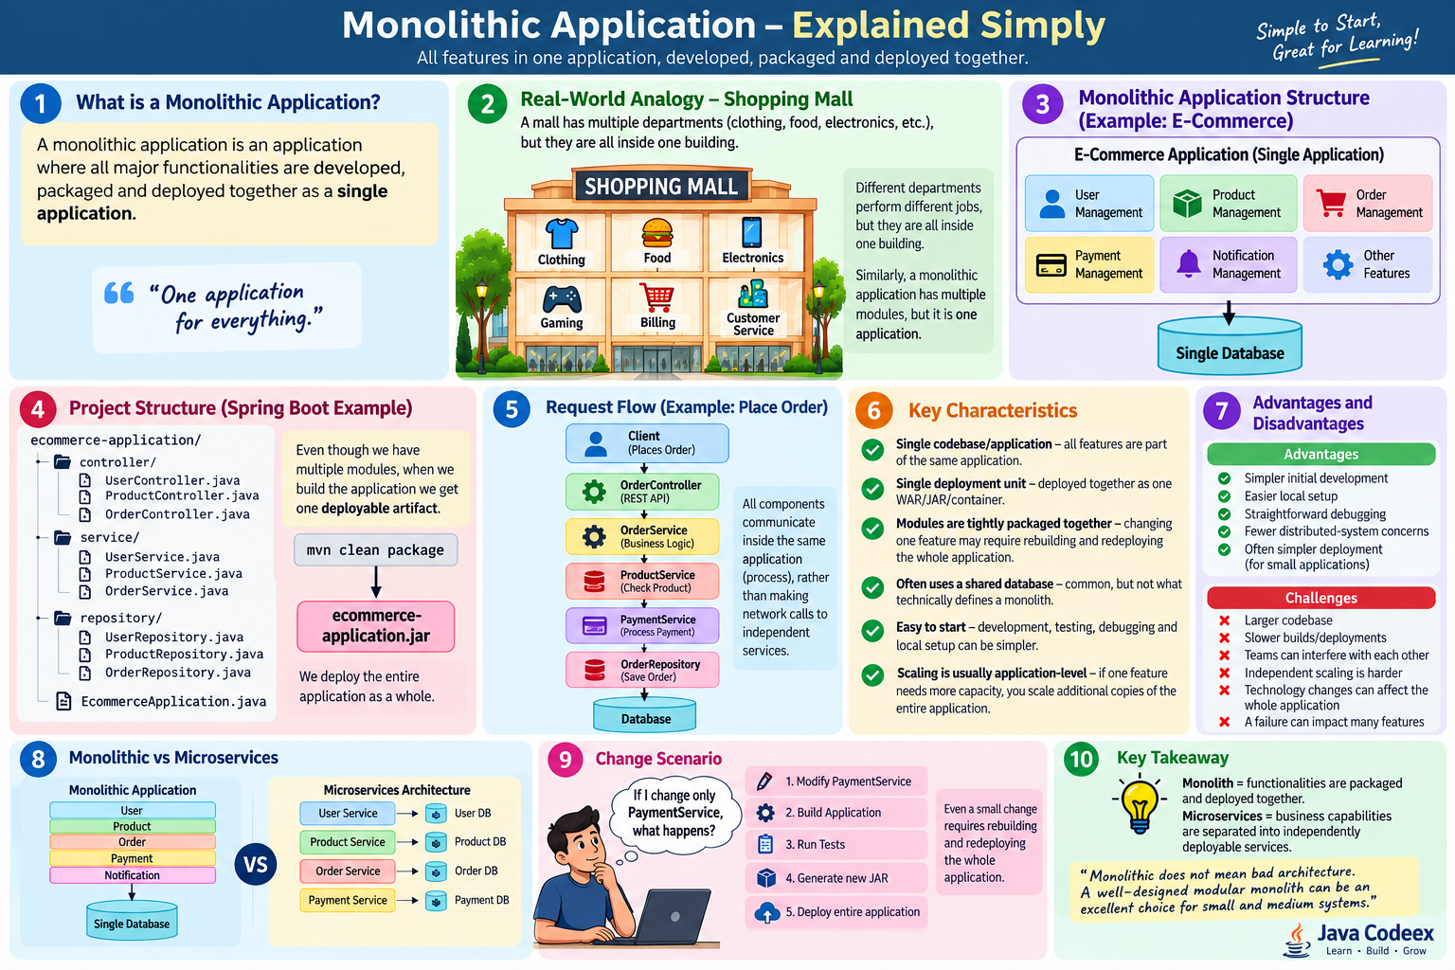

Learning Objectives
- Understand what a monolithic application is and how it is structured.
- Relate the concept to a real-world analogy.
- Understand a typical Spring Boot monolith project structure.
- Trace a request through controller, service, repository, and database layers.
- Identify the characteristics, advantages, and limitations of a monolith.
- Understand why a small change can require rebuilding and redeploying the application.
- Compare monolithic architecture with microservices.
- Understand when a monolith or modular monolith can be a good architectural choice.

1. What Is a Monolithic Application?
The word monolith means a single large unit. In software architecture, a monolithic application contains multiple business features inside one deployable application. For example, an e-commerce system may contain user management, product management, order management, payment, and notifications, while all of these features are packaged and released together.

Simple Definition for Students
Monolith = multiple functionalities inside one application, packaged and deployed together.

2. Real-World Analogy: Shopping Mall
Imagine one shopping mall containing clothing stores, a food court, electronics, gaming, billing, and customer service. Each department performs a different job, but all departments operate inside one building. A monolithic application is similar: it can have clearly separated modules, but those modules are part of one application and are normally released together.
Teaching question: If the electronics department changes its internal arrangement, is it still part of the same mall? Yes. In the same way, changing one module does not automatically make it a separate service.

3. E-Commerce Monolithic Architecture
A simple e-commerce monolith may contain:
- User Management – registration, login, profile, addresses.
- Product Management – products, categories, prices, inventory information.
- Order Management – cart checkout, order creation, order status.
- Payment Management – payment processing and payment status.
- Notification Management – email, SMS, or application notifications.
These are business modules, but they execute within the same application process. A single shared database is common in traditional monoliths, although using one database is not the technical definition of a monolith.

4. Spring Boot Project Structure Example
ecommerce-application/
controller/
UserController.java
ProductController.java
OrderController.java
service/
UserService.java
ProductService.java
OrderService.java
PaymentService.java
repository/
UserRepository.java
ProductRepository.java
OrderRepository.java
entity/
dto/
exception/
config/
EcommerceApplication.java
The packages separate responsibilities in the source code, but Maven still builds the project as one application artifact. With Spring Boot, running `mvn clean package` commonly creates a single executable JAR such as `ecommerce-application.jar`.

5. Request Flow: Place an Order
Step | Component | Responsibility
1 | Client | The browser/mobile client sends a request such as POST /api/orders.
2 | OrderController | Receives the HTTP request, validates input, and delegates business work.
3 | OrderService | Coordinates order creation and applies business rules.
4 | ProductService | Checks product information or availability.
5 | PaymentService | Processes or coordinates payment-related logic.
6 | OrderRepository | Uses Spring Data JPA to persist or retrieve order data.
7 | Database | Stores the application data.
Important point: calls between these components are normally in-process Java method calls, not network calls between independently deployed services.

6. Key Characteristics
- Single application/deployment unit – The application's features are packaged and deployed together.
- Shared runtime/process – Modules normally run inside the same application process.
- Internal method calls – Modules can directly call other Java classes/services without HTTP.
- One release lifecycle – A feature change usually goes through the build and deployment lifecycle of the whole application.
- Shared database is common – Many monoliths use one database/schema, but this is a design choice rather than the definition.
- Application-level scaling – When additional capacity is needed, teams commonly scale copies of the entire application.
- Simpler initial operations – There are fewer distributed-system concerns when starting with one deployable application.

7. Change Scenario: PaymentService
Suppose a developer changes only PaymentService. In a traditional monolithic delivery model, the usual flow is:
- Modify PaymentService.
- Build the application.
- Run unit, integration, and regression tests.
- Generate a new application JAR/WAR/container image.
- Deploy the new version of the complete application.
This illustrates deployment coupling: even when the code change is small, the deployable unit contains the complete application.

8. Advantages of a Monolithic Application
- Simple to start – one project is often easier for beginners and small teams.
- Easy local development – developers can start and debug the application as one process.
- Straightforward debugging – tracing a request can be simpler because most calls stay in-process.
- Simpler deployment – one application artifact can be easier to release than many services.
- Fewer distributed-system problems – fewer network failures, service discovery issues, and distributed tracing concerns.
- Transactions can be simpler – a single database transaction can often cover multiple modules.
- Good performance for internal calls – direct method calls avoid network serialization and latency.

9. Challenges as the Application Grows
- The codebase can become large and difficult to understand if modular boundaries are weak.
- Build and deployment times can increase.
- Multiple teams can create coordination problems when working in the same application.
- Independent deployment of one business capability is difficult.
- Independent scaling is harder because the whole application is typically replicated.
- A serious application/process failure can affect multiple features.
- Large technology upgrades may affect many modules at the same time.
- Poorly structured monoliths can develop tight coupling between modules.

10. Monolith vs Microservices
Area | Monolith | Microservices
Deployment | Features deployed together | Services can be deployed independently
Communication | Mostly in-process method calls | Usually network/API or messaging calls
Scaling | Often scale the whole application | Individual services can be scaled
Database | Shared database is common | Database-per-service is common
Operational complexity | Lower initially | Higher due to distributed systems
Failure boundaries | Process failure can affect many modules | Failures can be isolated, but cascading failures must be handled
Technology choices | Usually more standardized across application | Services may choose technologies independently where justified

11. Important Clarification: Monolith Does Not Mean Bad Architecture
A monolithic architecture can be clean, maintainable, and highly effective. The real problem is usually uncontrolled coupling, unclear module boundaries, or poor engineering practices—not the fact that the system is deployed as one unit.

Modular Monolith
A modular monolith keeps one deployable application but organizes the code into strong business modules with clear boundaries and controlled dependencies. This approach can provide much of the development simplicity of a monolith while preventing the codebase from becoming a 'big ball of mud.'

12. When Should We Choose a Monolith?
- The application is small or medium in scope.
- The team is small and wants fast development.
- The domain is still evolving and service boundaries are not yet clear.
- Independent scaling of individual features is not required.
- Operational simplicity is more valuable than independent service deployment.
- The organization does not yet need or want the infrastructure complexity of microservices.

13. When Might Microservices Become Useful?
Microservices may become useful when business capabilities have clear boundaries and there is a real need for independent deployment, independent scaling, separate team ownership, fault isolation, or different release cadences. They should not be introduced only because the application is becoming popular.

14. Classroom Explanation Script
“Students, imagine we are building an e-commerce application. We have User, Product, Order, Payment, and Notification modules. If all of these modules are part of one Spring Boot application, Maven builds one deployable JAR, and we deploy that application as a whole, we call it a monolithic application. The modules can still be well organized. The important point is that they share one deployment lifecycle. If we later separate these business capabilities into independently deployable services, we move toward a microservices architecture.”

15. Interview Questions for Students
- What is a monolithic application?
- Does monolithic architecture mean all code must be in one package?
- Is a single database mandatory for a monolith?
- What happens when only one module changes in a traditional monolith?
- How do modules normally communicate inside a monolithic Spring Boot application?
- What are the advantages of a monolith?
- What problems can appear as a monolith grows?
- What is a modular monolith?
- What is the main difference between a monolith and microservices?
- When would you choose a monolith instead of microservices?

16. Quick Revision
- Monolith: one deployable application containing multiple functionalities.
- Modules can be separated logically while still belonging to the same deployment.
- Internal communication is usually through direct method calls.
- One shared database is common but not mandatory.
- A change to one module can require rebuilding and redeploying the whole application.
- Monoliths are simpler to start and operate, but independent scaling/deployment is harder.
- A modular monolith is often a strong choice before introducing microservices.
- Microservices trade deployment independence for additional distributed-system complexity.

17. Visual Summary

Figure: Monolithic Application – Explained Simply

