https://maven.apache.org/download.cgi
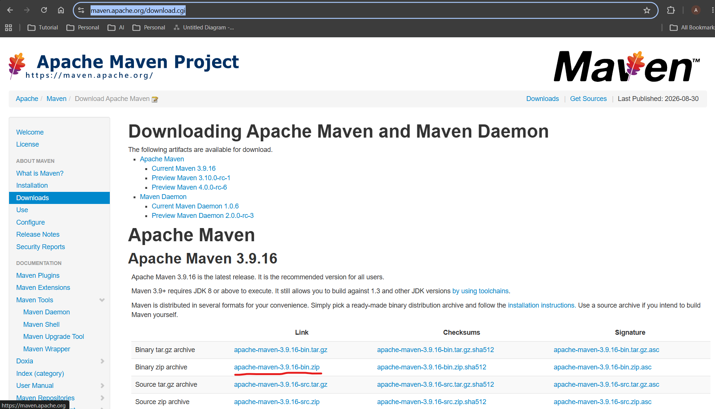

Download highlighted zip file
Unzip this file copy entire folder paste in C:\Program Files

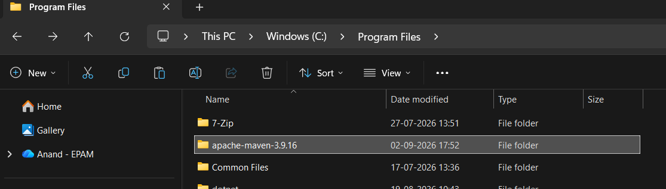

Open System Properties
d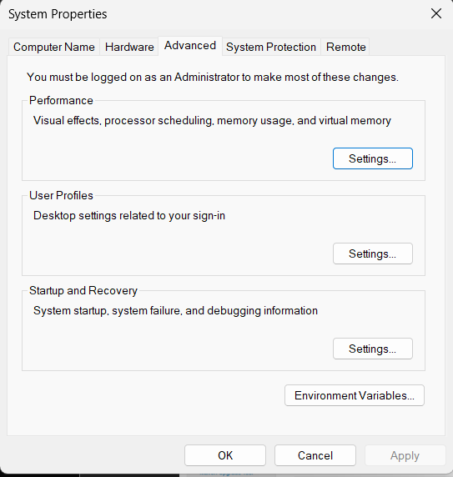

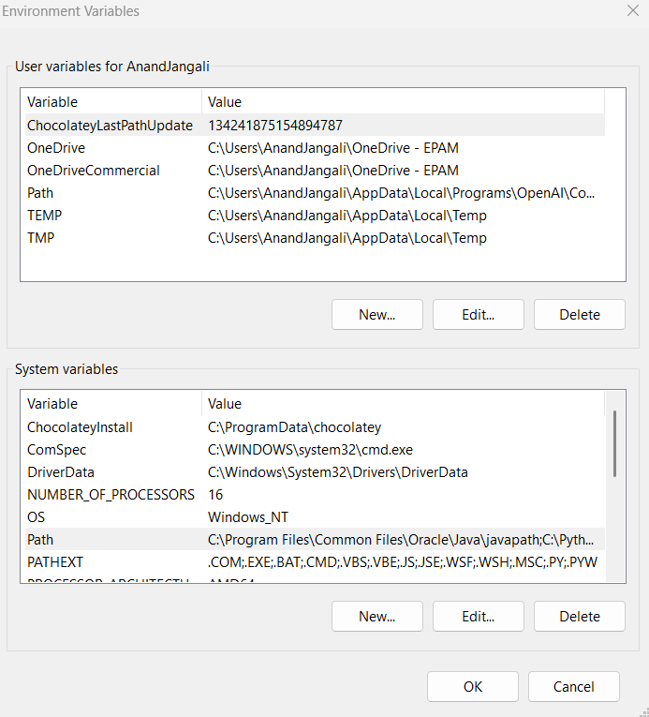

Click on Path -> Click on New -> add bin path
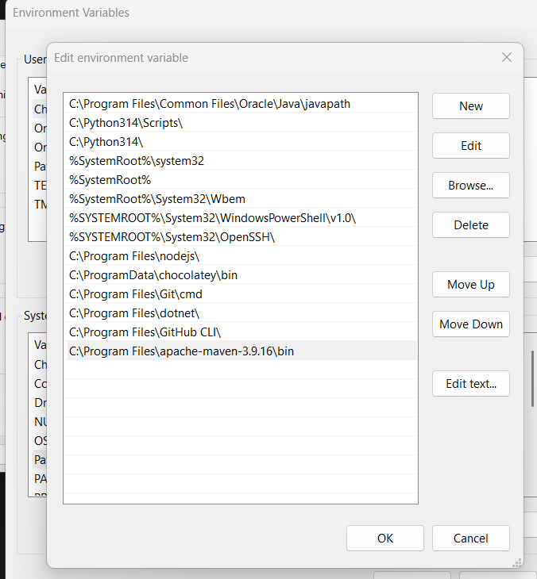

Click on OK
set MAVEN_HOME to system variables
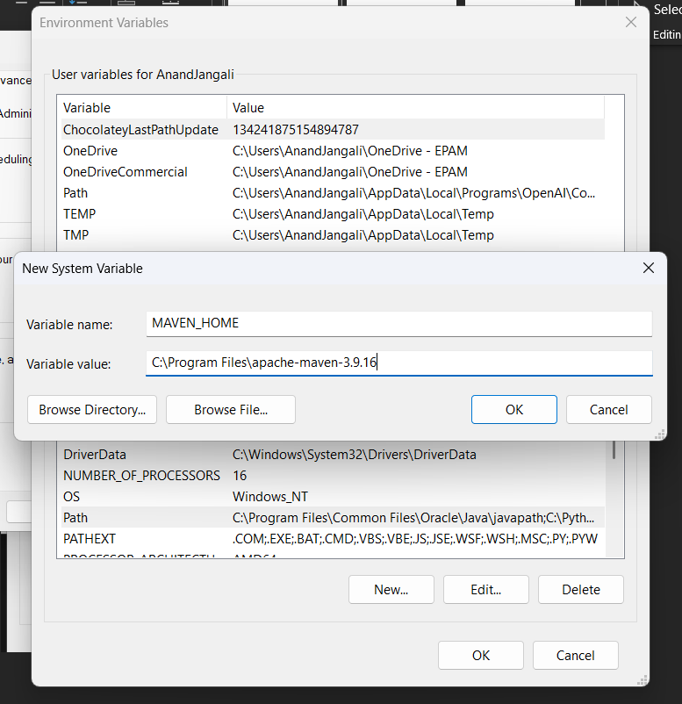

Click on ok

Go to cmd prompt
Type mvn
