Symmetric Encryption | Date:  Start time:

This activity explores Symmetric Encryption.
You may find it easier to sketch some answers on a separate piece of paper, and use that to come up with your report.
Before you start, complete the form below to assign a role to each member.
If you have 3 people, combine Manager & Reflector.
Time: | Date:
Team Roles | Team Member
Recorder: records all answers & questions, and provide copies to team & facilitator
Speaker: Talk to facilitator and other teams
Manager: keeps track of time and makes sure everyone contributes appropriately
Reflector: considers how the team could work and learn more effectively

Part I: Symmetric-Key Encryption
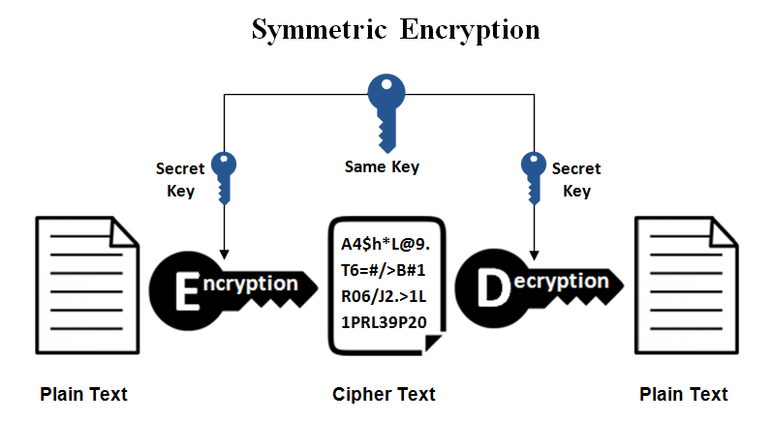
Symmetric-key Encryption is an encryption method in cryptography that uses the same cryptographic for both the encryption and decryption processes. The keys represent a shared secret between two or more parties that provides a private data link. The need for both parties to have the same symmetric key is considered a major drawback to symmetric key encryption. Substitution and Permutation are important aspects of any cipher. Substitution is a replacing of the original bits to produce a new message. Permutation is a rearranging of the original bits to produce a new message using the same bits.
Caesar Ciphers is a common substitution cipher. The Caesar cipher takes an original string and shifts 3 letters to each character as seen in Figure 1. The result being a new string with the original message masked. Take the following cipher texts and find the original text using the given shift value. The character set for the cipher is the normal alphabet.
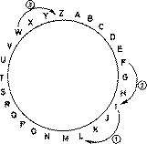
Figure 1: Caesar cipher

Critical thinking question 1: Please finish the following encryption using Caesar cipher.
Plaintext | Shift Value | Cipher Text
ATTACK | 3
INJECTION | 3
TROJAN | 3

Additive cipher is sometimes called a shift cipher. The following shows its mathematical nature.
- Encryption EK(x) = x + K mod 26
- Decryption DK(x) = x - K mod 26
for English alphabet by setting up a correspondence between alphabetic characters and residues modulo 26.

Critical thinking question 2:
Use the additive cipher with key = 15 to encrypt the message “hello”. Please apply the encryption algorithm to the plaintext, character by character. Hint: a corresponds to 00; b corresponds to 01; c corresponds to 02; d corresponds to 03, and so on.
Answer: WTAAD

Critical thinking question 3:
Use the additive cipher with key = 15 to decrypt the message “WTAAD”. We apply the decryption algorithm to the plaintext character by character
Answer: hellow
Critical thinking question 4:
Eve has intercepted the following ciphertext and guesses that additive cipher was used. Please help her to use a statistical attack to find the key, given the knowledge that letter E is the most frequently used letter in English. Hint: count the number of occurrence of each letter.
Key = 4

Critical thinking question 5:
Because additive, multiplicative, and affine ciphers have small key domains, they are very vulnerable to brute-force attack. A better solution is to create a mapping between each plaintext character and the corresponding ciphertext character. Alice and Bob can agree on a table showing the mapping for each character. Please use the following mapping between plaintext and ciphertext as the key to encrypt the message:
Answer:

In polyalphabetic substitution, each occurrence of a character may have a different substitute. The relationship between a character in the plaintext to a character in the ciphertext is one-to-many. The following shows encryption and decryption of Autokey Cipher. 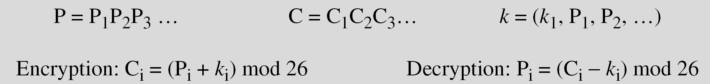
Critical thinking question 6:
Assume that Alice and Bob agreed to use an autokey cipher with initial key value k₁ = 12. Now Alice wants to send Bob the message “Attack is today”. Enciphering is done character by character. Please first exampain the key stream, and then complete the following C’s values and ciphter text.
C’s values
Ciphertext

Answer:

Critical thinking question 7:
Vigenere cipher can be seen as combinations of m additive ciphers.
We can encrypt the message “She is listening” using the 6-character keyword “PASCAL” (15, 0, 18, 2, 0, 11).
Please complete the following encryption by finishing C’s values and Ciphertext:
C’s values:
Cipher text:

Answer:

A transposition cipher does not substitute one symbol for another, instead it changes the location of the symbols. A transposition cipher reorders symbols. A good example of a keyless cipher using the first method is the rail fence cipher. The ciphertext is created reading the pattern row by row. For example, to send the message “Meet me at the park” to Bob, Alice writes
She then creates the ciphertext “MEMATEAKETETHPR”.
Critical thinking question 8:
Alice and Bob can agree on the number of columns and use the second method. Alice writes the same plaintext, row by row, in a table of four columns. What cipher text will she create?
Answer: MMTAEEHREAEKTTP

Critical thinking question 9:
Another method of transposition is to divide the plaintext into groups of predetermined size, called blocks, and then use a key to permute the characters in each block separately. Alice needs to send the message “Enemy attacks tonight” to Bob. What is the permutation result?
The key used for encryption and decryption is a permutation key, which shows how the character are permuted.
Answer:

Critical thinking question 10:
A single key was used in two directions for the column exchange: downward for encryption, upward for decryption. It is customary to create two keys. Please explain why the encryption and decryption keys work in transposition cipher.
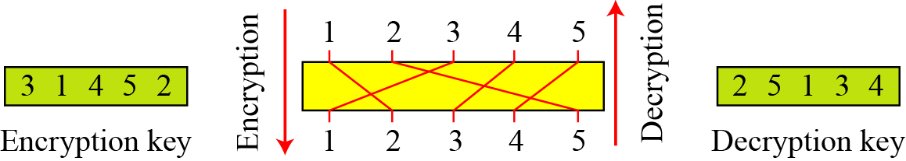

Critical thinking question 11:
The Playfair cipher uses a 5 by 5 table containing a key word or phrase. What is the cipher text if “hello” is the plaintext.
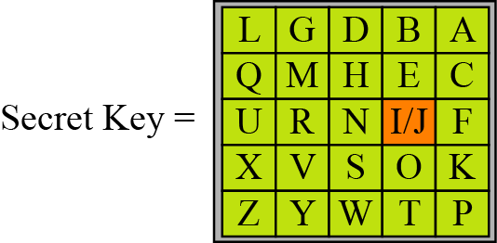

To perform the substitution, apply the following 4 rules, in order, to each pair of letters in the plaintext:
- If both letters are the same (or only one letter is left), add an "X" after the first letter. Encrypt the new pair and continue. Some variants of Playfair use "Q" instead of "X", but any letter, itself uncommon as a repeated pair, will do.
- If the letters appear on the same row of your table, replace them with the letters to their immediate right respectively (wrapping around to the left side of the row if a letter in the original pair was on the right side of the row).
- If the letters appear on the same column of your table, replace them with the letters immediately below respectively (wrapping around to the top side of the column if a letter in the original pair was on the bottom side of the column).
- If the letters are not on the same row or column, replace them with the letters on the same row respectively but at the other pair of corners of the rectangle defined by the original pair. The order is important – the first letter of the encrypted pair is the one that lies on the same row as the first letter of the plaintext pair.
Answer:
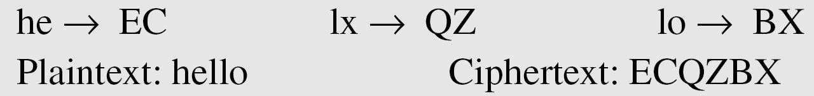

A stream cipher is a symmetric key cipher where plaintext digits are combined with a pseudorandom cipher digit stream (keystream). In a stream cipher, each plaintext digit is encrypted one at a time with the corresponding digit of the keystream, to give a digit of the ciphertext stream.
In a block cipher, a group of plaintext symbols of size m (m > 1) are encrypted together creating a group of ciphertext of the same size. A single key is used to encrypt the whole block even if the key is made of multiple values.
We can establish a criterion to divide stream ciphers based on their key streams. We can say that a stream cipher is a monoalphabetic cipher if the value of ki does not depend on the position of the plaintext character in the plaintext stream; otherwise, the cipher is polyalphabetic (block).
Critical thinking question 11:
Please explain the additive ciphers is a stream cipher or a block cipher.
Answer: Additive ciphers can be categorized as stream ciphers in which the key stream is the repeated value of the key. In other words, the key stream is considered as a predetermined stream of keys or
K = (k, k, …, k). In this cipher, however, each character in the ciphertext depends only on the corresponding character in the plaintext, because the key stream is generated independently.
Critical thinking question 12:
Please explain the Vigenere ciphers is a stream cipher or a block cipher.
Answer: Vigenere ciphers are polyalphabetic ciphers because k_{i} definitely depends on the position of the plaintext character. However, the dependency is cyclic. The key is the same for two characters m positions apart.
Critical thinking question 12:
Please explain the Playfair ciphers is a stream cipher or a block cipher.
Answer: Playfair ciphers are block ciphers. The size of the block is m = 2. Two characters are encrypted together.

Part II Modern Symmetric-key Ciphers
A symmetric-key modern block cipher encrypts an n-bit block of plaintext or decrypts an n-bit block of ciphertext. The encryption or decryption algorithm uses a k-bit key as seen below:
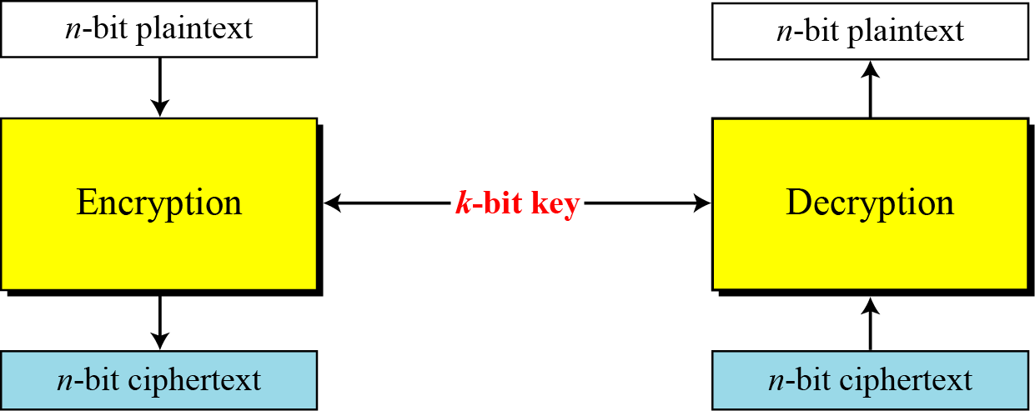
Critical thinking question 1:
How many padding bits must be added to a message of 100 characters if 8-bit ASCII is used for encoding and the block cipher accepts blocks of 64 bits?
Answer:

Critical thinking question 2:
Suppose that we have a block cipher where n = 64. If there are 10 1’s in the ciphertext, how many trial-and-error tests does Eve need to do to recover the plaintext from the intercepted ciphertext in each of the following cases?
- The cipher is designed as a substitution cipher.
- The cipher is designed as a transposition cipher.
Answer:

Critical thinking question 3:
Show the model and the set of permutation tables for a 3-bit block transposition cipher where the block size is 3 bits.

Answer:

A P-box (permutation box) parallels the traditional transposition cipher for characters. It transposes bits. There are three types of P-boxes. A straight P-box is invertible, but compression and expansion P-boxes are not.
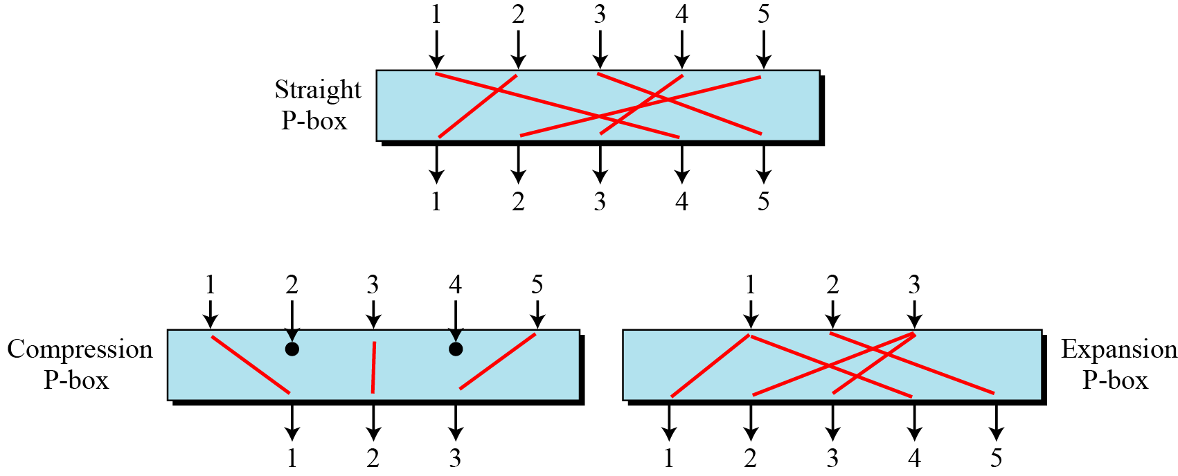
Critical thinking question 4:
Design an 8 × 8 permutation table for a straight P-box that moves the two middle bits (bits 4 and 5) in the input word to the two ends (bits 1 and 8) in the output words. Relative positions of other bits should not be changed.
Answer:

Critical thinking question 5:
The following steps show how to invert a permutation table represented as a one-dimensional table. Please use the same way to invert a permutation table [1 3 5 2 4 6].
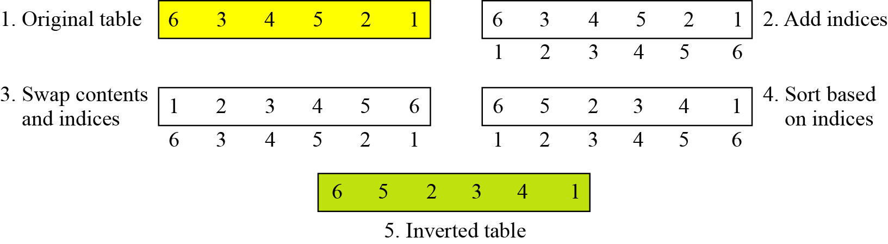
Answer:

Critical thinking question 6:
An S-box (substitution box) can be thought of as a miniature substitution cipher. In cryptography, an S-box (substitution-box) is a basic component of symmetric key algorithms which performs substitution. In block ciphers, they are typically used to obscure the relationship between the key and the ciphertext
In an S-box with three inputs and two outputs, we have The S-box is linear because a_{1,1} = a_{1,2} = a_{1,3} = a_{2,1} = 1 and a_{2,2} = a_{2,3} = 0.
The following table defines the input/output relationship for an S-box of size 3 × 2. The leftmost bit of the input defines the row; the two rightmost bits of the input define the column. The two output bits are values on the cross section of the selected row and column. Based on the table, what are the outputs if inputs are 010 and 101?

Critical thinking question 7:
An S-box may or may not be invertible. In an invertible S-box, the number of input bits should be the same as the number of output bits. Please explain why the following S-box is invertible.
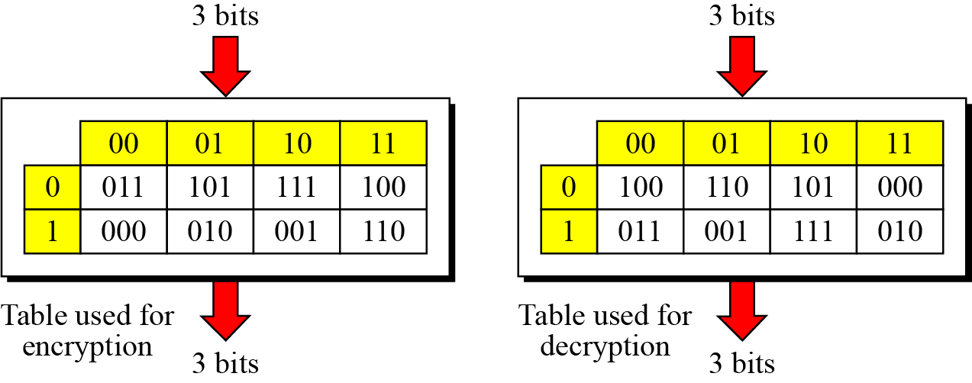

Answer:

Critical thinking question 8: Please find the 4-bit output give the 6-bit input. For example, the 6-bit input of 011011 yields a 4-bit output of 1001 from this S-box.
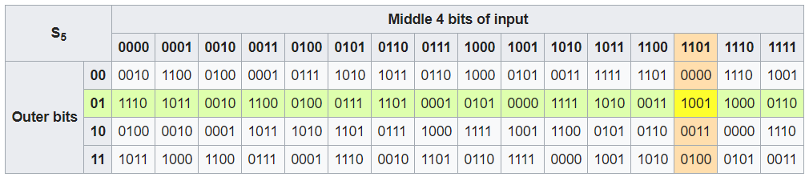
Input | Output |  | Input | Output
110011 |  |  | 110101
101010 |  |  | 000000
001100 |  |  | 001110
111111 |  |  | 011100

Feistel designed a very intelligent and interesting cipher that has been used for decades. Feistel cipher provides diffusion which hides the relationship between the ciphertext and the plaintext.
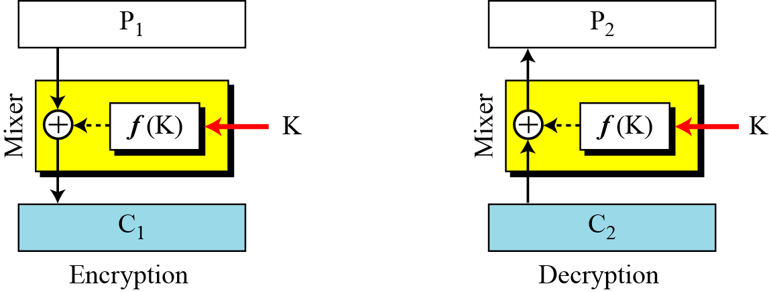
Critical thinking question 9:
This is a trivial example. The plaintext and ciphertext are each 4 bits long and the key is 3 bits long. Assume that the function takes the first and third bits of the key, interprets these two bits as a decimal number, squares the number, and interprets the result as a 4-bit binary pattern. Show the results of encryption and decryption if the original plaintext is 0111 and the key is 101. f(K) = f(101) = (2^1+1)^2=9=1001
Answer:

Differential Cryptanalysis is a chosen-plaintext attack. Differential cryptanalysis is based on a nonuniform differential distribution table of the S-boxes in a block cipher.
Assume that the cipher is made only of one exclusive-or operation, as shown in Figure 5.18. Without knowing the value of the key, Eve can easily find the relationship between plaintext differences and ciphertext differences, if by plaintext difference we mean P1 ⊕P2and by ciphertext difference, we mean C1⊕ C2. The following proves that C1⊕ C2 = P1 ⊕ P2:
We have the following S-box and its probabilistic relationship.
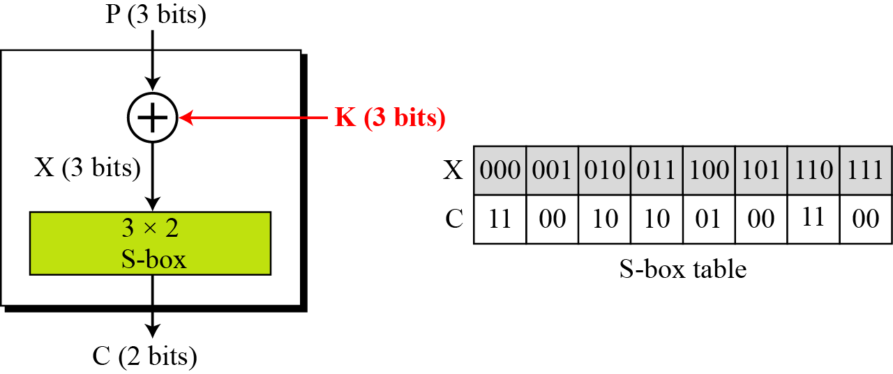
Critical thinking question 10:
Please list the combination of C1⊕ C2 and P1 ⊕ P2, which has high probability.

Eve knows that if P₁ ⊕ P₂ = 001, then C₁ ⊕ C₂ = 11 with the probability of 0.50 (50 percent). She tries C₁ = 00 and gets P₁ = 010 (chosen-ciphertext attack). She also tries C₂ = 11 and gets P₂ = 011 (another chosen-ciphertext attack). Now she tries to work backward, based on the first pair, P₁ and C₁,
101

If X1 = 101 K = 111

The two tests confirm that K = 011 or K =101.
Critical thinking question 11:
Please guess the key if C1=10, P1=001, C2=11, P2=011.

Linear Cryptanalysis:
This is a simple cipher to linear S-box:
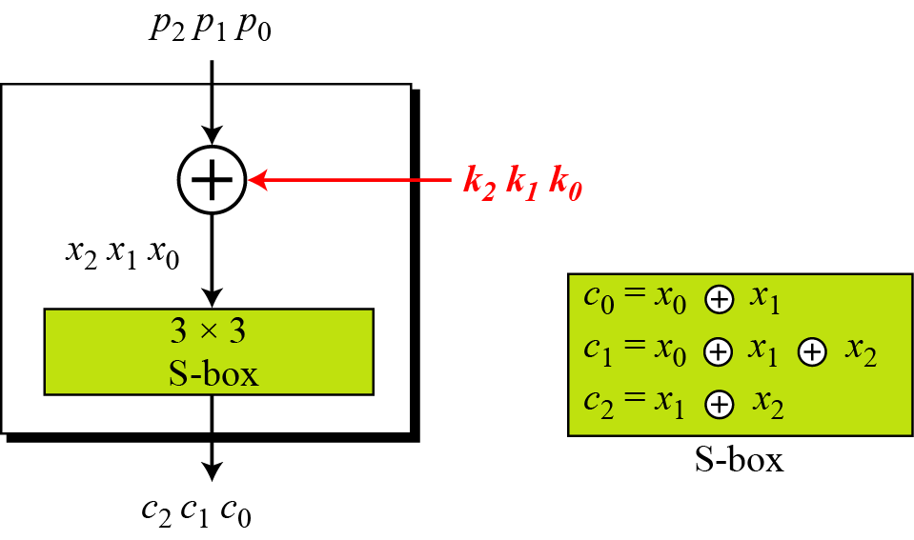
Solve the three unknows k0, k1, k2, we get:
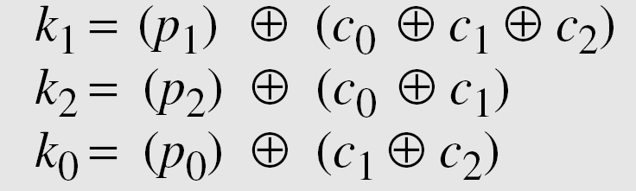
Critical thinking question 12: what does above mean?
Answer:

Add more from slides 50-68

P-box:
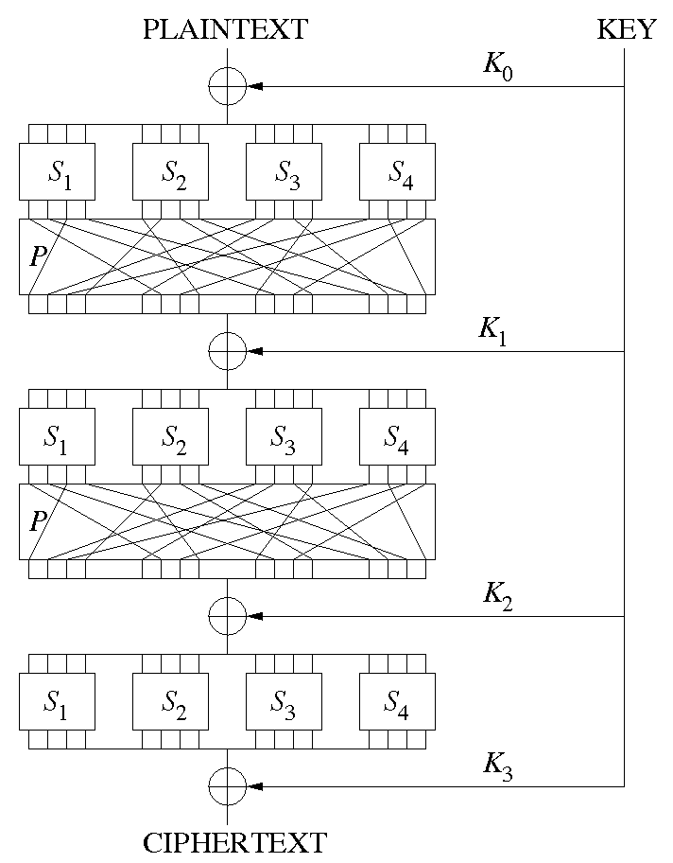
- A P-box is a permutation of all the bits: it takes the outputs of all the S-boxes of one round, permutes the bits, and feeds them into the S-boxes of the next round. A good P-box has the property that the output bits of any S-box are distributed to as many S-box inputs as possible.

Critical Thinking Questions:

In a S-box all input can be traced to a single output and vice-versa. A perfect S-box is where each output is produced by a bent function of the input bits.

Explain what vulnerabilities exist in S-box and why?

Part III: AES and DES
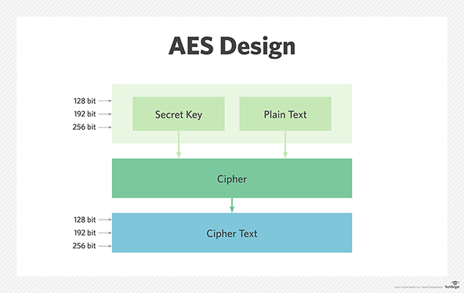
Advanced Encryption Standard (AES) is based on a design principle known as a substitution-permutation network, a combination of both substitution and permutation, and is fast in both software and hardware. Unlike its predecessor DES, AES does not use a Feistel network. AES is a variant of Rijndael which has a fixed block size of 128 bits, and a key size of 128, 192, or 256 bits. By contrast, the Rijndael specification per se is specified with block and key sizes that may be any multiple of 32 bits, with a minimum of 128 and a maximum of 256 bits.
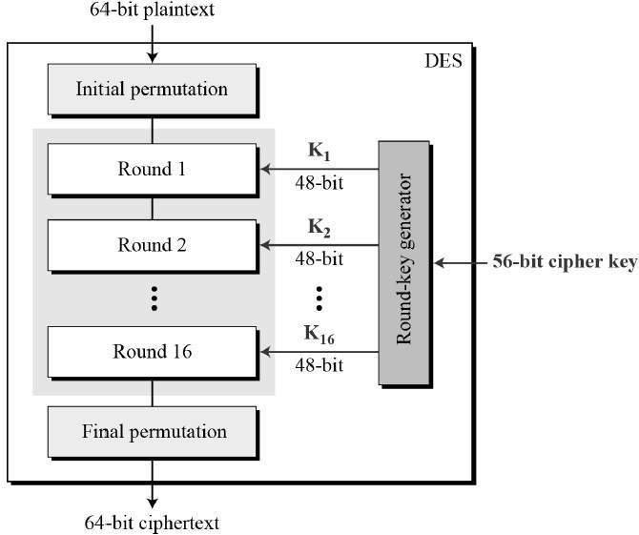
Data Encryption Standard (DES) is the archetypal block cipher—an algorithm that takes a fixed-length string of plaintext bits and transforms it through a series of complicated operations into another ciphertext bit string of the same length. In the case of DES, the block size is 64 bits. DES also uses a key to customize the transformation, so that decryption can supposedly only be performed by those who know the key used to encrypt. The key ostensibly consists of 64 bits; however, only 56 of these are used by the algorithm. Eight bits are used solely for checking parity, and are thereafter discarded. Hence the effective key length is 56 bits.

DES and AES ciphers:
- AES and DES ciphers are both symmetric block ciphers that serve as a foundation of symmetric cryptography. The next section will detail both encryption standards.
What are the key differences in DES, Triple-DES, and AES block ciphers? Explain the process of each block cipher:

Fill out the following table about AES and DES:
 | DES | AES
Developed
Key Length
Cipher Type
Block Size
General Security Level

Part III: Symmetric Cryptography modes
Symmetric cryptography comes in variety of symmetric-key ciphers also known as modes. These modes of operation can act on encipher text of any size and employ either AES or DES. These modes include Electronic Codebook, Cipher-Block Chaining, Cipher Feedback, Output Feedback, and Counter. The choice in which mode should be used is based on variables such as encryption / decryption speed, security against active and passive adversaries, and error propagation.
Electronic Codebook (ECB):
When using the ECB mode a message is broken into independent blocks that are then encrypted. Each block has a set value which is then substituted based on a book of rules. The important factor being that each block is encoded independently of other blocks. In the diagram below we can see a simple example of the ECB mode.

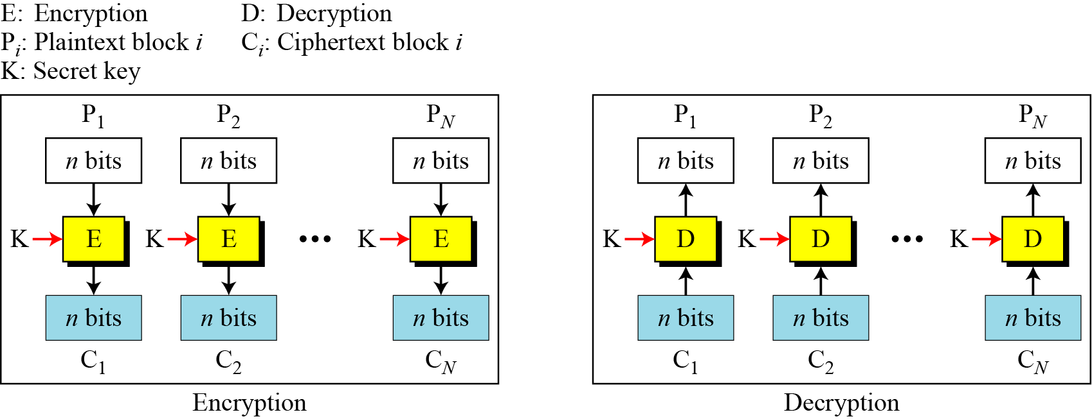

Critical Thinking Questions:
Based on the above explanation of the ECB mode what are some advantages of using this cryptographic mode? List 3 advantages below.

Based on the above explanation of the ECB mode what are some disadvantages of using this cryptographic mode? List 3 disadvantages or limitations below.


Below is an example of an image being processed using ECB in comparison with other cryptographic modes. Explain the issues with ECB in this scenario.
Left to Right: Plain Image, ECB, Other Modes
Explain how a replay attack can be used against the ECB mode. Give an example replay attack using the following scenario:
Scenario: Assume that Eve works in a company a few hours per month (her monthly payment is very low). She knows that the company uses several blocks of information for each employee in which the seventh block is the amount of money to be deposited in the employee’s account.

Cipher Block Chaining (CBC):
Cipher Block Chaining involves breaking up the original message in to blocks which are then linked together in the encryption operation. During the operation each of the previous cipher blocks are chained with the current plain text block. This is used with an initial vector (IV) to begin the operation. Below in the diagram we see that each plain text block uses an exclusive-or operator with the previous cipher text block before the encryption process begins. Also to account for short blocks that are not as large as the block size null data is used as message padding.

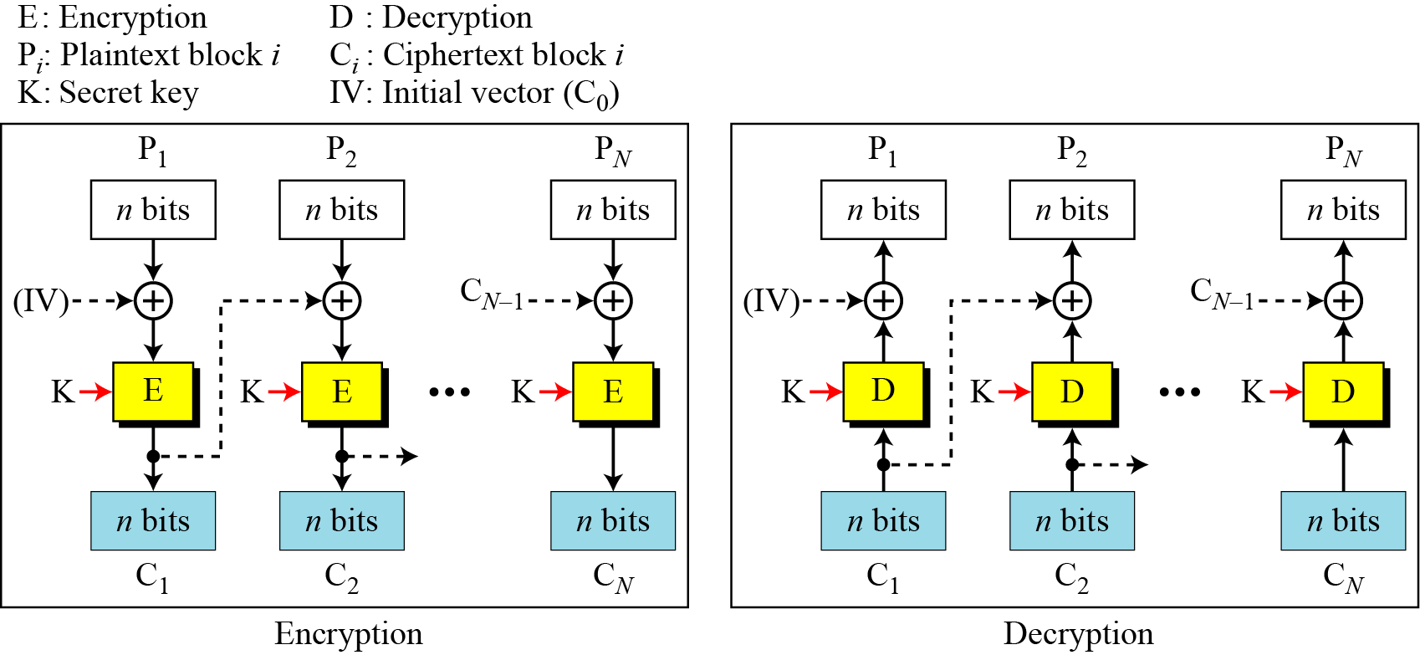

Critical Thinking Questions:
Based on the above explanation of the CBC mode what are some advantages of using this cryptographic mode? List 3 advantages below.

Based on the above explanation of the CBC mode what are some disadvantages of using this cryptographic mode? List 3 disadvantages or limitations below.

At the end of the CBC operation you are left with the block shown below. Explain what may have occurred to output the given block.
Last Block: [ b1 b2 b3 b4 0 0 0 0 0 0 7]

Explain what the Initialization Vector is and explain the possible issues it may have in practice.

Stream Ciphers:
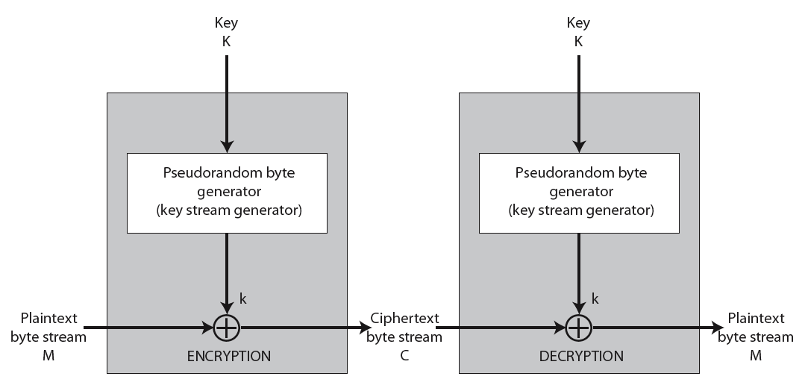
A stream cipher is a symmetric key cipher where plain text digits are combined with a pseudo random cipher digit stream (key stream). In a stream cipher, each plain text digit is encrypted one at a time with the corresponding digit of the key stream, to give a digit of the cipher text stream. Cryptographic modes such as Cipher Feedback (CFB) and Output Feedback (OFB) can be used as stream ciphers. Stream ciphers work under the assumption that the key stream is suitably random and that the key is never reused. Below we can see an example structure of a stream cipher.
Critical Thinking Questions:
What are some benefits to using a stream cipher in comparison to common block cipher methods? Can a stream cipher ever be as secure as its block cipher counterpart given the same size key is used?

Example Stream Cipher:
RC4 is a proprietary cipher that is owned by RSA that serves as a simple but effective stream cipher. It works on a variable key size, and is a byte-oriented stream cipher. RC4 is widely used across several applications such as SSL / TLS and WEP security. The cipher uses a key to form random permutations of all 8-bit values and uses that permutation to scramble input data processed a byte at a time.

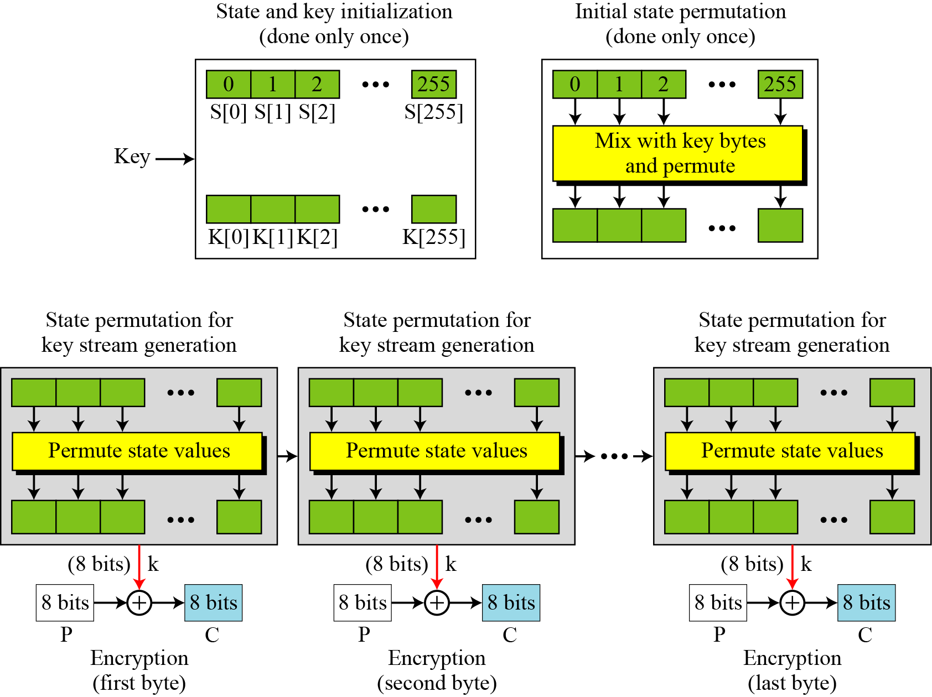

Critical Thinking Questions:

What are the main characteristics of a stream cipher in relationship to block ciphers? How can the RC4 be classified as a stream cipher?

If a given stream key is used twice explain how an attack can be formed to break the stream cipher using properties of the XOR operator.

