Azure Documentation

V 2.0

Generated by



# Table of Contents

Table of Contents 1

Subscription 4

Azure Active Directory 5

Azure Active Directory 5

Users 5

Groups 5

Applications 5

Roles 5

Web Sites 6

Web Site 6

Settings 6

Tags 6

Site diagnostics 6

App Settings 6

Default documents 7

Host Names 7

Virtual Applications and Directories 7

Slots 7

Connection Strings 7

Metrics 7

Average Response Time 7

Requests 7

Storages (Classic) 8

Storage 8

Settings 8

Blob Storage 8

Container 8

Biggest blob items 8

Last modified blob items 8

Table Storage 9

Warnings 9

Storages 10

Storage 10

Settings 10

Tags 10

Blob Storage 10

Container 10

Biggest blob items 10

Last modified blob items 10

Table Storage 11

Warnings 11

Virtual Machines (Classic) 12

Virtual Machine 12

Settings 12

EndPoints 12

Virtual Disks 12

Data Hard Disks 12

OS Hard Disks 12

Virtual Machines 14

Virtual Machine 14

Settings 14

Tags 14

Network Interfaces 14

Virtual Disks 14

Data Hard Disks 14

OS Hard Disks 14

SQL Servers 16

SQL Server 16

Settings 16

Database 16

Tables 16

Table 16

Procedures 17

Procedure 17

Views 17

Users 17

Roles 17

Firewall Rules 17

Service Bus 18

Service Bus 18

Settings 18

Queues 18

Topics 19

Virtual Networks (Classic) 20

Virtual Network 20

Settings 20

Subnets 20

DNS Servers 20

Media Services 21

Media Service 21

Settings 21

Automations 22

Automation account 22

Settings 22

Tags 22

Schedules 22

Runbooks 22

Schedulers 23

Scheduler 23

Settings 23

Tags 23

Job definitions 23

Batch 24

Batch 24

Settings 24

Tags 24

Remote Apps 25

Remote App Collection 25

Settings 25

Resource groups 26

Resource group 26

Resources 26

Cloud Services (Classic) 27

Cloud Service 27

Settings 27

Role 27

# Subscription

This document is about the subscription **275ddf79-b240-44e7-9916-f24175b451b1.**

The following Azure data centers are used in your deployment:

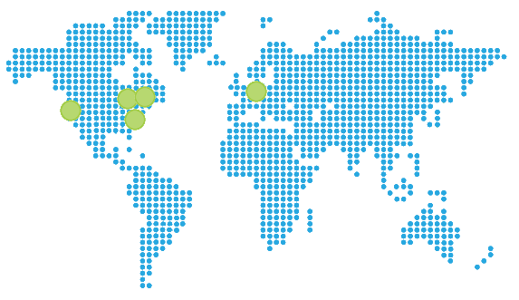

# Web Sites

## Office365Connectorf3646e3297b54eb8b7068b471a4358ec

The website **Office365Connectorf3646e3297b54eb8b7068b471a4358ec** has the following settings:

### Settings

|  |  |
| --- | --- |
| Web Site State | Running |
| Client Affinity Enabled | True |
| Client Certificate Enabled | False |
| Enabled | True |
| GatewaySiteName | default-web-eastus275ddf79b24044e79916f24175b451b1 |
| Location | East US |
| Outbound Ip Addresses | 23.96.33.205,23.96.34.196,23.96.35.20,23.96.36.229 |
| Premium App Deployed |  |
| Repository Site Name | Office365Connectorf3646e3297b54eb8b7068b471a4358ec |
| Scm Site Stopped | False |

### Tags

|  |  |
| --- | --- |
| Tag Key | Tag Value |
| packageId | Office365Connector |
| hidden-related:/subscriptions/275ddf79-b240-44e7-9916-f24175b451b1/resourceGroups/Default-Web-EastUS/providers/Microsoft.Web/serverfarms/Default1 | Resource |

### Site diagnostics

The site diagnostics options have been configured as follows.

|  |  |
| --- | --- |
| Request Tracing Enabled | false |
| Detailed logging enabled | false |
| Remote Debugging Enabled | false |
| Remote Debugging Version |  |

### App Settings

The following application settings have been used for the Web Site.

|  |  |
| --- | --- |
| Key | Value |
| EMA_MicroserviceId | Office365Connector |
| EMA_RuntimeUrl | https://default-web-eastus275ddf79b24044e79916f24175b451b1.azurewebsites.net/ |
| WEBSITE_START_SCM_ON_SITE_CREATION | 1 |
| WEBSITE_SLOT_NAME | Production |

### Default documents

The following default documents are defined.

* Default.htm
* Default.html
* Default.asp
* index.htm
* index.html
* iisstart.htm
* default.aspx
* index.php
* hostingstart.html

### Host Names

The following Host Names are defined.

* office365connectorf3646e3297b54eb8b7068b471a4358ec.azurewebsites.net

### Virtual Applications and Directories

This table contains the list of Virtual Applications defined in the Web Site.

|  |  |  |
| --- | --- | --- |
| Physical Path | Virtual Path | Preload Enabled |
| site\wwwroot | / | false |

### Metrics

#### Average Response Time

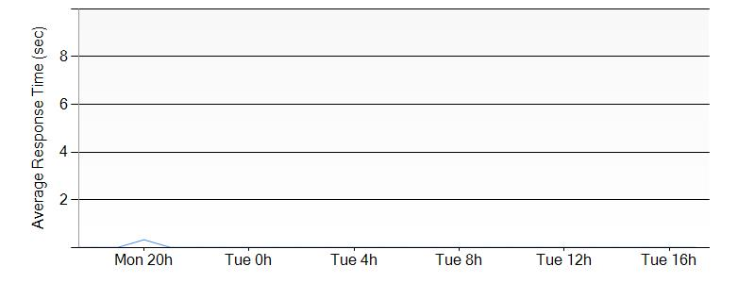

#### Requests

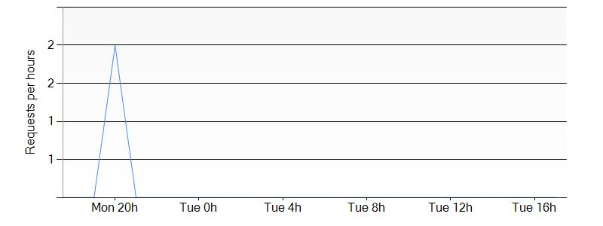

## MyConsentApp

The website **MyConsentApp** has the following settings:

### Settings

|  |  |
| --- | --- |
| Web Site State | Stopped |
| Client Affinity Enabled | True |
| Client Certificate Enabled | False |
| Enabled | True |
| GatewaySiteName |  |
| Location | East US |
| Outbound Ip Addresses | 23.96.33.205,23.96.34.196,23.96.35.20,23.96.36.229 |
| Premium App Deployed |  |
| Repository Site Name | MyConsentApp |
| Scm Site Stopped | False |

### Tags

|  |  |
| --- | --- |
| Tag Key | Tag Value |
| hidden-related:/subscriptions/275ddf79-b240-44e7-9916-f24175b451b1/resourcegroups/Default-Web-EastUS/providers/Microsoft.Web/serverfarms/Default2 | Resource |

### Site diagnostics

The site diagnostics options have been configured as follows.

|  |  |
| --- | --- |
| Request Tracing Enabled | false |
| Detailed logging enabled | false |
| Remote Debugging Enabled | false |
| Remote Debugging Version | VS2012 |

### App Settings

The following application settings have been used for the Web Site.

|  |  |
| --- | --- |
| Key | Value |
| WEBSITE_NODE_DEFAULT_VERSION | 0.10.32 |

### Default documents

The following default documents are defined.

* Default.htm
* Default.html
* Default.asp
* index.htm
* index.html
* iisstart.htm
* default.aspx
* index.php
* hostingstart.html

### Host Names

The following Host Names are defined.

* myconsentapp.azurewebsites.net

### Virtual Applications and Directories

This table contains the list of Virtual Applications defined in the Web Site.

|  |  |  |
| --- | --- | --- |
| Physical Path | Virtual Path | Preload Enabled |
| site\wwwroot | / | false |

### Metrics

#### Average Response Time

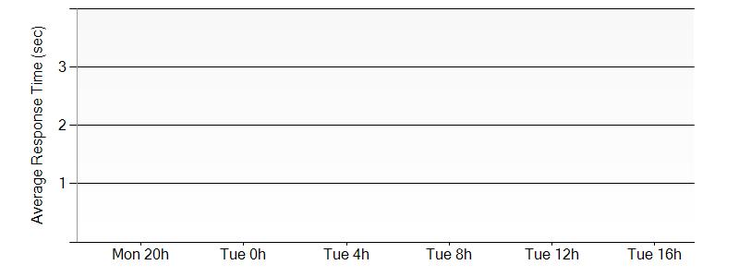

#### Requests

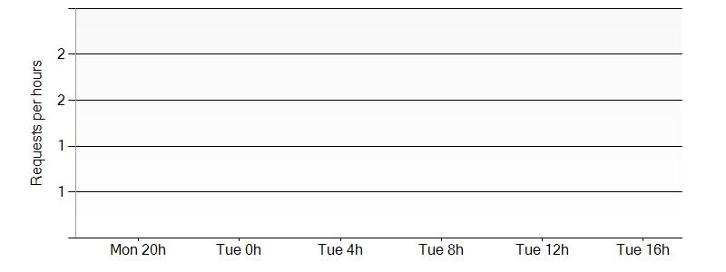

## WCFTestservicepascal

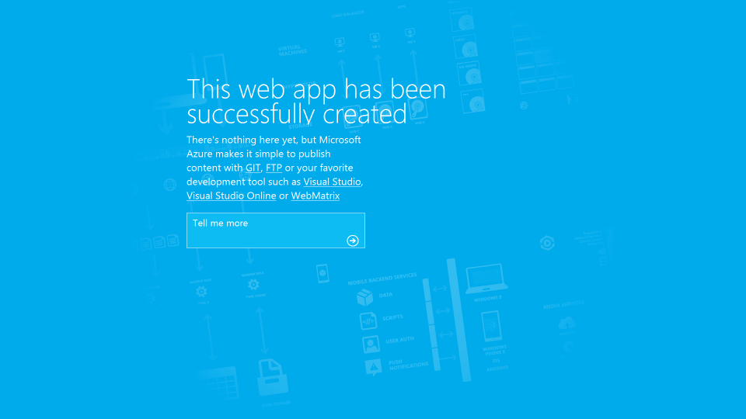

The website **WCFTestservicepascal** has the following settings:

### Settings

|  |  |
| --- | --- |
| Web Site State | Running |
| Client Affinity Enabled | True |
| Client Certificate Enabled | False |
| Enabled | True |
| GatewaySiteName |  |
| Location | East US |
| Outbound Ip Addresses | 23.96.33.205,23.96.34.196,23.96.35.20,23.96.36.229 |
| Premium App Deployed |  |
| Repository Site Name | WCFTestservicepascal |
| Scm Site Stopped | False |

### Tags

|  |  |
| --- | --- |
| Tag Key | Tag Value |
| hidden-related:/subscriptions/275ddf79-b240-44e7-9916-f24175b451b1/resourceGroups/Default-Web-EastUS/providers/Microsoft.Web/serverfarms/Default2 | Resource |

### Site diagnostics

The site diagnostics options have been configured as follows.

|  |  |
| --- | --- |
| Request Tracing Enabled | false |
| Detailed logging enabled | false |
| Remote Debugging Enabled | false |
| Remote Debugging Version | VS2012 |

### App Settings

The following application settings have been used for the Web Site.

|  |  |
| --- | --- |
| Key | Value |
| WEBSITE_NODE_DEFAULT_VERSION | 0.10.32 |

### Default documents

The following default documents are defined.

* Default.htm
* Default.html
* Default.asp
* index.htm
* index.html
* iisstart.htm
* default.aspx
* index.php
* hostingstart.html

### Host Names

The following Host Names are defined.

* wcftestservicepascal.azurewebsites.net

### Virtual Applications and Directories

This table contains the list of Virtual Applications defined in the Web Site.

|  |  |  |
| --- | --- | --- |
| Physical Path | Virtual Path | Preload Enabled |
| site\wwwroot | / | false |

### Metrics

#### Average Response Time

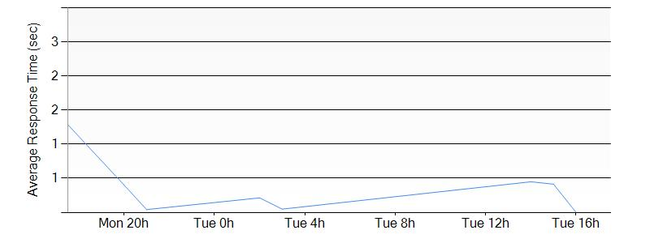

#### Requests

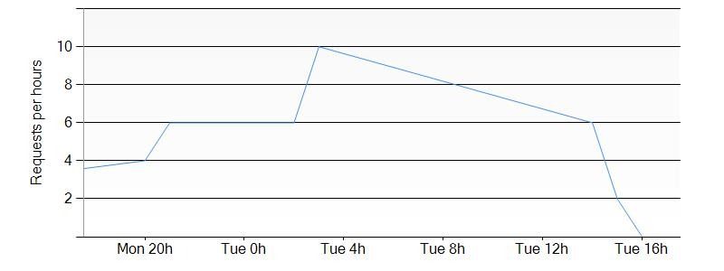

## UManageServiceTest

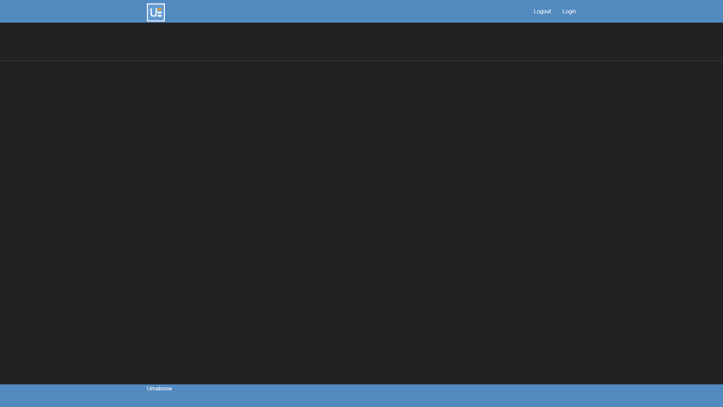

The website **UManageServiceTest** has the following settings:

### Settings

|  |  |
| --- | --- |
| Web Site State | Running |
| Client Affinity Enabled | True |
| Client Certificate Enabled | False |
| Enabled | True |
| GatewaySiteName |  |
| Location | East US |
| Outbound Ip Addresses | 23.96.33.205,23.96.34.196,23.96.35.20,23.96.36.229 |
| Premium App Deployed |  |
| Repository Site Name | UManageServiceTest |
| Scm Site Stopped | False |

### Tags

|  |  |
| --- | --- |
| Tag Key | Tag Value |
| hidden-related:/subscriptions/275ddf79-b240-44e7-9916-f24175b451b1/resourceGroups/Default-Web-EastUS/providers/Microsoft.Web/serverfarms/Default1 | empty |

### Site diagnostics

The site diagnostics options have been configured as follows.

|  |  |
| --- | --- |
| Request Tracing Enabled | false |
| Detailed logging enabled | false |
| Remote Debugging Enabled | false |
| Remote Debugging Version |  |

### App Settings

The following application settings have been used for the Web Site.

|  |  |
| --- | --- |
| Key | Value |
| WEBSITE_NODE_DEFAULT_VERSION | 0.10.32 |

### Default documents

The following default documents are defined.

* Default.htm
* Default.html
* Default.asp
* index.htm
* index.html
* iisstart.htm
* default.aspx
* index.php
* hostingstart.html

### Host Names

The following Host Names are defined.

* umanageservicetest.azurewebsites.net

### Virtual Applications and Directories

This table contains the list of Virtual Applications defined in the Web Site.

|  |  |  |
| --- | --- | --- |
| Physical Path | Virtual Path | Preload Enabled |
| site\wwwroot | / | false |

### Slots

The following Slots are defined.

* UManageServiceTest(Slot1)

### Connection Strings

This following connection strings are used in the Web Site.

|  |  |  |
| --- | --- | --- |
| Name | Type | Connection String |
| Data Source=tcp:umanageservice.database.windows.net,1433;Initial Catalog=UManageServiceTest_db;User Id=umanageAdmin@umanageservice;password=xxxxxx; | DefaultConnection | SQLAzure |

Based on the connection strings, the Web Site is depending on the following component:

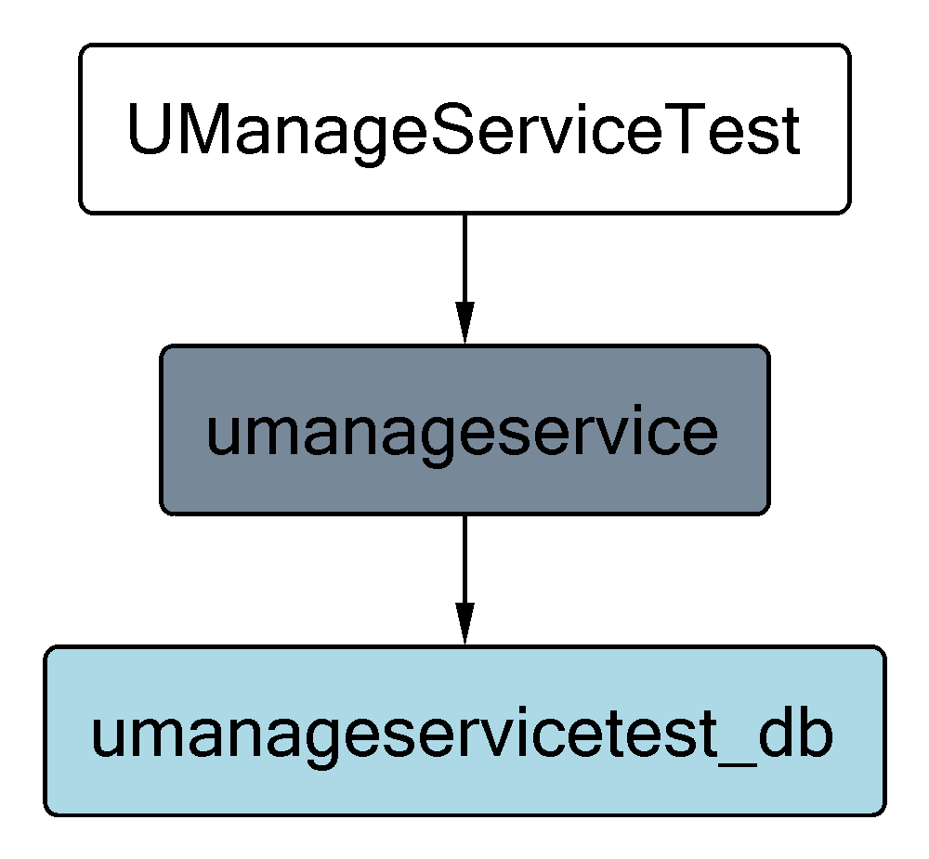

### Metrics

#### Average Response Time

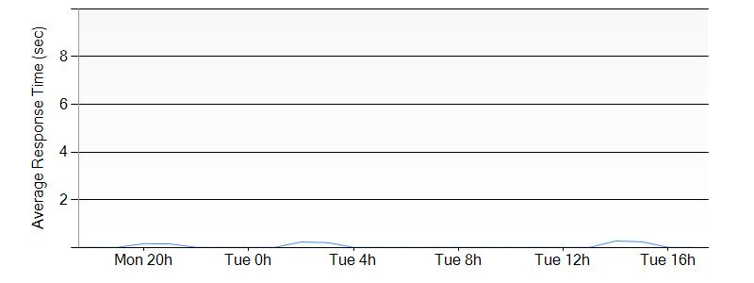

#### Requests

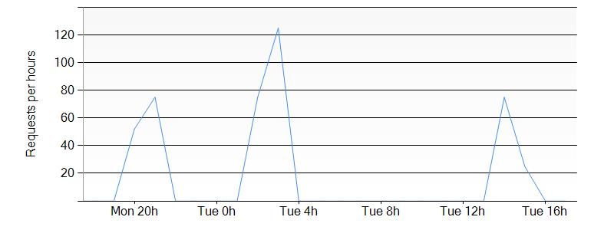

## umanage

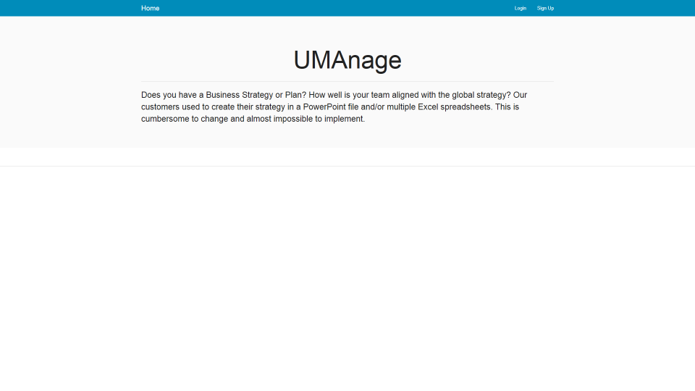

The website **umanage** has the following settings:

### Settings

|  |  |
| --- | --- |
| Web Site State | Running |
| Client Affinity Enabled | True |
| Client Certificate Enabled | False |
| Enabled | True |
| GatewaySiteName |  |
| Location | East US |
| Outbound Ip Addresses | 23.96.33.205,23.96.34.196,23.96.35.20,23.96.36.229 |
| Premium App Deployed |  |
| Repository Site Name | umanage |
| Scm Site Stopped | False |

### Tags

|  |  |
| --- | --- |
| Tag Key | Tag Value |
| hidden-related:/subscriptions/275ddf79-b240-44e7-9916-f24175b451b1/resourceGroups/Default-Web-EastUS/providers/Microsoft.Web/serverfarms/Default2 | Resource |

### Site diagnostics

The site diagnostics options have been configured as follows.

|  |  |
| --- | --- |
| Request Tracing Enabled | false |
| Detailed logging enabled | false |
| Remote Debugging Enabled | false |
| Remote Debugging Version | VS2012 |

### App Settings

The following application settings have been used for the Web Site.

|  |  |
| --- | --- |
| Key | Value |
| WEBSITE_NODE_DEFAULT_VERSION | 0.10.32 |

### Default documents

The following default documents are defined.

* Default.htm
* Default.html
* Default.asp
* index.htm
* index.html
* iisstart.htm
* default.aspx
* index.php
* hostingstart.html

### Host Names

The following Host Names are defined.

* umanage.azurewebsites.net

### Virtual Applications and Directories

This table contains the list of Virtual Applications defined in the Web Site.

|  |  |  |
| --- | --- | --- |
| Physical Path | Virtual Path | Preload Enabled |
| site\wwwroot | / | false |

### Connection Strings

This following connection strings are used in the Web Site.

|  |  |  |
| --- | --- | --- |
| Name | Type | Connection String |
| Server=tcp:nal8jdvson.database.windows.net,1433;Database=datafactory;User ID=yourlogin@yourserver;password=xxxxxx;Encrypt=True;TrustServerCertificate=False;Connection Timeout=30; | umanageDB | SQLAzure |
| sb:test | ServiceBus | Custom |
| http://rest | umanageWebAPI | Custom |
| Server=tcp:umanageservice.database.windows.net,1433;Database=umanageservicetest_db;User ID=yourlogin@yourserver;password=xxxxxx;Encrypt=True;TrustServerCertificate=False;Connection Timeout=30; | umanageServiceBD | SQLAzure |
| Server=tcp:datafactory.database.windows.net,1433;Database=datafactory;User ID=yourlogin@yourserver;password=xxxxxx;Encrypt=True;TrustServerCertificate=False;Connection Timeout=30; | DF | SQLAzure |
| Server=tcp:nal8jdvson.database.windows.net,1433;Database=Netlogon;User ID=yourlogin@yourserver;password=xxxxxx;Encrypt=True;TrustServerCertificate=False;Connection Timeout=30; | Netlogon | SQLAzure |
| Server=tcp:nal8jdvson.database.windows.net,1433;Database=umanageapi_db;User ID=yourlogin@yourserver;password=xxxxxx;Encrypt=True;TrustServerCertificate=False;Connection Timeout=30; | UManageAPIDB | SQLAzure |

Based on the connection strings, the Web Site is depending on the following component:

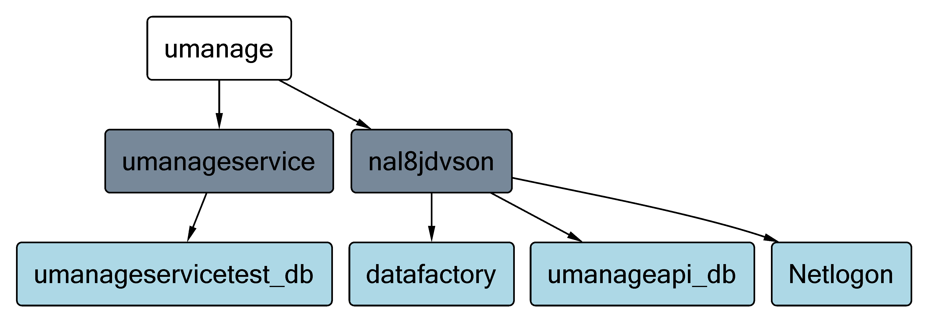

### Metrics

#### Average Response Time

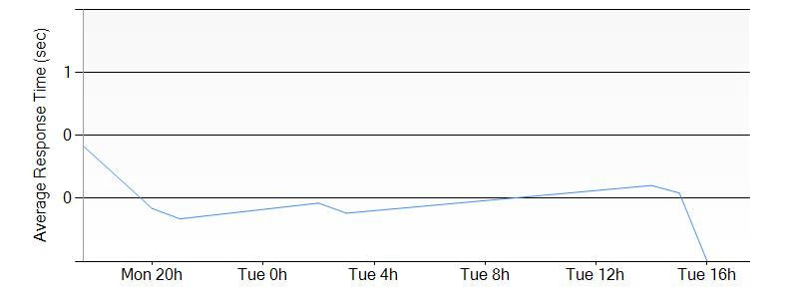

#### Requests

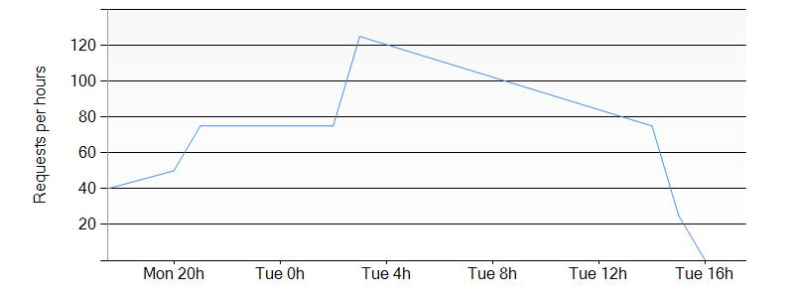

## RulesService21360963ff1e4c4b91c29727c528c556

The website **RulesService21360963ff1e4c4b91c29727c528c556** has the following settings:

### Settings

|  |  |
| --- | --- |
| Web Site State | Running |
| Client Affinity Enabled | True |
| Client Certificate Enabled | False |
| Enabled | True |
| GatewaySiteName | default-web-eastus275ddf79b24044e79916f24175b451b1 |
| Location | East US |
| Outbound Ip Addresses | 23.96.33.205,23.96.34.196,23.96.35.20,23.96.36.229 |
| Premium App Deployed |  |
| Repository Site Name | RulesService21360963ff1e4c4b91c29727c528c556 |
| Scm Site Stopped | False |

### Tags

|  |  |
| --- | --- |
| Tag Key | Tag Value |
| packageId | RulesService |
| hidden-related:/subscriptions/275ddf79-b240-44e7-9916-f24175b451b1/resourceGroups/Default-Web-EastUS/providers/Microsoft.Web/serverfarms/Default1 | Resource |

### Site diagnostics

The site diagnostics options have been configured as follows.

|  |  |
| --- | --- |
| Request Tracing Enabled | false |
| Detailed logging enabled | false |
| Remote Debugging Enabled | false |
| Remote Debugging Version |  |

### App Settings

The following application settings have been used for the Web Site.

|  |  |
| --- | --- |
| Key | Value |
| EMA_MicroserviceId | RulesService |
| EMA_RuntimeUrl | https://default-web-eastus275ddf79b24044e79916f24175b451b1.azurewebsites.net/ |
| WEBSITE_START_SCM_ON_SITE_CREATION | 1 |
| WEBSITE_SLOT_NAME | Production |

### Default documents

The following default documents are defined.

* Default.htm
* Default.html
* Default.asp
* index.htm
* index.html
* iisstart.htm
* default.aspx
* index.php
* hostingstart.html

### Host Names

The following Host Names are defined.

* rulesservice21360963ff1e4c4b91c29727c528c556.azurewebsites.net

### Virtual Applications and Directories

This table contains the list of Virtual Applications defined in the Web Site.

|  |  |  |
| --- | --- | --- |
| Physical Path | Virtual Path | Preload Enabled |
| site\wwwroot | / | false |

### Metrics

#### Average Response Time

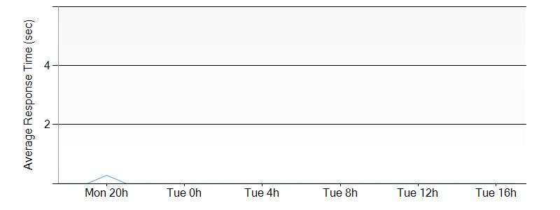

#### Requests

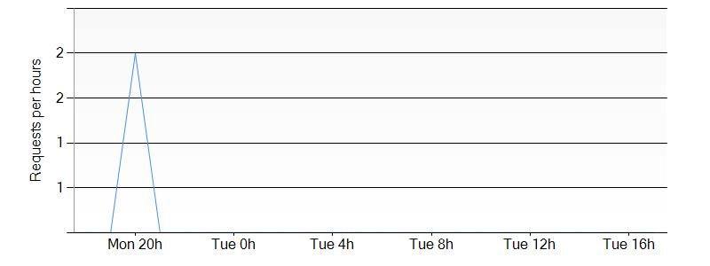

## adk-web

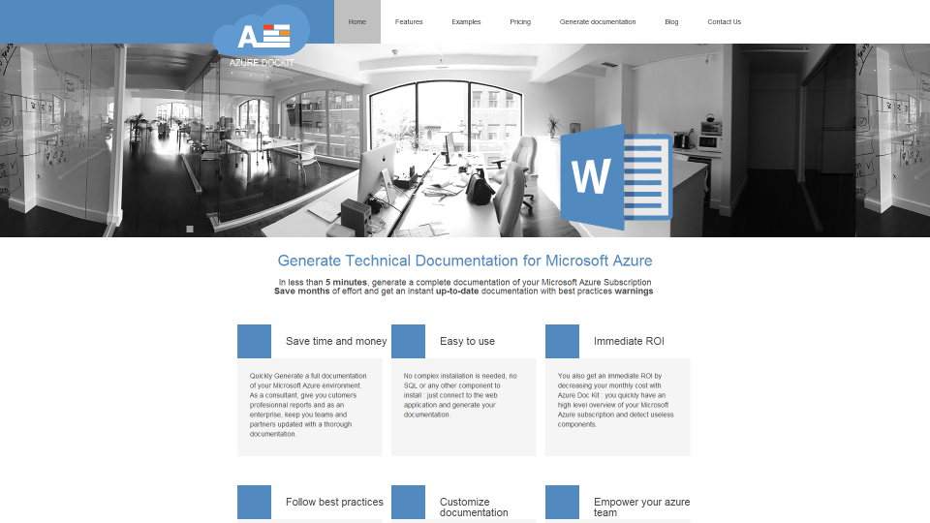

The website **adk-web** has the following settings:

### Settings

|  |  |
| --- | --- |
| Web Site State | Running |
| Client Affinity Enabled | True |
| Client Certificate Enabled | False |
| Enabled | True |
| GatewaySiteName |  |
| Location | East US |
| Outbound Ip Addresses | 23.96.33.205,23.96.34.196,23.96.35.20,23.96.36.229 |
| Premium App Deployed |  |
| Repository Site Name | adk-web |
| Scm Site Stopped | False |

### Tags

|  |  |
| --- | --- |
| Tag Key | Tag Value |
| hidden-related:/subscriptions/275ddf79-b240-44e7-9916-f24175b451b1/resourceGroups/Default-Web-EastUS/providers/Microsoft.Web/serverfarms/Default1 | Resource |

### Site diagnostics

The site diagnostics options have been configured as follows.

|  |  |
| --- | --- |
| Request Tracing Enabled | false |
| Detailed logging enabled | false |
| Remote Debugging Enabled | false |
| Remote Debugging Version | VS2012 |

### App Settings

The following application settings have been used for the Web Site.

|  |  |
| --- | --- |
| Key | Value |
| WEBSITE_NODE_DEFAULT_VERSION | 4.1.2 |

### Default documents

The following default documents are defined.

* Default.htm
* Default.html
* Default.asp
* index.htm
* index.html
* iisstart.htm
* default.aspx
* index.php
* hostingstart.html

### Host Names

The following Host Names are defined.

* www.azuredockit.com
* azuredockit.com
* adk-web.azurewebsites.net

### Virtual Applications and Directories

This table contains the list of Virtual Applications defined in the Web Site.

|  |  |  |
| --- | --- | --- |
| Physical Path | Virtual Path | Preload Enabled |
| site\wwwroot | / | false |

### Connection Strings

This following connection strings are used in the Web Site.

|  |  |  |
| --- | --- | --- |
| Name | Type | Connection String |
| Database=adkwebA3dtWnlBPV;Data Source=us-cdbr-azure-east-a.cloudapp.net;User Id=bb89854482ba5f;password=xxxxxx | adkwebA3dtWnlBPV | MySql |

Based on the connection strings, the Web Site is depending on the following component:

### Metrics

#### Average Response Time

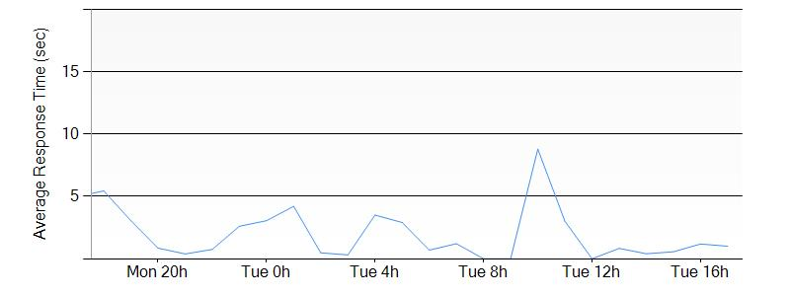

#### Requests

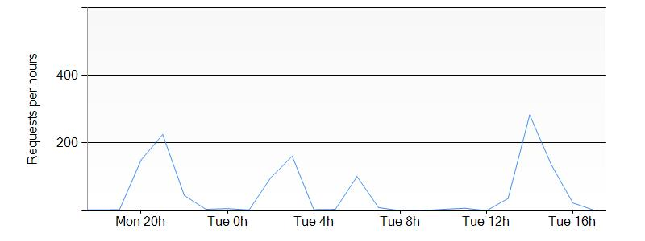

## WebApplicationCertifAzure

The website **WebApplicationCertifAzure** has the following settings:

### Settings

|  |  |
| --- | --- |
| Web Site State | Running |
| Client Affinity Enabled | True |
| Client Certificate Enabled | False |
| Enabled | True |
| GatewaySiteName |  |
| Location | East US |
| Outbound Ip Addresses | 23.96.33.205,23.96.34.196,23.96.35.20,23.96.36.229 |
| Premium App Deployed |  |
| Repository Site Name | WebApplicationCertifAzure |
| Scm Site Stopped | False |

### Tags

|  |  |
| --- | --- |
| Tag Key | Tag Value |
| hidden-related:/subscriptions/275ddf79-b240-44e7-9916-f24175b451b1/resourceGroups/Default-Web-EastUS/providers/Microsoft.Web/serverfarms/Default2 | Resource |

### Site diagnostics

The site diagnostics options have been configured as follows.

|  |  |
| --- | --- |
| Request Tracing Enabled | false |
| Detailed logging enabled | false |
| Remote Debugging Enabled | false |
| Remote Debugging Version | VS2012 |

### App Settings

The following application settings have been used for the Web Site.

|  |  |
| --- | --- |
| Key | Value |
| WEBSITE_NODE_DEFAULT_VERSION | 0.10.32 |

### Default documents

The following default documents are defined.

* Default.htm
* Default.html
* Default.asp
* index.htm
* index.html
* iisstart.htm
* default.aspx
* index.php
* hostingstart.html

### Host Names

The following Host Names are defined.

* webapplicationcertifazure.azurewebsites.net

### Virtual Applications and Directories

This table contains the list of Virtual Applications defined in the Web Site.

|  |  |  |
| --- | --- | --- |
| Physical Path | Virtual Path | Preload Enabled |
| site\wwwroot | / | false |

### Connection Strings

This following connection strings are used in the Web Site.

|  |  |  |
| --- | --- | --- |
| Name | Type | Connection String |
| Data Source=tcp:nal8jdvson.database.windows.net,1433;Initial Catalog=WebApplicationCertifAzure_db;User Id=concerto@nal8jdvson;password=xxxxxx; | DefaultConnection | SQLAzure |

Based on the connection strings, the Web Site is depending on the following component:

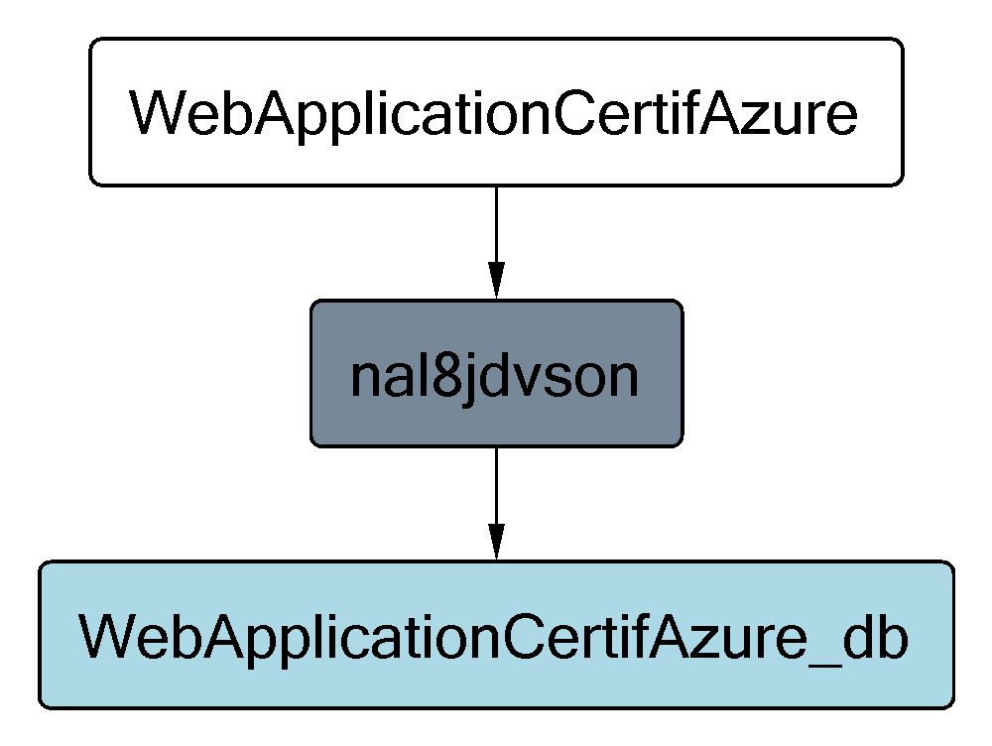

### Metrics

#### Average Response Time

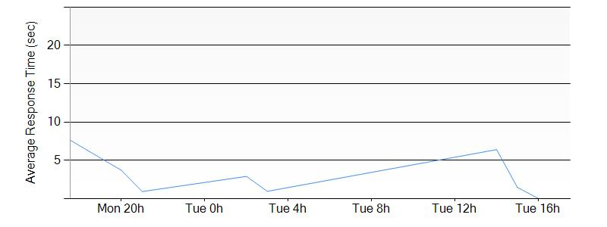

#### Requests

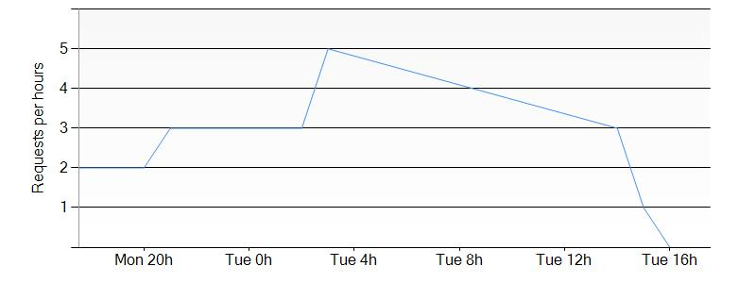

## Microsoft-ApiApp873f74e84a4c498097ef678f141a5dd3

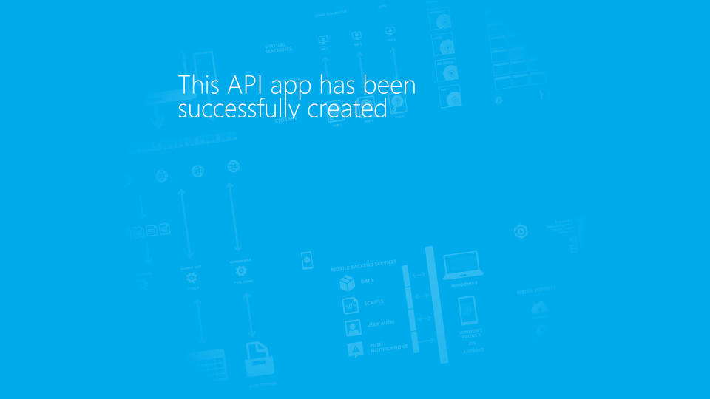

The website **Microsoft-ApiApp873f74e84a4c498097ef678f141a5dd3** has the following settings:

### Settings

|  |  |
| --- | --- |
| Web Site State | Running |
| Client Affinity Enabled | True |
| Client Certificate Enabled | False |
| Enabled | True |
| GatewaySiteName | Default-Web-EastUS275ddf79b24044e79916f24175b451b1 |
| Location | East US |
| Outbound Ip Addresses | 23.96.33.205,23.96.34.196,23.96.35.20,23.96.36.229 |
| Premium App Deployed |  |
| Repository Site Name | Microsoft-ApiApp873f74e84a4c498097ef678f141a5dd3 |
| Scm Site Stopped | False |

### Tags

|  |  |
| --- | --- |
| Tag Key | Tag Value |
| packageId | Microsoft.ApiApp |
| hidden-related:/subscriptions/275ddf79-b240-44e7-9916-f24175b451b1/resourceGroups/Default-Web-EastUS/providers/Microsoft.Web/serverfarms/Default1 | Resource |

### Site diagnostics

The site diagnostics options have been configured as follows.

|  |  |
| --- | --- |
| Request Tracing Enabled | false |
| Detailed logging enabled | false |
| Remote Debugging Enabled | false |
| Remote Debugging Version |  |

### App Settings

The following application settings have been used for the Web Site.

|  |  |
| --- | --- |
| Key | Value |
| EMA_MicroserviceId | WebApplication3APITEST |
| EMA_RuntimeUrl | https://default-web-eastus275ddf79b24044e79916f24175b451b1.azurewebsites.net |
| WEBSITE_START_SCM_ON_SITE_CREATION | 1 |
| WEBSITE_SLOT_NAME | Production |

### Default documents

The following default documents are defined.

* Default.htm
* Default.html
* Default.asp
* index.htm
* index.html
* iisstart.htm
* default.aspx
* index.php
* hostingstart.html

### Host Names

The following Host Names are defined.

* microsoft-apiapp873f74e84a4c498097ef678f141a5dd3.azurewebsites.net

### Virtual Applications and Directories

This table contains the list of Virtual Applications defined in the Web Site.

|  |  |  |
| --- | --- | --- |
| Physical Path | Virtual Path | Preload Enabled |
| site\wwwroot | / | false |

### Metrics

#### Average Response Time

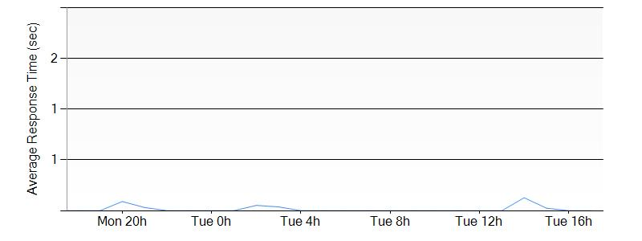

#### Requests

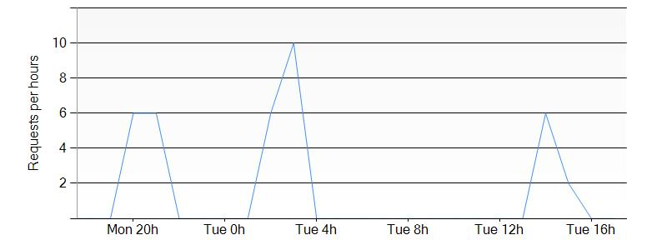

## DelayServicea63d8800ac254141a51fa3b3551add8a

The website **DelayServicea63d8800ac254141a51fa3b3551add8a** has the following settings:

### Settings

|  |  |
| --- | --- |
| Web Site State | Running |
| Client Affinity Enabled | True |
| Client Certificate Enabled | False |
| Enabled | True |
| GatewaySiteName | default-web-eastus275ddf79b24044e79916f24175b451b1 |
| Location | East US |
| Outbound Ip Addresses | 23.96.33.205,23.96.34.196,23.96.35.20,23.96.36.229 |
| Premium App Deployed |  |
| Repository Site Name | DelayServicea63d8800ac254141a51fa3b3551add8a |
| Scm Site Stopped | False |

### Tags

|  |  |
| --- | --- |
| Tag Key | Tag Value |
| packageId | DelayService |
| hidden-related:/subscriptions/275ddf79-b240-44e7-9916-f24175b451b1/resourceGroups/Default-Web-EastUS/providers/Microsoft.Web/serverfarms/Default1 | Resource |

### Site diagnostics

The site diagnostics options have been configured as follows.

|  |  |
| --- | --- |
| Request Tracing Enabled | false |
| Detailed logging enabled | false |
| Remote Debugging Enabled | false |
| Remote Debugging Version |  |

### App Settings

The following application settings have been used for the Web Site.

|  |  |
| --- | --- |
| Key | Value |
| EMA_MicroserviceId | DelayService |
| EMA_RuntimeUrl | https://default-web-eastus275ddf79b24044e79916f24175b451b1.azurewebsites.net/ |
| WEBSITE_START_SCM_ON_SITE_CREATION | 1 |
| WEBSITE_SLOT_NAME | Production |

### Default documents

The following default documents are defined.

* Default.htm
* Default.html
* Default.asp
* index.htm
* index.html
* iisstart.htm
* default.aspx
* index.php
* hostingstart.html

### Host Names

The following Host Names are defined.

* delayservicea63d8800ac254141a51fa3b3551add8a.azurewebsites.net

### Virtual Applications and Directories

This table contains the list of Virtual Applications defined in the Web Site.

|  |  |  |
| --- | --- | --- |
| Physical Path | Virtual Path | Preload Enabled |
| site\wwwroot | / | false |

### Metrics

#### Average Response Time

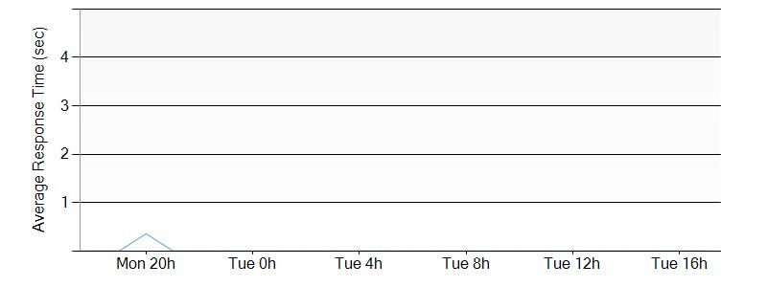

#### Requests

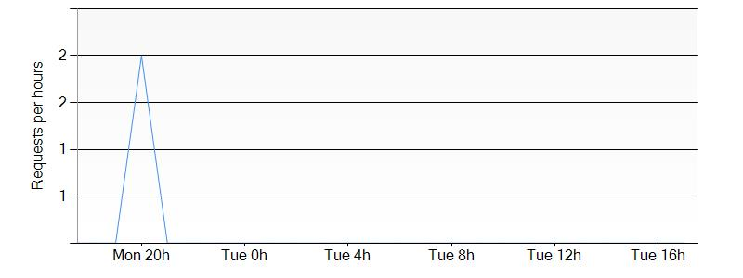

## MicrosoftSharePointOnlineConb234fa267dd24eecb755201d2127c4c7

The website **MicrosoftSharePointOnlineConb234fa267dd24eecb755201d2127c4c7** has the following settings:

### Settings

|  |  |
| --- | --- |
| Web Site State | Running |
| Client Affinity Enabled | True |
| Client Certificate Enabled | False |
| Enabled | True |
| GatewaySiteName | default-web-eastus275ddf79b24044e79916f24175b451b1 |
| Location | East US |
| Outbound Ip Addresses | 23.96.33.205,23.96.34.196,23.96.35.20,23.96.36.229 |
| Premium App Deployed |  |
| Repository Site Name | MicrosoftSharePointOnlineConb234fa267dd24eecb755201d2127c4c7 |
| Scm Site Stopped | False |

### Tags

|  |  |
| --- | --- |
| Tag Key | Tag Value |
| packageId | MicrosoftSharePointOnlineConnector |
| hidden-related:/subscriptions/275ddf79-b240-44e7-9916-f24175b451b1/resourceGroups/Default-Web-EastUS/providers/Microsoft.Web/serverfarms/Default1 | Resource |

### Site diagnostics

The site diagnostics options have been configured as follows.

|  |  |
| --- | --- |
| Request Tracing Enabled | false |
| Detailed logging enabled | false |
| Remote Debugging Enabled | false |
| Remote Debugging Version |  |

### App Settings

The following application settings have been used for the Web Site.

|  |  |
| --- | --- |
| Key | Value |
| EMA_MicroserviceId | MicrosoftSharePointOnlineConnector |
| EMA_RuntimeUrl | https://default-web-eastus275ddf79b24044e79916f24175b451b1.azurewebsites.net/ |
| WEBSITE_START_SCM_ON_SITE_CREATION | 1 |
| MicrosoftSharePointOnlineConnector_SiteUrl | https://umaknow.sharepoint.com/sites/appDevPascal |
| SharePoint_DocumentLibraryOrListRelativeUrl | /Lists/12 |
| WEBSITE_SLOT_NAME | Production |

### Default documents

The following default documents are defined.

* Default.htm
* Default.html
* Default.asp
* index.htm
* index.html
* iisstart.htm
* default.aspx
* index.php
* hostingstart.html

### Host Names

The following Host Names are defined.

* microsoftsharepointonlineconb234fa267dd24eecb755201d2127c4c7.azurewebsites.net

### Virtual Applications and Directories

This table contains the list of Virtual Applications defined in the Web Site.

|  |  |  |
| --- | --- | --- |
| Physical Path | Virtual Path | Preload Enabled |
| site\wwwroot | / | false |

### Metrics

#### Average Response Time

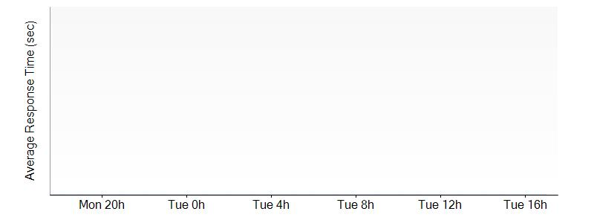

#### Requests

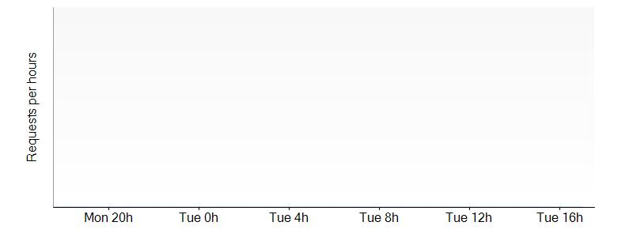

## umaknow-assesments

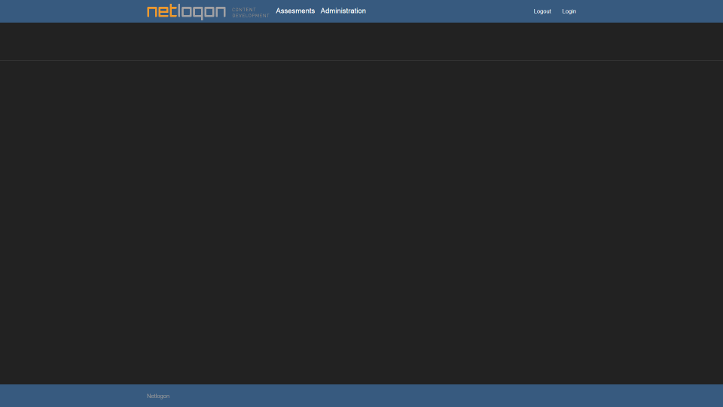

The website **umaknow-assesments** has the following settings:

### Settings

|  |  |
| --- | --- |
| Web Site State | Running |
| Client Affinity Enabled | True |
| Client Certificate Enabled | False |
| Enabled | True |
| GatewaySiteName |  |
| Location | East US |
| Outbound Ip Addresses | 23.96.33.205,23.96.34.196,23.96.35.20,23.96.36.229 |
| Premium App Deployed |  |
| Repository Site Name | umaknow-assesments |
| Scm Site Stopped | False |

### Tags

|  |  |
| --- | --- |
| Tag Key | Tag Value |
| hidden-related:/subscriptions/275ddf79-b240-44e7-9916-f24175b451b1/resourcegroups/Default-Web-EastUS/providers/Microsoft.Web/serverfarms/Default2 | Resource |

### Site diagnostics

The site diagnostics options have been configured as follows.

|  |  |
| --- | --- |
| Request Tracing Enabled | false |
| Detailed logging enabled | false |
| Remote Debugging Enabled | false |
| Remote Debugging Version | VS2012 |

### App Settings

The following application settings have been used for the Web Site.

|  |  |
| --- | --- |
| Key | Value |
| WEBSITE_NODE_DEFAULT_VERSION | 0.10.32 |

### Default documents

The following default documents are defined.

* Default.htm
* Default.html
* Default.asp
* index.htm
* index.html
* iisstart.htm
* default.aspx
* index.php
* hostingstart.html

### Host Names

The following Host Names are defined.

* umaknow-assesments.azurewebsites.net

### Virtual Applications and Directories

This table contains the list of Virtual Applications defined in the Web Site.

|  |  |  |
| --- | --- | --- |
| Physical Path | Virtual Path | Preload Enabled |
| site\wwwroot | / | false |

### Metrics

#### Average Response Time

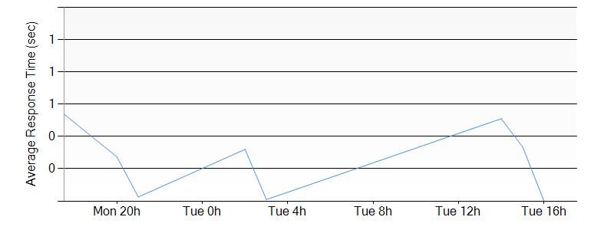

#### Requests

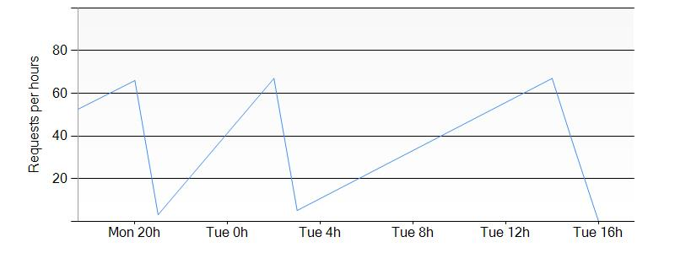

## sharepointhostedproviderpascal

The website **sharepointhostedproviderpascal** has the following settings:

### Settings

|  |  |
| --- | --- |
| Web Site State | Stopped |
| Client Affinity Enabled | True |
| Client Certificate Enabled | False |
| Enabled | True |
| GatewaySiteName |  |
| Location | East US |
| Outbound Ip Addresses | 23.96.33.205,23.96.34.196,23.96.35.20,23.96.36.229 |
| Premium App Deployed |  |
| Repository Site Name | sharepointhostedproviderpascal |
| Scm Site Stopped | False |

### Tags

|  |  |
| --- | --- |
| Tag Key | Tag Value |
| hidden-related:/subscriptions/275ddf79-b240-44e7-9916-f24175b451b1/resourcegroups/Default-Web-EastUS/providers/Microsoft.Web/serverfarms/Default2 | Resource |

### Site diagnostics

The site diagnostics options have been configured as follows.

|  |  |
| --- | --- |
| Request Tracing Enabled | false |
| Detailed logging enabled | false |
| Remote Debugging Enabled | false |
| Remote Debugging Version | VS2012 |

### App Settings

The following application settings have been used for the Web Site.

|  |  |
| --- | --- |
| Key | Value |
| WEBSITE_NODE_DEFAULT_VERSION | 0.10.32 |

### Default documents

The following default documents are defined.

* Default.htm
* Default.html
* Default.asp
* index.htm
* index.html
* iisstart.htm
* default.aspx
* index.php
* hostingstart.html

### Host Names

The following Host Names are defined.

* sharepointhostedproviderpascal.azurewebsites.net

### Virtual Applications and Directories

This table contains the list of Virtual Applications defined in the Web Site.

|  |  |  |
| --- | --- | --- |
| Physical Path | Virtual Path | Preload Enabled |
| site\wwwroot | / | false |

### Metrics

#### Average Response Time

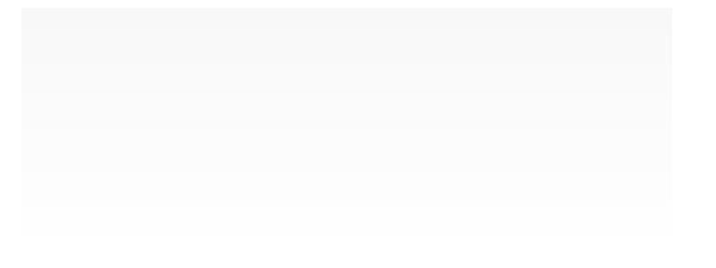

#### Requests



## Default-Web-EastUS275ddf79b24044e79916f24175b451b1

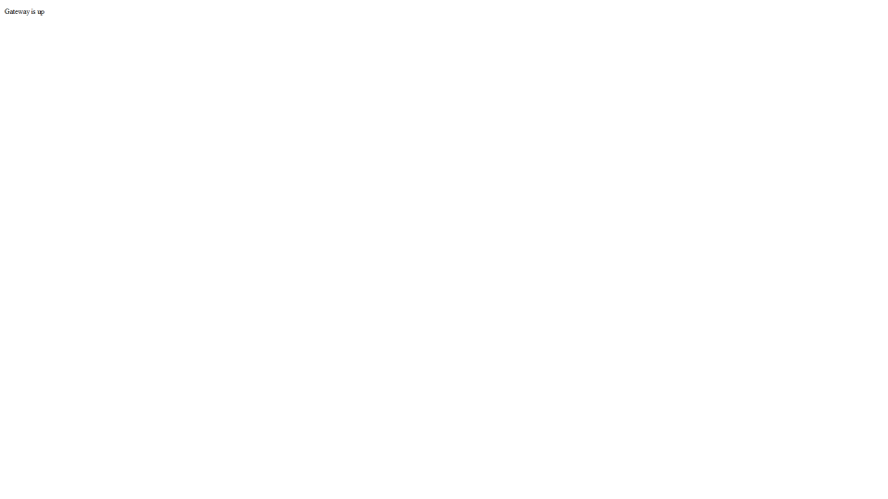

The website **Default-Web-EastUS275ddf79b24044e79916f24175b451b1** has the following settings:

### Settings

|  |  |
| --- | --- |
| Web Site State | Running |
| Client Affinity Enabled | True |
| Client Certificate Enabled | False |
| Enabled | True |
| GatewaySiteName | Default-Web-EastUS275ddf79b24044e79916f24175b451b1 |
| Location | East US |
| Outbound Ip Addresses | 23.96.33.205,23.96.34.196,23.96.35.20,23.96.36.229 |
| Premium App Deployed |  |
| Repository Site Name | Default-Web-EastUS275ddf79b24044e79916f24175b451b1 |
| Scm Site Stopped | False |

### Tags

|  |  |
| --- | --- |
| Tag Key | Tag Value |
| hidden-related:/subscriptions/275ddf79-b240-44e7-9916-f24175b451b1/resourceGroups/Default-Web-EastUS/providers/Microsoft.Web/serverfarms/Default1 | Resource |

### Site diagnostics

The site diagnostics options have been configured as follows.

|  |  |
| --- | --- |
| Request Tracing Enabled | false |
| Detailed logging enabled | false |
| Remote Debugging Enabled | false |
| Remote Debugging Version |  |

### App Settings

The following application settings have been used for the Web Site.

|  |  |
| --- | --- |
| Key | Value |
| ApiAppsGateway_EXTENSION_VERSION | latest |
| EmaStorage | D:\home\data\apiapps |
| WEBSITE_START_SCM_ON_SITE_CREATION | 1 |
| WEBSITE_SLOT_NAME | Production |

### Default documents

The following default documents are defined.

* Default.htm
* Default.html
* Default.asp
* index.htm
* index.html
* iisstart.htm
* default.aspx
* index.php
* hostingstart.html

### Host Names

The following Host Names are defined.

* default-web-eastus275ddf79b24044e79916f24175b451b1.azurewebsites.net

### Virtual Applications and Directories

This table contains the list of Virtual Applications defined in the Web Site.

|  |  |  |
| --- | --- | --- |
| Physical Path | Virtual Path | Preload Enabled |
| site\wwwroot | / | false |

### Metrics

#### Average Response Time

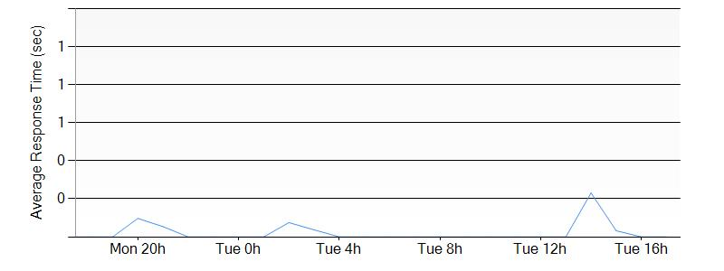

#### Requests

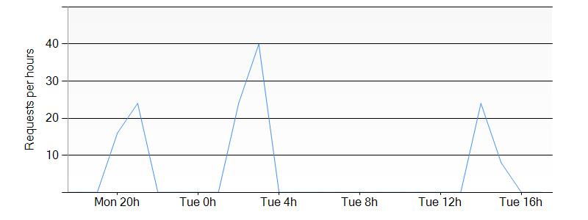

## umanageapi

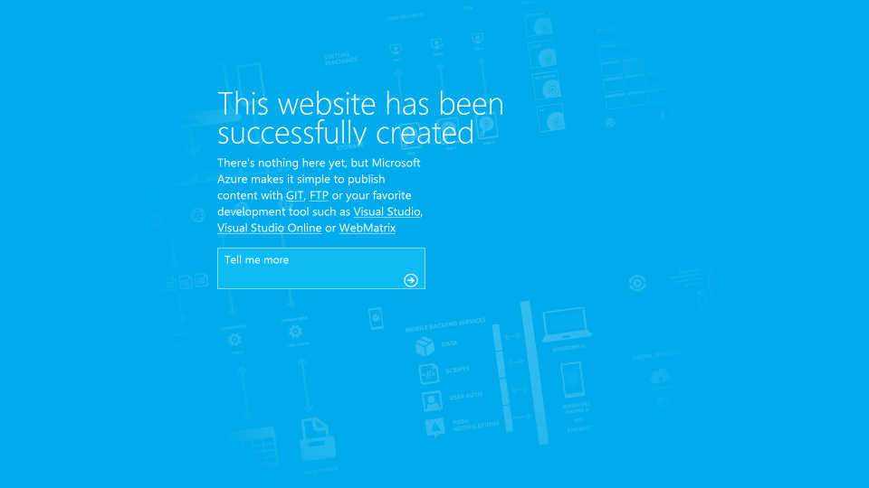

The website **umanageapi** has the following settings:

### Settings

|  |  |
| --- | --- |
| Web Site State | Running |
| Client Affinity Enabled | True |
| Client Certificate Enabled | False |
| Enabled | True |
| GatewaySiteName |  |
| Location | East US |
| Outbound Ip Addresses | 23.96.33.205,23.96.34.196,23.96.35.20,23.96.36.229 |
| Premium App Deployed |  |
| Repository Site Name | umanageapi |
| Scm Site Stopped | False |

### Tags

|  |  |
| --- | --- |
| Tag Key | Tag Value |
| hidden-related:/subscriptions/275ddf79-b240-44e7-9916-f24175b451b1/resourcegroups/Default-Web-EastUS/providers/Microsoft.Web/serverfarms/Default2 | Resource |

### Site diagnostics

The site diagnostics options have been configured as follows.

|  |  |
| --- | --- |
| Request Tracing Enabled | false |
| Detailed logging enabled | false |
| Remote Debugging Enabled | false |
| Remote Debugging Version | VS2013 |

### App Settings

The following application settings have been used for the Web Site.

|  |  |
| --- | --- |
| Key | Value |
| WEBSITE_NODE_DEFAULT_VERSION | 0.10.32 |

### Default documents

The following default documents are defined.

* Default.htm
* Default.html
* Default.asp
* index.htm
* index.html
* iisstart.htm
* default.aspx
* index.php
* hostingstart.html

### Host Names

The following Host Names are defined.

* umanageapi.azurewebsites.net

### Virtual Applications and Directories

This table contains the list of Virtual Applications defined in the Web Site.

|  |  |  |
| --- | --- | --- |
| Physical Path | Virtual Path | Preload Enabled |
| site\wwwroot | / | false |

### Connection Strings

This following connection strings are used in the Web Site.

|  |  |  |
| --- | --- | --- |
| Name | Type | Connection String |
| Data Source=tcp:nal8jdvson.database.windows.net,1433;Initial Catalog=umanageapi_db;User Id=concerto@nal8jdvson;password=xxxxxx; | DefaultConnection | SQLAzure |

Based on the connection strings, the Web Site is depending on the following component:

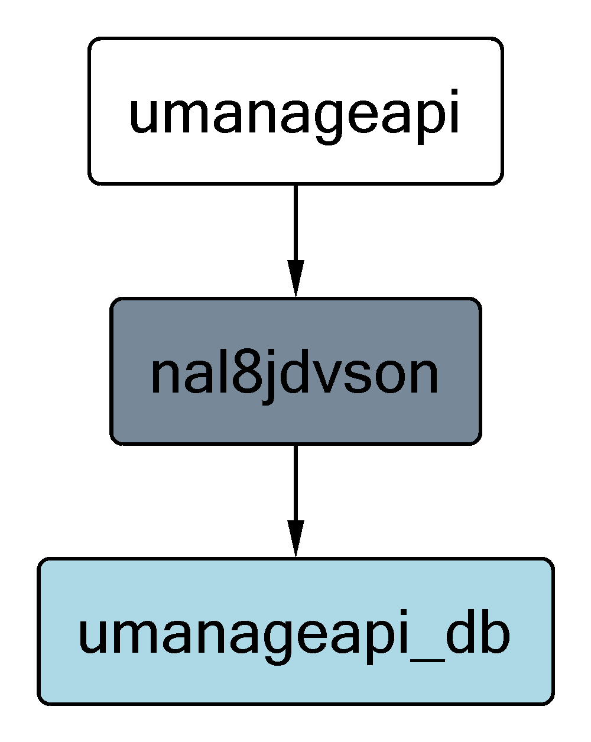

### Metrics

#### Average Response Time

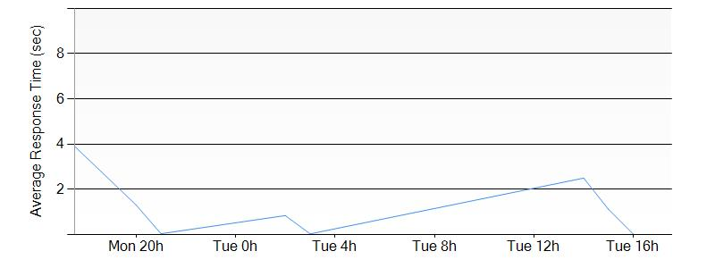

#### Requests

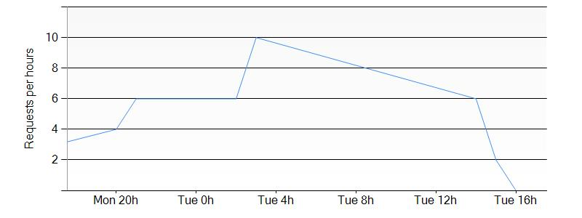

## UManageServiceTest/Slot1



The website **UManageServiceTest/Slot1** has the following settings:

### Settings

|  |  |
| --- | --- |
| Web Site State | Running |
| Client Affinity Enabled | True |
| Client Certificate Enabled | False |
| Enabled | True |
| GatewaySiteName |  |
| Location | East US |
| Outbound Ip Addresses | 23.96.33.205,23.96.34.196,23.96.35.20,23.96.36.229 |
| Premium App Deployed |  |
| Repository Site Name | UManageServiceTest |
| Scm Site Stopped | False |

### Site diagnostics

The site diagnostics options have been configured as follows.

|  |  |
| --- | --- |
| Request Tracing Enabled |  |
| Detailed logging enabled |  |
| Remote Debugging Enabled |  |
| Remote Debugging Version |  |

### App Settings

The following application settings have been used for the Web Site.

|  |  |
| --- | --- |
| Key | Value |

### Host Names

The following Host Names are defined.

* umanageservicetest-slot1.azurewebsites.net

### Metrics

#### Average Response Time

#### Requests

## SiziARMWebApp



The website **SiziARMWebApp** has the following settings:

### Settings

|  |  |
| --- | --- |
| Web Site State | Running |
| Client Affinity Enabled | True |
| Client Certificate Enabled | False |
| Enabled | True |
| GatewaySiteName |  |
| Location | East US |
| Outbound Ip Addresses | 23.96.33.205,23.96.34.196,23.96.35.20,23.96.36.229 |
| Premium App Deployed |  |
| Repository Site Name | SiziARMWebApp |
| Scm Site Stopped | False |

### Tags

|  |  |
| --- | --- |
| Tag Key | Tag Value |
| hidden-related:/subscriptions/275ddf79-b240-44e7-9916-f24175b451b1/resourcegroups/Default-Web-EastUS/providers/Microsoft.Web/serverfarms/Default1 | empty |

### Site diagnostics

The site diagnostics options have been configured as follows.

|  |  |
| --- | --- |
| Request Tracing Enabled | false |
| Detailed logging enabled | false |
| Remote Debugging Enabled | false |
| Remote Debugging Version |  |

### App Settings

The following application settings have been used for the Web Site.

|  |  |
| --- | --- |
| Key | Value |
| WEBSITE_NODE_DEFAULT_VERSION | 4.2.3 |

### Default documents

The following default documents are defined.

* Default.htm
* Default.html
* Default.asp
* index.htm
* index.html
* iisstart.htm
* default.aspx
* index.php
* hostingstart.html

### Host Names

The following Host Names are defined.

* siziarmwebapp.azurewebsites.net

### Virtual Applications and Directories

This table contains the list of Virtual Applications defined in the Web Site.

|  |  |  |
| --- | --- | --- |
| Physical Path | Virtual Path | Preload Enabled |
| site\wwwroot | / | false |

### Metrics

#### Average Response Time

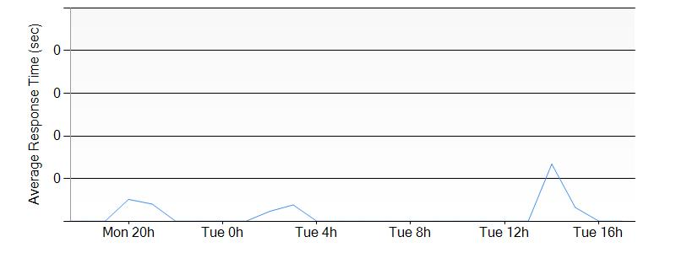

#### Requests

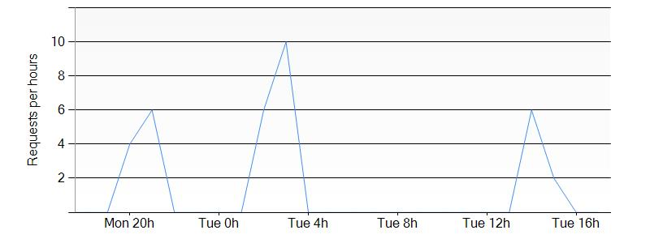

## siziAPIApp



The website **siziAPIApp** has the following settings:

### Settings

|  |  |
| --- | --- |
| Web Site State | Running |
| Client Affinity Enabled | True |
| Client Certificate Enabled | False |
| Enabled | True |
| GatewaySiteName |  |
| Location | East US |
| Outbound Ip Addresses | 23.96.33.205,23.96.34.196,23.96.35.20,23.96.36.229 |
| Premium App Deployed |  |
| Repository Site Name | siziAPIApp |
| Scm Site Stopped | False |

### Tags

|  |  |
| --- | --- |
| Tag Key | Tag Value |
| hidden-related:/subscriptions/275ddf79-b240-44e7-9916-f24175b451b1/resourcegroups/Default-Web-EastUS/providers/Microsoft.Web/serverfarms/Default1 | empty |

### Site diagnostics

The site diagnostics options have been configured as follows.

|  |  |
| --- | --- |
| Request Tracing Enabled | false |
| Detailed logging enabled | false |
| Remote Debugging Enabled | false |
| Remote Debugging Version |  |

### App Settings

The following application settings have been used for the Web Site.

|  |  |
| --- | --- |
| Key | Value |
| WEBSITE_NODE_DEFAULT_VERSION | 4.2.3 |

### Default documents

The following default documents are defined.

* Default.htm
* Default.html
* Default.asp
* index.htm
* index.html
* iisstart.htm
* default.aspx
* index.php
* hostingstart.html

### Host Names

The following Host Names are defined.

* siziapiapp.azurewebsites.net

### Virtual Applications and Directories

This table contains the list of Virtual Applications defined in the Web Site.

|  |  |  |
| --- | --- | --- |
| Physical Path | Virtual Path | Preload Enabled |
| site\wwwroot | / | false |

### Metrics

#### Average Response Time

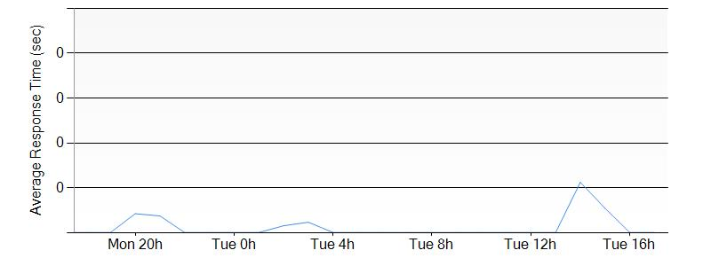

#### Requests

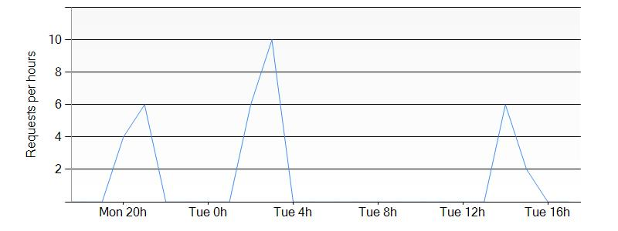

# Storages (Classic)

## adkdev

### Settings

The storage **adkdev** has the following settings:

|  |  |
| --- | --- |
| Uri | https://management.core.windows.net/275ddf79-b240-44e7-9916-f24175b451b1/services/storageservices/adkdev |
| Label | adkdev |
| Description |  |
| Location | East US |
| Status | Created |
| Resource Location | East US |
| Resource Group | Default-Storage-EastUS |
| Affinity Group |  |
| Geo Primary Region | East US |
| Geo Replication Enabled | False |
| Geo Secondary Region |  |

### Blob Storage

The following Blob Storage containers are defined in this storage.

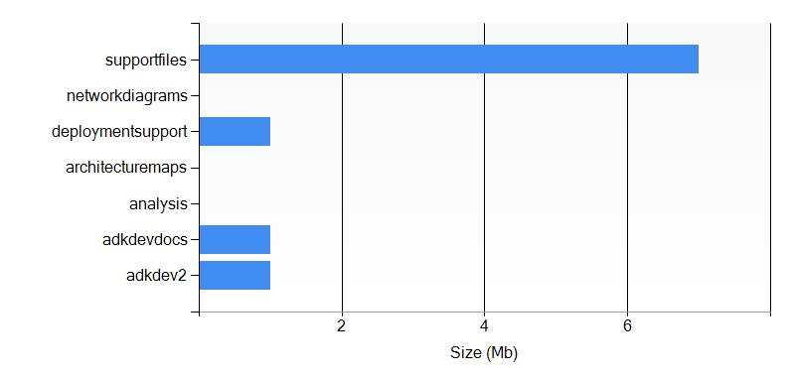

#### Container adkdev2

This container has 4 file(s).

##### Biggest blob items

|  |  |  |  |  |
| --- | --- | --- | --- | --- |
| Uri | Length | Content Type | Last Modified | Blob Type |
| https://adkdev.blob.core.windows.net/adkdev2/AzureDocumentation (1).docx | 1392039 | application/msword | 12/7/2015 1:54:30 AM | BlockBlob |
| https://adkdev.blob.core.windows.net/adkdev2/AzureStorageExplorer.exe.config | 555 | application/octet-stream | 12/7/2015 1:54:19 AM | BlockBlob |
| https://adkdev.blob.core.windows.net/adkdev2/analysis/file.txt | 4 | application/octet-stream | 12/16/2015 9:19:55 PM | BlockBlob |
| https://adkdev.blob.core.windows.net/adkdev2/analysis/specs/thespec.txt | 4 | application/octet-stream | 12/16/2015 9:20:15 PM | BlockBlob |
| https://adkdev.blob.core.windows.net/adkdev2/analysis/specs/ | 0 |  |  |  |
| https://adkdev.blob.core.windows.net/adkdev2/analysis/ | 0 |  |  |  |

##### Last modified blob items

|  |  |  |  |  |
| --- | --- | --- | --- | --- |
| Uri | Length | Content Type | Last Modified | Blob Type |
| https://adkdev.blob.core.windows.net/adkdev2/analysis/specs/thespec.txt | 4 | application/octet-stream | 12/16/2015 9:20:15 PM | BlockBlob |
| https://adkdev.blob.core.windows.net/adkdev2/analysis/file.txt | 4 | application/octet-stream | 12/16/2015 9:19:55 PM | BlockBlob |
| https://adkdev.blob.core.windows.net/adkdev2/AzureDocumentation (1).docx | 1392039 | application/msword | 12/7/2015 1:54:30 AM | BlockBlob |
| https://adkdev.blob.core.windows.net/adkdev2/AzureStorageExplorer.exe.config | 555 | application/octet-stream | 12/7/2015 1:54:19 AM | BlockBlob |

#### Container adkdevdocs

This container has 2 file(s).

##### Biggest blob items

|  |  |  |  |  |
| --- | --- | --- | --- | --- |
| Uri | Length | Content Type | Last Modified | Blob Type |
| https://adkdev.blob.core.windows.net/adkdevdocs/logs.txt | 1596345 | application/octet-stream | 12/2/2015 2:11:31 AM | BlockBlob |
| https://adkdev.blob.core.windows.net/adkdevdocs/AzureDocumentation.docx | 241956 | application/octet-stream | 12/2/2015 2:11:26 AM | BlockBlob |

##### Last modified blob items

|  |  |  |  |  |
| --- | --- | --- | --- | --- |
| Uri | Length | Content Type | Last Modified | Blob Type |
| https://adkdev.blob.core.windows.net/adkdevdocs/logs.txt | 1596345 | application/octet-stream | 12/2/2015 2:11:31 AM | BlockBlob |
| https://adkdev.blob.core.windows.net/adkdevdocs/AzureDocumentation.docx | 241956 | application/octet-stream | 12/2/2015 2:11:26 AM | BlockBlob |

#### Container analysis

This container has 0 file(s).

##### Biggest blob items

|  |  |  |  |  |
| --- | --- | --- | --- | --- |
| Uri | Length | Content Type | Last Modified | Blob Type |

#### Container architecturemaps

This container has 0 file(s).

##### Biggest blob items

|  |  |  |  |  |
| --- | --- | --- | --- | --- |
| Uri | Length | Content Type | Last Modified | Blob Type |

#### Container deploymentsupport

This container has 1 file(s).

##### Biggest blob items

|  |  |  |  |  |
| --- | --- | --- | --- | --- |
| Uri | Length | Content Type | Last Modified | Blob Type |
| https://adkdev.blob.core.windows.net/deploymentsupport/AzureDocumentation (2).docx | 1392013 | application/msword | 12/7/2015 1:59:38 AM | BlockBlob |

##### Last modified blob items

|  |  |  |  |  |
| --- | --- | --- | --- | --- |
| Uri | Length | Content Type | Last Modified | Blob Type |
| https://adkdev.blob.core.windows.net/deploymentsupport/AzureDocumentation (2).docx | 1392013 | application/msword | 12/7/2015 1:59:38 AM | BlockBlob |

#### Container networkdiagrams

This container has 0 file(s).

##### Biggest blob items

|  |  |  |  |  |
| --- | --- | --- | --- | --- |
| Uri | Length | Content Type | Last Modified | Blob Type |

#### Container supportfiles

This container has 6 file(s).

##### Biggest blob items

|  |  |  |  |  |
| --- | --- | --- | --- | --- |
| Uri | Length | Content Type | Last Modified | Blob Type |
| https://adkdev.blob.core.windows.net/supportfiles/AzureDocumentation (16).docx | 1815895 | application/msword | 12/7/2015 1:55:20 AM | BlockBlob |
| https://adkdev.blob.core.windows.net/supportfiles/AzureDocumentation (18).docx | 1815872 | application/msword | 12/7/2015 1:55:22 AM | BlockBlob |
| https://adkdev.blob.core.windows.net/supportfiles/AzureDocumentation (15).docx | 1815841 | application/msword | 12/7/2015 1:55:19 AM | BlockBlob |
| https://adkdev.blob.core.windows.net/supportfiles/AzureDocumentation (20).docx | 1126044 | application/msword | 12/7/2015 1:55:24 AM | BlockBlob |
| https://adkdev.blob.core.windows.net/supportfiles/AzureDocumentation (19).docx | 1125960 | application/msword | 12/7/2015 1:55:23 AM | BlockBlob |
| https://adkdev.blob.core.windows.net/supportfiles/AzureDocumentation (17).docx | 241953 | application/msword | 12/7/2015 1:55:21 AM | BlockBlob |

##### Last modified blob items

|  |  |  |  |  |
| --- | --- | --- | --- | --- |
| Uri | Length | Content Type | Last Modified | Blob Type |
| https://adkdev.blob.core.windows.net/supportfiles/AzureDocumentation (20).docx | 1126044 | application/msword | 12/7/2015 1:55:24 AM | BlockBlob |
| https://adkdev.blob.core.windows.net/supportfiles/AzureDocumentation (19).docx | 1125960 | application/msword | 12/7/2015 1:55:23 AM | BlockBlob |
| https://adkdev.blob.core.windows.net/supportfiles/AzureDocumentation (18).docx | 1815872 | application/msword | 12/7/2015 1:55:22 AM | BlockBlob |
| https://adkdev.blob.core.windows.net/supportfiles/AzureDocumentation (17).docx | 241953 | application/msword | 12/7/2015 1:55:21 AM | BlockBlob |
| https://adkdev.blob.core.windows.net/supportfiles/AzureDocumentation (16).docx | 1815895 | application/msword | 12/7/2015 1:55:20 AM | BlockBlob |
| https://adkdev.blob.core.windows.net/supportfiles/AzureDocumentation (15).docx | 1815841 | application/msword | 12/7/2015 1:55:19 AM | BlockBlob |

### Warnings

The following warnings have been detected in the storage.

|  |  |  |
| --- | --- | --- |
| Criticity | Description | Type |
| High | In case of a datacenter crash, be aware that your data may be unavailable | Availability |

## classicstoragepascal

### Settings

The storage **classicstoragepascal** has the following settings:

|  |  |
| --- | --- |
| Uri | https://management.core.windows.net/275ddf79-b240-44e7-9916-f24175b451b1/services/storageservices/classicstoragepascal |
| Label | classicstoragepascal |
| Description | classicstoragepascal |
| Location | East US |
| Status | Created |
| Resource Location | eastus |
| Resource Group | cdsbiztalk |
| Affinity Group |  |
| Geo Primary Region | East US |
| Geo Replication Enabled | False |
| Geo Secondary Region | West US |

## dropbuildtestcirque

### Settings

The storage **dropbuildtestcirque** has the following settings:

|  |  |
| --- | --- |
| Uri | https://management.core.windows.net/275ddf79-b240-44e7-9916-f24175b451b1/services/storageservices/dropbuildtestcirque |
| Label | dropbuildtestcirque |
| Description |  |
| Location | East US |
| Status | Created |
| Resource Location | East US |
| Resource Group | Default-Storage-EastUS |
| Affinity Group |  |
| Geo Primary Region | East US |
| Geo Replication Enabled | False |
| Geo Secondary Region | West US |

### Blob Storage

The following Blob Storage containers are defined in this storage.

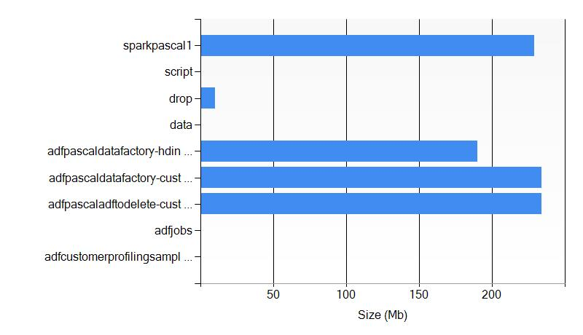

#### Container adfcustomerprofilingsample

This container has 65 file(s).

##### Biggest blob items

|  |  |  |  |  |
| --- | --- | --- | --- | --- |
| Uri | Length | Content Type | Last Modified | Blob Type |
| https://dropbuildtestcirque.blob.core.windows.net/adfcustomerprofilingsample/marketingcampaigneffectiveness/yearno=2014/monthno=5/dayno=2/000000_0 | 41480 | application/octet-stream | 11/19/2015 6:38:44 PM | BlockBlob |
| https://dropbuildtestcirque.blob.core.windows.net/adfcustomerprofilingsample/user/hdp/.Trash/Current/marketingcampaigneffectiveness/yearno=2014/monthno=5/dayno=2/000000_0 | 41480 | application/octet-stream | 11/19/2015 6:38:43 PM | BlockBlob |
| https://dropbuildtestcirque.blob.core.windows.net/adfcustomerprofilingsample/marketingcampaigneffectiveness/yearno=2014/monthno=5/dayno=1/000000_0 | 40936 | application/octet-stream | 11/19/2015 6:45:16 PM | BlockBlob |
| https://dropbuildtestcirque.blob.core.windows.net/adfcustomerprofilingsample/user/hdp/.Trash/Current/marketingcampaigneffectiveness/yearno=2014/monthno=5/dayno=1/000000_0 | 40936 | application/octet-stream | 11/19/2015 6:45:16 PM | BlockBlob |
| https://dropbuildtestcirque.blob.core.windows.net/adfcustomerprofilingsample/refdata/refgeocodedictionary/refgeocodedictionary.csv | 18647 | application/octet-stream | 11/19/2015 4:30:15 PM | BlockBlob |
| https://dropbuildtestcirque.blob.core.windows.net/adfcustomerprofilingsample/logs/enrichedgameevents/yearno=2014/monthno=5/dayno=4/part-r-00000 | 17439 | application/octet-stream | 11/19/2015 5:26:07 PM | BlockBlob |
| https://dropbuildtestcirque.blob.core.windows.net/adfcustomerprofilingsample/logs/enrichedgameevents/yearno=2014/monthno=5/dayno=2/part-r-00000 | 17377 | application/octet-stream | 11/19/2015 6:31:56 PM | BlockBlob |
| https://dropbuildtestcirque.blob.core.windows.net/adfcustomerprofilingsample/logs/rawgameevents/rawstats-20140504.csv | 16245 | application/octet-stream | 11/19/2015 4:30:15 PM | BlockBlob |
| https://dropbuildtestcirque.blob.core.windows.net/adfcustomerprofilingsample/logs/rawgameevents/rawstats-20140502.csv | 16119 | application/octet-stream | 11/19/2015 4:30:15 PM | BlockBlob |
| https://dropbuildtestcirque.blob.core.windows.net/adfcustomerprofilingsample/logs/rawgameevents/rawstats-20140503.csv | 16062 | application/octet-stream | 11/19/2015 4:30:15 PM | BlockBlob |

##### Last modified blob items

|  |  |  |  |  |
| --- | --- | --- | --- | --- |
| Uri | Length | Content Type | Last Modified | Blob Type |
| https://dropbuildtestcirque.blob.core.windows.net/adfcustomerprofilingsample/hive/scratch/admin/9a2b92eb-add8-4e61-83f1-82ecb5baaa97 | 0 |  | 11/19/2015 6:45:16 PM | BlockBlob |
| https://dropbuildtestcirque.blob.core.windows.net/adfcustomerprofilingsample/marketingcampaigneffectiveness/yearno=2014/monthno=5 | 0 |  | 11/19/2015 6:45:16 PM | BlockBlob |
| https://dropbuildtestcirque.blob.core.windows.net/adfcustomerprofilingsample/marketingcampaigneffectiveness/yearno=2014/monthno=5/dayno=1 | 0 |  | 11/19/2015 6:45:16 PM | BlockBlob |
| https://dropbuildtestcirque.blob.core.windows.net/adfcustomerprofilingsample/marketingcampaigneffectiveness/yearno=2014/monthno=5/dayno=1/000000_0 | 40936 | application/octet-stream | 11/19/2015 6:45:16 PM | BlockBlob |
| https://dropbuildtestcirque.blob.core.windows.net/adfcustomerprofilingsample/user/hdp/.Trash/Current/marketingcampaigneffectiveness/yearno=2014/monthno=5/dayno=1 | 0 |  | 11/19/2015 6:45:16 PM | BlockBlob |
| https://dropbuildtestcirque.blob.core.windows.net/adfcustomerprofilingsample/user/hdp/.Trash/Current/marketingcampaigneffectiveness/yearno=2014/monthno=5/dayno=1/000000_0 | 40936 | application/octet-stream | 11/19/2015 6:45:16 PM | BlockBlob |
| https://dropbuildtestcirque.blob.core.windows.net/adfcustomerprofilingsample/logs/enrichedgameevents/yearno=2014/monthno=5/dayno=1 | 0 |  | 11/19/2015 6:40:09 PM | BlockBlob |
| https://dropbuildtestcirque.blob.core.windows.net/adfcustomerprofilingsample/logs/enrichedgameevents/yearno=2014/monthno=5/dayno=1/_SUCCESS | 0 | application/octet-stream | 11/19/2015 6:40:09 PM | BlockBlob |
| https://dropbuildtestcirque.blob.core.windows.net/adfcustomerprofilingsample/logs/enrichedgameevents/yearno=2014/monthno=5/dayno=1/part-r-00000 | 13279 | application/octet-stream | 11/19/2015 6:40:09 PM | BlockBlob |
| https://dropbuildtestcirque.blob.core.windows.net/adfcustomerprofilingsample/logs/enrichedgameevents/yearno=2014/monthno=5 | 0 |  | 11/19/2015 6:39:24 PM | BlockBlob |

#### Container adfjobs

This container has 115 file(s).

##### Biggest blob items

|  |  |  |  |  |
| --- | --- | --- | --- | --- |
| Uri | Length | Content Type | Last Modified | Blob Type |
| https://dropbuildtestcirque.blob.core.windows.net/adfjobs/PigQueryJobs/676ec656-500c-4278-b396-0f962826a5bb/19_11_2015_05_21_28_615/Status/stderr | 18111 | application/octet-stream | 11/19/2015 5:26:15 PM | BlockBlob |
| https://dropbuildtestcirque.blob.core.windows.net/adfjobs/PigQueryJobs/3f779dbc-ba08-4e63-9b7e-3e64982107c3/26_10_2015_08_30_09_300/Status/stderr | 17888 | application/octet-stream | 10/26/2015 8:34:05 PM | BlockBlob |
| https://dropbuildtestcirque.blob.core.windows.net/adfjobs/PigQueryJobs/49304f0c-00de-45ef-9633-c972be5e9972/26_10_2015_09_35_06_252/Status/stderr | 17884 | application/octet-stream | 10/26/2015 9:38:48 PM | BlockBlob |
| https://dropbuildtestcirque.blob.core.windows.net/adfjobs/PigQueryJobs/c7ed33d1-1565-41e1-9964-adebca5e19e7/26_10_2015_09_42_15_970/Status/stderr | 17881 | application/octet-stream | 10/26/2015 9:45:18 PM | BlockBlob |
| https://dropbuildtestcirque.blob.core.windows.net/adfjobs/PigQueryJobs/93579731-65c7-4a96-ae27-d02b54cb897a/19_11_2015_06_27_31_318/Status/stderr | 17834 | application/octet-stream | 11/19/2015 6:32:04 PM | BlockBlob |
| https://dropbuildtestcirque.blob.core.windows.net/adfjobs/PigQueryJobs/554ac311-96c5-4ef7-9678-982175423e6a/19_11_2015_06_36_41_880/Status/stderr | 17829 | application/octet-stream | 11/19/2015 6:40:16 PM | BlockBlob |
| https://dropbuildtestcirque.blob.core.windows.net/adfjobs/HiveQueryJobs/c0963cdb-198f-47bc-856c-9381caa938ca/26_10_2015_08_33_18_814/Status/stderr | 3855 | application/octet-stream | 10/26/2015 8:36:37 PM | BlockBlob |
| https://dropbuildtestcirque.blob.core.windows.net/adfjobs/HiveQueryJobs/fc72d6bf-e151-457f-8b44-549d5a58fbfe/26_10_2015_09_38_42_661/Status/stderr | 3854 | application/octet-stream | 10/26/2015 9:41:24 PM | BlockBlob |
| https://dropbuildtestcirque.blob.core.windows.net/adfjobs/HiveQueryJobs/5cf9a1c7-37ba-40f8-af26-05c98e7e36b2/26_10_2015_07_58_36_327/Status/stderr | 3850 | application/octet-stream | 10/26/2015 8:28:58 PM | BlockBlob |
| https://dropbuildtestcirque.blob.core.windows.net/adfjobs/HiveQueryJobs/f7fbbeed-ba3e-4f48-9d2f-19c6a1eaea44/26_10_2015_08_29_56_273/Status/stderr | 3846 | application/octet-stream | 10/26/2015 8:32:35 PM | BlockBlob |

##### Last modified blob items

|  |  |  |  |  |
| --- | --- | --- | --- | --- |
| Uri | Length | Content Type | Last Modified | Blob Type |
| https://dropbuildtestcirque.blob.core.windows.net/adfjobs/HiveQueryJobs/767cfc8d-129f-46b9-bf8f-ce0aed32802a/19_11_2015_06_42_01_307/Status | 0 |  | 11/19/2015 6:45:27 PM | BlockBlob |
| https://dropbuildtestcirque.blob.core.windows.net/adfjobs/HiveQueryJobs/767cfc8d-129f-46b9-bf8f-ce0aed32802a/19_11_2015_06_42_01_307/Status/exit | 3 | application/octet-stream | 11/19/2015 6:45:27 PM | BlockBlob |
| https://dropbuildtestcirque.blob.core.windows.net/adfjobs/HiveQueryJobs/767cfc8d-129f-46b9-bf8f-ce0aed32802a/19_11_2015_06_42_01_307/Status/stderr | 3493 | application/octet-stream | 11/19/2015 6:45:17 PM | BlockBlob |
| https://dropbuildtestcirque.blob.core.windows.net/adfjobs/HiveQueryJobs/767cfc8d-129f-46b9-bf8f-ce0aed32802a/19_11_2015_06_42_01_307/Status/stdout | 269 | application/octet-stream | 11/19/2015 6:45:17 PM | BlockBlob |
| https://dropbuildtestcirque.blob.core.windows.net/adfjobs/HiveQueryJobs/767cfc8d-129f-46b9-bf8f-ce0aed32802a/19_11_2015_06_42_01_307/Query/b155b9fd-3e65-f7ec-8752-9f5ea1abce4d.hql | 1753 | application/octet-stream | 11/19/2015 6:42:01 PM | BlockBlob |
| https://dropbuildtestcirque.blob.core.windows.net/adfjobs/PigQueryJobs/554ac311-96c5-4ef7-9678-982175423e6a/19_11_2015_06_36_41_880/Status | 0 |  | 11/19/2015 6:40:19 PM | BlockBlob |
| https://dropbuildtestcirque.blob.core.windows.net/adfjobs/PigQueryJobs/554ac311-96c5-4ef7-9678-982175423e6a/19_11_2015_06_36_41_880/Status/exit | 3 | application/octet-stream | 11/19/2015 6:40:19 PM | BlockBlob |
| https://dropbuildtestcirque.blob.core.windows.net/adfjobs/PigQueryJobs/554ac311-96c5-4ef7-9678-982175423e6a/19_11_2015_06_36_41_880/Status/stderr | 17829 | application/octet-stream | 11/19/2015 6:40:16 PM | BlockBlob |
| https://dropbuildtestcirque.blob.core.windows.net/adfjobs/PigQueryJobs/554ac311-96c5-4ef7-9678-982175423e6a/19_11_2015_06_36_41_880/Status/stdout | 139 | application/octet-stream | 11/19/2015 6:40:16 PM | BlockBlob |
| https://dropbuildtestcirque.blob.core.windows.net/adfjobs/HiveQueryJobs/8586bf1f-aaa3-44ab-a94f-1917ef18588c/19_11_2015_06_33_16_690/Status | 0 |  | 11/19/2015 6:38:55 PM | BlockBlob |

#### Container adfpascaladftodelete-customerprofiling-hdin-20151119163206

This container has 542 file(s).

##### Biggest blob items

|  |  |  |  |  |
| --- | --- | --- | --- | --- |
| Uri | Length | Content Type | Last Modified | Blob Type |
| https://dropbuildtestcirque.blob.core.windows.net/adfpascaladftodelete-customerprofiling-hdin-20151119163206/apps/tez/tez-0.5.2.2.2.7.1-34.tar.gz | 41142436 | application/octet-stream | 11/19/2015 5:14:31 PM | BlockBlob |
| https://dropbuildtestcirque.blob.core.windows.net/adfpascaladftodelete-customerprofiling-hdin-20151119163206/user/hdp/share/lib/hcatalog/hive-exec-0.14.0.2.2.7.1-34.jar | 17427988 | application/octet-stream | 11/19/2015 5:15:31 PM | BlockBlob |
| https://dropbuildtestcirque.blob.core.windows.net/adfpascaladftodelete-customerprofiling-hdin-20151119163206/user/hdp/share/lib/hive/hive-exec-0.14.0.2.2.7.1-34.jar | 17427988 | application/octet-stream | 11/19/2015 5:15:47 PM | BlockBlob |
| https://dropbuildtestcirque.blob.core.windows.net/adfpascaladftodelete-customerprofiling-hdin-20151119163206/user/hdp/share/lib/pig/hive-exec-0.14.0.2.2.7.1-34.jar | 17427988 | application/octet-stream | 11/19/2015 5:16:08 PM | BlockBlob |
| https://dropbuildtestcirque.blob.core.windows.net/adfpascaladftodelete-customerprofiling-hdin-20151119163206/user/hdp/share/lib/pig/jython-2.5.3.jar | 8302357 | application/octet-stream | 11/19/2015 5:16:13 PM | BlockBlob |
| https://dropbuildtestcirque.blob.core.windows.net/adfpascaladftodelete-customerprofiling-hdin-20151119163206/user/hdp/share/lib/hcatalog/groovy-all-2.1.6.jar | 6377448 | application/octet-stream | 11/19/2015 5:15:30 PM | BlockBlob |
| https://dropbuildtestcirque.blob.core.windows.net/adfpascaladftodelete-customerprofiling-hdin-20151119163206/user/hdp/share/lib/hive/groovy-all-2.1.6.jar | 6377448 | application/octet-stream | 11/19/2015 5:15:45 PM | BlockBlob |
| https://dropbuildtestcirque.blob.core.windows.net/adfpascaladftodelete-customerprofiling-hdin-20151119163206/user/hdp/share/lib/pig/groovy-all-2.1.6.jar | 6377448 | application/octet-stream | 11/19/2015 5:16:07 PM | BlockBlob |
| https://dropbuildtestcirque.blob.core.windows.net/adfpascaladftodelete-customerprofiling-hdin-20151119163206/user/hdp/share/lib/hcatalog/hive-metastore-0.14.0.2.2.7.1-34.jar | 5119335 | application/octet-stream | 11/19/2015 5:15:32 PM | BlockBlob |
| https://dropbuildtestcirque.blob.core.windows.net/adfpascaladftodelete-customerprofiling-hdin-20151119163206/user/hdp/share/lib/hive/hive-metastore-0.14.0.2.2.7.1-34.jar | 5119335 | application/octet-stream | 11/19/2015 5:15:48 PM | BlockBlob |

##### Last modified blob items

|  |  |  |  |  |
| --- | --- | --- | --- | --- |
| Uri | Length | Content Type | Last Modified | Blob Type |
| https://dropbuildtestcirque.blob.core.windows.net/adfpascaladftodelete-customerprofiling-hdin-20151119163206/mapred/history/done/2015/11/19/000000 | 0 |  | 11/19/2015 6:45:40 PM | BlockBlob |
| https://dropbuildtestcirque.blob.core.windows.net/adfpascaladftodelete-customerprofiling-hdin-20151119163206/mapred/history/done/2015/11/19/000000/job_1447953281298_0024-1447958523452-admin-TempletonControllerJob-1447958727601-1-0-SUCCEEDED-joblauncher-1447958535515.jhist | 21372 | application/octet-stream | 11/19/2015 6:45:40 PM | BlockBlob |
| https://dropbuildtestcirque.blob.core.windows.net/adfpascaladftodelete-customerprofiling-hdin-20151119163206/mapred/history/done/2015/11/19/000000/job_1447953281298_0024_conf.xml | 141883 | application/octet-stream | 11/19/2015 6:45:40 PM | BlockBlob |
| https://dropbuildtestcirque.blob.core.windows.net/adfpascaladftodelete-customerprofiling-hdin-20151119163206/mapred/history/done/2015/11/19/000000/job_1447953281298_0025-1447958685550-admin-INSERT+OVERWRITE+TABLE+Marketin...rcd.State%2529%2528Stage-1447958712315-1-0-SUCCEEDED-default-1447958698109.jhist | 23402 | application/octet-stream | 11/19/2015 6:45:40 PM | BlockBlob |
| https://dropbuildtestcirque.blob.core.windows.net/adfpascaladftodelete-customerprofiling-hdin-20151119163206/mapred/history/done/2015/11/19/000000/job_1447953281298_0025_conf.xml | 212430 | application/octet-stream | 11/19/2015 6:45:40 PM | BlockBlob |
| https://dropbuildtestcirque.blob.core.windows.net/adfpascaladftodelete-customerprofiling-hdin-20151119163206/mapred/history/done_intermediate/admin | 0 |  | 11/19/2015 6:45:40 PM | BlockBlob |
| https://dropbuildtestcirque.blob.core.windows.net/adfpascaladftodelete-customerprofiling-hdin-20151119163206/app-logs/admin/logs/application_1447953281298_0024 | 0 |  | 11/19/2015 6:45:35 PM | BlockBlob |
| https://dropbuildtestcirque.blob.core.windows.net/adfpascaladftodelete-customerprofiling-hdin-20151119163206/app-logs/admin/logs/application_1447953281298_0024/workernode0.6026a2d0-e388-47ae-8f11-faa2b9c8a9a1.b10.internal.cloudapp.net_45454 | 8153 | application/octet-stream | 11/19/2015 6:45:35 PM | BlockBlob |
| https://dropbuildtestcirque.blob.core.windows.net/adfpascaladftodelete-customerprofiling-hdin-20151119163206/yarn/generic-history/ApplicationHistoryDataRoot/application_1447953281298_0024 | 1362 | application/octet-stream | 11/19/2015 6:45:35 PM | BlockBlob |
| https://dropbuildtestcirque.blob.core.windows.net/adfpascaladftodelete-customerprofiling-hdin-20151119163206/user/admin/.staging | 0 |  | 11/19/2015 6:45:29 PM | BlockBlob |

#### Container adfpascaldatafactory-customerprofiling-hdin-20151026195845

This container has 554 file(s).

##### Biggest blob items

|  |  |  |  |  |
| --- | --- | --- | --- | --- |
| Uri | Length | Content Type | Last Modified | Blob Type |
| https://dropbuildtestcirque.blob.core.windows.net/adfpascaldatafactory-customerprofiling-hdin-20151026195845/apps/tez/tez-0.5.2.2.2.7.1-0004.tar.gz | 40764778 | application/octet-stream | 10/26/2015 8:23:18 PM | BlockBlob |
| https://dropbuildtestcirque.blob.core.windows.net/adfpascaldatafactory-customerprofiling-hdin-20151026195845/user/hdp/share/lib/hcatalog/hive-exec-0.14.0.2.2.7.1-0004.jar | 17428556 | application/octet-stream | 10/26/2015 8:24:08 PM | BlockBlob |
| https://dropbuildtestcirque.blob.core.windows.net/adfpascaldatafactory-customerprofiling-hdin-20151026195845/user/hdp/share/lib/hive/hive-exec-0.14.0.2.2.7.1-0004.jar | 17428556 | application/octet-stream | 10/26/2015 8:24:23 PM | BlockBlob |
| https://dropbuildtestcirque.blob.core.windows.net/adfpascaldatafactory-customerprofiling-hdin-20151026195845/user/hdp/share/lib/pig/hive-exec-0.14.0.2.2.7.1-0004.jar | 17428556 | application/octet-stream | 10/26/2015 8:24:42 PM | BlockBlob |
| https://dropbuildtestcirque.blob.core.windows.net/adfpascaldatafactory-customerprofiling-hdin-20151026195845/user/hdp/share/lib/pig/jython-2.5.3.jar | 8302357 | application/octet-stream | 10/26/2015 8:24:46 PM | BlockBlob |
| https://dropbuildtestcirque.blob.core.windows.net/adfpascaldatafactory-customerprofiling-hdin-20151026195845/user/hdp/share/lib/hcatalog/groovy-all-2.1.6.jar | 6377448 | application/octet-stream | 10/26/2015 8:24:07 PM | BlockBlob |
| https://dropbuildtestcirque.blob.core.windows.net/adfpascaldatafactory-customerprofiling-hdin-20151026195845/user/hdp/share/lib/hive/groovy-all-2.1.6.jar | 6377448 | application/octet-stream | 10/26/2015 8:24:20 PM | BlockBlob |
| https://dropbuildtestcirque.blob.core.windows.net/adfpascaldatafactory-customerprofiling-hdin-20151026195845/user/hdp/share/lib/pig/groovy-all-2.1.6.jar | 6377448 | application/octet-stream | 10/26/2015 8:24:41 PM | BlockBlob |
| https://dropbuildtestcirque.blob.core.windows.net/adfpascaldatafactory-customerprofiling-hdin-20151026195845/user/hdp/share/lib/hcatalog/hive-metastore-0.14.0.2.2.7.1-0004.jar | 5119340 | application/octet-stream | 10/26/2015 8:24:09 PM | BlockBlob |
| https://dropbuildtestcirque.blob.core.windows.net/adfpascaldatafactory-customerprofiling-hdin-20151026195845/user/hdp/share/lib/hive/hive-metastore-0.14.0.2.2.7.1-0004.jar | 5119340 | application/octet-stream | 10/26/2015 8:24:23 PM | BlockBlob |

##### Last modified blob items

|  |  |  |  |  |
| --- | --- | --- | --- | --- |
| Uri | Length | Content Type | Last Modified | Blob Type |
| https://dropbuildtestcirque.blob.core.windows.net/adfpascaldatafactory-customerprofiling-hdin-20151026195845/app-logs/admin/logs/application_1445891020428_0025 | 0 |  | 10/26/2015 9:48:57 PM | BlockBlob |
| https://dropbuildtestcirque.blob.core.windows.net/adfpascaldatafactory-customerprofiling-hdin-20151026195845/app-logs/admin/logs/application_1445891020428_0025/workernode0.c3e10195-bc0e-45af-920f-5c3a7aa62fee.b10.internal.cloudapp.net_45454 | 7892 | application/octet-stream | 10/26/2015 9:48:57 PM | BlockBlob |
| https://dropbuildtestcirque.blob.core.windows.net/adfpascaldatafactory-customerprofiling-hdin-20151026195845/yarn/generic-history/ApplicationHistoryDataRoot/application_1445891020428_0025 | 1362 | application/octet-stream | 10/26/2015 9:48:57 PM | BlockBlob |
| https://dropbuildtestcirque.blob.core.windows.net/adfpascaldatafactory-customerprofiling-hdin-20151026195845/mapred/history/done/2015/10/26/000000 | 0 |  | 10/26/2015 9:48:51 PM | BlockBlob |
| https://dropbuildtestcirque.blob.core.windows.net/adfpascaldatafactory-customerprofiling-hdin-20151026195845/mapred/history/done/2015/10/26/000000/job_1445891020428_0025_conf.xml | 141591 | application/octet-stream | 10/26/2015 9:48:51 PM | BlockBlob |
| https://dropbuildtestcirque.blob.core.windows.net/adfpascaldatafactory-customerprofiling-hdin-20151026195845/mapred/history/done/2015/10/26/000000/job_1445891020428_0026-1445896089101-admin-INSERT+OVERWRITE+TABLE+Marketin...rcd.State%2529%2528Stage-1445896114813-1-0-SUCCEEDED-default-1445896100634.jhist | 23407 | application/octet-stream | 10/26/2015 9:48:51 PM | BlockBlob |
| https://dropbuildtestcirque.blob.core.windows.net/adfpascaldatafactory-customerprofiling-hdin-20151026195845/mapred/history/done/2015/10/26/000000/job_1445891020428_0026_conf.xml | 212903 | application/octet-stream | 10/26/2015 9:48:51 PM | BlockBlob |
| https://dropbuildtestcirque.blob.core.windows.net/adfpascaldatafactory-customerprofiling-hdin-20151026195845/mapred/history/done_intermediate/admin | 0 |  | 10/26/2015 9:48:51 PM | BlockBlob |
| https://dropbuildtestcirque.blob.core.windows.net/adfpascaldatafactory-customerprofiling-hdin-20151026195845/user/admin/.staging | 0 |  | 10/26/2015 9:48:51 PM | BlockBlob |
| https://dropbuildtestcirque.blob.core.windows.net/adfpascaldatafactory-customerprofiling-hdin-20151026195845/mapred/history/done/2015/10/26/000000/job_1445891020428_0025-1445895974958-admin-TempletonControllerJob-1445896129029-1-0-SUCCEEDED-joblauncher-1445895986515.jhist | 21365 | application/octet-stream | 10/26/2015 9:48:50 PM | BlockBlob |

#### Container adfpascaldatafactory-hdinsightondemandlinke-20151027155532

This container has 373 file(s).

##### Biggest blob items

|  |  |  |  |  |
| --- | --- | --- | --- | --- |
| Uri | Length | Content Type | Last Modified | Blob Type |
| https://dropbuildtestcirque.blob.core.windows.net/adfpascaldatafactory-hdinsightondemandlinke-20151027155532/user/hdp/share/lib/hcatalog/hive-exec-0.13.0.2.1.16.0-2374.jar | 15578721 | application/octet-stream | 10/27/2015 4:18:46 PM | BlockBlob |
| https://dropbuildtestcirque.blob.core.windows.net/adfpascaldatafactory-hdinsightondemandlinke-20151027155532/user/hdp/share/lib/hive/hive-exec-0.13.0.2.1.16.0-2374.jar | 15578721 | application/octet-stream | 10/27/2015 4:19:00 PM | BlockBlob |
| https://dropbuildtestcirque.blob.core.windows.net/adfpascaldatafactory-hdinsightondemandlinke-20151027155532/user/hdp/share/lib/pig/hive-exec-0.13.0.2.1.16.0-2374.jar | 15578721 | application/octet-stream | 10/27/2015 4:19:18 PM | BlockBlob |
| https://dropbuildtestcirque.blob.core.windows.net/adfpascaldatafactory-hdinsightondemandlinke-20151027155532/user/hdp/share/lib/pig/jython-2.5.3.jar | 8302357 | application/octet-stream | 10/27/2015 4:19:22 PM | BlockBlob |
| https://dropbuildtestcirque.blob.core.windows.net/adfpascaldatafactory-hdinsightondemandlinke-20151027155532/user/hdp/share/lib/hcatalog/groovy-all-2.1.6.jar | 6377448 | application/octet-stream | 10/27/2015 4:18:45 PM | BlockBlob |
| https://dropbuildtestcirque.blob.core.windows.net/adfpascaldatafactory-hdinsightondemandlinke-20151027155532/user/hdp/share/lib/hive/groovy-all-2.1.6.jar | 6377448 | application/octet-stream | 10/27/2015 4:18:57 PM | BlockBlob |
| https://dropbuildtestcirque.blob.core.windows.net/adfpascaldatafactory-hdinsightondemandlinke-20151027155532/user/hdp/share/lib/pig/groovy-all-2.1.6.jar | 6377448 | application/octet-stream | 10/27/2015 4:19:17 PM | BlockBlob |
| https://dropbuildtestcirque.blob.core.windows.net/adfpascaldatafactory-hdinsightondemandlinke-20151027155532/hive/warehouse/hivesampletable/HiveSampleData.txt | 5015508 | application/octet-stream | 10/27/2015 4:21:11 PM | BlockBlob |
| https://dropbuildtestcirque.blob.core.windows.net/adfpascaldatafactory-hdinsightondemandlinke-20151027155532/user/hdp/share/lib/hcatalog/hive-metastore-0.13.0.2.1.16.0-2374.jar | 4689519 | application/octet-stream | 10/27/2015 4:18:47 PM | BlockBlob |
| https://dropbuildtestcirque.blob.core.windows.net/adfpascaldatafactory-hdinsightondemandlinke-20151027155532/user/hdp/share/lib/hive/hive-metastore-0.13.0.2.1.16.0-2374.jar | 4689519 | application/octet-stream | 10/27/2015 4:19:00 PM | BlockBlob |

##### Last modified blob items

|  |  |  |  |  |
| --- | --- | --- | --- | --- |
| Uri | Length | Content Type | Last Modified | Blob Type |
| https://dropbuildtestcirque.blob.core.windows.net/adfpascaldatafactory-hdinsightondemandlinke-20151027155532/mapred/history/done/2015/10/27/000000 | 0 |  | 10/27/2015 4:24:50 PM | BlockBlob |
| https://dropbuildtestcirque.blob.core.windows.net/adfpascaldatafactory-hdinsightondemandlinke-20151027155532/mapred/history/done/2015/10/27/000000/job_1445962692064_0002-1445962934955-admin-TempletonControllerJob-1445963073011-1-0-SUCCEEDED-joblauncher-1445962945538.jhist | 21013 | application/octet-stream | 10/27/2015 4:24:50 PM | BlockBlob |
| https://dropbuildtestcirque.blob.core.windows.net/adfpascaldatafactory-hdinsightondemandlinke-20151027155532/mapred/history/done/2015/10/27/000000/job_1445962692064_0002_conf.xml | 126513 | application/octet-stream | 10/27/2015 4:24:50 PM | BlockBlob |
| https://dropbuildtestcirque.blob.core.windows.net/adfpascaldatafactory-hdinsightondemandlinke-20151027155532/mapred/history/done_intermediate/admin | 0 |  | 10/27/2015 4:24:50 PM | BlockBlob |
| https://dropbuildtestcirque.blob.core.windows.net/adfpascaldatafactory-hdinsightondemandlinke-20151027155532/app-logs/admin/logs/application_1445962692064_0002 | 0 |  | 10/27/2015 4:24:42 PM | BlockBlob |
| https://dropbuildtestcirque.blob.core.windows.net/adfpascaldatafactory-hdinsightondemandlinke-20151027155532/app-logs/admin/logs/application_1445962692064_0002/workernode0.bb15f3d7-8f0d-4735-8196-24216af78a70.b10.internal.cloudapp.net_45454 | 7635 | application/octet-stream | 10/27/2015 4:24:42 PM | BlockBlob |
| https://dropbuildtestcirque.blob.core.windows.net/adfpascaldatafactory-hdinsightondemandlinke-20151027155532/yarn/generic-history/ApplicationHistoryDataRoot/application_1445962692064_0002 | 1391 | application/octet-stream | 10/27/2015 4:24:41 PM | BlockBlob |
| https://dropbuildtestcirque.blob.core.windows.net/adfpascaldatafactory-hdinsightondemandlinke-20151027155532/user/admin/.staging | 0 |  | 10/27/2015 4:24:35 PM | BlockBlob |
| https://dropbuildtestcirque.blob.core.windows.net/adfpascaldatafactory-hdinsightondemandlinke-20151027155532/templeton-hadoop/jobs/job_1445962692064_0002 | 0 |  | 10/27/2015 4:24:32 PM | BlockBlob |
| https://dropbuildtestcirque.blob.core.windows.net/adfpascaldatafactory-hdinsightondemandlinke-20151027155532/templeton-hadoop/jobs/job_1445962692064_0002/completed | 4 | application/octet-stream | 10/27/2015 4:24:32 PM | BlockBlob |

#### Container data

This container has 6 file(s).

##### Biggest blob items

|  |  |  |  |  |
| --- | --- | --- | --- | --- |
| Uri | Length | Content Type | Last Modified | Blob Type |
| https://dropbuildtestcirque.blob.core.windows.net/data/partitioneddata/year=2014/month=1/000000_0 | 264031 | application/octet-stream | 10/27/2015 4:24:21 PM | BlockBlob |
| https://dropbuildtestcirque.blob.core.windows.net/data/hive | 0 | application/octet-stream | 10/27/2015 4:23:37 PM | BlockBlob |
| https://dropbuildtestcirque.blob.core.windows.net/data/hive/scratch | 0 |  | 10/27/2015 4:24:22 PM | BlockBlob |
| https://dropbuildtestcirque.blob.core.windows.net/data/hive/ | 0 |  |  |  |
| https://dropbuildtestcirque.blob.core.windows.net/data/partitioneddata | 0 | application/octet-stream | 10/27/2015 4:23:35 PM | BlockBlob |
| https://dropbuildtestcirque.blob.core.windows.net/data/partitioneddata/year=2014 | 0 | application/octet-stream | 10/27/2015 4:24:21 PM | BlockBlob |
| https://dropbuildtestcirque.blob.core.windows.net/data/partitioneddata/year=2014/month=1 | 0 |  | 10/27/2015 4:24:21 PM | BlockBlob |
| https://dropbuildtestcirque.blob.core.windows.net/data/partitioneddata/year=2014/month=1/ | 0 |  |  |  |
| https://dropbuildtestcirque.blob.core.windows.net/data/partitioneddata/year=2014/ | 0 |  |  |  |
| https://dropbuildtestcirque.blob.core.windows.net/data/partitioneddata/ | 0 |  |  |  |

##### Last modified blob items

|  |  |  |  |  |
| --- | --- | --- | --- | --- |
| Uri | Length | Content Type | Last Modified | Blob Type |
| https://dropbuildtestcirque.blob.core.windows.net/data/hive/scratch | 0 |  | 10/27/2015 4:24:22 PM | BlockBlob |
| https://dropbuildtestcirque.blob.core.windows.net/data/partitioneddata/year=2014 | 0 | application/octet-stream | 10/27/2015 4:24:21 PM | BlockBlob |
| https://dropbuildtestcirque.blob.core.windows.net/data/partitioneddata/year=2014/month=1 | 0 |  | 10/27/2015 4:24:21 PM | BlockBlob |
| https://dropbuildtestcirque.blob.core.windows.net/data/partitioneddata/year=2014/month=1/000000_0 | 264031 | application/octet-stream | 10/27/2015 4:24:21 PM | BlockBlob |
| https://dropbuildtestcirque.blob.core.windows.net/data/hive | 0 | application/octet-stream | 10/27/2015 4:23:37 PM | BlockBlob |
| https://dropbuildtestcirque.blob.core.windows.net/data/partitioneddata | 0 | application/octet-stream | 10/27/2015 4:23:35 PM | BlockBlob |

#### Container drop

This container has 17 file(s).

##### Biggest blob items

|  |  |  |  |  |
| --- | --- | --- | --- | --- |
| Uri | Length | Content Type | Last Modified | Blob Type |
| https://dropbuildtestcirque.blob.core.windows.net/drop/build/bin/roslyn/Microsoft.CodeAnalysis.VisualBasic.dll | 4901064 | application/octet-stream | 10/22/2015 3:57:29 PM | BlockBlob |
| https://dropbuildtestcirque.blob.core.windows.net/drop/build/bin/roslyn/Microsoft.CodeAnalysis.CSharp.dll | 4000448 | application/octet-stream | 10/22/2015 3:57:29 PM | BlockBlob |
| https://dropbuildtestcirque.blob.core.windows.net/drop/build/bin/roslyn/Microsoft.CodeAnalysis.dll | 1724080 | application/octet-stream | 10/22/2015 3:57:29 PM | BlockBlob |
| https://dropbuildtestcirque.blob.core.windows.net/drop/build/bin/roslyn/System.Reflection.Metadata.dll | 262896 | application/octet-stream | 10/22/2015 3:57:29 PM | BlockBlob |
| https://dropbuildtestcirque.blob.core.windows.net/drop/build/bin/roslyn/System.Collections.Immutable.dll | 204544 | application/octet-stream | 10/22/2015 3:57:29 PM | BlockBlob |
| https://dropbuildtestcirque.blob.core.windows.net/drop/build/bin/roslyn/Microsoft.Build.Tasks.CodeAnalysis.dll | 85192 | application/octet-stream | 10/22/2015 3:57:29 PM | BlockBlob |
| https://dropbuildtestcirque.blob.core.windows.net/drop/build/bin/roslyn/VBCSCompiler.exe | 63648 | application/octet-stream | 10/22/2015 3:57:29 PM | BlockBlob |
| https://dropbuildtestcirque.blob.core.windows.net/drop/build/bin/roslyn/csc.exe | 41608 | application/octet-stream | 10/22/2015 3:57:29 PM | BlockBlob |
| https://dropbuildtestcirque.blob.core.windows.net/drop/build/bin/roslyn/vbc.exe | 41608 | application/octet-stream | 10/22/2015 3:57:29 PM | BlockBlob |
| https://dropbuildtestcirque.blob.core.windows.net/drop/build/bin/Microsoft.CodeDom.Providers.DotNetCompilerPlatform.dll | 29344 | application/octet-stream | 10/22/2015 3:57:29 PM | BlockBlob |

##### Last modified blob items

|  |  |  |  |  |
| --- | --- | --- | --- | --- |
| Uri | Length | Content Type | Last Modified | Blob Type |
| https://dropbuildtestcirque.blob.core.windows.net/drop/build/bin/Microsoft.CodeDom.Providers.DotNetCompilerPlatform.dll | 29344 | application/octet-stream | 10/22/2015 3:57:29 PM | BlockBlob |
| https://dropbuildtestcirque.blob.core.windows.net/drop/build/bin/Microsoft.CodeDom.Providers.DotNetCompilerPlatform.xml | 1805 | application/octet-stream | 10/22/2015 3:57:29 PM | BlockBlob |
| https://dropbuildtestcirque.blob.core.windows.net/drop/build/bin/WebApplicationBuildTest.dll | 4096 | application/octet-stream | 10/22/2015 3:57:29 PM | BlockBlob |
| https://dropbuildtestcirque.blob.core.windows.net/drop/build/bin/WebApplicationBuildTest.dll.config | 1170 | application/octet-stream | 10/22/2015 3:57:29 PM | BlockBlob |
| https://dropbuildtestcirque.blob.core.windows.net/drop/build/bin/WebApplicationBuildTest.pdb | 7680 | application/octet-stream | 10/22/2015 3:57:29 PM | BlockBlob |
| https://dropbuildtestcirque.blob.core.windows.net/drop/build/bin/roslyn/Microsoft.Build.Tasks.CodeAnalysis.dll | 85192 | application/octet-stream | 10/22/2015 3:57:29 PM | BlockBlob |
| https://dropbuildtestcirque.blob.core.windows.net/drop/build/bin/roslyn/Microsoft.CSharp.Core.targets | 6416 | application/octet-stream | 10/22/2015 3:57:29 PM | BlockBlob |
| https://dropbuildtestcirque.blob.core.windows.net/drop/build/bin/roslyn/Microsoft.CodeAnalysis.CSharp.dll | 4000448 | application/octet-stream | 10/22/2015 3:57:29 PM | BlockBlob |
| https://dropbuildtestcirque.blob.core.windows.net/drop/build/bin/roslyn/Microsoft.CodeAnalysis.VisualBasic.dll | 4901064 | application/octet-stream | 10/22/2015 3:57:29 PM | BlockBlob |
| https://dropbuildtestcirque.blob.core.windows.net/drop/build/bin/roslyn/Microsoft.CodeAnalysis.dll | 1724080 | application/octet-stream | 10/22/2015 3:57:29 PM | BlockBlob |

#### Container script

This container has 1 file(s).

##### Biggest blob items

|  |  |  |  |  |
| --- | --- | --- | --- | --- |
| Uri | Length | Content Type | Last Modified | Blob Type |
| https://dropbuildtestcirque.blob.core.windows.net/script/partitionweblogs.hql | 1651 | application/octet-stream | 10/27/2015 3:46:20 PM | BlockBlob |

##### Last modified blob items

|  |  |  |  |  |
| --- | --- | --- | --- | --- |
| Uri | Length | Content Type | Last Modified | Blob Type |
| https://dropbuildtestcirque.blob.core.windows.net/script/partitionweblogs.hql | 1651 | application/octet-stream | 10/27/2015 3:46:20 PM | BlockBlob |

#### Container sparkpascal1

This container has 390 file(s).

##### Biggest blob items

|  |  |  |  |  |
| --- | --- | --- | --- | --- |
| Uri | Length | Content Type | Last Modified | Blob Type |
| https://dropbuildtestcirque.blob.core.windows.net/sparkpascal1/apps/tez/tez-0.5.2.2.2.7.1-0004.tar.gz | 40764778 | application/octet-stream | 10/26/2015 4:17:52 PM | BlockBlob |
| https://dropbuildtestcirque.blob.core.windows.net/sparkpascal1/user/hdp/share/lib/hcatalog/hive-exec-0.14.0.2.2.7.1-0004.jar | 17428556 | application/octet-stream | 10/26/2015 4:18:10 PM | BlockBlob |
| https://dropbuildtestcirque.blob.core.windows.net/sparkpascal1/user/hdp/share/lib/hive/hive-exec-0.14.0.2.2.7.1-0004.jar | 17428556 | application/octet-stream | 10/26/2015 4:18:24 PM | BlockBlob |
| https://dropbuildtestcirque.blob.core.windows.net/sparkpascal1/user/hdp/share/lib/pig/hive-exec-0.14.0.2.2.7.1-0004.jar | 17428556 | application/octet-stream | 10/26/2015 4:18:43 PM | BlockBlob |
| https://dropbuildtestcirque.blob.core.windows.net/sparkpascal1/user/hdp/share/lib/pig/jython-2.5.3.jar | 8302357 | application/octet-stream | 10/26/2015 4:18:48 PM | BlockBlob |
| https://dropbuildtestcirque.blob.core.windows.net/sparkpascal1/user/hdp/share/lib/hcatalog/groovy-all-2.1.6.jar | 6377448 | application/octet-stream | 10/26/2015 4:18:09 PM | BlockBlob |
| https://dropbuildtestcirque.blob.core.windows.net/sparkpascal1/user/hdp/share/lib/hive/groovy-all-2.1.6.jar | 6377448 | application/octet-stream | 10/26/2015 4:18:21 PM | BlockBlob |
| https://dropbuildtestcirque.blob.core.windows.net/sparkpascal1/user/hdp/share/lib/pig/groovy-all-2.1.6.jar | 6377448 | application/octet-stream | 10/26/2015 4:18:42 PM | BlockBlob |
| https://dropbuildtestcirque.blob.core.windows.net/sparkpascal1/user/hdp/share/lib/hcatalog/hive-metastore-0.14.0.2.2.7.1-0004.jar | 5119340 | application/octet-stream | 10/26/2015 4:18:10 PM | BlockBlob |
| https://dropbuildtestcirque.blob.core.windows.net/sparkpascal1/user/hdp/share/lib/hive/hive-metastore-0.14.0.2.2.7.1-0004.jar | 5119340 | application/octet-stream | 10/26/2015 4:18:24 PM | BlockBlob |

##### Last modified blob items

|  |  |  |  |  |
| --- | --- | --- | --- | --- |
| Uri | Length | Content Type | Last Modified | Blob Type |
| https://dropbuildtestcirque.blob.core.windows.net/sparkpascal1/SparkPascal1.azurehdinsight.net-hdidatasync/hdidatasync/zeppelin/notebooks/2ARN12QUS | 0 |  | 10/26/2015 5:58:10 PM | BlockBlob |
| https://dropbuildtestcirque.blob.core.windows.net/sparkpascal1/SparkPascal1.azurehdinsight.net-hdidatasync/hdidatasync/zeppelin/notebooks/2ARN12QUS/note.json | 143045 | application/octet-stream | 10/26/2015 5:58:10 PM | BlockBlob |
| https://dropbuildtestcirque.blob.core.windows.net/sparkpascal1/SparkPascal1.azurehdinsight.net-hdidatasync/hdidatasync/ipython/profile_pyspark/static/custom | 0 |  | 10/26/2015 5:58:09 PM | BlockBlob |
| https://dropbuildtestcirque.blob.core.windows.net/sparkpascal1/SparkPascal1.azurehdinsight.net-hdidatasync/hdidatasync/ipython/profile_pyspark/static/custom/custom.css | 144 | application/octet-stream | 10/26/2015 5:58:09 PM | BlockBlob |
| https://dropbuildtestcirque.blob.core.windows.net/sparkpascal1/SparkPascal1.azurehdinsight.net-hdidatasync/hdidatasync/ipython/profile_pyspark/static/custom/custom.js | 2803 | application/octet-stream | 10/26/2015 5:58:09 PM | BlockBlob |
| https://dropbuildtestcirque.blob.core.windows.net/sparkpascal1/SparkPascal1.azurehdinsight.net-hdidatasync/hdidatasync/spark/conf | 0 |  | 10/26/2015 5:58:09 PM | BlockBlob |
| https://dropbuildtestcirque.blob.core.windows.net/sparkpascal1/SparkPascal1.azurehdinsight.net-hdidatasync/hdidatasync/spark/conf/spark-defaults.conf | 1127 | application/octet-stream | 10/26/2015 5:58:09 PM | BlockBlob |
| https://dropbuildtestcirque.blob.core.windows.net/sparkpascal1/SparkPascal1.azurehdinsight.net-hdidatasync/hdidatasync/spark/conf/sparkhiveserver2.xml | 1534 | application/octet-stream | 10/26/2015 5:58:09 PM | BlockBlob |
| https://dropbuildtestcirque.blob.core.windows.net/sparkpascal1/SparkPascal1.azurehdinsight.net-hdidatasync/hdidatasync/ipython/profile_pyspark | 0 |  | 10/26/2015 5:58:08 PM | BlockBlob |
| https://dropbuildtestcirque.blob.core.windows.net/sparkpascal1/SparkPascal1.azurehdinsight.net-hdidatasync/hdidatasync/ipython/profile_pyspark/mycert.pem | 1783 | application/octet-stream | 10/26/2015 5:58:08 PM | BlockBlob |

### Table Storage

The following tables are defined in the container:

* Table u6026a2d0e38847ae8f1119nov2015at165240848hadoopinstalllog
* Table u6026a2d0e38847ae8f1119nov2015at165240848hadoopservicelog
* Table u6026a2d0e38847ae8f1119nov2015at165240848setuplog
* Table ubb15f3d78f0d4735819627oct2015at155614254hadoopinstalllog
* Table ubb15f3d78f0d4735819627oct2015at155614254hadoopservicelog
* Table ubb15f3d78f0d4735819627oct2015at155614254setuplog
* Table uc3e10195bc0e45af920f26oct2015at195917800hadoopinstalllog
* Table uc3e10195bc0e45af920f26oct2015at195917800hadoopservicelog
* Table uc3e10195bc0e45af920f26oct2015at195917800setuplog
* Table usparkpascal126oct2015at154432639hadoopinstalllog
* Table usparkpascal126oct2015at154432639hadoopservicelog
* Table usparkpascal126oct2015at154432639setuplog

## notredundant

### Settings

The storage **notredundant** has the following settings:

|  |  |
| --- | --- |
| Uri | https://management.core.windows.net/275ddf79-b240-44e7-9916-f24175b451b1/services/storageservices/notredundant |
| Label | notredundant |
| Description |  |
| Location | North Europe |
| Status | Created |
| Resource Location | North Europe |
| Resource Group | Default-Storage-NorthEurope |
| Affinity Group |  |
| Geo Primary Region | North Europe |
| Geo Replication Enabled | False |
| Geo Secondary Region |  |

### Warnings

The following warnings have been detected in the storage.

|  |  |  |
| --- | --- | --- |
| Criticity | Description | Type |
| High | In case of a datacenter crash, be aware that your data may be unavailable | Availability |

## portalvhds1z1nxx7v0xn9q

### Settings

The storage **portalvhds1z1nxx7v0xn9q** has the following settings:

|  |  |
| --- | --- |
| Uri | https://management.core.windows.net/275ddf79-b240-44e7-9916-f24175b451b1/services/storageservices/portalvhds1z1nxx7v0xn9q |
| Label | portalvhds1z1nxx7v0xn9q |
| Description | Implicitly created storage service |
| Location | East US |
| Status | Created |
| Resource Location | East US |
| Resource Group | Default-Storage-EastUS |
| Affinity Group |  |
| Geo Primary Region | East US |
| Geo Replication Enabled | False |
| Geo Secondary Region | West US |

### Blob Storage

The following Blob Storage containers are defined in this storage.

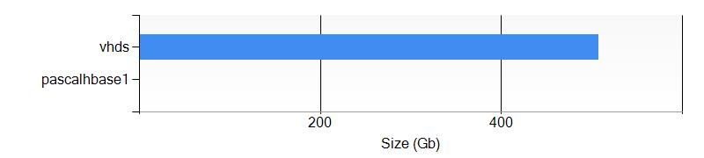

#### Container pascalhbase1

This container has 427 file(s).

##### Biggest blob items

|  |  |  |  |  |
| --- | --- | --- | --- | --- |
| Uri | Length | Content Type | Last Modified | Blob Type |
| https://portalvhds1z1nxx7v0xn9q.blob.core.windows.net/pascalhbase1/hbase/WALs/workernode0.pascalhbase1.b7.internal.cloudapp.net,60020,1445369217772 | 134217728 |  | 10/20/2015 8:27:07 PM | PageBlob |
| https://portalvhds1z1nxx7v0xn9q.blob.core.windows.net/pascalhbase1/hbase/WALs/workernode0.pascalhbase1.b7.internal.cloudapp.net,60020,1445369217772/workernode0.pascalhbase1.b7.internal.cloudapp.net%252C60020%252C1445369217772.1445369220089 | 134217728 | application/octet-stream | 10/20/2015 8:27:03 PM | PageBlob |
| https://portalvhds1z1nxx7v0xn9q.blob.core.windows.net/pascalhbase1/hbase/WALs/workernode0.pascalhbase1.b7.internal.cloudapp.net,60020,1445369217772/workernode0.pascalhbase1.b7.internal.cloudapp.net%252C60020%252C1445369217772.1445369224083.meta | 134217728 | application/octet-stream | 10/20/2015 8:27:07 PM | PageBlob |
| https://portalvhds1z1nxx7v0xn9q.blob.core.windows.net/pascalhbase1/hbase/WALs/workernode0.pascalhbase1.b7.internal.cloudapp.net,60020,1445369217772/workernode0.pascalhbase1.b7.internal.cloudapp.net%252C60020%252C1445369217772.1445372822980 | 134217728 | application/octet-stream | 10/20/2015 8:27:25 PM | PageBlob |
| https://portalvhds1z1nxx7v0xn9q.blob.core.windows.net/pascalhbase1/hbase/WALs/workernode0.pascalhbase1.b7.internal.cloudapp.net,60020,1445369217772/workernode0.pascalhbase1.b7.internal.cloudapp.net%252C60020%252C1445369217772.1445372826666.meta | 134217728 | application/octet-stream | 10/20/2015 8:27:55 PM | PageBlob |
| https://portalvhds1z1nxx7v0xn9q.blob.core.windows.net/pascalhbase1/apps/tez/tez-0.5.2.2.2.7.1-0004.tar.gz | 40764778 | application/octet-stream | 10/20/2015 7:33:46 PM | BlockBlob |
| https://portalvhds1z1nxx7v0xn9q.blob.core.windows.net/pascalhbase1/user/hdp/share/lib/hcatalog/hive-exec-0.14.0.2.2.7.1-0004.jar | 17428556 | application/octet-stream | 10/20/2015 7:34:41 PM | BlockBlob |
| https://portalvhds1z1nxx7v0xn9q.blob.core.windows.net/pascalhbase1/user/hdp/share/lib/hive/hive-exec-0.14.0.2.2.7.1-0004.jar | 17428556 | application/octet-stream | 10/20/2015 7:35:13 PM | BlockBlob |
| https://portalvhds1z1nxx7v0xn9q.blob.core.windows.net/pascalhbase1/user/hdp/share/lib/pig/hive-exec-0.14.0.2.2.7.1-0004.jar | 17428556 | application/octet-stream | 10/20/2015 7:35:54 PM | BlockBlob |
| https://portalvhds1z1nxx7v0xn9q.blob.core.windows.net/pascalhbase1/user/hdp/share/lib/pig/jython-2.5.3.jar | 8302357 | application/octet-stream | 10/20/2015 7:36:02 PM | BlockBlob |

##### Last modified blob items

|  |  |  |  |  |
| --- | --- | --- | --- | --- |
| Uri | Length | Content Type | Last Modified | Blob Type |
| https://portalvhds1z1nxx7v0xn9q.blob.core.windows.net/pascalhbase1/hbase/WALs/workernode0.pascalhbase1.b7.internal.cloudapp.net,60020,1445369217772/workernode0.pascalhbase1.b7.internal.cloudapp.net%252C60020%252C1445369217772.1445372826666.meta | 134217728 | application/octet-stream | 10/20/2015 8:27:55 PM | PageBlob |
| https://portalvhds1z1nxx7v0xn9q.blob.core.windows.net/pascalhbase1/hbase/data/hbase/meta/1588230740/.tmp | 0 |  | 10/20/2015 8:27:55 PM | BlockBlob |
| https://portalvhds1z1nxx7v0xn9q.blob.core.windows.net/pascalhbase1/hbase/data/hbase/meta/1588230740/info | 0 |  | 10/20/2015 8:27:55 PM | BlockBlob |
| https://portalvhds1z1nxx7v0xn9q.blob.core.windows.net/pascalhbase1/hbase/data/hbase/meta/1588230740/info/caf54b6ecac145568ea459515dd41dbe | 1209 | application/octet-stream | 10/20/2015 8:27:55 PM | BlockBlob |
| https://portalvhds1z1nxx7v0xn9q.blob.core.windows.net/pascalhbase1/hbase/WALs/workernode0.pascalhbase1.b7.internal.cloudapp.net,60020,1445369217772/workernode0.pascalhbase1.b7.internal.cloudapp.net%252C60020%252C1445369217772.1445372822980 | 134217728 | application/octet-stream | 10/20/2015 8:27:25 PM | PageBlob |
| https://portalvhds1z1nxx7v0xn9q.blob.core.windows.net/pascalhbase1/hbase/data/hbase/namespace/0dbf08dca37021646b8ba8dac69e6b17/.tmp | 0 |  | 10/20/2015 8:27:25 PM | BlockBlob |
| https://portalvhds1z1nxx7v0xn9q.blob.core.windows.net/pascalhbase1/hbase/data/hbase/namespace/0dbf08dca37021646b8ba8dac69e6b17/info | 0 |  | 10/20/2015 8:27:25 PM | BlockBlob |
| https://portalvhds1z1nxx7v0xn9q.blob.core.windows.net/pascalhbase1/hbase/data/hbase/namespace/0dbf08dca37021646b8ba8dac69e6b17/info/dfceb958eb824e169ce37cb7d2b3058f | 1045 | application/octet-stream | 10/20/2015 8:27:25 PM | BlockBlob |
| https://portalvhds1z1nxx7v0xn9q.blob.core.windows.net/pascalhbase1/hbase/WALs/workernode0.pascalhbase1.b7.internal.cloudapp.net,60020,1445369217772 | 134217728 |  | 10/20/2015 8:27:07 PM | PageBlob |
| https://portalvhds1z1nxx7v0xn9q.blob.core.windows.net/pascalhbase1/hbase/WALs/workernode0.pascalhbase1.b7.internal.cloudapp.net,60020,1445369217772/workernode0.pascalhbase1.b7.internal.cloudapp.net%252C60020%252C1445369217772.1445369224083.meta | 134217728 | application/octet-stream | 10/20/2015 8:27:07 PM | PageBlob |

#### Container vhds

This container has 12 file(s).

##### Biggest blob items

|  |  |  |  |  |
| --- | --- | --- | --- | --- |
| Uri | Length | Content Type | Last Modified | Blob Type |
| https://portalvhds1z1nxx7v0xn9q.blob.core.windows.net/vhds/ConcertoDev-ConcertoDev-2014-10-05.vhd | 136367309312 | binary/octet-stream | 11/13/2015 9:28:08 PM | PageBlob |
| https://portalvhds1z1nxx7v0xn9q.blob.core.windows.net/vhds/powerdesignpbon-powerdesignpbon-2015-07-30.vhd | 136367309312 | application/octet-stream | 9/19/2015 3:52:38 PM | PageBlob |
| https://portalvhds1z1nxx7v0xn9q.blob.core.windows.net/vhds/cdsbiztalk-cdsbiztalk-2015-06-25.vhd | 136365212160 | application/octet-stream | 6/30/2015 7:04:19 PM | PageBlob |
| https://portalvhds1z1nxx7v0xn9q.blob.core.windows.net/vhds/sqltestSelectWines-sql-2015-01-23.vhd | 136365212160 | application/octet-stream | 2/19/2015 3:52:07 PM | PageBlob |
| https://portalvhds1z1nxx7v0xn9q.blob.core.windows.net/vhds/ConcertoDev.ConcertoDev.ConcertoDev.status | 467 | application/octet-stream | 11/13/2015 9:27:54 PM | BlockBlob |
| https://portalvhds1z1nxx7v0xn9q.blob.core.windows.net/vhds/pbonsql2012.pbonsql2012.pbonsql2012.status | 467 | application/octet-stream | 11/20/2015 5:00:13 PM | BlockBlob |
| https://portalvhds1z1nxx7v0xn9q.blob.core.windows.net/vhds/cdsSSIS.cdsSSIS.cdsSSIS.status | 463 | application/octet-stream | 6/30/2015 7:03:27 PM | BlockBlob |
| https://portalvhds1z1nxx7v0xn9q.blob.core.windows.net/vhds/cdsbiztalk.cdsbiztalk.cdsbiztalk.status | 463 | application/octet-stream | 6/30/2015 7:03:58 PM | BlockBlob |
| https://portalvhds1z1nxx7v0xn9q.blob.core.windows.net/vhds/powerdesignerpascal.powerdesigner.powerdesigner.status | 463 | application/octet-stream | 7/30/2015 4:31:23 PM | BlockBlob |
| https://portalvhds1z1nxx7v0xn9q.blob.core.windows.net/vhds/powerdesignpbon.powerdesignpbon.powerdesignpbon.status | 463 | application/octet-stream | 9/19/2015 3:52:25 PM | BlockBlob |

##### Last modified blob items

|  |  |  |  |  |
| --- | --- | --- | --- | --- |
| Uri | Length | Content Type | Last Modified | Blob Type |
| https://portalvhds1z1nxx7v0xn9q.blob.core.windows.net/vhds/pbonsql2012.pbonsql2012.pbonsql2012.status | 467 | application/octet-stream | 11/20/2015 5:00:13 PM | BlockBlob |
| https://portalvhds1z1nxx7v0xn9q.blob.core.windows.net/vhds/ConcertoDev-ConcertoDev-2014-10-05.vhd | 136367309312 | binary/octet-stream | 11/13/2015 9:28:08 PM | PageBlob |
| https://portalvhds1z1nxx7v0xn9q.blob.core.windows.net/vhds/ConcertoDev.ConcertoDev.ConcertoDev.status | 467 | application/octet-stream | 11/13/2015 9:27:54 PM | BlockBlob |
| https://portalvhds1z1nxx7v0xn9q.blob.core.windows.net/vhds/powerdesignpbon-powerdesignpbon-2015-07-30.vhd | 136367309312 | application/octet-stream | 9/19/2015 3:52:38 PM | PageBlob |
| https://portalvhds1z1nxx7v0xn9q.blob.core.windows.net/vhds/powerdesignpbon.powerdesignpbon.powerdesignpbon.status | 463 | application/octet-stream | 9/19/2015 3:52:25 PM | BlockBlob |
| https://portalvhds1z1nxx7v0xn9q.blob.core.windows.net/vhds/powerdesignerpascal.powerdesigner.powerdesigner.status | 463 | application/octet-stream | 7/30/2015 4:31:23 PM | BlockBlob |
| https://portalvhds1z1nxx7v0xn9q.blob.core.windows.net/vhds/cdsbiztalk-cdsbiztalk-2015-06-25.vhd | 136365212160 | application/octet-stream | 6/30/2015 7:04:19 PM | PageBlob |
| https://portalvhds1z1nxx7v0xn9q.blob.core.windows.net/vhds/cdsbiztalk.cdsbiztalk.cdsbiztalk.status | 463 | application/octet-stream | 6/30/2015 7:03:58 PM | BlockBlob |
| https://portalvhds1z1nxx7v0xn9q.blob.core.windows.net/vhds/cdsSSIS.cdsSSIS.cdsSSIS.status | 463 | application/octet-stream | 6/30/2015 7:03:27 PM | BlockBlob |
| https://portalvhds1z1nxx7v0xn9q.blob.core.windows.net/vhds/testAADSync.testAADSync.testAADSync.status | 463 | application/octet-stream | 4/1/2015 7:40:19 PM | BlockBlob |

### Table Storage

The following tables are defined in the container:

* Table upascalhbase120oct2015at191029995hadoopinstalllog
* Table upascalhbase120oct2015at191029995hadoopservicelog
* Table upascalhbase120oct2015at191029995setuplog

## portalvhdscwxvs4rp320z1

### Settings

The storage **portalvhdscwxvs4rp320z1** has the following settings:

|  |  |
| --- | --- |
| Uri | https://management.core.windows.net/275ddf79-b240-44e7-9916-f24175b451b1/services/storageservices/portalvhdscwxvs4rp320z1 |
| Label | portalvhdscwxvs4rp320z1 |
| Description | Implicitly created storage service |
| Location | Central US |
| Status | Created |
| Resource Location | Central US |
| Resource Group | Default-Storage-CentralUS |
| Affinity Group |  |
| Geo Primary Region | Central US |
| Geo Replication Enabled | False |
| Geo Secondary Region | East US 2 |

### Blob Storage

The following Blob Storage containers are defined in this storage.

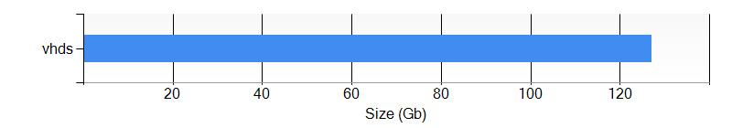

#### Container vhds

This container has 2 file(s).

##### Biggest blob items

|  |  |  |  |  |
| --- | --- | --- | --- | --- |
| Uri | Length | Content Type | Last Modified | Blob Type |
| https://portalvhdscwxvs4rp320z1.blob.core.windows.net/vhds/pascaltfs-pascaltfs-2015-10-15.vhd | 136367309312 | application/octet-stream | 10/17/2015 6:53:07 AM | PageBlob |
| https://portalvhdscwxvs4rp320z1.blob.core.windows.net/vhds/pascaltfs.pascaltfs.pascaltfs.status | 467 | application/octet-stream | 10/17/2015 6:52:52 AM | BlockBlob |

##### Last modified blob items

|  |  |  |  |  |
| --- | --- | --- | --- | --- |
| Uri | Length | Content Type | Last Modified | Blob Type |
| https://portalvhdscwxvs4rp320z1.blob.core.windows.net/vhds/pascaltfs-pascaltfs-2015-10-15.vhd | 136367309312 | application/octet-stream | 10/17/2015 6:53:07 AM | PageBlob |
| https://portalvhdscwxvs4rp320z1.blob.core.windows.net/vhds/pascaltfs.pascaltfs.pascaltfs.status | 467 | application/octet-stream | 10/17/2015 6:52:52 AM | BlockBlob |

## portalvhdsczzf11q6mlzhk

### Settings

The storage **portalvhdsczzf11q6mlzhk** has the following settings:

|  |  |
| --- | --- |
| Uri | https://management.core.windows.net/275ddf79-b240-44e7-9916-f24175b451b1/services/storageservices/portalvhdsczzf11q6mlzhk |
| Label | portalvhdsczzf11q6mlzhk |
| Description | Implicitly created storage service |
| Location | West Europe |
| Status | Created |
| Resource Location | West Europe |
| Resource Group | Default-Storage-WestEurope |
| Affinity Group |  |
| Geo Primary Region | West Europe |
| Geo Replication Enabled | False |
| Geo Secondary Region | North Europe |

### Blob Storage

The following Blob Storage containers are defined in this storage.

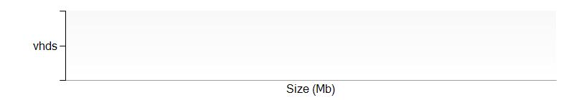

#### Container vhds

This container has 1 file(s).

##### Biggest blob items

|  |  |  |  |  |
| --- | --- | --- | --- | --- |
| Uri | Length | Content Type | Last Modified | Blob Type |
| https://portalvhdsczzf11q6mlzhk.blob.core.windows.net/vhds/exchangePascal.exchangePascal.exchangePascal.status | 463 | application/octet-stream | 5/7/2015 5:25:18 PM | BlockBlob |

##### Last modified blob items

|  |  |  |  |  |
| --- | --- | --- | --- | --- |
| Uri | Length | Content Type | Last Modified | Blob Type |
| https://portalvhdsczzf11q6mlzhk.blob.core.windows.net/vhds/exchangePascal.exchangePascal.exchangePascal.status | 463 | application/octet-stream | 5/7/2015 5:25:18 PM | BlockBlob |

## portalvhdsx480qkj71p27l

### Settings

The storage **portalvhdsx480qkj71p27l** has the following settings:

|  |  |
| --- | --- |
| Uri | https://management.core.windows.net/275ddf79-b240-44e7-9916-f24175b451b1/services/storageservices/portalvhdsx480qkj71p27l |
| Label | portalvhdsx480qkj71p27l |
| Description | Implicitly created storage service |
| Location | West US |
| Status | Created |
| Resource Location | West US |
| Resource Group | Default-Storage-WestUS |
| Affinity Group |  |
| Geo Primary Region | West US |
| Geo Replication Enabled | False |
| Geo Secondary Region | East US |

### Blob Storage

The following Blob Storage containers are defined in this storage.



#### Container vhds

This container has 2 file(s).

##### Biggest blob items

|  |  |  |  |  |
| --- | --- | --- | --- | --- |
| Uri | Length | Content Type | Last Modified | Blob Type |
| https://portalvhdsx480qkj71p27l.blob.core.windows.net/vhds/epdmCirque-epdmCirque-2015-05-21.vhd | 136367309312 | application/octet-stream | 5/21/2015 7:32:29 PM | PageBlob |
| https://portalvhdsx480qkj71p27l.blob.core.windows.net/vhds/epdmCirque.epdmCirque.epdmCirque.status | 463 | application/octet-stream | 5/21/2015 7:32:08 PM | BlockBlob |

##### Last modified blob items

|  |  |  |  |  |
| --- | --- | --- | --- | --- |
| Uri | Length | Content Type | Last Modified | Blob Type |
| https://portalvhdsx480qkj71p27l.blob.core.windows.net/vhds/epdmCirque-epdmCirque-2015-05-21.vhd | 136367309312 | application/octet-stream | 5/21/2015 7:32:29 PM | PageBlob |
| https://portalvhdsx480qkj71p27l.blob.core.windows.net/vhds/epdmCirque.epdmCirque.epdmCirque.status | 463 | application/octet-stream | 5/21/2015 7:32:08 PM | BlockBlob |

## testvpnpasc

### Settings

The storage **testvpnpasc** has the following settings:

|  |  |
| --- | --- |
| Uri | https://management.core.windows.net/275ddf79-b240-44e7-9916-f24175b451b1/services/storageservices/testvpnpasc |
| Label | testvpnpasc |
| Description | testvpnpasc |
| Location | Central US |
| Status | Created |
| Resource Location | centralus |
| Resource Group | Group |
| Affinity Group |  |
| Geo Primary Region | Central US |
| Geo Replication Enabled | False |
| Geo Secondary Region | East US 2 |

### Blob Storage

The following Blob Storage containers are defined in this storage.



#### Container vhds

This container has 1 file(s).

##### Biggest blob items

|  |  |  |  |  |
| --- | --- | --- | --- | --- |
| Uri | Length | Content Type | Last Modified | Blob Type |
| https://testvpnpasc.blob.core.windows.net/vhds/testVPNPascal.testVPNPascal.testVPNPascal.status | 463 | application/octet-stream | 5/7/2015 5:19:51 PM | BlockBlob |

##### Last modified blob items

|  |  |  |  |  |
| --- | --- | --- | --- | --- |
| Uri | Length | Content Type | Last Modified | Blob Type |
| https://testvpnpasc.blob.core.windows.net/vhds/testVPNPascal.testVPNPascal.testVPNPascal.status | 463 | application/octet-stream | 5/7/2015 5:19:51 PM | BlockBlob |

## umanage

### Settings

The storage **umanage** has the following settings:

|  |  |
| --- | --- |
| Uri | https://management.core.windows.net/275ddf79-b240-44e7-9916-f24175b451b1/services/storageservices/umanage |
| Label | umanage |
| Description | umanage |
| Location | East US |
| Status | Created |
| Resource Location | eastus |
| Resource Group | cloudservicepascaltest |
| Affinity Group |  |
| Geo Primary Region | East US |
| Geo Replication Enabled | False |
| Geo Secondary Region |  |

### Table Storage

The following tables are defined in the container:

* Table Tenant110171825866137858375

### Warnings

The following warnings have been detected in the storage.

|  |  |  |
| --- | --- | --- |
| Criticity | Description | Type |
| High | In case of a datacenter crash, be aware that your data may be unavailable | Availability |

# Storages

## concertodev9031

### Settings

The storage **concertodev9031** has the following settings:

|  |  |
| --- | --- |
| Uri |  |
| Account Type | StandardLRS |
| Location | eastus |
| Provisioning State | Succeeded |
| Geo Primary Region | eastus |
| Geo Secondary Region |  |

### Blob Storage

The following Blob Storage containers are defined in this storage.

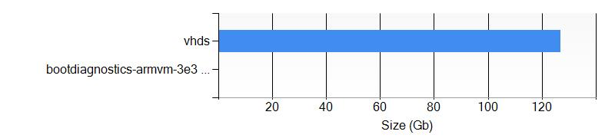

#### Container bootdiagnostics-armvm-3e36e855-ce38-4ff3-a4a8-2f398ad6d90d

This container has 1 file(s).

##### Biggest blob items

|  |  |  |  |  |
| --- | --- | --- | --- | --- |
| Uri | Length | Content Type | Last Modified | Blob Type |
| https://concertodev9031.blob.core.windows.net/bootdiagnostics-armvm-3e36e855-ce38-4ff3-a4a8-2f398ad6d90d/armVM.3e36e855-ce38-4ff3-a4a8-2f398ad6d90d.screenshot.bmp | 614912 | image/bmp | 12/30/2015 9:06:43 PM | PageBlob |

##### Last modified blob items

|  |  |  |  |  |
| --- | --- | --- | --- | --- |
| Uri | Length | Content Type | Last Modified | Blob Type |
| https://concertodev9031.blob.core.windows.net/bootdiagnostics-armvm-3e36e855-ce38-4ff3-a4a8-2f398ad6d90d/armVM.3e36e855-ce38-4ff3-a4a8-2f398ad6d90d.screenshot.bmp | 614912 | image/bmp | 12/30/2015 9:06:43 PM | PageBlob |

#### Container vhds

This container has 2 file(s).

##### Biggest blob items

|  |  |  |  |  |
| --- | --- | --- | --- | --- |
| Uri | Length | Content Type | Last Modified | Blob Type |
| https://concertodev9031.blob.core.windows.net/vhds/armVM.vhd | 136367309312 | application/octet-stream | 12/30/2015 9:07:38 PM | PageBlob |
| https://concertodev9031.blob.core.windows.net/vhds/armVM.3e36e855-ce38-4ff3-a4a8-2f398ad6d90d.status | 806 | application/octet-stream | 12/30/2015 9:07:15 PM | BlockBlob |

##### Last modified blob items

|  |  |  |  |  |
| --- | --- | --- | --- | --- |
| Uri | Length | Content Type | Last Modified | Blob Type |
| https://concertodev9031.blob.core.windows.net/vhds/armVM.vhd | 136367309312 | application/octet-stream | 12/30/2015 9:07:38 PM | PageBlob |
| https://concertodev9031.blob.core.windows.net/vhds/armVM.3e36e855-ce38-4ff3-a4a8-2f398ad6d90d.status | 806 | application/octet-stream | 12/30/2015 9:07:15 PM | BlockBlob |

### Table Storage

The following tables are defined in the container:

* Table SchemasTable
* Table WADDiagnosticInfrastructureLogsTable
* Table WADMetricsPT1HP10DV2S20151227
* Table WADMetricsPT1MP10DV2S20151227
* Table WADPerformanceCountersTable
* Table WADWindowsEventLogsTable

## epdmcirque1172

### Settings

The storage **epdmcirque1172** has the following settings:

|  |  |
| --- | --- |
| Uri |  |
| Account Type | PremiumLRS |
| Location | westus |
| Provisioning State | Succeeded |
| Geo Primary Region | westus |
| Geo Secondary Region |  |

## storagearm

### Settings

The storage **storagearm** has the following settings:

|  |  |
| --- | --- |
| Uri |  |
| Account Type | StandardRAGRS |
| Location | eastus |
| Provisioning State | Succeeded |
| Geo Primary Region | eastus |
| Geo Secondary Region | westus |

### Tags

|  |  |
| --- | --- |
| Tag Key | Tag Value |
| key1 | value1 |
| key2 | value2 |

### Blob Storage

The following Blob Storage containers are defined in this storage.

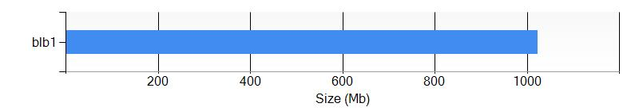

#### Container blb1

This container has 1 file(s).

##### Biggest blob items

|  |  |  |  |  |
| --- | --- | --- | --- | --- |
| Uri | Length | Content Type | Last Modified | Blob Type |
| https://storagearm.blob.core.windows.net/blb1/armVM-20151230-112005.vhd | 1073742336 | application/octet-stream | 12/30/2015 9:10:00 PM | PageBlob |

##### Last modified blob items

|  |  |  |  |  |
| --- | --- | --- | --- | --- |
| Uri | Length | Content Type | Last Modified | Blob Type |
| https://storagearm.blob.core.windows.net/blb1/armVM-20151230-112005.vhd | 1073742336 | application/octet-stream | 12/30/2015 9:10:00 PM | PageBlob |

# Virtual Machines (Classic)

## ConcertoDev

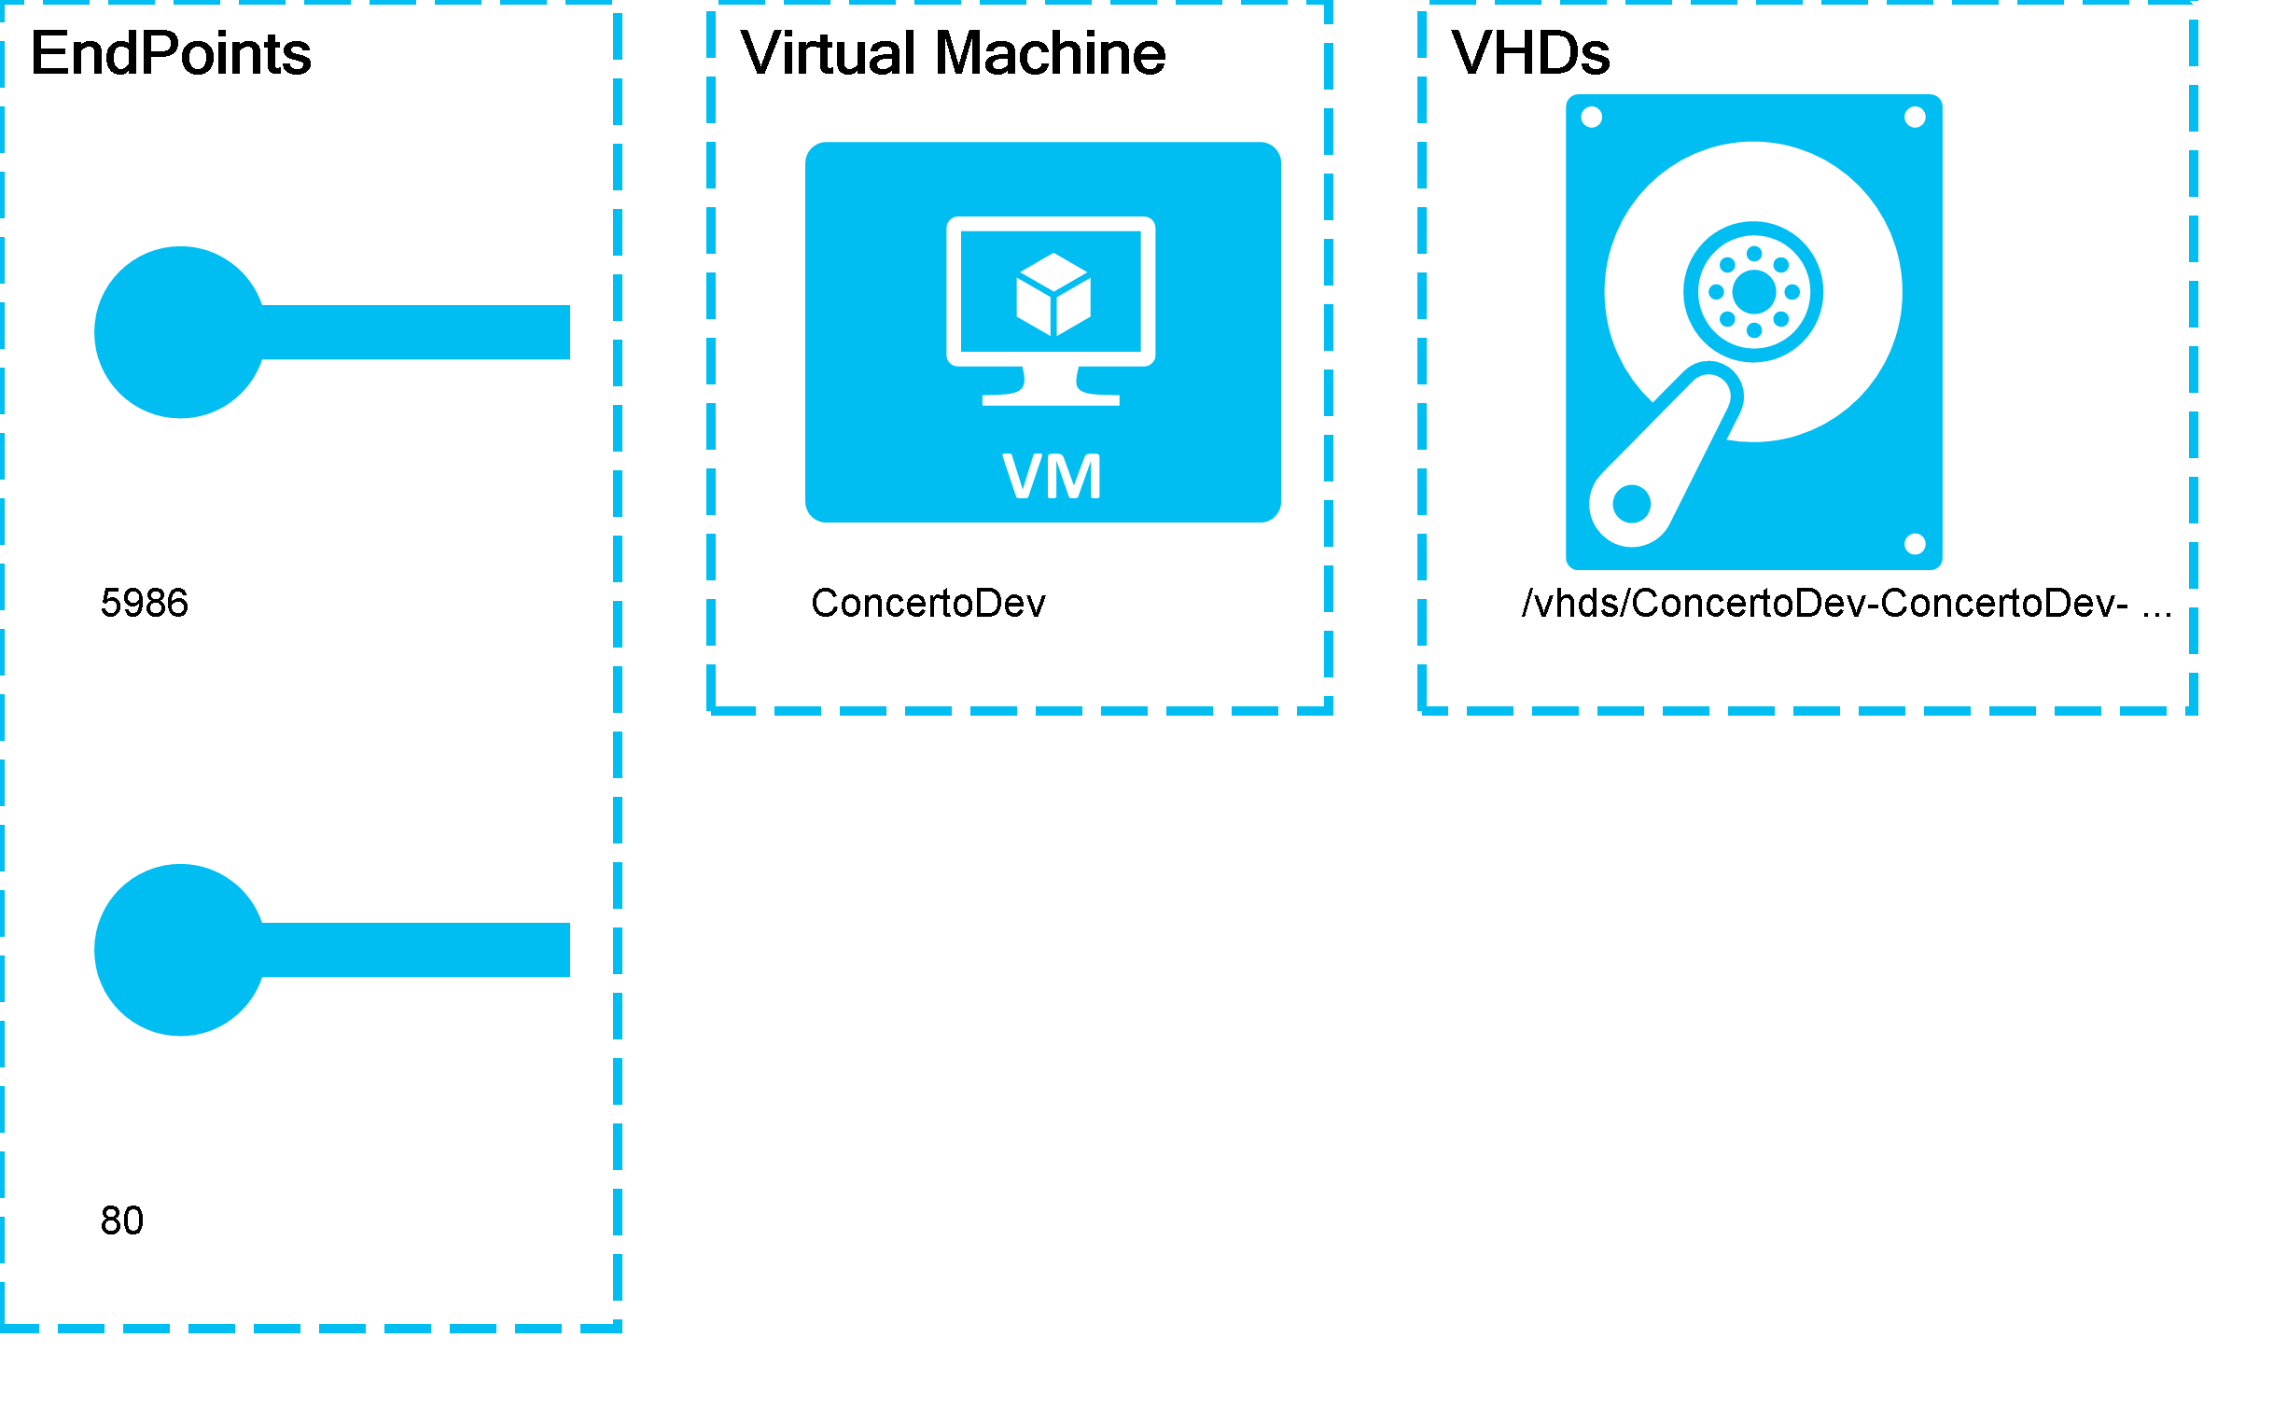

### Settings

The virtual machine **ConcertoDev** has the following settings:

|  |  |
| --- | --- |
| Name | ConcertoDev |
| Uri | http://concertodev.cloudapp.net/ |
| Operating System | Windows |
| Size |  |
| Availability Set |  |
| Virtual IP Address |  |
| IP Address |  |
| State | Stopped |
| Instance Status | StoppedDeallocated |
| Created Date | 10/5/2014 7:44:03 PM |
| Modified Date | 11/13/2015 9:26:04 PM |

### EndPoints

The following EndPoints are defined :

|  |  |  |  |  |
| --- | --- | --- | --- | --- |
| Name | Port | Local Port | Load Balancer | Protocol |
| PowerShell | 5986 | 5986 |  | tcp |
| Remote Desktop | 80 | 3389 |  | tcp |

### Virtual Disks

The Virtual Machine is using the following disks

#### OS Hard Disks

|  |  |  |  |
| --- | --- | --- | --- |
| Name | Size (GB) | Source Image Name | Host Caching |
| ConcertoDev-ConcertoDev-0-201410051944050962 |  | a699494373c04fc0bc8f2bb1389d6106__Windows-Server-2012-Datacenter-201409.01-en.us-127GB.vhd | ReadWrite |

# Virtual Machines

## armVM

### Settings

The virtual machine armVM has the following settings:

|  |  |
| --- | --- |
| Name | armVM |
| Operating System | WindowsServer |
| Location | eastus |
| Size | Standard_DS1 |
| Availability Set |  |
| State | VM deallocated |
| Provisioning Date | 1/6/2016 2:57:25 PM |

### Tags

|  |  |
| --- | --- |
| Tag Key | Tag Value |
| tag1 | value1 |
| tag2 | value2 |

### Network Interfaces

The following EndPoints are defined :

|  |  |  |  |  |
| --- | --- | --- | --- | --- |
| Name | Mac Address | IP Configuration | Enable IP Forwarding | Location |
| armvm580 |  | |  |  | | --- | --- | | Public IP | Private IP | |  | 10.1.0.4 | | False | eastus |

### Virtual Disks

The Virtual Machine is using the following disks

#### Data Hard Disks

|  |  |  |  |
| --- | --- | --- | --- |
| Name | VHD Uri | Size (GB) | Host Caching |
| armVM-20151230-112005 | https://storagearm.blob.core.windows.net/blb1/armVM-20151230-112005.vhd | 1 | None |

#### OS Hard Disks

|  |  |  |  |
| --- | --- | --- | --- |
| Name | VHD Uri | Size (GB) | Host Caching |
| armVM | https://concertodev9031.blob.core.windows.net/vhds/armVM.vhd |  | ReadWrite |

# SQL Servers

## nal8jdvson

The SQL Server **nal8jdvson** contains the following **SQL Databases**.

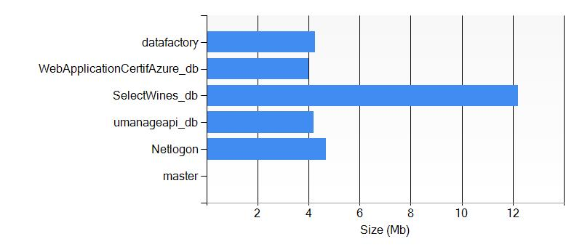

### Settings

The following settings are defined for the server **nal8jdvson**

|  |  |
| --- | --- |
| Administrator User Name | concerto |
| Fully Qualified Domain Name | nal8jdvson.database.windows.net |
| Location | East US |
| State | Ready |
| Version | 2.0 |

### Database master

The database is using the following settings:

|  |  |
| --- | --- |
| State | Normal |
| Edition | System |
| Creation Date | 10/2/2014 5:22:07 PM |
| Internal ID | 1 |
| Maximum Database Size (GB) | 5 |
| Size (MB) |  |
| Collation Name | SQL_Latin1_General_CP1_CI_AS |

### Database Netlogon

The database is using the following settings:

|  |  |
| --- | --- |
| State | Normal |
| Edition | Web |
| Creation Date | 2/11/2015 3:14:17 PM |
| Internal ID | 4 |
| Maximum Database Size (GB) | 1 |
| Size (MB) | 4.69 |
| Collation Name | SQL_Latin1_General_CP1_CI_AS |

### Database umanageapi_db

The database is using the following settings:

|  |  |
| --- | --- |
| State | Normal |
| Edition | Web |
| Creation Date | 2/13/2015 2:32:54 PM |
| Internal ID | 5 |
| Maximum Database Size (GB) | 1 |
| Size (MB) | 4.19 |
| Collation Name | SQL_Latin1_General_CP1_CI_AS |

### Database SelectWines_db

The database is using the following settings:

|  |  |
| --- | --- |
| State | Normal |
| Edition | Web |
| Creation Date | 1/20/2015 7:57:48 PM |
| Internal ID | 6 |
| Maximum Database Size (GB) | 0 |
| Size (MB) | 12.19 |
| Collation Name | SQL_Latin1_General_CP1_CI_AS |

### Database WebApplicationCertifAzure_db

The database is using the following settings:

|  |  |
| --- | --- |
| State | Normal |
| Edition | Web |
| Creation Date | 5/4/2015 5:36:44 PM |
| Internal ID | 7 |
| Maximum Database Size (GB) | 1 |
| Size (MB) | 4.00 |
| Collation Name | SQL_Latin1_General_CP1_CI_AS |

### Database datafactory

The database is using the following settings:

|  |  |
| --- | --- |
| State | Normal |
| Edition | Basic |
| Creation Date | 10/26/2015 7:55:15 PM |
| Internal ID | 8 |
| Maximum Database Size (GB) | 2 |
| Size (MB) | 4.25 |
| Collation Name | SQL_Latin1_General_CP1_CI_AS |

### Firewall Rules

The following rules have been defined

|  |  |  |  |
| --- | --- | --- | --- |
| Name | Start IP Address | End IP Address | State |
| all | 0.0.0.0 | 255.255.255.255 | Normal |
| AllowAllWindowsAzureIps | 0.0.0.0 | 0.0.0.0 | Normal |
| ClientIPAddress_2014-10-08_14:10:34 | 24.100.252.58 | 24.100.252.58 | Normal |
| ClientIPAddress_2014-10-08_21:23:25 | 184.160.132.111 | 184.160.132.111 | Normal |
| ClientIPAddress_2014-10-09_09:14:57 | 207.35.6.213 | 207.35.6.213 | Normal |
| ClientIPAddress_2014-10-09_09:50:20 | 24.100.220.68 | 24.100.220.68 | Normal |

## umanageservice

The SQL Server **umanageservice** contains the following **SQL Databases**.

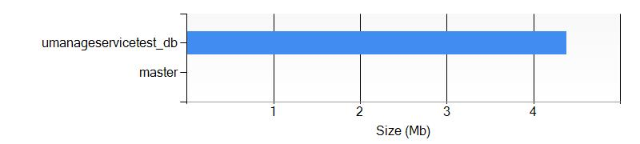

### Settings

The following settings are defined for the server **umanageservice**

|  |  |
| --- | --- |
| Administrator User Name | umanageAdmin |
| Fully Qualified Domain Name | umanageservice.database.windows.net |
| Location | East US |
| State | Ready |
| Version | 2.0 |

### Database master

The database is using the following settings:

|  |  |
| --- | --- |
| State | Normal |
| Edition | System |
| Creation Date | 10/29/2015 1:47:44 AM |
| Internal ID | 1 |
| Maximum Database Size (GB) | 5 |
| Size (MB) |  |
| Collation Name | SQL_Latin1_General_CP1_CI_AS |

### Database umanageservicetest_db

The database is using the following settings:

|  |  |
| --- | --- |
| State | Normal |
| Edition | Standard |
| Creation Date | 11/4/2015 3:03:58 AM |
| Internal ID | 4 |
| Maximum Database Size (GB) | 250 |
| Size (MB) | 4.38 |
| Collation Name | SQL_Latin1_General_CP1_CI_AS |

### Firewall Rules

The following rules have been defined

|  |  |  |  |
| --- | --- | --- | --- |
| Name | Start IP Address | End IP Address | State |
| AllowAllWindowsAzureIps | 0.0.0.0 | 0.0.0.0 | Normal |
| ClientIPAddress_2015-00-02_06:00:14 | 173.176.74.147 | 173.176.74.147 | Normal |
| ClientIPAddress_2015-10-28_19:21:27 | 216.206.111.130 | 216.206.111.130 | Normal |

# Service Bus

## SelectWinesMsg-ns

### Settings

|  |  |
| --- | --- |
| Name | SelectWinesMsg-ns |
| Type | Messaging |
| Acs Management Endpoint |  |
| Creation Date | 1/20/2015 7:58:07 PM |
| Enabled | True |
| Region | East US |
| Endpoint | https://selectwinesmsg-ns.servicebus.windows.net/ |
| Status | Active |

### Queues

Queue selectwqueue

|  |  |
| --- | --- |
| Name | selectwqueue |
| Creation Date | 11/17/2015 8:00:23 PM |
| Status | Active |
| Message Count | 0 |
| Size (Bytes) | 0 |
| Dead Lettering On Message Expiration | False |
| Default Message Time To Live | P14D |
| Duplicate Detection History Time Window | PT10M |
| Enable Batched Operations | True |
| Entity Availability Status | Available |
| Is Anonymous Accessible | False |
| Lock Duration | PT30S |
| Max Delivery Count | 10 |
| Max Size (MB) | 16384 |
| Requires Duplicate Detection | False |
| Requires Session | False |
| Support Ordering | False |
| Updated At | 11/17/2015 8:00:24 PM |

### Topics

Topic selectwtopic

|  |  |
| --- | --- |
| Name | selectwtopic |
| Creation Date | 11/17/2015 8:06:17 PM |
| Status | Active |
| Message Count |  |
| Size (Bytes) | 0 |
| Auto Delete On Idle | P10675199DT2H48M5.4775807S |
| Default Message Time To Live | P14D |
| Duplicate Detection History Time Window | PT10M |
| Enable Batched Operations | True |
| Entity Availability Status | Available |
| Is Anonymous Accessible | False |
| Max Size (MB) | 16384 |
| Requires Duplicate Detection | False |
| Support Ordering | False |
| Updated At | 11/17/2015 8:06:18 PM |
| Filtering Messages Before Publishing | False |

## SelectWRelay

### Settings

|  |  |
| --- | --- |
| Name | SelectWRelay |
| Type | Messaging |
| Acs Management Endpoint |  |
| Creation Date | 11/17/2015 8:06:29 PM |
| Enabled | True |
| Region | Central US |
| Endpoint | https://selectwrelay.servicebus.windows.net/ |
| Status | Active |

# Virtual Networks (Classic)

## Umaknow

### Settings

|  |  |
| --- | --- |
| Name | Umaknow |
| Address Space | Microsoft.WindowsAzure.Management.Network.Models.NetworkListResponse+AddressSpace |
| Affinity Group |  |
| Label |  |
| State | Created |

### Subnets

|  |  |
| --- | --- |
| Name | Address Prefix |
| Subnet-1 | 10.0.0.0/11 |

### DNS Servers

|  |  |
| --- | --- |
| Name | Address |
| UmaDNS | 12.12.34.56 |

# Media Services

## umaknowmedia

### Settings

|  |  |
| --- | --- |
| Name | umaknowmedia |
| Account Id | 461b4bb7-77aa-4cdb-b071-d4af505fb85c |
| State | Active |
| Type | MediaService |
| Uri |  |

# Resource groups

This section contains the **Resource Groups** deployed in your Azure Subscription.

## cdsbiztalk

### Resources

|  |  |  |  |
| --- | --- | --- | --- |
| Name | Id | Location | Type |
| cdsbiztalk | /subscriptions/275ddf79-b240-44e7-9916-f24175b451b1/resourceGroups/cdsbiztalk/providers/Microsoft.ClassicCompute/domainNames/cdsbiztalk | eastus | Microsoft.ClassicCompute/domainNames |
| classicstoragepascal | /subscriptions/275ddf79-b240-44e7-9916-f24175b451b1/resourceGroups/cdsbiztalk/providers/Microsoft.ClassicStorage/storageAccounts/classicstoragepascal | eastus | Microsoft.ClassicStorage/storageAccounts |
| PascalDataFactory | /subscriptions/275ddf79-b240-44e7-9916-f24175b451b1/resourceGroups/cdsbiztalk/providers/Microsoft.DataFactory/dataFactories/PascalDataFactory | westus | Microsoft.DataFactory/dataFactories |
| PASCALHDINSIGHT | /subscriptions/275ddf79-b240-44e7-9916-f24175b451b1/resourceGroups/cdsbiztalk/providers/Microsoft.HDInsight/clusters/PASCALHDINSIGHT | eastus | Microsoft.HDInsight/clusters |
| storagearm | /subscriptions/275ddf79-b240-44e7-9916-f24175b451b1/resourceGroups/cdsbiztalk/providers/Microsoft.Storage/storageAccounts/storagearm | eastus | Microsoft.Storage/storageAccounts |

## cloudservicepascaltest

### Resources

|  |  |  |  |
| --- | --- | --- | --- |
| Name | Id | Location | Type |
| umanage | /subscriptions/275ddf79-b240-44e7-9916-f24175b451b1/resourceGroups/cloudservicepascaltest/providers/Microsoft.ClassicStorage/storageAccounts/umanage | eastus | Microsoft.ClassicStorage/storageAccounts |
| searchapascal | /subscriptions/275ddf79-b240-44e7-9916-f24175b451b1/resourceGroups/cloudservicepascaltest/providers/Microsoft.Search/searchServices/searchapascal | eastus | Microsoft.Search/searchServices |

## ConcertoDev

### Resources

|  |  |  |  |
| --- | --- | --- | --- |
| Name | Id | Location | Type |
| ConcertoDev | /subscriptions/275ddf79-b240-44e7-9916-f24175b451b1/resourceGroups/ConcertoDev/providers/Microsoft.ClassicCompute/domainNames/ConcertoDev | eastus | Microsoft.ClassicCompute/domainNames |
| ConcertoDev | /subscriptions/275ddf79-b240-44e7-9916-f24175b451b1/resourceGroups/ConcertoDev/providers/Microsoft.ClassicCompute/virtualMachines/ConcertoDev | eastus | Microsoft.ClassicCompute/virtualMachines |
| armVM | /subscriptions/275ddf79-b240-44e7-9916-f24175b451b1/resourceGroups/ConcertoDev/providers/Microsoft.Compute/virtualMachines/armVM | eastus | Microsoft.Compute/virtualMachines |
| armVM/Microsoft.Insights.VMDiagnosticsSettings | /subscriptions/275ddf79-b240-44e7-9916-f24175b451b1/resourceGroups/ConcertoDev/providers/Microsoft.Compute/virtualMachines/armVM/extensions/Microsoft.Insights.VMDiagnosticsSettings | eastus | Microsoft.Compute/virtualMachines/extensions |
| armvm580 | /subscriptions/275ddf79-b240-44e7-9916-f24175b451b1/resourceGroups/ConcertoDev/providers/Microsoft.Network/networkInterfaces/armvm580 | eastus | Microsoft.Network/networkInterfaces |
| armVM | /subscriptions/275ddf79-b240-44e7-9916-f24175b451b1/resourceGroups/ConcertoDev/providers/Microsoft.Network/networkSecurityGroups/armVM | eastus | Microsoft.Network/networkSecurityGroups |
| armVM | /subscriptions/275ddf79-b240-44e7-9916-f24175b451b1/resourceGroups/ConcertoDev/providers/Microsoft.Network/publicIPAddresses/armVM | eastus | Microsoft.Network/publicIPAddresses |
| ConcertoDev | /subscriptions/275ddf79-b240-44e7-9916-f24175b451b1/resourceGroups/ConcertoDev/providers/Microsoft.Network/virtualNetworks/ConcertoDev | eastus | Microsoft.Network/virtualNetworks |
| concertodev9031 | /subscriptions/275ddf79-b240-44e7-9916-f24175b451b1/resourceGroups/ConcertoDev/providers/Microsoft.Storage/storageAccounts/concertodev9031 | eastus | Microsoft.Storage/storageAccounts |

## CS-EastUS-scheduler

## Default-BizTalk-East-US

## Default-Media-EastUS

### Resources

|  |  |  |  |
| --- | --- | --- | --- |
| Name | Id | Location | Type |
| umaknowmedia | /subscriptions/275ddf79-b240-44e7-9916-f24175b451b1/resourceGroups/Default-Media-EastUS/providers/Microsoft.Media/mediaservices/umaknowmedia | eastus | Microsoft.Media/mediaservices |

## Default-Networking

### Resources

|  |  |  |  |
| --- | --- | --- | --- |
| Name | Id | Location | Type |
| Umaknow | /subscriptions/275ddf79-b240-44e7-9916-f24175b451b1/resourceGroups/Default-Networking/providers/Microsoft.ClassicNetwork/virtualNetworks/Umaknow | eastus | Microsoft.ClassicNetwork/virtualNetworks |

## Default-NotificationHubs-EastUS

## Default-ServiceBus-CentralUS

### Resources

|  |  |  |  |
| --- | --- | --- | --- |
| Name | Id | Location | Type |
| SelectWRelay | /subscriptions/275ddf79-b240-44e7-9916-f24175b451b1/resourceGroups/Default-ServiceBus-CentralUS/providers/Microsoft.EventHub/namespaces/SelectWRelay | centralus | Microsoft.EventHub/namespaces |
| SelectWRelay | /subscriptions/275ddf79-b240-44e7-9916-f24175b451b1/resourceGroups/Default-ServiceBus-CentralUS/providers/Microsoft.ServiceBus/namespaces/SelectWRelay | centralus | Microsoft.ServiceBus/namespaces |

## Default-SQL-EastAsia

## Default-SQL-EastUS

### Resources

|  |  |  |  |
| --- | --- | --- | --- |
| Name | Id | Location | Type |
| nal8jdvson | /subscriptions/275ddf79-b240-44e7-9916-f24175b451b1/resourceGroups/Default-SQL-EastUS/providers/Microsoft.Sql/servers/nal8jdvson | eastus | Microsoft.Sql/servers |
| nal8jdvson/datafactory | /subscriptions/275ddf79-b240-44e7-9916-f24175b451b1/resourceGroups/Default-SQL-EastUS/providers/Microsoft.Sql/servers/nal8jdvson/databases/datafactory | eastus | Microsoft.Sql/servers/databases |
| nal8jdvson/Netlogon | /subscriptions/275ddf79-b240-44e7-9916-f24175b451b1/resourceGroups/Default-SQL-EastUS/providers/Microsoft.Sql/servers/nal8jdvson/databases/Netlogon | eastus | Microsoft.Sql/servers/databases |
| nal8jdvson/SelectWines_db | /subscriptions/275ddf79-b240-44e7-9916-f24175b451b1/resourceGroups/Default-SQL-EastUS/providers/Microsoft.Sql/servers/nal8jdvson/databases/SelectWines_db | eastus | Microsoft.Sql/servers/databases |
| nal8jdvson/umanageapi_db | /subscriptions/275ddf79-b240-44e7-9916-f24175b451b1/resourceGroups/Default-SQL-EastUS/providers/Microsoft.Sql/servers/nal8jdvson/databases/umanageapi_db | eastus | Microsoft.Sql/servers/databases |
| nal8jdvson/WebApplicationCertifAzure_db | /subscriptions/275ddf79-b240-44e7-9916-f24175b451b1/resourceGroups/Default-SQL-EastUS/providers/Microsoft.Sql/servers/nal8jdvson/databases/WebApplicationCertifAzure_db | eastus | Microsoft.Sql/servers/databases |

## Default-SQL-SoutheastAsia

## Default-Storage-CentralUS

### Resources

|  |  |  |  |
| --- | --- | --- | --- |
| Name | Id | Location | Type |
| portalvhdscwxvs4rp320z1 | /subscriptions/275ddf79-b240-44e7-9916-f24175b451b1/resourceGroups/Default-Storage-CentralUS/providers/Microsoft.ClassicStorage/storageAccounts/portalvhdscwxvs4rp320z1 | centralus | Microsoft.ClassicStorage/storageAccounts |

## Default-Storage-EastUS

### Resources

|  |  |  |  |
| --- | --- | --- | --- |
| Name | Id | Location | Type |
| adkdev | /subscriptions/275ddf79-b240-44e7-9916-f24175b451b1/resourceGroups/Default-Storage-EastUS/providers/Microsoft.ClassicStorage/storageAccounts/adkdev | eastus | Microsoft.ClassicStorage/storageAccounts |
| dropbuildtestcirque | /subscriptions/275ddf79-b240-44e7-9916-f24175b451b1/resourceGroups/Default-Storage-EastUS/providers/Microsoft.ClassicStorage/storageAccounts/dropbuildtestcirque | eastus | Microsoft.ClassicStorage/storageAccounts |
| portalvhds1z1nxx7v0xn9q | /subscriptions/275ddf79-b240-44e7-9916-f24175b451b1/resourceGroups/Default-Storage-EastUS/providers/Microsoft.ClassicStorage/storageAccounts/portalvhds1z1nxx7v0xn9q | eastus | Microsoft.ClassicStorage/storageAccounts |

## Default-Storage-EastUS2

## Default-Storage-JapanEast

## Default-Storage-NorthEurope

### Resources

|  |  |  |  |
| --- | --- | --- | --- |
| Name | Id | Location | Type |
| notredundant | /subscriptions/275ddf79-b240-44e7-9916-f24175b451b1/resourceGroups/Default-Storage-NorthEurope/providers/Microsoft.ClassicStorage/storageAccounts/notredundant | northeurope | Microsoft.ClassicStorage/storageAccounts |

## Default-Storage-SouthCentralUS

## Default-Storage-WestEurope

### Resources

|  |  |  |  |
| --- | --- | --- | --- |
| Name | Id | Location | Type |
| portalvhdsczzf11q6mlzhk | /subscriptions/275ddf79-b240-44e7-9916-f24175b451b1/resourceGroups/Default-Storage-WestEurope/providers/Microsoft.ClassicStorage/storageAccounts/portalvhdsczzf11q6mlzhk | westeurope | Microsoft.ClassicStorage/storageAccounts |

## Default-Storage-WestUS

### Resources

|  |  |  |  |
| --- | --- | --- | --- |
| Name | Id | Location | Type |
| portalvhdsx480qkj71p27l | /subscriptions/275ddf79-b240-44e7-9916-f24175b451b1/resourceGroups/Default-Storage-WestUS/providers/Microsoft.ClassicStorage/storageAccounts/portalvhdsx480qkj71p27l | westus | Microsoft.ClassicStorage/storageAccounts |

## Default-Web-EastUS

### Resources

|  |  |  |  |
| --- | --- | --- | --- |
| Name | Id | Location | Type |
| DelayService | /subscriptions/275ddf79-b240-44e7-9916-f24175b451b1/resourceGroups/Default-Web-EastUS/providers/Microsoft.AppService/apiapps/DelayService | eastus | Microsoft.AppService/apiapps |
| MicrosoftSharePointOnlineConnector | /subscriptions/275ddf79-b240-44e7-9916-f24175b451b1/resourceGroups/Default-Web-EastUS/providers/Microsoft.AppService/apiapps/MicrosoftSharePointOnlineConnector | eastus | Microsoft.AppService/apiapps |
| Office365Connector | /subscriptions/275ddf79-b240-44e7-9916-f24175b451b1/resourceGroups/Default-Web-EastUS/providers/Microsoft.AppService/apiapps/Office365Connector | eastus | Microsoft.AppService/apiapps |
| RulesService | /subscriptions/275ddf79-b240-44e7-9916-f24175b451b1/resourceGroups/Default-Web-EastUS/providers/Microsoft.AppService/apiapps/RulesService | eastus | Microsoft.AppService/apiapps |
| WebApplication3APITEST | /subscriptions/275ddf79-b240-44e7-9916-f24175b451b1/resourceGroups/Default-Web-EastUS/providers/Microsoft.AppService/apiapps/WebApplication3APITEST | eastus | Microsoft.AppService/apiapps |
| Default-Web-EastUS275ddf79b24044e79916f24175b451b1 | /subscriptions/275ddf79-b240-44e7-9916-f24175b451b1/resourceGroups/Default-Web-EastUS/providers/Microsoft.AppService/gateways/Default-Web-EastUS275ddf79b24044e79916f24175b451b1 | eastus | Microsoft.AppService/gateways |
| CPUHigh Default1 | /subscriptions/275ddf79-b240-44e7-9916-f24175b451b1/resourceGroups/Default-Web-EastUS/providers/microsoft.insights/alertrules/CPUHigh Default1 | eastus | microsoft.insights/alertrules |
| ForbiddenRequests UManageServiceTest | /subscriptions/275ddf79-b240-44e7-9916-f24175b451b1/resourceGroups/Default-Web-EastUS/providers/microsoft.insights/alertrules/ForbiddenRequests UManageServiceTest | eastus | microsoft.insights/alertrules |
| ForbiddenRequests WebApplication58483 | /subscriptions/275ddf79-b240-44e7-9916-f24175b451b1/resourceGroups/Default-Web-EastUS/providers/microsoft.insights/alertrules/ForbiddenRequests WebApplication58483 | eastus | microsoft.insights/alertrules |
| ForbiddenRequests WebApplicationWithQueue | /subscriptions/275ddf79-b240-44e7-9916-f24175b451b1/resourceGroups/Default-Web-EastUS/providers/microsoft.insights/alertrules/ForbiddenRequests WebApplicationWithQueue | eastus | microsoft.insights/alertrules |
| LongHttpQueue Default1 | /subscriptions/275ddf79-b240-44e7-9916-f24175b451b1/resourceGroups/Default-Web-EastUS/providers/microsoft.insights/alertrules/LongHttpQueue Default1 | eastus | microsoft.insights/alertrules |
| ServerErrors UManageServiceTest | /subscriptions/275ddf79-b240-44e7-9916-f24175b451b1/resourceGroups/Default-Web-EastUS/providers/microsoft.insights/alertrules/ServerErrors UManageServiceTest | eastus | microsoft.insights/alertrules |
| ServerErrors WebApplication58483 | /subscriptions/275ddf79-b240-44e7-9916-f24175b451b1/resourceGroups/Default-Web-EastUS/providers/microsoft.insights/alertrules/ServerErrors WebApplication58483 | eastus | microsoft.insights/alertrules |
| ServerErrors WebApplicationWithQueue | /subscriptions/275ddf79-b240-44e7-9916-f24175b451b1/resourceGroups/Default-Web-EastUS/providers/microsoft.insights/alertrules/ServerErrors WebApplicationWithQueue | eastus | microsoft.insights/alertrules |
| Default1-Default-Web-EastUS | /subscriptions/275ddf79-b240-44e7-9916-f24175b451b1/resourceGroups/Default-Web-EastUS/providers/microsoft.insights/autoscalesettings/Default1-Default-Web-EastUS | eastus | microsoft.insights/autoscalesettings |
| AzureDocKit | /subscriptions/275ddf79-b240-44e7-9916-f24175b451b1/resourceGroups/Default-Web-EastUS/providers/microsoft.insights/components/AzureDocKit | centralus | microsoft.insights/components |
| MyConsentApp | /subscriptions/275ddf79-b240-44e7-9916-f24175b451b1/resourceGroups/Default-Web-EastUS/providers/microsoft.insights/components/MyConsentApp | centralus | microsoft.insights/components |
| pjchost | /subscriptions/275ddf79-b240-44e7-9916-f24175b451b1/resourceGroups/Default-Web-eastus/providers/microsoft.insights/components/pjchost | centralus | microsoft.insights/components |
| pjcpayslipappweb | /subscriptions/275ddf79-b240-44e7-9916-f24175b451b1/resourceGroups/Default-Web-eastus/providers/microsoft.insights/components/pjcpayslipappweb | centralus | microsoft.insights/components |
| todolistservice-pbon | /subscriptions/275ddf79-b240-44e7-9916-f24175b451b1/resourceGroups/Default-Web-eastus/providers/microsoft.insights/components/todolistservice-pbon | centralus | microsoft.insights/components |
| todolistwebapp-pbon | /subscriptions/275ddf79-b240-44e7-9916-f24175b451b1/resourceGroups/Default-Web-eastus/providers/microsoft.insights/components/todolistwebapp-pbon | centralus | microsoft.insights/components |
| umaknow-assesments | /subscriptions/275ddf79-b240-44e7-9916-f24175b451b1/resourceGroups/Default-Web-EastUS/providers/microsoft.insights/components/umaknow-assesments | centralus | microsoft.insights/components |
| umanage | /subscriptions/275ddf79-b240-44e7-9916-f24175b451b1/resourceGroups/Default-Web-EastUS/providers/microsoft.insights/components/umanage | centralus | microsoft.insights/components |
| umanageapi | /subscriptions/275ddf79-b240-44e7-9916-f24175b451b1/resourceGroups/Default-Web-EastUS/providers/microsoft.insights/components/umanageapi | centralus | microsoft.insights/components |
| UManageServiceTest | /subscriptions/275ddf79-b240-44e7-9916-f24175b451b1/resourceGroups/Default-Web-EastUS/providers/microsoft.insights/components/UManageServiceTest | centralus | microsoft.insights/components |
| WebApplication58483 | /subscriptions/275ddf79-b240-44e7-9916-f24175b451b1/resourceGroups/Default-Web-EastUS/providers/microsoft.insights/components/WebApplication58483 | centralus | microsoft.insights/components |
| WebApplicationWithQueue | /subscriptions/275ddf79-b240-44e7-9916-f24175b451b1/resourceGroups/Default-Web-EastUS/providers/microsoft.insights/components/WebApplicationWithQueue | centralus | microsoft.insights/components |
| umanageservice | /subscriptions/275ddf79-b240-44e7-9916-f24175b451b1/resourceGroups/Default-Web-EastUS/providers/Microsoft.Sql/servers/umanageservice | eastus | Microsoft.Sql/servers |
| umanageservice/umanageservicetest_db | /subscriptions/275ddf79-b240-44e7-9916-f24175b451b1/resourceGroups/Default-Web-EastUS/providers/Microsoft.Sql/servers/umanageservice/databases/umanageservicetest_db | eastus | Microsoft.Sql/servers/databases |
| B40454952B786C921B92CE75CA4A496E25D91F09 | /subscriptions/275ddf79-b240-44e7-9916-f24175b451b1/resourceGroups/Default-Web-EastUS/providers/Microsoft.Web/certificates/B40454952B786C921B92CE75CA4A496E25D91F09 | eastus | Microsoft.Web/certificates |
| SelectWines | /subscriptions/275ddf79-b240-44e7-9916-f24175b451b1/resourceGroups/Default-Web-EastUS/providers/Microsoft.Web/classicMobileServices/SelectWines | eastus | Microsoft.Web/classicMobileServices |
| Default1 | /subscriptions/275ddf79-b240-44e7-9916-f24175b451b1/resourceGroups/Default-Web-EastUS/providers/Microsoft.Web/serverFarms/Default1 | eastus | Microsoft.Web/serverFarms |
| Default2 | /subscriptions/275ddf79-b240-44e7-9916-f24175b451b1/resourceGroups/Default-Web-EastUS/providers/Microsoft.Web/serverFarms/Default2 | eastus | Microsoft.Web/serverFarms |
| adk-web | /subscriptions/275ddf79-b240-44e7-9916-f24175b451b1/resourceGroups/Default-Web-EastUS/providers/Microsoft.Web/sites/adk-web | eastus | Microsoft.Web/sites |
| Default-Web-EastUS275ddf79b24044e79916f24175b451b1 | /subscriptions/275ddf79-b240-44e7-9916-f24175b451b1/resourceGroups/Default-Web-EastUS/providers/Microsoft.Web/sites/Default-Web-EastUS275ddf79b24044e79916f24175b451b1 | eastus | Microsoft.Web/sites |
| DelayServicea63d8800ac254141a51fa3b3551add8a | /subscriptions/275ddf79-b240-44e7-9916-f24175b451b1/resourceGroups/Default-Web-EastUS/providers/Microsoft.Web/sites/DelayServicea63d8800ac254141a51fa3b3551add8a | eastus | Microsoft.Web/sites |
| Microsoft-ApiApp873f74e84a4c498097ef678f141a5dd3 | /subscriptions/275ddf79-b240-44e7-9916-f24175b451b1/resourceGroups/Default-Web-EastUS/providers/Microsoft.Web/sites/Microsoft-ApiApp873f74e84a4c498097ef678f141a5dd3 | eastus | Microsoft.Web/sites |
| MicrosoftSharePointOnlineConb234fa267dd24eecb755201d2127c4c7 | /subscriptions/275ddf79-b240-44e7-9916-f24175b451b1/resourceGroups/Default-Web-EastUS/providers/Microsoft.Web/sites/MicrosoftSharePointOnlineConb234fa267dd24eecb755201d2127c4c7 | eastus | Microsoft.Web/sites |
| MyConsentApp | /subscriptions/275ddf79-b240-44e7-9916-f24175b451b1/resourceGroups/Default-Web-EastUS/providers/Microsoft.Web/sites/MyConsentApp | eastus | Microsoft.Web/sites |
| Office365Connectorf3646e3297b54eb8b7068b471a4358ec | /subscriptions/275ddf79-b240-44e7-9916-f24175b451b1/resourceGroups/Default-Web-EastUS/providers/Microsoft.Web/sites/Office365Connectorf3646e3297b54eb8b7068b471a4358ec | eastus | Microsoft.Web/sites |
| RulesService21360963ff1e4c4b91c29727c528c556 | /subscriptions/275ddf79-b240-44e7-9916-f24175b451b1/resourceGroups/Default-Web-EastUS/providers/Microsoft.Web/sites/RulesService21360963ff1e4c4b91c29727c528c556 | eastus | Microsoft.Web/sites |
| sharepointhostedproviderpascal | /subscriptions/275ddf79-b240-44e7-9916-f24175b451b1/resourceGroups/Default-Web-EastUS/providers/Microsoft.Web/sites/sharepointhostedproviderpascal | eastus | Microsoft.Web/sites |
| umaknow-assesments | /subscriptions/275ddf79-b240-44e7-9916-f24175b451b1/resourceGroups/Default-Web-EastUS/providers/Microsoft.Web/sites/umaknow-assesments | eastus | Microsoft.Web/sites |
| umanage | /subscriptions/275ddf79-b240-44e7-9916-f24175b451b1/resourceGroups/Default-Web-EastUS/providers/Microsoft.Web/sites/umanage | eastus | Microsoft.Web/sites |
| umanageapi | /subscriptions/275ddf79-b240-44e7-9916-f24175b451b1/resourceGroups/Default-Web-EastUS/providers/Microsoft.Web/sites/umanageapi | eastus | Microsoft.Web/sites |
| UManageServiceTest | /subscriptions/275ddf79-b240-44e7-9916-f24175b451b1/resourceGroups/Default-Web-EastUS/providers/Microsoft.Web/sites/UManageServiceTest | eastus | Microsoft.Web/sites |
| UManageServiceTest/Slot1 | /subscriptions/275ddf79-b240-44e7-9916-f24175b451b1/resourceGroups/Default-Web-EastUS/providers/Microsoft.Web/sites/UManageServiceTest/slots/Slot1 | eastus | Microsoft.Web/sites/slots |
| WCFTestservicepascal | /subscriptions/275ddf79-b240-44e7-9916-f24175b451b1/resourceGroups/Default-Web-EastUS/providers/Microsoft.Web/sites/WCFTestservicepascal | eastus | Microsoft.Web/sites |
| WebApplicationCertifAzure | /subscriptions/275ddf79-b240-44e7-9916-f24175b451b1/resourceGroups/Default-Web-EastUS/providers/Microsoft.Web/sites/WebApplicationCertifAzure | eastus | Microsoft.Web/sites |

## Default-Web-EastUS2

## epdmCirque

### Resources

|  |  |  |  |
| --- | --- | --- | --- |
| Name | Id | Location | Type |
| epdmCirque | /subscriptions/275ddf79-b240-44e7-9916-f24175b451b1/resourceGroups/epdmCirque/providers/Microsoft.ClassicCompute/domainNames/epdmCirque | westus | Microsoft.ClassicCompute/domainNames |
| armvm241 | /subscriptions/275ddf79-b240-44e7-9916-f24175b451b1/resourceGroups/epdmCirque/providers/Microsoft.Network/networkInterfaces/armvm241 | westus | Microsoft.Network/networkInterfaces |
| armVM | /subscriptions/275ddf79-b240-44e7-9916-f24175b451b1/resourceGroups/epdmCirque/providers/Microsoft.Network/networkSecurityGroups/armVM | westus | Microsoft.Network/networkSecurityGroups |
| armVM | /subscriptions/275ddf79-b240-44e7-9916-f24175b451b1/resourceGroups/epdmCirque/providers/Microsoft.Network/publicIPAddresses/armVM | westus | Microsoft.Network/publicIPAddresses |
| epdmCirque | /subscriptions/275ddf79-b240-44e7-9916-f24175b451b1/resourceGroups/epdmCirque/providers/Microsoft.Network/virtualNetworks/epdmCirque | westus | Microsoft.Network/virtualNetworks |
| epdmcirque1172 | /subscriptions/275ddf79-b240-44e7-9916-f24175b451b1/resourceGroups/epdmCirque/providers/Microsoft.Storage/storageAccounts/epdmcirque1172 | westus | Microsoft.Storage/storageAccounts |

## Group

### Resources

|  |  |  |  |
| --- | --- | --- | --- |
| Name | Id | Location | Type |
| testvpnpasc | /subscriptions/275ddf79-b240-44e7-9916-f24175b451b1/resourceGroups/Group/providers/Microsoft.ClassicStorage/storageAccounts/testvpnpasc | centralus | Microsoft.ClassicStorage/storageAccounts |

## hdinsightIODNXNMGOHEGOJVGEG76DCAK7NOUH3MHBG6NW5IH4BR2T2DXZJRA-East-US

## New_Resource_Group

### Resources

|  |  |  |  |
| --- | --- | --- | --- |
| Name | Id | Location | Type |
| umanage | /subscriptions/275ddf79-b240-44e7-9916-f24175b451b1/resourceGroups/New_Resource_Group/providers/Microsoft.DocumentDb/databaseAccounts/umanage | eastus | Microsoft.DocumentDb/databaseAccounts |

## pascalADFResourceToDelete

### Resources

|  |  |  |  |
| --- | --- | --- | --- |
| Name | Id | Location | Type |
| pascalADFToDelete | /subscriptions/275ddf79-b240-44e7-9916-f24175b451b1/resourceGroups/pascalADFResourceToDelete/providers/Microsoft.DataFactory/dataFactories/pascalADFToDelete | westus | Microsoft.DataFactory/dataFactories |

## pascaltfs

### Resources

|  |  |  |  |
| --- | --- | --- | --- |
| Name | Id | Location | Type |
| pascaltfs | /subscriptions/275ddf79-b240-44e7-9916-f24175b451b1/resourceGroups/pascaltfs/providers/Microsoft.ClassicCompute/domainNames/pascaltfs | centralus | Microsoft.ClassicCompute/domainNames |

## pbonsql2012

### Resources

|  |  |  |  |
| --- | --- | --- | --- |
| Name | Id | Location | Type |
| pbonsql2012 | /subscriptions/275ddf79-b240-44e7-9916-f24175b451b1/resourceGroups/pbonsql2012/providers/Microsoft.ClassicCompute/domainNames/pbonsql2012 | eastus | Microsoft.ClassicCompute/domainNames |

## pjcpoc

## samplepjcwebservice

## SharePointResourceGroup

## siziARMResourceGroup

### Resources

|  |  |  |  |
| --- | --- | --- | --- |
| Name | Id | Location | Type |
| ForbiddenRequests siziAPIApp | /subscriptions/275ddf79-b240-44e7-9916-f24175b451b1/resourceGroups/siziARMResourceGroup/providers/microsoft.insights/alertrules/ForbiddenRequests siziAPIApp | eastus | microsoft.insights/alertrules |
| ForbiddenRequests SiziARMWebApp | /subscriptions/275ddf79-b240-44e7-9916-f24175b451b1/resourceGroups/siziARMResourceGroup/providers/microsoft.insights/alertrules/ForbiddenRequests SiziARMWebApp | eastus | microsoft.insights/alertrules |
| ServerErrors siziAPIApp | /subscriptions/275ddf79-b240-44e7-9916-f24175b451b1/resourceGroups/siziARMResourceGroup/providers/microsoft.insights/alertrules/ServerErrors siziAPIApp | eastus | microsoft.insights/alertrules |
| ServerErrors SiziARMWebApp | /subscriptions/275ddf79-b240-44e7-9916-f24175b451b1/resourceGroups/siziARMResourceGroup/providers/microsoft.insights/alertrules/ServerErrors SiziARMWebApp | eastus | microsoft.insights/alertrules |
| siziAPIApp | /subscriptions/275ddf79-b240-44e7-9916-f24175b451b1/resourceGroups/siziARMResourceGroup/providers/microsoft.insights/components/siziAPIApp | centralus | microsoft.insights/components |
| SiziARMWebApp | /subscriptions/275ddf79-b240-44e7-9916-f24175b451b1/resourceGroups/siziARMResourceGroup/providers/microsoft.insights/components/SiziARMWebApp | centralus | microsoft.insights/components |
| siziAPIApp | /subscriptions/275ddf79-b240-44e7-9916-f24175b451b1/resourceGroups/siziARMResourceGroup/providers/Microsoft.Web/sites/siziAPIApp | eastus | Microsoft.Web/sites |
| SiziARMWebApp | /subscriptions/275ddf79-b240-44e7-9916-f24175b451b1/resourceGroups/siziARMResourceGroup/providers/Microsoft.Web/sites/SiziARMWebApp | eastus | Microsoft.Web/sites |

## testCloudServicePascal1

## UmbracoCMS-Group

### Resources

|  |  |  |  |
| --- | --- | --- | --- |
| Name | Id | Location | Type |
| ServerErrors-pascalumbraco | /subscriptions/275ddf79-b240-44e7-9916-f24175b451b1/resourceGroups/UmbracoCMS-Group/providers/microsoft.insights/alertrules/ServerErrors-pascalumbraco | eastus | microsoft.insights/alertrules |
| Plan-UmbracoCMS-Group | /subscriptions/275ddf79-b240-44e7-9916-f24175b451b1/resourceGroups/UmbracoCMS-Group/providers/microsoft.insights/autoscalesettings/Plan-UmbracoCMS-Group | eastus | microsoft.insights/autoscalesettings |

# Cloud Services (Classic)

This section contains the **Cloud Services** deployed in your Azure Subscription.

## cdsbiztalk

## ConcertoDev

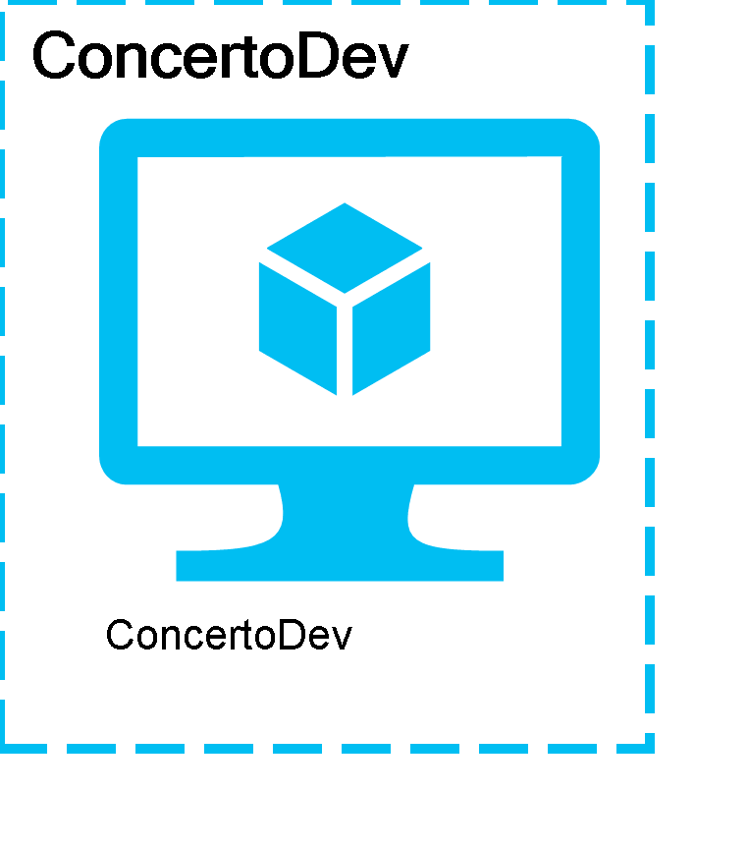

### Settings

The Cloud Service **ConcertoDev** has the following settings:

|  |  |
| --- | --- |
| Service Name | ConcertoDev |
| Uri | https://management.core.windows.net/275ddf79-b240-44e7-9916-f24175b451b1/services/hostedservices/ConcertoDev |
| Affinity Group |  |
| Description |  |
| Label | ConcertoDev |
| Location | East US |
| Status | Created |
| Creation Date | 10/5/2014 7:44:01 PM |
| Last modification Date | 10/5/2014 7:44:15 PM |

### Role ConcertoDev

|  |  |
| --- | --- |
| Name | ConcertoDev |
| Size |  |
| Guest Agent Status |  |
| State Details |  |
| Status | StoppedDeallocated |
| Upgrade Domain |  |
| IP Address |  |
| Power State | Stopped |

## epdmCirque

## pascaltfs

## pbonsql2012