PROJECT REPORT
IMPORT DATA USING TRANSFORM MAPS
A ServiceNow Micro Project
Govt Arts College for women in Ramanathapuram- ALUAU15
Computer Science-3 year
Submitted By;
Team Leader: 1.JANANI M
Members: 2.MOOMINABEEVI J
3.MUHILMATHI R
4.NIVEDHA C

5.PON ANANDHA LAKSHMI I

Project Abstract

This project demonstrates how structured employee data can be imported from an external spreadsheet into the ServiceNow platform using Import Sets and Transform Maps. The spreadsheet acts as the source of data, while an Import Set table is used as a staging area before the data is transformed into a custom Employee Test table. Field mapping is configured between the source and target tables, and the transformation process is executed to create or update employee records. The project also uses Coalesce to identify existing records and avoid duplicate entries. Reports and a dashboard are added to provide a visual view of employee information.

Introduction

ServiceNow provides tools for importing and managing structured data from external sources. In this project, employee information is prepared in spreadsheet format and loaded into ServiceNow. The data is first stored in an Import Set table and then transferred to a custom target table through a Transform Map. The project follows an end-to-end process covering data preparation, table creation, data loading, field mapping, transformation, validation, duplicate prevention, reporting, and dashboard creation.

Problem Statement

Manual entry of large amounts of employee information into ServiceNow can be time-consuming and may result in duplicate or inconsistent records. A systematic method is required to import spreadsheet data efficiently, map source fields correctly, update existing records, prevent duplicate records, and provide useful reports for monitoring the imported information.

Objectives

- To import structured employee data from a spreadsheet into ServiceNow.
- To create a custom Employee Test table for storing employee records.
- To create an Import Set table for temporary/staging data.
- To configure a Transform Map between source and target tables.
- To map source fields to the corresponding target fields.
- To use Coalesce to identify existing employee records and prevent duplicates.
- To validate inserted and updated records after transformation.
- To create reports based on department, location, and employee details.
- To create a dashboard containing the project reports.

Tools & Technologies Used
- ServiceNow Platform
- Import Sets
- Transform Maps
- Custom ServiceNow Tables
- ServiceNow Reports
- ServiceNow Dashboards
- Google Sheets / Microsoft Excel
- Web Browser

Project Requirements
Hardware Requirements:
- Computer or laptop with a working web browser.
- Stable internet connection.
Software / Platform Requirements:
- Access to a ServiceNow instance with the required permissions.
- Spreadsheet application such as Google Sheets or Microsoft Excel.
- Web browser such as Chrome, Edge, or Firefox.

System/Workflow Diagram
The overall workflow of the project is represented below. The spreadsheet data is prepared first, loaded into an Import Set table, transformed through a Transform Map, and stored in the Employee Test table. The resulting data is then used for reports and dashboard visualization.
External Spreadsheet
↓
Load Data
↓
Import Set Table
↓
Transform Map + Field Mapping
↓
Coalesce Check
↙ ↘
Insert Update
\ /
Employee Test Table
↓
Reports & Dashboard

Project Implementation

Phase 1 – Prepare the Spreadsheet

- Open a new Google Spreadsheet or spreadsheet application.
- Create employee sample data with fields such as Employee ID, Employee Name, Email, Department, and Location.

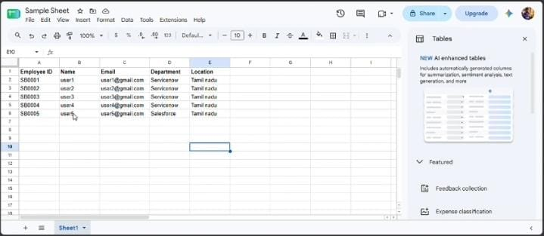

- Download/save the spreadsheet in Excel (.xlsx) format for importing into ServiceNow.

Phase 2 – Create the Custom Employee Table

- Navigate to Tables and select Create New.
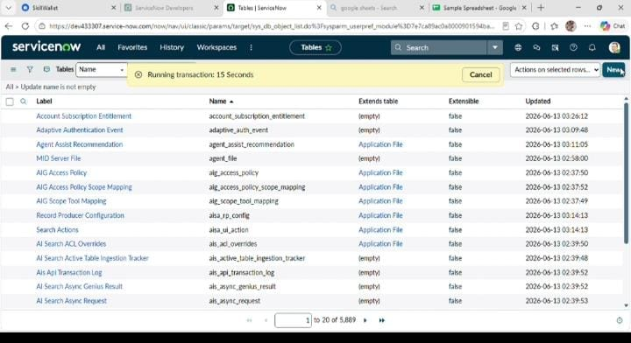

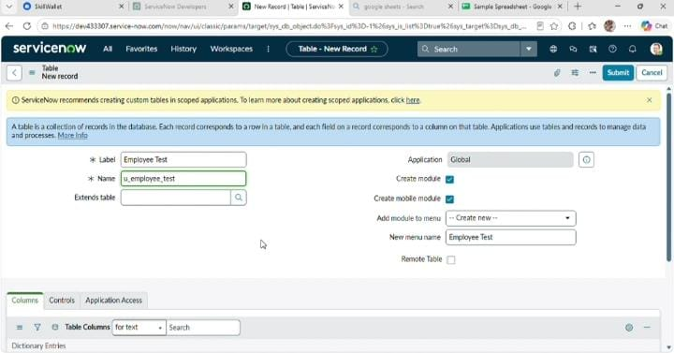
- Create a table with the label Employee Test.
- Use the table name u_employee_test.
- Save the table and verify that the fields appear on the form.
- After creating and saving the Employee Test table, scroll down to the bottom of the table form.
- Click Show Form to open the table form.

- On the form, locate the Form Context Menu / Additional Actions option on the left side of the form header.
- Click the Form Context Menu / Additional Actions icon.
- Click configure , select Form Layout.
- The Form Layout page will open, where you can configure the fields displayed on the form

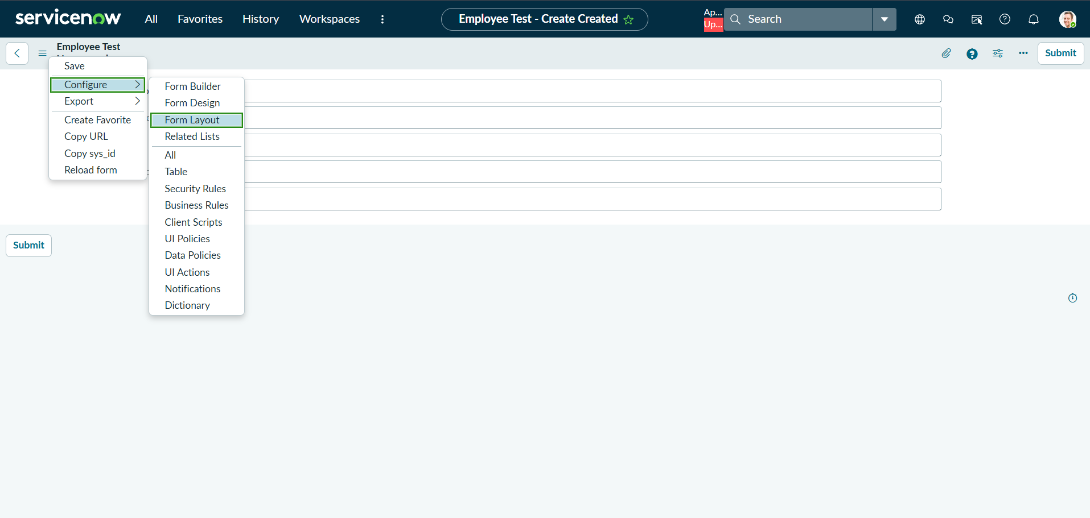

- After opening Form Layout, click New to create a new field.
Enter the field details:
- Column Label: Employee ID
- Type: String
- Click Add to create the field
- Repeat the same steps to create the following fields:

Employee Name – Type: String
Email – Type: String
Department – Type: String
Location – Type: String
- After creating all the required fields, click Save.
- Verify that the newly created fields are displayed on the Employee Test form.
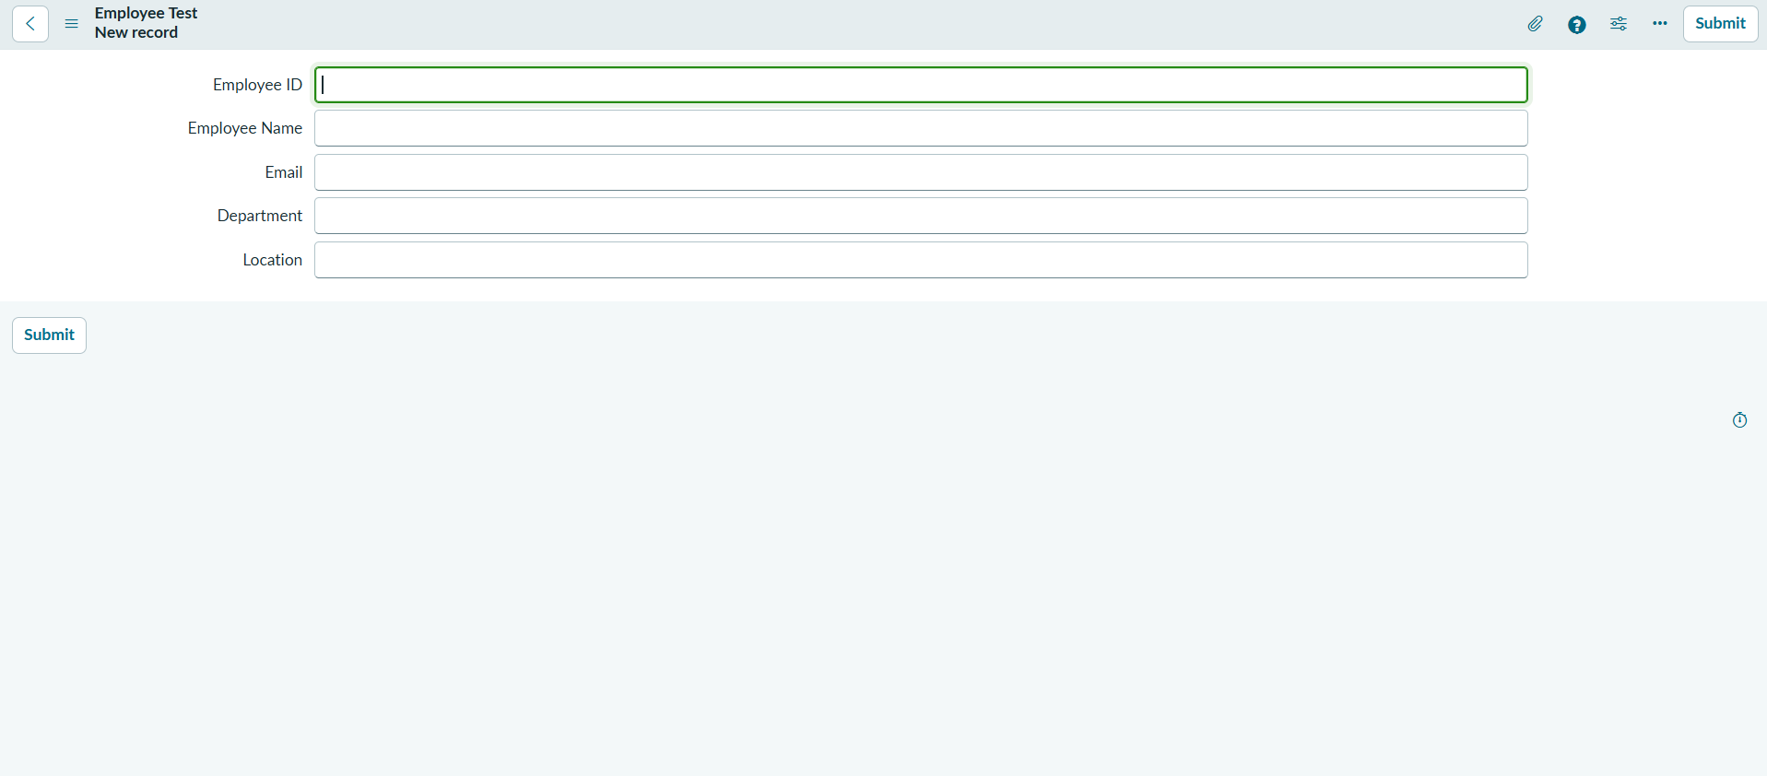

- Click on Submit or Save.

Phase 3 – Create the Import Set Table

- Navigate to Load Data in the ServiceNow Application Navigator.
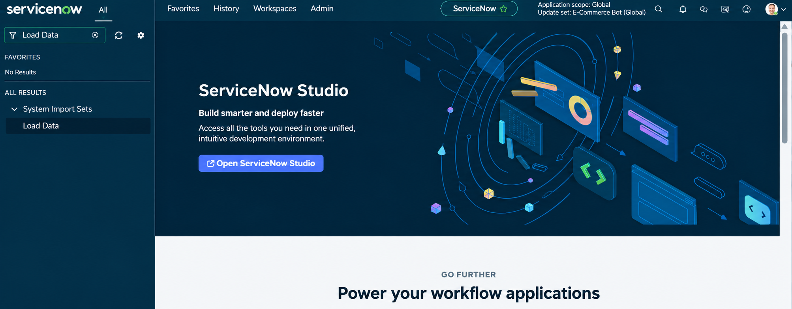

- Click on Load Data and create an import table Fill details as shown below
  - Label: Employee Import
  - Name: u_employee_import

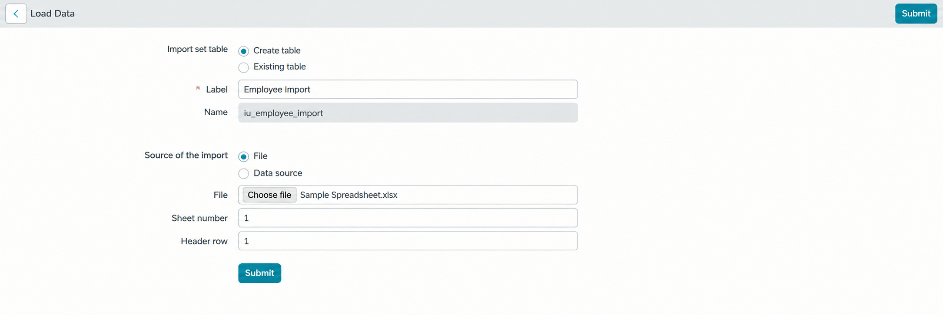

- Click on Submit
Once we click on Submit, we can see the success message as shown below. Also
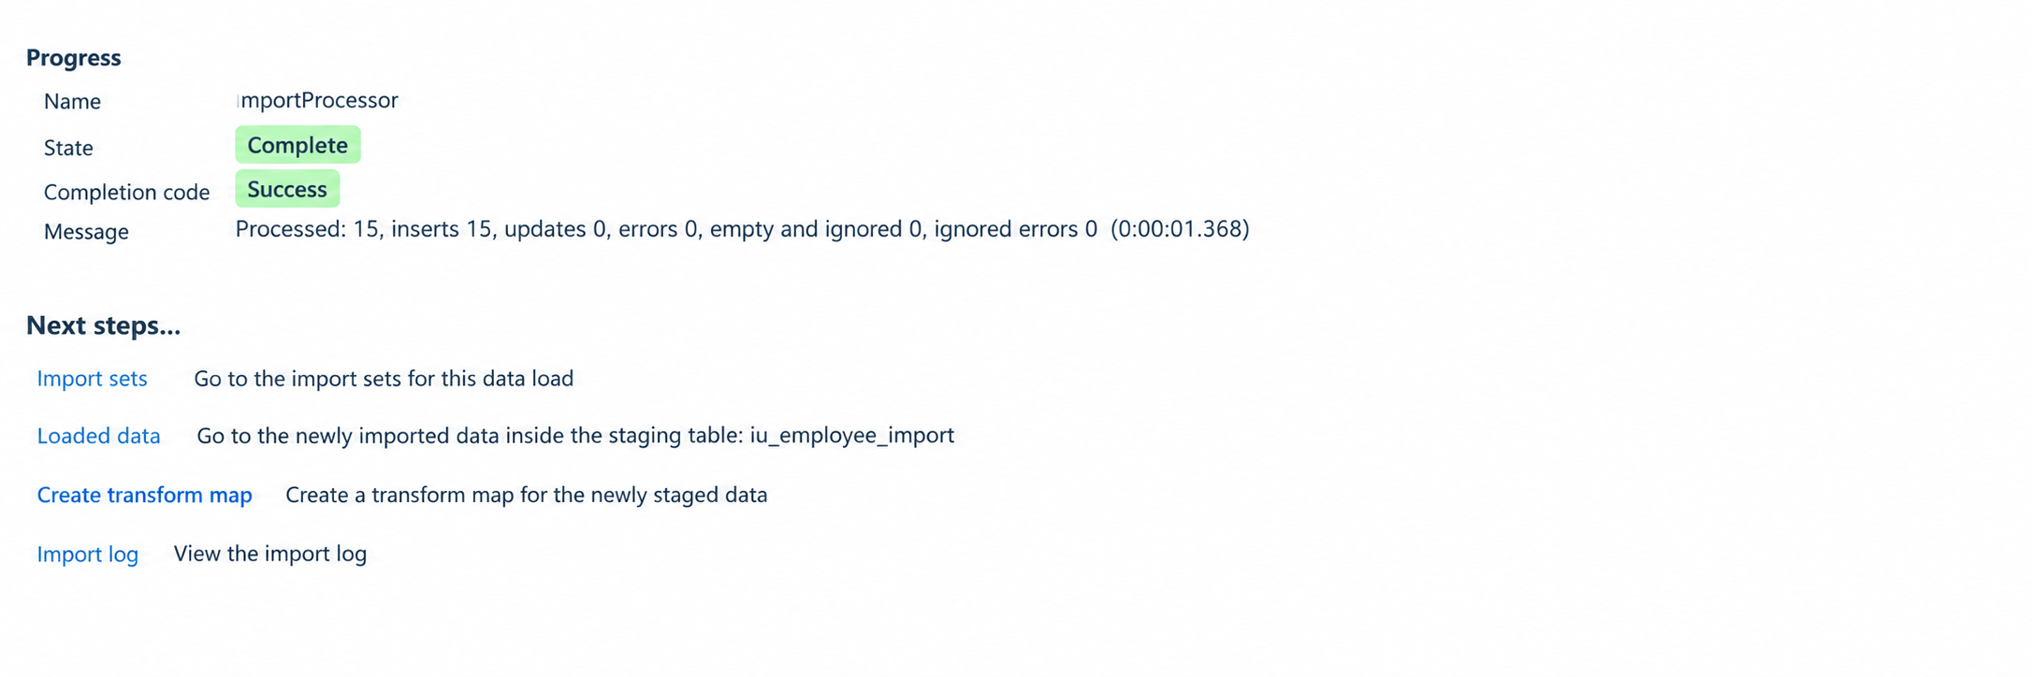

Phase 4 – Create the Transform Map

- In this phase we need to create the Transform Map by clicking on the Create Transform Map button as shown in above screenshot.
- Give inputs as shown below.
Name: Sample Spreadsheet Import
Source Table: Employee Import is
Target Table: Employee Test - as we created earlier Click on Auto Map Matching fields.

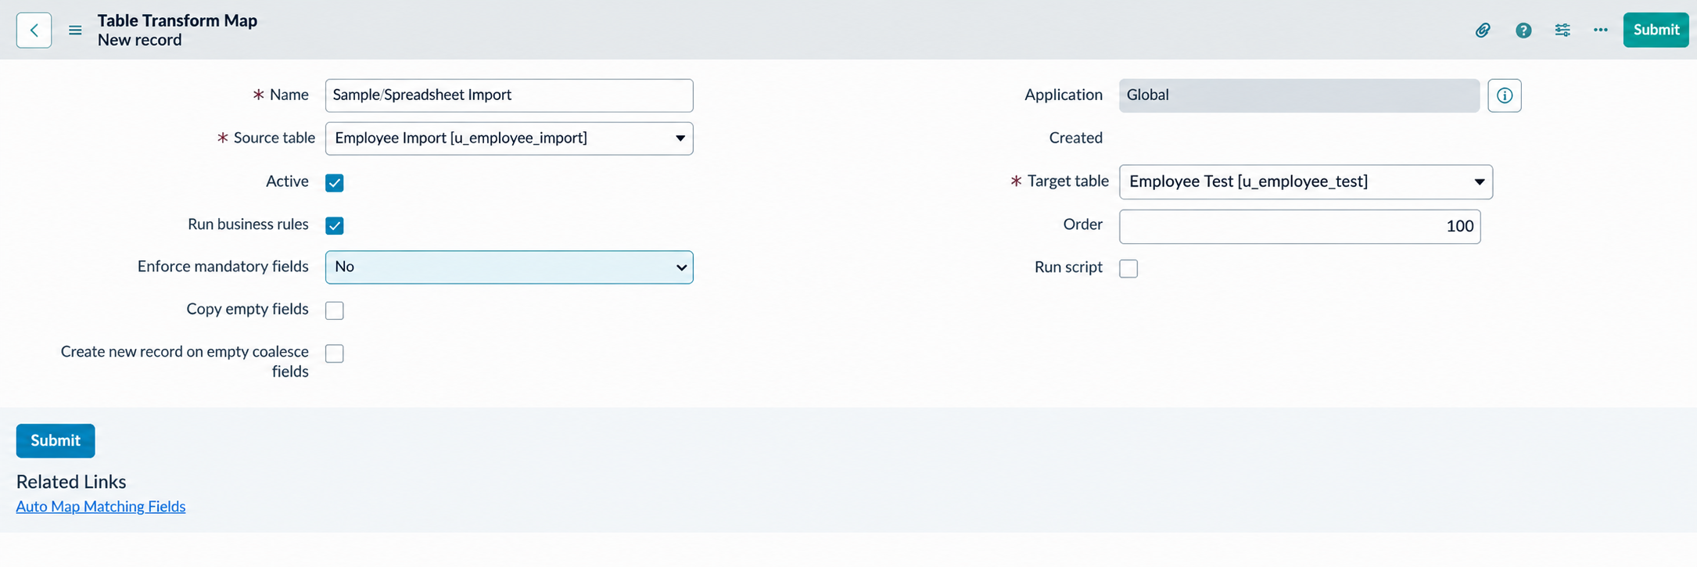

- Now click on Mapping Assist and map the fields with Source & Target Table
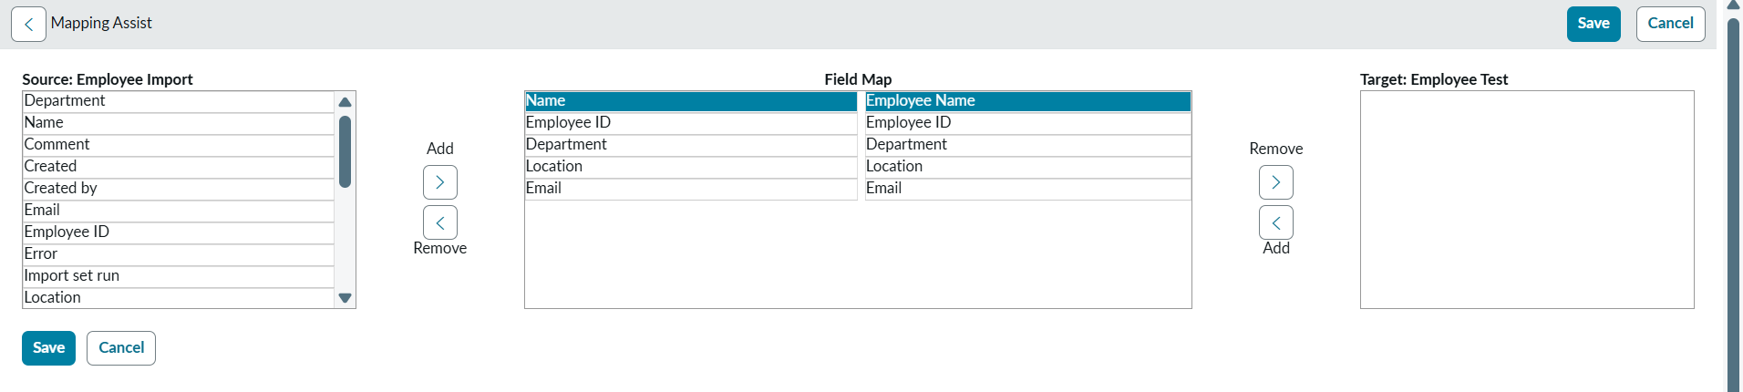

- Click on Save

Make sure the both Source & Target table fields are mapped

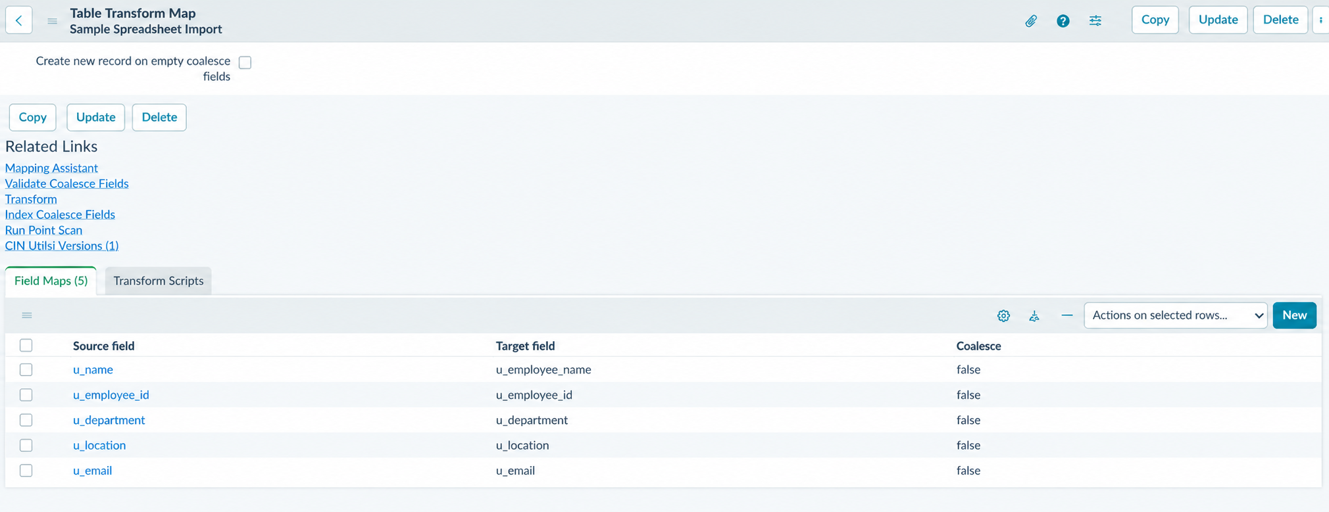

Now click on Transform

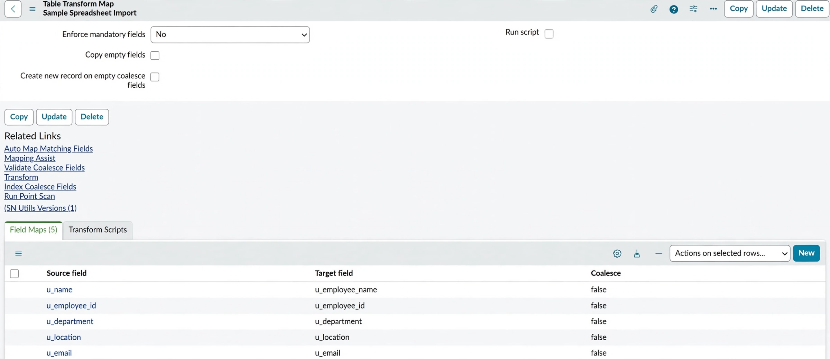

  - Now click on Transform Button
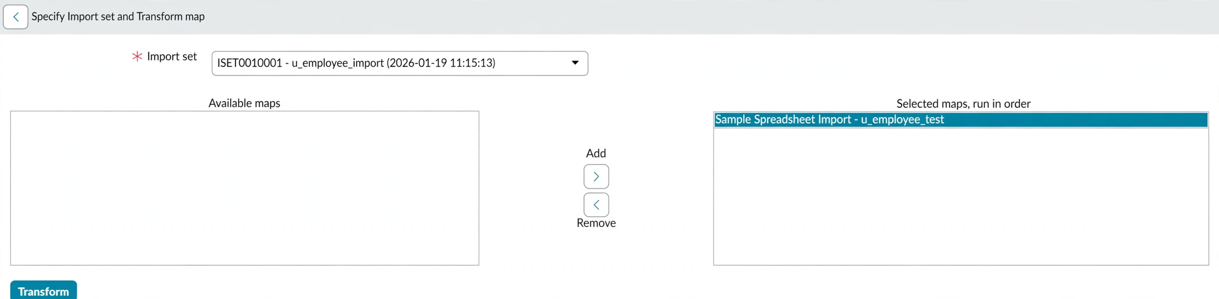

  - After

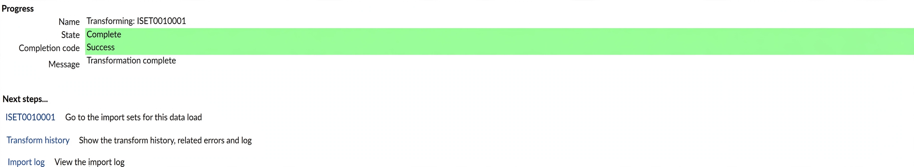

Phase 5: Transform Data & Validate

  - Open Employee Test Table from application navigator as shown below.

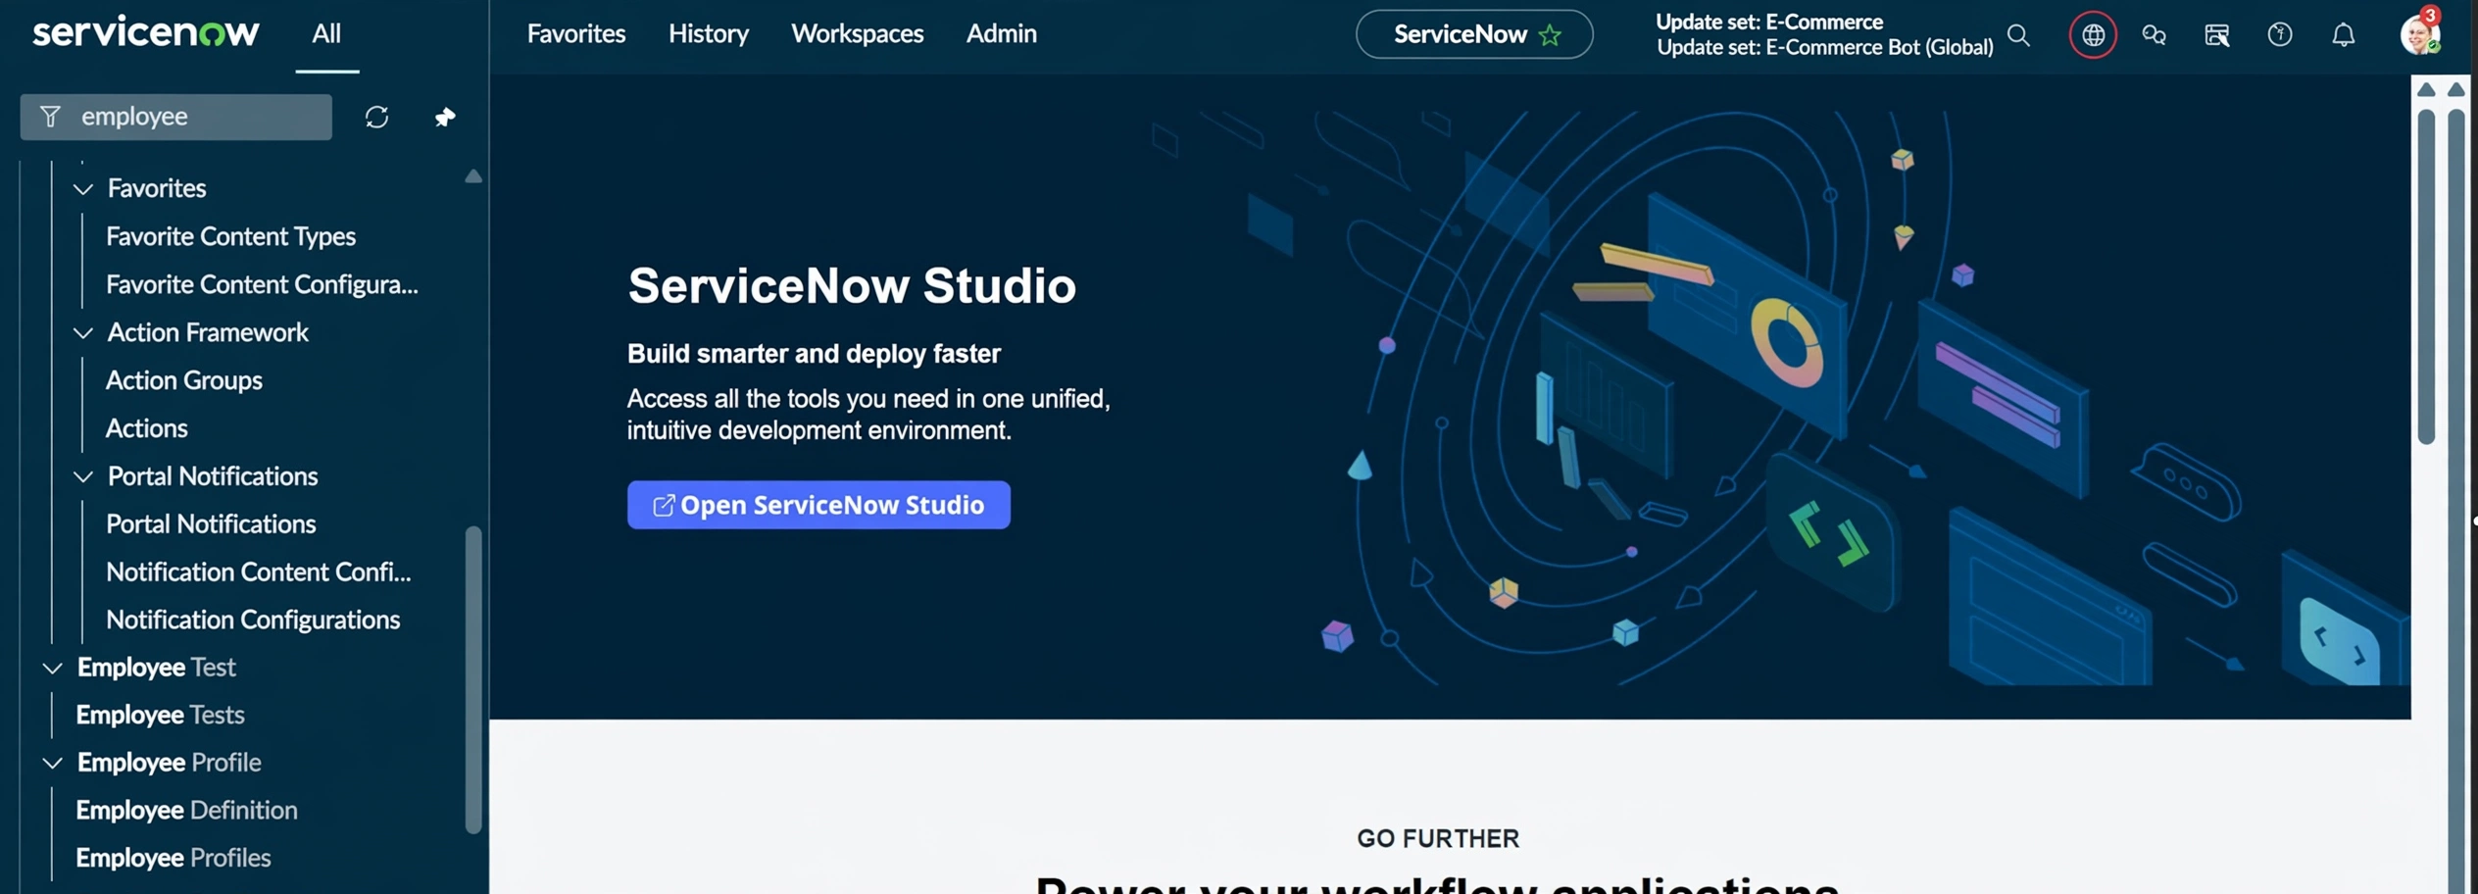

  - As our import got succeeded, all the records are created in the Employee Test Table.

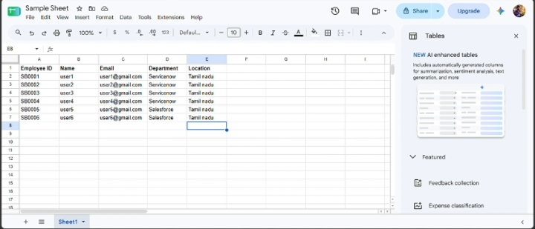

  - Make sure you rearrange the fields accordingly by using Personalised List Columns

- Click on OK

- All the records are successfully imported into the ServiceNow system with Import Set, Transform Map.

Phase 6: Enable Coalesce to Avoid Duplicate Records
  - In real projects, the same employee data may be imported multiple times.
  - To prevent duplicate employee records, we use Coalesce.
  - The Coalesce will update the same records with new values if we add and the duplicate values are not inserted.

  - Steps:
- Open Transform map Under System LDAP On All menus.
- Open the Created Transform map , Name is Sample Spreadsheet Import.
- Under Related list, select the Field maps Section and Make any one field Coalesce True which appears in False.
- Now save the form.
- Then again add some data which is in Excel format.

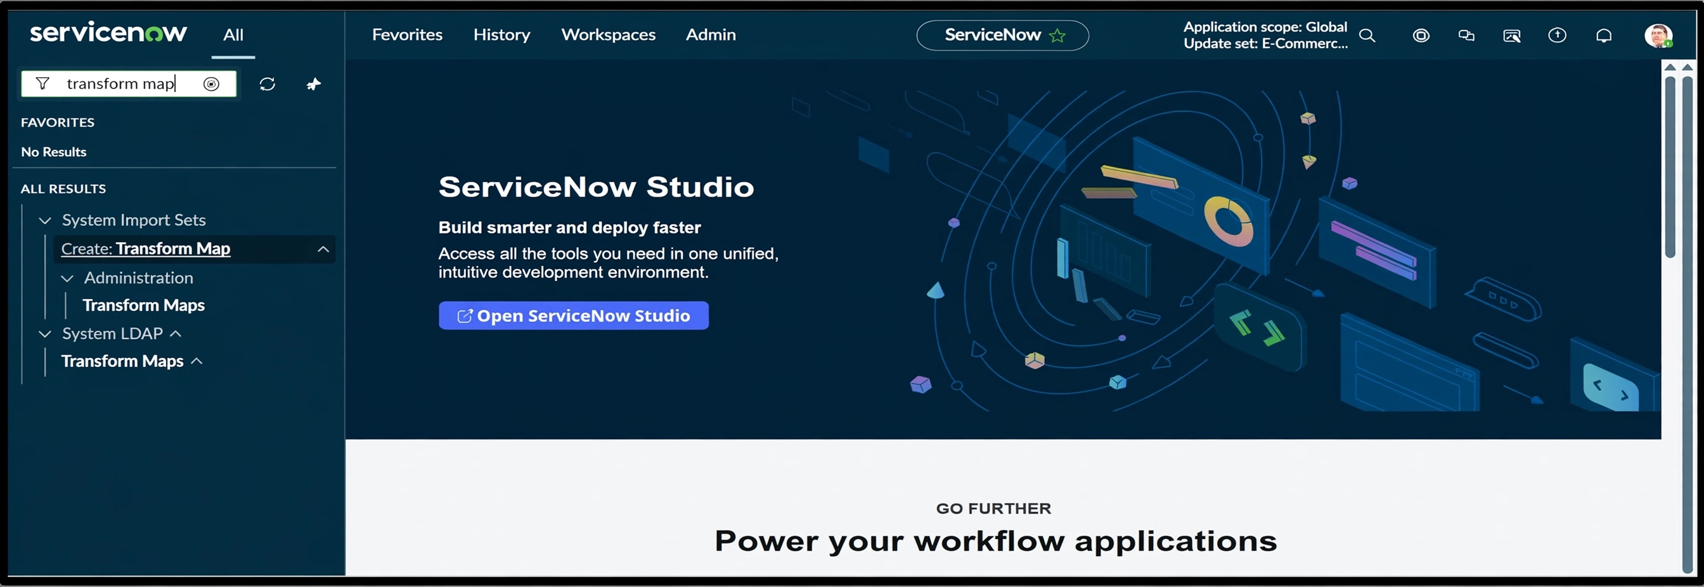

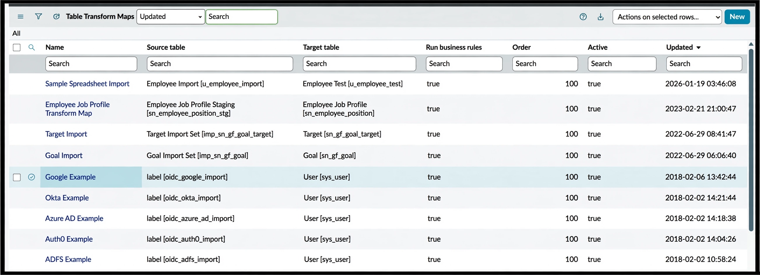

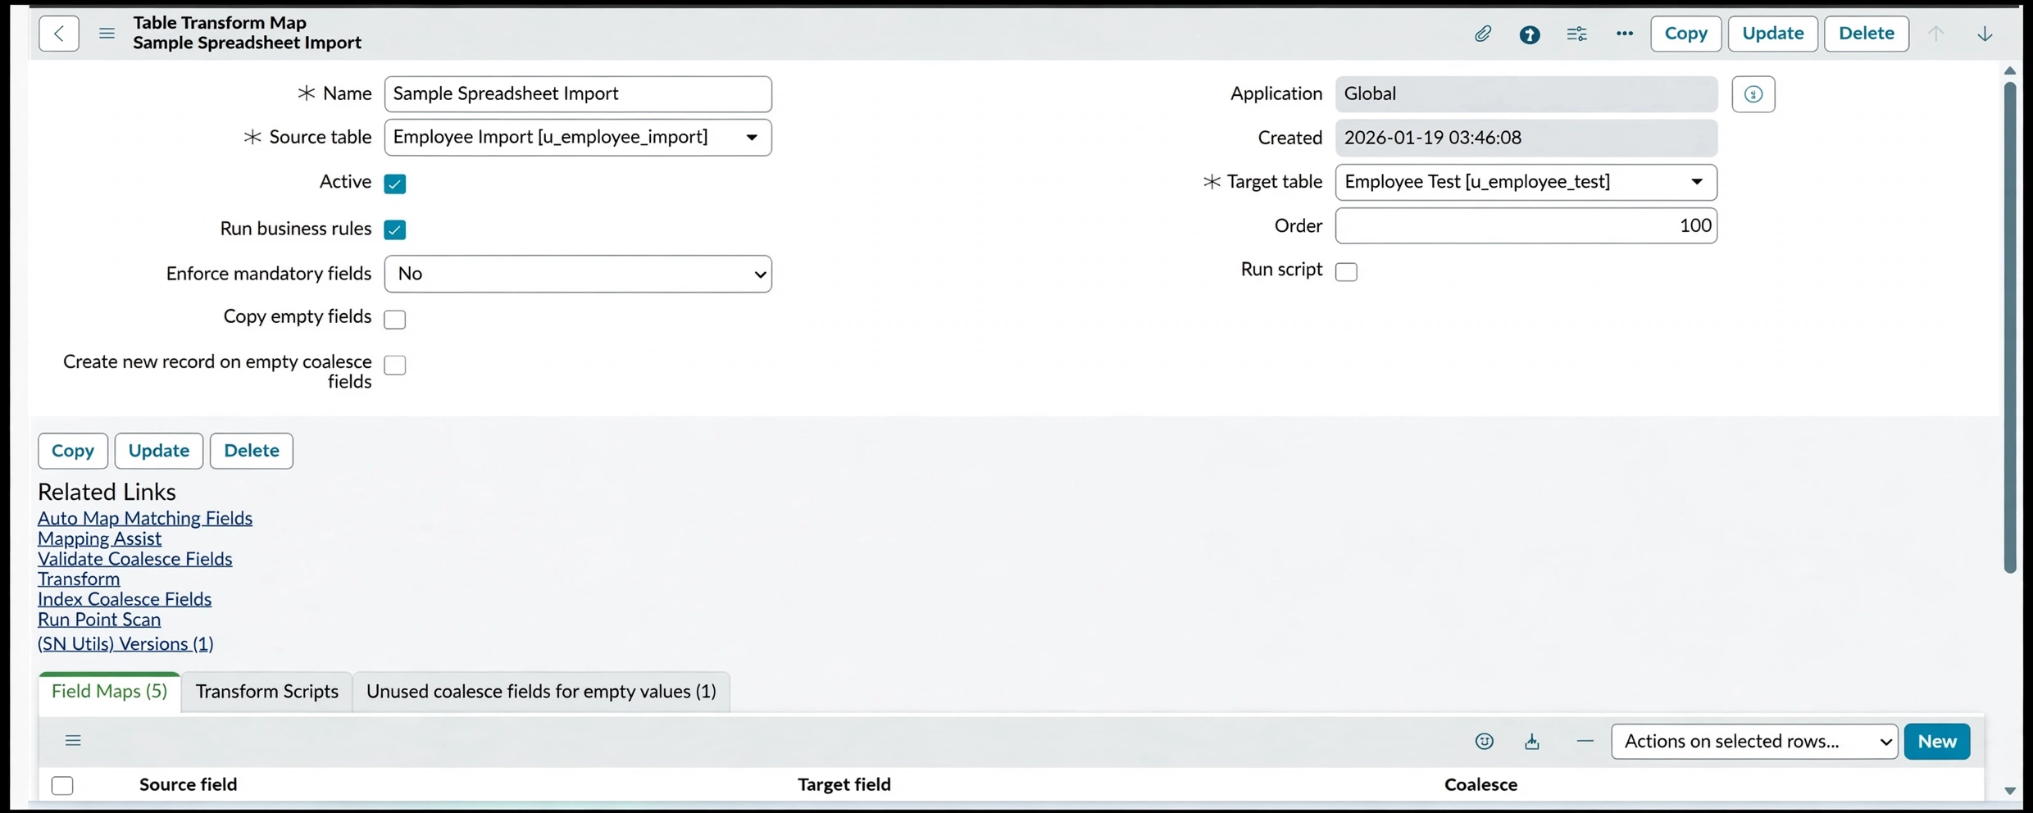

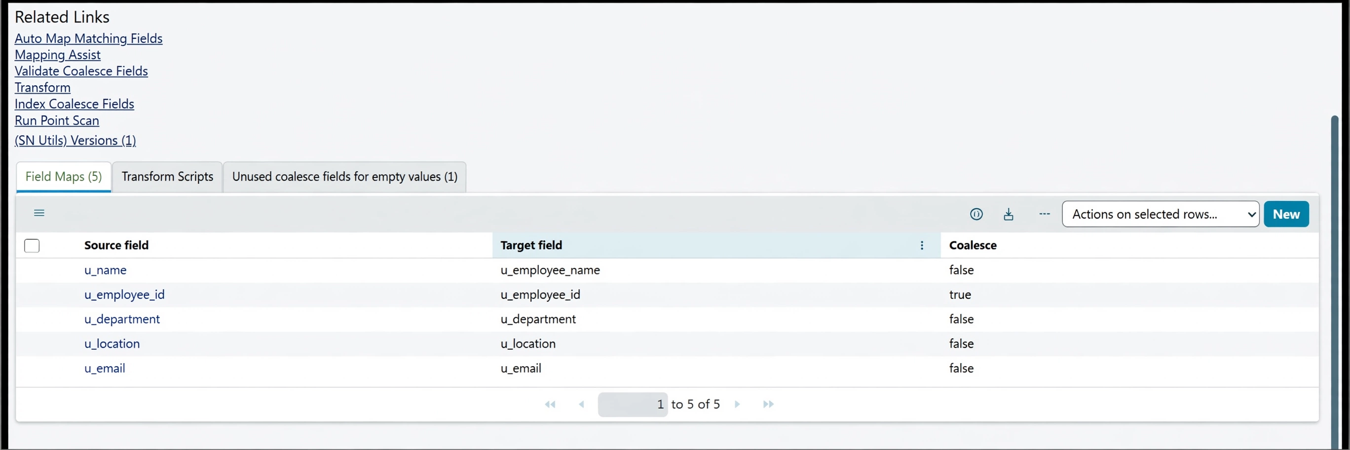

PHASE 7 : Inserting New Data In Excel Format

  - Navigate to All menus.
  - Search for Load data Under System Import set Open Load Data.
  - Fill the details as
  - Import set table as select Existing table
  - Source of Import is Select File and choose the file from Files.
  - Sheet number : 1, Header row : 1.
  - Now Click submit.

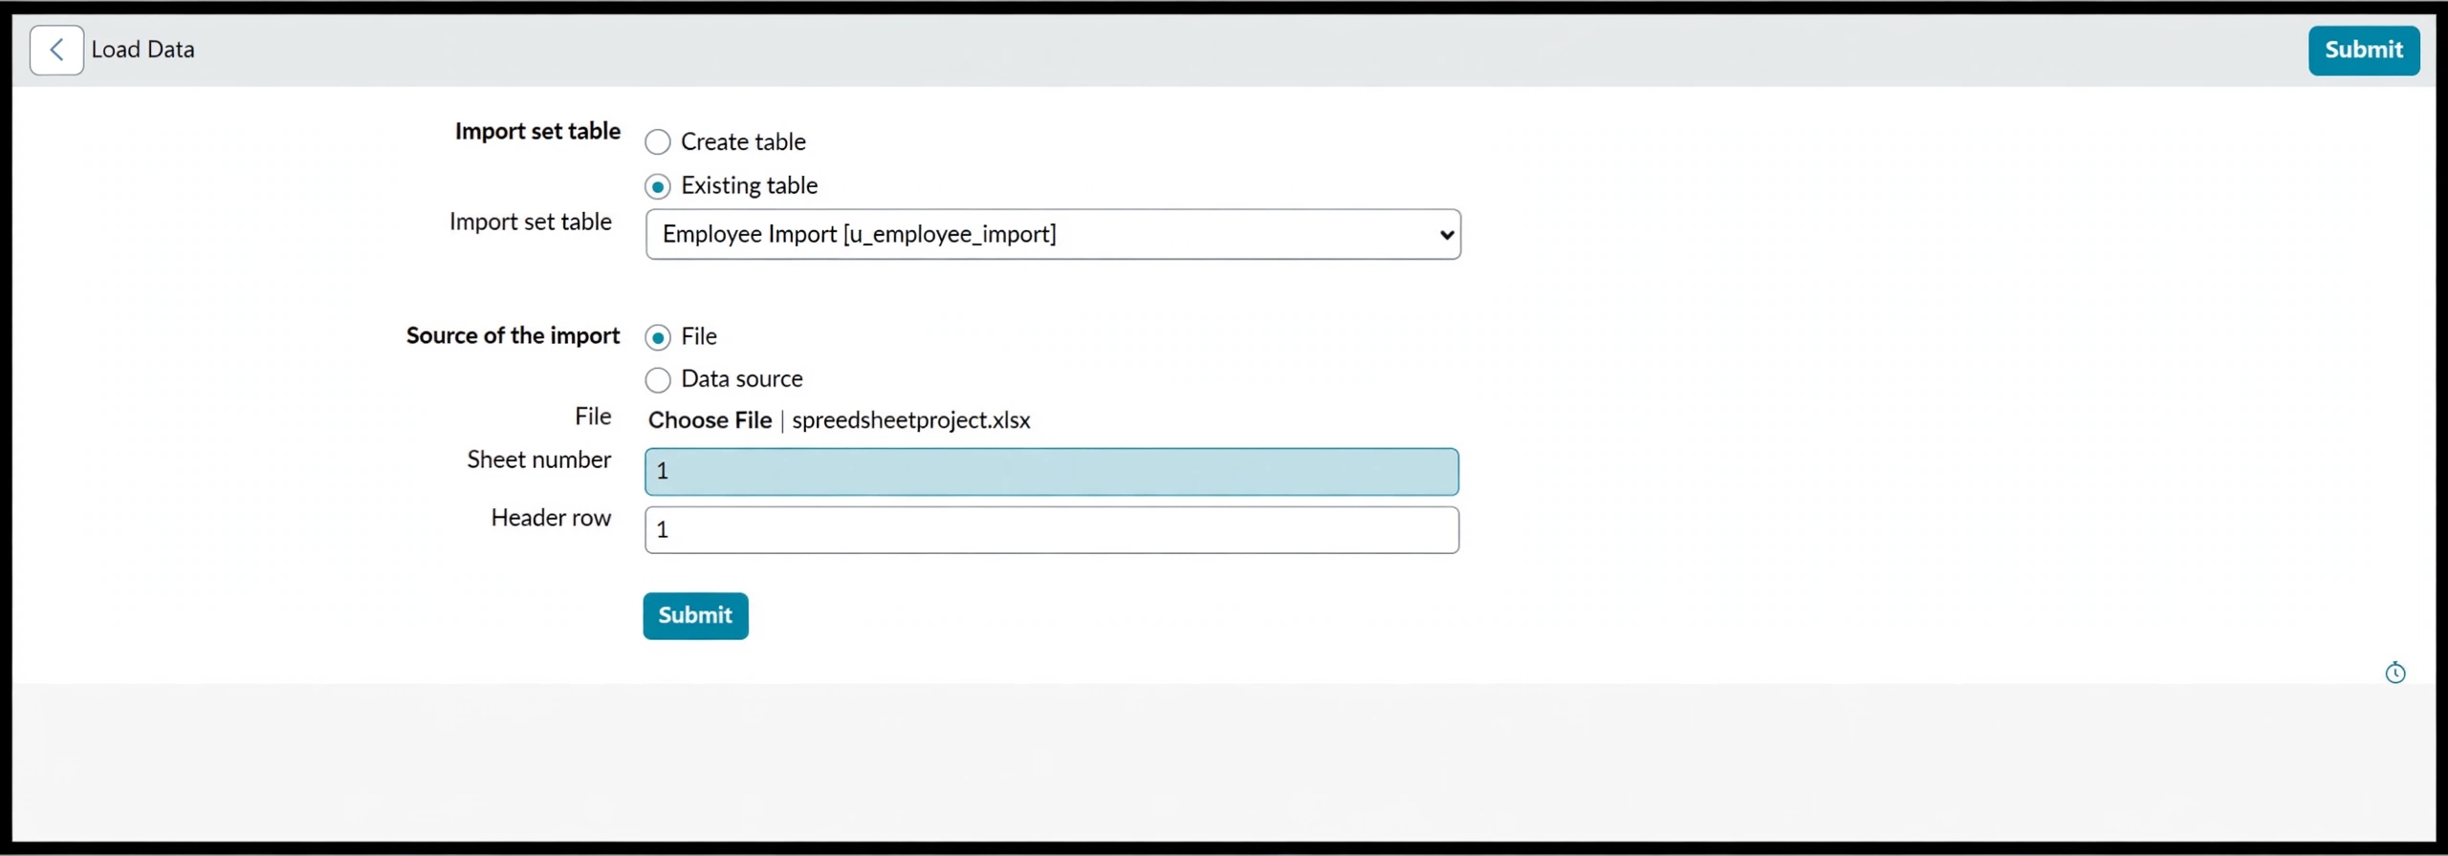

- Newly Created Excel Data is this.

PHASE 8 : Create Reports on Employee Test Table

  - Open All menus, Search for Reports.
  - Under Usage and governance Select Reports.
  - Click the New button to create a new report.
  - Create 3 Reports as follows.

Report 1: Employees by Department
  - In Data
  - Report name : Employees by Department.
  - Source Type : Table.
  - Table : Employee Test, Now click the Next button.

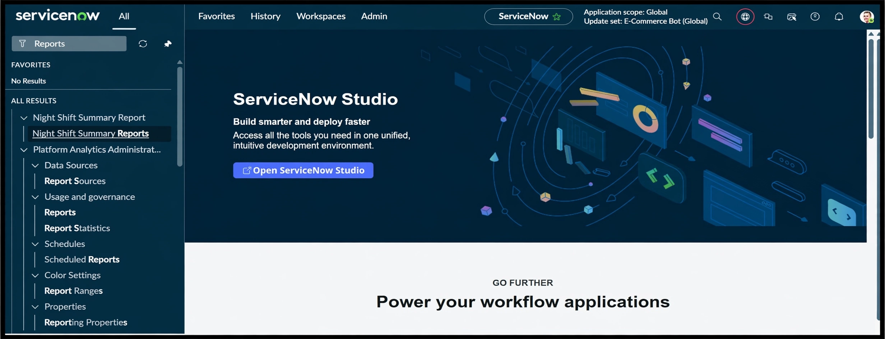

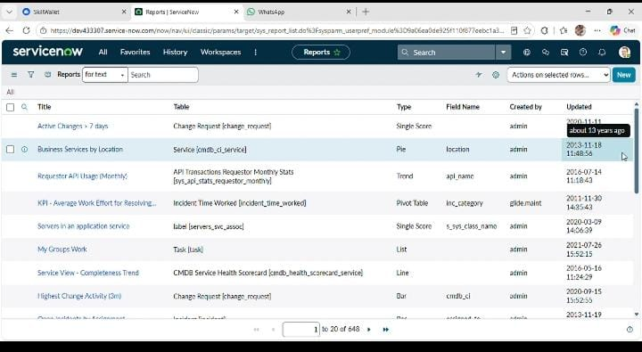

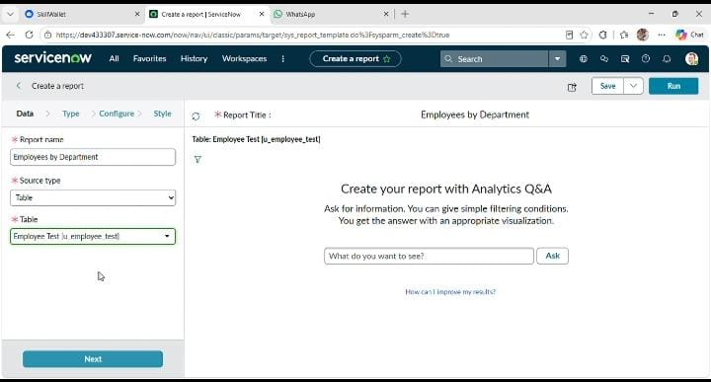

  - Now after Clicking next in type Select Pie chart .
  - And click the next button.

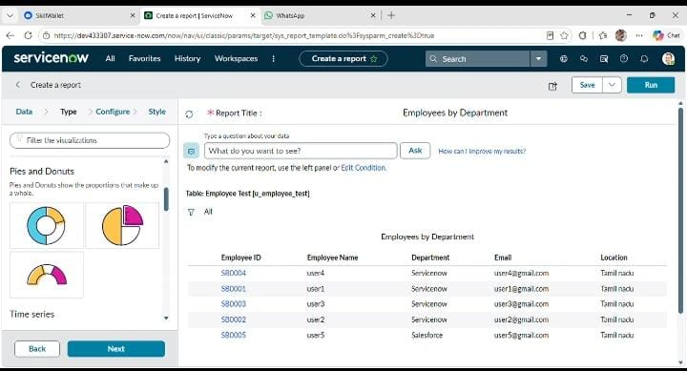

  - Now In Configure Select Group by Department Field.
  - In the Aggregation Field Select Count.
  - Then Click next.

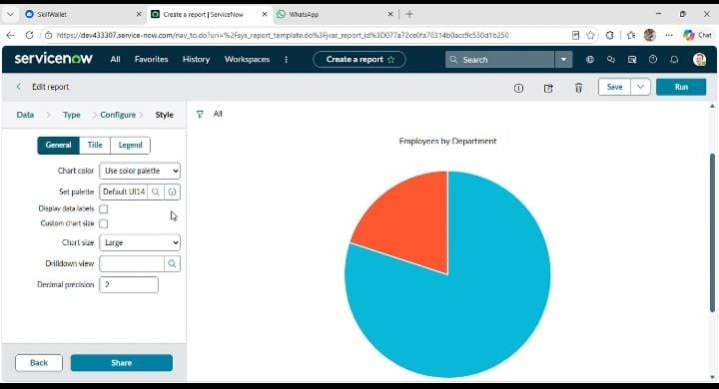

Now In Style Leave the Chart color by default.
- And Click the Run button to Execute the given data Report.
- And Click save button to Save the Report

Report 2: Employees by Location Configuration
  - Table: Employee Test
  - Type: Bar Chart
  - Aggregation: Count
  - Group By: Location

Steps :
- Create a New Report.
- Report name : Employees by Location.
- Table Select : Employee Test.
- Select Type : Bar Chart.
- In Configure Select Group by Field : Location.
- And Aggregation is Count.
- Now Click Run to Execute the Report and Click the Save to save the Report.

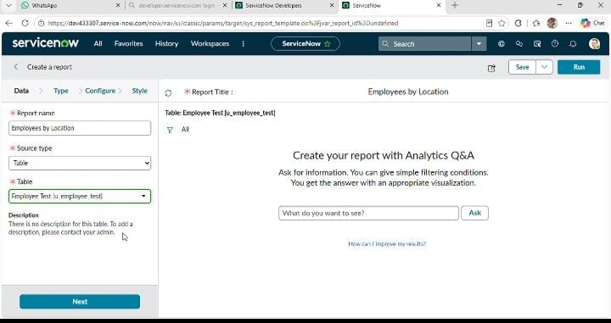

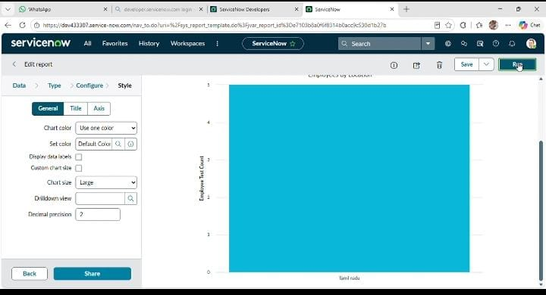

Report 3: Employee List Report. Configuration
  - Create a New Report name : Employee List Report.
  - Table: Employee Test.
  - Select Type: List.
  - In Configure Select Columns:
    - Employee ID.
    - Employee Name.
    - Email.
    - Department.
    - Location.
  - Now Select next and no required to choose anything in Style.
  - Now Click Run to Execute the Report and Click Save to Save the Report.

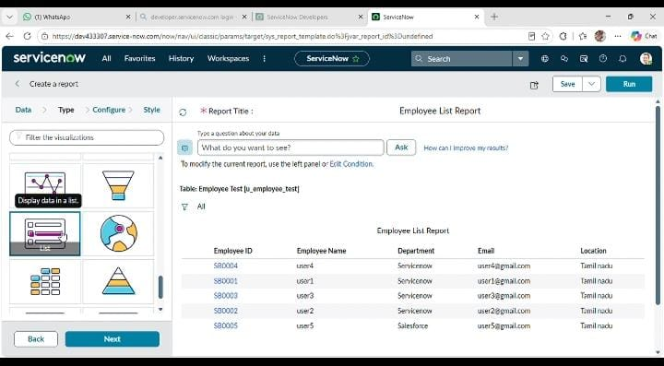

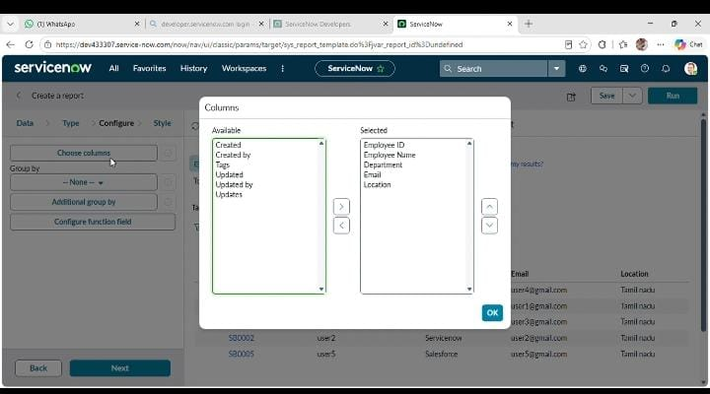
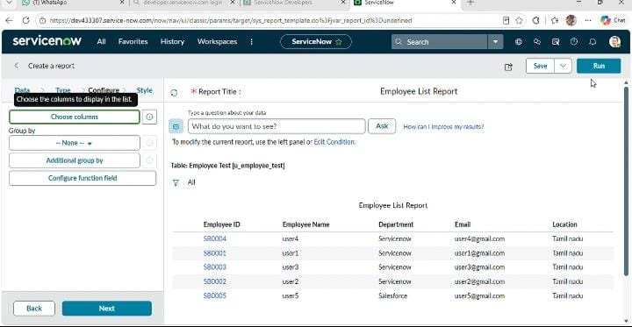

PHASE 9 : Add Reports to Dashboard

Create Dashboard

Navigation :
  - Open All menus → Search for Dashboards.
  - Under Self Service → Click Dashboards.
  - On the top right corner Click Create Dashboards or /
  - You can create Directly by using the backend name [ PA_DASHBOARDS.FORM ].
  - Then Click New to Create new Dashboard

- Only the backend name will open the form if the ACL has the pa_dashboards access to Admin Overrides True only.
- Then only we have access to the form.

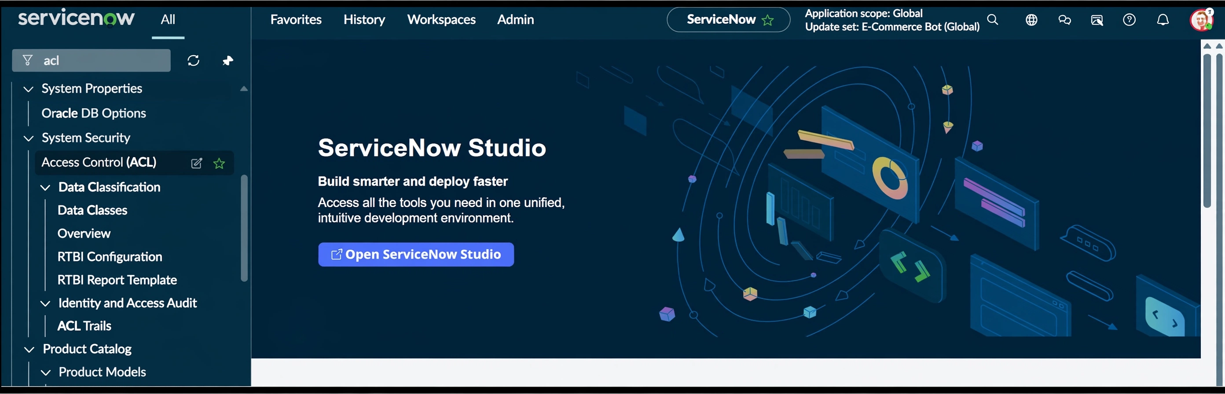

  - After Opening the ACL Search the pa_dashboards on Name Column.

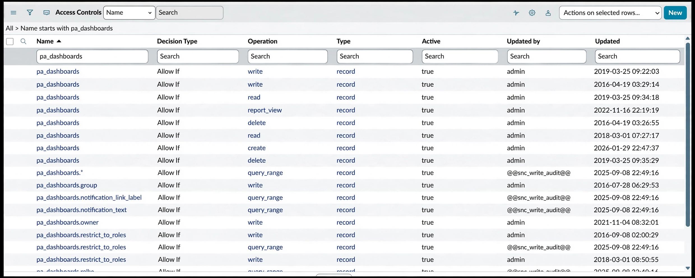
  - Now Open the Create Operation row.
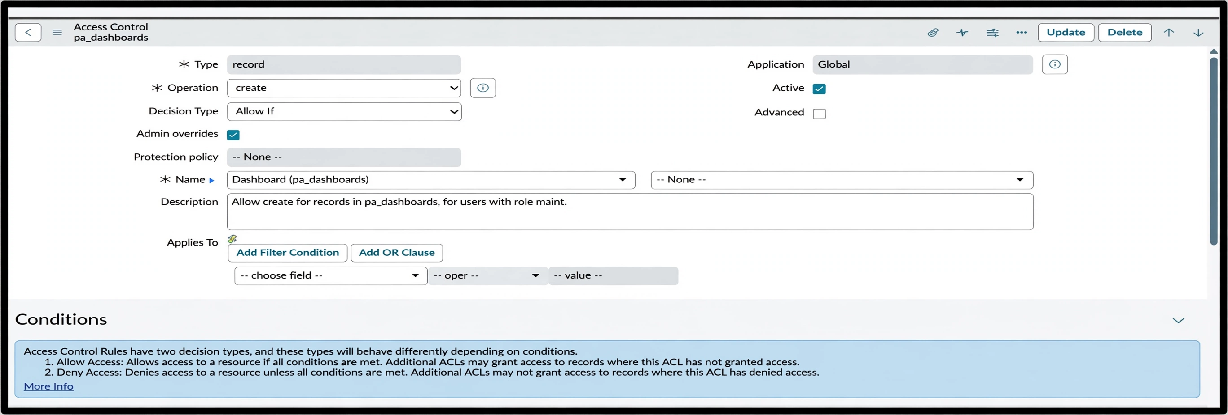

  - Then Click Enable the True for Admin Overrides and Update the Form.
  - Then the creation of dashboards will be possible by using the backend name.
  - Now Open the PA_DASHBOARDS.FORM create dashboard.
  - Dashboard name : Employee Analytics Dashboards.
  - Save the Form.
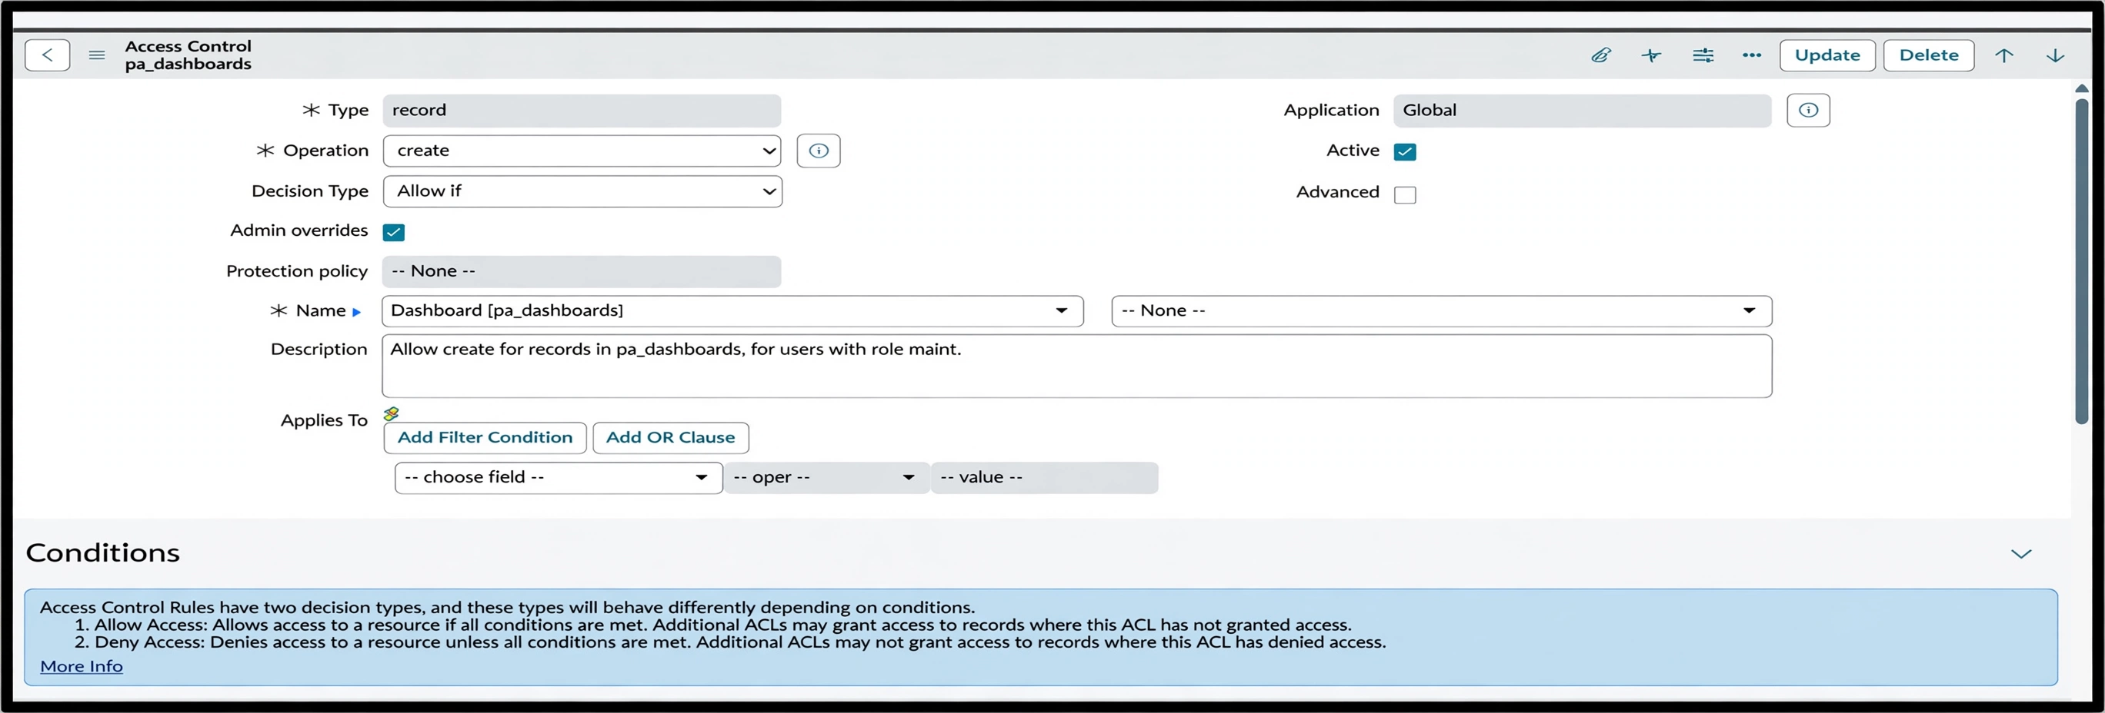

Add Reports to Dashboards.
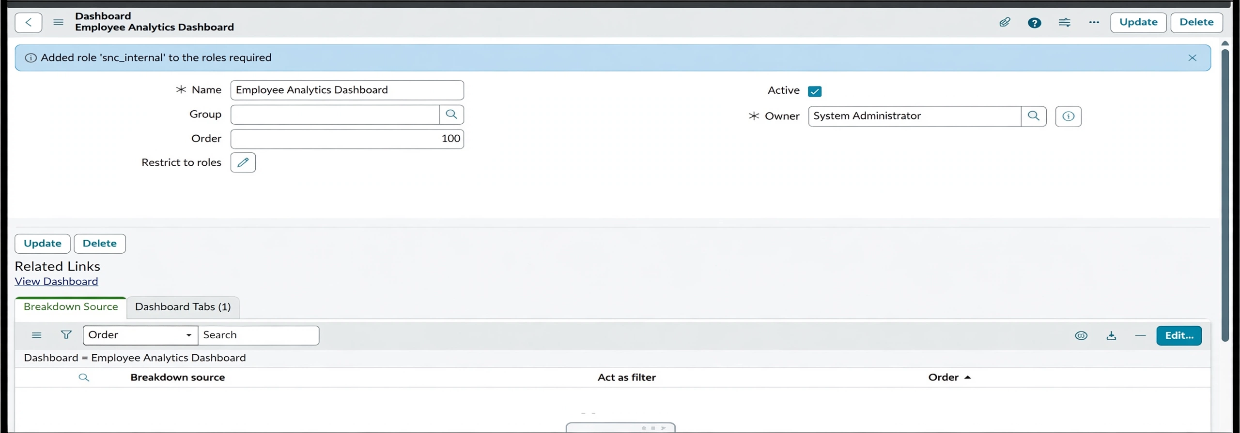

Conclusion:
- This project successfully implemented an automated employee data management solution using ServiceNow Import Sets and Transform Maps, ensuring accuracy, efficiency, and data integrity throughout the employee onboarding and update process.
- A key enhancement in this project was the use of Coalesce in the Transform Map. By enabling Coalesce on the Employee ID field, the system intelligently identifies existing employee records during every import. This prevents the creation of duplicate records and ensures that repeated imports update existing data instead of inserting redundant entries. As a result, the employee database remains clean, reliable, and consistent, which is critical in real-world enterprise environments where data may be imported multiple times from external systems.
- In addition to data integrity, the project was extended with Reports and Dashboards to provide meaningful insights and real-time visibility into employee data and import activities. Custom reports were created to track:
  - Total employee records.
  - Newly added employees.
  - Updated employee records.
  - Department-wise employee distribution.
  - Import success and error counts.
- These reports were then consolidated into a Dashboard, allowing administrators and HR teams to monitor employee data trends, import performance, and data quality from a single centralized view. Dashboards improved decision-making by presenting information visually through charts and graphs, reducing the need for manual analysis.

Reports & Dashboard
Three reports are created to provide different views of the employee data:
- Employees by Department – displays the number of employees in each department using a pie chart.
- Employees by Location – displays employee counts by location using a bar chart.
- Employee List Report – displays employee details in list format.
The reports are added to the Employee Analytics Dashboards dashboard so that administrators can view employee information from a centralized location.
The project demonstrates an end-to-end employee data import process in ServiceNow using Import Sets and Transform Maps. Employee data is loaded from a spreadsheet into an Import Set table and transformed into the Employee Test target table through configured field mappings. Coalesce provides a mechanism for recognizing existing employee IDs so that repeated imports can update existing records rather than create unwanted duplicates. Reports and a dashboard provide useful views of the resulting employee data. Overall, the project provides a practical demonstration of structured data migration and basic reporting within ServiceNow.

