### SSN COLLEGE OF ENGINEERING

**Department of Computer Science and Engineering CS6712 Grid and Cloud Computing Laboratory**

##### Assignment -9 : Live Migration of Virtual Machine

**Assigned Date: Due Date:**

**In OpenNebula FrontEnd VM do the following.**

* 1. Add 4 hosts (nodes) to /etc/hosts as follows

<IP of frontend> frontend

<IP of node1> node11

<IP of node2> node12

<IP of node3> node13

* 1. Create above mentioned 4 hosts in oneadmin user as follows. oneadmin@ ]$ onehost create frontend –i kvm –v kvm –n dummy oneadmin@ ]$ onehost create node11 –i kvm –v kvm –n dummy oneadmin@ ]$ onehost create node12 –i kvm –v kvm –n dummy oneadmin@ ]$ onehost create node13 –i kvm –v kvm –n dummy
  2. Update the VM template with SSH_PUBLIC_KEY using “*oneuser*” command.
  3. Creating a Virtual Machine (VM) Template
     1. Use CentOS 6.5 (64-bit) OS image to create virtual machine template.
     2. Use “*onetemplate*” command to do it.
  4. Create two VMs (VM1 and VM2) with CentOS 6.5 (64-bit) from the above created CentOS6.5 (64-bit) template.
  5. List all VMs and hosts running in Opennebula Cloud.
  6. Deploy VM1 in node11 host and VM2 in node12 host using the command oneadmin@ ]$ onevm deploy <vm-id> <host-id>
  7. Migrate VM1 and VM2 to node13 host using following command oneadmin@ ]$ onevm migrate <vm-id> <host-id>
  8. List all VMs and hosts running in Opennebula Cloud.

**LIVE MIGRATION OF VIRTUAL MACHINE**

###### AIM:

EX NO: 9

To perform live migration of Virtual Machine from One host to another host machine.

###### PRE-REQUISITES:

1. Install **OpenNebula Front-End VM and KVM node VM**(Refer EX: 7 ) [ 2 VMs with Ubuntu 16.04 desktop image]

###### PROCEDURE:

After installing OpenNebula front-end and kvm node , the following steps need to be performed in the **front-end VM:**

1. Initially , list all the hosts,templates and vms using:

###### $ onehost list

**$ onetemplate list**

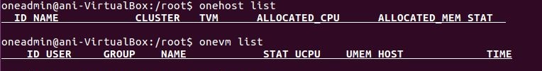**$ onevm list**

The fields are empty as there are no hosts,templates or VM.

` 2. **CREATION OF HOSTS:**

2.1. The hosts can be created via the command line using **$ onehost create frontend –i kvm –v kvm –n dummy**

###### (or)

Through the open nebula web interface : **localhost:9869 .** Login with the username and password as given in **/var/lib/one/.one/one_auth** file using the command **$sudo gedit /var/lib/one/.one/one_auth**

2.2 Navigate to **Infrastructure> hosts** in the left menu pane in the web interface as

shown:

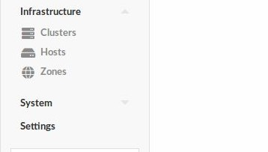

* 1. 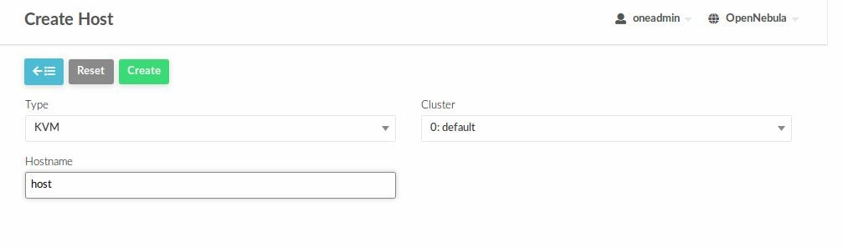Click on the ‘+’ add option and specify the hostname and click on “create” as shown :
  2. Similarly create another host and both will be listed as shown :

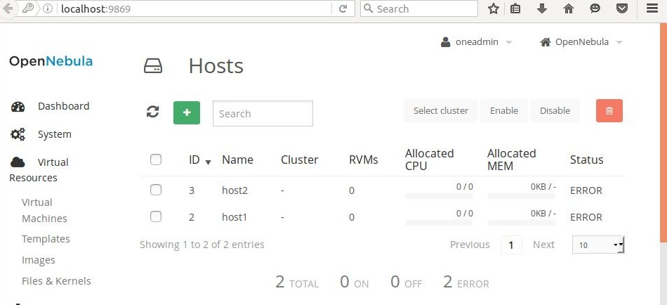

On clicking the **enable** button after creating the hosts, the status changes to init.

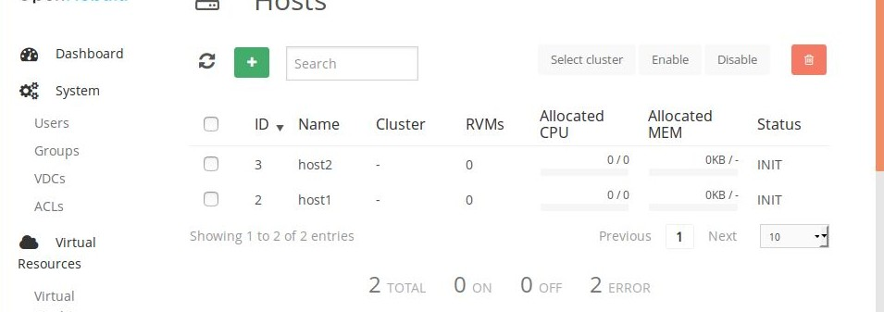

**$onehost list** can be used to list the hosts in the terminal which gives the following result:

###### CREATION OF TEMPLATE:

* 1. 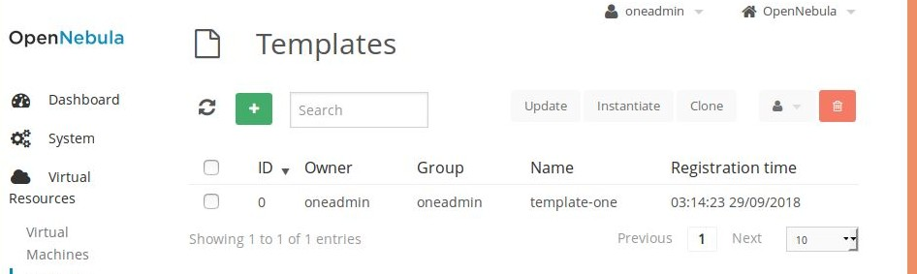Under the virtual resources > template option is selected and in the similar way to hosts , templates are created.

**$onetemplate list** will specify the new template created.

###### CREATION OF VM :

* 1. The template created is instantiated to create a virtual machine by clicking on the “instantiate” option in templates.

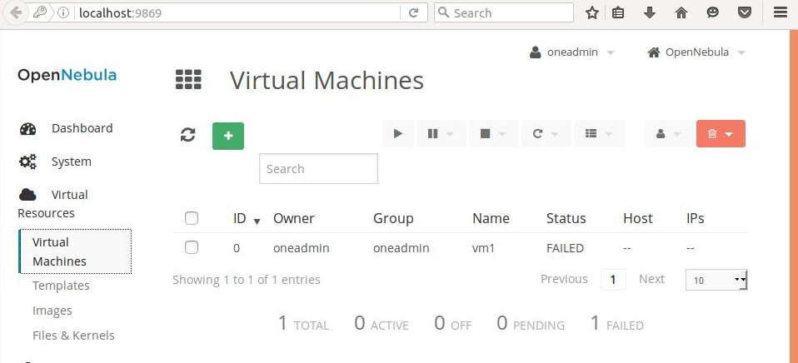

1. **Deploy and migrate the VM-** vm1 on host by specifying the vm id and host id.

###### $onevm deploy <vm-id> <host-id>

**$onevm migrate <vm-id> <host-**

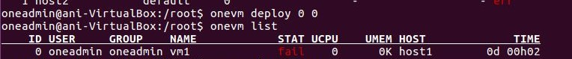Here, vm1 with id 0 is deployed on host 1 with id 0. host1 appears under the host column.

###### RESULT:

Thus, live migration of virtual machine is performed using Opennebula.