**BLIND WALK -IOT BASED SMART SHOE AND SPECS**

N.Duraimurugan 1, Janani Raghavan2, Janani Arumugam

Associate Professor, Department of Computer Science and Engineering, UG Scholar,

Department of Computer Science and Engineering

duraimurugan.n@rajalakshmi.edu.in 1,210701087@rajalaksmi.edu.in

2,210701085@rajalakshmi.edu.in 3

**ABSTRACT**

Eyesight is a precious gift, yet millions worldwide lack it, with 40 million in India alone, including 1.6 million children. To assist them, IoT-based Smart Shoe Systems and Smart Specs have emerged. These innovations, employing ultrasonic sensors and Arduino UNO boards, harness the power of IoT to empower the visually impaired. Smart Shoe Systems offer sustainable mobility solutions, embedded with sensors, Arduino technology, and buzzers, alerting wearers to obstacles with auditory cues, facilitating independent navigation. Similarly, Smart Specs enhance perception and navigation, featuring sensors and intelligent algorithms that deliver real-time audio or tactile feedback, aiding individuals with low vision in various environments. By leveraging cutting-edge technologies like smart shoes and glasses connected to the internet, we strive to create a more inclusive world. These smart shoes and specs ensure that they detect the objects that are present within a range of distance and in addition they provide these information to the mobile phones including voice notes.

These groundbreaking inventions not only enhance mobility for those with visual impairments but also foster independence and a sense of belonging. They enable individuals to navigate their surroundings more confidently, promoting self-sufficiency and empowerment. Through the integration of Bluetooth connectivity and smartphone apps, these assistive technologies take accessibility to new heights, offering tailored support and enhancing the quality of life for visually impaired individuals worldwide.

Keywords- Visual impairment,IoT-based Smart Shoe Systems,Smart Specs,Ultrasonic sensors,Arduino UNO boards, Real-time feedback.

# I. Introduction

Smart Shoe Systems, equipped with sensors and auditory alerts, offer long-term mobility solutions, enabling users to detect obstacles and navigate surroundings with newfound confidence. Similarly, Smart Specs utilize intelligent algorithms and sensory feedback to enhance perception and facilitate seamless navigation for those with low vision. Now, with the integration of Bluetooth connectivity, these assistive technologies take another leap forward, connecting seamlessly with companion smartphone apps. This integration enables the devices to communicate vital information about the surrounding environment directly to the user through speech synthesis. As obstacles are detected, the Smart Shoes and Smart Specs transmit real-time data to the smartphone app, which then translates this information into speech, providing users with instant auditory cues about the objects in their path. This innovative feature not only enhances mobility but also fosters a greater sense of independence and empowerment, allowing individuals with visual impairments to navigate their surroundings with dignity and autonomy.

II. Literature Survey

# 1. IoT based Smart Voice Controlled Blind Stick

In this study, a comprehensive solution is proposed to address the challenges faced by visually impaired individuals in navigating their surroundings safely and independently. By integrating advanced technologies such as ultrasonic sensors, infrared sensors, and voice control modules into a smart walking stick, the aim is to provide real-time obstacle detection and guidance. This approach builds upon previous research in the field, leveraging insights from existing smart stick designs to enhance functionality and usability. Through a thorough literature review, key features and limitations of current systems were identified, informing the design and development of the solution. By incorporating voice-controlled guidance and multiple sensor modalities, the smart stick offers a holistic approach to assist visually impaired users in detecting obstacles, navigating unfamiliar environments, and ensuring their safety. This study contributes to the ongoing efforts to improve accessibility and independence for individuals with visual impairments, addressing the growing need for reliable and user-friendly mobility aids in outdoor settings.

this study underscores the significance of leveraging emerging technologies to empower individuals with visual impairments, enabling them to navigate their surroundings with greater confidence and autonomy. By synthesizing insights from a diverse range of research efforts, including those focused on ultrasonic sensors, infrared technology, and voice-controlled interfaces, the proposed smart walking stick represents a promising advancement in assistive technology. Furthermore, the literature survey conducted as part of this study sheds light on the evolving landscape of mobility aids for the visually impaired, highlighting both the progress made and the remaining challenges to be addressed. Through continued innovation and collaboration within the research community, it is hoped that such solutions will continue to evolve, ultimately enhancing the quality of life for individuals with visual impairments worldwide.

1. IOT based Smart Shoe for the Blind

The proposed IoT-based smart shoe system addresses the pressing challenges faced by visually impaired individuals, especially in achieving mobility and independence. With approximately 40 million blind people in India, including 1.6 million children, there is a critical need for effective solutions. Traditional aids like white canes offer limited assistance, particularly in detecting obstacles while walking on roads. The smart shoe system offers a groundbreaking long-term solution for independent travel, utilizing IoT technology to embed sensors, microcontrollers, and buzzers into footwear.By integrating ultrasonic sensors paired with a servo motor, the shoes efficiently detect obstacles and provide real-time feedback to the user, enhancing safety and navigation. Piezoelectric panels embedded in the sole address common battery charging issues encountered in IoT devices, ensuring continuous functionality. Additionally, the smart glasses complement the shoes by extending obstacle detection range, maximizing efficiency, and coverage. These glasses, equipped with sensors, work seamlessly with the shoe system to enhance the user's ability to navigate safely.Cloud connectivity enables data transmission for further analysis, facilitating future advancements such as machine learning algorithms to automate indoor navigation. Real-time monitoring via cloud-based platforms enhances safety and provides peace of mind to both users and their guardians. Overall, the integrated smart shoe and glasses system represent a significant advancement in empowering visually impaired individuals to navigate their surroundings independently and confidently, thereby improving their quality of life and fostering greater inclusivity in society.

1. IOT Based Smart Security for the Blind.

The proposed IoT-based face detection system offers a comprehensive solution to the challenges of security and assistance for visually impaired individuals. It leverages advanced technologies such as machine learning and image processing to enable real-time recognition and alerting. Through the utilization of Raspberry Pi and a PI camera, the system captures live video, facilitating motion detection to identify potential intruders. Face detection and recognition are achieved through feature extraction and comparison with a stored database, employing techniques like principal component analysis (PCA) for dimension reduction. The system goes beyond mere face detection by enabling the differentiation between known and unknown individuals, enhancing security measures. Furthermore, an Android application integrates with the system, providing voice alerts to notify users about visitors at their door. By utilizing machine learning libraries like Scikit-learn and image processing libraries such as OpenCV, the system ensures efficient face recognition and classification. Additionally, APIs from Scikit-learn and OpenCV streamline model training and prediction processes, while Android Text to Speech library aids in speech synthesis for user notifications. In essence, the proposed system serves as a versatile and robust tool, addressing security concerns while providing invaluable assistance to visually impaired individuals, thereby fostering independence and safety in home environments.

1. Virtual Eye for Blind using IOT.

In this literature, a novel smart stick assistive navigation system is introduced to address the challenges faced by blind and visually impaired individuals during both indoor and outdoor travel. The prevalence of visual impairment, affecting over 1.3 billion people globally with more than 36 million classified as blind, underscores the urgent need for innovative solutions, particularly in countries like India, which accounts for a significant portion of the global blind population. By harnessing the capabilities of artificial intelligence, the system aims to provide a "secondary sight" to visually impaired individuals, enabling them to navigate their surroundings independently until comprehensive treatment options become available. The system integrates a camera and Raspberry Pi into a smart stick, effectively serving as a virtual eye by detecting obstacles and conveying crucial information to users through earphones. Furthermore, a sensor positioned at the bottom of the stick helps to avoid puddles, thereby enhancing safety. Advanced algorithms such as YOLO (You Only Look Once) and Dark Flow are utilized to achieve efficient object detection, while GPS technology assists in optimizing routes. The primary objective of the system is to empower visually impaired individuals to lead independent lives by providing them with a reliable and user-friendly navigation aid. This innovative system represents a significant advancement in assistive technology, offering real-time assistance and enhancing the quality of life for the visually impaired community.

1. .IOT based Assistive Device for Deaf,Dumb and Blind People.

Focusing on addressing the challenges encountered by differently abled individuals, including those with visual, auditory, and speech impairments, through a unified device presents a significant endeavor. While considerable research has been conducted on each of these challenges independently, there remains a gap in providing integrated solutions. The primary objective of this project is to develop a single-device solution that is simple, efficient, accurate, and cost-effective, aiming to instill independence and confidence in differently abled individuals by facilitating sight, hearing, and communication. This paper introduces a Google API and Raspberry Pi-based assistive device tailored for the blind, deaf, and mute population.

For individuals with visual impairments, the proposed device facilitates reading by capturing images of text, converting them into digital text using the Google Vision API, and synthesizing the extracted text into audio format for auditory playback. Auditory impairments are addressed by converting spoken input captured via a microphone into text, which is then displayed as a pop-up window on the device screen for the user to read. Speech-impaired individuals are assisted through a customized on-screen keyboard, allowing them to input text, which is then converted into speech output by the device's text-to-speech (TTS) functionality.

# 6. IoT Enabled Intelligent Stick for Visually Impaired People for

# Obstacle Recognition.

Assistive technologies tailored for the visually impaired encompass a broad spectrum of innovations aimed at enhancing independence and accessibility. These solutions often leverage ultrasonic sensors and microcontrollers to detect obstacles, providing tactile or auditory feedback to users. Additionally, navigation apps are prevalent, utilizing GPS technology to offer real-time guidance and location information audibly. Emerging wearable devices integrate cameras and sensors to aid navigation and object recognition. Object recognition systems further enhance accessibility by identifying objects and text in the user's environment. Braille displays and readers remain integral, with digital advancements enabling dynamic Braille content. The field continually evolves, emphasizing the integration of sensors, GPS, and wearables to improve the quality of life for visually impaired individuals. Recent trends also include the development of AI-powered systems for enhanced object recognition and contextual understanding, opening new possibilities for assistive technologies in this domain. As technology advances, there is a growing focus on user-centered design and seamless integration into daily life, ensuring that visually impaired individuals can navigate the world with greater confidence and independence.

7. LOW-COST Smart Shoe for Visually impaired

This project aims to develop an electronically aided shoe to assist visually impaired individuals in navigating their surroundings more safely. Visually impaired individuals face significant challenges when traveling independently, often encountering obstacles that can lead to accidents or injuries. While traditional white canes are commonly used for guidance, this project introduces a smart shoe equipped with advanced sensors for enhanced efficiency and effectiveness. The shoe incorporates ultrasonic sensors to detect obstacles within a certain range and promptly alerts the wearer through audio or vibration signals. This real-time feedback helps visually impaired individuals identify obstacles in their path and avoid potential discomfort or harm. The proposed smart shoe integrates ultrasonic sensors, an Arduino Nano microcontroller, and a buzzer to detect obstacles and alert visually impaired users. Ultrasonic sensors emit and receive ultrasonic waves to measure distances and detect nearby obstacles. The Arduino Nano processes sensor data and triggers the buzzer to emit alerts when obstacles are detected within a certain range. This real-time feedback enables visually impaired individuals to navigate their surroundings more confidently and safely. The smart shoe design emphasizes ease of use, reliability, and adaptability to different environmental conditions.

# III. Limitations in Existing System

The existing IoT-based Smart Shoe Systems and Smart Specs have significantly enhanced mobility and independence for visually impaired individuals.. However, these systems often come with a set of limitations such as,

1. Range limitations
2. Environmental Adaptability
3. Battery life
4. User interface complexity
5. Cost Accessibility

These are few limitations faced in real-time and to address these issues, we propose a model that consolidates all essential features into a single, more affordable system, providing a comprehensive solution for Blind people.

Moreover, interoperability issues between different IoT devices and platforms can hinder the seamless integration and functionality of smart shoes and specs with other assistive technologies or IoT ecosystems. Incompatibilities in communication protocols, data formats, or device interfaces may prevent these devices from exchanging data or coordinating effectively with other systems, limiting their overall utility and interoperability.Additionally, concerns about battery life and power consumption remain relevant for IoT-based assistive devices. Smart shoes and specs rely on battery power to operate sensors, wireless communication modules, and other electronic components. Prolonged battery life and efficient power management are essential to ensure uninterrupted operation and minimize the need for frequent recharging or replacement of batteries, particularly for users who rely heavily on these devices for daily activities.

.

# IV. Proposed System

The BLIND WALK includes two devices one is smart shoe and other one is the smart spectacle. It aims at detecting obstacles and provides auditory alerts through embedded buzzers . These empower the users to navigate their surroundings independently and safely. By providing realtime audio or tactile feedback, they assist users in navigating diverse environments with confidence and ease. By harnessing the power of the internet and cutting-edge technologies, such as smart shoes and glasses, we can create a more inclusive world.

The proposed sytstems empower users that is visually impared people to navigate their surroundings independently enhancing their sense of freedom and autonomy.Navigating environments without adequate visual cues can pose significant safety risks . By detecting the oresence of objects using these devices may help avoid accidents and navigate safely.Accessing information about ones's surrounding is crucial for individuals with visual impairmenys to make informed decisions and navigate effectively.This model reduces the reluctance of visually impared people by not socializing them. It may boost user's confidence by providing reliable navigation support and promote self reliance.With millions of individuals worldwide experiencing visual impairment, there is a pressing need for innovative solutions that can scale and address diverse needs.

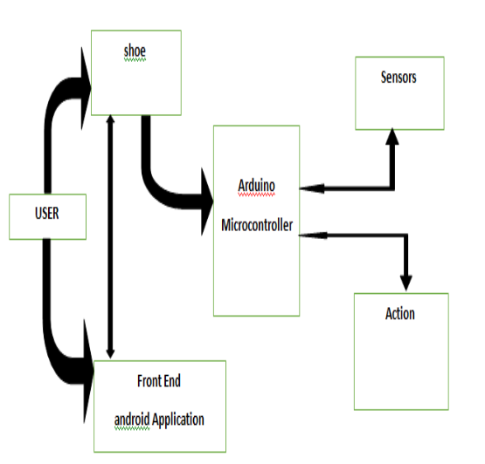

## Figure 1: System Architecture

This setup additionally incorporates UART hardware, enabling connectivity between your mobile device and the system via Bluetooth. This connection allows users to receive alerts and warnings directly on their mobile phones.. In summary, these functionalities play a significant role in preventing accidents and improving safety on the road.

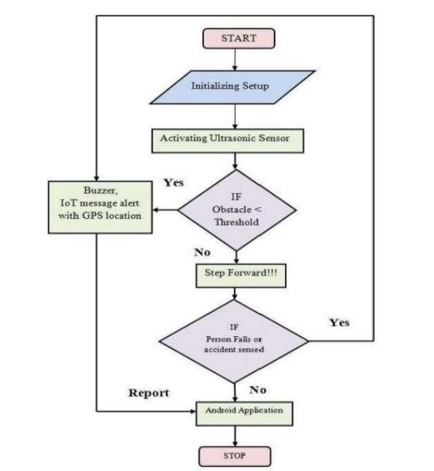

**Figure 2: Data Flow Diagram**

V. Work Process

# 1. Sensor Technology:

The work process begins with the integration of advanced sensor technology into the design of the smart shoe. Engineers meticulously select and install sensors capable of detecting obstacles at ground level, ensuring comprehensive coverage of the user's surrounding environment. These sensors function akin to miniature eyes, continuously scanning the area for potential obstructions such as walls, objects, or people.

Once the sensors are selected, they are strategically integrated into the smart shoe design. This involves carefully placing the sensors in key locations on the shoe to maximize their effectiveness in detecting obstacles

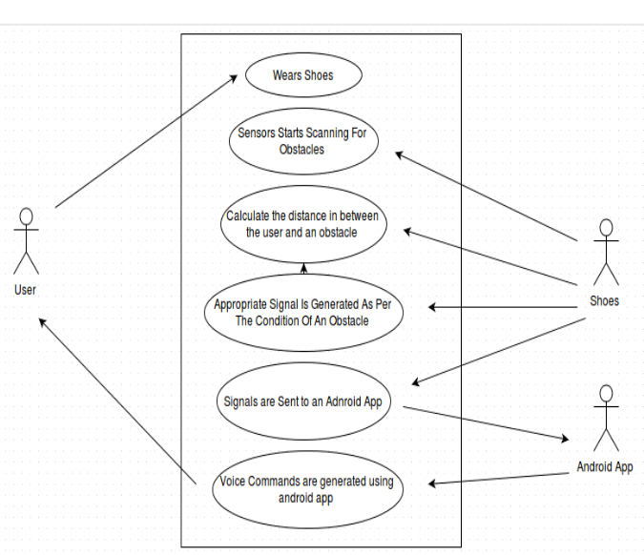

**Figure 3: Usecase Diagram**

# 2. Arduino UNO Board Setup:

Once the sensors are in place, attention turns to the implementation of the Arduino UNO board, a powerful microcontroller that serves as the central processing unit of the smart shoe. Engineers program the Arduino board to receive input from the sensors, process this data using sophisticated algorithms, and make autonomous decisions based on the detected obstacles. This intelligent processing capability enables the smart shoe to operate seamlessly and respond promptly to potential hazards.

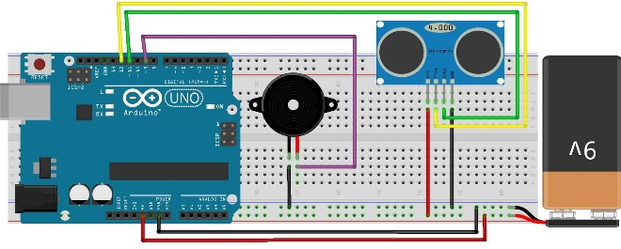

**Figure 4: Arduino board setup**

The Arduino UNO board serves as the central processing unit within the smart shoe and specs due to its versatility, reliability, and computational power. Its primary function is to receive data from various sensors embedded within the footwear, including ultrasonic sensors for obstacle detection.Once the Arduino UNO board receives sensor data, it executes intelligent algorithms programmed to analyze this information in real-time. These algorithms are designed to interpret the sensor readings, identify potential obstacles such as walls or objects, and determine the appropriate response based on pre-defined parameters.The board's computational capabilities enable it to make rapid decisions about how to alert the user to detected obstacles.

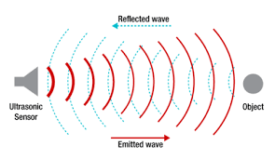

**Figure 5: Ultrasonic wave configuration**

# 3. Buzzer Alerts:

When an obstacle is detected in close proximity by the sensors embedded within the smart shoe and specs, a built-in buzzer discreetly positioned within the footwear emits a distinctive sound, instantly capturing the user's attention. This audible alert acts as a crucial warning signal, providing invaluable cues to the user about potential obstructions in their path. By promptly alerting the user to the presence of obstacles, the buzzer alerts serve as a proactive safety measure, enabling individuals with visual impairments to take immediate and appropriate action to avoid potential collisions or accidents. This real-time feedback mechanism enhances the user's situational awareness and promotes confident navigation in various environments. Furthermore, the discreet placement of the buzzer within the shoe and specs ensures minimal disruption to the user's mobility experience while effectively conveying essential information about their surroundings.

# 4. Bluetooth Connectivity:

The integration of Bluetooth technology in the smart shoe and specs serves a crucial purpose in enhancing user experience and safety. By establishing a wireless connection with a companion smartphone app, these devices enable seamless communication and data exchange. This connectivity enables the smart shoe and specs to transmit real-time information about detected obstacles directly to the user's smartphone, ensuring prompt awareness of the surroundings.

The Bluetooth connection works by establishing a short-range wireless link between the smart shoe, specs, and the smartphone. Once paired, the devices can exchange data efficiently and effectively. When the sensors detect obstacles in close proximity, they send signals to the microcontroller, which then relays this information to the smartphone via Bluetooth. The companion app interprets these signals and generates alerts or notifications to alert the user about the detected obstacles.

This technology works by utilizing radio waves to transmit data over short distances, typically up to 30 feet. Bluetooth operates on the 2.4 GHz frequency band and employs frequency hopping to minimize interference and ensure secure communication. By leveraging Bluetooth connectivity, the smart shoe and specs provide users with real-time updates about their environment, empowering them to navigate safely and confidently.

5. Companion Smartphone App

The Companion Smartphone App functions as a centralized hub for users to interact with their smart shoe and specs, enhancing their navigation experience and overall safety. Upon downloading and installing the dedicated app on their smartphone, users initiate the pairing process, establishing a connection between their mobile device and the smart shoe or specs.Once paired, the app continuously receives real-time data and alerts from the smart shoe and specs regarding detected obstacles in the user's surroundings. This information is relayed to the app via Bluetooth connectivity, ensuring prompt updates and notifications.The app's intuitive interface allows users to customize settings according to their preferences, such as adjusting alert frequencies or modifying notification preferences. Additionally, users can access detailed information about detected obstacles, including their location and proximity to the user.Through the app, users can receive informative alerts in various formats, such as audible notifications or visual indicators. These alerts provide users with vital insights into their surroundings, empowering them to navigate safely and confidently.

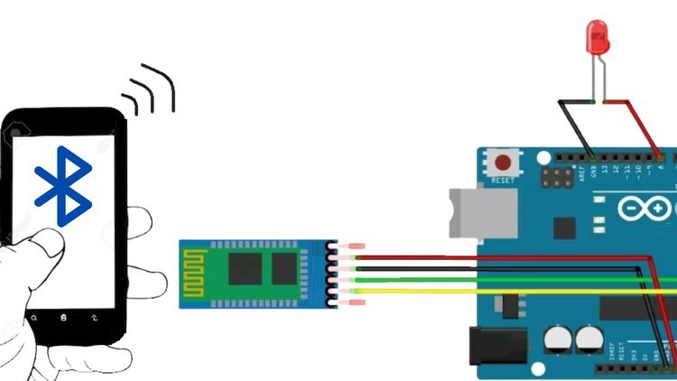

**Figure 6: Bluetooth configuration**

6.Voice Note Generation

The Voice Notes Generation feature of the companion smartphone app plays a crucial role in enhancing the user's navigation experience with the smart shoe and specs. When the app receives data from the smart shoe and specs regarding detected obstacles, it employs intelligent algorithms to generate personalized voice messages tailored to the user's specific needs.To begin, the app interprets the incoming data, which includes information about the type and location of detected obstacles. Using this data as input, the app generates voice messages that succinctly describe the nature of the obstacle and its proximity to the user.Once the voice messages are generated, they are delivered to the user through the smartphone's audio output. Users receive real-time auditory cues about the obstacles in their surroundings, enabling them to navigate safely and confidently.

# VI. Future Enhancements

One potential enhancement for the smart shoe and specs involves incorporating waterproof materials and sealing mechanisms into their construction. This enhancement would make the devices more resilient to water damage, allowing users to confidently navigate in various weather conditions without worrying about moisture affecting their functionality. Integrating cameras into the smart shoe and specs could enable advanced object recognition capabilities. By capturing images of the surrounding environment, the devices could leverage machine learning algorithms to identify and classify objects in real-time. This enhancement would provide users with detailed information about the objects detected, enhancing their situational awareness and navigation experience. Future iterations of the smart shoe and specs could feature enhanced connectivity options, such as support for 5G networks or Wi-Fi 6. These advancements would enable faster data transmission between the devices and the companion smartphone app, ensuring seamless communication and real-time updates for users. Implementing a voice-controlled interface would offer users a hands-free way to interact with the smart shoe and specs. By integrating voice recognition technology, users could issue commands and access information using voice commands, enhancing convenience and accessibility for individuals with visual impairments. ptimizing the battery life of the smart shoe and specs would extend their usage time and reduce the need for frequent recharging. This could be achieved through the use of energy-efficient components, advanced power management algorithms, and rapid charging technologies.

# VII. Results and Discussions

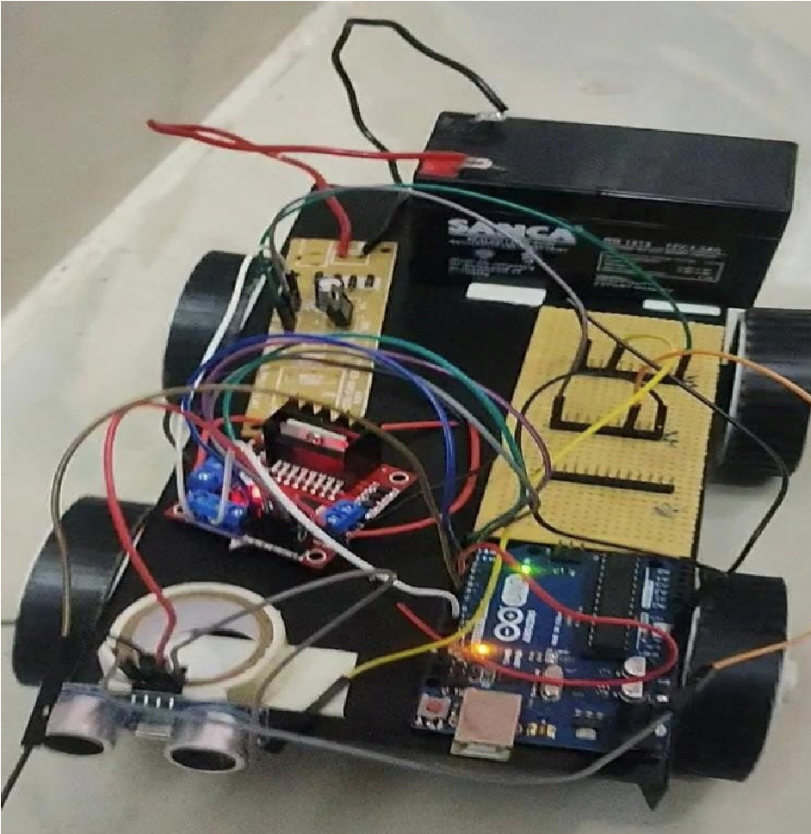

## Figure 7: Implementation

The proposed system integrates UV sensors into both the smart shoes and glasses, strategically positioned to provide full coverage around the user. These sensors continuously monitor the surroundings and generate real-time data, enabling the detection of obstacles from all directions. By leveraging UV sensor technology, the system effectively identifies nearby objects and vehicles, including cars and motorcycles, thereby enhancing the user's situational awareness and safety. Furthermore, the system incorporates advanced algorithms to calculate the speed and distances of nearby vehicles, enabling proactive collision prevention measures. By analyzing the sensor data and image inputs, the system can accurately estimate the trajectory and proximity of surrounding vehicles, providing timely alerts to the user through auditory or tactile feedback. This proactive approach significantly reduces the risk of accidents and enhances the user's confidence in navigating their surroundings independently.of nearby vehicles.

# VIII. Conclusion

In conclusion, the proposed system presents a promising solution for enhancing the mobility and safety of blind or visually impaired individuals. By leveraging advanced technology, including obstacle detection sensors and real-time alert mechanisms, the system enables users to navigate their surroundings independently while providing peace of mind to their guardians. The inclusion of objectives such as edge sensitivity, voice alerts, and AI-based object identification demonstrates the commitment to continuously improving the system's functionality and effectiveness.

# References

[2] Feng Lan, Guangtao Zhai, Wei Lin “Lightweight smart glass system

with audio aid for visually impaired people” ,IEEE conference, 2016.

[3] Tan, Bo; Woodbridge, Karl; Chetty, Kevin "A real-time high resolution

passive WiFi Doppler-radar and its applications", Radar Conference

(Radar), 2014 International, On page(s): 1 - 6

[4] Brunner, Eberhard, “Ultrasound System Considerations and their

Impact on Front-End Components,” Analog Devices, Inc., 2002,

http://www.analog.com/library/analogDialogue/archives/36-

03/ultrasound/UltrasoundFrontend.pdf

[5] Shinnosuke Hirata1, Minoru Kuribayashi Kurosawa and Takashi

Katagiri, "Accuracy and resolution of ultrasonic distance measurement with

high-time-resolution cross-correlation function obtained by single- bit

signal processing", Acoust. Sci. & Tech. 30, 6 (),The Acoustical Society of

Japan. 2009

[6] Mohan Kumar Ch, Shaik Shahbaz, Manikanta Varma, Tanu Shri,

International Journal of Mechanical Engineering and Technology (IJMET)

Volume 8, Issue 12, December 2017, pp. 529–535, Article ID:

IJMET_08_12_053

[7] R.L.R. Lokesh Babu, D Rambabu, A. Rajesh Naidu, R. D. Prasad, P.

Gopi Krishna , IoT Enabled Solar Power Monitoring System, International

Journal of Engineering &Technology, 7 (3.12) (2018) 526-530

[8] M. Chandan, Srinivas.Malladi*, M. Nishitha, K. Sindhu Priya, Y. Sree

Lekha, Automatic gas booking system using IoT, International Journal of

Engineering & Technology, 7 (2.8) (2018) 235-238

[9] Saranyakumar Chigurupati Ravi Teja Vallamsetti Yogesh Misra

Ragipati Karthik Intelligent vehicle pollution monitoring using IoT,

International Journal of Engineering & Technology 7 (2.7) (2018) 376-378

[10] P. Gopi Krishna, K. Sreenivasa Ravi, K Hari Kishore, K KrishnaVeni,

K. N. Siva Rao, R. D. Prasad, Design and development of bi-directional

IoT gateway using ZigBee and Wi-Fi technologies with MQTT protocol,

International Journal of Engineering & Technology, 7 (2.8) (2018) 125-129

[11] A. Gopi *, M. Kameswara Rao , Survey of privacy and security

issues in IoT, International Journal of Engineering & Technology, 7 (2.7)

(2018) 293-296

[12] P.Gupta,KVV Satyanarayan, DD Shah, IoT multitasking:

Development of hybrid execution service oriented architecture (HESOA) to

reduce response time for iot application, Journal of Theoretical and Applied

Information Technology 96(5):1398-1407

[13] Ahmad Roihan, Tri Kuntoro Priyambodo, Ahmad Ashari, "A Survey

on Protocols for Internet of Things", Science and Technology (ICST) 2019

5th International Conference on, vol. 1, pp. 1-6, 2019.

[14] Sarah Jaafari, Areej Alhasani, Ebtihal alghosn, Rehab alfahhad, Saad

M Almutairi, "Certain Investigations on IoT system for COVID19", Computing and Information Technology (ICCIT-1441) 2020

International Conference on, pp. 1-4, 2020.

[15] N. Naik, "Choice of effective messaging protocols for iot systems:

Mqtt coap amqp and http", 2017 IEEE international systems engineering

symposium (ISSE). IEEE, pp. 1-7, 2017.