SIMATS ENGINEERING
ASSESSMENT TOOL 1

COURSE NAME: Artificial Intelligence COURSE CODE: CSA17

COURSE OUTCOME COVERED
CO1: Apply AI basics such as intelligent agents and uninformed search methods to solve problems effectively. (BL3)
Assessment Tool Weightage: 50%

QUESTIONS: 5 Duration : 1 Hour
Total Marks:50
Annexure A
Analytical Problem Solving

Code of Conduct:
I JANANI.K [192511243] certify that this submission is my original work and that I have adhered to the guidelines specified for this assessment.
I understand that any violation of academic integrity rules will result in disciplinary action.
Signature of the student:
Annexure A
Analytical Problem Solving
- Solve the Water Jug problem: you are given 2 jugs, a 4-gallon one and 3-gallon one. Neither has any measuring maker on it. There is a pump that can be used to fill the jugs with water. How can you get exactly 2 gallons of water into 4-gallon jug? Explicit assumptions: A jug can be filled from the pump, water can be poured out of a jug onto the ground, water can be poured from one jug to another and that there are no other measuring devices available.
Sure. For a 50-mark assessment, your answer should be detailed but not overly lengthy. Below is a concise, exam-ready version that still satisfies the rubric.

Water Jug Problem

1. Problem Understanding
Two jugs are given:
- 4-gallon jug (A)
- 3-gallon jug (B)
Allowed operations:
- Fill a jug completely.
- Empty a jug.
- Pour water from one jug to another.
Initial State: (0,0)
Goal State: Obtain exactly 2 gallons in the 4-gallon jug, i.e., (2,0).

2. Method Selection
Method Used: State Space Search using Breadth-First Search (BFS).
Reason:
Each water arrangement is treated as a state. BFS explores all possible states level by level and guarantees finding the goal state.

3. Solution Process
Step | Action | State (4G, 3G)
Initial | Both jugs empty | (0,0)
1 | Fill the 3G jug | (0,3)
2 | Pour 3G into 4G | (3,0)
3 | Fill the 3G jug again | (3,3)
4 | Pour from 3G to 4G until 4G is full | (4,2)
5 | Empty the 4G jug | (0,2)
6 | Pour the remaining 2 gallons into 4G | (2,0)

4. State Diagram
(0,0)
|
Fill 3G
|
(0,3)
|
Pour to 4G
|
(3,0)
|
Fill 3G
|
(3,3)
|
Pour to 4G
|
(4,2)
|
Empty 4G
|
(0,2)
|
Pour to 4G
|
(2,0) ← Goal State

5. Interpretation
The Water Jug problem is solved using State Space Search (BFS). By applying the allowed operations systematically, the goal state (2,0) is reached, which means the 4-gallon jug contains exactly 2 gallons.

Final Answer
- Initial State: (0,0)
- Goal State: (2,0)
- Method Used: State Space Search (BFS)
- Final Path:
(0,0) → (0,3) → (3,0) → (3,3) → (4,2) → (0,2) → (2,0)
This version is the right length to score well according to the rubric while fitting comfortably into an assessment booklet.

- Find out how Mars Rover, analyse and explore the samples on Mars by answering the following questions.
i. What are the percept’s for this agent? ii. Characterize the operating environment. iii. What are the actions the agent can take? iv. How can one evaluate the performance of the agent?
v. What sort of agent architecture do you think is most suitable for this agent? Why?

Mars Rover Intelligent Agent

Problem Understanding
A Mars Rover is an autonomous intelligent agent that explores the surface of Mars, collects rock and soil samples, analyzes them, avoids obstacles, and sends scientific data back to Earth.

i. What are the percepts for this agent?
Percepts are the inputs received by the rover through its sensors.
- Camera images of the surroundings
- Rock and soil characteristics
- Temperature and weather conditions
- Distance to obstacles
- Battery level
- Position and direction
- Radiation levels
These percepts help the rover understand its environment and make decisions.

ii. Characterize the Operating Environment
Property | Description
Observability | Partially Observable
Agents | Single Agent
Deterministic | Stochastic
Episodes | Sequential
Dynamics | Dynamic
State Space | Continous

The Mars environment is uncertain and continuously changing, so the rover must adapt based on sensor inputs.

iii. What actions can the agent take?
- Move forward, backward, left, and right
- Capture images
- Collect rock and soil samples
- Analyze samples
- Avoid obstacles
- Send data to Earth
- Recharge using solar energy
These actions help the rover safely explore Mars and complete its scientific mission.

iv. How can one evaluate the performance of the agent?
The rover's performance is evaluated based on:
- Number of samples collected successfully
- Accuracy of sample analysis
- Safe navigation without collisions
- Efficient battery usage
- Distance explored
- Successful transmission of data to Earth
- Completion of mission objectives

v. What sort of agent architecture is most suitable? Why?
Model-Based Goal-Based Agent
Reason:
- Maintains an internal model of the environment.
- Plans actions to achieve mission goals.
- Works effectively in a partially observable environment.
- Adapts to changing conditions while making intelligent decisions.

Interpretation
The Mars Rover functions as an intelligent autonomous agent that senses its environment, plans its actions, collects scientific data, and sends the information to Earth. A Model-Based Goal-Based Agent is the most suitable architecture because it can operate efficiently in the uncertain and dynamic environment of Mars.

- Explore the search space using search strategies and formulate the problem components for the 8-Queens problem using the following information: Place 8 queens on a chessboard such that none of the queen’s attack any of the others. A configuration of 8 queens on the board as shown in the figure below, but this does not represent a solution as the queen in the first column is on the same diagonal as the queen in the last column.

8-Queens Problem

Problem Understanding
The objective is to place 8 queens on an 8 × 8 chessboard such that no two queens attack each other.
A queen can attack:
- Horizontally (same row)
- Vertically (same column)
- Diagonally
The given configuration is not a solution because the queen in the first column attacks the queen in the last column diagonally.

Method Selection
Search Strategy: State Space Search using Backtracking (Depth-First Search)
Reason:
Backtracking places one queen at a time. If a queen attacks another queen, it backtracks and tries a different position. This reduces unnecessary search.

Problem Formulation
Initial State:
An empty chessboard with no queens placed.
State:
A state represents the placement of queens on the chessboard.
Operators:
- Place one queen in the next column.
- If a conflict occurs, remove the queen and try another row.
Goal State:
Place all 8 queens such that:
- No two queens are in the same row.
- No two queens are in the same column.
- No two queens are on the same diagonal.
Path Cost:
Each queen placement has a cost of 1.

Solution Process
- Start with an empty chessboard.
- Place the first queen in the first column.
- Move to the next column and place a queen in a safe row.
- Continue placing queens one column at a time.
- If no safe position is available in a column, remove the previously placed queen and try another position (Backtracking).
- Repeat the process until all 8 queens are placed safely.

Search Space
Without constraints:
Total possible states = 8⁸ = 16,777,216
Backtracking eliminates invalid states and reduces the search space significantly.

Interpretation
The 8-Queens Problem is a Constraint Satisfaction Problem (CSP). Backtracking efficiently explores the search space by placing queens one by one and removing invalid configurations. A solution is reached when all eight queens are placed without attacking each other.

Final Answer
- Problem Type: Constraint Satisfaction Problem (CSP)
- Search Strategy: Backtracking (Depth-First Search)
- Initial State: Empty 8 × 8 chessboard
- Operators: Place one queen per column and backtrack if conflicts occur
- Goal State: All 8 queens placed without sharing the same row, column, or diagonal
- Search Space: 8⁸ = 16,777,216 possible states (reduced using backtracking)

- A customer wants to travel from the one location to another location using OLA Cab booking mobile application. The customer can select the any of the cab type as mini, micro, sedan, shared, prime and so on based on his comfort to reach the destination. Identify what type of problem-solving agent can be used and write the pseudocode for the above problem.

OLA Cab Booking Problem

Problem Understanding
A customer wants to travel from one location to another using the OLA Cab Booking application. The customer can choose different cab types such as Mini, Micro, Sedan, Shared, or Prime based on comfort and availability.

Type of Problem-Solving Agent
Goal-Based Agent
Reason:
A Goal-Based Agent selects the best action to achieve a specific goal. In this case, the goal is to book the most suitable cab and reach the destination safely and efficiently.

Solution Process
- The customer enters the pickup location and destination.
- The application displays the available cab types.
- The customer selects a preferred cab based on comfort and fare.
- The system checks the availability of drivers.
- If a driver is available, the nearest driver is assigned.
- The booking is confirmed, and the trip begins.
- The customer reaches the destination, and the payment is completed.

Pseudocode
BEGIN

Input Pickup_Location
Input Destination

Display available cab types
(Mini, Micro, Sedan, Shared, Prime)

Customer selects cab type

Check driver availability

IF driver is available THEN
Assign nearest driver
Calculate fare
Confirm booking
Start trip
Reach destination
Generate bill
ELSE
Display "No cab available"
ENDIF

END

Interpretation
The Goal-Based Agent is suitable because it evaluates the customer's destination and preferences, selects the appropriate cab, and successfully completes the journey by achieving the desired goal.

Final Answer
- Problem-Solving Agent: Goal-Based Agent
- Goal: Book a suitable cab and reach the destination.
- Inputs: Pickup location, destination, cab type.
- Output: Cab booking confirmation and successful trip completion.

- A logistics company operates a delivery network where packages must be transported between warehouses at minimum cost. Each route between warehouses has an associated travel cost (fuel + time). The company wants to determine the least-cost path from the starting warehouse S to the destination warehouse G using the Uniform Cost Search (UCS) algorithm.
The delivery network is represented as a weighted graph:
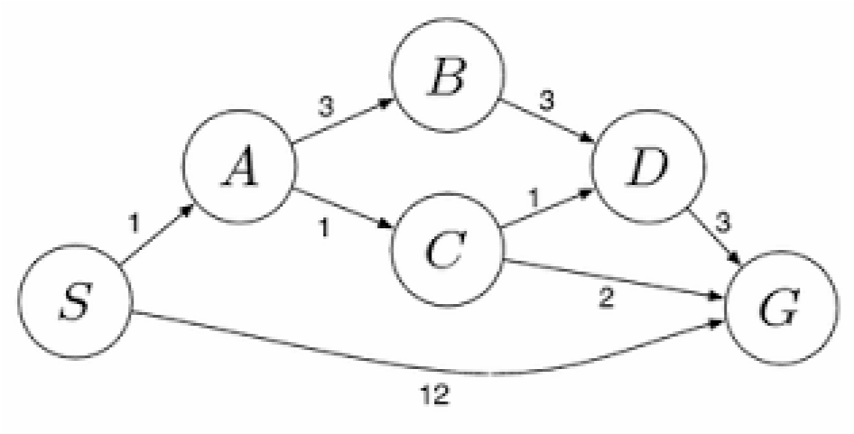

Question 5: Uniform Cost Search (UCS)

Problem Understanding
A logistics company wants to transport packages from the starting warehouse (S) to the destination warehouse (G) with the minimum travel cost. Each route has a cost representing fuel and travel time.

Method Selection
Algorithm Used: Uniform Cost Search (UCS)
Reason: Uniform Cost Search always expands the node with the lowest cumulative cost, ensuring the least-cost path is found.

Solution Process
Step 1: Start at node S
Node | Cost
S | 0
Expand S.
Possible paths:
- S → A = 1
- S → G = 12
Frontier:
Node | Cost
A | 1
G | 12
Expand A because it has the lowest cost.
Step 2: Expand A
Possible paths:
- S → A → B = 1 + 3 = 4
- S → A → C = 1 + 1 = 2
Frontier:
Node | Cost
C | 2
B | 4
G | 12
Expand C because it has the lowest cost.
Step 3: Expand C
Possible paths:
- S → A → C → D = 2 + 1 = 3
- S → A → C → G = 2 + 2 = 4
Frontier:
Node | Cost
D | 3
B | 4
G | 4
G | 12
Expand D because it has the lowest cost.
Step 4: Expand D
Possible path:
- S → A → C → D → G = 3 + 3 = 6
Frontier:
Node | Cost
B | 4
G | 4
G | 6
G | 12
The next node with the minimum cost is G (Cost = 4). Since G is the goal node, the search stops.

Search Tree
S (0)
├── A (1)
│ ├── B (4)
│ └── C (2)
│ ├── D (3)
│ └── G (4) ✓
└── G (12)

Least-Cost Path
S → A → C → G

Cost Calculation
- S → A = 1
- A → C = 1
- C → G = 2
Total Cost = 1 + 1 + 2 = 4

Interpretation
Uniform Cost Search expands nodes in increasing order of cumulative cost and guarantees the optimal (least-cost) path.

Final Answer
- Algorithm Used: Uniform Cost Search (UCS)
- Least-Cost Path: S → A → C → G
- Minimum Cost: 4
RUBRICS FOR CALCULATION:
Criteria | Weightage | Level 4 (Exemplary) | Level 3 (Proficient) | Level 2 (Developing) | Level 1 ( Beginning )
Problem  Understanding | 20% | Clearly interprets problem,  identifies all  parameters and requirements accurately | Understands problem with minor gaps | Partial understanding; misses key elements | Misinterprets or unable to  understand  problem
Method Selection | 20% | Selects most appropriate method/formula with strong justification | Selects correct method with minor errors | Inappropriate or  partially correct  method | Unable to select method
Solution  Process | 25% | Logical, systematic steps with correct approach throughout | Mostly correct steps with minor mistakes | Disorganized steps; multiple errors | No clear process
Accuracy of Calculation | 20% | All calculations accurate; correct final  answer | Minor calculation errors | Frequent errors;  incorrect final  answer | No valid calculations
Interpretation of Results | 15% | Clearly interprets results with units and engineering relevance | Basic interpretation with minor omissions | Limited or unclear interpretation | No  interpretation
Problem  Understanding | 20% | Clearly interprets problem,  identifies all  parameters and  requirements  accurately | Understands problem with minor gaps | Partial understanding; misses key elements | Misinterprets or unable to  understand  problem

