**Final Project Documentation**

**Project name – Fitness Club App for fitness club members**

**Objective:**

The main motto of this project is to use and learn more features in Android which was established successfully.

**Basic Concept behind this app:**

Every one are health consious nowadays which leads them to take a fitness club membership. In that motto, an app was designed in android where a fitness club members are entitled to use the app offered by their corresponding fitness club in which they are enrolled.

**Features of this app:**

After a through research about the other fitness club apps, we came to a conclusion to offer these below mentioned features for the fitness club members.

1. BMI Calculator – Designed to calculate the body mass index based on the user’s weight and the height. This feature enables the users to check whether they maintain a perfect fitness level. This was basically integrated to reduce the manual work of the users to calculate manually or to check online.
2. Tip of the day – This feature was implemented to give few health tips for the users to be followed on daily basis.
3. Activities of the fitness club – This feature provides the members to know the various activites which are scheduled to take place the following week.
4. Tracker – This is an analytic chart to track the user’s fitness level based on their efforts.
5. Contact your instructor – This feature gives the user about their instructor’s personal details such as name, phone number and contact address.
6. Diet Chart – This feature is a personalised diet chart prepared for the users by their dietcians. This will provide a check list of the food items the users can have for their week in a schedule format.

**Screenshots:**

Launcher icon showing the fitness club app symbol

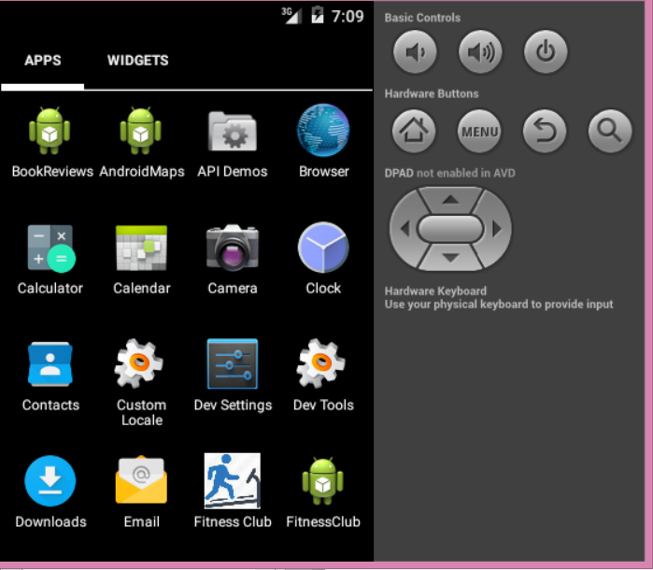

On click of the launcher icon – the user’s signin/ signup page arrives

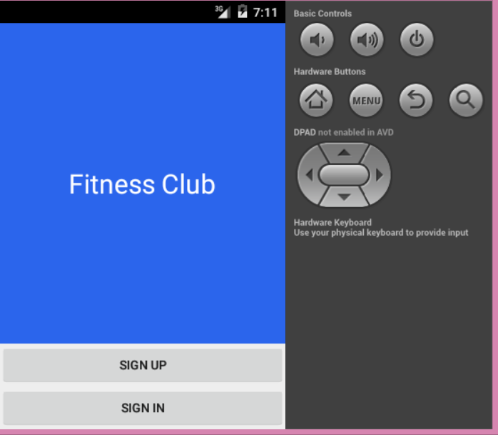

Onclick of the sign up page for the new users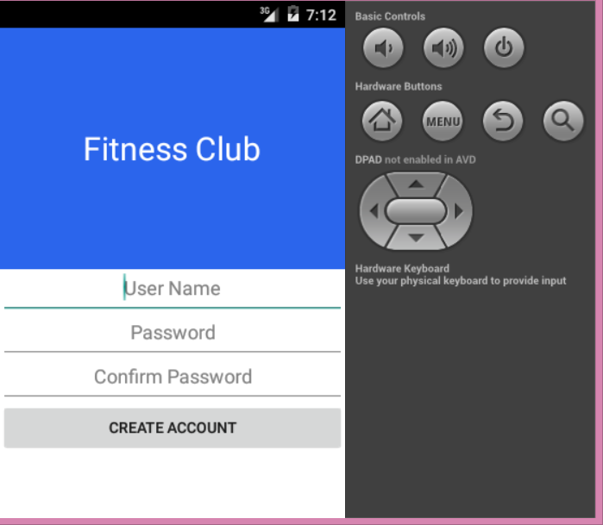

Onclick of the sign in page from the main page, this login in page arrives for the existing users

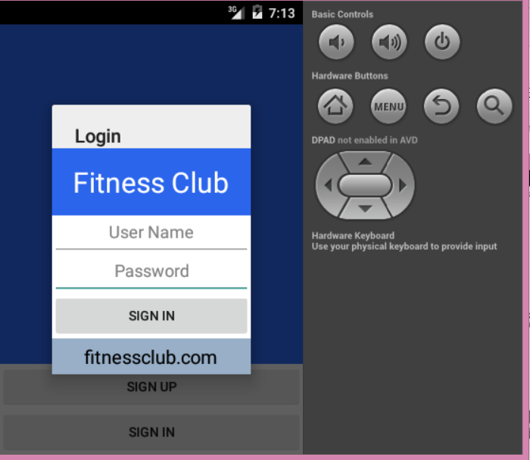

Error message to indicate the wrong credentials

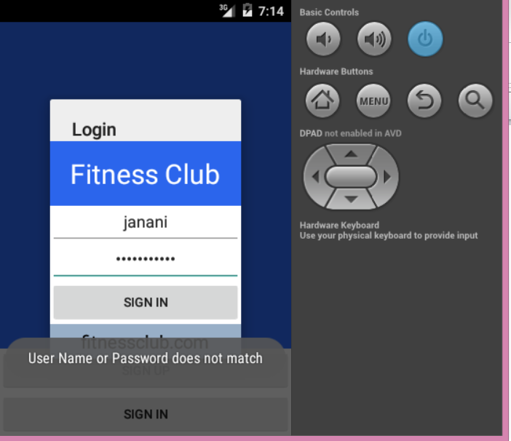

On successful signin, the toast message popups

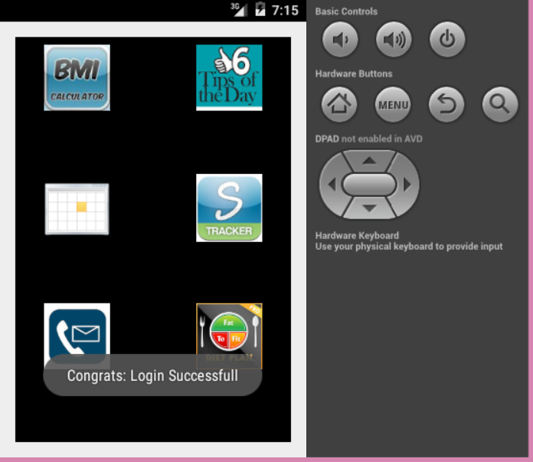

On successful signin, the main home page of the app

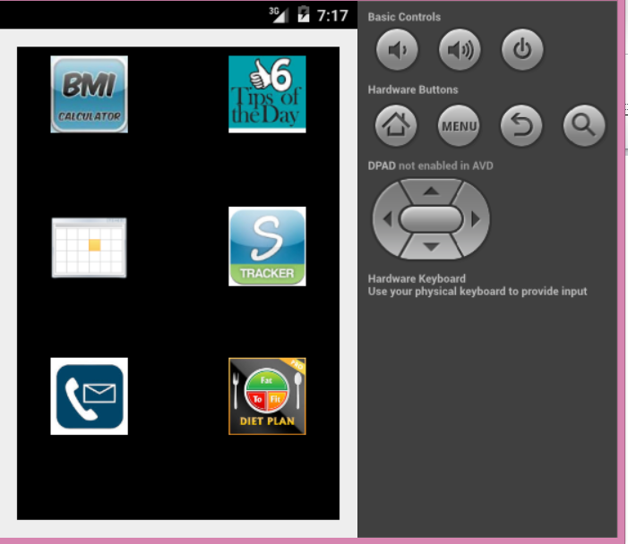

On click of the 1st icon – BMI calculator in the home page from the home page grid view

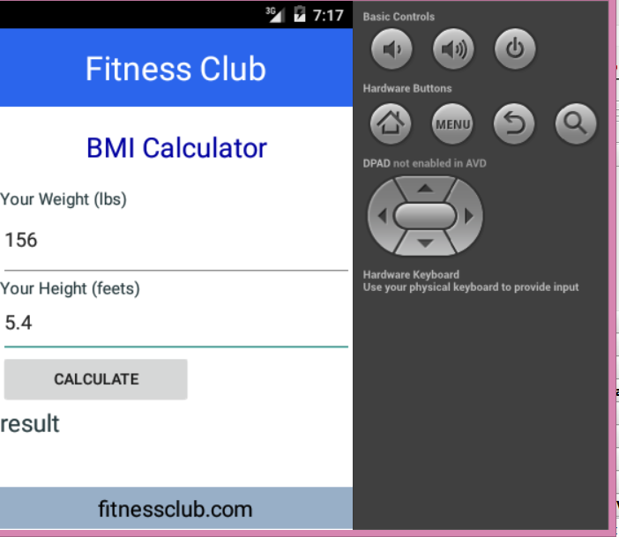

On click of the calculate button in the BMI calculator, it gives the result based on their height and weight. – Over weight, Underweight, Normal

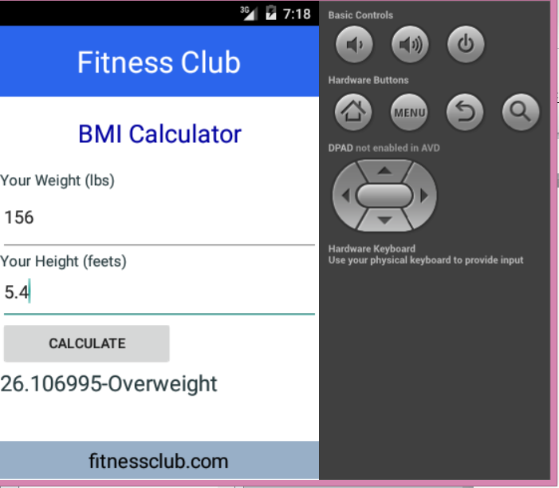

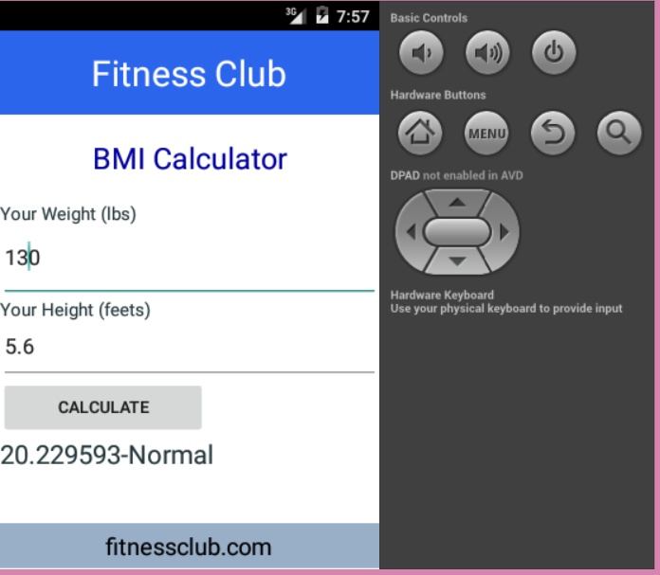

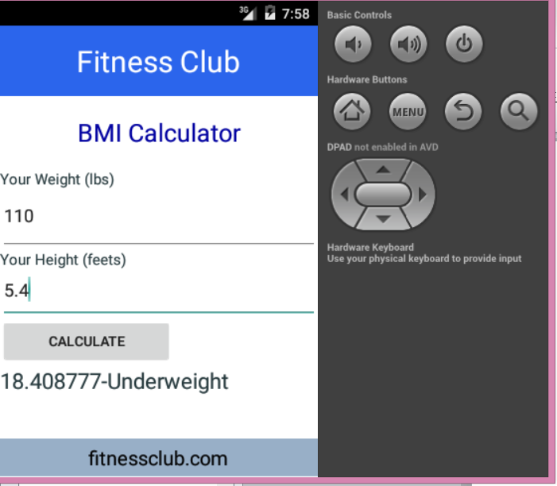

On click Tip of the day from the home page

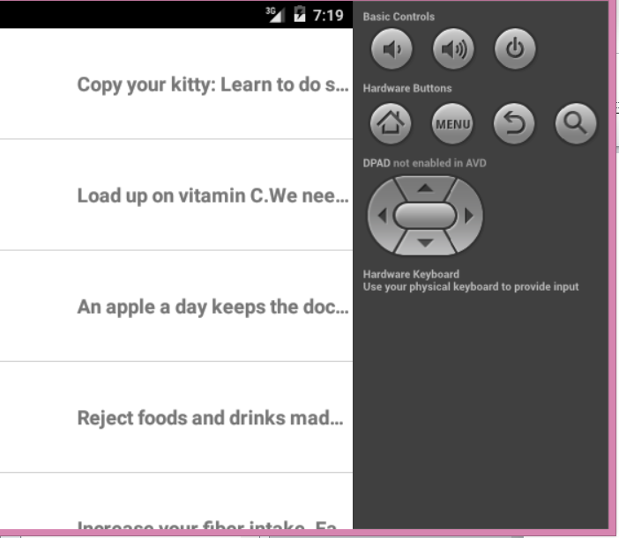

On click the individual item from the list view of tip of the day this detail screen appears

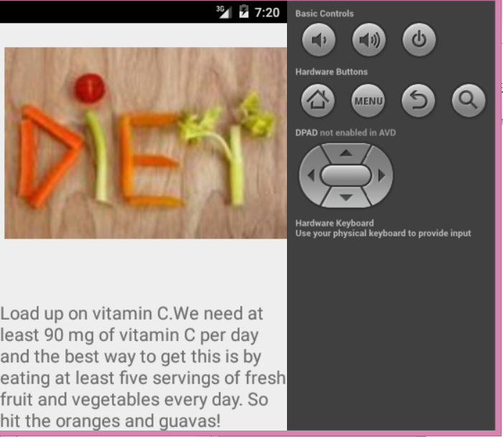

On click tracker icon

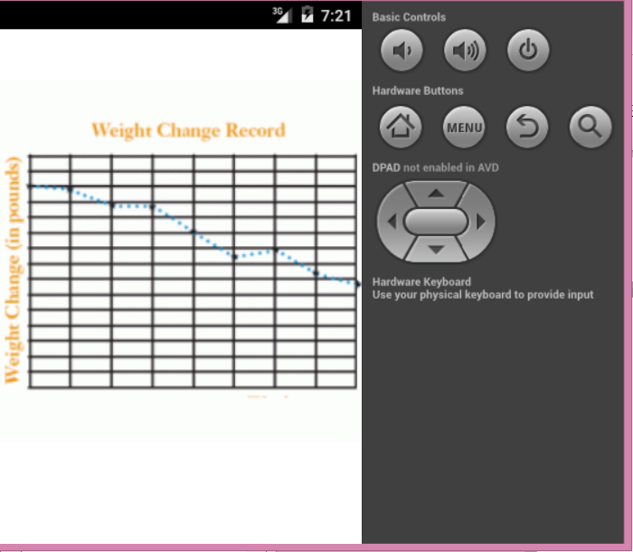

On click of diet Activites of the week icon in the home page

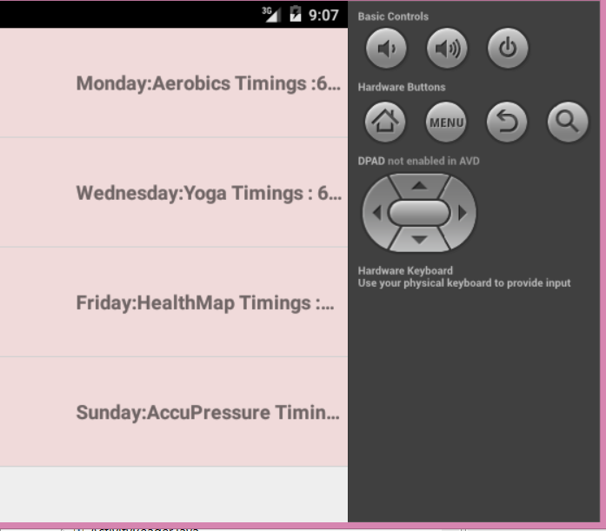

On click of list view gives the detail Activity page

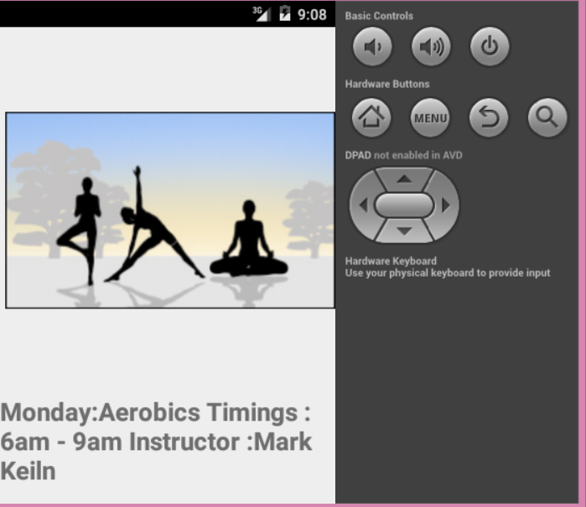

On click of Contact icon in the home page

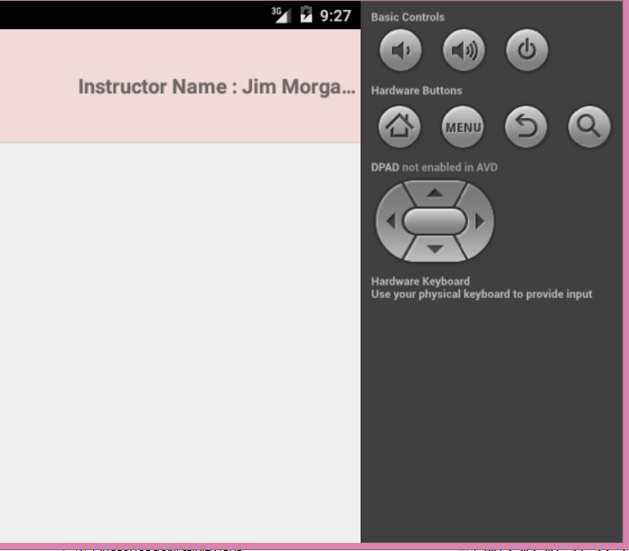

On click of detail contact page

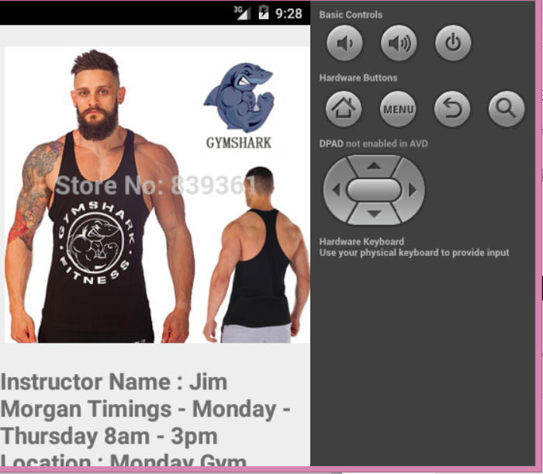

On click of diet plan icon in the home page

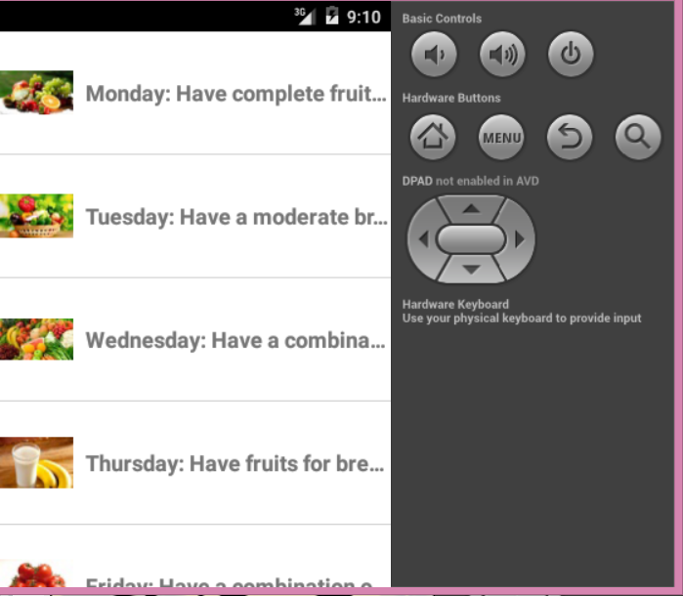

On click of diet plan detail from the list view

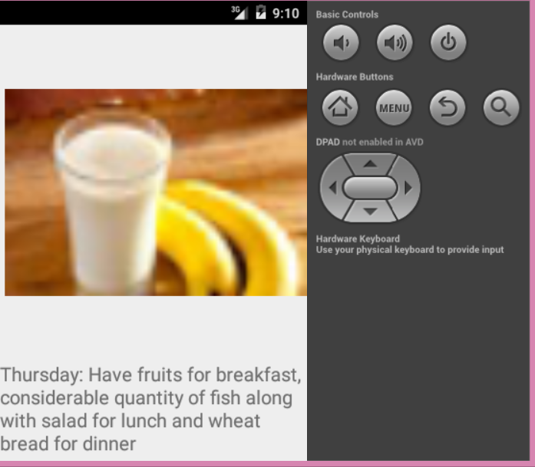

**Screen shots related to database:**

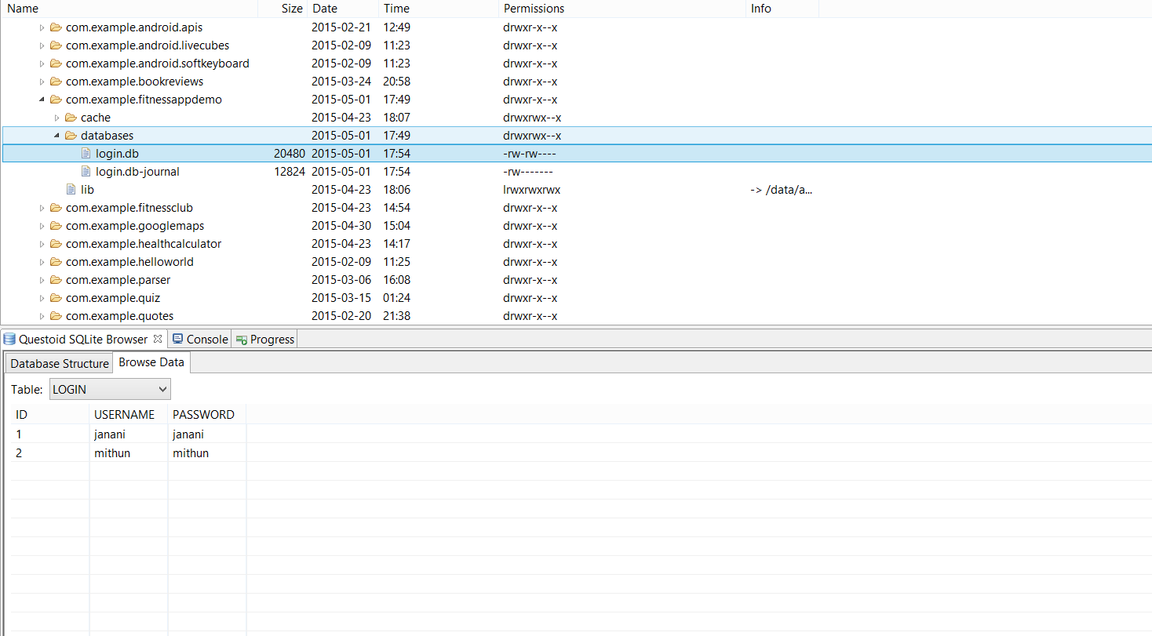

**When the user creates a new sign up:**

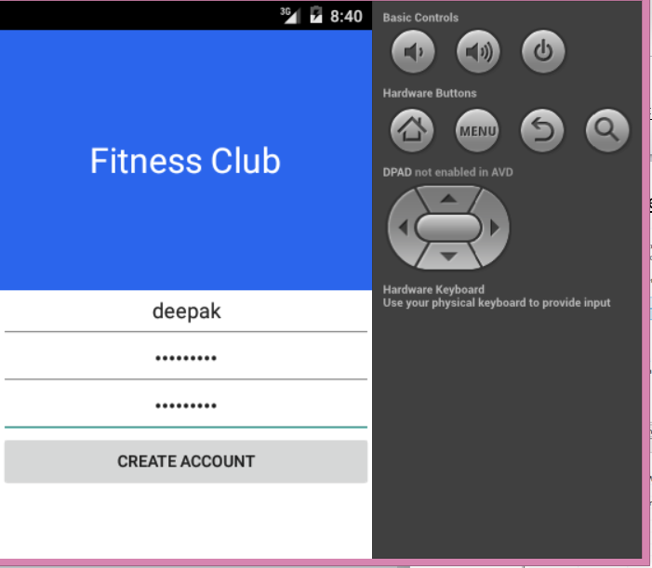

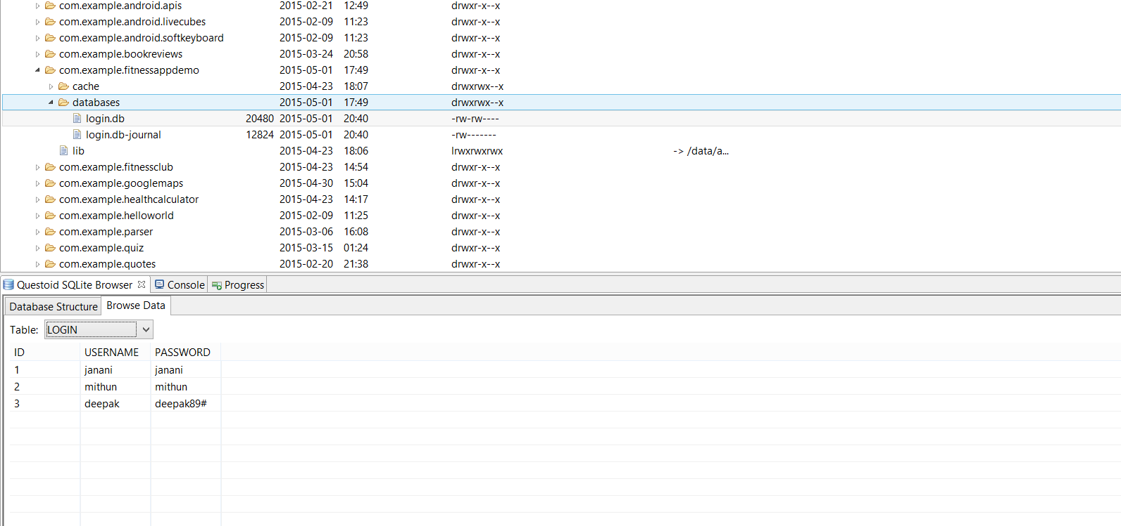

**Code Snippets:**

Double click on the file to open it

*Java files:*











***XML files:***







