**WSGI - Web Server Gateway Interface**

* WSGI is a specification that describes the communication between web servers and Python web applications or frameworks. It explains how a web server communicates with python web applications/frameworks and how web applications/frameworks can be chained for processing a request.
* Hence, a mediator is required for carrying out the interaction between the web servers and the Python application. So, the standard for carrying out communication between the web server and Python application is WSGI(Web Server Gateway Interface).
* Internet says that gunicorn is easier to use for beginners, but uwsgi works better with nginx

**Set up with Flask:** <https://flask.palletsprojects.com/en/2.0.x/deploying/wsgi-standalone/>

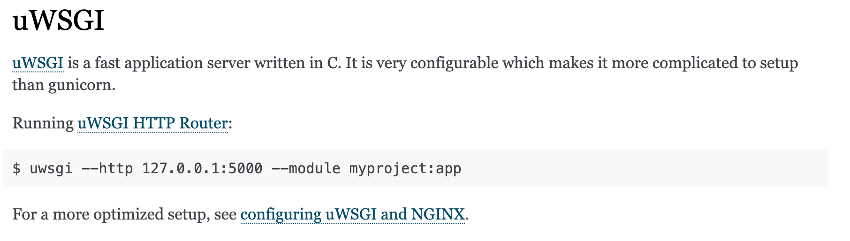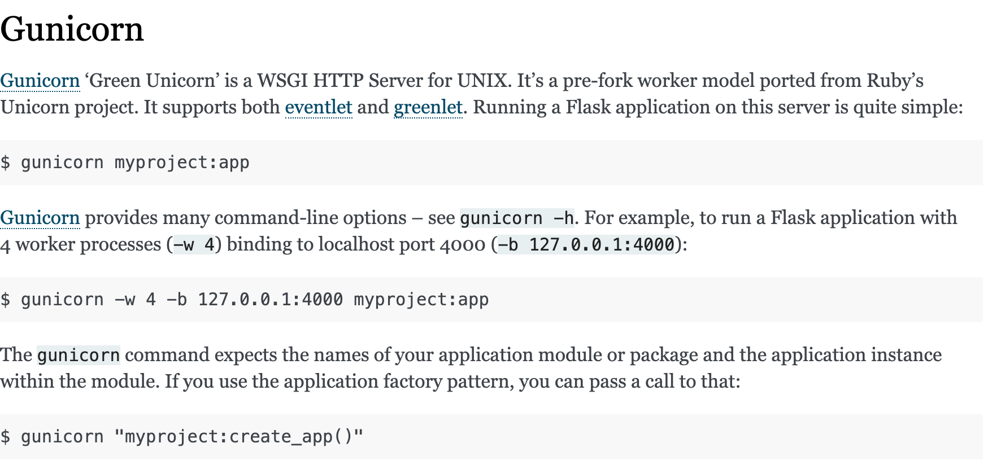

# **How To Serve Flask Applications with Gunicorn and Nginx on Ubuntu 18.04**

* <https://www.digitalocean.com/community/tutorials/how-to-serve-flask-applications-with-gunicorn-and-nginx-on-ubuntu-18-04>