PROJECT REPORT
EDUGENIE
Google Gemini Powered Learning Assistant
An AI-Powered Educational Web Application
University | University of Madras (Madras University)
College | Quaid-e-Millath Government College for Women (Autonomous)
College Code | 1110005
Student Name | Mary.R
Project | EduGenie – Google Gemini Powered Learning Assistant
Academic Year | 2026

TABLE OF CONTENTS
1. Introduction
2. Problem Statement
3. Objectives
4. Scope of the Project
5. Use-Case Scenarios
6. System Architecture
7. Prerequisites and Technologies
8. Project Workflow
9. Folder Architecture
10. Core Functional Modules
11. Backend API with FastAPI
12. Frontend Development
13. Coding Implementation
14. Sample Input and Output
15. Functional Testing
16. Importance of EduGenie
17. Advantages
18. Limitations
19. Future Enhancements
20. Conclusion
21. Project Submission Details

1. Introduction
EduGenie is an AI-powered learning assistant designed to support students through an easy-to-use web interface. The system combines a FastAPI backend with educational modules and Google Gemini-based AI processing. It can answer questions, explain concepts in simple language, generate quizzes, summarize long passages, and provide structured learning recommendations.
The project demonstrates practical application of artificial intelligence, prompt-based interaction, REST APIs, web development, modular programming, and educational technology.

2. Problem Statement
Students often need quick explanations, revision material, practice questions, and guidance while studying. Traditional resources may require searching through several sources. EduGenie brings common learning-support functions into one lightweight application.

3. Objectives
- Provide quick question-and-answer support for academic topics.
- Explain difficult concepts in simple and readable language.
- Generate multiple-choice quizzes for active learning.
- Summarize long educational passages for revision.
- Create beginner-to-advanced learning paths and resource guidance.
- Demonstrate integration of an AI service with a FastAPI web application.

4. Scope of the Project
The project is suitable for students, self-learners and educational demonstrations. It focuses on five core learning functions: Q&A, explanation, quiz generation, summarization, and learning-path recommendations. The modular design allows additional functions to be added later.

5. Use-Case Scenarios
- Question answering: a learner enters an academic question and receives an AI-generated response.
- Concept explanation: a learner enters a difficult topic and requests a simple explanation.
- Quiz generation: a learner supplies a passage and receives multiple-choice questions.
- Summarization: a long passage is converted into a concise revision summary.
- Learning path: a learner enters a subject and receives a structured beginner-to-advanced study path.

6. System Architecture
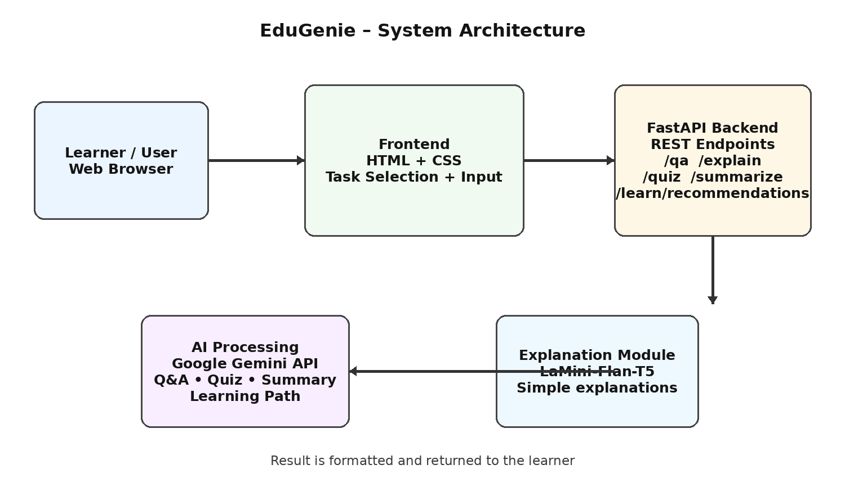
Figure 1. EduGenie high-level system architecture

7. Prerequisites and Technologies
Technology | Purpose
Python | Backend and AI integration
FastAPI | REST API framework
Google Gemini API | AI processing for learning tasks
HTML & CSS | Frontend and styling
Uvicorn | ASGI server
Jinja2 | HTML templating support
Internet/API access | Required for cloud AI requests

8. Project Workflow
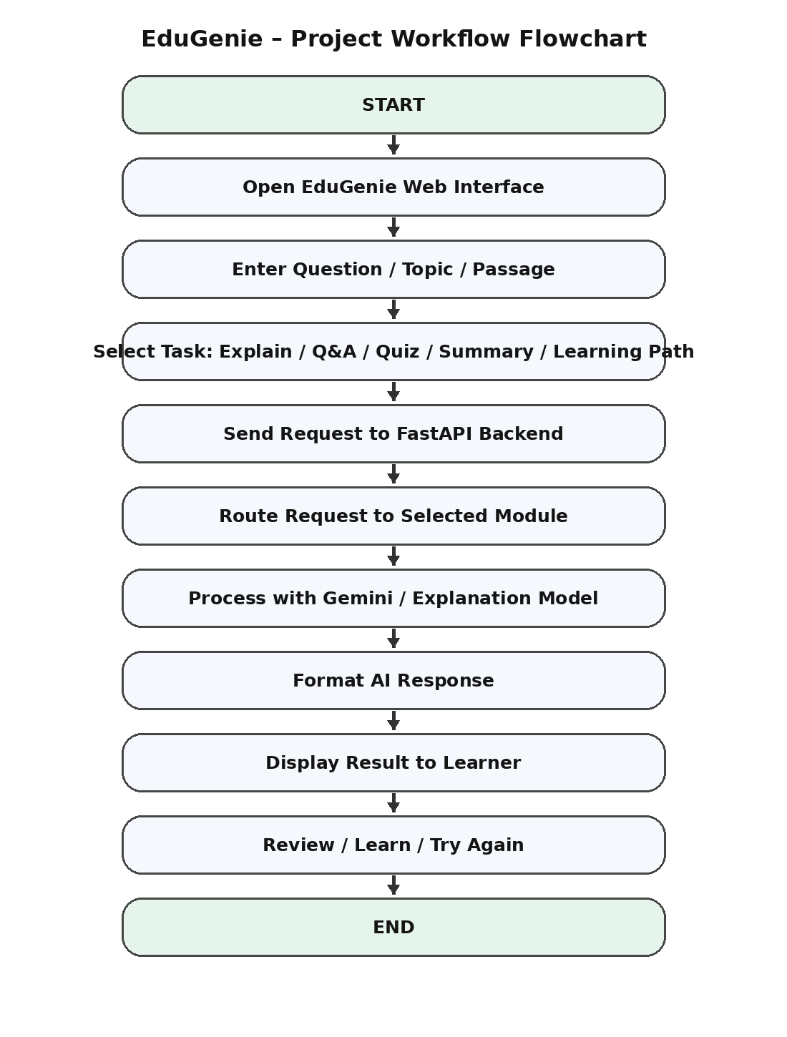
Figure 2. Main project workflow
Start → open interface → enter learning content → select a task → send request → FastAPI routes it → AI module processes it → result is displayed → learner reviews and continues.

9. Folder Architecture
EduGenie/
├── main.py
├── explanation_module.py
├── qna.py
├── quiz_module.py
├── summary_module.py
├── learning_path.py
├── templates/index.html
├── static/style.css
└── requirements.txt

10. Core Functional Modules
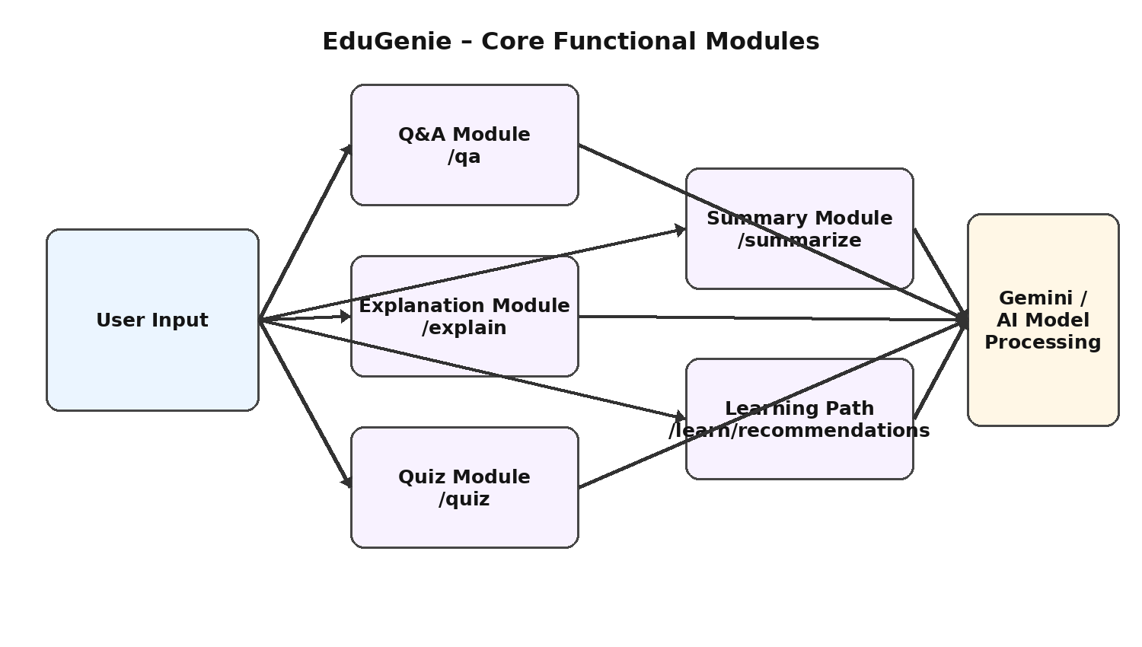
Figure 3. EduGenie functional modules

10.1 Q&A Module
Receives a question and sends an instruction to the AI model to produce a clear educational answer.

10.2 Explanation Module
Converts a difficult concept into simpler language. A lightweight local model such as LaMini-Flan-T5 can be used for this function.

10.3 Quiz Module
Generates three multiple-choice questions with four options each from supplied educational content.

10.4 Summary Module
Transforms a long passage into a concise summary while retaining important ideas.

10.5 Learning Path Module
Creates a structured learning plan from beginner to advanced level, including suggested topics and resources.

11. Backend API with FastAPI
The backend exposes separate endpoints so each learning function can be tested independently.
Endpoint | Purpose
/qa | Question answering
/explain | Concept explanation
/quiz | Quiz generation
/summarize | Text summarization
/learn/recommendations | Learning recommendations

12. Frontend Development
- Task dropdown: Explain, Q&A, Quiz, Summary and Recommend Path.
- Text area for the learner's question or educational passage.
- Submit button for sending the request.
- Result container for displaying the response.
- Responsive HTML/CSS layout for different screen sizes.

13. Coding Implementation
Example FastAPI backend using the Google GenAI Python SDK. Store the API key in an environment variable rather than directly in the source code.
# main.py
import os
from fastapi import FastAPI
from pydantic import BaseModel
from google import genai
app = FastAPI(title="EduGenie - Google Gemini Learning Assistant")
client = genai.Client(api_key=os.environ.get("GEMINI_API_KEY"))
MODEL = "gemini-2.0-flash"
class RequestData(BaseModel):
text: str
def ask_gemini(prompt: str) -> str:
response = client.models.generate_content(
model=MODEL,
contents=prompt
)
return response.text
@app.post("/qa")
def question_answer(data: RequestData):
return {"answer": ask_gemini(
f"Answer this student question clearly: {data.text}")}
@app.post("/explain")
def explain(data: RequestData):
return {"explanation": ask_gemini(
f"Explain this topic simply for a student: {data.text}")}
@app.post("/summarize")
def summarize(data: RequestData):
return {"summary": ask_gemini(
f"Summarize this passage in clear bullet points: {data.text}")}
@app.post("/quiz")
def quiz(data: RequestData):
prompt = ("Create 3 MCQs from this passage. Give 4 options and "
"mark the correct answer.\n\n" + data.text)
return {"quiz": ask_gemini(prompt)}
@app.post("/learn/recommendations")
def learning_path(data: RequestData):
prompt = ("Create a beginner-to-advanced learning path with "
"topics and practice suggestions:\n" + data.text)
return {"learning_path": ask_gemini(prompt)}
@app.get("/")
def home():
return {"message": "EduGenie is running"}

13.1 Requirements
fastapi
uvicorn
google-genai
pydantic

13.2 Run the Application
pip install -r requirements.txt
# Set GEMINI_API_KEY in the environment
uvicorn main:app --reload
Open: http://127.0.0.1:8000

14. Sample Input and Output
Module | Sample Input | Expected Output
Q&A | What is photosynthesis? | Clear AI-generated answer
Explanation | Explain database normalization | Simple explanation with examples
Quiz | Passage about computer networks | 3 MCQs with 4 options each
Summary | Long educational paragraph | Concise revision summary
Learning Path | Learn Python programming | Beginner → intermediate → advanced path

15. Functional Testing
- Open the application and confirm the home endpoint responds.
- Submit a question to /qa and verify an answer is returned.
- Submit a concept to /explain and verify a simplified explanation.
- Submit a passage to /quiz and verify three MCQs are generated.
- Submit a passage to /summarize and verify a concise summary.
- Submit a topic to /learn/recommendations and verify a staged learning path.

16. Importance of EduGenie
- Simplifies difficult educational concepts.
- Provides quick question-and-answer assistance.
- Supports active learning through quiz generation.
- Helps students revise long passages using summaries.
- Provides structured learning guidance from beginner to advanced levels.
- Demonstrates practical use of AI, APIs and web development.
- Modular architecture makes future expansion easier.

17. Advantages
- Single interface for multiple learning tasks.
- Fast response for common educational queries.
- Simple and student-friendly interaction.
- Can be extended with new modules.
- Can support different subjects and learning levels.

18. Limitations
- AI-generated responses should be checked against trusted sources when accuracy is important.
- Cloud-based AI functions require API access and may have usage limits.
- Response quality depends on the input and prompt.
- Sensitive personal information should not be entered into the application.

19. Future Enhancements
- Voice interaction
- Multilingual support
- Mobile application
- Progress dashboards and analytics
- Gamification
- Adaptive learning paths
- Group study and teacher/parent dashboards
- LMS integration
- Image/PDF input
- Smart notifications

20. Conclusion
EduGenie is an AI-powered educational assistant that combines a lightweight web interface, FastAPI backend, modular learning functions and generative AI. The project provides question answering, simple explanations, quizzes, summaries and personalized learning recommendations. It demonstrates how modern AI services can be integrated into an educational application while keeping the system modular and extendable.

21. Project Submission Details
Field | Details
University Name | Madras of university
College Name | Quiad-e-millath Government college for women (Autonomous)
College Code | 1110005
Full Name | Mary.R
TN Skills Registered Email ID | ravimary593@gmail.com
Course Completion Email ID | ravimary593@gmail.com
NM ID | A60351E05E89EC1B2944EE728C205198
Project GitHub Repository
PROJECT SUBMISSION
Submitted by: Mary.R
Date: 29/09/2026

