EduGenie: Google Gemini Powered Learning Assistant

Reference Project Board – Selected Activities

EduGenie: Google Gemini Powered Learning Assistant
EduGenie is a Generative AI based educational assistant designed to support learners through question answering, topic explanation, quiz generation, summarization and personalized learning recommendations.

Selected Activities
- Activity 3.2 – Live Integration
- Activity 4.1 – Run Locally
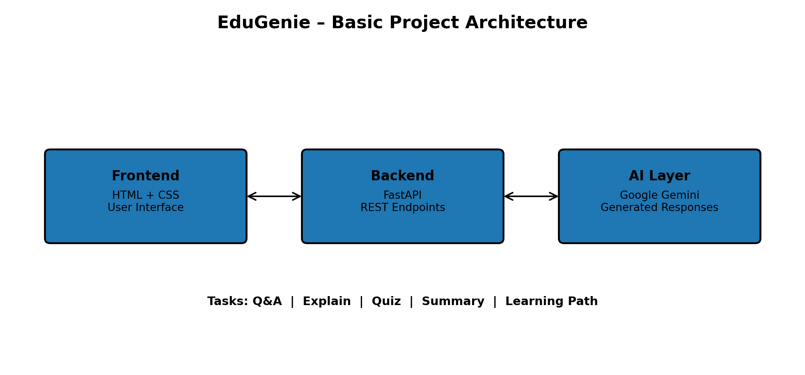

1. Activity 3.2 – Live Integration
Live Integration connects the EduGenie frontend with the FastAPI backend. The user selects a task, enters content and submits the request. The frontend sends a POST request to the backend, the relevant EduGenie module processes the request, and the generated response is displayed in the result area.

Objective
- Connect the HTML interface with the FastAPI backend.
- Send user input and the selected task to the correct endpoint.
- Receive the generated AI response.
- Display the result dynamically on the same interface.

Live Integration Flowchart
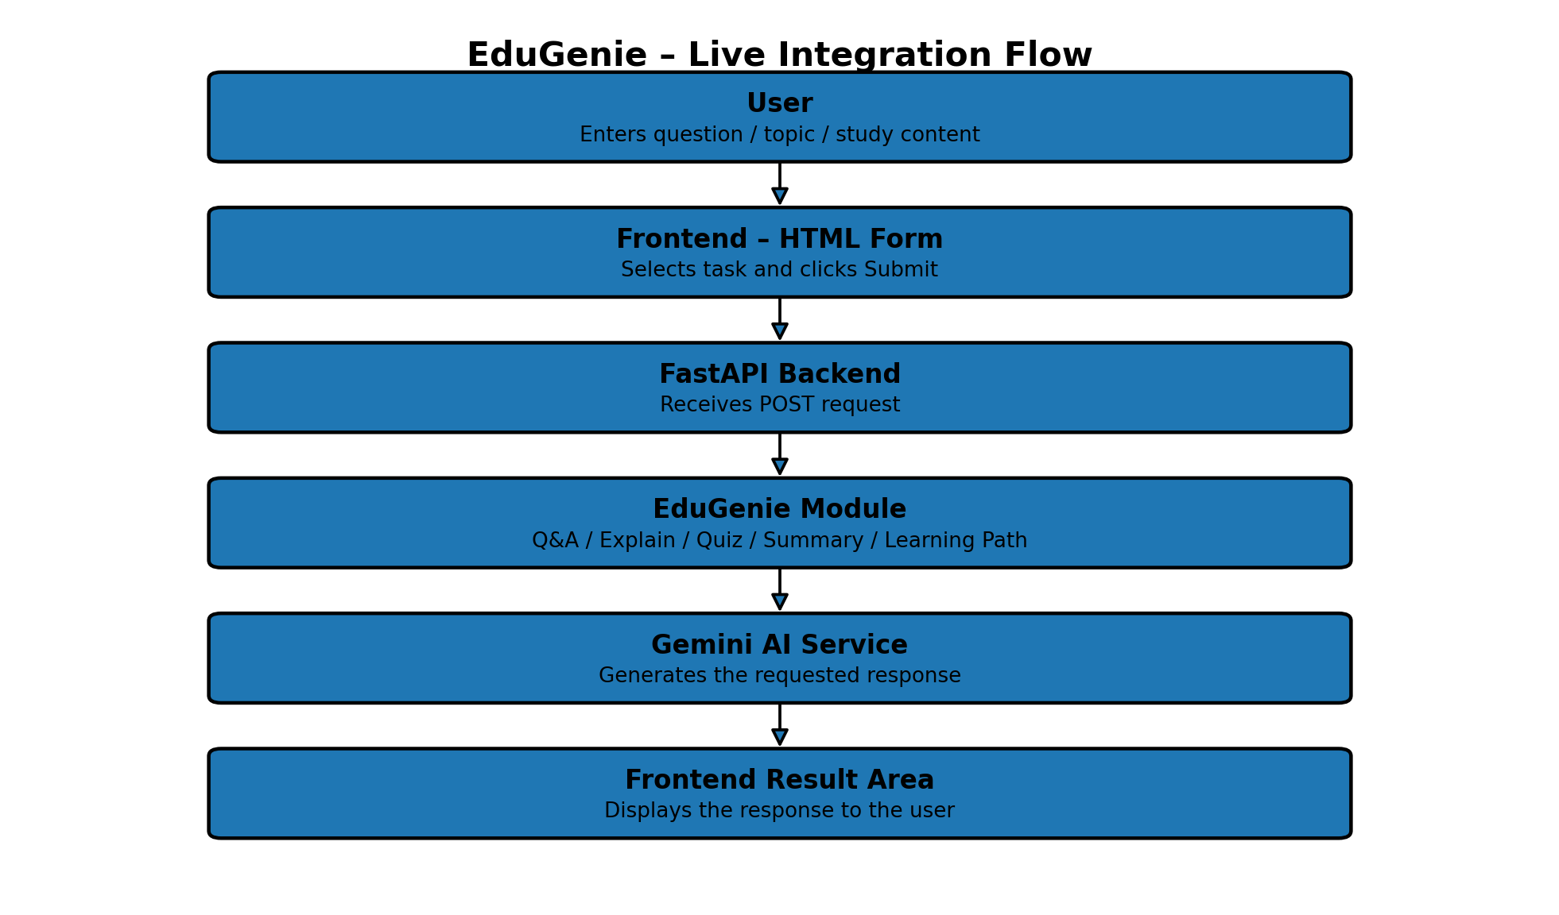

Frontend Components
- HTML form – user input and task selection.
- Task dropdown – Explain, QnA, Quiz, Summary and Recommend Path.
- Text area – accepts a question, topic or study passage.
- Submit button – sends the request.
- Result container – displays the generated response.
- CSS – provides responsive and clear styling.

Backend Endpoints
Endpoint | Purpose
/qa | Question and Answer
/explain | Explain a topic in simple language
/quiz | Generate multiple-choice questions
/summarize | Summarize long content
/learn/recommendations | Generate a structured learning path

Live Integration Steps
- Open the EduGenie web interface.
- Select the required task.
- Enter the question, topic or study content.
- Click Submit.
- The frontend sends a POST request to the FastAPI backend.
- The backend calls the corresponding EduGenie module.
- The AI-generated response is returned.
- The result is displayed below the input area.

Expected Output
The frontend and backend should communicate successfully and the requested EduGenie response should appear in the result area without opening a separate page.

2. Activity 4.1 – Run Locally
Run Locally is the deployment activity used to start EduGenie on a local computer. The FastAPI application is launched using Uvicorn and opened through a local browser address.

Run Locally Flowchart
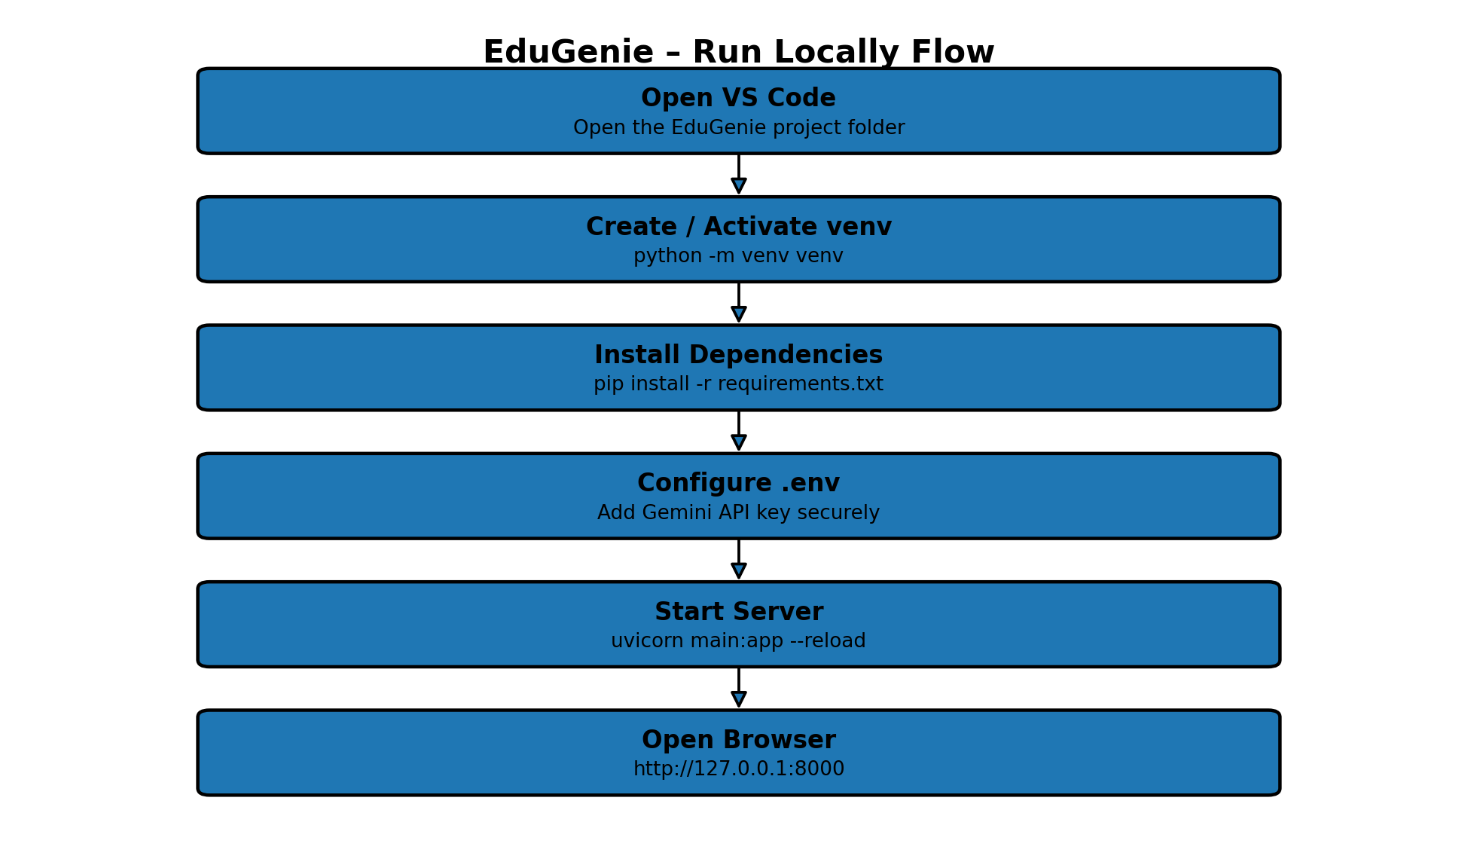

Prerequisites
- Python 3.10 or later
- Visual Studio Code
- EduGenie project folder
- Internet connection for Gemini API access
- Google account / Google AI Studio access
- Gemini API key
- Required packages listed in requirements.txt

VS Code Setup
- Open VS Code and open the EduGenie project folder.
- Open the VS Code Terminal.
- Create a virtual environment: python -m venv venv
- Activate the virtual environment.
- Install dependencies: pip install -r requirements.txt
- Create a .env file in the project root.
- Add the Gemini API key using the environment variable expected by the application.

Start the Application
uvicorn main:app --reload
After the server starts, open the application in a browser using:
http://127.0.0.1:8000

Local Testing Checklist
- Check that Uvicorn starts without errors.
- Open the local browser address.
- Verify that the EduGenie interface loads.
- Submit a sample question.
- Verify that the response is displayed.
- Test explanation, quiz, summary and learning-path features when required.
- Stop the server using Ctrl + C after testing.

Security and Error Handling
- Keep the Gemini API key outside the source code by using an environment file.
- Do not upload the real .env file or API key to a public repository.
- Validate user input before sending requests.
- Handle API failures and invalid responses with clear error messages.

Expected Outcome
EduGenie should run successfully on the local computer and provide an interactive AI learning interface through the local
Submitted by
Name: Narmadha.R
Date: 29.09.2026

— End of Project Documentation —

