NAAN MUDHALVAN PROJECT
EduGenie: Google Gemini Powered Learning Assistant
Backend API with FastAPI & Web Interface
Generative AI Project
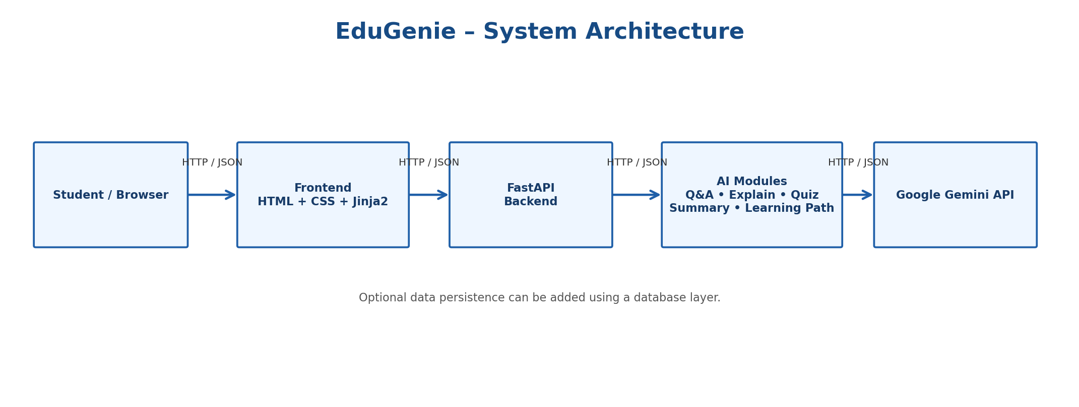
University Name | Madras of university
College Name | Quiad-e-millath Government college for women (Autonomous)
College Code | 1110005
Full Name | Sivasankari V
TN Skills Registered Email ID | sivasankari072008@gmail.com
Course Completion Email ID | sivasankari072008@gmail.com
NM ID | 15EBC9B57B7BF349F87401753AD0B825
Project GitHub Repository

Table of Contents
- 1. Project Description
- 2. Objectives
- 3. Technologies Used
- 4. Project Architecture
- 5. Core Modules
- 6. Backend API Endpoints
- 7. Frontend Web Interface
- 8. Project Workflow
- 9. Milestones
- 10. Prerequisites
- 11. VS Code Setup
- 12. Frontend UI Example
- 13. Testing and Expected Results
- 14. Conclusion

1. Project Description
EduGenie is a lightweight Generative AI powered educational assistant designed to simplify learning through natural-language interaction. The application uses Google Gemini for generating educational responses and FastAPI for providing a clean backend API. A simple HTML/CSS/Jinja2 web interface allows students to select a task, enter a question or learning material, and view the generated result.
The project focuses on five major learning features: question answering, topic explanation, quiz generation, text summarization, and personalized learning-path recommendations. The modular design makes the application easier to maintain, test, and extend.

2. Objectives
The main objectives of EduGenie are:
• Provide smart and concise answers to students' questions.
• Explain complex concepts in simple and readable language.
• Generate multiple-choice quizzes from a topic or passage.
• Summarize long educational passages for quick revision.
• Provide structured beginner-to-advanced learning recommendations.
• Create a simple and responsive web interface.
• Connect frontend requests to reusable FastAPI endpoints.
• Use secure environment-based configuration for the Gemini API key.

3. Technologies Used
• Python 3.10+ – application programming language.
• FastAPI – backend web framework for building APIs.
• Uvicorn – ASGI server used to run the FastAPI application.
• HTML/CSS – frontend structure and styling.
• Jinja2 – server-side HTML templating.
• Google Gemini API – generative AI capabilities.
• python-dotenv – loading configuration such as API keys from an environment file.
• VS Code – development environment.
• JSON – request/response data exchange format.

4. Project Architecture
The system follows a modular client–server architecture. The student interacts with the frontend web page. The frontend sends an HTTP request to the FastAPI backend. FastAPI validates the request and routes it to the appropriate educational module. The module creates a suitable prompt and sends it to Google Gemini. The generated response is processed and returned to the frontend, where it is displayed to the student.
A database is optional in the basic version. If persistence is required later, a database layer can be added without changing the main frontend workflow.

5. Core Modules
1. Explanation Module – explains educational topics in simple, context-aware language.
2. Q&A Module – answers general knowledge and academic questions using Gemini.
3. Quiz Module – generates multiple-choice questions with answer options and a suitable result format.
4. Summary Module – converts longer educational content into concise summaries while retaining key points.
5. Learning Path Module – creates a structured learning path from beginner to advanced level with suggested resources and steps.

6. Backend API Endpoints
The FastAPI backend exposes task-specific endpoints. Each endpoint accepts a request, validates the input, calls the relevant module, and returns a structured response.
POST /qa – question answering
POST /explain – topic explanation
POST /quiz – quiz generation
POST /summarize – text summarization
POST /learn/recommendations – personalized learning recommendations
The endpoints can exchange JSON data between the frontend and backend.

7. Frontend Web Interface
The frontend provides a simple interface for students. It contains a task selector, a text input area for a topic/question/passage, a submit button, and a result container. The interface is designed to be responsive and easy to use.
Typical user actions:
• Select Explain, Q&A, Quiz, Summary, or Recommend Path.
• Enter the required topic, question, or passage.
• Click Submit.
• Wait for the backend response.
• Read the generated educational result.

8. Project Workflow
1. Student selects an educational task.
2. Student enters a question, topic, or passage.
3. Frontend sends an HTTP request to the corresponding FastAPI endpoint.
4. FastAPI validates the request.
5. The backend calls the relevant educational module.
6. The module sends an appropriate prompt to Google Gemini.
7. Gemini returns generated educational content.
8. Backend processes the response and sends JSON to the frontend.
9. Frontend displays the result to the student.
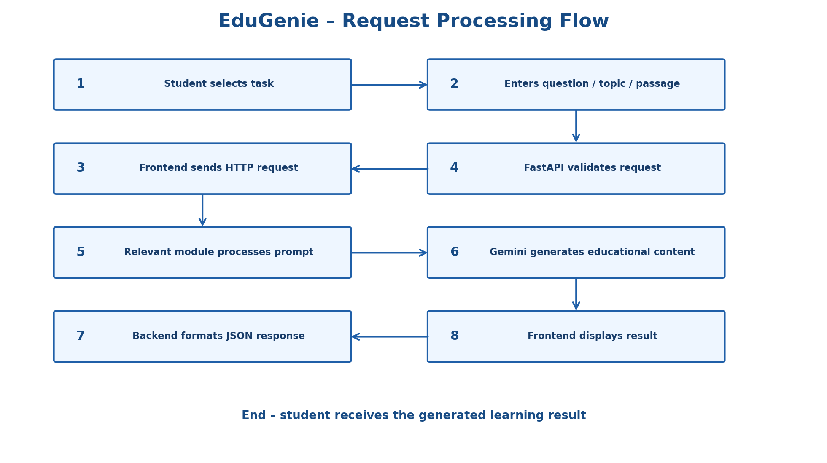

9. Milestones
Milestone 1 – Model Selection and Architecture
• Select Google Gemini for cloud-based generative AI.
• Design a modular architecture for maintenance and extension.
Milestone 2 – Core Functionalities Development
• Implement explanation, question answering, quiz, summarization, and personalized learning features.
• Connect each feature to a FastAPI endpoint.
Milestone 3 – Frontend Development
• Build the HTML form and task selector.
• Add text input and submit controls.
• Create responsive CSS styling.
• Connect frontend requests to FastAPI.
• Display results dynamically.
Milestone 4 – Testing and Deployment
• Run the application using Uvicorn.
• Test each endpoint and frontend workflow.
• Check topic explanation, quiz generation, summarization, and learning recommendations.

10. Prerequisites
• Python 3.10 or later
• VS Code or another Python IDE
• Internet connection for Gemini API
• Google account with access to the Gemini API
• Gemini API key
• Basic knowledge of Python, HTML, and REST APIs

11. VS Code Setup
1. Open VS Code and create/open the EduGenie project folder.
2. Open the VS Code terminal.
3. Create a virtual environment using: python -m venv venv
4. Activate the environment.
5. Install the required packages using: pip install -r requirements.txt
6. Create a .env file and add the Gemini API key.
7. Start the application using Uvicorn.
8. Open the local web page in a browser and test the available tasks.

12. Frontend UI Example
The user interface can contain the EduGenie title, a task dropdown, a large input area, a Submit button, and a result section. The dropdown can provide: Explain, Q&A, Quiz, Summary, and Recommend Path. The result section displays the generated content returned by the backend.

13. Testing and Expected Results
Testing should verify both API and user-interface behavior.
Test cases:
• Valid Q&A request → relevant educational answer.
• Valid explanation request → simple topic explanation.
• Valid quiz request → multiple-choice quiz content.
• Valid summary request → concise summary.
• Valid recommendation request → structured learning path.
• Empty input → validation message rather than an invalid API call.
• Invalid endpoint → appropriate HTTP error response.
Expected result: the student can select a learning task, submit educational content, and receive a readable Gemini-generated result through the web interface.

14. Conclusion
EduGenie demonstrates how a modern educational assistant can combine a FastAPI backend, a simple web interface, modular Python components, and Google Gemini generative AI. The project provides a foundation for interactive learning by supporting explanations, question answering, quizzes, summaries, and learning recommendations. Its modular architecture also makes future improvements such as authentication, database storage, analytics, and additional learning modules easier to implement.

Project File Structure
EduGenie/
│
├── main.py
├── explanation_module.py
├── qna.py
├── quiz_module.py
├── summary_module.py
├── learning_path.py
├── requirements.txt
├── .env
├── .env.example
│
├── templates/
│ └── index.html
│
└── static/
└── style.css

Student Details
University Name: Madras of university
College Name: Quiad-e-millath Government college for women (Autonomous)
College Code: 1110005
Full Name: Sivasankari V
TN Skills Registered Email ID: sivasankari072008@gmail.com
Course Completion Email ID: sivasankari072008@gmail.com
NM ID: 15EBC9B57B7BF349F87401753AD0B825
Project GitHub Repository: ________________________________
Date: 29/09/2026

15. Complete Source Code
The following code provides a simple working implementation of the EduGenie prototype. Create the files using the project structure below. Add the Gemini API key only to the .env file and do not upload that secret key to GitHub.

15.1 requirements.txt
fastapi
uvicorn[standard]
jinja2
python-dotenv
google-generativeai

15.2 .env
GEMINI_API_KEY=YOUR_GEMINI_API_KEY

15.3 .env.example
GEMINI_API_KEY=your_gemini_api_key_here

15.4 main.py
import os
from dotenv import load_dotenv
from fastapi import FastAPI, Request
from fastapi.responses import HTMLResponse
from fastapi.templating import Jinja2Templates
from pydantic import BaseModel
from explanation_module import explain_topic
from qna import answer_question
from quiz_module import generate_quiz
from summary_module import summarize_text
from learning_path import recommend_learning_path
load_dotenv()
app = FastAPI(title="EduGenie API", version="1.0.0")
templates = Jinja2Templates(directory="templates")
class LearningRequest(BaseModel):
text: str
@app.get("/", response_class=HTMLResponse)
async def home(request: Request):
return templates.TemplateResponse("index.html", {"request": request})
@app.post("/qa")
async def qa(data: LearningRequest):
return {"result": answer_question(data.text)}
@app.post("/explain")
async def explain(data: LearningRequest):
return {"result": explain_topic(data.text)}
@app.post("/quiz")
async def quiz(data: LearningRequest):
return {"result": generate_quiz(data.text)}
@app.post("/summarize")
async def summarize(data: LearningRequest):
return {"result": summarize_text(data.text)}
@app.post("/learn/recommendations")
async def recommendations(data: LearningRequest):
return {"result": recommend_learning_path(data.text)}

15.5 explanation_module.py
import os
import google.generativeai as genai
genai.configure(api_key=os.getenv("GEMINI_API_KEY"))
model = genai.GenerativeModel("gemini-1.5-flash")
def explain_topic(topic: str) -> str:
prompt = f"""
Explain the following educational topic for a college student.
Use simple language, headings, examples and important points.
Topic: {topic}
"""
response = model.generate_content(prompt)
return response.text

15.6 qna.py
import os
import google.generativeai as genai
genai.configure(api_key=os.getenv("GEMINI_API_KEY"))
model = genai.GenerativeModel("gemini-1.5-flash")
def answer_question(question: str) -> str:
prompt = f"""
Answer this student's academic question accurately and clearly.
Give a concise explanation and an example when useful.
Question: {question}
"""
response = model.generate_content(prompt)
return response.text

15.7 quiz_module.py
import os
import google.generativeai as genai
genai.configure(api_key=os.getenv("GEMINI_API_KEY"))
model = genai.GenerativeModel("gemini-1.5-flash")
def generate_quiz(topic: str) -> str:
prompt = f"""
Create 5 multiple-choice questions about the following topic.
For each question provide four options (A, B, C, D) and identify the correct answer.
Keep the questions suitable for a college student.
Topic: {topic}
"""
response = model.generate_content(prompt)
return response.text

15.8 summary_module.py
import os
import google.generativeai as genai
genai.configure(api_key=os.getenv("GEMINI_API_KEY"))
model = genai.GenerativeModel("gemini-1.5-flash")
def summarize_text(text: str) -> str:
prompt = f"""
Summarize the following educational passage.
Keep the important facts and write the result as clear bullet points.
Passage:
{text}
"""
response = model.generate_content(prompt)
return response.text

15.9 learning_path.py
import os
import google.generativeai as genai
genai.configure(api_key=os.getenv("GEMINI_API_KEY"))
model = genai.GenerativeModel("gemini-1.5-flash")
def recommend_learning_path(topic: str) -> str:
prompt = f"""
Create a beginner-to-advanced learning path for this topic.
Include stages, key concepts, practice activities and suggested next steps.
Topic: {topic}
"""
response = model.generate_content(prompt)
return response.text

15.10 templates/index.html
<!DOCTYPE html>
<html lang="en">
<head>
<meta charset="UTF-8">
<meta name="viewport" content="width=device-width, initial-scale=1.0">
<title>EduGenie - AI Learning Assistant</title>
<link rel="stylesheet" href="/static/style.css">
</head>
<body>
<div class="container">
<h1>🤖 EduGenie</h1>
<p class="subtitle">Your AI Learning Assistant</p>
<div class="form-card">
<label for="task">Select Task</label>
<select id="task">
<option value="explain">Explain</option>
<option value="qa">Q&A</option>
<option value="quiz">Quiz</option>
<option value="summarize">Summary</option>
<option value="recommendations">Recommend Path</option>
</select>
<label for="inputText">Enter topic, question or passage</label>
<textarea id="inputText"
placeholder="Type your question or learning content here..."></textarea>
<button onclick="submitTask()">Submit</button>
</div>
<div class="result-card">
<h2>Result</h2>
<pre id="result">Your AI-generated result will appear here...</pre>
</div>
</div>
<script>
async function submitTask() {
const task = document.getElementById("task").value;
const text = document.getElementById("inputText").value.trim();
const result = document.getElementById("result");
if (!text) {
result.textContent = "Please enter a topic, question or passage.";
return;
}
result.textContent = "Generating response...";
const endpoint = task === "recommendations"
? "/learn/recommendations"
: "/" + task;
try {
const response = await fetch(endpoint, {
method: "POST",
headers: {"Content-Type": "application/json"},
body: JSON.stringify({text: text})
});
const data = await response.json();
if (!response.ok) {
result.textContent = data.detail || "Request failed.";
return;
}
result.textContent = data.result;
} catch (error) {
result.textContent = "Unable to connect to the backend.";
}
}
</script>
</body>
</html>

15.11 static/style.css
body {
font-family: Arial, sans-serif;
background: #eef4fb;
margin: 0;
padding: 30px;
}
.container {
max-width: 850px;
margin: auto;
}
h1 {
text-align: center;
color: #174b84;
margin-bottom: 5px;
}
.subtitle {
text-align: center;
color: #555;
}
.form-card, .result-card {
background: white;
padding: 24px;
margin-top: 20px;
border-radius: 12px;
box-shadow: 0 3px 12px rgba(0,0,0,0.08);
}
label {
display: block;
margin-top: 10px;
margin-bottom: 7px;
font-weight: bold;
}
select, textarea {
width: 100%;
box-sizing: border-box;
padding: 12px;
border: 1px solid #b9c8d8;
border-radius: 8px;
font-size: 15px;
}
textarea {
min-height: 170px;
resize: vertical;
}
button {
width: 100%;
margin-top: 15px;
padding: 12px;
border: none;
border-radius: 8px;
background: #1f5fa8;
color: white;
font-size: 16px;
cursor: pointer;
}
button:hover {
background: #174b84;
}
pre {
white-space: pre-wrap;
line-height: 1.6;
}

15.12 Recommended Project Structure
EduGenie/
│
├── main.py
├── explanation_module.py
├── qna.py
├── quiz_module.py
├── summary_module.py
├── learning_path.py
├── requirements.txt
├── .env
├── .env.example
│
├── templates/
│ └── index.html
│
└── static/
└── style.css

15.13 Run Commands
# Create virtual environment
python -m venv venv
# Windows
venv\Scripts\activate
# Install packages
pip install -r requirements.txt
# Run the FastAPI application
uvicorn main:app --reload
# Open in browser
http://127.0.0.1:8000
# FastAPI interactive API documentation
http://127.0.0.1:8000/docs

15.14 Sample API Request
POST /explain
Content-Type: application/json
{
"text": "Explain the basics of microprocessors"
}

15.15 Sample API Response
{
"result": "A microprocessor is..."
}

16. Coding Explanation
main.py is the central FastAPI application. It creates the web server, serves the frontend page, defines the API endpoints, validates incoming JSON using Pydantic, and connects each endpoint to a separate educational module. The module files keep the application organized by feature.
The frontend uses HTML and CSS for the interface and JavaScript fetch() to send HTTP POST requests to FastAPI. The backend returns JSON, and JavaScript places the returned result into the result area.
The Gemini API key is loaded from .env using python-dotenv. The .env file should remain private and should be excluded from version control.

17. GitHub Preparation
Before uploading the project to GitHub, create a .gitignore file and exclude the virtual environment and secret configuration.

17.1 .gitignore
venv/
.env
__pycache__/
*.pyc
Project GitHub Repository: ________________________________________________

18. Important Note
The Google Gemini SDK/API syntax can change over time. If the installed Gemini package uses a newer Google GenAI SDK, the model initialization and generation calls may need to be updated to that SDK's current syntax. The architecture and FastAPI endpoint design remain the same.

