HackerRank

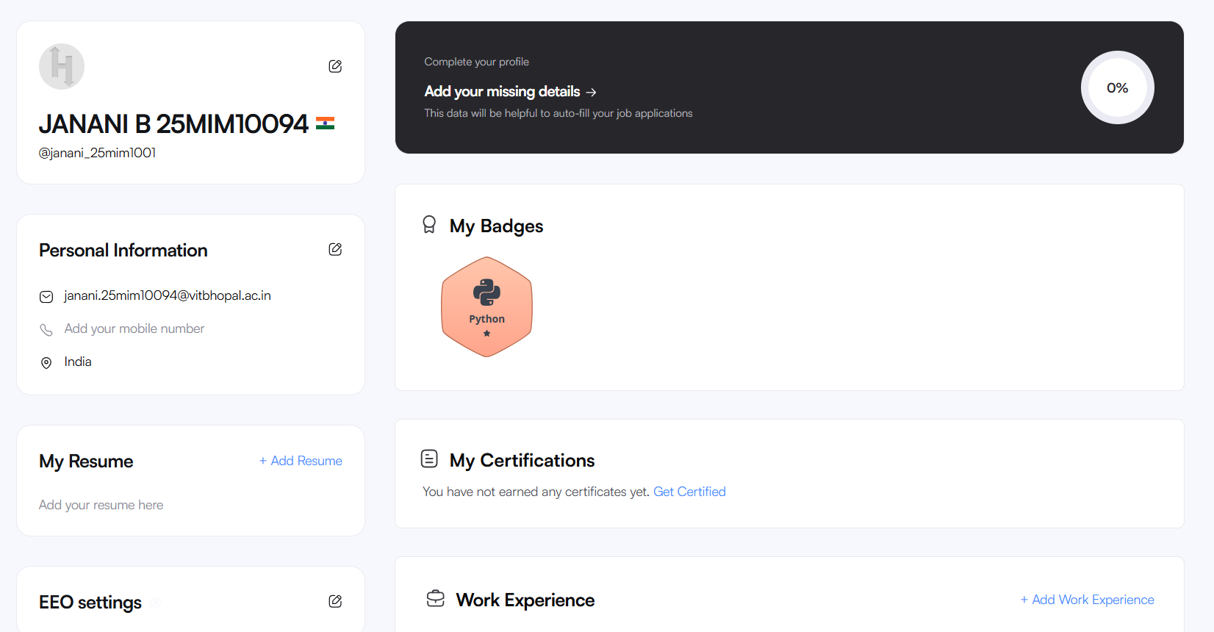

Google Form for the topic Digital Literacy Awareness

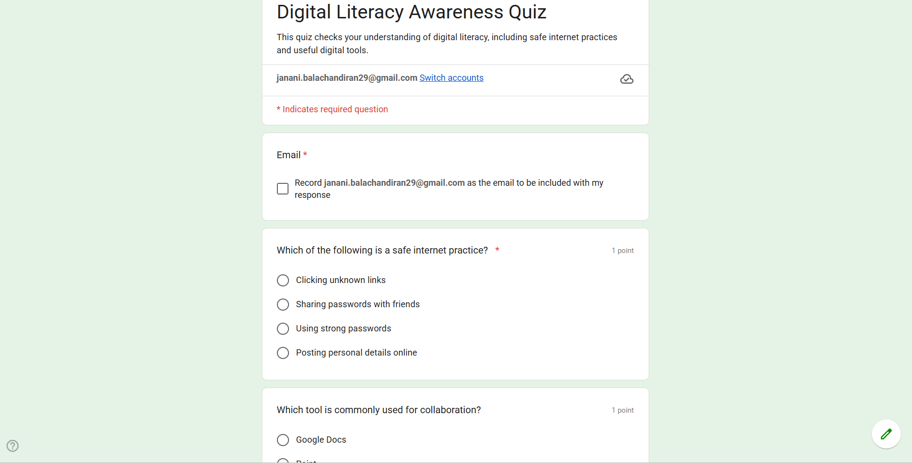

Response Sheet

