Activity 16

NAME : B Janani COURSE : Mobile Computing
Reg No : 192321100 COURSE CODE: ITA0301

Develop a wireframe for a mobile application that addresses challenges related to ad hoc wireless networks using Figma.

Aim: -
Create a Wireframe for a mobile application that addresses challenges related to ad hoc wireless networks using Figma.

Procedure: -

- open Figma
- Create a new file
- Select the Frames
- Design Visual Elements
- Make it Interactive
- Add icons on the Frame
- Incorporate Multimedia
- Storyboard Animation
- Review and edit the Prototype
- Save and Share

Design: -

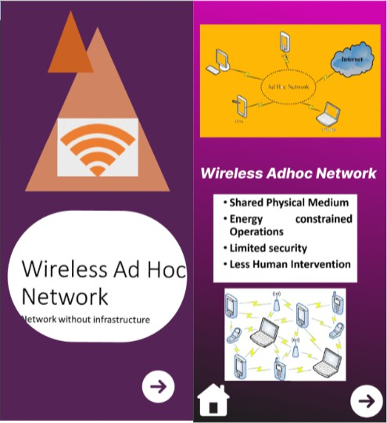

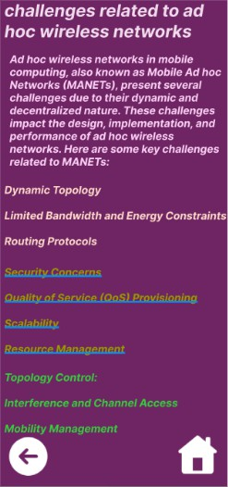

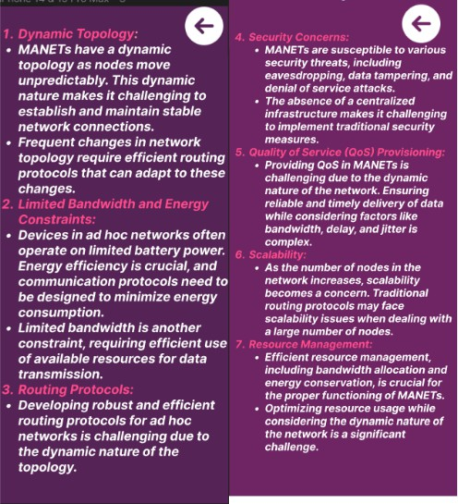

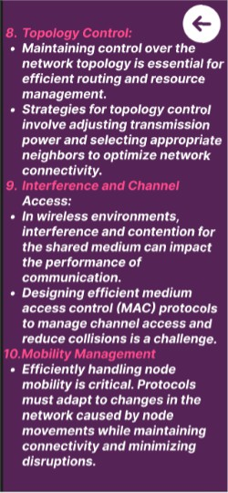

Prototype: -

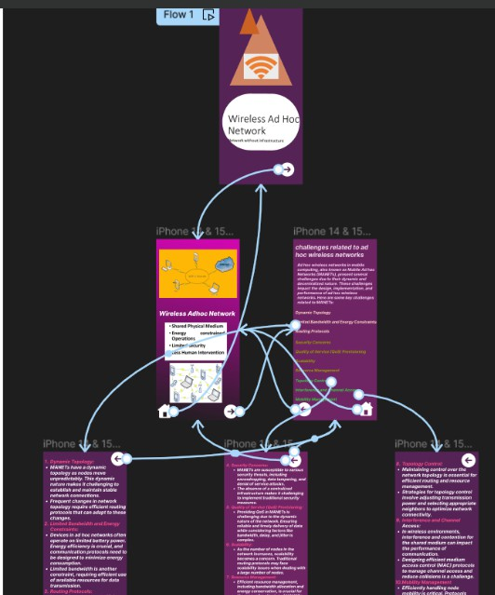

Result: -
Hence a wireframe for a mobile application that addresses challenges related to ad hoc wireless networks using Figma is created and executed successfully

