NAME : B Janani COURSE : Mobile Computing
Reg No : 192321100 COURSE CODE: ITA0301

28. Design a wireframe in Figma for a multimedia-rich mobile app, incorporating elements
from both Core Video and Core Media frameworks.

Aim:
Design a wireframe for a multimedia-rich mobile app, incorporating elements from both Core Video and Core Media frameworks using figma

Procedure:

- Open Figma
- Create a new file
- Select the Frames
- Design Visual Elements
- Make it Interactive
- Add icons on the Frame
- Incorporate Multimedia
- Storyboard Animation
- Review and edit the Prototype
- Save and Share

Design:

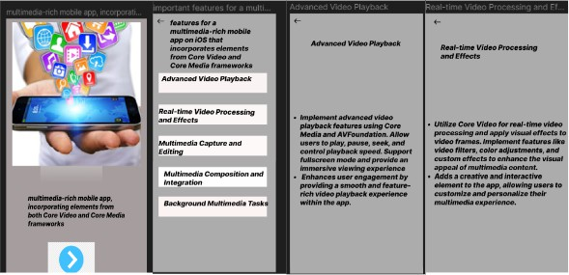

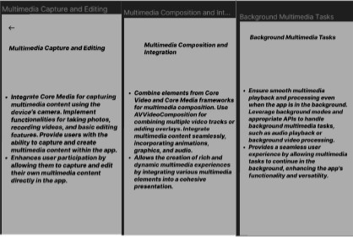

Prototype:

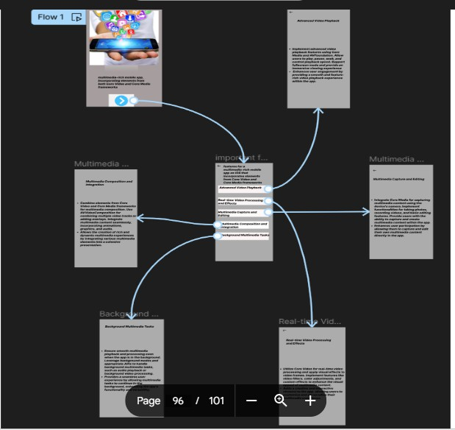

Result:
A wireframe for a multimedia-rich mobile app, incorporating elements from both Core Video and Core Media frameworks using figma have been created successfully

