Create a SQL storage service and perform a basic query using any Public Cloud Service
Provider (Azure/GCP/AWS) to demonstrate Database as a Service (DaaS) using Azure.
AIM: To demonstrate Database as a Service (DBaaS) by creating a SQL storage service in Azure and performing a basic query on it.
Procedure:

STEP 1: Login to Azure Portal
- Open browser → https://portal.azure.com
- Sign in with your Azure credentials.

STEP 2: Create a Resource Group
- Search Resource Groups → Click Create
- Enter:
  - Resource Group Name: DaaS-RG
  - Region: Central India (or nearest)
- Click Review + Create → Create

STEP 3: Create SQL Database
- Click Create a Resource → Search SQL Database → Click Create
- Fill in details:
  - Subscription: Select your subscription
  - Resource Group: DaaS-RG
  - Database Name: DaaSDemoDB
  - Server: Click Create New
    - Server Name: daas-demo-server
    - Admin Username: dbadmin
    - Password: StrongPassword123
    - Location: Same as Resource Group
  - Compute + Storage: Basic Tier (2 vCores, 5 GB)
- Click Review + Create → Create
⏳ Wait 2–5 minutes for deployment.

STEP 4: Configure Firewall
- Go to SQL Database → Set server firewall
- Click Add client IP → Save
- This allows your machine to connect to the database.

STEP 5: Connect to SQL Database
Using Azure Data Studio / SSMS:
- Server Name: daas-demo-server.database.windows.net
- Authentication: SQL Login
- Username: dbadmin
- Password: As created
- Database: DaaSDemoDB

STEP 6: Perform Basic SQL Query
Example Queries:
-- Create a table
CREATE TABLE Employees (
EmployeeID INT PRIMARY KEY,
Name NVARCHAR(50),
Department NVARCHAR(50)
);

-- Insert data
INSERT INTO Employees (EmployeeID, Name, Department)
VALUES (1, 'Alice', 'IT'),
(2, 'Bob', 'HR');

-- Retrieve data
SELECT * FROM Employees;
✅ Expected Output:
EmployeeID | Name | Department
1 | Alice | IT
2 | Bob | HR

ARCHITECTURE
User → Azure SQL Database (DBaaS) → Azure Data Center
Azure manages:
- Database engine
- Server OS
- Backup & replication
- Security & scaling
User manages:
- Data
- Tables & queries

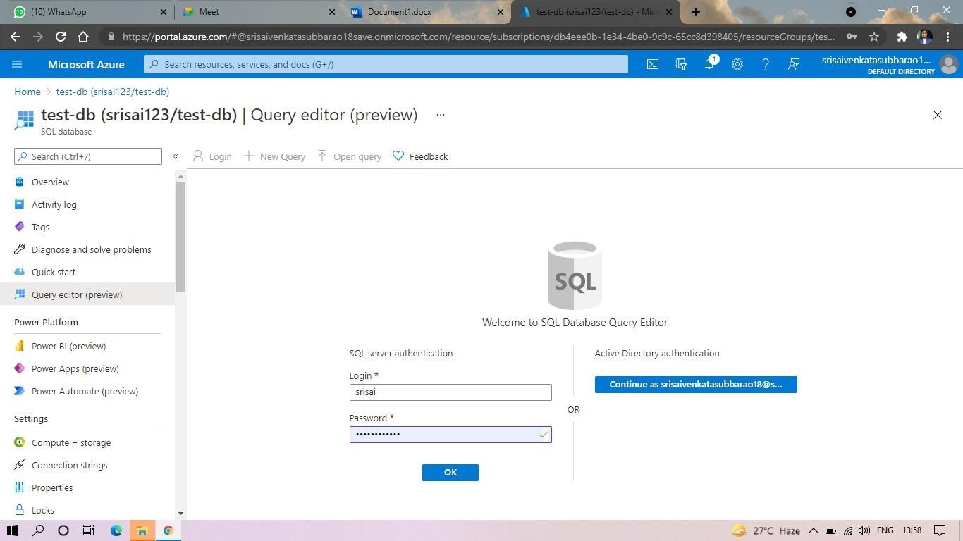

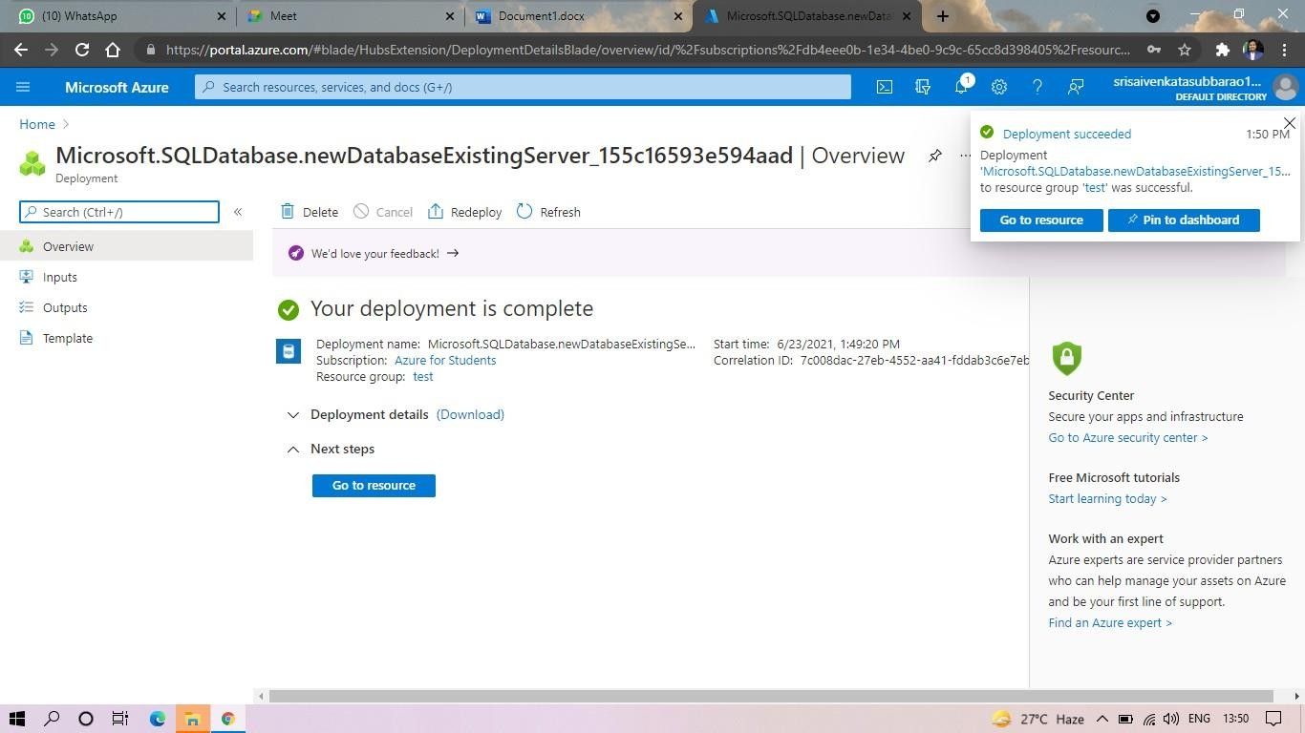

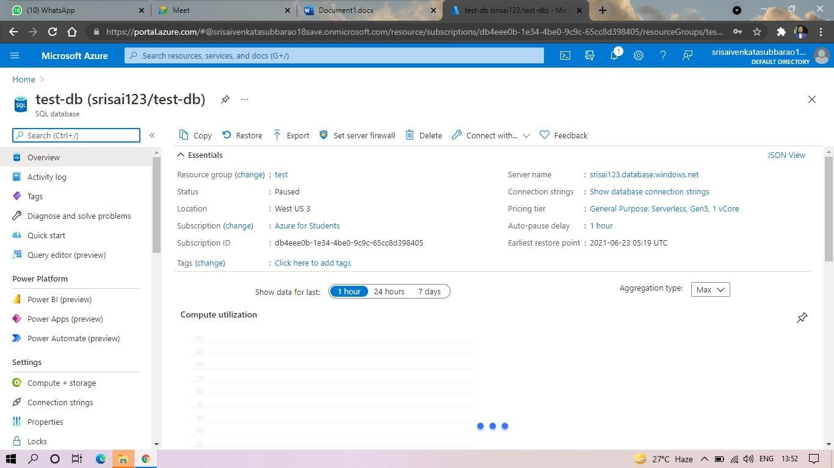

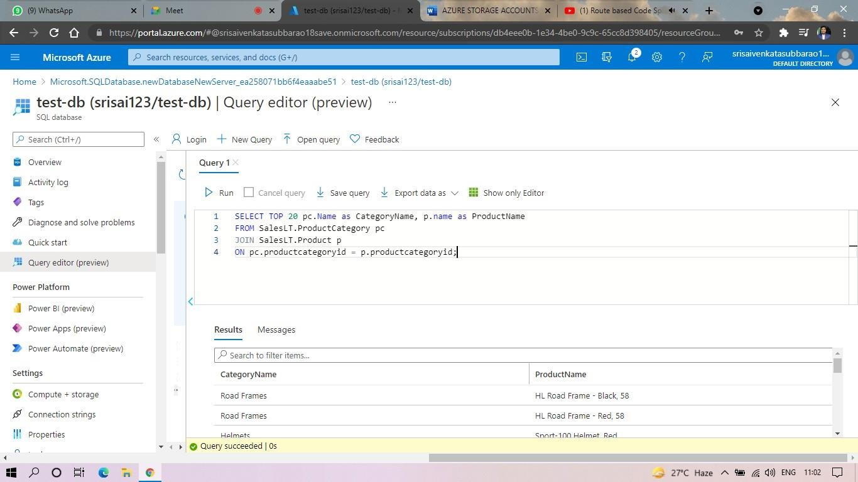

RESULT:
- Azure SQL Database was successfully created.
- A table was created, data inserted, and a basic query executed.
- DBaaS was demonstrated without managing underlying infrastructure.
✅ Database as a Service (DBaaS) was successfully demonstrated using Microsoft Azure.

