R.V.S SCHOOL OF ENGINEERING AND TECHNOLOGY
DINDIGUL

PROJECT TITLE : Customer Support Ticket Priority Prediction and Automated assignment system using Agentforce

Team leader: Janani.D-jananid08082006@gmail .com
Team members: Harshini.A-harshiniashokkumar3@gmail.com
Team members: Kanaheshwari.P-
kanaheshwarip@gmail.com
Team members: Pothumani.M-
Pothumanimani452@gmail.com
Objective:
The objective of this project is to understand how customer support teams manage large volumes of service requests and the challenges involved in manual ticket prioritization and assignment. The goal is to build an intelligent system using Salesforce and Agentforce that can automatically analyze ticket details, determine priority levels, and assign tickets to the appropriate support agents.
This system aims to reduce response time, improve customer satisfaction, minimize manual effort, and ensure efficient handling of critical issues through automation and AI-driven decision-making.
Approach:
Gather requirements from key stakeholders such as support agents, managers, and customers to understand current ticket handling processes. Study how tickets are currently created, prioritized, and assigned manually within the organization. Identify major challenges such as delays in resolving urgent issues, inconsistent prioritization, and uneven workload distribution. Analyze sample ticket data to identify commonly used keywords that indicate urgency (e.g., “urgent”, “not working”, “failure”). Conduct research using sources like ChatGPT, Salesforce Trailhead, and documentation to design a scalable and automated solution. Plan the system architecture using Salesforce components such as custom objects, flows, and Agentforce for AI-based automation.
Key Business Requirements Identified:
- Provide a centralized system to create, store, and manage customer support tickets.
- Automatically classify ticket priority into High, Medium, or Low based on issue description.
- Enable automated assignment of tickets to appropriate support agents.
- Use Agentforce AI to analyze ticket details and trigger automation.
- Create tasks automatically for high-priority tickets to ensure immediate attention.
- Provide visibility to managers for monitoring ticket status, priority, and workload.
- Improve response time and overall customer experience.
- Ensure secure access with role-based permissions for agents and managers.
- Generate reports and dashboards for tracking performance and efficiency.

Project Scope:
- Build a ticket management system using Salesforce
- Automate ticket priority classification (High, Medium, Low)
- Enable automatic assignment of tickets to support agents
- Use Agentforce to analyze ticket descriptions
- Create tasks for high-priority tickets
- Provide basic visibility of tickets for agents and managers
Objectives Summary:
- Reduce response time for customer issues
- Improve customer satisfaction
- Minimize manual effort in ticket handling
- Ensure critical issues are handled first
- Improve team productivity and efficiency

Users Involved:
- Support Agents – Handle tickets, need clear priority and assignment
- Managers – Monitor workload, ticket status, and team performance
- Customers – Raise issues and expect quick resolution
- AI Agent (Agentforce) – Automates analysis and triggers actions
Key Functional Needs:
- Ability to create and manage support tickets
- Automatic priority classification based on ticket description
- Automatic assignment of tickets to the right support agent
- Task creation for high-priority tickets
- Visibility of ticket status and priority for agents and managers
- SLA risk identification for delayed tickets
- Clear output messages indicating actions taken
Tools Used:
- Salesforce – For data management and application development
- Flow Builder – To automate ticket processing logic
- Agentforce – For AI-based ticket analysis and automation
- Apex (optional) – For advanced logic and bulk processing
- Reports & Dashboards – For monitoring performance and insights

Salesforce Features Planned:
- Custom Object (Support Ticket Intelligence) – Store and manage ticket data including customer, description, priority, status, and assigned agent using Salesforce
- Custom Fields & Relationships – Capture ticket details such as Issue Type, SLA Risk, Resolution Time, and link tickets to Account and Contact
- Auto-Launched Flow – Automate ticket processing by fetching records, analyzing description, setting priority, creating tasks for high-priority tickets, and assigning agents
- Flow Variables (Input & Output) – Use variables like Account Name (input) and Priority Level, Assigned Agent, Ticket ID (output) to interact with the system
- Decision Logic in Flow – Classify tickets based on keywords (urgent, slow, issue) to determine priority (High/Medium/Low)
- Task Automation – Automatically create tasks for urgent tickets to ensure quick action
- Agentforce Configuration – Use Agentforce to analyze ticket details, trigger flows, and provide intelligent responses
- Agent Topic & Actions – Create a topic (Support Ticket Priority Analysis) to define how the AI agent handles ticket prioritization and automation
- Input/Output Handling in Agent – Capture user input (Account Name) and return outputs like priority level, assigned agent, and action message
- Security & Access (Basic) – Ensure controlled access using profiles and roles for agents and managers

Data Model Includes:
- Custom Object (Support Ticket Intelligence) – Stores all ticket-related data in Salesforce
- Ticket Details Fields – Includes Ticket Number, Description, Issue Type, Priority Level, Status, and Resolution Time
- Customer Relationship – Lookup relationship with Account to link tickets to customers
- Contact Relationship – Lookup with Contact to track customer contact details
- Assignment Tracking – Assigned To field to store the support agent handling the ticket
- SLA Tracking – SLA Breach Risk checkbox to identify delayed or risky tickets
- Data Flow Structure – Flow fetches Account → retrieves latest ticket → processes description → updates priority and assignment
Security Model Includes:
- Role-Based Access – Different access levels for Support Agents and Managers
- Profiles & Permissions – Agents: Create and view tickets; Managers: Full access including priority and assignment
- Sharing Rules – Ensure agents can view only their assigned tickets
- Field-Level Security – Restrict editing of important fields like Priority Level and SLA Breach Risk
- Data Visibility – Managers can view all team tickets through role hierarchy

PHASE 2
Data Model Includes:
- Custom Object (Support Ticket Intelligence) – Stores all ticket-related data in Salesforce
- Ticket Details Fields – Includes Ticket Number, Description, Issue Type, Priority Level, Status, and Resolution Time
- Customer Relationship – Lookup relationship with Account to link tickets to customers
- Contact Relationship – Lookup with Contact to track customer contact details
- Assignment Tracking – Assigned To field to store the support agent handling the ticket
- SLA Tracking – SLA Breach Risk checkbox to identify delayed or risky tickets
- Data Flow Structure – Flow fetches Account → retrieves latest ticket → processes description → updates priority and assignment
Security Model Includes:
- Role-Based Access – Different access levels for Support Agents and Managers
- Profiles & Permissions – Agents: Create and view tickets; Managers: Full access including priority and assignment
- Sharing Rules – Ensure agents can view only their assigned tickets
- Field-Level Security – Restrict editing of important fields like Priority Level and SLA Breach Risk
- Data Visibility – Managers can view all team tickets through role hierarchy

Creating a Developer Org in Salesforce:
Go to https://developer.salesforce.com/signup
On the sign-up form, enter the following details:
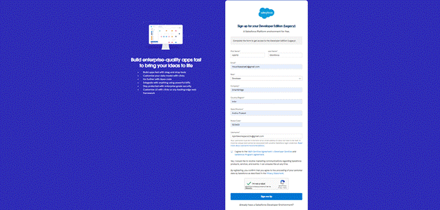
- First name & Last name
- Email
- Job Title: Developer
- Company: College Name
- Country: India
Click on sign me up after filling these.

Salesforce Account Verification and Setup:
- Go to the inbox of the email that you used while signing up. Click on the verify account to activate your account. The email may take 10-30mins and sometimes 2 hours.
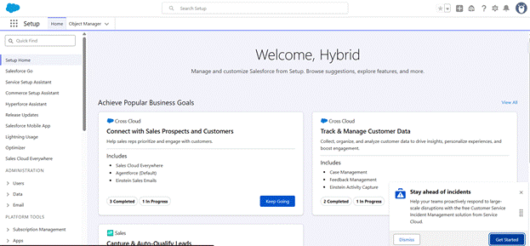
- Click on Verify Account
- Give a password and answer a security question and click on change password.
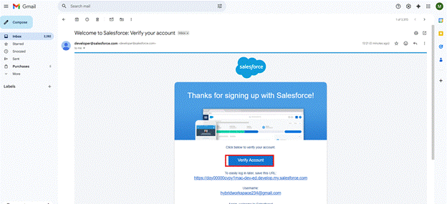
- Then you will redirect to your salesforce setup page. 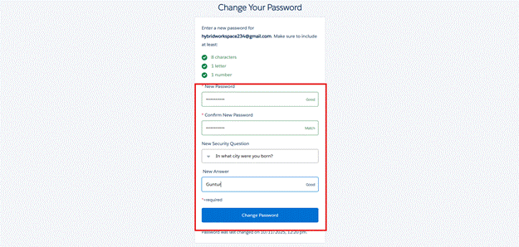

To create an object:
- From the setup page
- Click on Object Manager
- Click on Create >> Click on Custom Object.
- Enter the label name as Support Ticket Intelligence API Name: Support_Ticket_Intelligence__c
- Enter Plural label name as Support Ticket Intelligence
- Select Allow reports.
- Select Allow search.
- Allow Track Field History
- Click on Save.

Creating the Support Ticket Intelligence Custom Object Tab:
- Go to the setup page → type Tabs in Quick Find bar
- Click on tabs
- Click on New (under custom object tab).
- Select Object (Support Ticket Intelligence) >> Select the tab style
- Click on Next >> (Add to profiles page) keep it as default >> Click on Next (Add to Custom App) uncheck the include tab.
- Make sure that the Append tab to the user's existing personal customizations is checked.
- Click save

