FinSight AI: Personal Finance Behaviour Analysis and Spending Prediction System
Janani G, Himesh Niranjhan A
∗Department of Computer Science and Engineering, Rajalakshmi Engineering College, Chennai, Tamil Nadu, India
janani.g.2024.cse@rajalakshmi.edu.in
Student IDs: 240701208 (Janani G), 240701192 (Himesh Niranjhan A)

Abstract—Most people cannot say, at the end of a month, where their money went and why. Bank statements list hundreds of small transactions that are hard to read as patterns, and budgeting tools usually describe what has already been spent rather than what is likely to happen next. This paper presents FinSight AI, a proposed intelligent system that analyses a user’s transaction history, groups spending into behaviour profiles, flags unusual transactions, predicts next month’s spending for each category, and recommends a monthly budget that satisfies the user’s own constraints, such as a savings target and essential minimums. The design joins k-means clustering, Isolation Forest anomaly scoring, time-series forecasting, A* and local search, constraint satisfaction, rule-based logical inference, and Q-learning inside one agent, so that every output can be traced to a rule, a model score, or a search result. The system is at the design stage. No code has been run and no results are reported; every performance figure is a target, and the evaluation protocol states how each target will be measured, against which baselines, and on which data.
Index Terms—personal finance, intelligent agent, anomaly detection, spending forecasting, A* search, constraint satisfaction, rule-based inference, Q-learning
I. Introduction
Planning personal spending is difficult for four reasons that FinSight AI addresses directly.
- Spending is irregular. Category totals vary by weekday, month, and event, so a simple average is a poor guide to next month.
- Budgets are constrained. Income is fixed, essentials must be met, and a savings target must be reached. An arbitrary split can violate a constraint without the user noticing.
- Unusual transactions are hard to judge. A large or unfamiliar payment may be an error, a fraudulent charge, or a genuine one-off. Flagging every outlier overwhelms the user, while missing a real problem is costly.
- Advice is opaque. Recommendations from a black-box model are difficult to trust or act on; the user needs to know which rule, pattern, or calculation produced each alert.
This paper describes FinSight AI, a personal finance agent that categorises transactions, groups users into behaviour profiles, detects unusual transactions with an unsupervised score and a stated reason, predicts category-level spending, generates a feasible budget with A* and local search under a constraint satisfaction model, adapts its advice with reinforcement learning, and presents the results in a web application that works on a phone and on a desktop. The main contributions are:
- An integrated design in which each technique is established in the literature, but all are combined in one personal finance system with every recommendation traceable to a rule, a model output, or a search result.
- A formal agent specification (PEAS) and a single shared state representation, with a clear division of responsibility between the nine modules.
- An evaluation protocol, fixed before any experiment is run, that tests each module against a simple baseline and reports failures as openly as successes.
The system handles one user’s transaction history in one currency at a time. Inputs are transactions with a date, amount, description, and optional merchant name, together with a profile holding monthly income, household size, savings target, and fixed costs. Outputs are a behaviour summary, anomaly alerts, category-level predictions, a recommended budget, and a short explanation of each. Section II reviews related work, Section III presents the proposed system, Section IV describes the modules, Section V gives a worked example, Section VI sets out the implementation plan and evaluation protocol, and Sections VII to IX cover limitations, future work, and the conclusion.
II. Related Work
Russell and Norvig define an intelligent agent as a system that perceives its environment through sensors and acts on it through actuators, with behaviour judged by a performance measure, and they describe the PEAS framework for specifying an agent before building it [1]. Their treatment of partially observable environments applies directly, because a bank feed reveals only part of a person’s financial life.
Transaction categorisation is usually treated as text classification. Rule-based matching is transparent but brittle, whereas supervised classifiers generalise better but need labels that a new user does not have; FinSight AI therefore applies deterministic rules first and a classifier second. For behaviour clustering, k-means partitions observations by minimising within-group squared distance [2], and the silhouette coefficient measures how well each observation fits its cluster and is a standard basis for choosing k [3]. For forecasting, Hyndman and Athanasopoulos recommend comparing every method with simple benchmarks (the naive and seasonal naive forecasts) and validating on later periods rather than random splits [4]; random forests [5] offer non-linear regression but have no native sense of time. Isolation Forest isolates anomalous points in fewer random splits, needs no labels, and scales linearly with the number of observations [6], which suits transaction data where confirmed fraud labels are rare.
A* orders nodes by the cost so far plus a heuristic estimate of the remaining cost and returns an optimal path when the heuristic never overestimates [7]. Local search methods such as hill climbing and simulated annealing do not guarantee optimality. A constraint satisfaction problem consists of variables, domains, and constraints, and backtracking with minimum-remaining-values, least-constraining-value, and forward checking suits budgets whose constraints are explicit and whose domains are small [1]. Q-learning learns action values from reward without a model of the environment [8]. Table I summarises the techniques and the gap each leaves for personal finance.
TABLE I
Reviewed Techniques and the Gap Addressed by FinSight AI
Technique and source | Gap for personal finance | FinSight AI response
PEAS agents [1] | Toy environments; no finance-specific measure | Finance-specific PEAS (Table II)
k-means [2], silhouette [3] | Choice of k; weak separation with few users | Silhouette reported; weak clusters stated
Forecast benchmarks [4] | Complex models trusted without benchmarks | Naive and seasonal naive baselines
Random forest [5] | No native time awareness | Lagged and calendar features
Isolation Forest [6] | Scores are not probabilities | Score paired with a rule-based reason
A* [7] | Needs an admissible heuristic | Heuristic shown admissible
CSP and backtracking [1] | First feasible solution may be poor | Optimisation added to feasibility
Q-learning [8] | Reward can favour ignored advice | Reward from acceptance and outcome
Rule-based inference [1] | Rules must be maintained | Small rule base, plain-language text

The reviewed literature supplies strong components, but they are usually studied in isolation, each with its own data and evaluation. A personal finance system needs them to share one representation of the user, so that a predicted overspend can trigger a feasible budget, an alert can cite a rule, and a recommendation can be learned from the user’s response. FinSight AI addresses this gap with one agent, one state representation, and one evaluation plan that covers all modules.
III. Proposed System
A. System Overview
FinSight AI takes a user’s transactions and profile as input and returns four outputs: a behaviour summary, a list of anomaly alerts with reasons, a category-level forecast for the next month, and a recommended budget with a short explanation. The user can see the evidence for each output and can correct an input, such as a mislabelled merchant, which then changes the downstream results.
B. PEAS Description of the Finance Agent
Following [1], the agent is specified by its performance measure, environment, actuators, and sensors (Table II).
TABLE II
PEAS Description of the FinSight AI Agent
Element | Description
Performance measure | Forecast error (MAE) per category; precision of alerts; share of recommended budgets that are feasible; share of recommendations accepted; change in share of months within budget
Environment | The user’s transaction history, income, savings target, fixed costs, and corrections; partially observable (cash and other accounts are invisible), sequential (each month affects the next), and stochastic
Actuators | Alert notifications; dashboard updates; budget recommendations; prompts for category correction; explanation text
Sensors | Transaction feed or uploaded statement; user edits to categories; budget acceptance or rejection; profile form

C. Architecture
The system has five layers: presentation, application service, reasoning, learning, and data. Each layer reads only from the layer below it, so a change of data source or algorithm stays within its own layer. Fig. 1 shows the data flow. Transactions enter at the top, pass through categorisation and feature extraction, and feed the learning layer. Predictions and scores become facts for the knowledge base; the reasoning layer combines these facts with the user’s constraints to produce a budget and explanations, which the presentation layer shows.
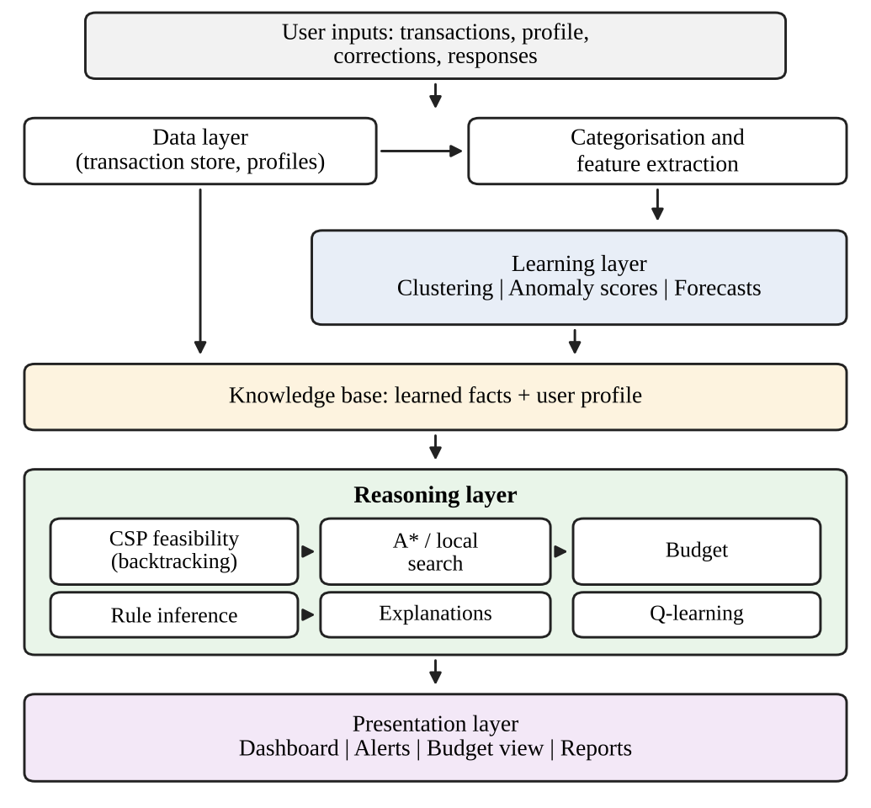
Fig. 1. Data flow and layers of FinSight AI.
D. Monthly Planning Cycle
The planning cycle has eight steps:
- Validate new transactions: dates must parse, amounts must be numeric, and duplicates are removed.
- Categorise each transaction with the merchant dictionary, then the classifier.
- Aggregate monthly totals per category.
- Profile: update behaviour features and assign the user to a cluster.
- Score new transactions for anomalies.
- Forecast next month’s spending per category.
- Plan the budget with the CSP and the search methods.
- Explain: write the reasons for each output from the rules that fired and the values used.
E. Design Decisions and Requirements
- Monthly cycle. Forecasts and budgets are meaningful at monthly scale; daily budgets would be too noisy for one user with limited history.
- Rules plus classifier for categorisation, unsupervised anomaly detection (no fraud labels exist for one user), and linear regression as the main forecaster with a random forest as comparison.
- CSP for feasibility, search for optimality. Constraints must always hold, so they are modelled explicitly and A* then minimises disruption.
- Q-learning over a small state space suits the limited interaction data of a single user better than deep reinforcement learning.
- Non-functional requirements: privacy (data kept on the user’s machine or in an encrypted store, nothing shared with third parties); explainability (every alert and recommendation carries a reason, target 100%); reproducibility (fixed random seeds and stored model versions); and usability (core tasks on a 390 px wide screen).
IV. Modules and Methods
A. Module 1: Transaction Ingestion and Categorisation
Each transaction is checked for a parseable date, a numeric amount, and a non-empty description. Failed records are kept in a rejected list with the reason, and duplicates are identified by date, amount, normalised description, and an occurrence index. Categorisation has two stages. The first normalises the description (lower-casing, removing digits and reference codes) and matches it against a merchant dictionary; a match assigns the category and records the rule. The second applies a text classifier on character n-grams with a linear model, which is fast and tolerant of misspellings. Assignments with confidence below 0.60 are marked uncertain and shown to the user first, and a user correction is written back as a new merchant rule.
B. Module 2: Behaviour Analysis and Clustering
For each user and full month the module computes total spending, the share of spending in each of the seven categories, the savings rate (one minus spending divided by income), the coefficient of variation of weekly spending, the share of spending in the last week of the month, and the number of distinct merchants, over a rolling window of six months. Standardised feature vectors are clustered with k-means, with k chosen from {2, 3, 4} by the silhouette score, preferring the smaller k when two values are within 0.02. For user i,
s(i) = (b(i) − a(i)) / max{a(i), b(i)} (1)
where a(i) is the mean distance to other users in the same cluster and b(i) is the smallest mean distance to users in any other cluster [3]. Clusters are named by their centres: savers have the highest savings rate and lowest irregularity, high spenders the lowest savings rate, and balanced spenders lie between; any other cluster is labelled “irregular”. A silhouette near zero is reported as a warning that the clusters are not meaningfully separated.
C. Module 3: Anomaly Detection
An Isolation Forest of t trees is trained on a sample of transactions from the user’s history, using the amount, its logarithm, the category, the weekday, the hour where available, and the days since the last transaction in the same category. For a transaction x the anomaly score is [6]
s(x, n) = 2^{−E[h(x)] / c(n)} (2)
where h(x) is the path length, and c(n) = 2H(n−1) − 2(n−1)/n normalises by the expected path length of an unsuccessful binary search, with H(i) ≈ ln(i) + 0.5772. A score alone is hard to act on, so each alert carries a reason derived from the user’s own history: an amount above the 95th percentile of the category (amount outlier), a rarely used category (category outlier), or a merchant not seen before (new merchant). Reasons are ordered by how strongly each departs from the history.
D. Module 4: Spending Prediction
The target is the total spending y(c, m) of category c in month m. Features are the lagged totals for the previous one, two, and three months, the mean of the previous three, the same month in the previous year where available, a seasonal index for the calendar month, income, household size, savings target, and the number of days in the month. Four models are compared: the naive forecast, the seasonal naive forecast (falling back to the three-month mean), ridge regression, whose coefficients can be shown to the user, and a random forest with 300 trees and a minimum leaf size of five [5]. Validation is time-based: for each user with at least twelve months of history the model is trained on earlier months and tested on the next, moving the origin forward one month at a time. Mean absolute error and root mean squared error are reported per category and overall; mean absolute percentage error is not used because it is undefined for months with zero spending.
E. Module 5: Budget Search with A* and Local Search
A state is a vector of monthly allocations b = (b₁, …, b₇) over the seven categories, with savings as the remainder of income. The start state is the forecast spending, the goal is any state satisfying every constraint of Module 6, and the cost of a path is the total absolute change summed over moves, weighted by a user-set category importance. A* expands nodes by [7]
f(n) = g(n) + h(n) (3)
where g(n) is the cost so far. Let D be the total absolute difference between the current allocation and the nearest feasible allocation and s the step size. At least ⌈D/s⌉ moves are still needed, so h = ⌈D/s⌉ times the minimum cost of one move never overestimates the remaining cost; it is admissible, and, because a move changes one category at a fixed step cost, also consistent when the minimum category weight is used. Each returned path is converted into a list of changes, such as “reduce entertainment by 5% of income and add the same amount to savings”, each linked to the constraint or forecast that motivated it.
F. Module 6: Constraint Satisfaction
The variables are the seven monthly allocations, each with a domain bounded by the user’s history and profile and discretised in steps of 1% of income. Essential categories have lower bounds set by household size and minimum living cost; discretionary categories have upper bounds set by the user’s preference, defaulting to their own 75th percentile over six months. Table III lists the constraints. The CSP is solved by backtracking with minimum-remaining-values variable ordering, least-constraining-value ordering, and forward checking [1]; because the domains are small, the feasible set is found quickly.
TABLE III
Constraints of the Budget CSP
ID | Constraint | Type
C1 | All allocations, including savings, sum to monthly income | Equality
C2 | Savings allocation is at least the savings target | Inequality
C3 | Food is at least household size times minimum food cost per person | Essential
C4 | Housing and utilities are at least the user’s fixed costs | Essential
C5 | Entertainment does not exceed the discretionary limit | Preference
C6 | Each allocation lies inside its domain | Domain
C7 | Discretionary total does not exceed income minus essentials and savings | Inequality

G. Module 7: Knowledge Base and Logical Inference
Propositional rules cover a single category in a single month. Let H denote that a category is high risk, O that spending exceeds the limit, and R that the last two months both exceeded it. The rule set includes:
R1: O -> Warning(c)
R2: R -> HighRisk(c)
R3: HighRisk(c) and Essential(c) -> Alert(c)
R4: Anomaly(t) and NewMerchant(t) -> Review(t)
R5: Review(t) and not UserConfirmed(t) -> Alert(t)
First-order schemas, such as ∀c: exceeds(c, m) ∧ exceeds(c, m−1) → highRisk(c, m), apply the same rule to every category and user and are grounded into propositional facts over which forward chaining operates [1]. During the month, forward chaining fires every rule whose premises are satisfied by newly derived facts, raising alerts as they occur. The rule base is small by design, about twenty rules in the first version; each has a plain-language text and a switch the user can turn off, and switched-off rules are logged for the evaluation.
H. Module 8: Adaptive Recommendation with Q-Learning
A state is the category with the largest forecast overspend, a bin of its size (none, small, large), and the user’s profile cluster, giving 7 × 3 × (number of profiles) states, small enough for a tabular method. The three actions for the highlighted category are to keep the allocation or reduce it by 5% or 10% of income; one category is recommended per month so as not to overwhelm the user. The learner uses the standard update [8]
Q(s, a) ← Q(s, a) + α[r + γ max_{a′} Q(s′, a′) − Q(s, a)] (4)
with an ε-greedy policy. The defaults are α = 0.2, γ = 0.7, and ε decaying from 0.2 to 0.02 over the first twelve months; the discount is moderate because the effect of a recommendation is visible within a month. The reward is based on acceptance of the recommendation and on whether the month stayed within the planned allocation.
I. Module 9: Web Application and Explanations
The application has five screens: a dashboard (month total against budget, category breakdown, forecast, active alerts), an alerts screen with confirm and dismiss buttons, a budget screen showing each change with its explanation, a reports screen (history, profile, measured forecast accuracy), and settings (profile, savings target, alert tolerance, rule switches). Fig. 2 shows the prototype dashboard. Every displayed number carries a source line naming the module and the rule or method that produced it; the line is written from stored metadata rather than generated freely, so the explanation always matches the computation. The layout is a single column below 560 px, tables collapse to labelled rows on narrow screens, and alerts use a text label so that colour is not the only signal.
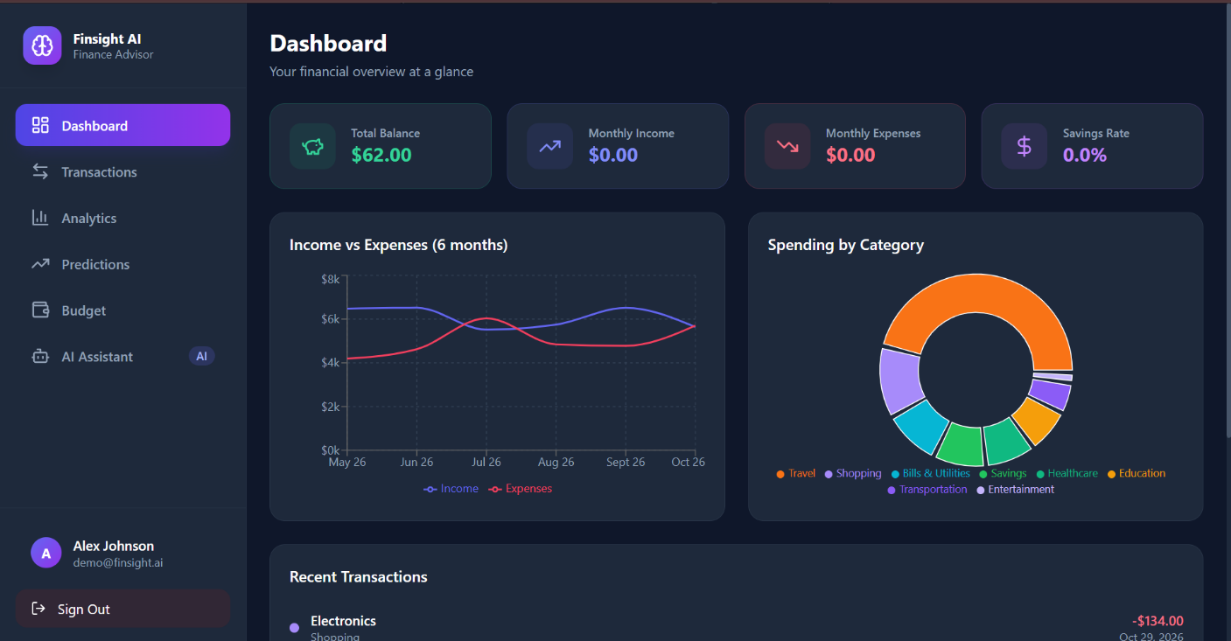
Fig. 2. Prototype dashboard screen (placeholder demonstration data).
V. Worked Example (Hypothetical)
The figures below are invented to show the form of each calculation and are not results. Take a monthly income of 60,000 units and a step of 5% of income, i.e., 3,000 units. Module 6 finds that the forecast satisfies every constraint except the entertainment limit of 5,000, which the forecast of 6,500 exceeds by 1,500. Module 5 starts from the forecast; reducing entertainment by 3,000 and adding the same amount to savings gives 3,500, inside the limit. The heuristic estimates ⌈1,500/3,000⌉ = 1 move, which is the move A* returns. The explanation states that entertainment was forecast at 6,500 against a limit of 5,000 and that 3,000 is the smallest step that satisfies it.
During the month a transaction of 4,200 in entertainment from a new merchant exceeds the Isolation Forest threshold; the reasons are an amount above the category’s 95th percentile and a new merchant. Rule R4 derives Review(t), and since the user has not confirmed it, R5 derives Alert(t) with both reasons. At month end, spending of 3,600 against the planned 3,500 is within the 5% tolerance, so Module 8 receives a positive reward and updates the Q-value; in practice the value moves gradually over many months.
VI. Implementation Plan and Evaluation
A. Technology Stack and Data Design
Table IV lists the planned stack. The database has six tables: transactions, categories, merchant rules, profiles, budgets, and events (alerts, user responses, and rewards, the source of data for Module 8). The back end exposes JSON endpoints, and each returns an explanation field alongside its numerical results so the interface can show the reason with the number.
TABLE IV
Planned Technology Stack
Area | Choice and reason
Language | Python 3.11 or later; mature machine learning and data libraries
Data handling | pandas and NumPy; standard for tabular time series
Machine learning | scikit-learn [9]: k-means, silhouette, Isolation Forest, ridge, random forest, metrics
Text classification | scikit-learn with a character n-gram vectoriser
Search and reasoning | Custom Python implementation, keeping A*, CSP, and inference code visible
Storage and service | SQLite (single user, no server) and FastAPI (typed endpoints)
Front end | Responsive browser interface; one code base for phone and desktop
Testing and control | pytest with fixed random seeds; Git

B. Datasets
No real user data is used without the user’s consent, and no personal data is published. Evaluation uses three kinds of data, each stated in the results with its source: (i) synthetic users generated from stated distributions with a fixed seed and injected anomalies with known labels; (ii) any public transaction dataset that permits academic use, with its licence and citation, omitted with a statement if none is suitable; and (iii) the authors’ own records, used only with consent, anonymised, with merchant names replaced by category tokens.
C. Experimental Protocol and Tests
The protocol is fixed before the experiments run:
- Splits. Forecasts use rolling-origin validation for users with at least twelve months of history; no parameter is tuned on test months.
- Repetition. Every stochastic component (Isolation Forest, random forest, k-means, Q-learning) is run with five seeds, reporting mean and range.
- Baselines. Seasonal naive forecast for Module 4, a fixed-threshold rule for Module 3, a greedy proportional cut for Module 5, and a bandit for Module 8.
- Ablation. Module 6 is removed to measure how often the resulting budget violates the savings target or essential minimums.
- Reporting. Negative results are reported like positive ones; where a method does not beat its baseline, the paper says so.
Automated tests cover each module and their connections: unit tests (malformed rows, known-merchant categorisation, the score of a constructed outlier), algorithm tests (A* against exhaustive search on small budgets, constraint satisfaction of every returned budget, and the Q-learning update against a hand-calculated example), and integration tests that run the full cycle on a synthetic user and check that an alert cites a rule and a budget satisfies the constraints the status reports.
VII. Current Status and Limitations
This paper describes a design. The system has not yet been built, and the targets above are to be tested. FinSight AI does not connect to live bank accounts in its first version, gives no investment advice, does not move money, and does not replace professional financial advice. Predictions depend on the amount and quality of history: with fewer than six months of data the system reports that its predictions are unreliable rather than producing a confident forecast. Cash spending, other accounts, and money given to family members are invisible and appear as unexplained variation. Categorisation depends on the quality of merchant descriptions, and the explanations describe the system’s reasoning, not the user’s psychology. The system informs a decision and does not make it.
VIII. Future Work
- Bank connection: a consented, read-only feed would remove manual import and allow real-time anomaly scoring.
- Generative explanations: a language model could rewrite rule-based explanations, provided every statement is checked against the stored source line.
- Multi-month and household planning: extend the search to a horizon of months and to several users sharing one budget.
- Richer forecasting and calibrated alerts: hierarchical forecasts across sub-categories, sequence models when enough users exist, and per-user alert thresholds learned from confirmations.
- Rule learning: propose new rules from patterns the user repeatedly confirms while keeping the rule base readable.
IX. Conclusion
FinSight AI is designed as one intelligent system that joins agent specification, informed and local search, constraint satisfaction, logical inference, machine learning, and reinforcement learning in a personal finance application. The agent specification gives the system a clear performance measure and environment; search finds low-cost budget changes; constraint satisfaction ensures every budget respects income, savings target, and essential needs; inference produces explanations that can be checked; and learning supplies the profiles, anomaly scores, and forecasts and adapts the advice to the user’s responses. The paper makes no claim about results. If the planned tests show that a component does not beat its baseline, that will be reported and the design revised.
Acknowledgment
The authors thank the Department of Computer Science and Engineering, Rajalakshmi Engineering College, and their faculty mentors for guidance during this project, carried out for the course CS23533 Foundations of Artificial Intelligence.
References
[1] S. Russell and P. Norvig, Artificial Intelligence: A Modern Approach, 4th ed. Harlow, U.K.: Pearson, 2021.
[2] J. MacQueen, “Some methods for classification and analysis of multivariate observations,” in Proc. 5th Berkeley Symp. Math. Statist. Probab., vol. 1, 1967, pp. 281–297.
[3] P. J. Rousseeuw, “Silhouettes: A graphical aid to the interpretation and validation of cluster analysis,” J. Comput. Appl. Math., vol. 20, pp. 53–65, 1987.
[4] R. J. Hyndman and G. Athanasopoulos, Forecasting: Principles and Practice, 3rd ed. Melbourne, Australia: OTexts, 2021. [Online]. Available: https://otexts.com/fpp3/
[5] L. Breiman, “Random forests,” Mach. Learn., vol. 45, no. 1, pp. 5–32, 2001.
[6] F. T. Liu, K. M. Ting, and Z.-H. Zhou, “Isolation forest,” in Proc. 8th IEEE Int. Conf. Data Mining (ICDM), 2008, pp. 413–422.
[7] P. E. Hart, N. J. Nilsson, and B. Raphael, “A formal basis for the heuristic determination of minimum cost paths,” IEEE Trans. Syst. Sci. Cybern., vol. 4, no. 2, pp. 100–107, 1968.
[8] C. J. C. H. Watkins and P. Dayan, “Q-learning,” Mach. Learn., vol. 8, no. 3–4, pp. 279–292, 1992.
[9] F. Pedregosa et al., “Scikit-learn: Machine learning in Python,” J. Mach. Learn. Res., vol. 12, pp. 2825–2830, 2011.

