Data Science / Analysis with Python – Task1
Student Performance Dataset
Name: B. Janani
Internship: Maincrafts Technology
Domain: Data Analysis with Python
Objective of the Project
The main objective of this project is to perform an in-depth analysis of the Student Performance dataset using Python.
This project aims to understand how different factors such as study time, gender, and other attributes influence students’ final academic performance.
Specific objectives include:
- To load and understand the structure of the student performance dataset.
- To clean the dataset by checking missing values and removing duplicate records.
- To analyze students’ final grades (G3) using statistical methods.
- To identify how study time affects academic performance.
- To compare average performance between male and female students.
- To visualize important patterns and trends using graphs.
- To gain hands-on experience with the complete data analysis workflow:
Load → Clean → Analyze → Visualize → Conclude.
2. Tools Used
Python
Google Colab (Jupyter Notebook)
Pandas
Matplotlib
3. Dataset Description
The dataset student-mat.csv contains student academic and personal details along with final grades (G3).
It consists of multiple rows and columns including study time, gender, and grades.
4. Data Loading & Cleaning
The dataset was loaded using Pandas.
Missing values were checked using isnull() and none were found.
Duplicate records were removed.
Dataset structure and data types were inspected.
5. Analysis
🔹 Average Final Grade (G3)
The average final grade was calculated using the mean function.
🔹 Students Scoring Above 15
The number of students who scored above 15 in final grade (G3) was calculated.
🔹 Study Time vs Performance
Correlation analysis was performed to understand the relationship between study time and final grades.
🔹 Gender-wise Performance
Average grades of male and female students were compared.
6. VisualizationsHistogram showing distribution of final grades.Scatter plot showing relationship between study time and grades.Bar chart comparing average grades of male and female students.
Code
Plt.figure(figsize=(6,4))
Plt.hist(df[‘G3’], bins=15)
Plt.title(“Distribution of Students’ Final Grades (G3)”)
Plt.xlabel(“Final Grade”)
Plt.ylabel(“Number of Students”)
Plt.show()

The output
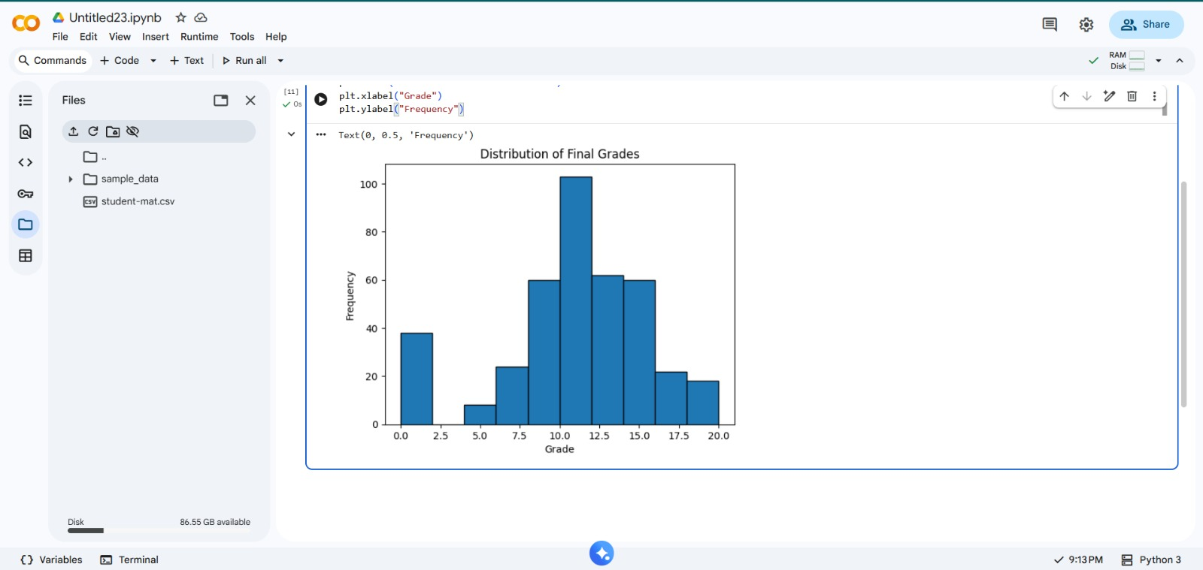

7. Conclusion
This project successfully analyzed student performance using Python.
The analysis provided insights into student grades, study habits, and gender-based performance.
This task helped in understanding the complete data science workflow:
Load → Clean → Analyze → Visualize → Conclude.

