CHAPTER 1
INTRODUCTION

1.1 Data Structure
A data structure is a systematic way of organizing, managing, and storing data so that it can be accessed and modified efficiently. It defines the relationship between the data and the operations that can be performed on that data. Data structures are the foundation of efficient programming and algorithm design.

1.2 Importance of Data Structures
Data structures are crucial for solving complex computational problems and optimizing performance. Efficient data structures lead to faster execution, lower memory usage, and scalable code. They are used in various domains such as artificial intelligence, databases, operating systems, graphics, networking, and more.

1.3 Basic Terminologies
- Data: Raw facts and figures.
- Information: Processed data with meaning.
- Data Type: A classification of data which tells the compiler or interpreter how the programmer intends to use the data (e.g., int, float, char).
- Abstract Data Type (ADT): A model for a data structure that specifies the type of data stored, operations supported, and the types of parameters of the operations.

1.4 Types of Data Structures
Data structures can be broadly classified into the following categories:

1.4.1 Linear Data Structures
- Array: A collection of elements stored at contiguous memory locations.
- Linked List: A linear collection of data elements called nodes, where each node points to the next.
- Stack: A LIFO (Last-In, First-Out) structure.
- Queue: A FIFO (First-In, First-Out) structure.

1.4.2 Non-linear Data Structures
- Tree: A hierarchical data structure with nodes connected by edges.
- Graph: A collection of nodes connected by edges, useful for representing networks.

1.4.3 Hash-based Structures
- Hash Table: A structure that maps keys to values using a hash function for efficient lookups.

1.5 Operations on Data Structures
Common operations include:
- Insertion: Adding a new element.
- Deletion: Removing an existing element.
- Traversal: Visiting elements in a particular order.
- Searching: Finding a specific element.
- Sorting: Arranging elements in a particular order.

1.6 Need for Data Structures in Programming
Without proper data structures, even simple problems can become complex and inefficient. Choosing the right data structure can lead to:
- Reduced complexity
- Easier data management
- Better performance and resource usage

1.7 Applications of Data Structures
Data structures are used in:
- Compilers and interpreters
- Databases and file systems
- Operating systems
- Artificial Intelligence
- Web development and APIs
- Gaming and simulation

CHAPTER 2

METHODOLOGY

2.1 Objective

The main objective of this project is to develop an Inventory Management System using C.

It helps users to manage product information efficiently and perform various operations

Easily.

2.2 Problem Statement
Managing inventory manually is difficult and time-consuming. There may be errors in maintaining records. This project aims to provide a simple and efficient way to store and manage product details using a computerized system.

2.3 Technology Stack
Programming Language: C
Compiler: GCC (MinGW-w64)
Platform: Windows
Tools Used: NotePad / Command Prompt

2.4 Project Description
The Inventory Management System is a console-based application. It allows users to perform operations such as adding new products, displaying product details, searching for products, updating product information, deleting products, checking low stock, and sorting products.
The system uses structures to store product details and functions to perform different operations.

CHAPTER 3

RESULTS AND DISCUSSION

Screenshots

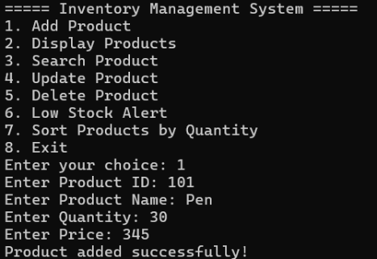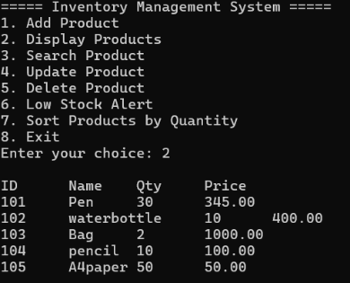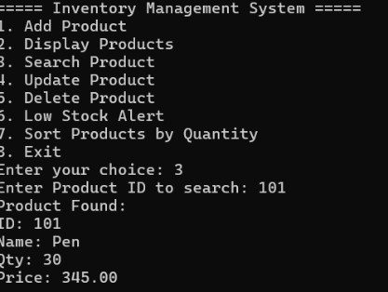

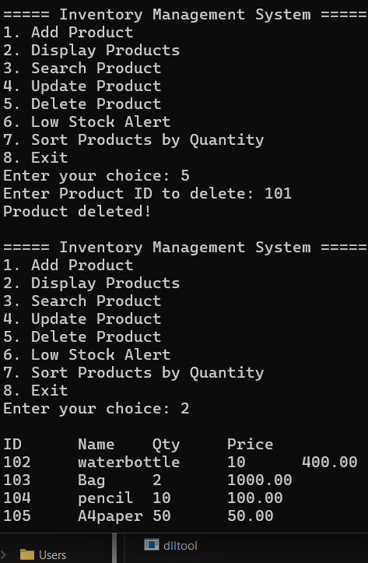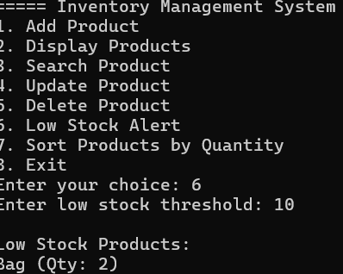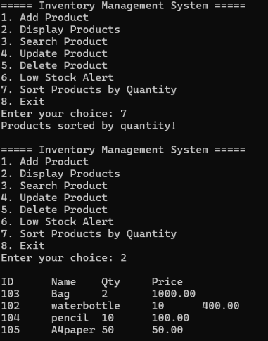

Figure 3.1 Inventory Management System

CHAPTER 4

CONCLUSION
The Inventory Management System was successfully implemented using C programming language. This project helped in understanding the practical application of data structures and various operations such as insertion, deletion, searching, and sorting.
The system provides a simple and user-friendly interface to manage product details efficiently. It reduces manual effort and minimizes errors in maintaining inventory records. The use of structures and functions makes the program organized and easy to understand.
This project also improves problem-solving skills and programming knowledge. It can be further enhanced by adding features like file handling for permanent data storage and a graphical user interface for better user experience.
Overall, the project is useful for small-scale inventory management and serves as a strong foundation for developing advanced software applications in the future.

REFERENCES
- Horowitz, E., Sahni, S., & Anderson-Freed, S. (2008). Fundamentals of Data Structures in C (2nd ed.). Universities Press.
- Weiss, M. A. (2013). Data Structures and Algorithm Analysis in C++ (4th ed.). Pearson Education.
- Lafore, R. (2002). Data Structures and Algorithms in Java (2nd ed.). Sams Publishing.
- Cormen, T. H., Leiserson, C. E., Rivest, R. L., & Stein, C. (2009). Introduction to Algorithms (3rd ed.). MIT Press.
- Tanenbaum, A. S., & Langsam, Y. (1991). Data Structures Using C. Prentice Hall.
- Goodrich, M. T., Tamassia, R., & Mount, D. M. (2011). Data Structures and Algorithms in C++ (2nd ed.). Wiley.
- Shaffer, C. A. (2011). Data Structures and Algorithm Analysis. Dover Publications.
- Patil, P. S. (2020). Data Structures Using Python. Oxford University Press.
- Knuth, D. E. (1997). The Art of Computer Programming, Vol. 1: Fundamental Algorithms (3rd ed.). Addison-Wesley.
- Wirth, N. (1986). Algorithms + Data Structures = Programs. Prentice Hall.

