EXPERIMENT – 2
Encryption – Crypto 101 using TryHackMe
Aim:
To understand the fundamentals of cryptography by performing hands-on exercises in the Crypto 101 room on the TryHackMe platform, including basic encryption, encoding, hashing, and cryptographic concepts.
Procedure:
Step 1: Login to Platform
Open browser and go to TryHackMe. Login using your account.
Step 2: Open Crypto 101 Room
Search for Crypto 101 and click Join Room.
Step 3: Start Environment
Click Start Machine / AttackBox to launch the virtual lab.
Step 4: Perform Cryptography Tasks
- Base64 Encoding/Decoding
- Hex Conversion
- Caesar Cipher
Step 5: Submit Answers
Enter the decoded results in the answer boxes and complete all tasks.

Output:

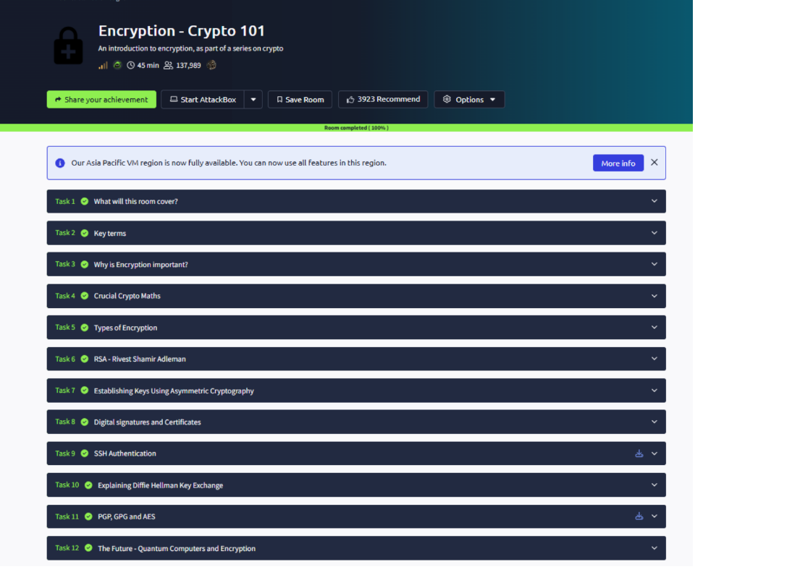

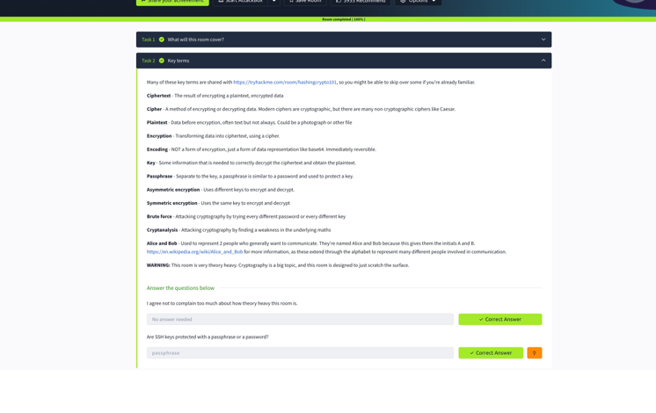
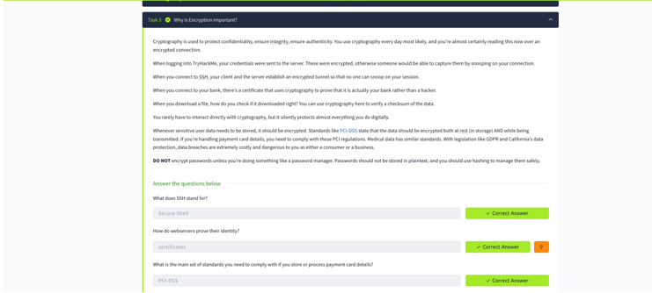

Result
Basic cryptography concepts such as encoding, decoding, hashing, and classical ciphers were successfully performed using TryHackMe.

