EXPERIMENT - 4 Hash Cracking Using John the Ripper
Aim:
To demonstrate password hash cracking using the John the Ripper tool in Kali Linux for understanding password vulnerabilities and security analysis.
Procedure:
Step 1: Start Environment
Open Oracle VirtualBox and start Kali Linux. Login to the system.
Step 2: Open Terminal and Verify Tool
Open terminal and check if John the Ripper is installed: john --version
Step 3: Create Hash File
Create a file and store a password hash: nano hash.txt
Step 4: Run Hash Cracking john hash.txt
The tool attempts to crack the hash using default wordlists. Step 5: View Cracked Password john --show hash.txt

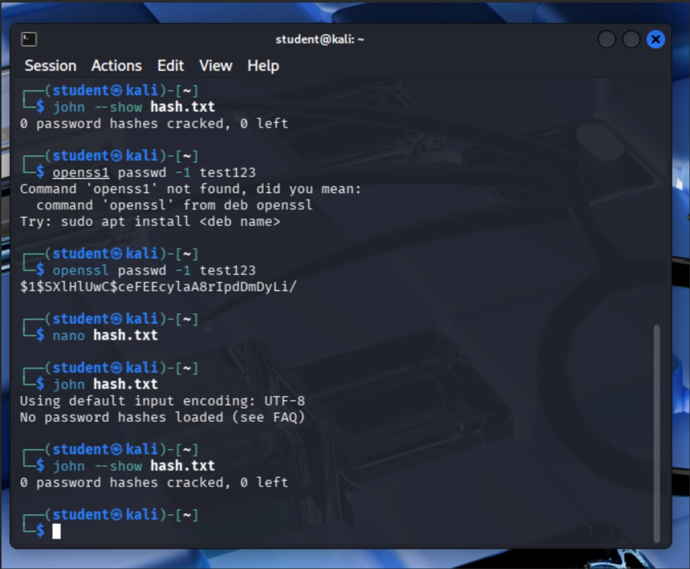
OUTPUT:

Result
Password hash cracking was successfully demonstrated, highlighting the need for strong passwords and secure hashing techniques.

