EXPERIMENT – 10
Wireless Audit Using Aircrack-ng
Step 1: Start Environment
Open Oracle VirtualBox and start Kali Linux. Connect the external Wi-Fi adapter.
Step 2: Verify Wireless Interface
Check the available wireless interface and ensure it is detected properly.
Step 3: Enable Monitor Mode
Switch the wireless adapter to monitor mode to capture network packets.
Step 4: Scan Wireless Networks
Scan nearby Wi-Fi networks and identify the target network details such as BSSID and channel.
Step 5: Capture Handshake
Capture the WPA/WPA2 handshake by monitoring the target network traffic.
Step 6: Perform Password Cracking
Use a wordlist to attempt password recovery from the captured handshake.
Step 7: Stop Monitoring
Disable monitor mode after completing the analysis.

Output
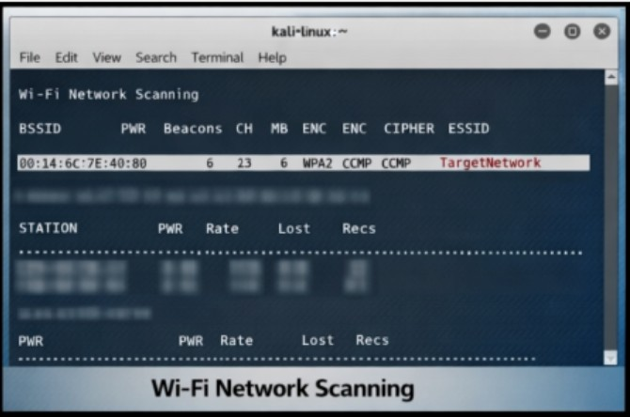
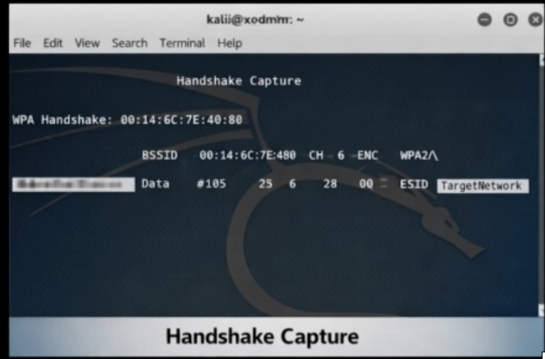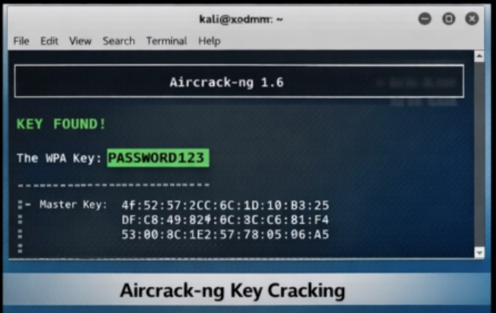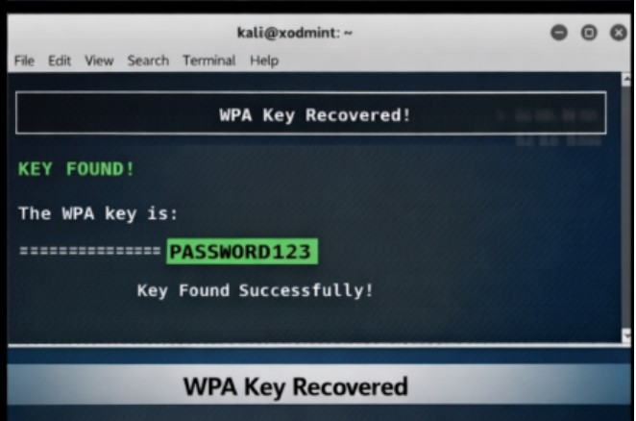

Result
Wireless auditing was successfully demonstrated using Aircrack-ng, highlighting the importance of strong passwords and secure wireless configurations.

